A COMPARISON OF THE MARKETING METHODS OF TWO HOTEL BRANDS

Student Name: Mihaela Robutu
Student ID Number: 2245306
Course: Marketing Essentials (BMIH4005)
Hospitality and Tourism Management
Professor: Scott James

A Comparison of the Marketing Methods of Two Hotel Brands
Marketing is essential to the success of every company, and multinational hotel brands are no exception. This paper compares Six Senses and Holiday Inn's marketing approaches in the competitive hospitality business, analysing internal and external elements impacting their marketing strategy using situational analysis methods like SWOT and PESTLE. The 7Ps of the marketing mix—product, price, location, promotion, people, process, and physical evidence—are also examined to understand better how these firms create their offers and connect with their target markets. Both brands' segmentation, targeting, and positioning tactics are also analysed. The paper's conclusion includes recommendations for their future development and success, encompassing aspects such as entering new markets, leveraging technology, and addressing business challenges like sustainability. It also highlights excellent practices and problems in the competitive hospitality business by offering insights into some well-known hotel chains' marketing strategies.
Using the SWOT and PESTLE frameworks is crucial to understand the internal and external issues impacting these brands thoroughly. The PESTLE study evaluates the political, economic, social, technical, legal, and environmental variables affecting the brands' operations, whereas the SWOT analysis looks at the brands' strengths, weaknesses, opportunities, and threats. Internally, Six Senses has made a name for itself as a premium hotel brand known for its dedication to health and sustainability (Calisto et al., 2021). It has established a solid brand image in the hotel sector by providing extraordinary experiences while embracing environmental and social responsibilities. On the other hand, Holiday Inn is a mid-range hotel brand and strongly emphasises accessibility, price, and consistency in service quality. Both brands operate in different geographic areas, which presents various opportunities and problems regarding external influences. Due to the significant expansion of the tourist sector with increased foreign visitors, Six Senses has flourished due to its advantageous location. The brand may benefit from the city's extensive cultural legacy by luring travellers looking for rich experiences and healthy getaways. In contrast, Holiday Inn operates where the market is more crowded and requires creative marketing approaches to set itself apart from other mid-range hotel chains (Su and Reynolds, 2019). The PESTLE study also identifies outside forces that affect these brands. Both brands must handle political issues, including taxes, labour rules, and travel limitations, to comply with laws and policies specific to the hospitality sector.
Exchange rates, inflation, and general economic circumstances influence a company's profitability and pricing policies. Social changes in consumer trends and preferences, such as the rise in interest in sustainability and wellness-focused experiences, significantly impact how businesses sell their products. Digital marketing and other technological developments, like online reservation systems, allow brands to reach and interact successfully with their target customers (Banyeva et al., 2023). The laws governing data protection, intellectual property, and health and safety affect how businesses operate and sell their products. Therefore, environmental aspects, including the rising interest in environmental sustainability and lowering carbon footprints, need both brands to act ecologically friendly (Calisto et al., 2021). Both brands may better understand their internal strengths and weaknesses and the external possibilities and dangers they must contend with using the situational analysis tools SWOT and PESTLE. These assessments help to provide insightful information on the elements driving their marketing efforts, and these brands can build on their strengths, fix their shortcomings, exploit opportunities, and manage dangers.
The marketing mix provides a complete framework for assessing and contrasting the two brands' marketing tactics, including the 7Ps (Product, Price, Place, Promotion, People, Process, and Physical Evidence) (Kwok, Tang, and Yu, 2020). Six Senses offers opulent lodgings, health retreats, and one-of-a-kind experiences that are environmentally sensitive and sustainable (Calisto et al., 2021). Being a mid-range brand, Holiday Inn strongly emphasises convenience, comfort, and standardised facilities. Six Senses places itself in the high-end luxury market in terms of cost, charging premium prices for its extraordinary services and desirable experiences (Su and Reynolds, 2019). On the other hand, Holiday Inn uses a more reasonable pricing approach to appeal to budget-conscious tourists looking for dependable and consistent lodging alternatives. To improve the whole experience for its visitors, Six Senses carefully chooses the best settings, often adjacent to scenic areas or exciting landmarks (John, 2020).
However, Holiday Inn prioritises accessibility and convenience by positioning its facilities adjacent to crucial commercial, tourist, and transportation centres. Both brands use various marketing strategies to reach their target markets regarding promotion. However, Six Senses emphasises experiential marketing, showcasing its unique services via collaborations with influencers, social media platforms, and word-of-mouth advertising (Casado, Tur, and Solano, 2019). Holiday Inn uses digital advertising, loyalty programs, and online travel agents for marketing its brand and drawing consumers (Banyeva et al., 2023). The marketing mix's components related to people, procedure, and tangible proof are equally crucial. Six Senses highly values skilled staff members who provide individualised service to make a lasting impression on visitors. Holiday Inn strongly emphasises quick check-in and check-out procedures and consistent service delivery to maintain uniformity throughout its hotels. Both businesses invest in keeping their physical locations in top condition to match client expectations.
Utilising the Similarweb analysis tool will determine and contrast the client categories that the two brands target. Six Senses generally serves rich people looking for luxurious experiences, health retreats, and eco-friendly lodging (Liz, 2023). High net-worth people, eco-conscious tourists, and wellness specialists are among their target markets. On the other hand, Holiday Inn caters to a broader consumer base, including families, business travellers, and vacationers on a tight budget. They want to appeal to those seeking a mix between affordability and quality by offering welcoming, dependable lodging at fair prices. These brands' positioning tactics fit with their target markets. Six Senses sells its dedication to health, environmental preservation, and top-notch service as a supplier of unique and sustainable luxury experiences (Calisto et al., 2021).
sWith an emphasis on reliability, accessibility, and affordability, Holiday Inn advertises itself as a mid-range hotel brand that can be trusted. The marketing mix and situational analysis may connect the segmentation, targeting, and positioning analysis conclusions. For instance, Six Senses' emphasis on health and sustainability is consistent with its focus on product uniqueness and its reaction to the rising demand for luxurious eco-apartments. Holiday Inn targets budget-conscious tourists looking for convenient lodging inaccessible areas by promoting itself as a cheap and dependable brand in conjunction with its price and placement tactics. To efficiently reach its target demographic, Six Senses combines digital marketing, social media presence, and collaborations with influencers and wellness professionals in its promotional initiatives (Cunha, Correia, and Costa, 2021). To set themselves apart in the market for premium hospitality, they promote their exclusive features, such as private villas, spa facilities, and comprehensive wellness programs. On the other hand, Holiday Inn combines conventional and digital marketing channels, such as online booking systems, loyalty programs, and ad campaigns aimed at families and business visitors (Banyeva et al., 2023). They emphasise their reliable quality, suitable locations, and affordable prices to attract their target demographics. Essential components of these two brands' marketing strategies include people, procedures, and tangible proof (Fernandes, 2021). Both brands understand the importance of customer-focused and well-trained workers to provide outstanding customer service. They invest in personnel training and development initiatives to guarantee consistent quality across all locations.
Process-wise, Holiday Inn emphasises efficiency and simplified service procedures to increase client satisfaction, while Six Senses prioritises sustainability and ecologically friendly methods in its operations. Physical indicators like hotel layout, facilities, and cleanliness help both businesses build a favourable reputation for their target audiences. The marketing efforts of these two brands can be analysed to understand how they effectively target different client demographics and position themselves in the competitive hospitality industry (Xia et al., 2020). By utilising segmentation, targeting, and positioning techniques, these brands capitalise on their strengths, meet customer desires, and adapt to market trends. These strategies are aligned with the overall marketing mix and consider internal and external factors identified during the situational analysis.
In conclusion, there are similarities and differences observed in the marketing approaches and methods employed by the two brands. While Holiday Inn caters to a broader consumer base, emphasising price and accessibility, Six Senses targets wealthy customers seeking luxury experiences. Both businesses successfully use the marketing mix to appeal to their target markets by capitalising on their distinct advantages and positioning techniques. It is essential to consider pertinent issues in the hospitality business when building and improving marketing strategies. These concerns include the growing number of digital marketing platforms and the importance of environmental practices. These elements may help these brands react to shifting consumer preferences and grab development opportunities by being included in their marketing plans. Examining both brands' marketing techniques and strategies offers insightful information about each brand's practice. It is possible to make suggestions to improve their marketing efforts and ensure ongoing success and development in the dynamic hospitality industry by comprehending their internal and external elements, analysing the marketing mix, and looking at segmentation, targeting, and positioning tactics.

References List
Banyeva, I., Lebedieva, N., Nehrey, M., Velychko, O., Petrova, O. and Peresichna, S., 2023. Digital Tools of Marketing Strategies in Hotel Branding. Journal of Information Technology Management, 15(1), pp.62-88.
Calisto, M.D.L., Umbelino, J., Gonçalves, A. and Viegas, C., 2021. Environmental sustainability strategies for smaller companies in the hotel industry: doing the right thing or doing things right?. Sustainability, 13(18), p.10380.
Cunha, M., Correia, R. and Costa, A., 2021. Digital marketing in hospitality-case study of social networks as a communication toll in Oporto hotels. Journal of Internet Social Networking & Virtual Communities, pp.1-17.
Fernandes, F.S.M.S., 2021. Intercontinental hotels group-time to check-in? analysis of one of the biggest hotel players in times of a global pandemic (Doctoral dissertation).
John Ollila 2020. Six Senses Uluwatu Pandemic Stay Offer. Loyalty Lobby Loyalty Programs Maximised
Kwok, L., Tang, Y. and Yu, B., 2020. The 7 Ps marketing mix of home-sharing services: Mining travelers' online reviews on Airbnb. International Journal of Hospitality Management, 90, p.102616.
Liz March 2023. SimilarWeb Graph. Market Research: What It Is, Why It Matters, and How To Get It Right
Sánchez-Casado, N., Artal-Tur, A. and Tomaseti-Solano, E., 2019. Social Media, Customers' Experience, and Hotel Loyalty Programs. Tourism Analysis, 24(1), pp.27-41.
Su, N. and Reynolds, D., 2019. Categorical differences of hotel brand personality: Identifying competition across hotel categories. International Journal of Contemporary Hospitality Management, 31(4), pp.1801-1818.
Xia, H., Vu, H.Q., Law, R. and Li, G., 2020. Evaluation of hotel brand competitiveness based on hotel features ratings. International Journal of Hospitality Management, 86, p.102366.

Appendix
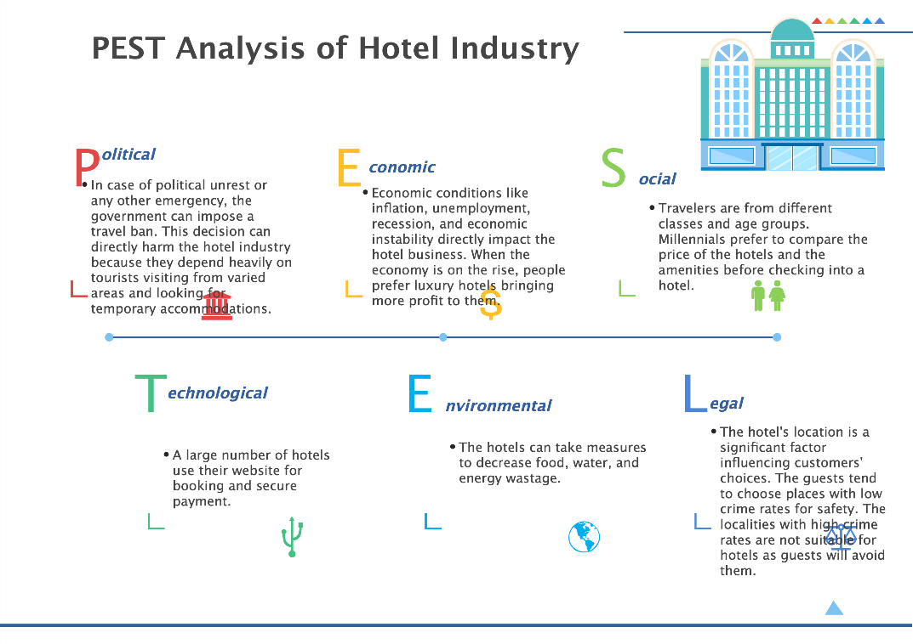
Figure 1 – EdrawMax's Pestel Analysis

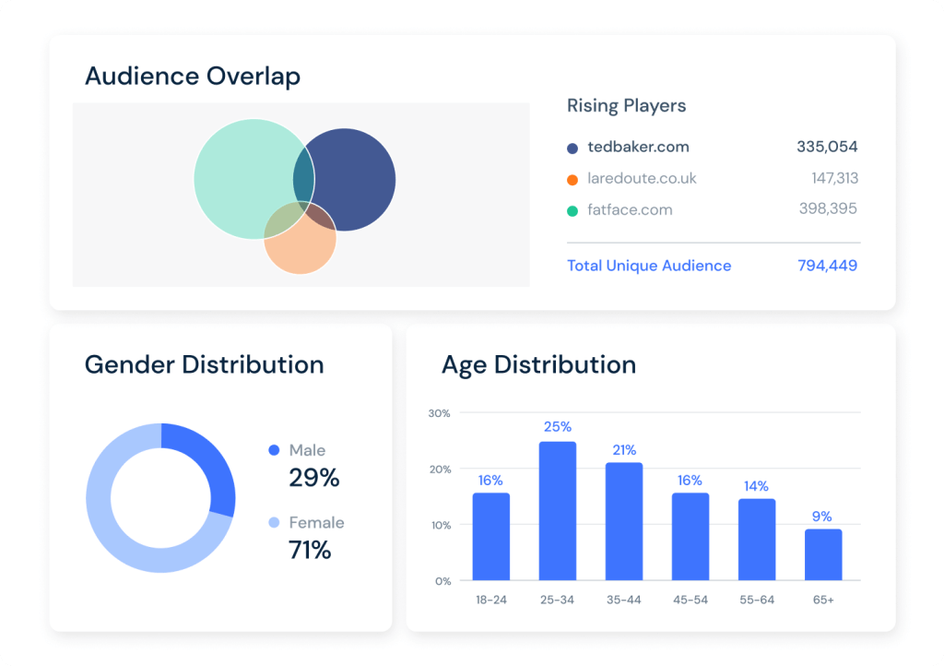
Figure 2 - SimilarWeb Graph

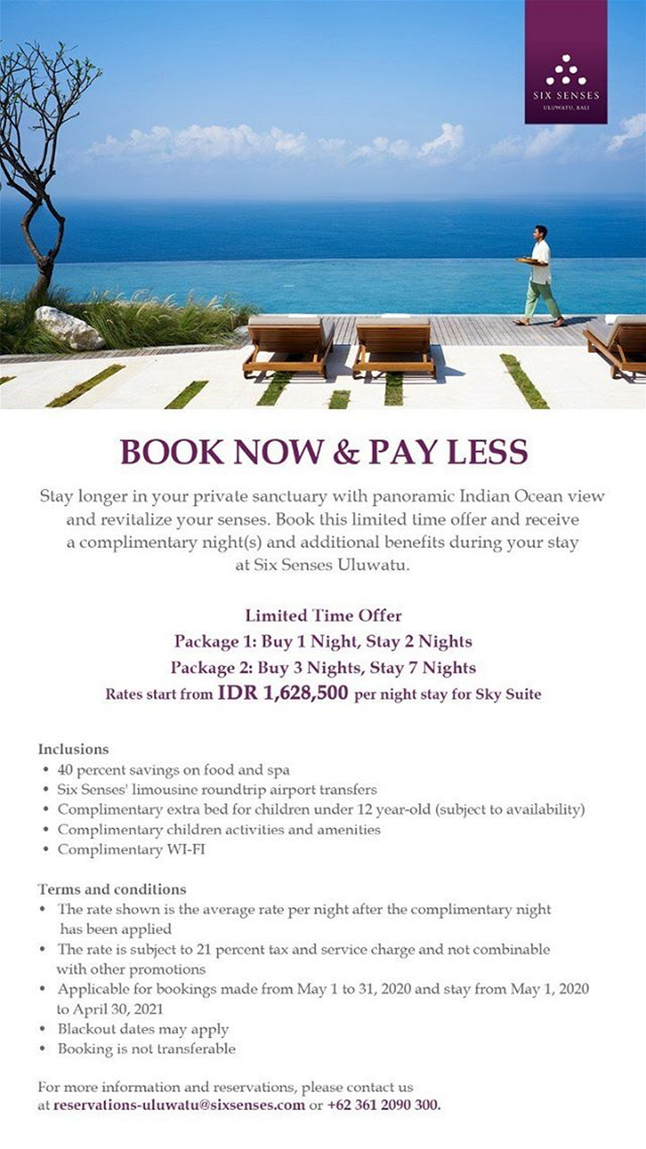
Figure 3 - Six Senses Uluwatu Pandemic Stay Offer

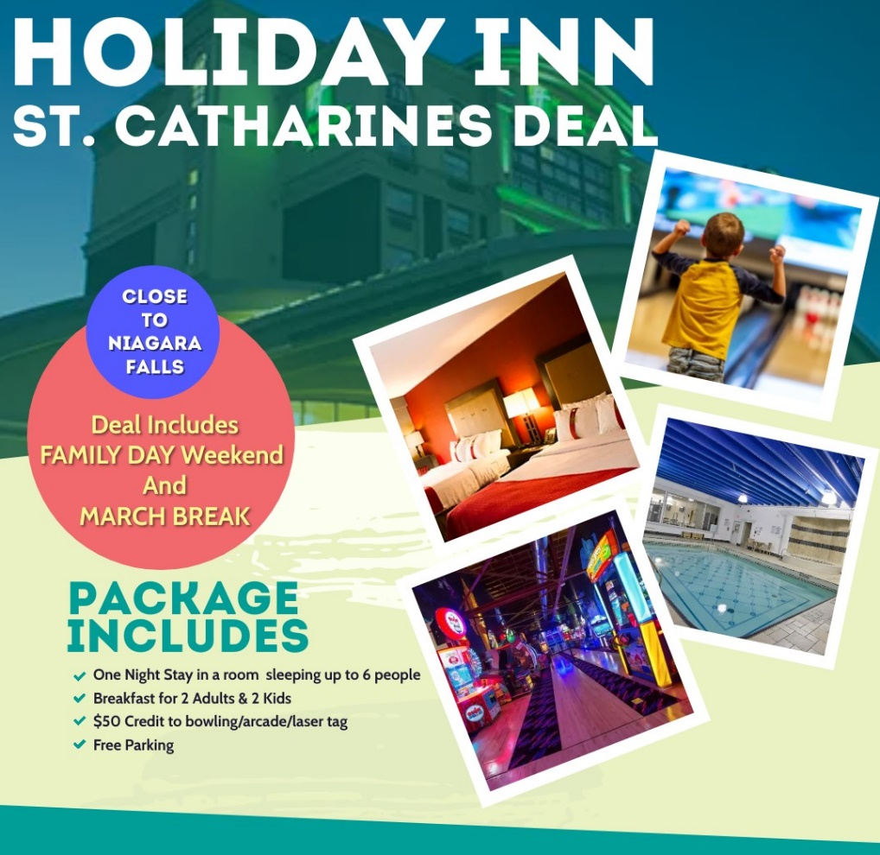
Figure 4 - Holiday Inn St. Catharines Deal

