University of Wales Trinity Saint David

Wales Institute of Science and Art

Engine Performance Characteristics

Megan Gwilym
2200683

Motorcycle Technology

(ACHA4003)

1st March 2024
Contents

1.0 Introduction 3
2.0 Methodology 4
3.0 Results 5
3.1 SFC against Engine Speed 5
3.2 Torque against Engine Speed 6
3.3 Brake power against Engine Speed 7
4.0 Analysis 8
4.1 Specific fuel consumption 8
4.2 Torque 8
4.3 Brake power 8
5.0 Conclusion 9
6.0 References 10
7.0 Appendix 11

1.0 Introduction

This assignment involves compiling data and characteristics of a 1.6 Honda vTec engine into an Excel spreadsheet. The spreadsheet will allow line graph to be created to answer specific questions that relates to specifications from this engine.
Additionally, this assignment will include an explanation of how the dynamotor works and an analysis of fuel consumption, Torque and Brake power in relation to engine speed to provide a comprehensive insight of the 1.6 Honda vTec engine.

2.0 Methodology

Before completing the Dyno session with Mark Fall a brief description on how the dyno produced results was given.
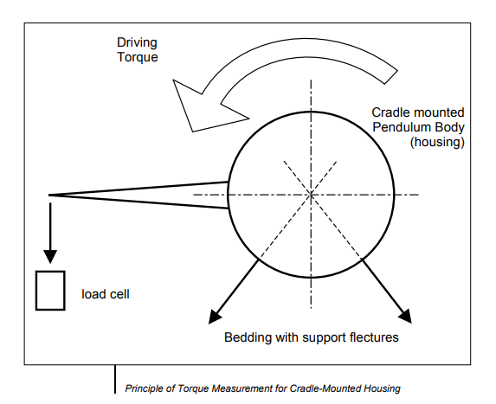
The test specimen, 1.6 Honda vTec engine, drives the dynamotor. The dynamotor absorbs the power and transforms it into heat energy (Schenck, P, 2001) A key part of this is the Torque Acquisition, via a shaft and a flange the engine relates to the rotor of the dynamotor. The special bedding of the dynamotor only takes up the weight force of the pendulum body and the countervailing force to the load cell.
Picture 1 (Schenck, P, 2001)

The power supply unit for the dynamotor supplies it with the extraction currently required for its operation, in this case, testing the 1.6 Honda vTec. The current regulator built into the power component ensures that the command value is quickly set and is evenly maintained during temperature changes in the dynamotor (Schenck, P, 2001). Which in fact, the engine has sensors connected to monitor temperature.
The engine is self-contained on a rig that’s bolted to the dynamotor via a crank shaft. Basic functions are controlled by the main controls and extraction pipes are required.

3.0 Results

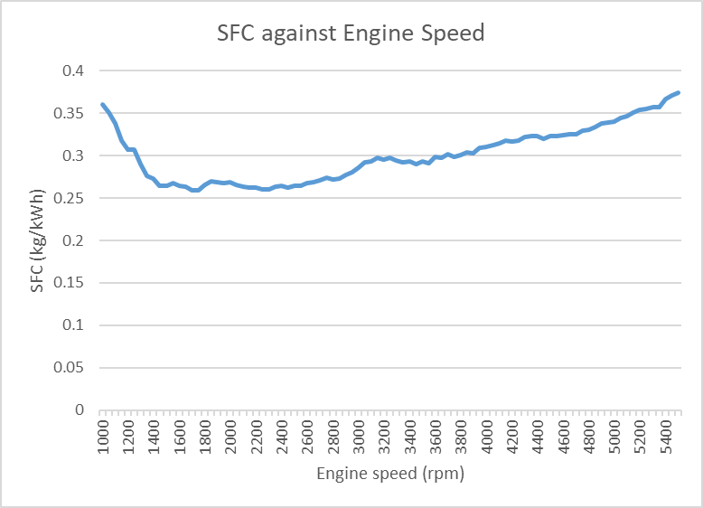
3.1 SFC against Engine Speed
Figure 1(SFC against Engine Speed)

Specific fuel consumption (SFC) is defined as the amount of fuel consumed by a vehicle for each unit of power output.
For the 1.6 Honda vTec a line diagram was created to show the SFC against engine speed. To work out the SFC measured in kilograms of fuel used per kilowatt hour (kg/kWh) Ellsworth, R.M (2019), which is an important measure of the engine efficiency in producing power.

SFC = $\frac{Flow fuel rate × 0.75 ×60}{Corrected power ×1000}$
- The 0.75 is litres to kg.
- Because the flow fuel rate is measured in I/min the equation changes from 3600 to 60.
- 1000 converts fuel volume in cc to litres.

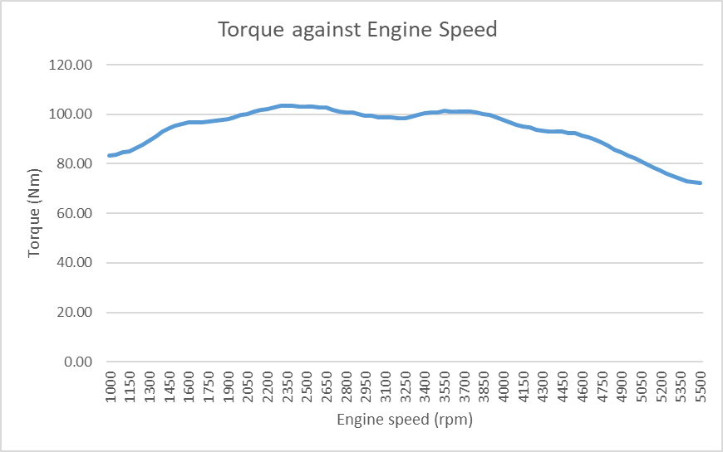
3.2 Torque against Engine Speed
Figure 2 (Torque against Engine speed)
In a vehicle, there is an inverse relationship between torque and speed. When torque is high, speed is low and vice versa. As speed increases, the torque required decreases, allowing the vehicle to reach higher speeds.
Torque (Nm) = $Load ×Radius$
- Load is measured in Newtons.
- Radius is in metres.

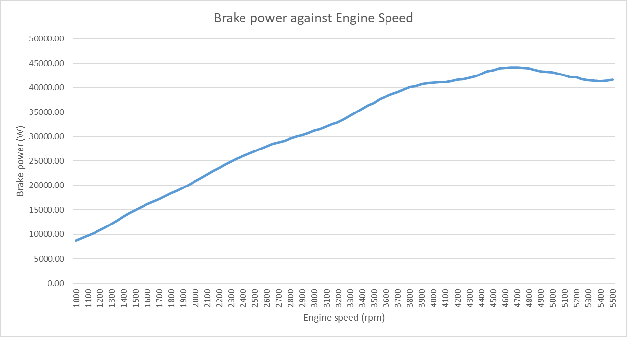
3.3 Brake power against Engine Speed
Figure 3 (Brake power against Engine Speed)

Brake power is the equivalent amount of load you must apply to bring the engine to rest. Brake power and engine speed builds together meaning that the increase in speed also increases the amount of brake power a person would need to get the car to a full stop, considering there is more power.

Brake power = $\frac{2 × π ×Engine speed ×Torque}{60}$

- Engine speed is measured in rpm.
- Torque is measured in Nm.

4.0 Analysis

4.1 Specific fuel consumption

When analysing ‘Figure 1’ it’s important to take note of the units for SFC the unit used is Kg/Kwh meaning the amount of fuel it takes to produced 1Kw of energy per hour. At idle, the engine is very in-efficient, so it needs a lot more fuel to produce a little bit of power, as seen in the graph where it starts just over 3.5kg/Kwh. As Torque peaks, seen in ‘Figure 2’ it starts to use the fuel energy, as this occurs more power is being produced meaning SFC is at its lowest area on ‘Figure 1’.
As rpm increases so does the friction and heat produced by the engine power, which is why the SFC graph keeps increasing as more fuel is needed to produce a unit of power per hour.

4.2 Torque

At the beginning of ‘Figure 2’ there is a high amount of torque needed to turn over the engine. As the speed is still low but gradually increasing, there is still a need for a large amount of torque. However, once high speeds are reached the turning force needed becomes less as the power and speed makes it easier to turn over the engine.
A good example of this is when riding a push bike. When starting off slow a lot of force is needed to peddle but as speed increases using the peddles become a lot easier because the speed is maintained, just like this engine.

4.3 Brake power

As speed of the engine increases the brake power needed to slow the engine and have a complete stop increases because more power and force will be used to control the speed. This is proven in ‘Figure 3’ as you can see the brake power increases greatly with engine speed.
Towards high speeds on ‘Figure 3’ the brake power levels out, which indicates that when the engine is as such a high speed and brake power starts to get used, the brake power will gradually build the engine speed will maintain and will quickly start to decrease. Once the brake power has hit its mark the engine speed will be hitting a full stop.

5.0 Conclusion

By the end of this assignment there is an understanding of a 1.6 Honda vTec engines data and characteristics. Knowledge on how the dynamotor works collecting data needed for an analysis of the line’s graphs created from the spreadsheet, to answer how does SFC, torque and brake power act against the engine power.

6.0 References

- Ellsworth, R.M. (2019). What is specific fuel consumption vs. engine speed graph explained briefly? [online] Quora. Available at: https://www.quora.com/What-is-specific-fuel-consumption-vs-engine-speed-graph-explained-briefly#:~:text=SFC%20is%20a%20time%20measure [Accessed 12 Mar. 2024].
- Schenck, P. (2001). Technical Specification Eddy-Current Dynamometer W Series. Pegasus Schenck.

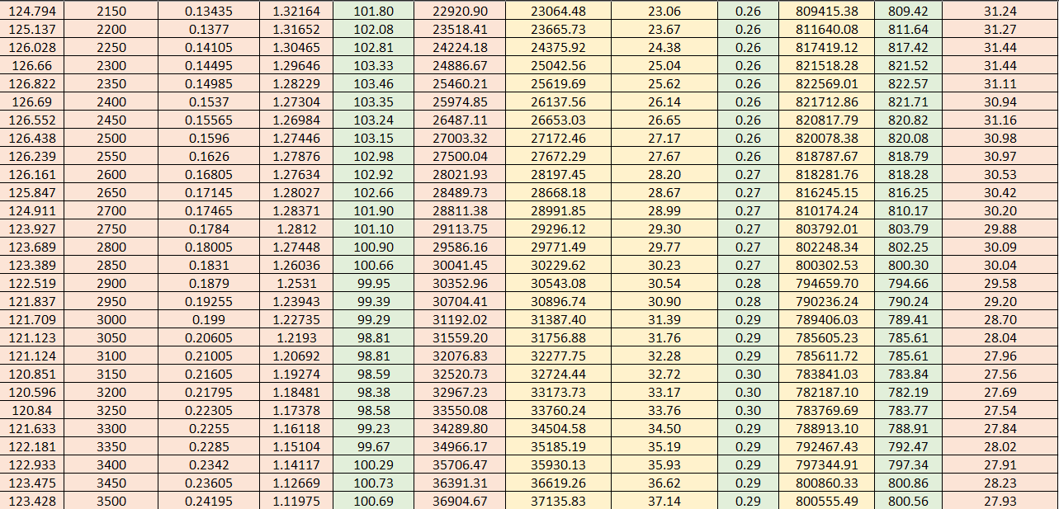
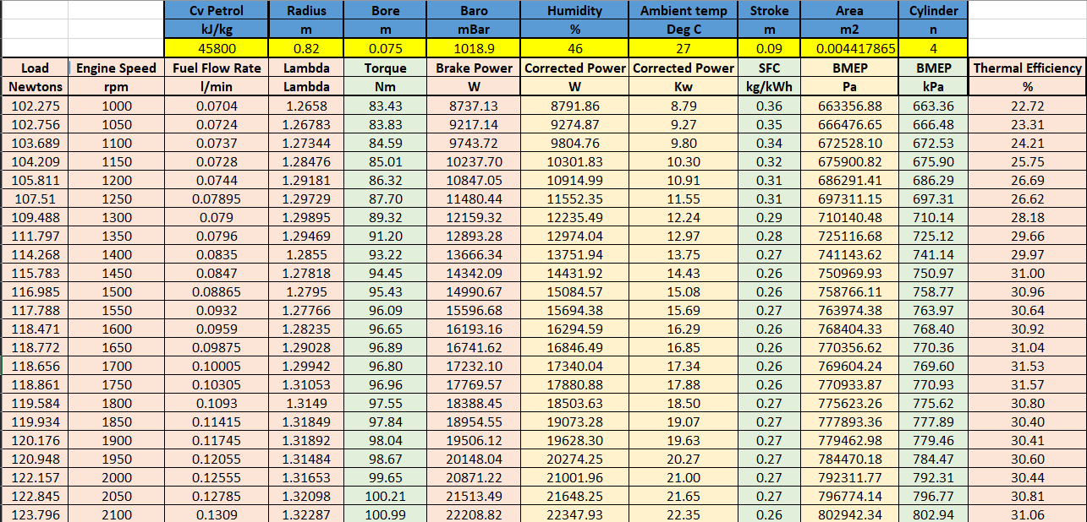
7.0 Appendix



