Report on Effective Teamworking for business success

Valentina Vasilica Dinca
Student number: 2131463
BMSW 4002
Module Effective team working and communication

Summary
An efficient team is needed for the success of a company. The presented report provides a clear definition of the term "team". For the analysis of the presented case study, the Tuckam model will be applied, and then the behaviors possessed by the team members will be explained, using the types presented by Belbin.
Also, advantages were identified, but also barriers that led to the generation of a conflict at the level of the entire team.
Contents
Introduction 2
Definition of team 2
Characteristics of teamwork 3
Model of teamwork 4
The Tuckman Model 4
Wheelan model 6
Creating effective team 6
Advantages of effective teamworking (Casper 2017) 8
Barriers of team work 9
Conclusions and recommendations 10
Reference list 12

Introduction

In the business environment, more and more emphasis is placed on teamwork. The present work offers an analysis of the presented case study, to create an efficient team that will successfully complete the project regarding the expansion of the Amazon company in Europe.
Defining the concept of the team is very important, which will be the first step in developing the report. A working model will be applied, this being the one developed by Tuckman, and Tom's current situation will be presented. At the same time, the roles held by the team members will be identified, according to those developed by Belbin. An efficient team presents advantages, these were encountered in the situation in which Tom and the team are, but at the same time there were also barriers, both of which will be highlighted in the following pages.

Definition of team

Katzenbach and Smith define the team as a small group, made up of people who are undeniably devoted to a cause towards which they tend. Interpersonal relationships are clothed in a common effort, the team members being aware of their necessary interdependence in reaching the common objective, exercising specific roles, sometimes for a limited duration. (Mound et al 2017)
In the present case, Tom and the other people form a team that must bring the project to the end be succesfull.

Characteristics of teamwork

Creating the team does not only involve the simple assembly of the various skills necessary to accomplish the task, but also the identification of the personality types that ensure efficiency. Both Tom, Mihaela and Spencer have different personalities and must communicate in order to all agree with the points of view presented, so that everyone is satisfied that they were able to contribute to the achievement of the objectives. It must be taken into account the extent to which the future members of the team, Mihaela and Spencer have the basic skills, such as the ability to communicate or how to approach conflicts, for teamwork to be effective.
Also, the team seems to have a sufficient level of diversity in terms of the functional background, culture, life and work experience of the members that ensure varied perspectives in the activity and in decision-making. (Andersen 2021)
This trait will translate into efficiency and innovation, which will benefit Amazon, but only if individuals can view difference as a valuable asset and not as a threat to their individual identity.
Intrapersonal conflict is the conflict that a member carries with himself, in this case Tom is the one who brought it, generated by unfulfilled personal expectations at the team level or dissatisfactions that can appear together with the awareness of the skills and knowledge of the other members, creating some tensions regarding the potential value he can add to the team relative to others.(Smith and Beard 2018)
It is that feeling of inferiority that produces inner frustrations.
Tom had to make a team, but he didn't know how to communicate with the other members about his expectations, about what he wants to achieve, to set a clear starting point so that everyone else knows the attributions he has they have to achieve, in the present case the goal is to open the three warehouses in Europe, more precisely in London, Paris and Berlin.
Tom is the leader in the presented case study, he was delegated to handle the opening of the 3 warehouses. He bears a greater part of the blame because he did not know how to communicate with the team members, to give them the chance to express their point of view, to have a suggestion and based on the ideas presented, he could make the best decisions.
Part of the blame also belongs to the other two members, Mihaela and Spencer. They probably did not understand exactly what tasks they had to perform, they had small impediments, which led to the generation of a conflict with Tom, because the result obtained was not up to his expectations.

Model of teamwork

The Tuckman Model
The best-known and most widespread model of team evolution was formulated by BW Tuckman and involves five stages: forming, storming, norming, performing and adjourning. (Rojas 2021)
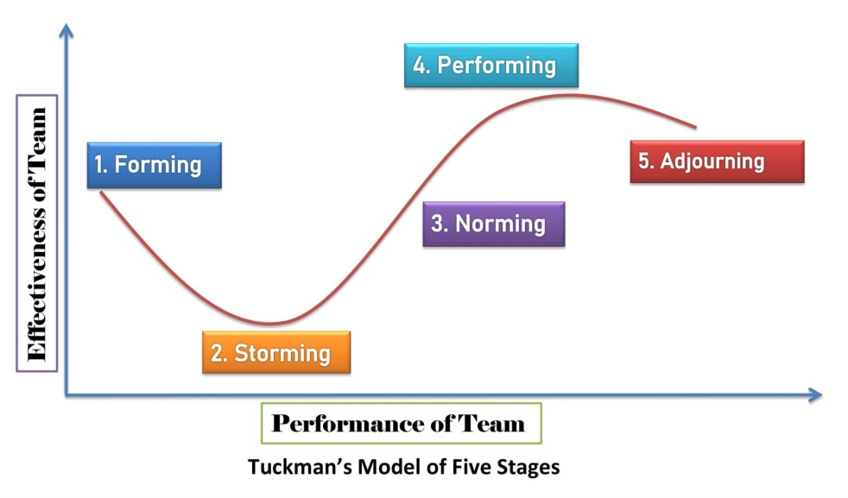
Figure no 1: Tuckman Model (Rojas 2021)

Forming
Individuals within the team seek information about other colleagues, especially related to their background and experience during the task that the team must perform. The most important task is the clear and mutually agreed establishment of the objectives. In the current situation, the main objective was to create a team that would successfully complete the project regarding the expansion of Amazon's warehouses.
Storming.
During this stage, conflicts between individuals and subgroups occur, and Tom was in this stage. The elections, the authority and the competence of the coordinator are targeted, and the members do not accept possible attempts to dominate on the part of the management.(Rojas 2021)
The team members, Mihaela and Spencer question the relevance and practicability of the task imposed by Tom. This stage is also characterized by honesty and openness in resolving differences. Tom as a leader must encourage the smoothing of misunderstandings in order to get them to focus on common objectives. He must communicate openly with the two to see what is the reason that generated this conflict. He must also create trust, establish well-established team roles and conflict resolution strategies.
Norming.
Tom and the other members must show their trust, be honest and share their opinions, so as to create a network of mutual support. Tom needs to allow the team to take more responsibility for the warehouse opening planning and process, allow them to make mistakes, but make them reflect on it. In order for the whole project to be completed well, Tom must also establish some rules that apply to the project he has, such as:
• Punctuality when a meeting takes place;
• Honesty when tasks are unclear and to ask for directions ;
• Participation of the whole team in decision-making;
Performing
Now, the team members are beginning to see the results of constructively focusing energy on the common task of accomplishing all the tasks given by Tom to finish the project and open the 3 warehouses.
Adjourning
Assuming that Mihaela, Spencer and Tom have resolved all the conflict, and the two team members themselves feel misunderstood because their point of view does not coincide with the objective pursued by Tom, they will decide to leave. In this case, Tom could distribute the tasks of the two to other members of the team in order to successfully complete the objective pursued.

Wheelan model
Another model that can be successfully applied in the present case is the one developed by Wheelan. This model is show the perspective that teams reach maturity as they continue to work together, rather than simply passing through stages of activity. The model includes four steps. (Noel 2006)
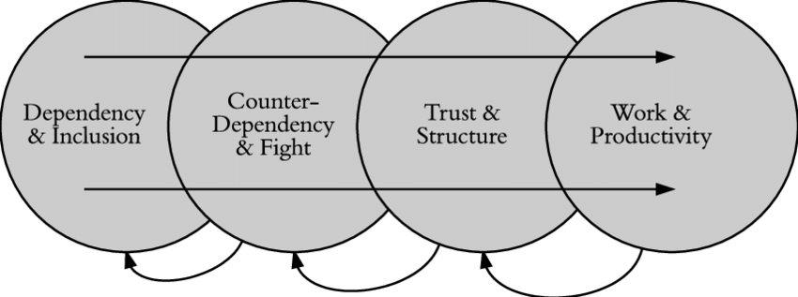
Figure no 2: Wheelan model (Noel 2006)

According to this model, Tom is in the second stage, of counterdependency and struggle, the members do not agree with each other about the goals and procedures of the group. Conflict is an inevitable part of this process.

Creating effective team

Belbin, a management researcher known for his work in the field of team management, was looking for the answer to know what kind of lies are behind the performance or failure from inside the team. He found out that, not the level of intelligence of the members that transforms the teams into high performing ones, but all kind of the behaviors of the members it can do. Basic on that, are nine types of team behaviors were related. (Belbin 2010)
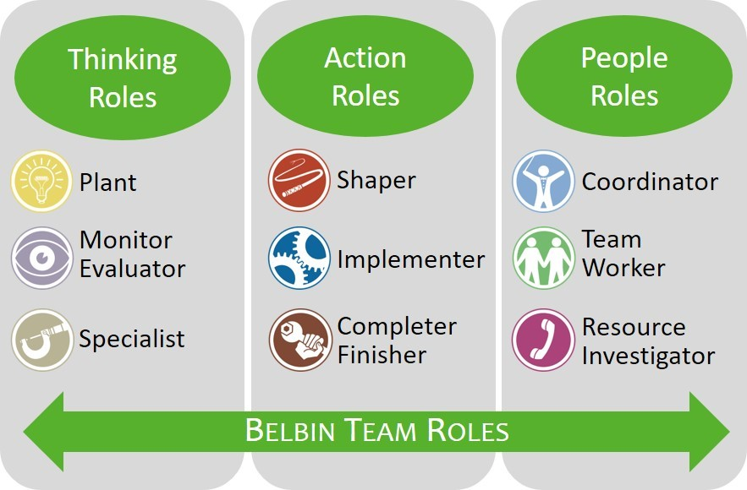
Figure no 3: Belbin roles (Belbin 2010)

Tom is the one who implements, he is the person aware of the external obligation, to expand Amazon's warehouses in Europe. He is characterized by discipline, has a positive image of himself, tolerates and respects the tasks given to him by the management of the Amazon company. Tom has to implement various strategies within the project, he has full responsibility and does very well what others don't want to do, he disciplines the other members, Mihaela and Spencer, who in turn have to lead the operational team. In the presented case study, Mihaela and Spencer are shapers.
The shaper is the person responsible for the proposed task, having overflowing energy and a strong motivation to succeed, his goal being victory. It is dedicated to the achievement of goals, "shaping" others in this direction. He will provoke, support or disapprove, showing aggression in pursuit of the goal. In Belbin's opinion, the presence of two or three modelers in the team can lead to conflicts, upsets and internal disputes. It can be seen that the presence of the two members as shapers led to the creation of a direct conflict with Tom. The differences in personality, the correct misunderstanding of all assigned tasks are the main factors for the outbreak of the conflict. Once this tension appears in the team, it can have an unfavorable result, that of not being able to complete the project. The conflict that arose and the misunderstandings between Tom, Mihaela and Spencer flow directly to the team work, which is directly coordinated by Mihaela and Spencer.
That's why, in order to create a team that works efficiently, one of the two, Mihaela or Spencer, should be the one who generates ideas, have a radical attitude towards the correct functioning of the team, and especially care about important issues , such as shortening the project completion time or the existence of a communication channel, which allows the clear circulation of information between all involved members. (Normore et al 2019)

Advantages of effective teamworking

An efficient team is characterized by the following aspects:
- it includes between five and eight members, and it is possible that this number is higher or lower. In the presented case study, 3 members are highlighted, plus the operational team, it is not known how many members has.
- is the one in which the component members apply the solutions that they found. If he expected to get the best results, person who is manager should give the members the chance to applyt what they set out to do.
- is the one in which the members understand that they are supported by the manager. It provides the team with the resources, help and encouragement they need. It is the one that has a leader, Tom in the presented case study, he is totally involved in the mission of the team, guiding all activities.
- creativity and innovation are promoted in team-based organizations through the exchange of opinions.
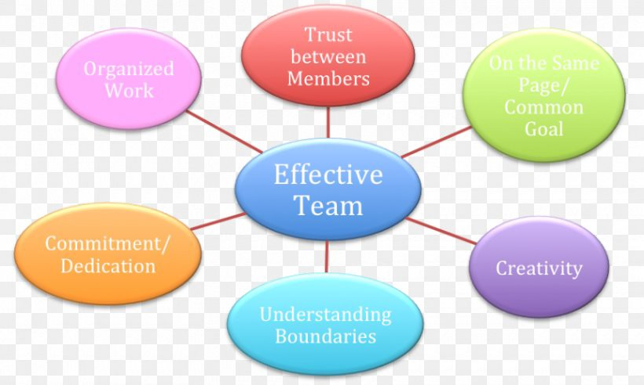
Figure no 4: Advantages of effective team (Casper 2017)

Barriers of team work.
Although all the reasons listed above support teamwork, they do not always work. Simply naming a department in an organization a "team" does not lead to teamwork, on the contrary, it can reduce effectiveness, innovation and satisfaction. (HBR guide 2021)
- Loss of effort; By the fact that Mihaela and Spencer work less as a team than if they were the only ones responsible for the expected results, it is rather a characteristic of their behaviors, especially when the task itself does not motivate them, or the team members do not have a strong sense of cohesion.
- The reduced degree of efficiency in solving problems and making decisions; Researchers have suggested that group decision-making is generally superior to the decision of an ordinary member, but often inferior to that of the most competent individual. The conflict between Tom and the other members was not resolved and Tom did not make any decision to fix the problem.
- Internal conflicts, arising in the current situation;
- role ambiguity, the members of Tom's team do not each know what role they have;
- confusion regarding the team's values ​​or mission, the team must focus on the mission to complete the project; (Regenold 2019)

Conclusions and recommendations

Following the report, it can be observed that Tom and his team do not form an efficient team. The lack of communication between them, the need for Tom to take over control and the misunderstanding of the tasks that must be performed by Mihaela and Spencer could prevent the expansion of the three Amazon warehouses.
In order to form an effective team, all the members involved, Tom, Mihaela and Spencer must be able to solve the problems that have arisen, identifying and removing the obstacles that do not allow the achievement of the proposed goal.
Communication is the key to resolve the conflict between them

Reference list

- Andersen, H.R. (2021) Diversity intelligence : how to create a culture of inclusion for your business. 1st edn. Hoboken: John Wiley & Sons, Inc.
- Bryant-Smith, R. and Beard, G. (2018) Fix your team : the tools you need to rebuild relationships, address conflict and stop destructive behaviours. 1st edition. Milton, Queensland: Wiley.
- Bryant-Smith, R. and Beard, G. (2018) Fix your team : the tools you need to rebuild relationships, address conflict and stop destructive behaviours. 1st edition. Milton, Queensland: Wiley.
- HBR guide to collaborative teams (2021). Boston, Massachusetts: Harvard Business Review Press
- Maund, A., Schriek, M. and Tinkler, P.K. (2017) Certificate in higher education : skills for the workplace student yearbook. Edited by A. Maund, M. Schriek, and P.K. Tinkler. London: Sage.
- Noel, D.R. (2006) Cohesive strategies for group leadership: The relationship of cohesion to stages of group development. ProQuest Dissertations Publishing.
- Normore, A.H., Javidi, M. and Long, L.W. (2019) Handbook of research on strategic communication, leadership, and conflict management in modern organizations. Hershey, Pennsylvania: IGI Global.
- Regenold, T.A. (2019) ‘Review of The Culture Code: The Secrets of Highly Successful Groups, by Daniel Coyle’, Performance Improvement. Silver Spring: Wiley Subscription Services, Inc, pp. 44–46.
- Wm Camron Casper (2017) ‘Teaching beyond the Topic Teaching Teamwork Skills in Higher Education’, Journal of higher education theory and practice, 17(6), pp. 53–63.

