

MODULE CODE: Digital Skills for Personal Development and Business Growth BMSW4008

ASSESSMENT COMPONENT: PORTFOLIO

STUDENT NAME: Brooke Waith

STUDENT NUMBER: 2522659

LECTURER: Scott

DATE: 09/03/2026
Contents
Task 1 3
Assessment of Digital Skills 3
References 3
Task 2 4
LinkedIn Learning Certificates for Office365 4
Task 3 5
Essay on Relevance of Excel in professional and personal life. 5
References 5
Task 4 6
7 Minute Reflective Presentation 6
References 6

I confirm that I have not presented any AI generated materials as my own work.
I confirm that I have copies of my drafts, notes, and other resources I used, which I may be asked to provide in evidence.

Task 1

Assessment of Digital Skills
Introduction

Digital skills are now a normal part of everyday life in the modern-day society. Most students use technology daily for studying, communication and conducting research. At university, learning platforms, digital libraries and online collaboration tools are used for many different tasks. Because of this, it is important for students to develop strong digital skills. These skills help students find information, complete their assignments and communicate with their peers and tutors more easily.

The Joint Information Systems Committee explains that digital capability includes several areas such as communication, collaboration, digital wellbeing and the ability to work with digital information. By understanding these areas, students can see what they are good at and where they may need to improve. Digital literacy also involves the ability to understand and evaluate digital information more critically, which is an important skill in higher education (Gilster, 1997). To reflect on my own digital abilities, I completed the JISC Digital Capabilities Discovery Tool.

Summary of My JISC Results

The JISC tool asked questions about how I use technology in learning and everyday situations. At the end, it showed my results in a graph that highlighted my strongest and weakest areas.

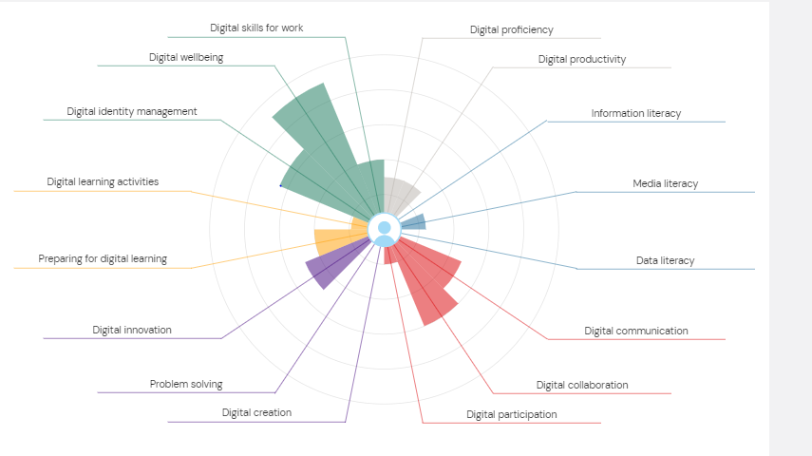
Figure 1:

Figure 1: JISC Digital Capabilities Discovery Tool Results

From my results, my strongest section was the green category, which includes digital identity management, digital wellbeing and digital skills for work. I was happy with this result because these skills are important in both university and future employment. Digital identity management means understanding how to manage personal information online and behave responsibly on digital platforms. Digital wellbeing also matters because it involves using technology in a balanced and healthy way.

Another strong area was the red category, which includes digital participation, digital collaboration and digital communication. These results show that I am confident when working with others online. For example, I often use email, shared documents and discussion boards when working with classmates. I am quite comfortable taking part in group activities and communicating through digital platforms. According to Beetham and Sharpe (2019), digital communication and collaboration help students share ideas and learn from each other.

Strengths

One of my main strengths is digital identity management and wellbeing. I understand the importance of protecting personal information online and using digital tools responsibly. This is important because many employers expect people to behave professionally in online environments. Knowing how to manage my digital identity will also help me maintain a positive online presence in the future.

Another strength is digital collaboration and communication. I feel confident working with others using digital platforms. Group work is common at university, so being able to communicate clearly and share ideas online is very useful. These skills also reflect how many workplaces operate today, where teams often communicate through digital tools rather than face-to-face.

Weaknesses

Although I had several strong areas, the JISC report also highlighted some weaknesses. One of these was digital productivity and digital proficiency, which was shown in the grey section. This area focuses on how well someone can use digital tools to organise tasks and complete work efficiently. My score suggests that I could improve the way I manage digital tools when completing assignments.

Another weak area was the media literacy and information searching, shown in the blue section. This was actually my lowest result. The media literacy involves finding, evaluating and using digital information. At university this is very important because students need to use reliable academic sources when writing assignments. Developing strong information evaluation skills is an important part of digital literacy (Gilster, 1997). My result shows that I need to improve in this area, so that I can strengthen my ability to find better academic references and judge whether they are suitable for academic my work.

Action Plan (SMART Goals)

To improve my weaker areas, I created an action plan using SMART goals. SMART stands for specific, measurable, achievable, relevant and time-bound.

My first goal is to improve my digital productivity skills. Over the next eight weeks, I will learn how to use at least two digital productivity tools, such as task management apps or planning tools. I will spend one hour each week practising these tools and using them to organise my assignments and deadlines.

My second goal is to improve my media literacy skills. Over the next three months, I will practise using online academic databases to find reliable sources. Each week, I will find two academic journal articles related to my course topic and check their reliability. This will help me develop better research skills and improve the quality of my assignments.

Insert your digital badge screenshots here

Figure 2: Digital Badges Achieved from the JISC Discovery Tool

Conclusion

In conclusion, digital skills are essential for both education and future careers. My JISC results showed that I have strong skills in digital identity management, wellbeing, communication and collaboration. However, they also highlighted areas where I need to improve, particularly digital productivity and the media literacy. By following my SMART action plan, I will work on improving these areas. Developing stronger digital skills will help me become a more organised student and better prepared for future employment.

References

Beetham, H. and Sharpe, R. (2019) Rethinking Pedagogy for a Digital Age. London: Routledge.

Gilster, P. (1997) Digital Literacy. New York: Wiley.

Joint Information Systems Committee (2022) Building Digital Capabilities Framework. Available at: https://www.jisc.ac.uk

Joint Information Systems Committee (2023) Digital Capabilities Discovery Tool.

Redecker, C. (2017) European Framework for the Digital Competence of Educators. Luxembourg: European Commission.

UNESCO (2018) Digital Skills Critical for Jobs and Social Inclusion. Paris: UNESCO.

Task 2

LinkedIn Learning Certificates for Office365
Add all the certificates from LinkedIn learning here

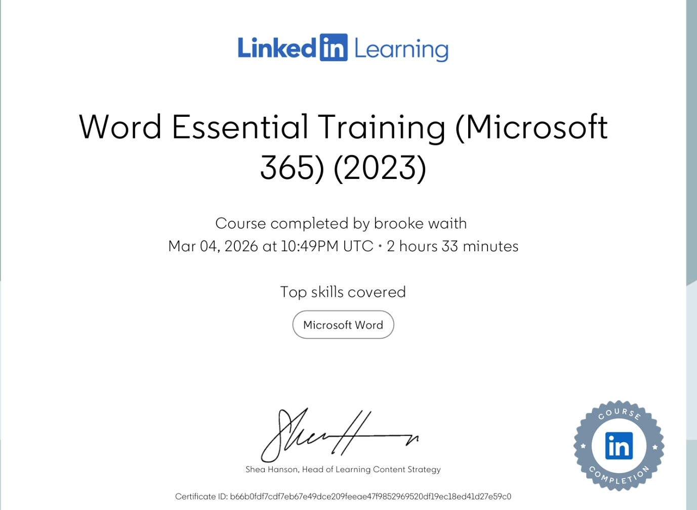

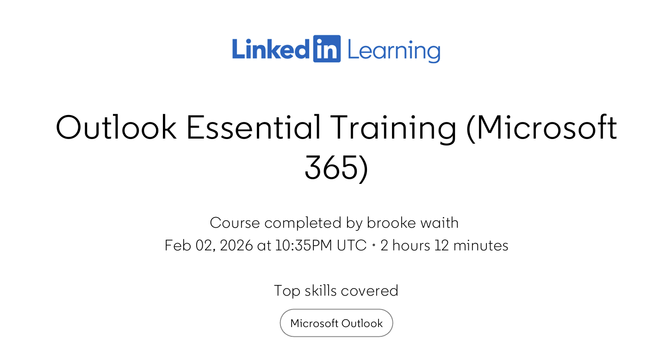



Task 3

Essay on Relevance of Excel in professional and personal life.
Introduction

In today’s business world, information moves very quickly, and many decisions often need to be made under pressure. Companies collect the data on aspects such as sales, supplier costs, staffing levels, and customer activity every day. However, data on its own is not very useful. Without proper organisation and analysis of this data, managers and business owners may struggle to understand what is really happening.

Digital tools that help to structure, interpret, and present information are therefore essential. Microsoft Excel is one of the most widely used of these tools. Excel allows users to enter data, perform calculations, and create visual summaries. While more advanced systems do exist, Excel remains popular because it is flexible, easy to use, and familiar to most employees (Harrison, 2017). It is a key tool that supports both daily operations and longer-term planning that is necessary in pretty much all companies.

This essay examines why Excel continues to be important in business in the modern day era. It looks at how the software is used for data analysis, budgeting, reporting, and decision-making, using practical examples to show how the tool is still very much of value if used efficiently.

Using Excel for Data Analysis

Businesses generate large amounts of data, but raw figures alone do not provide a deeper insight. Excel helps organise and analyse this information.

For example, a delivery company could track transport costs and delivery times in a spreadsheet. Using formulas, managers can calculate average delivery times and total weekly fuel expenses. These calculations update automatically if new data is added, helping to reduce errors and save time.

Excel also allows managers to reorganise information without changing the original dataset. Sorting and filtering allows them to focus on specific areas, such as high-cost routes or late deliveries. PivotTables provide an even more flexible way to summarise data. A manager could use a PivotTable to compare transport costs by region or vehicle type for example. This reveals patterns that may not be so obvious in raw data tables. According to Albright and Winston (2017), spreadsheet modelling allows managers to test assumptions and explore relationships in data before making decisions.

Excel also supports trend analysis. By comparing data over time, businesses can spot patterns. An example of this could be, if customer complaints rise in certain months, managers can investigate why. Furthermore, charts make trends easier to understand and highlight important figures (Powell and Baker, 2020). This means Excel does more than record information, it helps managers analyse and think critically about their operations and ways to improve.

The Role of Excel in Budgeting

Budgeting is a key part of financial management. It involves predicting income and expenses to plan for the future. Excel is particularly useful because it combines both flexibility with accuracy when it comes to money planning.

Imagine a small events company planning its yearly budget. The manager enters projected revenue from bookings and expected costs like venue hire, staff wages, and marketing expenses. Excel calculates the totals automatically and shows whether the business expects a surplus or deficit. If costs change, the totals update instantly. This makes planning faster and more reliable. Also allowing the small events company to clearly picture how they can increase profits in the future.

Excel also allows scenario analysis. Managers can test different possibilities. For example, what happens if bookings drop by 15%? Excel shows the likely effect on profit, helping the business prepare for uncertainty. Drury (2018) argues that budgeting supports cost control and the allocating of resources, and Excel strengthens this process by providing clear, structured information.

Standard templates further improve budgeting. This is because when all departments use the same format, it is easier to compare results and reduce mistakes. While specialised accounting software does exist, Excel remains widely used because it is simple, adaptable and effective (Rebman et al., 2023).

Excel as a Reporting Tool

Once data is analysed, it needs to be communicated clearly. Large tables of numbers can be difficult to interpret, especially for the staff that don’t usually deal in finance. Excel helps by converting data into more simple and clear visual summaries.

Charts and graphs make results easier to understand. A human resources manager might use a bar chart to show staff turnover, while a finance manager could use a line graph for quarterly profits. Few (2012) highlighted that effective visualisation makes key information easier to spot and reduces cognitive load.

Dashboards take this even further. By combining several indicators on one screen, a dashboard gives a quick overview of performance. A sales manager could monitor revenue, orders and customer satisfaction together, spotting problems immediately. Which of course is highly beneficial and important for any company.

Excel also works well with other Microsoft Office applications. Data from a spreadsheet can be included in reports or presentations without having to re-enter information, this saves time and reduces errors (Harris, 2019). However, managers must still be careful. In some circumstances these visual results can be oversimplified or may be hiding important details, therefore interpretation still requires critical thinking.

Supporting Managerial Decision-Making

Good decisions require reliable information. Excel helps managers evaluate options by relying on factual numbers rather than intuition alone.

For example, a manufacturing firm thinking about expanding production could use Excel to estimate future revenues and costs. Functions such as Net Present Value (NPV) and Internal Rate of Return (IRR) provide structured measures to support investment decisions (Atrill and McLaney, 2019). Break-even analysis is another useful tool, showing how many units must be sold to cover costs.

Excel is also helpful for risk assessment. By changing variables like demand or supplier costs, managers can see how profit is affected. This type of sensitivity analysis allows organisations to plan for any uncertainty. Laudon and Laudon (2020) argue that reliable information systems improve performance by providing accurate and timely data. Excel contributes to this at both operational and strategic levels. Though it is important to remember that spreadsheets are a tool, not a substitute for professional judgement.

Limitations and Continued Significance

Excel does have limitations. If a company is dealing with large or complex spreadsheets, they can be difficult to manage especially when multiple users are collaborating. Another limitation is that formula errors are common and can reduce accuracy if thy are not checked carefully (Panko, 2015). Therefore, for very large datasets, specialised software may be more effective.

Despite these issues, Excel remains highly relevant in the modern day business world. It is accessible, cost effective and flexible enough for a wide range of tasks. Even organisations using advanced software often rely on Excel for additional analysis and reporting. For Level 4 business students, mastering Excel develops analytical thinking, attention to detail, and problem-solving skills that extend beyond the software itself (Baskarada, 2012). Which clearly can be used personally day to day, and the skills can be transferred into working life in the future.

Conclusion

Microsoft Excel remains a vital tool in modern organisations. It allows managers to analyse data, plan budgets, report results visually, and make evidence-based decisions. Features such as formulas, PivotTables, charts, and dashboards transform raw data into informative actionable insights.

While Excel has limitations, its flexibility, accessibility, and widespread use ensures that it continues to be important in business. For Level 4 Employability skills students, developing competence in Excel is not only valuable for coursework but also prepares them for professional roles that require analytical thinking and practical problem-solving.

Reference List

Albright, S.C. and Winston, W.L. (2017) Business analytics: Data analysis and decision making. 6th edn. Boston: Cengage Learning.

Atrill, P. and McLaney, E. (2019) Accounting and finance for non-specialists. 11th edn. Harlow: Pearson.

Baskarada, S. (2012) ‘How spreadsheet applications affect information quality’, Journal of Computer Information Systems, 51(3), pp. 77–84.

Drury, C. (2018) Management and cost accounting. 10th edn. London: Cengage Learning.

Few, S. (2012) Show me the numbers: Designing tables and graphs to enlighten. Oakland: Analytics Press.

Harrison, G. (2017) Data management and analysis using Microsoft Excel. London: Routledge.

Laudon, K.C. and Laudon, J.P. (2020) Management information systems: Managing the digital firm. 16th edn. Harlow: Pearson.

Panko, R.R. (2015) ‘What we know about spreadsheet errors’, Journal of End User Computing, 10(2), pp. 15–21.

Powell, S. and Baker, M. (2020) Practical Excel for business analytics. 2nd edn. New York: Springer.

Rebman, C. et al. (2023) ‘An Industry Survey of Analytics Spreadsheet Tools Adoption: Microsoft Excel vs Google Sheets’, Information Systems Education Journal, 21(5), pp. 29–42.

My Excel spreadsheet is embedded below:
Description | Money In | Money Out | Balance
Start Balance | 0
Salary | 2000
Rent |  | 500 | 1500
Gas |  | 50 | 1450
Electric |  | 50 | 1400
Water |  | 50 | 1350
Food |  | 200 | 1150
TOTAL | 2000 | 850 | 1150 LEFT

https://1drv.ms/x/c/BE501E200A8E2C59/IQDkIa5P6nEARIKZRHjML4QLAb8TS_MjSVeBVw0UqoHkaYo

Task 4

7 Minute Reflective Presentation
I have embedded my PowerPoint presentation here:
https://1drv.ms/p/c/BE501E200A8E2C59/IQD2V2eULiv_Qbaa4dZX7uW_Ae1invJrgDqSNzvg2KxFd0Y

