Academic Discipline of Hospitality and Tourism
Management
BA International Hotel Management
BMIH5005 Personnel Resourcing and Development
Student’s Name: Catalin Mircea Leva
Student ID: 2244690
Course Name:BMIH5005
Personnel Resourcing and Development
Module leader : Jemma Smith

Essay Topic - Discuss how the evolution of HRM facilitates the strategic development of an international hotel brand through workforce planning, recruitment and selection.

Table of Contents
Selected Company - Marriott Hotel 3
Introduction 3
Main Discussion 3
Conclusion 8
References 9

Selected Company - Marriott Hotel

Introduction
Armstrong and Taylor (2020) claim, human resource management refers to the process of planning, approaching and implementing different strategies that eventually help in strengthening the core functions associated with a business organisation. The following essay would attempt to analyse different factors associated with the strategic HR planning process and its impact on managing sustainable business performance for a hospitality brand like Marriott Hotel. The functionality of HRM working has changed a lot over the years since the inception of digitalisation. The emergence of different strategies and planning based on technology has helped brands like Marriott Hotel in securing stable growth on a large scale altogether. However, different stages associated with HRM planning and processes in sustaining a profitable output would get illustrated in this section of the essay as well for a better understanding of the topic.
Background of the organisation
Marriott Hotel is one of the fastest-growing luxury hotel brands in the UK, which operates within the hospitality industry. The hotel chain was established back in 1957 with its headquarters in Bethesda, Maryland. Currently, the hotel chain operates in almost 586 locations across different continents to manage its business expansion. However, it belongs to one of the very few brands, which have always maintained a positive profit margin since its inception back in 67 years ago. As of 2023, the Marriott hotel chain has almost 411,000 employees working in its different locations across the entire globe. Apart from that, the brand has managed to generate a revenue margin of 19.05 billion GBP as of 2022, which is one of the highest considering the hospitality industry of the UK (marriott.gcs-web.com, 2023).
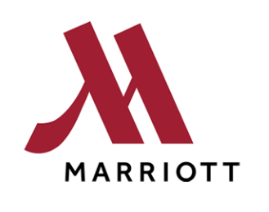
Figure 1: Official Logo of Marriott
(Source: marriott.com, 2024)

Main Discussion
Discuss about the evolution of HRM
As stated by Torrington et al., (2020), human resource management practices have completely changed over the years since the inception of digitalisation. HRM is one of the most important business functions associated with an organisation that eventually looks after the entire working process to maintain a safe & inclusive working environment on a large scale altogether. The working of HRM not only manages recruitment & selection but ultimately ensures the streamlined process of different operations to maintain sustainable growth in terms of market share (Shin et al., 2018, p. 280). For this. HRM can be considered as one of such very crucial business functions that is responsible for overviewing all the primary work done on a large scale (Marchington and Wilkinson, 2016). The working of HRM has changed a lot from what it was back in the 20th century. Since the inception of digitalisation, all the primary work of HRM has completely shifted towards digital mode a lot.
As per the views of Murton et al., (2010), starting from recruitment to management employee training, all the working of HRM is now completely dependent on technology to get the work done within the given specific period. Having said that, the working of HRM in overviewing all the primary processes associated with the business has also changed over the years as a virtual mode of operation has taken over the HRM's perspective in managing a sustainable working position. Hence, the change in working processes such as recruitment, employee training, talent management, and development of a safe working environment has evolved a lot since the emergence of technical disruption (Banfield et al., 2018). Marriott Hotel is one of such very few brands, which has completely changed its entire working style based on the requirement of technology. The hotel chain has managed to develop a sustainable revenue margin by using different technical advancements in its operations throughout. It has very well managed all its work through digital technology to manage and motivate employees to achieve sustainable growth overall.
Discuss the strategic role of HR functions
As opined by Blom et al., (2020, p. 24), the HRM functioning can be referred to as one of the most crucial elements in managing suitable growth as far as the hospitality industry is concerned. The hospitality sector is all about achieving consumer satisfaction to meet the recruitment of the industry in terms of revenue margin. This eventually calls for rapid working growth from HRM's perspective irrespective of different brands (Opatha, 2019). Marriott is one of the largest hospitality brands in the UK, which has significantly made a name for itself by serving people with quality services. Apart from consumer satisfaction, human resource management is responsible for providing different amenities to the employees to make them motivated at work. However, looking after all the recruitment of the employees, HRM also ensures a strong employee retention score at the end of the financial year (Bratton et al., 2021). Besides that, HRM also ensures that the working environment is safe for all the workers so that enforcing equality can be achieved. Eliminating discriminatory approaches and developing certain rules and regulations, the HRM department of an organisation eventually looks after different procedures starting from scratch. However, analysing the working of different functions and looking after the needs of the organisation, HRM eventually recruited employees based on the recruitment of the business entity. Marriott has been very blessed with a strong and vigorous core HRM team in its different locations across the globe. However, by following strong working norms in all of its working locations, the HRM of Marriott ensures a streamlined working flow for the brand to secure a competitive advantage in the market on a large scale.
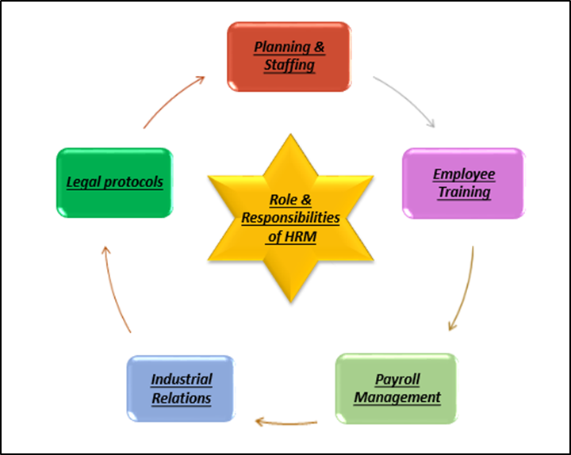
Figure 2: Strategic roles of Human resource management
Strategic HR planning process
As proposed by Collins (2021, p. 340), changing roles of HRM over the years is affecting the working process for different brands operating in the hospitality industry. Changes in the working process in terms of recruitment, selection, and working norms have completely substituted the working process for various brands. Apart from recruitment, employee motivation, and talent management, the strategic working process of the employees includes forecasting labour demand & supply, goal setting & strategic planning and program implementation & evaluation (Otoo, 2019, p. 960). All of these are essential for a large-scale business entity to ensure sustainable growth in terms of securing a stable revenue margin.
Forecasting labour demand & supply is one such thing that makes recruitment easy for business entities operating in a tough market. Understanding market trends and labour industry composition, HRM strategically develops their job advertisement so that it can eventually attract many consumers from different sections of society (Fuenzalida and Riccucci, 2019, p. 560). However, the working of HRM also helps various business functions operate smoothly as HRM ensures to recruitment of the right people in the right place through market forecasting. Hence, market forecasting and ensuring a strong labour supply is one of such strategic approaches that eventually get maintained by the working of HRM. Moreover, by looking at different features associated with national and international markets, HRM generally mobilises staff to perform well on behalf of the brand. By analysing the composition of the labour market lawfully, fairly, efficiently and effectively, the HRM does its strategic positioning in the market to extract the best possible output.
As stated by Gope et al., (2018,p. 170), goal setting & strategic planning is yet another strategic positioning of HRM that eventually helps a brand in achieving a competitive edge over others in the market. Socialising personnel into the organisation through effective recruitment procedures, HRM helps in achieving value diversity within a particular workplace. However, by setting up different goals and objectives for the entire working section of the organisation, human resource departments ensure meeting different medium and large-scale goals of an organisation like Marriott Hotel. The hotel chain has implemented different HRM working in its business operations over the years so that securing stable growth in terms of revenue margin can eventually be achieved on a large scale altogether.
Program implementation & evolution is another major strategic approach that often gets seen from HRM’s perspectives in achieving business excellence within an industry (Greer, 2021). Processes of managing performance, innovating new working practices, delivering outstanding customer service and breeding an environment where talent may grow are some of the examples of HRM strategic approaches under the program implementation process. Marriott Hotel has been very much privileged to have a strong core HRM group in managing a stable outcome in its various locations across the globe. Hence, these are some of the strategic HRM planning processes, which eventually helped Marriott Hotel in securing a stable outcome from its business operations through these years to stay ahead of all the competition.
Recruitment stages and selection process
As per the views of Hong et al., (2019, p. 60), recruitment and selection can be considered as the most important working step associated with the function of human resource management. The HRM of Marriott recruits employees based on the market composition and organisational recruitment to meet certain business objectives. However, strategic positioning in the labour market and employee benefits & benefits have always been the core strengths associated with the HRM of Marriott Hotel. However, the employee training and development process is one such thing, which can eventually get better with time and can be considered as a weakness for the brand considering their working in different locations. However, focusing on its labour market position and strategic recruitment, the brand would eventually have the opportunity to expand its business in different locations in various countries as well. Apart from that, if the HRM department of the brand does not focus on the employee training process from now onwards then lack of revenue margin through consumer satisfaction can come as a threat for them, which is not at all desirable at any given point in time. However, employee norms, recruitment procedures, and employee benefits are some of the internal factors that eventually contribute towards the employee recruitment process for an organisation (Macke and Genari, 2019, p. 810). Additionally, the political situation of a country like the UK, economic instability, and technical advancements are some of the major external factors, which also influence the working of HRM function in terms of recruiting capable candidates.
As opined by Mariappanadar (2019), HR planning, recruitment and selection are some of the major things, which eventually decide how much success a company is going to achieve in the end. However, the HRM department of Marriott Hotel has encountered different instances regarding employee recruitment and selection where they had to make situational decisions to help the brand secure sustainable growth. For example, analysing the issue with the retailer and the supply chain, the HRM of Marriott has managed to make decisions to recruit employees for the overall betterment of the organisation. However, during the workplace transformation process in the Marriott Hotel, there was a situation when the employees were unable to adapt to certain changes due to the lack of technical skills. The HRM of Marriott in that instance decides to recruit technical superior employees into their workplace so that the employee training process can eventually take place to uplift the knowledge of all the employees. Job advertisement, primary screening, technical proficiency test, group discussion, personal interview, and document verification are some of the major stages associated with employee recruitment & selection which the HRM manages to maintain throughout for getting a sustainable output (Mira et al., 2019). Despite facing different issues and situational problems, the HRM of Marriott has managed to maintain a decent outcome in terms of employee recruitment and selection to keep them ahead in the market competition. Hence, these are some of the major instances where the HRM of Marriott Hotel made certain situational decisions to have the upper hand over different competitors in the market.

Conclusion
The above-concluded essay has analysed different factors associated with HRM working and its impact on the business development of an organisation like Marriott Hotel. Sustainable working output for an organisation requires different factors to remain in place from HRM's perspective. The decision-making for the HRM department in employee recruitment & selection eventually decides how much success a company is going to achieve in the end. However, different roles associated with the HRM function for Marriott Hotel are something that eventually illustrated in this section of the essay as well. Moreover, different strategic planning approaches associated with the HRM function have been elaborated in this particular essay as well for further clarification purposes.

References
Armstrong, M. and Taylor, S. (2020) Armstrong’s handbook of human resource management practice. 15th edition. London, United Kingdom: KoganPage.
Banfield, P., Kay, R. and Royles, D., (2018). Introduction to human resource management. Oxford University Press.
Blom, R., Kruyen, P.M., Van der Heijden, B.I. and Van Thiel, S., (2020). Does one HRM fit all? A meta-analysis of the effects of HRM practices in the public, semipublic, and private sector. Review of Public Personnel Administration, 40(1), pp.3-35. https://journals.sagepub.com/doi/abs/10.1177/0734371x18773492
Bratton, J., Gold, J., Bratton, A. and Steele, L., (2021). Human resource management. Bloomsbury Publishing.
Collins, C.J., (2021). Expanding the resource-based view model of strategic human resource management. The International Journal of Human Resource Management, 32(2), pp.331-358. https://www.tandfonline.com/doi/abs/10.1080/09585192.2019.1711442
Fuenzalida, J. and Riccucci, N.M., (2019). The effects of politicization on performance: The mediating role of HRM practices. Review of Public Personnel Administration, 39(4), pp.544-569. https://journals.sagepub.com/doi/abs/10.1177/0734371X18758378
Gope, S., Elia, G. and Passiante, G., (2018). The effect of HRM practices on knowledge management capacity: a comparative study in Indian IT industry. Journal of Knowledge Management, 22(3), pp.649-677. https://www.emerald.com/insight/content/doi/10.1108/JKM-10-2017-0453/full/html?fullSc=1
Greer, C.R., (2021). Strategic human resource management. Pearson Custom Publishing.
Hong, J.F., Zhao, X. and Stanley Snell, R., (2019). Collaborative-based HRM practices and open innovation: A conceptual review. The International Journal of Human Resource Management, 30(1), pp.31-62. https://www.tandfonline.com/doi/abs/10.1080/09585192.2018.1511616
Macke, J. and Genari, D., (2019). Systematic literature review on sustainable human resource management. Journal of cleaner production, 208, pp.806-815. https://www.sciencedirect.com/science/article/pii/S0959652618331056
Marchington, M. and Wilkinson, A. (2016) Human resource management at work. 6th ed. London: Chartered Institute of Personnel and Development.
Mariappanadar, S. ed., (2019). Sustainable human resource management: Strategies, practices and challenges. Bloomsbury Publishing.
marriott.com, (2024). Marriott Hotel. [Online] Available at: https://www.marriott.com/default.mi?nst=paid&cid=PAI_GLB00050CK_GLE000BLSZ_GLF000ONTS&ppc=ppc&pId=intbppc&gad_source=1&gclid=CjwKCAjwrcKxBhBMEiwAIVF8rEZT9WXnaLPe-qInLO2K1fIMztv9U8rxasAQtLOjxezgyCnm4YbEGRoCpTAQAvD_BwE&gclsrc=aw.ds
marriott.gcs-web.com, (2023). Annual Report of 2022. [Online] Available at: https://marriott.gcs-web.com/static-files/b82978a6-9d28-4e38-9855-fc4ae2cebe11
Mira, M., Choong, Y. and Thim, C., (2019). The effect of HRM practices and employees’ job satisfaction on employee performance. Management Science Letters, 9(6). http://growingscience.com/beta/msl/3113-the-effect-of-hrm-practices-and-employees-job-satisfaction-on-employee-performance.html
Murton, A,. Inman, M., O’Sullivan, N. (2010) Unlocking Human Resource Management, Hodder Education
Opatha, H.H., (2019). Sustainable human resource management. LAP LAMBERT Academic Publishing.
Otoo, F.N.K., (2019). Human resource management (HRM) practices and organizational performance: The mediating role of employee competencies. Employee Relations: The International Journal, 41(5), pp.949-970. https://www.emerald.com/insight/content/doi/10.1108/ER-02-2018-0053/full/html
Shin, S.J., Jeong, I. and Bae, J., (2018). Do high-involvement HRM practices matter for worker creativity? A cross-level approach. The International Journal of Human Resource Management, 29(2), pp.260-285. https://www.tandfonline.com/doi/abs/10.1080/09585192.2015.1137612
Torrington, D, Hall, L, Atkinson, C, & Taylor, S. (2020), Human Resource Management PDF EBook, Pearson Education, Limited, Harlow. Available from: ProQuest Ebook Central.

