Design of an Unsigned two Number uneven Parallel Multiplier and the design of a FSM in hardware and VHDL

Name: Morgan jones
Student number: 1706863
Module : (CDA6000)
Course: Electric and Electronic Engineering

Contents
Name: Morgan jones 1
Different types of multipliers 3
Picture and details 3
Booth multiplier. 3
Combinational multiplier. 4
Braun Multiplier. 4
Wallace tree multiplier. 4
Array multiplier. 5
Sequential multiplier. 5
Multiplier Table with advantages 5
1 . Aims and Objectives: 6
Code screenshots with description 6
Test bench screenshots 6
2. Aims and Objectives: 6
VHDL Test Bench 9
Requirements 13
References 14

Figures
Figure 1 The flow chart of Booth multiplication algorithm. [1] 5
Figure 2 Combinational multiplier [3] 6
Figure 3 Wallace tree multiplier [4] 7
Figure 4 array multiplier [5] 7
Figure 5 Sequential multiplier [6] 8
Figure 6 Braun multiplier [7] 9
Figure 7 state diagram 45

Tables
Table 1 multipliers 10
Table 2 15
Table 3 line x in implementation window 22
Table 4 line 0 test bench 28
Table 5 35
Table 6 39
Table 7 44

Introduction
This report will contain information on several multipliers and how each one works. There two separate tasks. Task one will contain code for a 4 bit by 12 bit multiplier with observations. Task 2 will contain a VHDL FSM and a discrete gate solution.

Different types of multipliers

Booth multiplier.
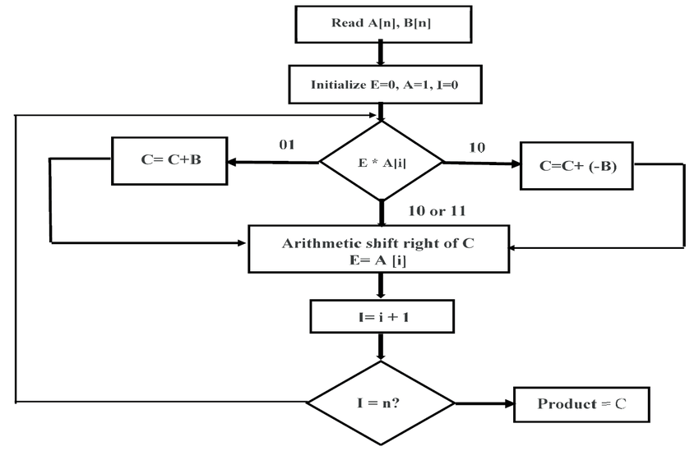
Figure 1 The flow chart of Booth multiplication algorithm. [1]
The Booth multiplier is a technique used to multiply binary numbers in signed -2’s full representation. [2]

Combinational multiplier.
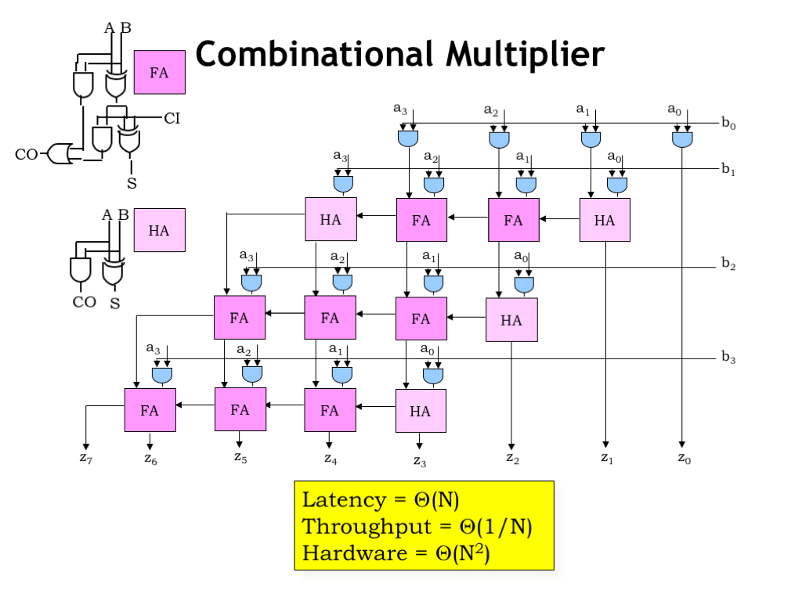
Figure 2 Combinational multiplier [3]
Combinational Multipliers are capable of doing multiplication using two unsigned binary numbers. It has also been used in the multiplication of two signed number. It works by having each part of the multiplier multiplied by a multiple and the result location is dependant upon the location of the bit inside the multiplier and the ensuing values are then combined to create the final value. [2]

Wallace tree multiplier. 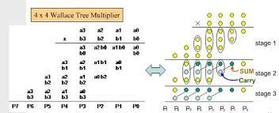
Figure 3 Wallace tree multiplier [4]
A Wallace tree multiplier is an effective physical implementation of a circuit that multiply two integers. “Wallace tree reduces the no. of partial products and use carry select adder for the addition of partial products.” [2]

Array multiplier
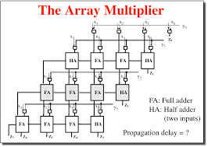
Figure 4 array multiplier [5]
Array multiplier is well established because of its consistent structure. The multiplier is established upon repetitive addition and shifting. Each partial result value is being created using the multiplication of a multiple with one figure multiplier. The partial results are altered depending on their bit sequences which are subsequently added. “The summation can be performed with normal carry propagation adder. N-1 adders are required where N is the no. of multiplier bits.” [2]

Sequential multiplier.
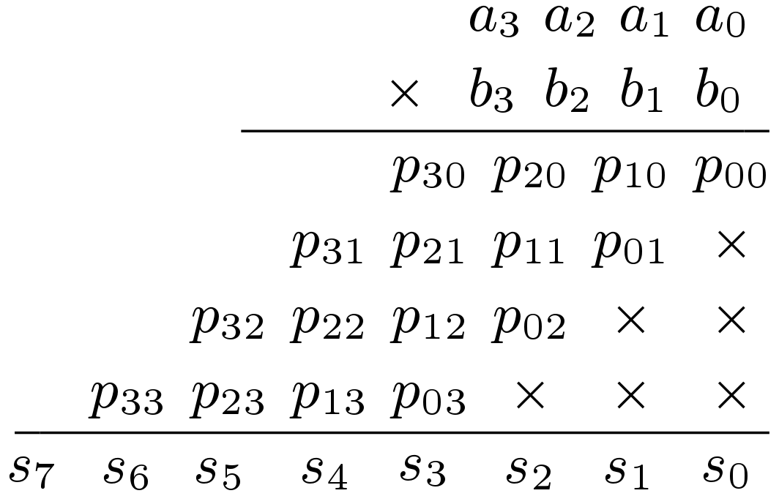
Figure 5 Sequential multiplier [6]
If you need to multiply two binary numbers by using a single n bit adder, you will be able to create a sequential multiplier that handles a single partial value at a time and then cycle the multiplier a certain number of times. This type of system is called a sequential multiplier. In a sequential multiplier, the process is separated into multiple steps. In each step a value will be created, added to an amassed sum and partial sum these will automatically be shifted to line up the collected sum with partial values. Consequently, every step of the multiplier involves three distinct procedures which generate partial values, adding the partial products to the partial sum, and shifting the partial sum. [2]

Braun multiplier
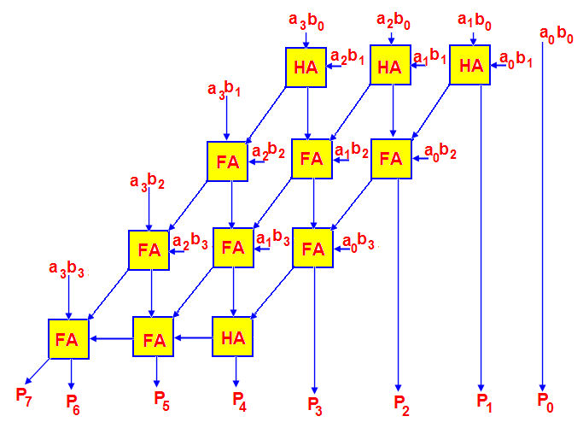
Figure 6 Braun multiplier [7]
“It is a simple parallel multiplier generally called as carry save array multiplier. It has been restricted to perform signed bits. The structure consists of array of AND gates and adders arranged in an iterative manner and no need of on n*n bit Braun multiplier is constructed with n (n-1) adders, n2 AND gates and (n-1) rows of Carry Save Adder.” [7]
“Each value can be produced in parallel by using AND gates. Each partial value can be added with the sum of partial product which has previously produced by using the row of adders. The carry out will shift one bit to the left or right and then it would be included in the sum which is produced by the first adder and the recently created value.” [7]

Multiplier Table with advantages
Multipliers | Advantages
Booth | regular structure  easy layout  small size.  Quick design time  ease of design for a pipelined architecture.
Combinational | unrolling multiplier loop  carry save addition  regular and modular
Wallace tree | small delay.  Low logic levels required to perform the summation
Array | reduces the number of partial products
[2]
Table 1 multipliers

1 . Aims and Objectives:
The aim of task 1 is to design, simulate and synthesise a 12 bit x 4 bit unsigned number multiplier using the Xilinx design software in order to achieve your aims.

Half adder
Module Name: half_adder - Behavioral
-- Project Name:
-- Target Devices:
-- Tool versions:
-- Description:
--
-- Dependencies:
--
-- Revision:
-- Revision 0.01 - File Created
-- Additional Comments:
--
----------------------------------------------------------------------------------
library IEEE;
use IEEE.STD_LOGIC_1164.ALL;

-- Uncomment the following library declaration if using
-- arithmetic functions with Signed or Unsigned values
--use IEEE.NUMERIC_STD.ALL;

-- Uncomment the following library declaration if instantiating
-- any Xilinx primitives in this code.
--library UNISIM;
--use UNISIM.VComponents.all;

entity half_adder is
Port ( A : in STD_LOGIC;
B : in STD_LOGIC;
Sum : out STD_LOGIC;
Carry : out STD_LOGIC);
end half_adder;

architecture Behavioral of half_adder is

begin

Sum <= A xor B;
Carry <= A and B;

end Behavioral;
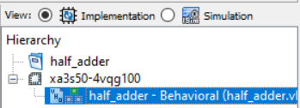
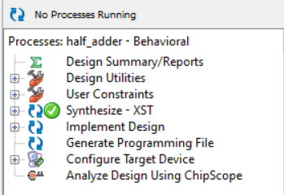
Project Name: half_adder
-- Target Device:
-- Tool versions:
-- Description:
--
-- VHDL Test Bench Created by ISE for module: half_adder
--
-- Dependencies:
--
-- Revision:
-- Revision 0.01 - File Created
-- Additional Comments:
--
-- Notes:
-- This testbench has been automatically generated using types std_logic and
-- std_logic_vector for the ports of the unit under test. Xilinx recommends
-- that these types always be used for the top-level I/O of a design in order
-- to guarantee that the testbench will bind correctly to the post-implementation
-- simulation model.
--------------------------------------------------------------------------------
LIBRARY ieee;
USE ieee.std_logic_1164.ALL;

-- Uncomment the following library declaration if using
-- arithmetic functions with Signed or Unsigned values
--USE ieee.numeric_std.ALL;

ENTITY half_adder_TB IS
END half_adder_TB;

ARCHITECTURE behavior OF half_adder_TB IS

-- Component Declaration for the Unit Under Test (UUT)

COMPONENT half_adder
PORT(
A : IN std_logic;
B : IN std_logic;
Sum : OUT std_logic;
Carry : OUT std_logic
);
END COMPONENT;

--Inputs
signal A : std_logic := '0';
signal B : std_logic := '0';

--Outputs
signal Sum : std_logic;
signal Carry : std_logic;
-- No clocks detected in port list. Replace <clock> below with
-- appropriate port name

BEGIN

-- Instantiate the Unit Under Test (UUT)
uut: half_adder PORT MAP (
A => A,
B => B,
Sum => Sum,
Carry => Carry
);

-- Stimulus process
stim_proc0: process
begin
-- hold reset state for 100 ns.
wait for 10 ns;

A <= not A;

end process;

stim_proc1: process
begin
-- hold reset state for 100 ns.
wait for 20 ns;

B <= not B;
end process;

END;
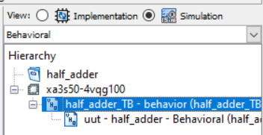
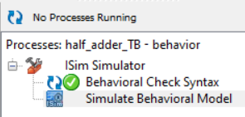
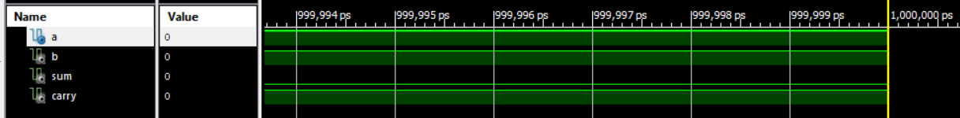
Table 2

Full adder
Module Name: full_adder - Behavioral
-- Project Name:
-- Target Devices:
-- Tool versions:
-- Description:
--
-- Dependencies:
--
-- Revision:
-- Revision 0.01 - File Created
-- Additional Comments:
--
----------------------------------------------------------------------------------
library IEEE;
use IEEE.STD_LOGIC_1164.ALL;

-- Uncomment the following library declaration if using
-- arithmetic functions with Signed or Unsigned values
--use IEEE.NUMERIC_STD.ALL;

-- Uncomment the following library declaration if instantiating
-- any Xilinx primitives in this code.
--library UNISIM;
--use UNISIM.VComponents.all;

entity full_adder is
Port ( A : in STD_LOGIC;
B : in STD_LOGIC;
C : in STD_LOGIC;
Sum : out STD_LOGIC;
Carry : out STD_LOGIC);
end full_adder;

architecture Behavioral of full_adder is

signal AxB : STD_LOGIC;
signal AxBnC: STD_LOGIC;
signal AnB : STD_LOGIC;

begin
AxB <= A xor B;
AxBnC <= AxB and C;
AnB <= A and B;

Sum <= AxB xor C;
Carry <= AxBnC or AnB;

end Behavioral;
Project Name: full_adder
-- Target Device:
-- Tool versions:
-- Description:
--
-- VHDL Test Bench Created by ISE for module: full_adder
--
-- Dependencies:
--
-- Revision:
-- Revision 0.01 - File Created
-- Additional Comments:
--
-- Notes:
-- This testbench has been automatically generated using types std_logic and
-- std_logic_vector for the ports of the unit under test. Xilinx recommends
-- that these types always be used for the top-level I/O of a design in order
-- to guarantee that the testbench will bind correctly to the post-implementation
-- simulation model.
--------------------------------------------------------------------------------
LIBRARY ieee;
USE ieee.std_logic_1164.ALL;

-- Uncomment the following library declaration if using
-- arithmetic functions with Signed or Unsigned values
--USE ieee.numeric_std.ALL;

ENTITY full_adder_TB IS
END full_adder_TB;

ARCHITECTURE behavior OF full_adder_TB IS

-- Component Declaration for the Unit Under Test (UUT)

COMPONENT full_adder
PORT(
A : IN std_logic;
B : IN std_logic;
C : IN std_logic;
Sum : OUT std_logic;
Carry : OUT std_logic
);
END COMPONENT;

--Inputs
signal A : std_logic := '0';
signal B : std_logic := '0';
signal C : std_logic := '0';

--Outputs
signal Sum : std_logic;
signal Carry : std_logic;
-- No clocks detected in port list. Replace <clock> below with
-- appropriate port name

BEGIN

-- Instantiate the Unit Under Test (UUT)
uut: full_adder PORT MAP (
A => A,
B => B,
C => C,
Sum => Sum,
Carry => Carry
);

-- Stimulus process
stim_proc: process
begin
-- hold reset state for 10 ns.
wait for 10 ns;
A <= not A;

end process;

stim_proc1: process
begin
-- hold reset state for 20 ns.
wait for 20 ns;
B <= not B;

end process;

stim_proc2: process
begin
-- hold reset state for 40 ns.
wait for 40 ns;
C <= not C;

end process;

END;
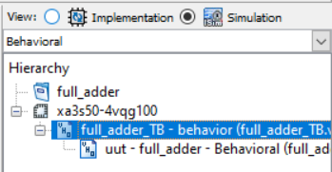
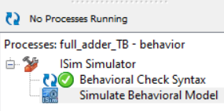
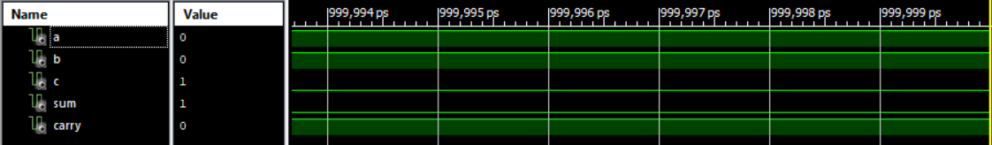

Line 0
Module Name: line_0 - Behavioral
-- Project Name:
-- Target Devices:
-- Tool versions:
-- Description:
--
-- Dependencies:
--
--
----------------------------------------------------------------------------------
library IEEE;
use IEEE.STD_LOGIC_1164.ALL;

-- Uncomment the following library declaration if using
-- arithmetic functions with Signed or Unsigned values
--use IEEE.NUMERIC_STD.ALL;

-- Uncomment the following library declaration if instantiating
-- any Xilinx primitives in this code.
--library UNISIM;
--use UNISIM.VComponents.all;

entity line_0 is
Port ( A1 : in STD_LOGIC;
A2 : in STD_LOGIC;
A3 : in STD_LOGIC;
A4 : in STD_LOGIC;
B1 : in STD_LOGIC;
Q0 : out STD_LOGIC;
Q1 : out STD_LOGIC;
Q2 : out STD_LOGIC;
Q3 : out STD_LOGIC;
Q4 : out STD_LOGIC;
Q5 : out STD_LOGIC;
Q6 : out STD_LOGIC;
Q7 : out STD_LOGIC;
Q8 : out STD_LOGIC;
Q9 : out STD_LOGIC;
Q10 : out STD_LOGIC;
Q11 : out STD_LOGIC);
end line_0;

architecture Behavioral of line_0 is

begin

Q0 <= A1 and B1;
Q1 <= A1 and B1;
Q2 <= A1 and B1;
Q3 <= A2 and B1;
Q4 <= A2 and B1;
Q5 <= A2 and B1;
Q6 <= A3 and B1;
Q7 <= A3 and B1;
Q8 <= A3 and B1;
Q9 <= A4 and B1;
Q10 <= A4 and B1;
Q11 <= A4 and B1;

end Behavioral;
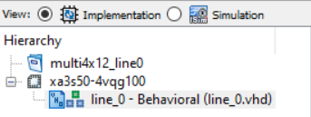
The Behavioral location
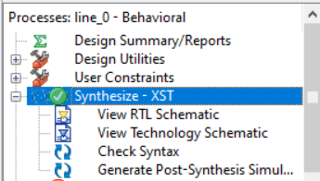
Synthesis confirmed and no errors found
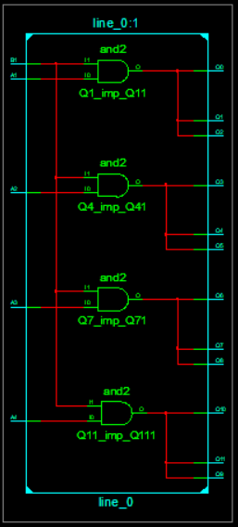
RTL Schematic
Table 3 line x in implementation window

multi4x12_line0/line0_TB.vhd
-- Project Name: multi4x12_line0
-- Target Device:
-- Tool versions:
-- Description:
--
-- VHDL Test Bench Created by ISE for module: line_0
--
-- Dependencies:
--
-- Revision:
-- Revision 0.01 - File Created
-- Additional Comments:
--
-- Notes:
-- This testbench has been automatically generated using types std_logic and
-- std_logic_vector for the ports of the unit under test. Xilinx recommends
-- that these types always be used for the top-level I/O of a design in order
-- to guarantee that the testbench will bind correctly to the post-implementation
-- simulation model.
--------------------------------------------------------------------------------
LIBRARY ieee;
USE ieee.std_logic_1164.ALL;

-- Uncomment the following library declaration if using
-- arithmetic functions with Signed or Unsigned values
--USE ieee.numeric_std.ALL;

ENTITY line0_TB IS
END line0_TB;

ARCHITECTURE behavior OF line0_TB IS

-- Component Declaration for the Unit Under Test (UUT)

COMPONENT line_0
PORT(
A1 : IN std_logic;
A2 : IN std_logic;
A3 : IN std_logic;
A4 : IN std_logic;
B1 : IN std_logic;
Q0 : OUT std_logic;
Q1 : OUT std_logic;
Q2 : OUT std_logic;
Q3 : OUT std_logic;
Q4 : OUT std_logic;
Q5 : OUT std_logic;
Q6 : OUT std_logic;
Q7 : OUT std_logic;
Q8 : OUT std_logic;
Q9 : OUT std_logic;
Q10 : OUT std_logic;
Q11 : OUT std_logic
);
END COMPONENT;

--Inputs
signal A1 : std_logic := '0';
signal A2 : std_logic := '0';
signal A3 : std_logic := '0';
signal A4 : std_logic := '0';
signal B1 : std_logic := '0';

--Outputs
signal Q0 : std_logic;
signal Q1 : std_logic;
signal Q2 : std_logic;
signal Q3 : std_logic;
signal Q4 : std_logic;
signal Q5 : std_logic;
signal Q6 : std_logic;
signal Q7 : std_logic;
signal Q8 : std_logic;
signal Q9 : std_logic;
signal Q10 : std_logic;
signal Q11 : std_logic;

BEGIN

-- Instantiate the Unit Under Test (UUT)
uut: line_0 PORT MAP (
A1 => A1,
A2 => A2,
A3 => A3,
A4 => A4,
B1 => B1,
Q0 => Q0,
Q1 => Q1,
Q2 => Q2,
Q3 => Q3,
Q4 => Q4,
Q5 => Q5,
Q6 => Q6,
Q7 => Q7,
Q8 => Q8,
Q9 => Q9,
Q10 => Q10,
Q11 => Q11
);

-- Stimulus process
stim_proc: process
begin
-- hold reset state for 10 ns.
wait for 10 ns;
A1 <= not A1;

end process;

stim_proc2: process
begin
-- hold reset state for 20 ns.
wait for 20 ns;
A2 <= not A2;

end process;

stim_proc3: process
begin
-- hold reset state for 40 ns.
wait for 40 ns;
A3 <= not A3;

end process;

stim_proc4: process
begin
-- hold reset state for 40 ns.
wait for 80 ns;
A4 <= not A4;

end process;

stim_proc5: process
begin
-- hold reset state for 80 ns.
wait for 160 ns;
B1 <= not B1;

end process;

END;
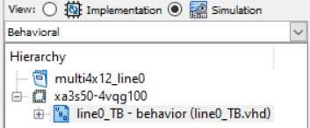
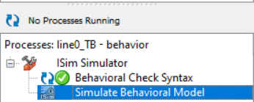
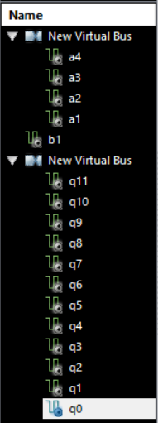
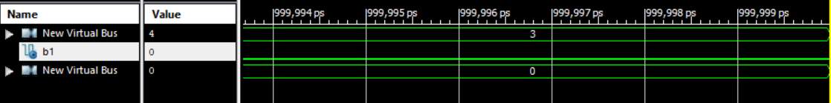
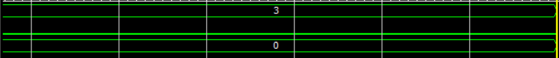
Table 4 line 0 test bench

Line X
Module Name: line_X - Behavioral
-- Project Name:
-- Target Devices:
-- Tool versions:
-- Description:
--
-- Dependencies:
--
-- Revision:
-- Revision 0.01 - File Created
-- Additional Comments:
--
----------------------------------------------------------------------------------
library IEEE;
use IEEE.STD_LOGIC_1164.ALL;

-- Uncomment the following library declaration if using
-- arithmetic functions with Signed or Unsigned values
--use IEEE.NUMERIC_STD.ALL;

-- Uncomment the following library declaration if instantiating
-- any Xilinx primitives in this code.
--library UNISIM;
--use UNISIM.VComponents.all;

entity line_X is
Port ( A1 : in STD_LOGIC;
A2 : in STD_LOGIC;
A3 : in STD_LOGIC;
B : in STD_LOGIC;
P1 : in STD_LOGIC;
P2 : in STD_LOGIC;
P3 : in STD_LOGIC;
Q1 : out STD_LOGIC;
Q2 : out STD_LOGIC;
Q3 : out STD_LOGIC;
Q4 : out STD_LOGIC);
end line_X;

architecture Behavioral of line_X is

COMPONENT half_adder
PORT(
A : IN std_logic;
B : IN std_logic;
Sum : OUT std_logic;
Carry : OUT std_logic
);
END COMPONENT;

COMPONENT full_adder
PORT(
A : IN std_logic;
B : IN std_logic;
C : IN std_logic;
Sum : OUT std_logic;
Carry : OUT std_logic
);
END COMPONENT;

signal s0 : STD_LOGIC;
signal s1 : STD_LOGIC;
signal s2 : STD_LOGIC;

signal c1 : STD_LOGIC;
signal c2 : STD_LOGIC;

begin

s0 <= A1 and B;
s1 <= A2 and B;
s2 <= A3 and B;

HA1: half_adder
Port map
( s0 , p1 , Q1 , c1 );

FA1 : full_adder
Port map
( s1 , p2 , c1 , Q2, c2 );

FA2 : full_adder
Port map
( s2 , P3 , c2 , Q3, Q4 );

end behavioral;

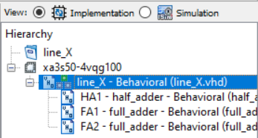
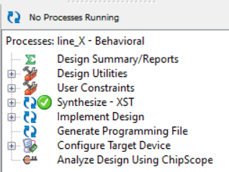
roject Name: line_X
-- Target Device:
-- Tool versions:
-- Description:
--
-- VHDL Test Bench Created by ISE for module: line_X
--
-- Dependencies:
--
-- Revision:
-- Revision 0.01 - File Created
-- Additional Comments:
--
-- Notes:
-- This testbench has been automatically generated using types std_logic and
-- std_logic_vector for the ports of the unit under test. Xilinx recommends
-- that these types always be used for the top-level I/O of a design in order
-- to guarantee that the testbench will bind correctly to the post-implementation
-- simulation model.
--------------------------------------------------------------------------------
LIBRARY ieee;
USE ieee.std_logic_1164.ALL;

-- Uncomment the following library declaration if using
-- arithmetic functions with Signed or Unsigned values
--USE ieee.numeric_std.ALL;

ENTITY line_X_TB IS
END line_X_TB;

ARCHITECTURE behavior OF line_X_TB IS

-- Component Declaration for the Unit Under Test (UUT)

COMPONENT line_X
PORT(
A1 : IN std_logic;
A2 : IN std_logic;
A3 : IN std_logic;
B : IN std_logic;
P1 : IN std_logic;
P2 : IN std_logic;
P3 : IN std_logic;
Q1 : OUT std_logic;
Q2 : OUT std_logic;
Q3 : OUT std_logic;
Q4 : OUT std_logic
);
END COMPONENT;

--Inputs
signal A1 : std_logic := '0';
signal A2 : std_logic := '0';
signal A3 : std_logic := '0';
signal B : std_logic := '0';
signal P1 : std_logic := '0';
signal P2 : std_logic := '0';
signal P3 : std_logic := '0';
--Outputs
signal Q1 : std_logic;
signal Q2 : std_logic;
signal Q3 : std_logic;
signal Q4 : std_logic;
-- No clocks detected in port list. Replace <clock> below with
-- appropriate port name

BEGIN

-- Instantiate the Unit Under Test (UUT)
uut: line_X PORT MAP (
A1 => A1,
A2 => A2,
A3 => A3,
B => B,
P1 => P1,
P2 => P2,
P3 => P3,
Q1 => Q1,
Q2 => Q2,
Q3 => Q3,
Q4 => Q4
);

-- Stimulus process
stim_proc: process
begin
-- hold reset state for 100 ns.
wait for 10 ns;
A1 <= not A1;
end process;

-- Stimulus process
stim_proc2: process
begin
-- hold reset state for 100 ns.
wait for 20 ns;
A2 <= not A2;
end process;

-- Stimulus process
stim_proc3: process
begin
-- hold reset state for 100 ns.
wait for 40 ns;
A3 <= not A3;
end process;

-- Stimulus process
stim_proc4: process
begin
-- hold reset state for 100 ns.
wait for 80 ns;
P1 <= not P1;
end process;

-- Stimulus process
stim_proc5: process
begin
-- hold reset state for 100 ns.
wait for 160 ns;
P2 <= not P2;
end process;

stim_proc6: process begin
-- hold reset state for 100 ns.
wait for 320 ns;
P3 <= not P3;
end process;

-- Stimulus process
stim_proc7: process
begin
-- hold reset state for 100 ns.
wait for 640 ns;
B <= not B;
end process;

END;
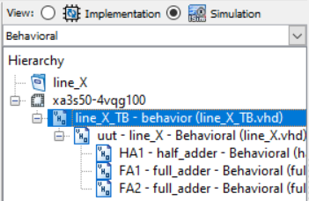
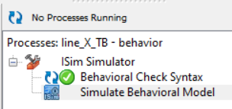
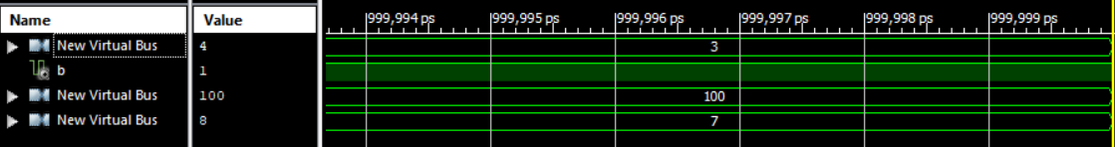
Table 5

Multi Full
Module Name: multi4x12_full - Behavioral
-- Project Name:
-- Target Devices:
-- Tool versions:
-- Description:
--
-- Dependencies:
--
-- Revision:
-- Revision 0.01 - File Created
-- Additional Comments:
--
----------------------------------------------------------------------------------
library IEEE;
use IEEE.STD_LOGIC_1164.ALL;

-- Uncomment the following library declaration if using
-- arithmetic functions with Signed or Unsigned values
--use IEEE.NUMERIC_STD.ALL;

-- Uncomment the following library declaration if instantiating
-- any Xilinx primitives in this code.
--library UNISIM;
--use UNISIM.VComponents.all;

entity multi4x12_full is
Port ( A1 : in STD_LOGIC;
A2 : in STD_LOGIC;
A3 : in STD_LOGIC;
B1 : in STD_LOGIC;
B2 : in STD_LOGIC;
B3 : in STD_LOGIC;
Q0 : out STD_LOGIC;
Q1 : out STD_LOGIC;
Q2 : out STD_LOGIC;
Q3 : out STD_LOGIC;
Q4 : out STD_LOGIC;
Q5 : out STD_LOGIC);
end multi4x12_full;

architecture Behavioral of multi4x12_full is
COMPONENT line_0

PORT(
A1 : IN std_logic;
A2 : IN std_logic;
A3 : IN std_logic;
A4 : IN std_logic;
B1 : IN std_logic;
Q0 : OUT std_logic;
Q1 : OUT std_logic;
Q2 : OUT std_logic;
Q3 : OUT std_logic;
Q4 : OUT std_logic;
Q5 : OUT std_logic;
Q6 : OUT std_logic;
Q7 : OUT std_logic;
Q8 : OUT std_logic;
Q9 : OUT std_logic;
Q10 : OUT std_logic;
Q11 : OUT std_logic
);
END COMPONENT;

COMPONENT line_X
PORT(
A1 : IN std_logic;
A2 : IN std_logic;
A3 : IN std_logic;
B : IN std_logic;
P1 : IN std_logic;
P2 : IN std_logic;
P3 : IN std_logic;
Q1 : OUT std_logic;
Q2 : OUT std_logic;
Q3 : OUT std_logic;
Q4 : OUT std_logic
);
END COMPONENT;

signal p1_1 : STD_LOGIC;
signal p1_2 : STD_LOGIC;

signal p2_1 : STD_LOGIC;
signal p2_2 : STD_LOGIC;
signal p2_3 : STD_LOGIC;
begin

line1 : line_0
Port Map
( A1, A2 , A3 , B1 , Q0 , p1_1 , p1_2 );

line2 : line_X
Port Map
( A1 , A2 , A3 , B2 , p1_1 , p1_2 , P3 , Q1 , p2_1 , p2_2 , p2_3 );

line3 : line_X
Port Map
( A1 , A2 , A3 , B3 , p2_1 , p2_2 , p2_3, Q2 , Q3 ,Q4 , Q5 );

end Behavioral;

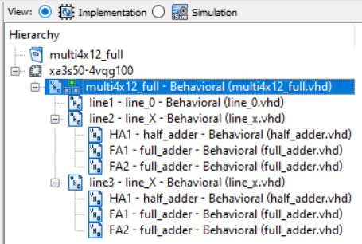
Table 6

Project Name: multi4x12_full
-- Target Device:
-- Tool versions:
-- Description:
--
-- VHDL Test Bench Created by ISE for module: multi4x12_full
--
-- Dependencies:
--
-- Revision:
-- Revision 0.01 - File Created
-- Additional Comments:
--
-- Notes:
-- This testbench has been automatically generated using types std_logic and
-- std_logic_vector for the ports of the unit under test. Xilinx recommends
-- that these types always be used for the top-level I/O of a design in order
-- to guarantee that the testbench will bind correctly to the post-implementation
-- simulation model.
--------------------------------------------------------------------------------
LIBRARY ieee;
USE ieee.std_logic_1164.ALL;

-- Uncomment the following library declaration if using
-- arithmetic functions with Signed or Unsigned values
--USE ieee.numeric_std.ALL;

ENTITY full_TB IS
END full_TB;

ARCHITECTURE behavior OF full_TB IS

-- Component Declaration for the Unit Under Test (UUT)

COMPONENT multi4x12_full
PORT(
A1 : IN std_logic;
A2 : IN std_logic;
A3 : IN std_logic;
B1 : IN std_logic;
B2 : IN std_logic;
B3 : IN std_logic;
Q0 : OUT std_logic;
Q1 : OUT std_logic;
Q2 : OUT std_logic;
Q3 : OUT std_logic;
Q4 : OUT std_logic;
Q5 : OUT std_logic
);
END COMPONENT;

--Inputs
signal A1 : std_logic := '0';
signal A2 : std_logic := '0';
signal A3 : std_logic := '0';
signal B1 : std_logic := '0';
signal B2 : std_logic := '0';
signal B3 : std_logic := '0';

--Outputs
signal Q0 : std_logic;
signal Q1 : std_logic;
signal Q2 : std_logic;
signal Q3 : std_logic;
signal Q4 : std_logic;
signal Q5 : std_logic;
-- No clocks detected in port list. Replace <clock> below with
-- appropriate port name

BEGIN

-- Instantiate the Unit Under Test (UUT)
uut: multi4x12_full PORT MAP (
A1 => A1,
A2 => A2,
A3 => A3,
B1 => B1,
B2 => B2,
B3 => B3,
Q0 => Q0,
Q1 => Q1,
Q2 => Q2,
Q3 => Q3,
Q4 => Q4,
Q5 => Q5
);

-- Stimulus process
stim_proc: process
begin
-- hold reset state for 100 ns.
wait for 10 ns;

A1 <= not A1;

end process;

stim_proc2: process
begin
-- hold reset state for 100 ns.
wait for 20 ns;

A2 <= not A2;

end process;

stim_proc3: process
begin
-- hold reset state for 100 ns.
wait for 40 ns;

A3 <= not A3;

end process;

stim_proc4: process
begin
-- hold reset state for 100 ns.
wait for 80 ns;

B1 <= not B1;

end process;

stim_proc5: process
begin
-- hold reset state for 100 ns.
wait for 160 ns;

B2 <= not B2 ;

end process;
stim_proc6: process
begin
-- hold reset state for 100 ns.
wait for 320 ns;

B3 <= not B3;

end process;

END;
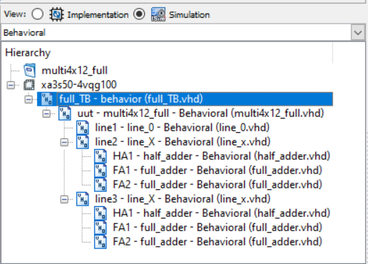
Table 7

2. Aims and Objectives:
The task 2 is to design, simulate and synthesise the FSM described by the state diagram in figure 4 as both a VHDL and discrete gate solution.
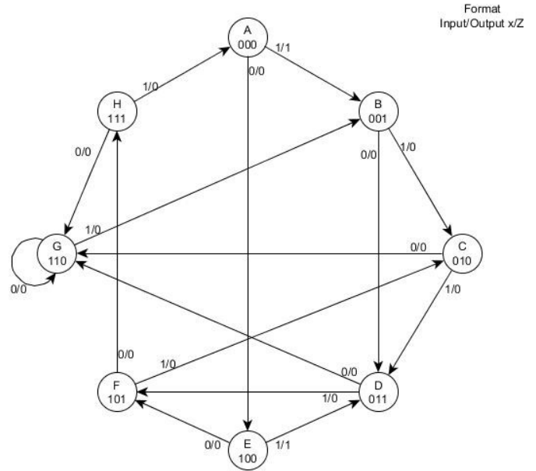
Figure 7 state diagram

Discrete gate solution
 | State |  |  |  |  |  | Next state
state | A | B | C | X |  | A | B | C | Z
A | 0 | 0 | 0 | 0 |  | 1 | 0 | 0
 | 0 | 0 | 0 | 1 |  | 0 | 0 | 1
B | 0 | 0 | 1 | 0 |  | 0 | 1 | 1
 | 0 | 0 | 1 | 1 |  | 0 | 1 | 0
C | 0 | 1 | 0 | 0 |  | 1 | 1 | 0
 | 0 | 1 | 0 | 1 |  | 0 | 1 | 1
D | 0 | 1 | 1 | 0 |  | 1 | 1 | 0
 | 0 | 1 | 1 | 1 |  | 1 | 0 | 1
E | 1 | 0 | 0 | 0 |  | 1 | 0 | 1
 | 1 | 0 | 0 | 1 |  | 0 | 1 | 1
F | 1 | 0 | 1 | 0 |  | 1 | 1 | 1
 | 1 | 0 | 1 | 1 |  | 0 | 1 | 0
G | 1 | 1 | 0 | 0 |  | 1 | 1 | 0
 | 1 | 1 | 0 | 1 |  | 0 | 0 | 1
H | 1 | 1 | 1 | 0 |  | 1 | 1 | 0
 | 1 | 1 | 1 | 1 |  | 0 | 0 | 0 | 1
 |  | AB
 | Da | _00 | _01 | 11 | 10
CX | _00 | 1 | 1 | 1 | 1
 | _01 | 0 | 0 | 0 | 0
 | 11 | 0 | 1 | 0 | 0
 | 10 | 0 | 1 | 1 | 1
Da = /C/X + B/X + A/X + /A.B.C

 |  | AB
 | Db | _00 | _01 | 11 | 10
CX | _00 | 0 | 1 | 1 | 0
 | _01 | 0 | 1 | 0 | 1
 | 11 | 1 | 0 | 0 | 1
 | 10 | 1 | 1 | 1 | 1
Db =B/X + /B. C + /A. B/ C + A /B. X

 |  |  | AB
 | Dc |  | _00 | _01 | 11 | 10
CX | _00 |  | 0 | 0 | 0 | 1
 | _01 |  | 1 | 1 | 1 | 1
 | 11 |  | 0 | 1 | 0 | 0
 | 10 |  | 1 | 0 | 0 | 1
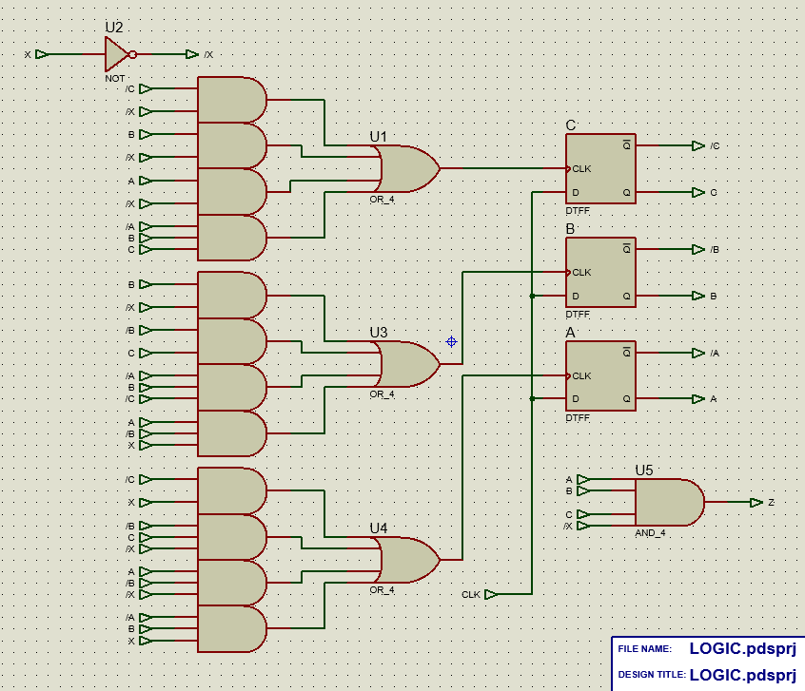
Dc = /C.X+ /B.C/X+A/B/X+/A.B.X

FSM

VHDL Module
Module Name: fm1 - Behavioral
----------------------------------------------------------------------------------
library IEEE;
use IEEE.STD_LOGIC_1164.ALL;

-- Uncomment the following library declaration if using
-- arithmetic functions with Signed or Unsigned values
--use IEEE.NUMERIC_STD.ALL;

-- Uncomment the following library declaration if instantiating
-- any Xilinx primitives in this code.
--library UNISIM;
--use UNISIM.VComponents.all;

entity fm1 is
Port ( x : in STD_LOGIC;
Clk : in STD_LOGIC;
Z : out STD_LOGIC);
end fm1;

architecture Behavioral of fm1 is

type state_type is (state_A, state_B, state_C, state_D, state_E, state_F, state_G, state_H);
signal present_state : state_type := state_A;
signal next_state : state_type := state_A;
begin

State: process (present_state,X)
begin
if x='0' Then
case present_state is
when state_A => next_state <= state_E;Z<='0';
when state_B => next_state <= state_D;Z<='0';
when state_C => next_state <= state_G;Z<='0';
when state_D => next_state <= state_G;Z<='0';
when state_E => next_state <= state_D;Z<='0';
when state_F => next_state <= state_C;Z<='0';
when state_G => next_state <= state_G;Z<='0';
when state_H => next_state <= state_A;Z<='0';
end case;
else if x='1' Then
case present_state is
when state_A => next_state <= state_B;Z<='0';
when state_B => next_state <= state_C;Z<='0';
when state_C => next_state <= state_D;Z<='0';
when state_D => next_state <= state_F;Z<='0';
when state_E => next_state <= state_D;Z<='0';
when state_F => next_state <= state_C;Z<='0';
when state_G => next_state <= state_B;Z<='0';
when state_H => next_state <= state_G;Z<='1';
when OTHERS => NULL;
end case;
end if;
end if;
end Process state;

clocked: Process (Clk)
begin
if ((Clk='1') and (Clk'last_value='0')) Then
present_state <= next_state;
end if;
end process clocked;

end Behavioral;
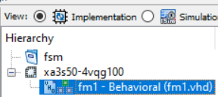
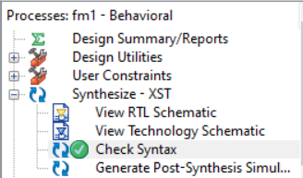

VHDL Test Bench
VHDL Test Bench Created by ISE for module: fm1
--
-- Dependencies:
--
-- Revision:
-- Revision 0.01 - File Created
-- Additional Comments:
--
-- Notes:
-- This testbench has been automatically generated using types std_logic and
-- std_logic_vector for the ports of the unit under test. Xilinx recommends
-- that these types always be used for the top-level I/O of a design in order
-- to guarantee that the testbench will bind correctly to the post-implementation
-- simulation model.
--------------------------------------------------------------------------------
LIBRARY ieee;
USE ieee.std_logic_1164.ALL;

-- Uncomment the following library declaration if using
-- arithmetic functions with Signed or Unsigned values
--USE ieee.numeric_std.ALL;

ENTITY fm1_TB IS
END fm1_TB;

ARCHITECTURE behavior OF fm1_TB IS

-- Component Declaration for the Unit Under Test (UUT)

COMPONENT fm1
PORT(
x : IN std_logic;
Clk : IN std_logic;
Z : OUT std_logic
);
END COMPONENT;

--Inputs
signal x : std_logic := '0';
signal Clk : std_logic := '0';

--Outputs
signal Z : std_logic;

-- Clock period definitions
constant Clk_period : time := 10 ns;

BEGIN

-- Instantiate the Unit Under Test (UUT)
uut: fm1 PORT MAP (
x => x,
Clk => Clk,
Z => Z
);

-- Clock process definitions
Clk_process :process
begin
Clk <= '0';
wait for Clk_period/2;
Clk <= '1';
wait for Clk_period/2;
end process;

-- Stimulus process
stim_proc: process
begin
-- hold reset state for 100 ns.
wait for 100 ns;

wait for Clk_period*10;

-- insert stimulus here

wait;
end process;
END;
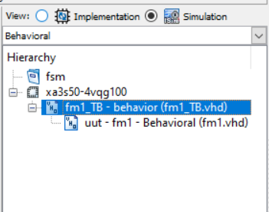
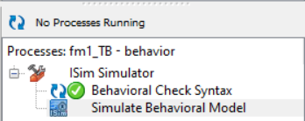
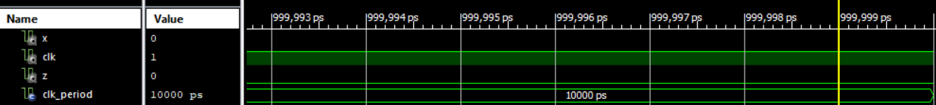

References

[1] | “The flow chart of Booth multiplication algorithm.,” [Online]. Available: https://www.researchgate.net/figure/The-flow-chart-of-Booth-multiplication-algorithm_fig3_308574775. [Accessed March 2021].
[2] | “A Review ofDifferent Type of Multipliers and Multiplier-Accumulator Unit.,” International Journal of Emerging Trends & Technology in Computer Science, [Online]. Available: https://www.ijettcs.org/Volume2Issue4/IJETTCS-2013-08-25-115.pdf. [Accessed February 2021].
[3] | “Combinational multiplier diagram,” [Online]. Available: https://ocw.mit.edu/courses/electrical-engineering-and-computer-science/6-004-computation-structures-spring-2017/c8/c8s1/Slide18.png. [Accessed March 2021].
[4] | [Online]. Available: https://www.google.com/url?sa=i&url=http%3A%2F%2Fwww.ijarse.com%2Fimages%2Ffullpdf%2F1523964041_IIMT19.pdf&psig=AOvVaw2Gd5nypjDnAZfAN9aHYCfe&ust=1621505354063000&source=images&cd=vfe&ved=0CAkQjhxqFwoTCKjnu6rA1fACFQAAAAAdAAAAABAD.
[5] | [Online]. Available: https://www.google.com/url?sa=i&url=http%3A%2F%2Fpeople.ee.duke.edu%2F~krish%2Fteaching%2FLectures%2FArithmeticCircuits_2.pdf&psig=AOvVaw1GLR9GXnlJnoVE6osA5nxb&ust=1621505455363000&source=images&cd=vfe&ved=0CAkQjhxqFwoTCKCrstnA1fACFQAAAAAdAAAAABAD.
[6] | [Online]. Available: https://www.google.com/url?sa=i&url=https%3A%2F%2Fdigitalsystemdesign.in%2Fsequential-multiplier%2F&psig=AOvVaw3dRFPhvls3qvU0n2S4nHXC&ust=1621506144808000&source=images&cd=vfe&ved=0CAkQjhxqFwoTCOC46qfD1fACFQAAAAAdAAAAABBL.
[7] | [Online]. Available: https://www.ijser.org/paper/Design-of-Braun-Multiplier-with-Kogge-Stone-Adder-Its-Implementation-on-FPGA.html. [Accessed May 2021].

