
PROGRAMME: MSC ENGINEERING PROJECT MANAGEMENT, MSC LEAN AND AGILE OPERATIONS, MSC INDUSTRIAL ENGINEERING AND MSC MECHANICAL ENGINEERING

Module Name: Sustainable Operations Management

Module code: ACHA7031

Assignment Title: Addressing Inventory Management Concerns of Brocksweir Engineering Ltd

Student Name: :Aminur Islam Tonmoy
Student ID: 2522779

Word Count: 2504

TASK DESCRIPTION

Use of Generative AI in Assessment
(Lecturer to indicate Yes or No against each element)

RESEARCH | For this assessment, you can use Generative AI to support you in research, including searching for bibliography, using tools to summarise, compare and  interrogate materials. | Yes ☒  No ☐
STRUCTURE | For this assessment, you can use Generative AI to support you in structuring your submission, including creating a draft argument structure, identifying parts  and headings, etc. | Yes ☐  No ☒
PROOFREADING | For this assessment, you can use Generative AI to check your own text/creation for grammatical and syntactical mistakes, including rephrasing of your  own work within specific standards. | Yes ☐  No ☒
WRITING | For this assessment, you can use Generative AI to create text for submission. | Yes ☐  No ☒
CREATIVE | For this assessment, you can use Generative AI to create creative materials, such as images. | Yes ☐  No ☒
PROGRAMING | For this assessment, you can use Generative AI to create and check code. | Yes ☐  No ☒
NONE | For this assessment, you are not allowed to use any type of Generative AI support. This includes research support, structure support, writing/proofreading  support and creative support. | Yes ☐  No ☒

Table of Contents
1. Introduction 5
2. Main Body 5
2.1 Evaluation of the way the company can manage its sand and resin inventory better 5
2.2 Options available to the company to deal with the obsolete stock 9
2.3 Measures to get a better understanding of lead time across the business and its extended enterprises 12
3. Conclusion 15
References 16

List of Figures
Figure 1: Economic Order Quantity (EOQ) model 6
Figure 2: Just-In-Time (JIT) inventory system 7
Figure 3: Green Supply Chain Management (GSCM) practices 8
Figure 4: Recycling and reprocessing 10
Figure 5: Corporate Social Responsibility (CSR) 12
Figure 6: Enterprise Resource Planning (ERP) system 13
Figure 7: Critical Path Analysis (CPA) 14

1. Introduction
Product management is the structured practice of planning, executing and overseeing the tasks to achieve specific goals within constraints like time, budget and scope (Rusch et al. 2023). Brocksweir Engineering Ltd is a long-established company with the main focus on manufacturing, with more than 250 years of foundry heritage and 50 years of continuous trading. The company, now run by the founder's son, wants to modernise its operations and stay competitive in the market despite the increase in global competition. However, there have been some operational issues lately, especially in the sand foundry, which has revealed a lot of inefficiency in the inventory management. This case study analysis focuses on Brocksweir Engineering Ltd for the adoption of structured inventory management practices to optimise resource utilisation, reduce waste and improve overall supply chain efficiency.

2. Main Body

2.1 Evaluation of the way the company can manage its sand and resin inventory better
The current approach of Brocksweir Engineering Ltd to manage its sand and resin inventory is clearly inefficient, which has led to financial loss due to ineffective bulk buying. This is a prime example of a reactive and unsystematic approach, as the company implies a lack of structured inventory control systems, which is detrimental to operational efficiency and sustainability goals. As opined by Chilcott (2023), a reactive and unsystematic approach is characterised by managing events without a structured plan, strategy or standardised processes. Moreover, it can be derived from the case study that excessive bulk buying, resin stock expiring, increasing waste disposal costs, and a lack of systematic control raise financial and environmental concerns for the company. However, to address these challenges, the company needs to implement a strategic and integrated approach to inventory management, enhance supply chain responsiveness and emphasise cost-effectiveness with minimising waste.
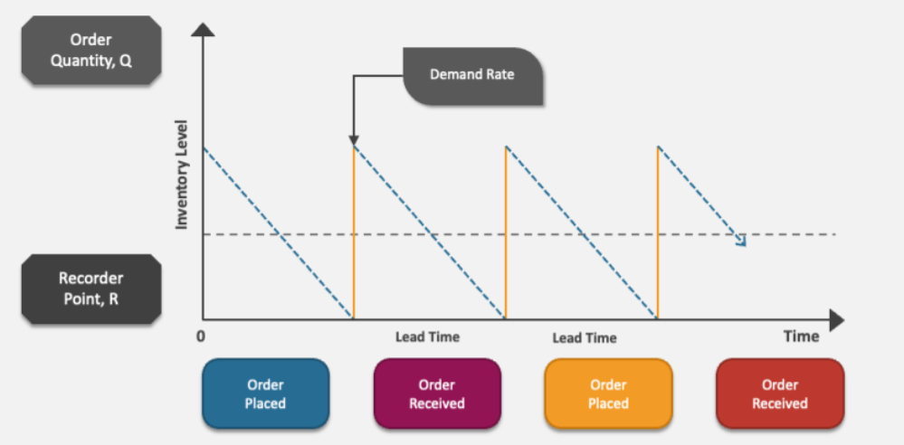

Figure 1: Economic Order Quantity (EOQ) model
(Source: Collidu, 2025)
Figure 1 illustrates the EOQ model, which shows the order quantity and inventory levels with the demand rate and the lead time to get the order received on time. One of the key areas for improvement for Brocksweir Engineering Ltd is the implementation of the Economic Order Quantity (EOQ) model. EOQ is the minimum order size a company should purchase to minimise its total inventory costs, including shortage costs, holding and ordering (Alnahhal et al. 2024). Based on this context, the application of this model can help the company to strike a balance between ordering items frequently and ordering too much, which results in high holding costs. This approach further can help the company to identify the best order size to minimise their inventory costs, as the sand binding has a shorter shelf life, so more frequent orders will be appropriate. Moreover, this would significantly reduce the risk of obsolescence and financial loss for the company from the expired stock based on the context of inventory management of EOQ.
It is also important to set minimum and maximum inventory levels, as Brocksweir Engineering Ltd can avoid stockouts and overstocking by setting reorder points. As stated by Jean (2024), setting minimum and maximum inventory levels is critical for balancing the supply chain with demand, avoiding costly stockouts and reducing overstock. For example, maximum levels stop production from being halted due to a lack of resin, and maximum levels prevent excess buildup that could lead to expiration (Munshi and Kulkarni, 2025). These control mechanisms are especially important in the sand foundry, where the inventory turnover must be closely coordinated with the production schedules.
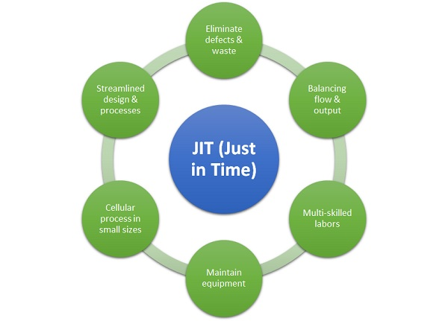

Figure 2: Just-In-Time (JIT) inventory system
(Source: MBA Skool, 2025)
Figure 2 illustrates the JIT inventory system that reduces capital by receiving goods only as needed for production rather than stockpiling. Another promising strategy for improvement for Brocksweir Engineering Ltd is the implementation of the Just-In-Time (JIT) inventory system. JIT inventory is a management strategy that minimises waste by reducing capital and receiving goods only as per production or sales (Jenkins, 2024). It cuts inventory holding time by proper material delivery with the best production schedules, as it is particularly needed for short shelf-life materials such as phenolic and furan resins. For example, IKEA has implemented GSCM practices successfully by emphasising eco-friendly packaging to extend the product life (Gupta et al. 2025). This can help the company to establish good supplier relationships and accurate demand forecasting, yet it would greatly reduce the amount of resin held on site and the expiry risk of the products. However, JIT can make the supply chain more vulnerable, especially when the suppliers cannot be relied on too much.
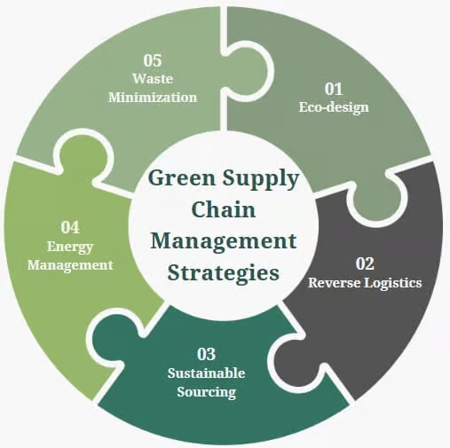

Figure 3: Green Supply Chain Management (GSCM) practices
(Source: Six Sigma, 2025)
Figure 3 shows the green supply chain management strategies that consist of eco-design, reverse logistics, sustainable sourcing, energy management and waste minimisation. In this context, Brocksweir Engineering Ltd needs to adopt Green Supply Chain Management (GSCM) practices from a sustainable point of view to classify the environmental and regulatory hazards. GSCM practices refer to the process of integrating environmentally friendly practices within the entire supply chain of a company, from the production of the goods to the disposal of waste (Six Sigma, 2025). It involves both forward and reverse logistics, with the main focus on reducing waste and improving the reuse and recycling of materials throughout a product's lifecycle. Additionally, the company can reduce the production of hazardous waste by reducing overstocking and improving stock control, which could further reduce the regulatory burden and the disposal waste costs. Yet again, the high initial capital expenditures and increased operational costs can be a significant gap in implementing the GSCM practices in the supply chain.
Brocksweir Engineering Ltd can greatly improve its sand and resin inventory management by using structured techniques like EOQ, JIT and GSCM supported by effective forecasting systems. For example, BAM Ireland has analysed daily data insights and has improved its operations by predicting safety hazards and increasing efficiency regarding high-risk issues (Pinnacle Infotech, 2025). Thus, these steps will help reduce costs and waste, improve operational efficiencies and position the company for sustainable growth in the competitive marketplace in future.

2.2 Options available to the company to deal with the obsolete stock
Brocksweir Engineering Ltd has a significant problem with the obsolete stock, which has lost its operational value due to expired shelf life. The company now has 20,000 euros of unusable resins classified as special waste that may require a series of short-term corrective and long-term preservative measures. As denoted by Arunagiri et al. (2024), short-term corrective and long-term preservative measures are the key strategies used to address immediate threats to product stability and ensure enduring quality for a company. Moreover, managing the obsolete stock requires multi-criteria decision-making, compliance and sustainability and balancing cost for the company to stay in the competitive marketplace. However, to address this challenge, the company needs to implement several practical options with different costs, environmental and operational implications.
The most immediate and unavoidable step is the option of disposal of resin waste in accordance with licensed waste management contractors. As opined by Singh (2025), licensed waste management contractors ensure legal compliance and offer key services like bio-medical, e-waste, and municipal waste management. For example, Westminster City Council partners with the Veolia company for waste collection by including innovative vehicle-to-grid projects for saving energy (Veolia, 2026). The article shows that engaging licensed contractors for resin waste disposal is necessary to ensure legal compliance and mitigate risk over cost recovery.
From the above article, Brocksweir Engineering Ltd can learn to keep resin waste in compliance with the environmental regulations and out of any legal trouble by making some of the important and critical decisions at the time of implementing it. Moreover, this approach is aligned to avoid the risk from a project management perspective, where legal compliance is prioritised over cost recovery, as disposal is highly necessary. Yet again, a shortage of qualified contractors or operators can cause delays in removing resin waste from the facility, which can potentially lead to on-site storage bottlenecks.
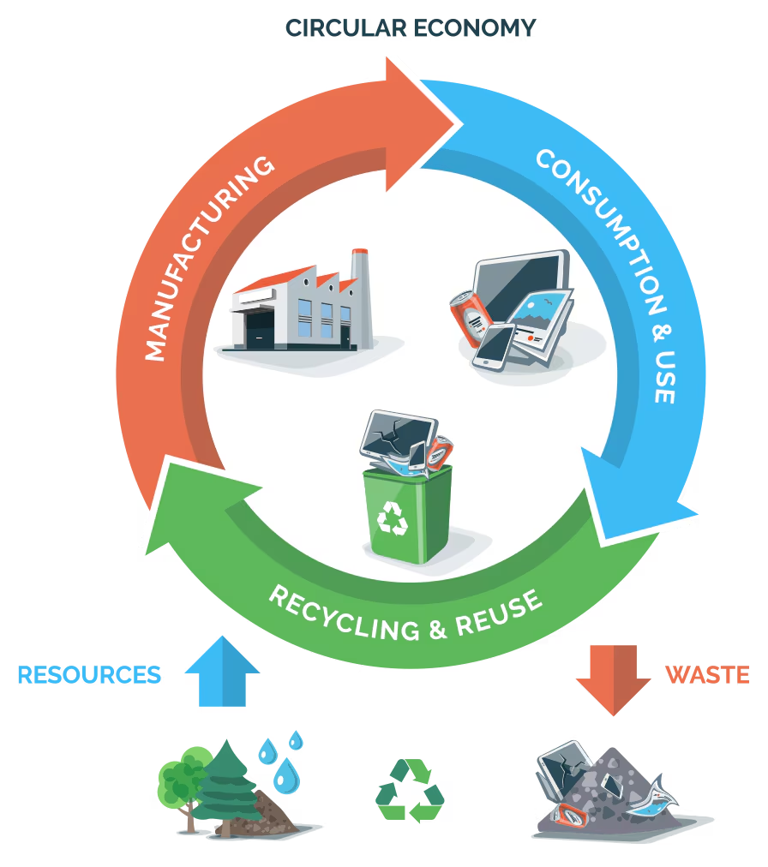

Figure 4: Recycling and reprocessing
(Source: LG, 2026)
Figure 4 shows the recycling process, where the waste is recycled into new raw materials to conserve resources and lower energy consumption. According to Liu et al. (2024), recycling is the process of collecting and breaking down waste materials into raw materials to manufacture new products that can reduce waste and lower energy consumption.
Another possibility to deal with the obsolete stock is recycling or re-processing of some resin materials, which can be treated and used in low-grade applications. For example, Biffa Plc handles household and commercial waste by focusing on turning the waste materials into raw materials to support a circular economy with a significant capacity (Reji, 2025). This is consistent with the principles of the circular economy, which aims to reduce waste and maximise the use of resources. Moreover, Brocksweir Engineering Ltd also needs to focus on reducing waste and lowering energy usage by recycling the resin waste to generate new raw materials that can be good for the environment. Implementing this can eliminate risk and free up storage space for the company to make a much better inventory management system. While often used interchangeably, recycling is overall a holistic process to minimise radioactive waste from the lower quality products.
Another option for Brocksweir Engineering Ltd to deal with the obsolete stock is donation for research or for educational purposes, as the expired resins can be used in experimental or training situations by universities. This approach does not produce direct financial returns, yet it can improve the corporate social responsibility (CSR) and reduce the disposal volumes. According to Fatima and Elbanna (2023), CSR is a self-regulating business model where many companies integrate social, environmental and ethical concerns into their operations to benefit society and the environment. Yet again, it can cause conflicts with the shareholder interests and shift focus away from the core business objectives.
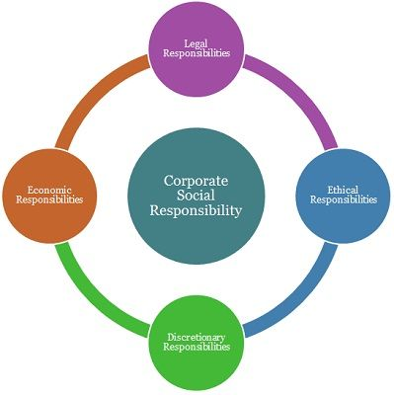

Figure 5: Corporate Social Responsibility (CSR)
(Source: Business Jargons, 2025)
Figure 5 illustrates the proactive efforts that a business can implement to improve its brand image while integrating sustainability and ethical labour practices. From this approach, Brocksweir Engineering Ltd can improve its relations with the academic institutions, which could bring in great benefits for the company in the long run to compete in the market. Therefore, more importantly, setting up the inventory management systems and preventive measures can help the company to prevent such issues from hindering both operational efficiency and environmental responsibility.

2.3 Measures to get a better understanding of lead time across the business and its extended enterprises
Brocksweir Engineering Ltd has suffered from poor visibility of lead time, both internally and across its extended supply chain, which has been a major contributor to inefficient inventory decisions. According to Balaji et al. (2022), lead time is the total latency between the initiation to the competition of a process that includes pre- and post-processing times. The company needs to adopt a structured, data-driven and collaborative approach that captures the entire value supply chain from sourcing suppliers to delivering the final product for a better understanding of the lead times. As opined by Danladi et al. (2023), a collaborative approach involves two or more individuals or groups working together to achieve a shared goal that encourages diverse perspectives and promotes shared responsibility with active engagement. However, high resource and time demands can be a limitation in implementing this approach, and it can slow down the progress and demand significant resources.
One of the key steps in better understanding the lead time is to map out the entire supply chain and internal processes in Brocksweir Engineering Ltd. The company can deconstruct lead time into its core elements, which can consist of supplier lead time, goods-in processing, transportation time, storage and final delivery. As denoted by Onuma (2025), mapping out the entire supply chain is essential for an organisation to improve transparency, reduce risk, identify bottlenecks and ensure compliance through supplier chain surveys and internal processes. Additionally, this is critical for Brocksweir Engineering Ltd to make well-informed decisions and remove bottlenecks to continuously reflect the changes in the supply chain. Yet again, it can make the supply chain map obsolete, which can make it difficult to track the new raw materials in the inventory.
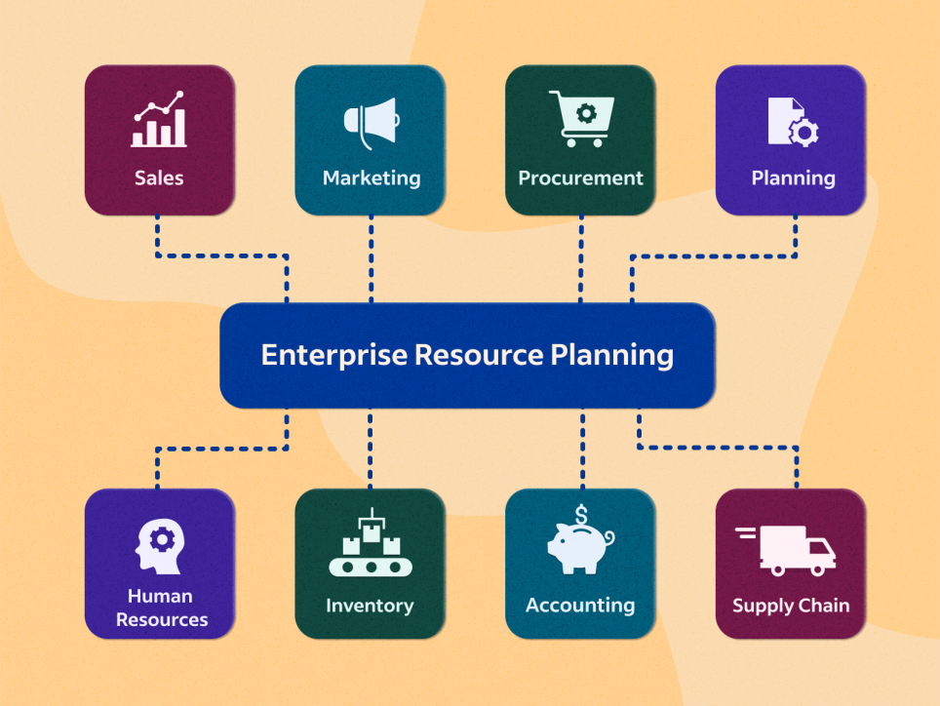

Figure 6: Enterprise Resource Planning (ERP) system
(Source: Indeed, 2025)
Figure 6 illustrates that an ERP system can be implemented to increase operational efficiency and scalability for companies through a centralised database and modular software. Another important measure is to adopt a digital inventory and supply chain management system, such as an Enterprise Resource Planning (ERP) system.
ERP systems are integrated software platforms that manage the core business processes, which include finance, HR, supply chain and services, to automate the workflows and provide real-time data visibility (Hernandez, 2025). For example, companies like Amazon use predictive systems, mostly the ERP system, to optimise logistics in their operations and predict the risks early (Frazer, 2025). Moreover, this can be beneficial for Brocksweir Engineering Ltd as it can reduce manual data entry and automate repetitive tasks to save time and costs. This will automatically calculate the lead times to develop more precise benchmarks and create alerts for delays in production planning. However, it is important to understand that ERP is an all-encompassing business management tool, and it can be complex, as it can result in a poor return on investment (ROI) and cannot be well-suited.


Figure 7: Critical Path Analysis (CPA)
(Source: Indeed, 2025)
Figure 7 shows the critical path analysis, which helps to identify the minimum time needed for a project's completion. From the project management perspective, Critical Path Analysis (CPA) can be implemented in the operations of Brocksweir Engineering Ltd, as it can have a direct impact on the lead time to save time and costs and optimise logistics. CPA is a project management technique that identifies the longest sequence of dependent tasks required to complete a project (Indeed, 2025). It allows different teams to determine the longest stretch of the dependent activities as well as to monitor their progress to finish the work before the deadline. Moreover, by emphasising the critical processes, Brocksweir Engineering Ltd can focus on the improvements of using resin waste to turn it into new raw materials. This can be good for the environment as the company can gain a competitive advantage in the manufacturing sector. However, CPA assumes the deterministic time lines, while the real-world supply chains are often chaotic, which can fail to determine the critical path of the process or project.

3. Conclusion
It can be concluded that Brocksweir Engineering Ltd must adopt a structured and data-driven approach to overcome the current challenges of resin waste and dealing with the obsolete stock. Implementing several techniques like EOQ, JIT, GSCM, ERP and CPA can help the company to increase collaboration with the suppliers, create strong systems and streamline the entire supply chain process. Ultimately, this will increase supply chain performance in the company through recycling waste products and gain a competitive advantage in the market through sustainable growth by manufacturing raw materials that are good for the environment.

References
Alnahhal, M., Aylak, B.L., Al Hazza, M. and Sakhrieh, A. (2024) ‘Economic order quantity: A state-of-the-art in the era of uncertain supply chains.’ Sustainability, 16(14), p.5965.
Arunagiri, T., Kannaiah, K.P., Vasanthan, M. and Kannaiah, K.P. (2024) ‘Enhancing pharmaceutical product quality with a comprehensive Corrective and Preventive Actions (CAPA) framework: From reactive to proactive.’ Cureus, 16(9).
Balaji, M., Dinesh, S.N., Raja, S., Subbiah, R. and Kumar, P.M. (2022) ‘Lead time reduction and process enhancement for a low volume product.’ Materials Today: Proceedings, 62, pp.1722-1728.
Business Jargons (2026) Corporate Social Responsibility (CSR). Available at: https://businessjargons.com/corporate-social-responsibility.html (Accessed: 27 April 2026)
Chilcott, L. (2023) A systematic review and investigation of judgment of learning (JoL) reactivity (Doctoral dissertation, University of Southampton). Available at: https://eprints.soton.ac.uk/484785/1/Chilcott_Lloyd_Thesis_October_2022.pdf (Accessed: 11 April 2026)
Collidu (2025) Economic Order Quantity (EOQ) model. Available at: https://www.collidu.com/presentation-economic-order-quantity (Accessed: 13 April 2026)
Danladi, S., Prasad, M.S.V., Modibbo, U.M., Ahmadi, S.A. and Ghasemi, P. (2023) ‘Attaining sustainable development goals through financial inclusion: exploring collaborative approaches to Fintech adoption in developing economies.’ Sustainability, 15(17), p.13039.
Fatima, T. and Elbanna, S. (2023) ‘Corporate social responsibility (CSR) implementation: A review and a research agenda towards an integrative framework.’ Journal of business ethics, 183(1), pp.105-121.
Frazer, J. (2025) Amazon and the Shift to AI-Driven Supply Chain Planning. Available at: https://logisticsviewpoints.com/2025/03/26/amazon-and-the-shift-to-ai-driven-supply-chain-planning/#:~:text=AI%20adoption%20presents%20several%20challenges,it%20is%20an%20operational%20necessity. (Accessed: 17 April 2026)
Gupta, P., Sharma, Y., Chauhan, A., Parewa, B., Rai, P., Naik, N. (2025) Investigation of green supply chain management practices and sustainability in Indian manufacturing enterprises using a structural equation modelling approach. Available at: https://www.nature.com/articles/s41598-025-95940-9 (Accessed: 22 April 2026)
Hernandez, J. P. (2025) The advantages and disadvantages of ERP systems. Available at: https://www.ibm.com/think/insights/enterprise-resource-planning-advantages-disadvantages (Accessed: 18 April 2026)
Indeed (2025) 26 ERP Systems for Enterprise Management (Plus Definition). Available at: https://www.indeed.com/career-advice/career-development/erp-system-examples (Accessed: 19 April 2026)
Indeed (2025) Critical Path Analysis (CPA). Available at: https://www.indeed.com/career-advice/career-development/critical-pathway-analysis (Accessed: 16 April 2026)
Jean, G. (2024) Inventory Management Strategies: Balancing Cost, Efficiency, and Customer Satisfaction [online] Available at: https://www.researchgate.net/profile/Guillaume-Jean-6/publication/386106872_Inventory_Management_Strategies_Balancing_Cost_Efficiency_and_Customer_Satisfaction/links/6744d201b5bd9d17d606f213/Inventory-Management-Strategies-Balancing-Cost-Efficiency-and-Customer-Satisfaction.pdf (Accessed: 15 April 2026)
Jenkins, A. (2024) Just-in-Time (JIT) Inventory: A Definition and Comprehensive Guide. Available at: https://www.netsuite.com/portal/resource/articles/inventory-management/just-in-time-inventory.shtml (Accessed: 20 April 2026)
LG (2026) E-Waste regulation. Available at: https://www.lg.com/in/recycling/?srsltid=AfmBOoqcV55DvR9S_7ANQy5fOabg03YF3aAOojagSP2afHNVyW3giwxD (Accessed: 26 April 2026)
Liu, Q., Martinez-Villarreal, S., Wang, S., Tien, N.N.T., Kammoun, M., De Roover, Q., Len, C. and Richel, A. (2024) ‘The role of plastic chemical recycling processes in a circular economy context.’ Chemical Engineering Journal, 498, p.155227.
Munshi, G.A. and Kulkarni, V.M. (2025) ‘A comprehensive study on restoring properties in expired/aged ABS materials: Advanced techniques, additive integration and challenges for sustainable industrial reuse and manufacturing.’ Journal of Materials Science: Materials in Engineering, 20(1), p.48.
Onuma, E.P. (2025) ‘Multi-tier supplier visibility and ethical sourcing: leveraging blockchain for transparency in complex global supply chains.’ Int J Res Publ Rev, 6(3), pp.3579-93. Available at: https://www.researchgate.net/profile/Enyinnaya-Onuma/publication/389978236_Multi-Tier_Supplier_Visibility_and_Ethical_Sourcing_Leveraging_Blockchain_for_Transparency_in_Complex_Global_Supply_Chains/links/6887d12f96f3c0122ef4a26c/Multi-Tier-Supplier-Visibility-and-Ethical-Sourcing-Leveraging-Blockchain-for-Transparency-in-Complex-Global-Supply-Chains.pdf (Accessed: 28 April 2026)
Pinnacle Infotech (2025) IoT in Construction: Top Benefits, Use-Cases & Application. Available at: https://pinnacleinfotech.com/iot-in-construction/#:~:text=Use%2DCases%20of%20IoT%20in%20the%20Construction%20Sector&text=A%20leading%20construction%20firm%20undertook,safety%20of%20the%20construction%20crew. (Accessed: 23 April 2026)
Reji, S. (2025) Top Waste-to-Energy Companies to Watch in 2025. Available at: https://earth5r.org/top-waste-to-energy-companies-2025/#:~:text=Waste%2Dto%2Denergy%20companies%20are%20developing%20technologies%20to%20reduce,turnkey%20plants%2C%20retrofit%20services%2C%20and%20integrated%20options (Accessed: 25 April 2026)
Rusch, M., Schöggl, J.P. and Baumgartner, R.J. (2023) ‘Application of digital technologies for sustainable product management in a circular economy: A review.’ Business strategy and the environment, 32(3), pp.1159-1174.
Singh, B. (2025) ‘Global Regulatory Framework and Guidelines for Biomedical Waste Disposal and Management.’ In Impact of Environmental Degradation on Ecosystems and Preventive Measures (pp. 135-160). IGI Global Scientific Publishing.
Six Sigma (2025) Green Supply Chain Management (GSCM). Available at: https://sixsigmadsi.com/glossary/green-supply-chain-management/ (Accessed: 21 April 2026)
Veolia (2026) Veolia won £1bn municipal waste management contracts in the UK in 2025. Available at: https://www.veolia.com/en/our-media/press-releases/veolia-won-ps1bn-municipal-waste-management-contracts-uk-2025#:~:text=1.2%20million%20residents).-,Veolia%20now%20partners%20with%20over%2050%20local%20authorities%20in%20the,treatment%20and%20materials%20processing%20services.&text=Estelle%20Brachlianoff%2C%20CEO%20of%20Veolia,their%20batteries%20to%20the%20grid. (Accessed: 24 April 2026)

