Critical response to an article that provides evidence of sound knowledge and understanding of themes related to the teaching of Welsh in the English-medium sector.

This essay will critically evaluate three of the themes discussed within Bernardo and Gaerlan’s (2011) article to see if they would work within Wales for the teaching of Welsh as an additional language. It could be argued that these themes would be very useful for the teaching of Welsh, however many changes would need to be made within Wales to ensure the use of the themes would be effective. In addition to this, some of the themes would not be as effective within certain areas of Wales as there are limited language resources for the learners in particular areas.

Allan Bernardo and Jennifer Gaerlan have both carried out research about international languages prior to the creation of this article this shows that they are both well-respected researchers within the language community (Research Gate, 2019a: Research Gate 2019b), thus making the article a reliable source. The article looks into the Philippine educational system, in particular the various learning experiences that non-native English speakers encounter and how these impact their second language (L2) acquisition. The article, however, explicitly states that its purpose is not to discuss how these students learn their L2 which limits the relevance of this article with regards to L2 learning. But it could be argued that the experiences may have impacted the way the students learnt their L2, making the article relevant for language learning.

It could be argued that the implementation of some of the themes addressed within Bernardo’s and Gaerlan’s (2011) article could support the Welsh Government in achieving their goals. By 2050 the Welsh Government (2017a, p.2) aims to have one million people enjoying ‘speaking and using Welsh’, they want workplaces to become bilingual and communities to speak bilingually. However, the Welsh Government fail to state the level of bilingualism they wish to achieve by 2050 as there are many different interpretations of what a bilingual person is. Diebold (1961, p.99) interprets bilingualism as someone ‘learn[ing] elements of the other language’, thus suggesting that by defining the term it constricts people of thinking they are bilingual. However, Haugen (1953) suggests that bilingualism is being able to produce meaningful conversations within another language, arguably this view is more realistic as it would enable effective communication between two people. Mayor (1994, p.75) emphasises that recognising bilingualism is a ‘matter of personal judgement’, thus suggesting people may not identify themselves as being bilingual yet, to another person they may be. This could therefore limit the amount of people that may classify themselves as bilingual within Welsh, thus emphasising the need for the Government to make people aware whether they are bilingual or not in order to be successful in achieving their goal.

The article addresses the impact of social factors on students learning their L2. Gaerlan’s study (Bernardo and Gaerlan, 2011) stated that the bilingual students believed that their community and family had a positive impact on their learning of English. Thus suggesting that in order to develop the students' second language, the community and family would need to help support this by providing meaningful social interactions. Baker (2014) suggests that this experience outside of the classroom will enable the learners to develop their Welsh language skills. This can be supported further by Sorace and Serratrice (2009, p. 203), who carried out research on Italian children, who suggest the use of the language within the community increases the exposure and thus increases the language development of the learner. Estyn (2018) also support the use of this within Primary schools for the teaching of Welsh as they have identified that successful schools are encouraging students to use their Welsh language skills outside of the classroom. Therefore showing that the use of this within Wales would be successful as it would immerse the students within the language.

It is, however, important to recognise that not all communities within Wales speak Welsh, in fact only 19% of Wales reported they could speak Welsh in 2011 (Office for National Statistics, 2011). Thus, non-Welsh speaking communities, such as Pembrokeshire (see Appendix 1), would not have good access to language opportunities which would limit the effectiveness of this within certain areas of Wales. The Welsh Government (2015) identified this problem and they suggested that people should be given more informal opportunities to engage with the Welsh language. Currently the Welsh Government (2019) are pushing more shops and banks to use Welsh more frequently, once this is achieved within all supermarkets and banks, then the students will begin to engage with the Welsh language more. In relation to this there is now more of a demand for employees to be Welsh speaking, for example BT are considering Welsh speakers more than the non-Welsh speakers (Careers Wales, unknown date). This places a higher demand on the need to understand the Welsh language which can therefore motivate students to try more within schools.

Another limitation with using this theme within Wales is the quality of the language used within the communities. There is a possibility that the quality will not always be good and therefore this may have an impact on the way the students learn the language. However, it could be argued that although the language may not always be correct, the learners are still developing their self confidence within the language through talking. Clement, Dornei and Noels (1994) suggest that the most important factor in any L2 acquisition is the confidence that the learner has in speaking the language. This can be supported by the statistics from the National Survey (WG, 2018a) which showed that there was a correlation between confidence and fluency within Welsh speaking individuals. This therefore suggests that by applying this theme to Wales the students’ would be able to develop their language skills a lot better even if the language quality is not the best.

Another theme being discussed within the article is the importance of English as an international language (Bernardo and Gaerlan, 2011). The article suggests that within certain communities of the world people viewed English as a way of gaining their own personal goals, for example having more opportunities of gaining a higher education (Bernardo and Gaerlan, 2011). However, the article fails to mention whether all of the learners were motivated to learn the language through this, thus suggesting that it may not be as successful on most learners.

It can be argued that this theme could work within Wales as some learners may require the Welsh language for their own personal goals such as becoming a nurse or a teacher (NHS Jobs, 2019: ETeach, 2019). Gardner (2007) states that the learners personal characteristics will have an impact on their motivation for learning a second language. However, it is important to recognise that not all learners will have the same personal goals, as observed from the writers Professional Teaching Experience a number of pupils expressed that they wished to travel abroad to other countries when they were older, whereas other students wished to stay within Wales. It was observed that this did have an impact on the way particular students learnt the Welsh language as they did not see the purpose of learning it. Donaldson (2015) supports this and suggests that the learners personal motivations need to be considered in order for successful learning to occur.

The article also suggests that within the Philippines, the English language had a great amount of respect as the families encouraged their children to learn the language (Bernardo and Gaerlan, 2011). It could be argued that this impacted the way the students wanted to learn the language as it was being encouraged from a wide range of people. Whereas in Wales, the Welsh language is being treated ‘less favourably’ (Welsh Government, 2018b) than English. In addition to this, the English language is the main language used across most media platforms within Wales. It could be argued that there is a risk of a language becoming irrelevant if it cannot ‘meet the challenges of modernity’ (UNESCO, 2003, p.11). Thus suggesting that if the Welsh language is not being used enough within media then it is as risk of becoming irrelevant within the community. This therefore stresses the need to include Welsh more within the media to ensure it stays relevant. The Welsh Government have recognised this and they have been asking teachers to include various media when carrying out Welsh lessons (see Appendix 2 and 3). If the language is used more within social media and television programmes it enables learners to interact with the language within a different context. Cook (2008) supports this and suggests that placing a language within a context the learners are going to have contact with will increase their language development.

The final theme to be discussed is the teacher being the model of good language use. Within the article Gaerlan mentions that the students viewed the teachers as good models of English within the classroom and they implied that this helped them within their language development (Bernardo and Gaerlan, 2011). MacDonald (as cited in Turnbull, 2001, p.533) also supports the use of the teacher in L2 acquisition and suggests that the language should be used to motivate the students into using the language more often. However, Martin (2008) suggests that teachers confidence and knowledge of a language limits the effectiveness of being a good language model, this would therefore limit the effectiveness of the theme within Wales for certain teachers. Stander (as cited in Nel and Müller, 2010, p.637) agrees with this and he argues that when a teacher’s language ability is bad the students will begin to pick up on this and therefore they would be learning the language wrong. Baker (2014) also supports this view as he states that if the model for the language is poor then it would be very problematic for the child. However, Swanson (2014) argues that this poor language model could be prevented if the teachers are given opportunities to develop their own language skills. The Welsh Government (2017b) and Estyn (2013b) have also recognised this issue and they have currently made changes in order to ensure the teachers are improving their Welsh ability constantly. For example, the Qualified Teacher Status standards (Welsh Government, 2018c) have recently been updated to have more of an emphasis on Welsh language and culture within teacher values.

In addition to this, another limitation for this theme within Wales is the lack of teacher self-confidence with the Welsh language (Welsh Government, 2018c). Gurler (2015, p.14) argues that ‘self-confidence is one of the facilitators to start a conversation’. This therefore suggests that when confidence is low then the conversations are not frequent. This issue has been identified within Estyn (2013a: 2017) reports , where they have observed teachers who are lacking confidence within their Welsh language skills. The Welsh Government have recommended courses to various schools to develop their self-confidence within Welsh, one of these being the Sabbatical Scheme (WJEC, 2019). This scheme enables teachers to develop their confidence through an intense Welsh development course, however, there are some limitations to the use of this scheme within schools for example the teacher would be absent from teaching for a number of weeks.

To conclude, the themes raised within the article could be beneficial for the teaching of Welsh to an extent. The use of social factors on the language development would be extremely beneficial for the teaching of the Welsh language, however this would be difficult to implement within certain communities of Wales as not all communities have language rich opportunities. Currently the Government are pushing for more workplaces to use the Welsh language more frequently, therefore a recommendation would be to ensure that fluent Welsh speakers use Welsh more frequently to increase the number of interactions Welsh learners may have daily. The use of Welsh as an international language would be challenging to adopt in Wales due to the amount of English being used within various media. A recommendation to tackle this problem would be to include the use of Welsh more within these medias and normalise the use of the Welsh language within daily life. Finally, the use of the teacher as a role model is currently being adopted within Wales however, in order to get it to the same standard as the teachers in the Philippines more accessible training would need to be provided for student teachers as well as current teachers to enable them to teach the language through the medium of Welsh, like the Philippine schools.

Appendices:
Appendix 1:

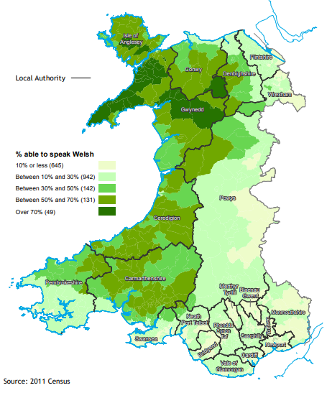
Source: Office for National Statistics (2012)

Appendix 2:
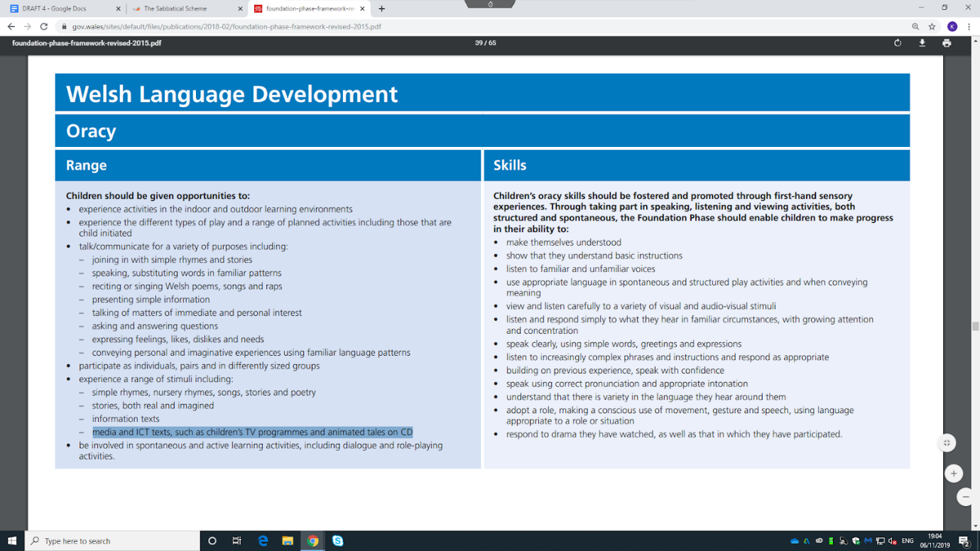
Source: Welsh Government (2015c, p.37)
Appendix 3:
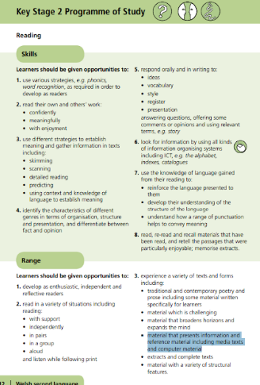
Source: Welsh Government (2015b, p.12).
Reference List:

Baker, C. (2014) A Parents’ and Teachers’ Guide to Bilingualism. 4th Ed. Bristol: Multilingual Matters.

Bernardo, A.B.I. & Gaerlan, M.J.M. (2011) Non-Native English Students Learning in English: Reviewing and Reﬂecting on the Research. In Jaidey, R., Sadorra, M.L.C., Wong, J.O., Lee, M.C. & Lorente, M.C. (eds.) Global perspectives, local initiatives: Reflections and practices in ELT. National University of Singapore, CELC, pp.1-9.

Careers Wales (unknown date) Advantages of being bilingual. Available at: https://www.careerswales.com/en/tools-and-resources/dewis-da-why-choose-welsh/advantages-of-being-bilingual/1-stand-out-from-the-crowd/ (Accessed: 2nd November 2019).

Clement, R., Dornyei, Z. and Noels, K. (1994) ‘Motivation, Self-Confidence, and Group Cohesion in the Foreign Language Classroom’, Language Learning, 44(3), pp.417-448. Available at: http://citeseerx.ist.psu.edu/viewdoc/download?doi=10.1.1.681.9589&rep=rep1&type=pdf (Accessed: 2nd November 2019).

Cook, V. (2008) Second Language learning and language teaching. 4th Ed. London: Hodder Education.

Diebold, R. (1961) ‘Incipient Bilingualism’, Language, 37(1), pp.97-112. Available at: https://www.jstor.org/stable/pdf/411253.pdf?casa_token=dEV0XwV5JwUAAAAA:0CooyyWITW3op4R-UtPaWoOuQ9PPvkcxsGwTL0s-FEzEAZ6g0Qt8-hVEqKH00vNnmzfd7I9VqsEj9r2nImuyJzfmyvExbArd0bc7kWwsOuKmpPCcs6mt (Accessed: 4th November).

Donaldson, G. (2015) Successful Futures. Available at: https://dera.ioe.ac.uk/22165/2/150225-successful-futures-en_Redacted.pdf (Accessed: 29th October 2019).

Estyn (2013a) A report on Holton Primary School. Available at: https://www.estyn.gov.wales/sites/www.estyn.gov.wales/files/documents/Inspection%20report%20Holton%20Primary%20School%202013%20%28English%20only%29_0.pdf.pdf.pdf.pdf.pdf.pdf.pdf.pdf.pdf.pdf.pdf.pdf (Accessed: 4th November 2019).

Estyn (2013b) Welsh Language Development in the Foundation Phase. Available at: https://www.estyn.gov.wales/sites/www.estyn.gov.wales/files/documents/Welsh%20Language%20Development%20in%20the%20Foundation%20Phase%20-%20January%202013.pdf (Accessed: 4th November 2019).

Estyn (2018) The Annual Report of Her Majesty’s Chief Inspector of Education and Training in Wales 2016-17. Available at: https://www.estyn.gov.wales/sites/www.estyn.gov.wales/files/documents/Estyn_Annual%20Report_2018_English_Accessible.pdf (Accessed: 4th November 2019).

Estyn (2017) A report on Blackwood Primary School. Available at: https://www.estyn.gov.wales/sites/www.estyn.gov.wales/files/documents/Blackwood%20Primary%20School.pdf (Accessed: 4th November 2019).

ETeach (2019) Teacher [Job Application]. Available at: https://www.eteach.com/job/teacher-1073178?lang=en-GB&frmsrh=Y (Accessed: 4th November 2019).

Gardner, R. (2007) ‘Motivation and Second Language Acquisition’, Porta Linguarum, pp.9-20. Available at:https://digibug.ugr.es/bitstream/handle/10481/31616/Gardner.pdf;jses (Accessed: 4th November 2019).

Gurler, I. (2015) ‘Correlation between Self-confidence and Speaking Skill of English Language Teaching and English Language and Literature Preparatory Students’, Curr Res Soc Sci, 1(2), pp. 14-19. Available at:https://s3.amazonaws.com/academia.edu.documents/37801312/5000116953-5000182148-1-PB.pdf?response-content-disposition=inline%3B%20filename%3DCorrelation_between_Selfconfidence_and_S.pdf&X-Amz-Algorithm=AWS4-HMAC-SHA256&X-Amz-Credential=AKIAIWOWYYGZ2Y53UL3A%2F20191105%2Fus-east-1%2Fs3%2Faws4_request&X-Amz-Date=20191105T225556Z&X-Amz-Expires=3600&X-Amz-SignedHeaders=host&X-Amz-Signature=b67cc3a987b91a0f125c9a89cff56d94b100e439e3362406a16c36495c3622d1 (Accessed: 4th November 2019).

Haugen, E. (1953) The Norwegian language in America: A study in bilingual behaviour. Philadelphia: University of Pennsylvania Press.

Martin, C. (2008) Primary Languages: Effective Learning and Teaching. Exeter: Learning Matters.

Mayor, B. (1994) ‘What does it mean to be bilingual?’, in Stierer, B. and Maybin, J. (ed.) Language, Literacy and Learning in Educational Practice. Avon: Multilingual Matters Ltd.

Nel, N. and Müller, H. (2010) ‘The impact of teachers’ limited English proficiency on English second language learners in South African schools’, South African Journal of Education, 30, pp.635-650. Available at: https://www.ajol.info/index.php/saje/article/viewFile/61790/49875. (Accessed: 2nd November 2019).

NHS Jobs (2019) Staff Nurse [Job application]. Available at:https://www.nhsjobs.com/job/UK/Merthyr_Tydfil/Merthyr_Tydfil/Cwm_Taf_Morgannwg_University_Health_Board/Nursing_Clinical_Decisions_Unit/Nursing_Clinical_Decisions_Unit-v1837301?_ts=1 (Accessed: 4th November 2019).

Office for National Statistics (2012) 2011 Census: Key Statistics for Wales, March 2011. Available at: https://www.ons.gov.uk/peoplepopulationandcommunity/populationandmigration/populationestimates/bulletins/2011censuskeystatisticsforwales/2012-12-11 (Accessed: 4th November 2019).

Research Gate (2019a) Allan B. I. Bernardo. Available at: https://www.researchgate.net/profile/Allan_Bernardo (Accessed: 4th November 2019).

Research Gate (2019b) Marianne Jennifer Mariano Gaerlan. Available at: https://www.researchgate.net/profile/Marianne_Jennifer_Gaerlan (Accessed: 4th November 2019).

Sorace, A. and Serratrice, L. (2009) ‘Internal and external interfaces in bilingual language development: Beyond structural overlap’, International Journal of Bilingualism, 13(2), pp.195-210. DOI: 10.1177/1367006909339810. (Accessed 31st October 2019).

Swanson, P. (2014) ‘Confidence is essential for language teachers’, World Languages and Cultures, 40(3), pp. 34-39. Available at: https://scholarworks.gsu.edu/cgi/viewcontent.cgi?article=1008&context=mcl_facpub (Accessed: 4th November 2019).

Turnbull, M. (2001) ‘There is a Role for the L1 in Second and Foreign Language Teaching, But …’, The Canadian Modern Language Review, 57(4), pp.531-540. Available at:https://web-a-ebscohost-com.ezproxy.uwtsd.ac.uk/ehost/pdfviewer/pdfviewer?vid=1&sid=0137fd15-0462-4f8b-84b6-b4b0878d208d%40sessionmgr4007 (Accessed: 4th November 2019).

UNESCO (2003) Language Vitality and Endangerment. Available at: http://www.unesco.org/new/fileadmin/MULTIMEDIA/HQ/CLT/pdf/Language_vitality_and_endangerment_EN.pdf (Accessed: 4th November 2019).

Welsh Government (2015a) Welsh Language Use in the Community. Available at: https://gov.wales/sites/default/files/statistics-and-research/2019-01/welsh-language-use-in-the-community-research-study.pdf (Accessed: 2nd November 2019).

Welsh Government (2015b) Programme of Study – Welsh Second Language, Key Stages 2-3. Available at: https://hwb.gov.wales/storage/535c1f8f-5b2f-4243-a232-e669a3ec6a0b/welsh-second-language-in-the-national-curriculum.pdf (Accessed: 4th November 2019).

Welsh Government (2015c) Foundation Phase Framework. Available at: https://gov.wales/sites/default/files/publications/2018-02/foundation-phase-framework-revised-2015.pdf (Accessed: 4th November 2019).

Welsh Government (2017a) Cymraeg 2050: A million Welsh speakers. Available at: https://gov.wales/sites/default/files/publications/2018-12/cymraeg-2050-welsh-language-strategy.pdf (Accessed: 28th October 2019).

Welsh Government (2017b) Welsh in education: Action plan 2017-21. Available at: https://gov.wales/sites/default/files/publications/2018-02/welsh-in-education-action-plan-2017%E2%80%9321.pdf (Accessed: 28th October 2019).

Welsh Government (2018a) National Survey for Wales, 2017-18. Available at: https://gov.wales/sites/default/files/statistics-and-research/2019-01/national-survey-wales-welsh-language-confidence-attitudes-2017-18.pdf (Accessed: 2nd November 2019).

Welsh Government (2018b) The Welsh Government’s Annual Report on compliance with the Welsh Language Standards 2017-18. Available at: https://gov.wales/sites/default/files/publications/2018-10/annual-report-welsh-language-standards-2017-2018.pdf (Accessed: 2nd November 2019).

Welsh Government (2018c) An introduction to the professional standards for teaching and leadership. Available at: https://hwb.gov.wales/storage/932d8940-56f5-4660-aa85-afb4e87560a9/an-introduction-to-the-professional-standards-for-teaching-and-leadership.pdf (Accessed: 4th November 2019).

Welsh Government (2019) Written Statement: Welsh Language Bill. Available at:https://gov.wales/written-statement-welsh-language-bill (Accessed: 4th November 2019).

WJEC (2019) The Sabbatical Scheme. Available at: https://www.wjec.co.uk/teachers/support-team-for-the-welsh-language-in-education/the-sabbatical-scheme.html (Accessed: 4th November 2019).

