Additive manufacturing
Introduction

The intention of this report is to investigate additive manufacturing and find a process that would benefit the manufacture of games console controllers. As the gaming industry has grown massively in recent years, more and more people have become top tier players in their game of choice. These players look to invest in customisable controllers, which can be more comfortable, have more ergonomic designs and extra buttons in easy to reach places. This can help keep up with their competition and to practice for long periods of time without their hands feeling uncomfortable, and also have an edge over their opponents. This report will look into how controllers are currently manufactured and an additive process which could improve the design of the controller in multiple ways.

Aims

To investigate additive manufacturing and choose a new method of making gaming controllers to benefit the strength, weight, manufacturing time and other factors of the controller. To represent the modifications that could be made to the controller through the freedom of additive manufacture via CAD.

What is additive manufacturing?

Additive manufacturing is commonly referred to as 3D printing is a process where a 3-dimensional component can be produced from a CAD design. This process of manufacture is being used more and more in various areas in industry, from automotive components to dentistry. Some older more traditional methods of manufacturing require a material to be carved or shaped into the final product by small pieces being removed in various different ways. Additive manufacturing is the opposite, where the part is made up of thousands of miniscule layers.

One of the largest benefits of this modern form of manufacturing is the greater range of shapes and designs that can be created. Designs that normally could not be produced in one entire piece can easily be made. For example, parts that need a hollow inside or small holes inside can be produced as a single part rather than needing to be split in two and then welded or attached together by other means. This gives the advantage of being a stronger part as it would have no weak spot at the joint of the two parts.
Additive manufacturing machines are being developed and improving over the years whilst also getting easier to use. As more powerful lasers are developed and simple touch screen interfaces. These lasers can allow for small parts to be made with intricate details and high precision which would be much more difficult to create using more generic methods of manufacturing.

Weight reduction is a large factor when it comes to additive manufacturing. The internals of a part can be easily redesigned to be made hollow in places that won’t affect the strength and a stronger material can be used, allowing some of the part could be changed in the design stage to reduce weight, this could also reduce the part making cycle time, allowing more parts to be made in the same amount of time.
Additive manufacturing allows freedom for different customers to customise shape and design easily using the design software which will fulfil customer satisfaction and can allow for some products to be made perfect for a certain person such as someone using a mouse who has much larger hands than someone else. (Reinshaw, 2017)

Machinery can also be used to check each part after manufacture, gauging parameters and tools can be pre-set to ensure each part is made to exactly the correct dimensions.

These newer manufacturing processes are much faster than traditional methods. With the designs being created on CAD software, changes can be made quickly, and a new part can be made straight away. This allows for rapid prototyping and provides much more flexibility and a result of this is that a lot of price cuts can be made. (Lasers, 2018)

Selective Laser Sintering (SLS)

SLS and DMLS are similar processes, both merging particles in a material by partially melting them. SLS is the sintering process used for non-metals and DMLS is used for metals.

SLS is an additive manufacturing process which involves powder bed fusion of polymers. In SLS, a laser partially sinters the particles of polymer powder, this fuses them together and builds up the part one layer at a time.
SLS is often used for prototyping polymer components and for small quantity production. It offers a high level of freedom when designing the part, high accuracy and the part will have good mechanical properties. This is not the case with other types of 3D printing such as FDM or SLA.

The greatest benefit of SLS is that it leaves no support structures. The unsintered powder provides enough support to hold the part together without the need of added support for each layer. This means that SLS can be used to create designs that cannot be manufactured using any other method.
SLS requiring no support material means that parts can be accurately made with hollow sections inside. These sections can reduce the weight, cost and production time of a part as less material is required. SLS is capable of adding a honeycomb patterned structure inside the part to add strength to hollowed out areas.
Parts are left with a grainy unprotected surface finish, this can be improved by using post processing methods, such as polishing or painting. (FormLabs, 2018)

SLS provides exceptional bond strength between layers, giving it very good mechanical properties in all directions. A polymer powder, Nylon PA 12 is the most commonly used material for SLS and is a great substitute for injection moulding plastics. It has a tensile strength of 48MPa in the X and Y direction and 42MPa in the Z direction. Nylon 12 (PA12) is priced at around £40 per kilogram, other thermoplastics are capable of being used in SLS but are not used so commonly.

SLS is one of the least wasteful manufacturing methods with the ability to re-use left-over material.
Any excess powder that remains after the part is made can be recovered, filtered to remove large particles and then recycled. Unfused powder can degrade due to the high temperature so should be mixed in with fresh powder before being used again. Another benefit of SLS is that multiple parts can be closely arranged in the CAD design to print the maximum amount of parts per cycle in the machine. Each part will be held to the other by a small tab that can be cut and filled off. Parts can also be added to the build process whilst printing has already started. This allows for last minute design changes or to add another part into the cycle. (Varotsis, 2019)

Ergonomics

Ergonomics is a study of people’s efficiency in their working environment, it can be applied to designing things that they use daily to make them more comfortable, productive and efficient.

Rather than expecting people to adapt to the design that forces them to use a product in an uncomfortable position. Ergonomics helps to find the best way to handle this product for it to be comfortable, stress free and safe. Altering the design to suit the person using it.
Ergonomics uses anthropometrics and biometrics to measure things like body part sizes, shapes, variations and the strength in these different areas. These are taken into account when designing products such as office chairs, computer mice and game controllers. For example, in a controller, buttons are places in places where the fingers naturally rest making them easy to access and the controller is made with dimensions to fit comfortably in the users hand. (Dohrman, 2018)

Due to the growth of the gaming industry in recent years and the growth in gaming consumers, there has been a lot of development in the ergonomics of gaming controllers. As the controller is the main input to the game users play, and some users spending multiple hours of their day playing their favourite games, controllers must be made as comfortable as possible to accommodate for the long hours spent holding the controller.
When game consoles were first introduced, their controllers were large, heavy and had uncomfortable designs with buttons and joysticks in hard to reach places. (Figure.1) (Porter, 2018)


It can be seen from this picture that in the past, ergonomics were not fully taken into account when designing these initial Xbox controllers. However, it is becoming more essential to look at things like size, shape, comfort and style in modern controller design as the gaming industry has grown so much. This controller was far too big, with thumb sticks in places that would hurt most users hands after use due to the placement.
Figure 1

How are controllers made?

The casing for controllers are currently made though injection moulding using ABS plastics. The top and bottom piece of the controller are made separately and held together by seven screws.

In Injection moulding, material is fed into the machine by a hopper. The plastic being used is fed into a heated barrel with a screw which drives the molten plastic into the split mould. The barrel melts the polymer and the screw acts as a ram when injecting into the mould. The rotating screw also adds to the heating of the polymer through the shearing action it provides.
The tools and moulds used in this process are often made of hardened or plated steels and aluminium alloys. This adds to the cost of this manufacturing process and in turn means that injection moulding is mainly used for high volume manufacture.
The mould can be used to manufacture one part consistently by repeating the injection moulding process. Another mould can be made with multiple moulds inside it which can make several parts with one injection. (BPF, 2018)

ABS is the main material used for injection moulding. It is a commonly used thermoplastic with good durability. ABS stands for acrylonitrile butadiene styrene which can be moulded to create many products which are lightweight and strong. The advantage of using ABS is that it can be modified according to the part it is needed for. Impact resistance and toughness can be improved by moulding at different temperatures. For example, moulding at low temperature will increase impact resistance and overall strength or the final part. (Mold, 2017)

The customisation of these controllers can be scanned and designed on CAD and then manufactured through SLS printing. This is an efficient and inexpensive way to manufacture a product where each part is a different size, has a different grip and different colour. This freedom is not as available in injection moulding due to the tool being made out of metal, it needs to be machined into the right shape for the part to then be moulded. A new tool would have to be made for every customer that orders a custom controller. This would be far too expensive and time consuming, making it not a suitable manufacturing process for this kind of product.

CAD – what could be customised?

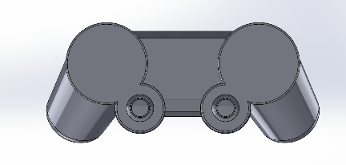
Figure 2

This is a CAD design of a game console controller which is being redesigned. The controller is fully customisable, meaning that the redesign can vary for each customer.

The features on the controller that can be customised include; the colour, the size, the grip can be moulded to the customers hand for an exact placement of their fingers to make the controller as comfortable as possible. The material can also be modified to make a softer rubber feel, or a more metallic look for the casing of the controller.

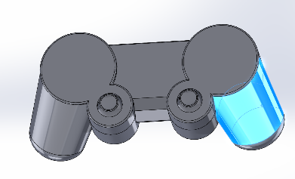
Figure 3

This screenshot shows the area on the controller which would be moulded to the hand of the customer. A clay impression could be sent out for the customer to mould their hands to. This could then be scanned into the computer and allow for the design to be modified for each purchase. Finger grooves could be modified slightly in cad for a smoother finish which would also add to the comfort of the grip.
The grip section of the controller could also be made from a different material top the top piece. This would allow for a softer, gripper material to be used. This freedom in design is allowed by using this method of additive manufacture.
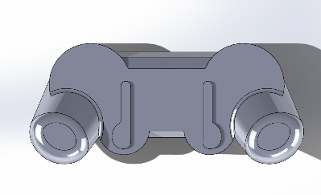
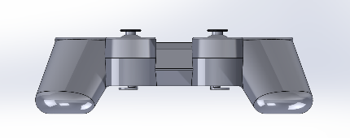
Figure 4
Figure 5

These screenshots show a front and bottom view of the controller design. The bottom of the controller has two added buttons with paddles to allow your fingers to press the buttons from a wider surface area. The need for these extra buttons comes from competitive players in console gaming. They are able to press these buttons with their middle fingers instead of having to remove their thumbs from the thumb sticks to press the buttons on the top of the controller, this may not seem like a lot of time saved but it can improve a players skill by a large amount and allow them to play at a higher skill level.

QFD

This QFD analysis shows a comparison between the customer requirements of a game console controller in the left hand rows of the table to the quality characteristics of this product, across the columns of the table. The circle with a dot in the centre represents a strong connection between the demand quality and the quality characteristics, the circle on its own shows a moderate relationship and the triangle symbol shows a weak relationship. Boxes left blank are where there is no direct relationship between the two. An example of this can be seen between the product being light weight and the material selection. There is a strong relationship between these two points as the material selected directly effects the weight of the product and it must be chosen carefully to ensure it is still as durable as possible.
Another example of a strong relationship is the link between material cost and manufacturing cost compared to the overall price of the product. In order to maintain an affordable price for the product the material and manufacturing costs must be kept as low as possible, this also allows for a larger profit margin.

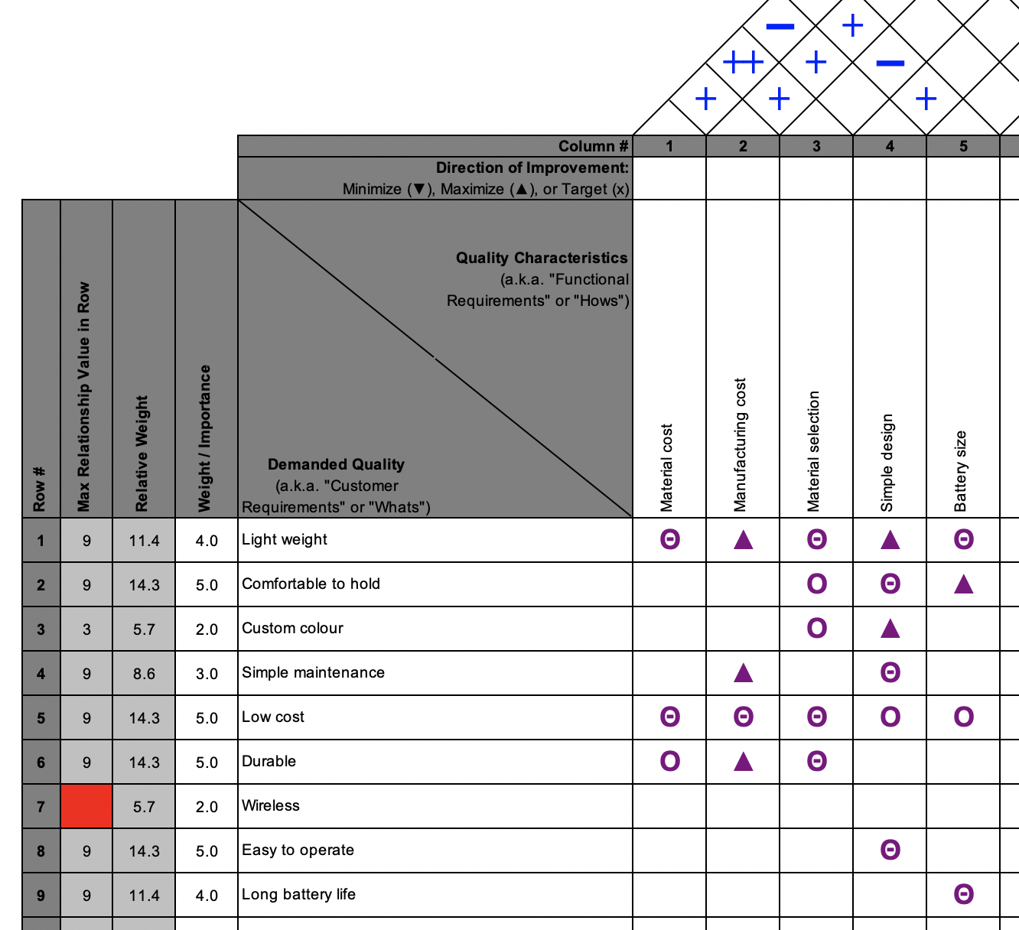
The pyramid above the table shows the correlation between the different quality characteristics, with a double plus sign representing a strong positive correlation, single plus sign shows a positive correlation and the negative sign displays a negative correlation. For example, from this it can be seen that there is a strong positive correlation between material cost and material selection. This is because the choice of the material used in this part must be inexpensive in order to keep the product cost down.
Figure 6
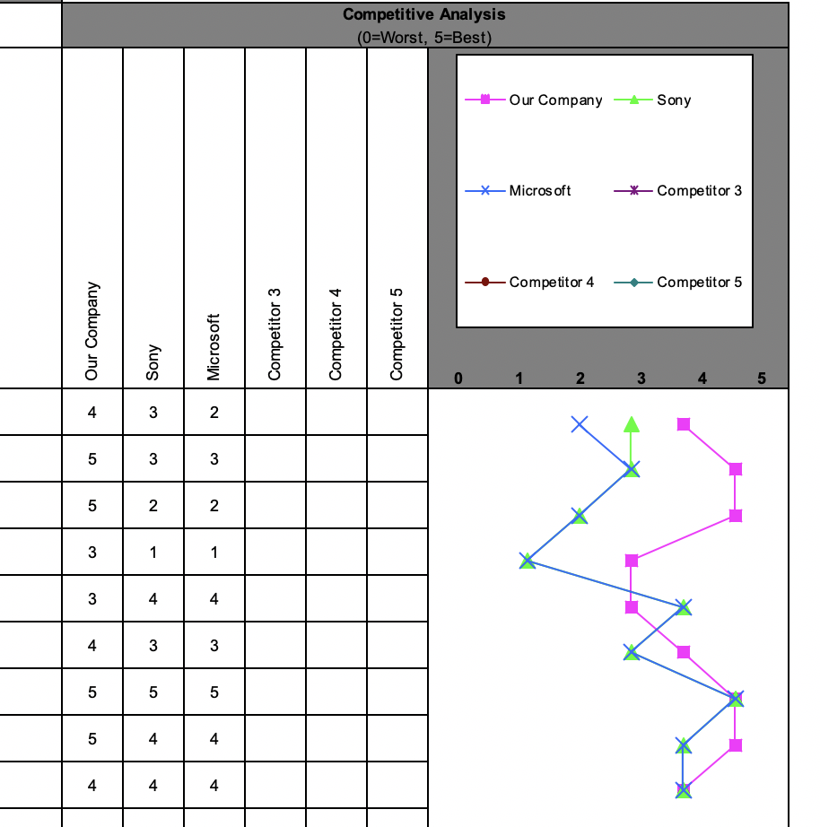
Figure 7
This is a competitive analysis between the controller being discussed in this report, compared to Sony and Microsofts controllers.

This analysis plots a graph, from this it can be seen that point one, two, three and eight outclass the competitors. With this design being light weight, more comfortable to hold, more freely available to customise the colour of the product and finally it is the easiest to operate.

Points four and five are the lowest for the redesigned controller, with it being slightly more expensive than the competitors controllers. Which would be expected with a customisable controller.

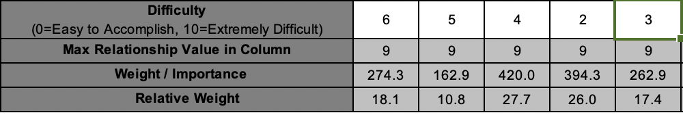
Figure 8

The final figure from the QFD analysis shows importance of each of the functionality requirements. It calculates a value for the impact this characteristic has on the product and how important it is to the customer, the higher number being more important. From this it can be seen that the material selection is the most important characteristic for this product, as it would effect the most amount of demands. This is because the material chosen has a direct impact on the weight of the controller, the comfort to hold, the colour variations, the cost and finally the durability. This means that the material selection should be a priority in the manufacturing of this product to find a material which best fits all of these requirements.
The second most weighted function of the controller is that it has a simple design, customers are looking for a product that does exactly what they want in the most simplistic way with no difficult to understand features. This product has a simple design similar to the competitors however, with added functionality and comfort in a smooth, straightforward way.
The third most impactful design requirement is the material cost. Whilst being required to choose a material which fulfils all of the customer requirements, the material must also be a reasonable price in order to keep the final product price down. This is important to customers as whilst they have the need for a customisable controller, they would also have a budget on what they would like to pay for such an item.

Conclusion

In conclusion, additive manufacturing is a fast growing area of manufacturing, which allows products to be made on demand and completely customised through the freedom of CAD design. SLS manufacturing could be the ideal answer for this customisable controller design as it offers all of the freedom necessary for creating a new controller for every customer. The ability to redesign in CAD allowing any sizes to be modified and the custom grip to be simply added in makes this method ideal for the chosen product.
The console controller has been redesigned and improved in more than one way and additive manufacturing is beginning to allow for customisable products like this to be made by manufacturers. In the past it wasn’t possible for a manufacturer to make every controller they sell completely different and customisable, but through the development of SLS this is no longer the case.

Bibliography
BPF, 2018. injection moulding. [Online]
Available at: http://www.bpf.co.uk/plastipedia/processes/injection_moulding.aspxhttp://www.bpf.co.uk/plastipedia/processes/injection_moulding.aspx
[Accessed 15 02 2019].
Dohrman, 2018. Dohrman consulting. [Online]
Available at: https://www.ergonomics.com.au/what-is-ergonomics/
[Accessed 30 01 2019].
FormLabs, 2018. introductory guide to SLS 3D printing. [Online]
Available at: https://formlabs.com/blog/what-is-selective-laser-sintering/
[Accessed 30 01 2019].
Lasers, S., 2018. additive manufacturing. [Online]
Available at: https://www.spilasers.com/application-additive-manufacturing/additive-manufacturing-a-definition/
[Accessed 28 01 2019].
Mold, M., 2017. most common thermo plastics used. [Online]
Available at: https://www.midstatemold.com/common-thermoplastics-injection-molding/
[Accessed 15 02 2019].
Porter, J., 2018. remake of origional xbox controller. [Online]
Available at: https://www.techradar.com/news/remake-of-original-xbox-controller-will-rip-off-your-rose-tinted-goggles-this-march
[Accessed 01 02 2019].
Reinshaw, 2017. additive manufacturing for series production. [Online]
Available at: https://www.youtube.com/watch?v=zAV_n0WKuew
[Accessed 28 01 2019].
Varotsis, A. B., 2019. introduction to SLS 3D printing. [Online]
Available at: https://www.3dhubs.com/knowledge-base/introduction-sls-3d-printing
[Accessed 29 01 2019].

