


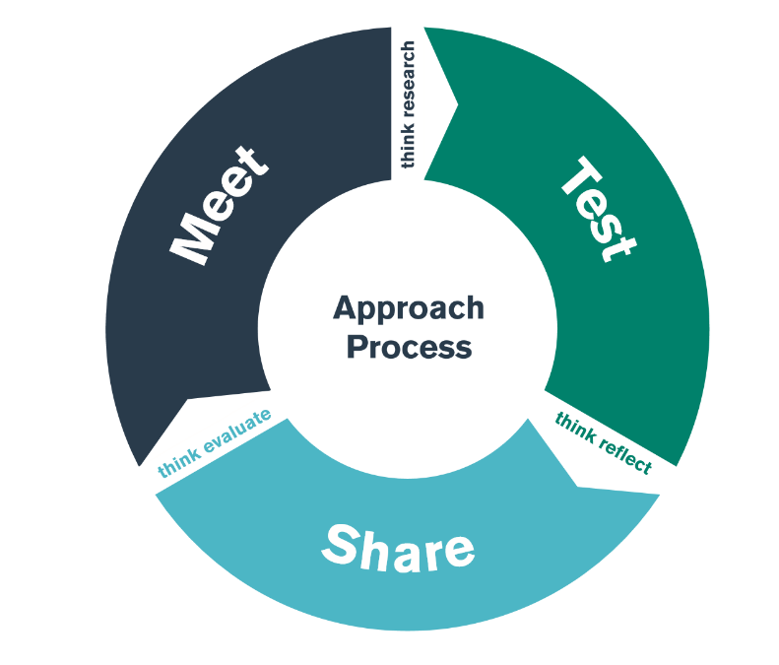

Emotional and Social Development
TEST Day

Student-Teacher Enquiry Evidence Record

‘Policy to practice &
respecting their rights’

7th October 2026

What is the purpose of the ‘EMOTIONAL and SOCIAL FOCUS’ bridging activity?

By the end of the ‘Emotional and Social focus’ TEST day, you should have an understanding of some of the strategies, policies and approaches that the school use to ensure the emotional and social development of their foundation learners.

Is there an emotional or social aspect to the school’s vision/ mission statement/ ethos?

Which policies include children’s wellbeing as a focus?

What does/ do the policy/cies state?

How is the importance of children’s wellbeing evident throughout the school/ class? (eg posters/ charts)

How do staff get to know their children? What approaches / strategies are used to find children’s likes/ dislikes/ interests/ talents etc? How are these interests and likes used to aid development/ progress?

How does the school develop their pupils’ understanding of the difference between right and wrong?

What approaches do the school utilise to help children take responsibility for their own actions?

How are children made to feel special?

What do the staff do to create a classroom climate that promotes self-esteem?

How does the physical environment of the classroom promote self-esteem? Are there specific resources that aid this?

What strategies do staff utilise to support children who are less emotionally secure?

How do staff enable children to acknowledge and express their feelings?

What strategies do staff use to avoid temper tantrums and manage anger?

Did you see any of the following:

Activity/ Strategy | Where?/ With who? | Purpose/ Aim
Mindfulness

Circle time

Independent choices

Positive responses & praise

Let’s share
(personal news)

Other strategies observed / shared

What do the staff do to create a classroom climate that promotes their children’s social skills?

How do staff develop children’s ability to show respect and care for the natural world?

How does the school develop children’s awareness of different cultures and religions?

How do staff enable children to understand how to foster new / maintain friendships?

From classroom observation, can you describe a learning experience where children were ‘confident’ OR ‘not confident’ when working cooperatively? What was the role of the teacher in this learning event?

What strategies do staff employ that support children to share and take turns?

Observe a session. Can you provide examples of the following social behaviours?
(Take a non-participant role and do not identify specific children or adults below or take any pictures of the child)

Social behaviour | Lunchtime observations Description and comments Context  (Class observed, age, indoor/ outdoor environment) | Classroom observations Description and comments Context  (Class observed, age, indoor/ outdoor environment)
A child positively interacts with their peers

A child positively interacts with practitioners

A child initates conversation

A child initates play

A child helps other children

A child is confident to work cooperatively

A child is aware of and respectful of others

A child is accepting of individual similarities/differences

A child is aware of differing needs and views of other people

A child is able to debate /discuss in an appropriate manner

A child is able to resolve conflict without adult intervention

A child is able to accept rules and instruction

PERSONAL TARGET

As a result of what you have learnt/reflected upon during the meet, test and share days of this bridge, please set yourself a target to improve your own practice.

TARGET

What area do you want to develop in your own practice?
TIMESCALE

When do you want to achieve this by?
RESOURCES

What do you need to help you achieve this? Who do you need to talk to/observe? What do you need to research?
SUCCESS CRITERIA/
OUTCOME

How will you judge whether it has been successful or not? What impact do you hope to see in teaching and learning?
MONITORING/
EVALUATION

How will you check that you have successfully achieved your target? Lesson observation? Book scrutiny? Pupil voice?

