Ispas Cristina
1905821
Abstract
This report is short analyses of the questionnaire research for the future business plan
BUSINESS PLAN
Questionnaire Analysis

Table of Contents
0
Section 1- Introduction 2
SECTION 2-Analysis of questions 3
2.1 First question analyzes the edge 3
2.2 Second question analyze the,, value’’ 4
2.3 Third question analyze the menu concept 5
2.4 Fourth question analyze the taste 6
2.5 Last question analyse the dessert 7
3.0 Summary of the report 8
References 9

Section 1- Introduction

The business Plan Research questionnaire - American Queen Food

The first step in achieving a business plan is realizing an online questionnaire for a better understanding of customer interest and market research regarding street food (Vincent A. Gabriel,2015).
Based on the strategic online questioner completed by 11 individuals, their answers can help the business to be on the right track and ensure a continuous success by analyzing the results for only five of the questions as is followed in section 2 (Ian B. ,2008).

SECTION 2-Analysis of questions

2.1 First question analyzes of the edge
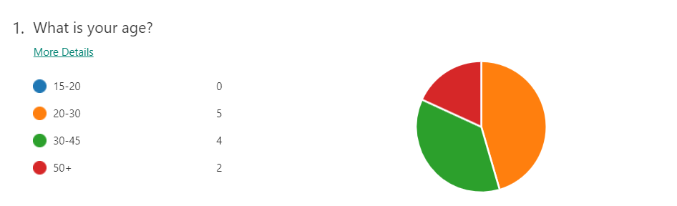

By analyzing this question regarding the age of the future customers, the frame is showing that the big percentage of 45% is between the edge of 20-30 and is followed with a 36% by 30-45 years old and the third position with small percentage of 18% is people with 50+.
To have a profitable company we must seek the opportunities in the disadvantage that means to be able to attract the minority category that is groups with the edge between 15-20 and 50+. To manage to attract these categories as well to buy is by offering a discount 10% in the case on teenagers and 5% in situation of people of 50+ years old every time they buy over 10 £. Discounts applied on the street food is provoking a motivate relationship with the customers offering the possibility for all pockets to access and check the products, this can conduct to loyal customers to our services (Stuart C. Rogers, 2001).

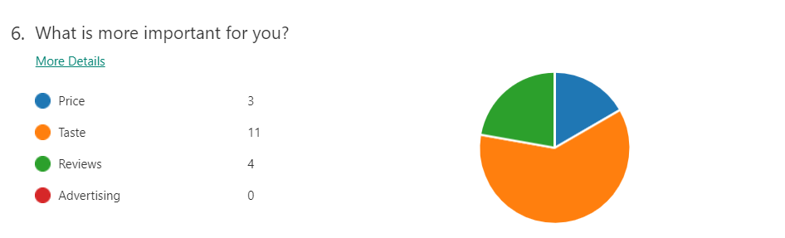
2.2 Second question analyze the,, value’’

Analyzing the answer to this question what future customers is giving more value of the following options, the major percentage was on taste of the products 61% followed by 22% on reviews and 17% that they chaise the price first. This percentage shows that the company must put accent on the taste of the food to complete the requests. In our days with plenty on varieties of street food most of the customers are locking for taste and quality of the food according with Jonathan Downey, chief executive of London Union which runs the popular Street Feast markets says that “People’s thirst for knowledge is huge – they want to know the history of the dish, what’s in it and how you make it” (https://www.independent.co.uk).
For the future business with a highly competitive industry, the researcher must apply a unique technique to combine the taste of the food with reasonable prices as a solution to cover both of the sections that will conduct with good reviews that will bring more customers and a good profit for the business.

2.3 Third question analyze the menu concept

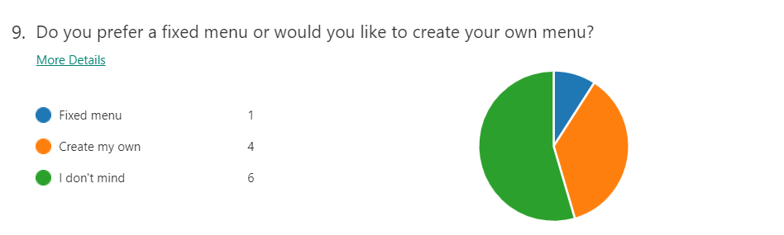

The answers show high percentage of 55%for the customers that there are fine with both options and 36% percentage they would like to create personalized menu.
Analyzing the percentage of the online questionnaire, the future company has more chances to succeed if it would be able to adapt with customers’ demands and don’t exclude the opportunity to leave them personalized the own menu, this means taking care of the customers that have different taste. By applying this option and thinking for all the category’s, the seller will win trust and gain loyal customers.
The seller can give the opportunities for the customers to mix different types of products in the menu or include more items in return of small fee.

2.4 Fourth question analyze the taste

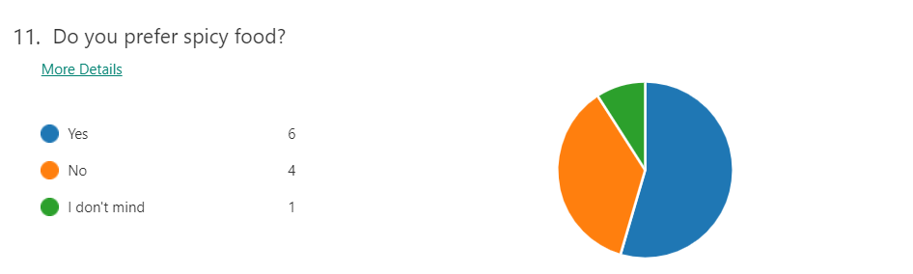
Based on the answer of question regarding the taste of the food results shows a major percentage of 55% of customer that enjoy spice food and on other side 36%. This is offering a better understanding of our customers tastes, and in the same time is allowing the future company to be flexible with his menu by cover all the customers’ demands.
With the results been collected given the knowledge about what flavors must be in the menu to obtain a success for the business, the menu must include types of spicey food or sauces to be able to gain more customers.

2.5 Last question analyses the dessert

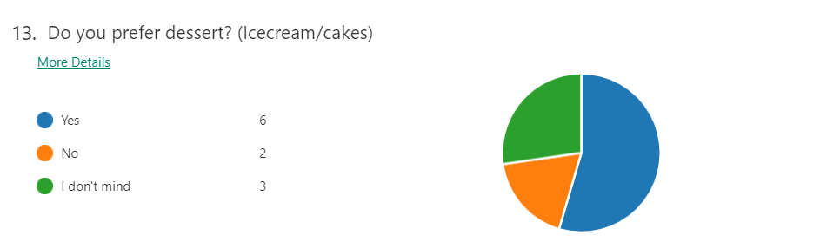
Based on the questionnaire, if in the menu should include a desert, results show a 55% of those who would prefer a dessert and a 27% of individuals who don’t mind the option and a minor percentage of 18% of people who do not prefer dessert. Most of the customers would be delighted to be able to choose a type of desert.
For the future company this is representing an advantage because it is bringing new customers but in the same time means an extra investment in machines and technology. This investment will offer the company a profit if it is exploited all time of the year. Deserts may vary depending on the season with example hot or cold deserts. This will prove creativity and flexibility in front of competitors.

3.0 Summary of the report

Based on the answers of the 11 people who have completed the online questionnaire, for the business plan to succeed must be completed the essential steps to ensure a good functioning of the company:
-to make sure everyone is treated with the same importance, and applying discount regarding the edge.
-to offer a good quality and taste of the food with affordable prices.
-to give chance to customers to be creative with their menu.
-to hold different flavors(spices) of their dishes
-to make sure that they can enjoy a dessert at the end.
Regarding the report above of the online questionnaire answers results are in the favor of the business plan and it is offering a large section that can be covered. To ensure a long-time success for the company the skills that must be completed are flexibility, creativity, prepared for any situation and win-win situation. A good profit can be achieved if the seller offers customers the best quality and taste with a good price in comparation with the market offer.

References

1. Vincent A. Gabriel, 2015, Street food success. How to succeed as a street operator, published by Smart business series.
2. https://www.independent.co.uk/life-style/food-and-drink/street-food-2018-sophistication-why-kerb-club-mexicana-bao-pop-brixton-street-feast-a8186716.html ,[Accessed 14.06.2020]
3. Stuart C. Rogers,2001, Marketing tactics and techniques, published by Quorum Books.
4. Ian B. ,2008, Questionnaire Design: How to Plan, Structure and Write Survey Material for effective market research, second edition, published by Kogan Page

