CULTURAL AWARENESS - REPORT

MODULE: FOREIGN LANGUAGES & CULTURAL AWARNESS
MODULE CODE: BMIH5003
STUDENT ID: 2212616
STUDENT NAME: VLAD DANCEANU
LECTURER: LISA BASSLER

Table of Contents
1. Introduction 3
2. Cultural Overview of Germany 3
3. The GLOBE Project and its Relevance 3
4. Analysis of Managing Appartement hotel Cura in Germany 4
5. Strategies and Recommendations 5
6. Conclusion 6

Introduction
The Appartement Hotel Cura, located in Germany, is well recognised as a prominent hotel establishment that offers a unique opportunity for individuals to get valuable experience within the global hotel sector. This research will delve into the intricacies of managing the Appartement hotel Cura in Germany, a country known for its distinct corporate culture and rich historical background. The success of the General Manager and the Hotel is contingent upon their capacity to acquire knowledge about and adapt to German culture and commercial practises. The objective is to analyse potential challenges faced by the General Manager and provide strategies for effective management based on insights derived from the GLOBE Project, which offers valuable cultural dimensions. The hotel management sector in Germany is characterised by continuous evolution, and our study endeavour aims to assist individuals in staying abreast of these developments.

Cultural Overview of Germany
The German culture is characterised by punctuality, correctness, and a committed work ethic, which have contributed to the country's esteemed global standing. The significance of authority and order inside the workplace has prompted the meticulous establishment of organisational structures. The German society places significant importance on rules and regulations, with a strong sense of personal responsibility towards fulfilling one's commitments. The German culture places a high importance on the qualities of openness and honesty within their interpersonal connections, and they highly esteem direct forms of communication.
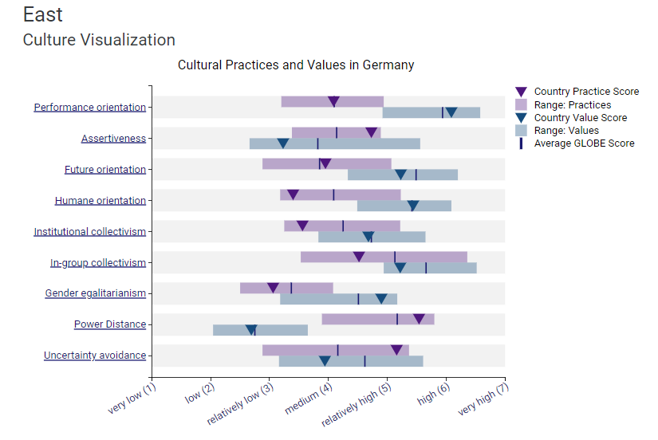
Figure 1 Cultural Visualisation of Germany
(Source: Globe Project, 2020)
The German workplace places a significant emphasis on professionalism, with individuals often maintaining a clear separation between their professional and personal spheres (De Carlos et al., 2019). The General Manager of the Appartement hotel Cura must demonstrate sensitivity towards cultural differences, since these variations significantly impact decision-making processes, communication strategies, and service provision (Geert et al., 2020). The hotel's performance in the German market hinges upon its capacity to effectively cater to these cultural values.

The GLOBE Project and its Relevance
The Global Leadership and organisational Behaviour Effectiveness (GLOBE) Project was undertaken by researchers with the aim of enhancing comprehension of the impact of many cultures on leadership and organisational practises. The relevance of its observations about the cultural determinants of leadership, communication, and work practises extends to the management of the Appartement hotel Cura in Germany. By using the findings of the GLOBE Project, the General Manager may enhance their understanding of the nuanced cultural aspects of Germany, hence enabling them to effectively adapt their managerial approach. The attainment of effective hotel operations and the establishment of positive relationships with both local staff and customers may be facilitated via the use of these cultural insights.

Analysis of Managing Appartement hotel Cura in Germany
The specific challenges and opportunities associated with operating the Appartement hotel Cura in Germany are noteworthy. To effectively oversee hotel operations and foster positive relationships with both employees and guests, it is essential for the General Manager to possess a comprehensive comprehension of the cultural intricacies specific to Germany (Sgobba et al., 2018). German leadership and management approaches are distinguished by their emphasis on precision and hierarchical structures. The majority of German enterprises exhibit well-defined organisational structures and hierarchical lines of command (Sajadi and Badreh, 2019). The General Manager will need to adapt their leadership style appropriately. German workers often prioritise accurate instructions and efficiently structured procedures, so presenting a potential challenge in achieving a harmonious equilibrium between these two aspects.
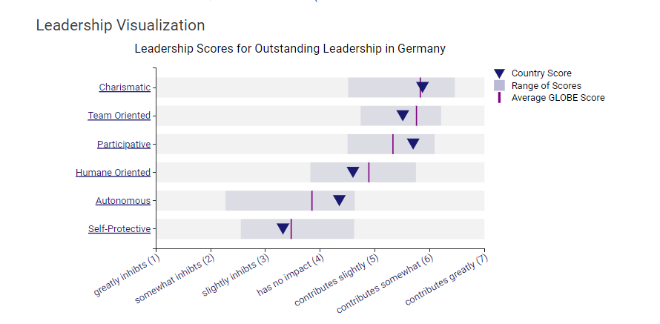
Figure 2 Leadership Visualisation of Germany
(Source: Globe Project, 2020)
Despite the widespread usage of English in the hospitality industry, it is not uncommon to encounter challenges related to communication and language barriers. The mitigation of misunderstandings may be achieved by the cultivation of a multilingual workforce and the provision of adequate communication tools to enhance workers' effectiveness in their interactions (Luthans et al., 2021). The German society values the significance of transparent and sincere communication, thereby emphasising the need for leaders to possess a comprehensive understanding of the language and culture. The focus of this study is to examine the employment policies and work-life balance practises in Germany. Germany has stringent labour regulations that impose limitations on working hours, so exemplifying the nation's steadfast commitment to maintaining a healthy work-life equilibrium (Javidan et al., 2016). The General Manager has the responsibility of ensuring the adherence to these ideals across the hotel, therefore fostering contentment among all individuals and ensuring compliance with legal regulations. The satisfaction and devotion of a hotel's workers are essential aspects for achieving success in the German hospitality industry.
German customers are often regarded as discerning and having high expectations when it comes to service providers. The primary responsibility of the General Manager is to ensure the provision of a continuously high-quality of service that not only meets but also beyond the expectations of guests. The provision of exceptional customer service requires meticulous attention to detail, operational efficiency, and the maintenance of a clean environment (Giorgi et al., 2015). The comprehension of the competitive landscape is crucial in the context of local competition and market analysis. The effective positioning of Appartement hotel Cura in the market may be achieved by the General Manager via diligent study of local competitors and comprehensive market analysis. In order to establish a distinct presence in the German market, the hotel should identify its unique selling proposition (USP) and design a tailored marketing approach.

Strategies and Recommendations
- The implementation of cultural adaptation courses and training is of paramount importance.
- It is important to provide training to the hotel's staff, especially those in positions of power, to facilitate their assimilation into German culture (Ushakov et al., 2020).
- The need of instructing workers on and fostering an appreciation for the rigid hierarchies, attention to detail, and strong work ethic that characterise the German corporate culture cannot be overemphasized (Spoerr, 2021).
- To enhance the readiness of the management team to operate proficiently within a multicultural and hierarchical environment, it is advisable to provide leadership training sessions (Talón-Ballestero et al., 2018).
- The removal of barriers to communication, particularly those arising from linguistic differences, has significant significance.

Conclusion
The effective management of the Appartement hotel Cura in Germany requires a keen awareness of cultural norms and a flexible disposition towards adapting to changing circumstances. Effectively manoeuvring through these challenges and fostering a financially viable hotel in an ever-changing market necessitates the General Manager's adoption of German cultural principles, promotion of transparent communication, prioritisation of staff welfare, and delivery of exceptional customer service.

References
De Carlos, P., Alén, E., Pérez-González, A. and Figueroa, B., 2019. Cultural differences, language attitudes and tourist satisfaction: A study in the Barcelona hotel sector. Journal of Multilingual and Multicultural Development, 40(2), pp.133-147.
Geert, H., Hofstede, H., Jan, G. and Minkov, M., 2020. Cultures and organizations: Software for the mind. McGraw-Hill.
Giorgi, S., Lockwood, C. and Glynn, M.A., 2015. The many faces of culture: Making sense of 30 years of research on culture in organization studies. The academy of management annals, 9(1), pp.1-54.
Globe Project (2020). Country Map, Germany. [Online] Available at: Results - Germany GLOBE Project [Accessed on 9th Nov 23].
Javidan, M., Dorfman, P.W., De Luque, M.S. and House, R.J., 2016. In the eye of the beholder: Cross-cultural lessons in leadership from Project GLOBE. In Readings and cases in international human resource management (pp. 119-154). Routledge.
Luthans, F., Luthans, B.C. and Luthans, K.W., 2021. Organizational behavior: An evidence-based approach fourteenth edition. IAP.
Sajadi, H. and Badreh, M., 2019. A Critique of Theory of Dimensions of National Culture, Concentrating on Book “Cultures and Organizations: The Software of the Mind”. Pizhuhish nāmah-i intiqādī-i mutūn va barnāmah hā-yi ̒ulūm-i insāni (Critical Studies in Texts & Programs of Human Sciences), 19(10), pp.113-135.
Sgobba, T., Landon, L.B., Marciacq, J.B., Groen, E., Tikhonov, N. and Torchia, F., 2018. Selection and training. In Space safety and human performance (pp. 721-793). Butterworth-Heinemann.
Spoerr, D., 2021. Factor analysis of hotel selection attributes and their significance for different groups of German leisure travelers. Journal of Quality Assurance in Hospitality & Tourism, 22(3), pp.312-335.
Talón-Ballestero, P., González-Serrano, L., Soguero-Ruiz, C., Muñoz-Romero, S. and Rojo-Álvarez, J.L., 2018. Using big data from customer relationship management information systems to determine the client profile in the hotel sector. Tourism Management, 68, pp.187-197.6
Ushakov, R.N., Kryukova, E.M., Khetagurova, V.S., Mukhomorova, I.V. and Zelenov, V.V., 2020. Efficiency of hotel management. Training of specialists in hotel industry field. Journal of Environmental Management & Tourism, 11(2 (42)), pp.388-395.

