
Certificate of Higher Education
Employability Skills
Module: Digital Skills for Personal and Professional Growth
Module code: BMSW4008
Lecturer: Philippa Fitzgerald
Student: Florina Tutuiu (2409707)

I confirm that I have not presented any AI generated materials as my own work.
I confirm that I have copies of my drafts, notes, and other resources I used, which I may be asked to provide in evidence.

Task 1 - Analysis Report

Glow to Go Aesthetics by F.T. presents an innovative concept of a mobile aesthetic clinic offering treatments at clients chosen locations. The business is currently in development, and a questionnaire was designed to uncover user preferences and inform strategic decisions. The ultimate goal is to offer high-quality, professional treatments in a safe, private, and highly convenient environment. This analysis integrates key findings, connects them to business strategy, and explains their influence on marketing materials, website design, and service development.
The research showed that convenience is a top priority for potential clients (Figure 1). Around 68% of respondents identified accessibility and flexibility as critical to their decision-making process, validating the mobile clinic concept. This was a central factor in developing a service model that allows clients to book treatments at home or work, an idea established in the modern consumer’s desire for time saving and discretion (Sandhu, 2020).

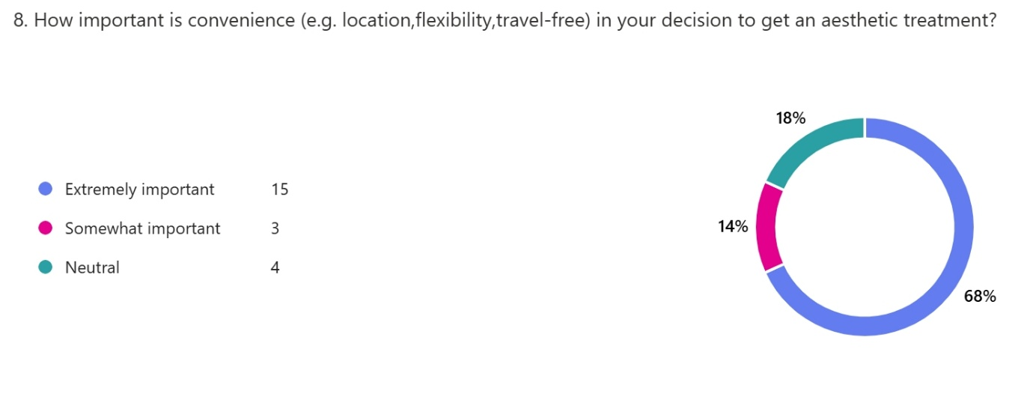
Figure 1. Screenshot of questionnaire responses: Tutuiu, F. (2025).

Another key insight was the importance of trust. Respondents repeatedly mentioned professionalism, licensing, hygiene, and insurance as essential (Figure 2). As a result, our branding and communications, emphasise that our team is fully insured, licensed, and experienced. According to Pinto and Guarda (2020), clear communication of professional credentials plays an essential role in building early credibility.
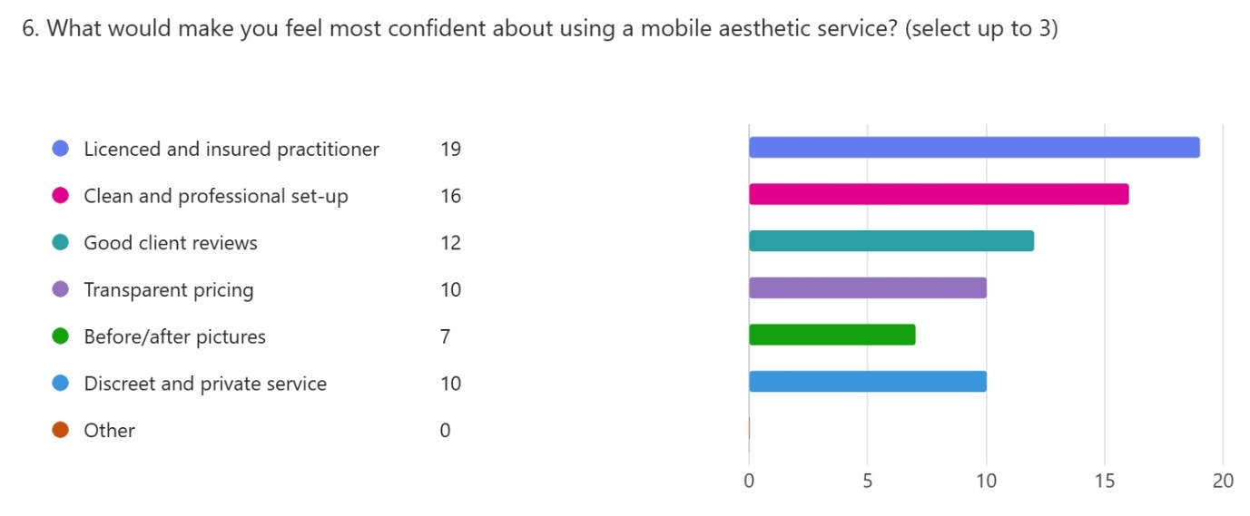
Figure 2. Screenshot of questionnaire responses: Tutuiu, F. (2025).

The treatments clients were most interested in, include anti-wrinkle injections, skin boosters, vitamin treatments, and dermal fillers (Figure 3). To align with actual demand, these services were prioritized in the initial offering, following the principles of lean startup as outlined by Reedy and Parker (2017). Rather than launching with an extensive menu, Glow to Go focuses on treatments that the target market actually wants.

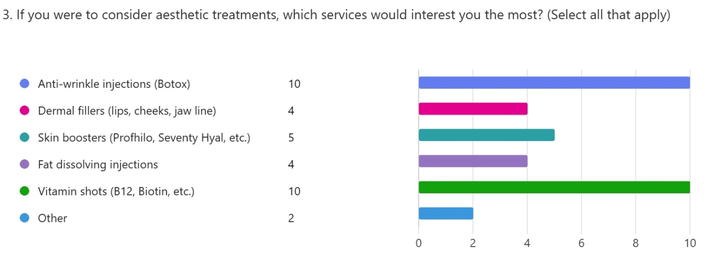
Figure 3. Screenshot of questionnaire responses: Tutuiu, F. (2025).

Perhaps most promisingly, over half of respondents said they would prefer a mobile service to traditional clinic visits, citing comfort, discretion, and convenience (Figure 4). Only a small segment remained sceptical, highlighting that the business must continue to reassure clients about hygiene and safety, especially as it lacks reviews and before-and-after images due to being in the pre-launch stage
.
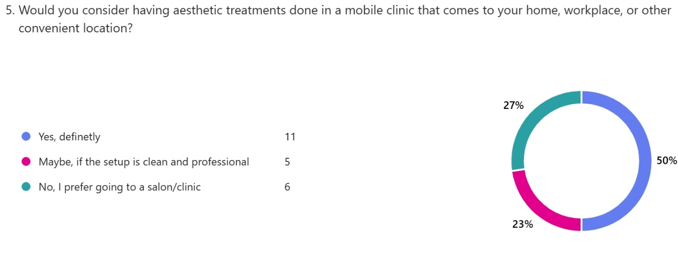
Figure 4. Screenshot of questionnaire responses: Tutuiu, F. (2025).

These findings influenced the business concept in multiple ways. From service offering to pricing and branding, Glow to Go Aesthetics was designed with its future clients in mind. The mobile clinic van has been customised with luxury finishes such as white leather seating, soft lighting, gold accent, creating a calm and elegant atmosphere. This directly reflects the expectations expressed in the questionnaire for cleanliness, professionalism, and quality.
The business flyer, website, and business card all echo this tone. A minimalist black-and-gold theme signals elegance, while messaging assures potential clients of licensing and hygiene practices. The flyer invites people to complete the questionnaire to help refine the offer. Byrd (2021) states that early marketing aligned with audience needs and values increases long-term loyalty and customer retention. The flyer and business card were designed with customer preferences in mind, simple, professional layouts, clear service descriptions, and strong emphasis on safety and convenience (Figure 5, 6, 7). The colour palette, language, and layout were chosen specifically to attract the identified target segments
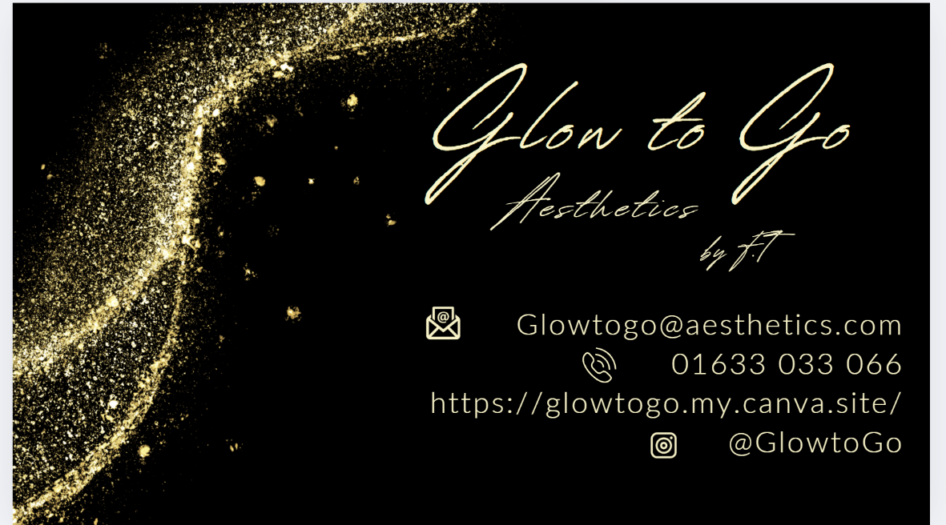
Figure 5. Glow to Go business card: Tutuiu, F. (2025).
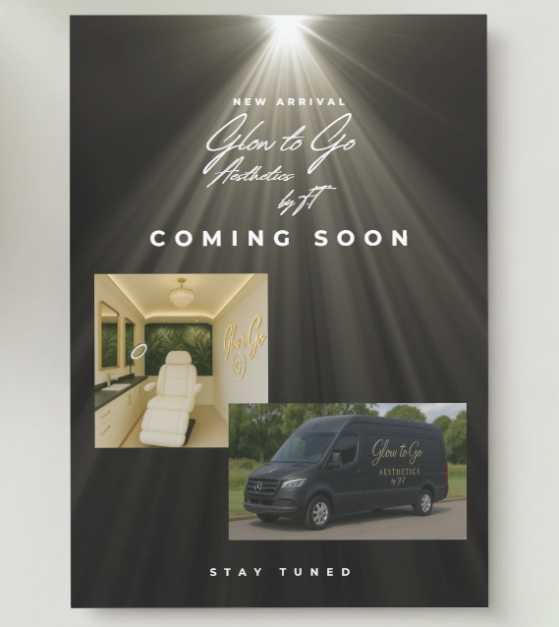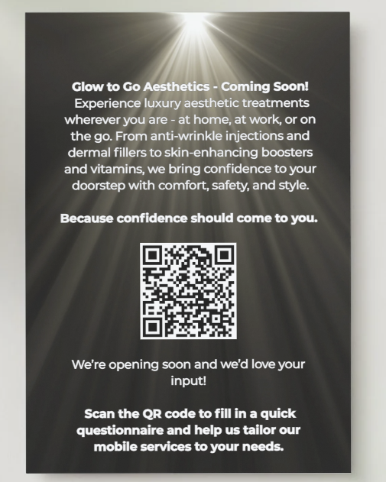
Figure 6, 7. Glow to Go promotional flyer: Tutuiu, F. (2025).

Similarly, the website’s layout, navigation, and written tone were shaped by what respondents said they wanted: ease of access, professionalism, and clear, reassuring messaging (Figure 8, 9).
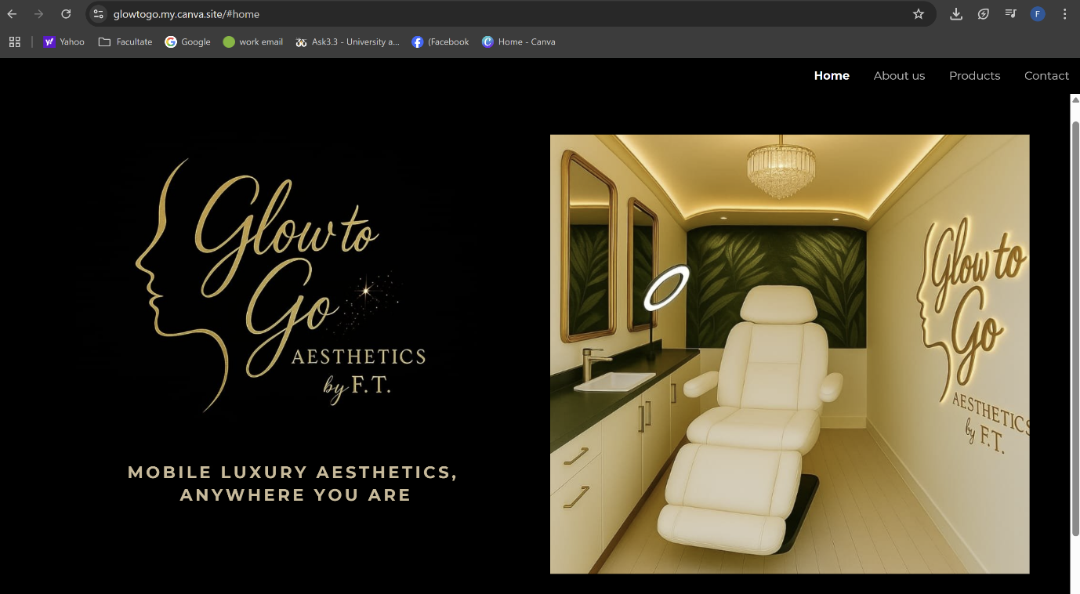
Figure 8. Glow to Go (2025) Home page. Available at: https://glowtogo.my.canva.site/#home

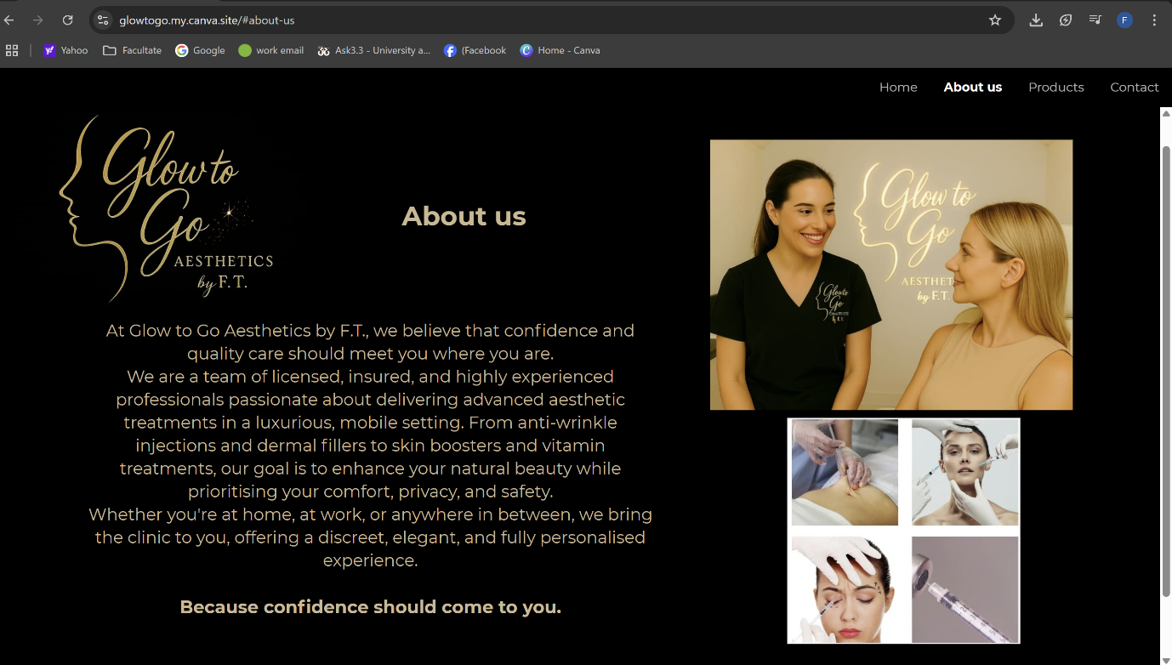
Figure 9. Glow to Go (2025) About Us. Available at: https://glowtogo.my.canva.site/#about-us

The questionnaire responses helped define three audience segments. First, new clients who are curious but cautious. For them, trust, insurance, and simplicity matter most. Second, working professionals looking for discreet and flexible appointments. Finally, regular aesthetics clients who already use such treatments and are motivated by convenience. According to Dadwal,( 2020), customizing content and messaging for each segment enhances engagement. While Glow to Go is not yet using full-scale digital marketing, the website was designed with SEO basics in mind. Strategic use of phrases like “mobile Botox in South Wales” and “aesthetic treatments at your location” are embedded in headings, metadata, and content. Pinto and Guarda (2020) state that foundational SEO boosts long term visibility without high advertising costs.

SWOT Analysis for Glow to Go Aesthetics
The SWOT analysis derived from questionnaire data has significantly contributed to defining the strategic direction of Glow to Go Aesthetics. One of the key features of the mobile concept is its response to the demand for convenience and flexibility. A professionally managed service model gives the brand a market advantage. Weaknesses such as a lack of client reviews, limited initial services, and operational dependence on vehicle reliability were also acknowledged early. These informed plans to implement strong hygiene protocols, secure backup transportation solutions, and roll out core treatments first.
Identified opportunities include capitalising on seasonal demand peaks during events such as Valentine’s Day, Mother’s Day, and Christmas. Additionally, collaborating with offices or salons to offer mobile pop-up services presents a strategic avenue for growth. At the same time, potential threats such as competition from budget clinics, public perception of mobile service safety, and fluctuating operational costs like fuel and supplies were noted. These elements align with Barrow et al. (2021), who stress that a strong business plan must anticipate threats and prepare contingency strategies while capitalising on market gaps. By incorporating this structured reflection into the planning process, Glow to Go has taken a realistic, opportunity-driven approach to its launch strategy.

The development of Glow to Go Aesthetics by F.T. has been guided entirely by prospective client feedback. By placing consumer needs at the heart of planning, the business is creating a service that feels personal, professional, and relevant. While marketing efforts are still modest, and there are no reviews or photos yet, the brand is being built on solid foundations: trusted service, luxury experience, and true convenience. Every element, from interior design to web content and marketing materials, has been influenced by the survey findings. The flyer, website, and business card were all designed to reflect what our future clients value: clarity, trust, professionalism, and ease of use. These visual and strategic decisions ensure that our materials support early engagement and build credibility, laying the groundwork for stable client flow and long-term growth.

References List:

Barrow, C., Barrow, P. and Brown, R. (2021). The Business Plan Workbook: A Step-by-Step Guide to Creating and Developing a Successful Business. 10th ed. London: Kogan Page.
Burgess, J., Marwick, A. and Poell, T. (2018). The SAGE Handbook of Social Media. London: SAGE Publications Ltd. Available at: http://www.doi.org/10.4135/9781473984066
Byrd, L. S. (2021). Cultivating Entrepreneurial Changemakers Through Digital Media Education. IGI Global. http://doi:10.4018/978-1-7998-5808-9
Dadwal, S. S. (2020). Handbook of Research on Innovations in Technology and Marketing for the Connected Consumer. IGI Global. http://doi:10.4018/978-1-7998-0131-3
Pinto, F. M. & Guarda, T. (2020). Digital Marketing Strategies and Models for Competitive Business. IGI Global. http://doi:10.4018/978-1-7998-2963-8
Reedy, K. & Parker, J. (2017). Digital Literacy Unpacked. Facet Publishing. Available via ProQuest Ebook Central: https://ebookcentral.proquest.com/lib/trinity/detail.action?docID=5490897
Sandhu, K. (2020). Digital Transformation and Innovative Services for Business and Learning. IGI Global. http://doi:10.4018/978-1-7998-5175-2
Soltanifar, M., Hughes, M. & Gocke, L. (2021). Digital Entrepreneurship. Springer. http://doi.org/10.1007/978-3-030-53914-6
Tutuiu, F. (2025) Screenshot of questionnaire responses
Glow to Go (2025) Home page. Available at: https://glowtogo.my.canva.site/#home
Glow to Go (2025) About Us. Available at: https://glowtogo.my.canva.site/#about-us

Task 2 - Excel in the Digital Era: A Fundamental Tool for Business Strategy and Growth

In today’s fast-paced digital world, it’s easy to assume that Excel might be fading into the background, especially with the rise of artificial intelligence, automation tools, and specialised software platforms. However, for new entrepreneurs, especially those launching small, service based ventures like Glow to Go Aesthetics, Excel remains not only relevant but also indispensable (Adams, 2022). This simple yet powerful tool continues to be the foundation stone for organising, analysing, and planning key aspects of business, particularly in its early stages when flexibility and control are vital.
From the outset, Excel offers a user-friendly platform for capturing data and structuring it in ways that are easy to understand and use. For Glow to Go, which is still in the planning phase, the ability to clearly organise projected income, expenses, and stock levels in simple spreadsheets is fundamental. Broman and Woo (2018) explain how structuring data in a smooth format reduces errors and supports clear interpretation, something essential when testing business models or comparing different pricing structures. Scenarios have been simulated and Glow to Go's operations and financial expectations refined using tools available in Excel, without the need for costly software.
Financial forecasting is one of Excel’s most impactful uses. With built-in formulas like PMT, SUMIF, and conditional formatting, the tool enables clear cash flow planning, as well as identifying how seasonal trends such as Christmas, Valentine’s Day, or Mother’s Day may boost income. Mohammadi et al. (2024) suggest that businesses using spreadsheet modelling for forecasting and budgeting are better prepared to respond to economic variables. For Glow to Go, which must anticipate both fixed costs, such as insurance and accountancy fees, and variable ones, like fuel or restocking medical supplies, Excel has offered a framework to prepare, adapt, and respond with anticipation.
An important aspect in a business still developing its structure is the ability to use Excel for informed decision-making. By utilizing pivot tables and lookup functions, it is possible to compare treatments by profitability and project monthly outcomes based on estimated client volume. While these figures are simulated, they are directly informed by early market research and the questionnaire results, giving the plan grounded expectations. As pointed out by ERIC (2022), Excel helps bridge the gap between raw data and strategic action, and this has certainly been true for the ongoing development of Glow to Go Aesthetics.
Presentation is also important. Excel’s charting capabilities enable the transformation of numerical data into visuals, such as bar charts for monthly profit, pie charts for treatment popularity, and line graphs for income fluctuations. This helps in reviewing strategy and is valuable when sharing the vision with stakeholders. Kumar and Zhmke (2023) note that visual data enhances understanding and persuasion, which is key when a startup is seeking to establish credibility and direction. These visuals have already been used within Glow to Go Aesthetic internal planning documents and will support future pitches to investors or partners.
Excel has helped Glow to Go Aesthetic with operational planning by tracking vehicle maintenance, client schedules, and travel logistics. In a mobile aesthetics clinic, where consistency, professionalism, and timeliness are not negotiable, this level of detailed planning becomes a clear asset.
Beyond daily operations, Excel plays a role in long term risk management (Investopedia, 2015). The software enables scenario testing, which has helped me explore various “what if” situations. For example, what happens to monthly net profit if there is a 20% rise in fuel prices, or a sudden drop in appointment bookings during the summer? Scenario planning has helped build a more resilient business plan. Mohammadi et al. (2024) stress that this kind of simulation builds preparedness, especially in uncertain economic conditions.
Using Excel to build financial documents has also contributed to the development of marketing materials and strategic choices. The marketing materials designed were informed by the questionnaire insights, which themselves were analysed in Excel.
In sum, while Glow to Go is still in its pre-launch phase, Excel has served as both a calculator and a compass. It has given structure to what began as a raw business idea and offered tools to test, adapt, and prepare for growth. Barrow et al. (2021) argue that the strength of a business plan lies not only in the vision but in the precision of its execution, and Excel makes that precision possible. Even with newer tools available, its reliability, adaptability, and low barrier to entry make it an essential component of modern digital literacy for entrepreneurs

.

Reference List:

Adams, J. (2022). ‘80% of jobs require Excel’. European Journal of Educational Research, May.
Barrow, C., Barrow, P. and Brown, R. (2021). The Business Plan Workbook: A Step-by-Step Guide to Creating and Developing a Successful Business. 10th ed. London: Kogan Page.
Broman, K.W. and Woo, K.H. (2018). ‘Data Organization in Spreadsheets’. The American Statistician, 72(1), pp.2–10.
ERIC (2022). ‘Survey of Analytics Spreadsheet Tool Adoption’. ERIC Papers, June.
Investopedia (2015). ‘The Importance of Excel in Business’. Investopedia. [online] Available at: https://www.investopedia.com/articles/investing/022216/importance-microsoft-excel-business.asp [Accessed 20 June 2025].
Kumar, D. and Zhmke, A. (2023). ‘Excel: Transforming Digital Landscapes’. LinkedIn.
Mohammadi, A., Riahi, M. and Benali, A. (2024). ‘Dynamic Cash Flow Management Under Uncertainty’. International Journal of Applied Research in Management Economics and Accounting, 2(1), pp.23–34

