

Matthew Howells (1702520)
(FACE)
Dr Kemi Ademoye

Monday, 16th December 2019

Extended Deadline – 23rd March 2020

Shape up Gyms Database
Contents:

1. Abstract: 2
2. Performance Tuning: 3
2.1. Secondary Indexes: 4
2.1.1. Index number one - Regions Table: 5
2.1.2. Index number two – Gym Table: 6
2.1.3. Index number three – Customer Table: 7
3. Distributed Database Solution: 8
3.1.1. Regions: 8
3.1.2. City: 8
3.1.3. Gym: 9
3.1.4. Membership Type: 9
3.1.5. Gym Membership Price: 10
3.1.6. Customer: 10
3.1.7. Membership Purchase: 11
4. Bibliography: 12

Abstract:

As expected, the amount of developments has increased changing the way businesses run overall. As society develops it is now be possible for businesses to manage information using technology within their environment. Any business that doesn’t have access to an appropriate database is missing a significant marketing tool. Within Enterprise it is necessarily for businesses to organize key information as well as securing records using database platforms.
The Company, shape up Gyms, started out as a small company operating around the city of Swansea. Due to underwhelming success the business wishes to expand their services to other parts of Wales. In order to continue supporting their clients and development of services, they have chosen to upgrade their IT systems. As part of this process, full implementation of a distributed database model must be established. These days most people make the opportunity to research a sports facility before signing up or making any subscription purchases.
For this reason, a database must be established offering the opportunity to access any key information about the gym or enrol into a membership package. Users will be able to integrate some prominent features along with all the necessary requirements within the implementation. Queries can be completed in order to search for selective sources. The established database can be additionally improved later within the future.

Performance Tuning:

As a developer I have been asked to investigate the transactions which are required as part of the Shape up Gyms Database [3]. These transactions can be used as a way of improving queries which shall run within the database. Research shows that SQL performance tuning can stand as a tough mission especially while working with large amounts of data. [1] Unfortunately, slight changes detected within the database can cause a dramatic impact affecting the overall performance of the system.

Secondary Indexes:

All indexes other than the clustered index are known as secondary indexes [2]. Secondary Indexes play a negative role based on a performance point of view. If developers create any secondary index for a table, it possibly will reduce the performance of the overall database. This feature can include how certain information can be accessed by using a query. It is always necessary to learn and recognize the benefits of using a wide range of different functions within the executed gym organisations database. These queries are adapted as a way of helping individuals while allowing a selection of methods of filtering through any required important and useful information. This method can save users searching though information which they may not require. It is always ideal to search for alternative ways of searching information in order to establish a better solution. Indexes are related to specific tables and can consist of one or more keys. Each record in a secondary index holds the primary key columns for the row, as well as the columns required for the secondary index.

Within the Shape Up Gym Case study there are going to be a certain amount of data query requirements that are going to be important and frequently executed by users within the database. These indexes can make a difference in searching for a data entry and being navigated to the correct material. Indexes can be known to be implemented on more than one table.

Index number one - Regions Table:

Each table will contain certain data query requirements that are going to be important and run multiple times by users. For this reason, secondary indexes must be identified and used as a way of trying to improve data queries.
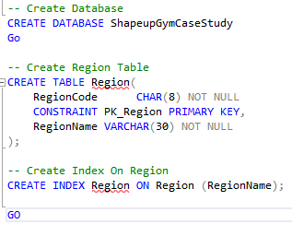
Figure 1 - Index 1 – Create Region

Initially based on the available data within the table it seemed ideal to implement an index to collate together all Gym members who are based within the United Kingdom region. This seemed suitable as certain customers may only wish to view branches based within the United Kingdom. Potentially certain Gym Branches may only wish to access the information of any registered customers who attend Branches within the United Kingdom rather than further afield.
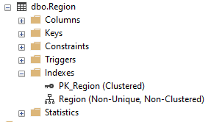
The command to create the Region index is:


Index number two – Gym Table:

The second index that has been built is within the Gym Table. The index has been assigned using the following columns within the table: -
- Name,
- ID,
- Address,
- PhoneNo,
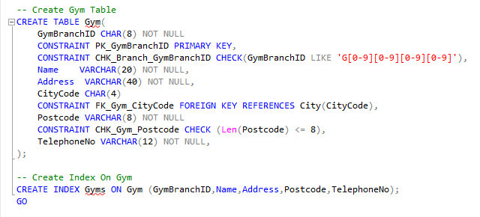
Figure 3 - Create Index on Gym

Based on the available data it seemed ideal to implement a second index to allow members to collate together the information for their local gym branch. This seemed beneficial due to the fact most clients may only wish to request additional information based on the local Gym. This can include information to contact instructors to check class availability or cancel any transactions.
The command used to create the Gym index is: -

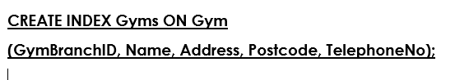

Index number three – Customer Table:

The last index that has been set up within the table structure is based within the Customer Table. The index has been assigned by using the following columns within the table: -
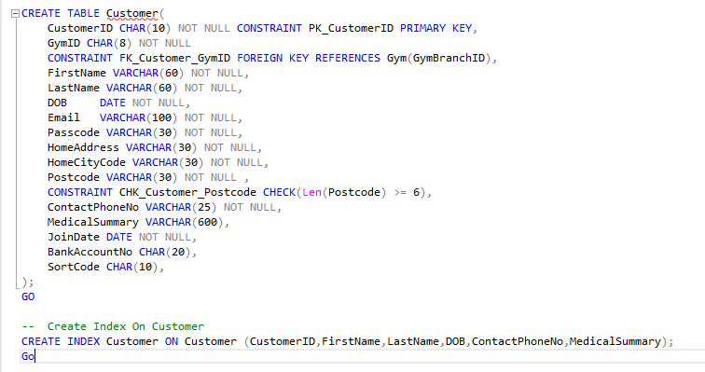
- CustomerID,
- FirstName,
- LastName,
- DOB,
- ContactPhoneNo,
- MedicalSummary,
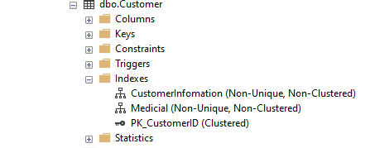
Based on the data available within the Customer table I chose to implement a third index to allow administrators to collate together customers information based on which branch location the customer attends as well as additional banking details to finalise payments for gym subscription fees. Secondarily as part of customer safety Shape Up Gyms may need to pass on medical information to a doctor or emergency contact if anything happens to a specified customer on site. Customers may also wish to be kept informed using additional newsletters and offers which shall require extra permission details in order to communicate with dedicated customers.

The command used to create the Customer index is: -
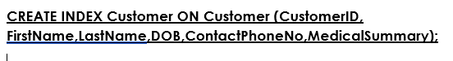

Distributed Database Solution:

By using the identified Shape up Gyms case study, I have been requested to create a proposed distributed database design that can be used to distribute the company’s information. A suitable fragmentation schema has been created for the system by identifying the strategies applied to each table followed by reasons for the choices. This can include using mixed vertical and horizontal fragments. Vertical Fragmentation involves splitting one table into multiple tables unlike Horizontal fragmentation which divides a relation horizontally into the group of rows to create a selection of subsets of tables [4].

Regions:

Each region has been broken down to contain a Shape up Gym with the country. If customers wish to view a branch based on their region customers can search the database. For example, if a customer based in the UK wished to locate Gyms within their area, they would use their region as region such as


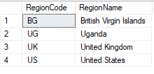

City:

Most cities in different regions contain a multiple Gym Branches. The city table contain a list of cities organised categorised by using the regional areas. If customers wish to search based on city codes, the Where condition would be based on city code. This would direct to branches which are based in Swansea. An example can be: -


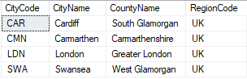

Gym:

The Gym table contains a list of gyms in selected locations. This allows information to be stored based on location and region. If clients wish to locate data based around their local Branches this would be where the Primary Gym branch ID comes convenient as the condition would be based on Gym Branch ID. This condition would search for branches which are based in Cardiff.
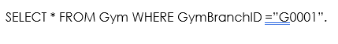

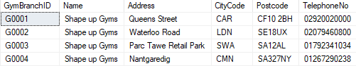

Membership Type:

Shape Up offers a wide selection of memberships across all centres. The Membership Type table stores a range of subscriptions that are available at various prices based on the time of subscription. This can differ between day passes or fixed term memberships. Each gym can set their own prices or promote various offers depending on franchise. If clients wish to locate data based around their membership this would be where the membership type ID becomes appropriate. This statement directs to the Membership package known as Fit X which is available across all branches.

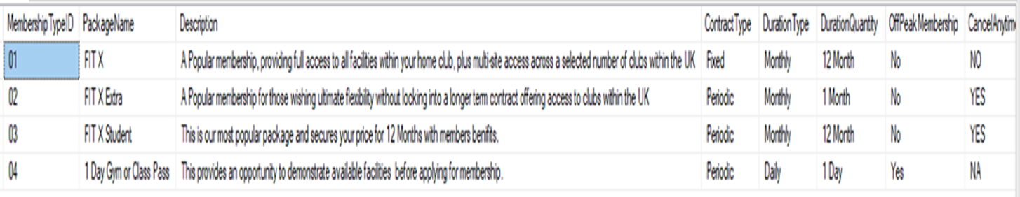

Gym Membership Price:

Shape Up Gyms offers selected membership packages for various prices. Customers can access a selection of Membership fees which can be paid up front all at once or spread across a monthly basis depending on the type of membership. Unfortunately, some membership shall require additional joining fee charges as part of administration and induction fees. These prices are also based on around the amount of benefits offered to members. If clients wish to locate information based around membership prices this is ideally where the membership type ID as well as GymID becomes appropriate as the condition shall be based around which additional charges must be enforced depending which membership is allocated. The following statement shall direct to the appropriate charges which are similar across all branches.
The condition for this process would be: -
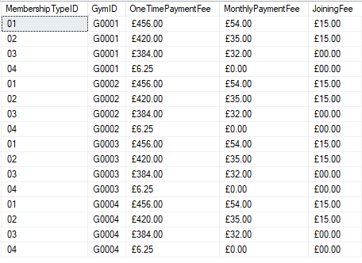

Customer:

As an expanding company Shape Up Gym offers a service to a range of customers all over Wales. For this reason, a table containing details of each customer registered with the gym must be implemented. As part of health and safety the gym must ensure all customers information remains secure and up to date in case of an emergency. Customers can be searched using a dedicated customer ID. The following statement shall direct to customers ID.
In order to access customer information, the condition for this process would be: -

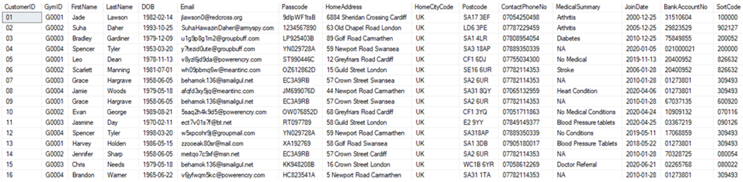

Membership Purchase:

As an everyday company Shape up Gym provides a service to a range of customers proving facilities all over Wales. In order to keep track of customers information and purchases its important to monitor information using a suitable table. The table contains details of each membership contract that has been purchased by a customer. This includes up to date banking details in order to collect financial payments from customers based on their subscriptions within the business. Customers purchase can be tracked by using a dedicated PurchaseNo. The following statement shall create a direct connection to recent purchases that have been carried out. Membership status can also be tracked within the database.
In order to access Membership Purchases the condition for this process would be:

Bibliography:

[1] | K. Bloch, “SQL Database Performance Tuning for Developers,” https://www.toptal.com/, [Online]. Available: https://www.toptal.com/sql-server/sql-database-tuning-for-developers. [Accessed 19th March 2020].
[2] | O. Corporation, “Clustered and Secondary Indexes,” Oracle Corporation, 2020. [Online]. Available: https://dev.mysql.com/doc/refman/5.7/en/innodb-index-types.html. [Accessed 29 03 2020].
[3] | U. o. W. T. S. David, Shape up Gyms Database - Database Assignment, sWANSE: UWTSD, 2019.
[4] | FakeAddressGenerator.com, “Fake Address Generator,” fakeaddressgenerator.com, 2020. [Online]. Available: https://www.fakeaddressgenerator.com/World_Address/get_uk_address/city/carmarthen. [Accessed 01 Jan 2020].
[5] | RANDOM.ORG, “Random Calendar Date Generator,” random.com, 2020. [Online]. Available: https://www.random.org/calendar-dates. [Accessed 01 Jan 2020].
[6] | iban, “UK IBAN Examples,” iban.co.uk, 2014. [Online]. Available: http://iban.co.uk/examples.html. [Accessed 01 01 2020].

marking criteria and Student FEEDBACK

This section details the extent to which the assessment criteria are demonstrated by you, which in turn determines your mark. The marks available for each category of skill are shown. Lecturers will use the space provided to comment on the achievement of the task(s), including those areas in which you have performed well and areas that would benefit from development/improvement.

Common Assessment Criteria Applied (Assignment 1) | Marks available | Marks  awarded
1. Engagement with Literature Skills

2. Knowledge and Understanding Skills

A very good range of queries to create sample data for the database has been provided. Please note that your submission does not include the required code to test the constraints. A basic attempt at the required transaction to purchase a new membership but there is room for improvement as the logic is not quite correct. (Grade mark: 52.00%) | 25 | 13
3. Cognitive and Intellectual Skills

A satisfactory analysis of the case study for determining indexes, generally there is room for improvement. Your chosen indexes include too many columns. This will make the size of the indexes large and also inefficient. You have also chosen to index the region table which is a very small table and there is no benefit adding an index to small tables. A basic attempt at the distributed database design. The proposed solution generally requires improvements. See your report for additional comments. (Grade mark: 35.00%) | 30 | 10.5
4. Practical Application Skills

A good attempt. There are some things to note. Note the difference between the CHAR and VARCHAR types. CHAR is for fixed length string e.g. your student number, while VARCHAR is for varying string lengths e.g. names. Good attempt at implementing check constraints, but some of your implemented check constraints were redundant and generally not relevant as they simply did the same thing as the size specified in the brackets () when specifying the type. For the OffPeakMembership and Cancel Anytime columns, use the BIT type which is used to store Boolean data (True/False or Yes/No). DurationQty in MembershipType should be an integer. Payments and Fees should be stored as numerical data i.e. decimals. Also, when using the decimal type specify the precision to improve storage efficiency. MonthlyPaymentDay in MembershipPurchase would have been better as an integer to store the day i.e. 1 to 31 to indicate the direct debit payment day. The size of some of your columns are also too large e.g. in some place you have defined postcode columns with a size of 30 characters which is too much. Note that that FKs do not have to have the same name as PKs and your understanding of this was being assessed. The FKs to the PK in the Gym table is missing in the gym membership price, table. The PK on the Gym Membership Price table is a composite key made up of the MembershipTypeId and GymID columns. Remember a composite PK is made up of more than one columns and needs to be specified after the column definitions. (Grade mark: 65.00%) | 40 | 26
5. Transferable Skills for Life and Professional Practice

The report is of a good standard. (Grade mark: 70.00%) | 5 | 3.5

Assignment Mark (Assessment marks are subject to ratification at the Exam Board. These comments and marks are to give feedback on module work and are for guidance only until they are confirmed. ) | Late Submission Penalties (tick if appropriate) |  | 53%
 | Up to 1 week late (40% Max) |  | 53%
 | Over 1 week late (0%) |  | 53%

