Engineering Design

M4X01160

Drill Press Redesign Reflective report

Paul Thomas
1708327

Table of Contents
1. Introduction 2
2. Design Appraisal 3
2.1. Drill Press Assembly Appraisal 3
2.2. DSPMU Appraisal 4
3. Design Considerations 6
3.1. Manufacturing Process 6
3.2. Injection Molding Process Basics 7
3.3. Material Selection 8
3.4. Design Characteristics 9
3.4.1. Wall Thickness 9
3.4.1. Ribs and Bosses 9
3.4.3. Drafts 9
4. Design Specification 10
4.1. Market Requirements 10
4.2. Operational Requirements 10
4.3. Manufacturing Requirements 11
5. Final Design 12
5.1. Design Features 13
6. Conclusion 17
8. References 19
9. Appendix 20

1. Introduction
In the following report I will be documenting how I went from the original DPMSU design to my new design. This will involve critically appraising the original before researching the material and manufacturing techniques available to create a new and improved design.
The assignment brief is only that the part is of a polymeric material and that the process is capable of 500 units per week batch numbers.
The drill press is a mechanical device used from the DIY user all the way through industry in numerous forms. The design ranges from the very simple to fully automated complex designs.
Drilling machines, or drill presses, are primarily used to drill or enlarge a cylindrical hole in a workpiece or part. The chief operation performed on the drill press is drilling, but other possible operations include: reaming, countersinking, counterboring, and tapping. (Davies.edu, 2017)
The basics of the drill press can be broken down into just few parts.
The column of most drill presses is circular and built rugged and solid. The column supports the head and the sleeve or quill assembly. The worktable is supported on an arm mounted to the column. The worktable can be adjusted vertically to accommodate different heights of work. or it may be swung completely out of the way. It may be tilted up to 90° in either direction, to allow for long pieces to be end or angled drilled. The base of the drilling machine supports the entire machine and when bolted to the floor, provides for vibration-free operation and best machining accuracy. The top of the base is similar to a worktable and maybe equipped with T-slots for mounting work too large for the table. (Cheme, 2017)

2. Design Appraisal

2.1. Drill Press Assembly Appraisal

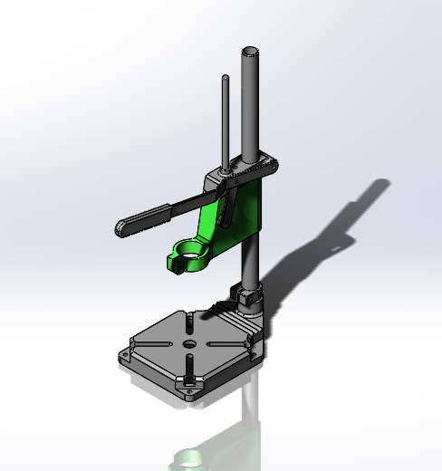
The drill press we are redesigning is a basic model comprising of the base DSPMU, column, arm and connecting parts (see Figure 1). While basic it is a fully functional, widely used and proven design. It is designed to be used with a handheld drill which is then held in the DSMPU. There is a spring which provides a positive recoil, returning the unit to the top of its stroke. The base doubles up as the work surface. It incorporates holes enabling it to be bolted down and for workpiece holding.
Figure 1 - Drill Press Assembly

2.2. DSPMU Appraisal

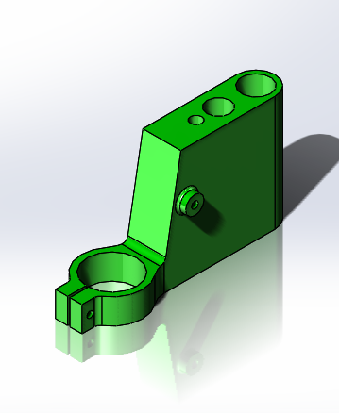
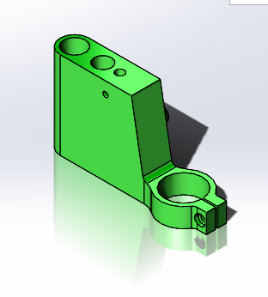
The DSPMU is connected to the column, guide bar, top brace, spring and arm. This making it the main part of the assembly (see Figure 2). This all adds to its design complexity, as it needs to connect accurately to all mentioned parts. While providing it function of accurately sliding up and down the main column. It must do this with a negligible amount of friction, whilst standing up to the flex and twisting forces acting on it.
Figure 2 -DSPMU
Figure 3 - DSPMU
As you can see from the original design it has all the required functional requirements (see Figure 3). It is a time proven design and looks aesthically pleasing. The design could be described as simple and this could affect the user’s assessment of its value/cost. The material of this design is not specified, but it would lend its self to a cast iron or possibly aluminium.
Figure 4 - DSPMU 3D Model – Please rotate
Ours is to be a made of a polymeric material which can be produced at 500 units per week. As a result, it is now an unsuitable design, meaning this needs to be redesigned to suit the nature of its material and manufacturing process. The current design has far too much material in the main body for polymeric part production. The cooling times would be excessive, the resulting sink age would render the part very in accurate. The current design of any holes would be badly deformed, again due to the amount of material that would cool at different rates. For the redesign the production technique characteristics will need to be researched and followed for a successful redesign.

3. Design Considerations

3.1. Manufacturing Process
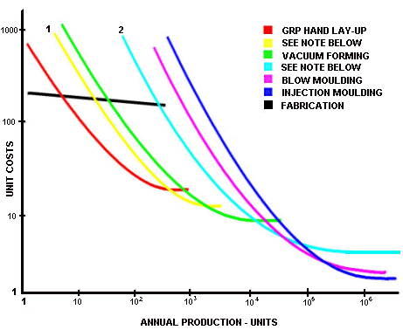
The material has been specified as a polymeric material, with a possible batch production of 500 units per week. The most common production techniques available to us include blow, thermo, injection moulding, and PIM.
Figure 5- Plastic Production Costs
The cost of these techniques varies greatly and is shown in attached graph (see Figure 5). Noting that our part is to be batch produced in high volume, certain production techniques will be better suited. Injection moulding is the cheapest at high volume.
After researching different production techniques, injection molding will be the choice of production to use when considering my design. Whilst many different production techniques could have been chosen, injection molding meets provides the best cost per part when producing at high volumes.
Injection Moulding, along with extrusion ranks as one of the prime processes for producing plastics. It is a fast process and is used to produce large numbers of identical items from high precision engineering components to disposable consumer goods. (Bpf, 2017)
Injection moldings count for a significant proportion of all plastics products from micro parts to large components. Virtually all sectors of manufacturing use injection molded parts - the flexibility in size and shape possible through use of this process have consistently extended the boundaries of design in plastics and enabled significant replacement of traditional materials thanks to light weighting and design freedom (Bpf, 2017)

3.2. Injection Molding Process Basics
Material is introduced into the injection molding machine (see Figure 6) via a Hopper. The injection molding machine consists of a heated barrel equipped with a reciprocating screw, which feeds the molten polymer into a temperature controlled split mold via a channel system of gates and runners.
The screw melts (plasticises) the polymer, and also acts as a ram during the injection phase. The screw action also provides additional heating by virtue of the shearing action on the polymer.
The polymer is injected into a mold tool that defines the shape of the molded part
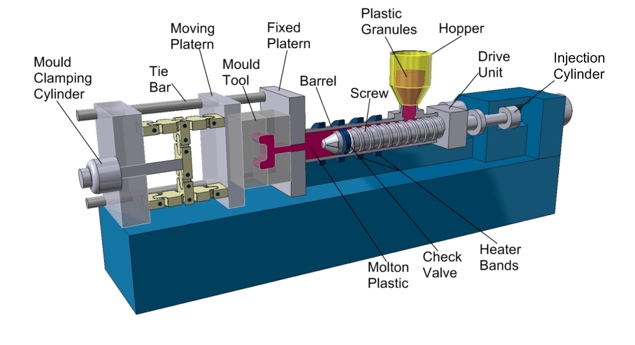

Figure 6 - Injection Moulding Model

3.3. Material Selection

Due to the vast number of polymeric materials available, this required me to be very specific in my requirements for the material. The properties important to me in my design are Strength, low coefficient of friction, cost, resistance to temperature, chemicals, stress cracking and fatigue.
Of all the above, cost is very high up in its importance. The drill press design is basic and targeted at the DIY user so choosing a material needs to be fine balance of cost versus performance.
Choosing a material such as Polyimide (PI) or PEEK would provide a high-quality product, but the high material cost cannot be warranted.
Other materials such as PEI polyetherimide while high in strength, stiffness and temperature resistance would to be unsuitable. As chemical resistance was a requirement then any amorphous plastic would need to be discounted due to their poor chemical resistance.
I decided to go with a material choice of POM Polyacetals such as DELRIN, CELCON. These materials provide the balance of cost versus performance. These materials offer exceptionally high mechanical strength and rigidity without reinforcing. High resistance to repeated impacts. Outstanding long-term fatigue endurance. Excellent resistance to moisture, gasoline, solvents and many other chemicals of neutral ph. Excellent dimensional stability. Natural lubricity
The British plastic federation list its properties as Creep resistance, strength, stiffness, hardness, dimensional stability, toughness, fatigue resistance, solvent and fuel resistance, abrasion resistance, low wear and low friction. (Bpf, 2017)

3.4. Design Characteristics

With injection moulding the desired production technique, the product design must be tailored to suit. When designing, the mould required to make the part has to thought about as well. Injection moulding production creates many design considerations some are explained further below.

3.4.1. Wall Thickness
Cost savings are maximised when the wall thickness is minimised, this is due to less material being used. This has a duel saving as the part also cools quicker resulting in quicker production times. A further saving is made when transporting part as overall part weight can be reduced.
Uniform wall thickness is also a requirement as this allows the mould to fill more efficiently, as the molten plastic not need to be forced through restricted wall thickness areas.

3.4.1. Ribs and Bosses
Ribs are incorporated in design to increase the part stiffness whilst keeping material to a minimum. Ribs thickness is designed in relation to wall thickness and recommended not to exceed 70%. This reduces sink age at the rib connection point, another good practise is a radius blend at the connection point. Bosses are used to create location points for mating parts, for attaching fasteners such as screws, or for accepting threaded inserts. The good design of any boss, reduces any warpage whilst producing accurate sizes. Boss should be kept away from corners, using ribs or gussets for strength.

3.4.3. Drafts
Drafts are used for the easy removal form the mould. The are a must in the good design of components for injection moulding. The draft must be designed at the correct angle to allow mould opening and closing. Ideal draft angles range from 1 to 2 degrees. It is possible to have no draft in certain circumstances, but this requires special moulding techniques which hinder efficient injection moulding.

4. Design Specification
The redesign of a product is led by its market, operational and manufacturing demands. For any product to be successful it must meet the demands identified, these are decided from thorough research and correct assessment of the actual problem. It must be better than the competition in its design. All the requirements must be accurately identified for the best outcome. Ultimately our product must meet the targets set out below.

4.1. Market Requirements
This product is designed primarily for the DIY user or small workshop setup. As a result, the cost of this should be a real factor when identifying designs. The item needs to low maintenance, strong, aesthetically appealing and be able to be mass-produced.
Current product competition starts at as little as £12 up to £70 before it stops be targeted at the DIY market and more towards small industry.

4.2. Operational Requirements
The primary requirement is to transfer the leverage created by the arm into downward movement accurately. To do this it must designed to bear all loads which are applied during the drilling operation. This requires the item to be resistant to excessive flex and twist. It must slide efficiently/smoothly down the guide bar offering little friction. The material chosen must have high temperature tolerance due to the nature of hot swarf created when drilling. Finally, a chemical resistance must be considered due to cutting compounds used when drilling

4.3. Manufacturing Requirements
The design is to be made using a polymeric material suited to injection moulding. The requirements associated with good mould design must be considered, including draft angles, wall thickness and removal from mould. A production number of 500 parts per week must be achievable. Material selection must be low cost, lightweight with good strength properties. With special consideration given to a design which reduces parts, production operations and fasteners is highly desirable.

5. Final Design

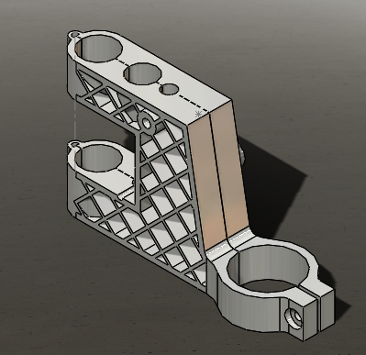
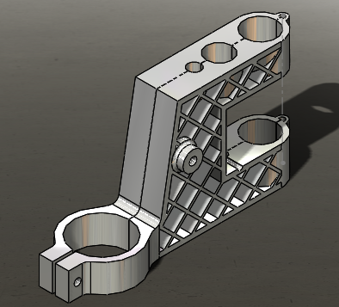
Here is my final design solution for the redesign of the DSPMU unit. It meets as many of my design targets as possible, whilst balancing cost versus performance.
Figure 7 - Final design
Figure 8 -Final Design
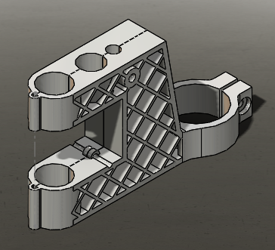
Its design will improve on the current design in many areas. It includes as many design features incorporated with good injection moulding design as possible.
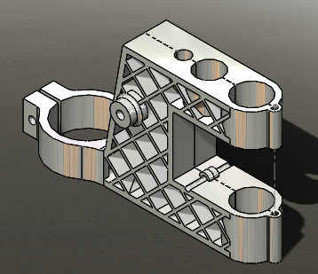
These include uniform wall thicknesses, ribs, bosses and draft angles. This results in material optimisation, low sink age and efficient production.
Figure 9 - Final Design
The design also incorporates a living hinge and snap hooks. This results in no extra fastening processes or parts and it can be produced in one mould.
Figure 10 - Final Design

5.1. Design Features

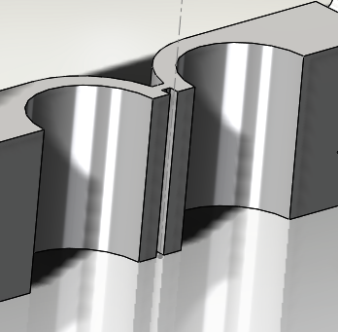
My design incorporates a living hinge (see Figure 11). This enables the part to fold through 180 degrees accurately. It eliminates the need for secondary fixing components.
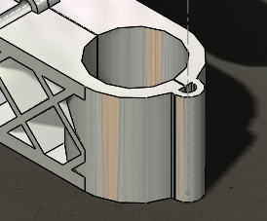
Figure 11 - Living Hinge

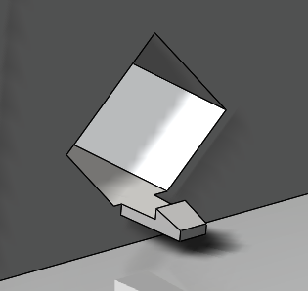
Figure 12 - Living Hinge
Figure 13 - Snap Hook

I’ve used snap hooks (see Figure 13) and the corresponding slots on my design. These work with the living hinge to securely fix the component once it has folded through 180 degrees.

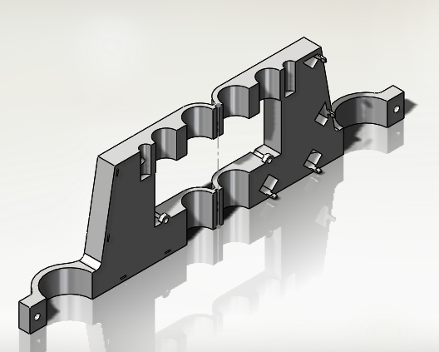

Figure 14 -Snap Hook

Figure 15 - 3D model – Please rotate

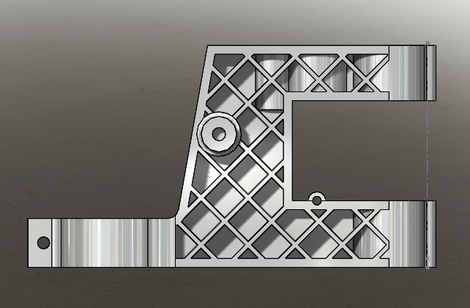
The DSPMU has been designed with uniform wall thickness, the ribs are within 70% wall thickness requirements (see Figure 16).
Figure 16 -Wall Thickness

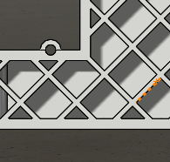

Ribs start at corners, designed to eliminate potential stress points (see Figure 17).

Figure 17 - Rib Position

Figure 18 -Boss

The bosses are well designed to produce accurately placed holes holding good geometric tolerances (see Figure 18).

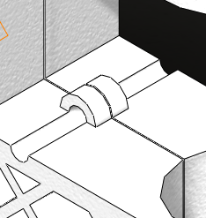
Figure 19 -Spring Connector

Here is the connection for the tension spring, the spring would hook underneath. This would also assist in holding the part together at this point.

Figure 20 - 3D model - Please rotate

Figure 21 - 3D Model - Please rotate

6. Conclusion
This assignment was to redesign one of the parts of a basic drill press assembly. The task required me to critically appraise the original model and design an improved model. Potential production methods and materials needed to be researched, this information would be used to select the best method and material. The specification detailed that it was a polymeric material, capable of producing of 500 unit per week.
I started this task with a critical appraisal of the DSPMU and drill press assembly. It was clear to me that whilst this was a fully functional part it was both basic and not suitable to being produced as a plastic part. The research that followed into the production methods and materials were vital in conjunction with the appraisal to help me achieve a successful redesign. Once I had chosen injection molding this guided me into the molding process and the requirements of my new design. The ribs, bosses, uniform wall thickness, drafts, living hinge and snap hooks which appear in my final design are a result of the process requirements. My final design has tried to incorporate as many of these features, this really tested my new CAD drawing skills and took up a lot of my time. My CAD skills really held back my progress as I had many ideals but found it hard to model what I was thinking. The material POM polyacetal that was chosen again was the result of the research into both the process and polymeric materials. The options were vast and finding the balance between both cost and performance was critical in designing an improved product.
I think my design is very successful in both improving the original and using as many of the features available to me by using injection molding. I’m particularly pleased with the design being produced from one mould, requiring no extra processing or fasteners. The living hinge and snap hooks are features of injection molding and to include them into my design took a lot of time and effort.
I feel the assignment brief has been achieved in my final design. The research for this assignment has taught me a lot in both production methods and materials. The topic is vast, I feel I have only just touched on it. There is still lot I could learn in both areas which I’m sure would mean I could produce a better product with more knowledge and experience.

8. References
Bpf, 2017. Plastipedia. [Online]
Available at: http://www.bpf.co.uk/Plastipedia/Processes/Injection_Moulding.aspx
[Accessed 20 12 2017].
Cheme, U., 2017. Drill presses. [Online]
Available at: http://uhv.cheme.cmu.edu/procedures/machining/ch4.pdf
Davies.edu, U., 2017. Drill presses. [Online]
Available at: http://engineering.ucdavis.edu/wp-content/uploads/2013/08/DRILLPRESS.pdf?69cb4f

9. Appendix

https://uk.3dsystems.com/quickparts/learning-center/injection-molding-basics#polymers
https://medium.com/@Jaycon/engineering-guidelines-to-designing-plastic-parts-for-injection-molding-1c554a4545be
file:///C:/Users/Tomo/AppData/Local/Packages/Microsoft.MicrosoftEdge_8wekyb3d8bbwe/TempState/Downloads/Injection_Molding_Design_Guidelines_2017.pdf

