Gender Quotas in Norway - An Employer’s Perspective
(Nicola, Andrew, Geraint, Annette, Karen, Sarah, Rhiannon, Paul)

Women in the Boardroom – Symbols or Substance?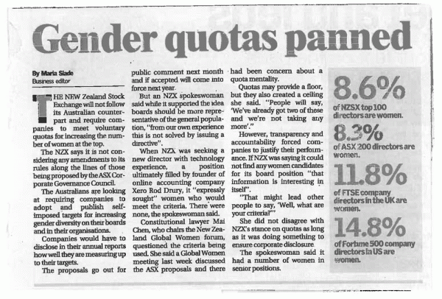



BACKGROUND INFORMATION OF THE QUOTA

- In 2002 the Norwegian Government set the objective to appoint women to at least 40% of boardroom seats.

- Deadline for State Owned companies was 2004.

- Deadline for listed Private companies was 2005.

- Law became effective on 1st January 2006 with a 2 year transition period.

- Firms that did not comply by January 2008 would be forced to dissolve.

OTHER USEFUL INFORMATION

These issues may affect females on Boards;

- Norway has relatively high birth rates (top five in Europe).
- Parents are entitled to one year leave after birth, and the parents can divide this between them (six weeks reserved for Dad’s).
- Government ensures full day care coverage (no childcare issues)
- Employees with small children have a right to request flexible working.

EMPLOYMENT/SECTOR INFORMATION

(JUST TO GIVE US AN IDEA OF WHAT KIND OF INDUSTRY/EMPLOYER WE ARE??)
- In 2009 Norway was affected by the economic downturn resulting in layoffs and increased unemployment.
- Demand for labour varies across the counties.
- Public Services and Fisheries are the dominant sectors in the North.
- Industry in the South.

ARGUMENTS AGAINST THE QUOTA

We believe that;

Businesses should be able to choose their own Board Members to maximise value, based on capability and not Gender.

Directors should be appointed on Performance and Merit.

We find that the constraint imposed by the quota will;

Depreciate value of women.

(Because their success will be seen as due to the quota and not their ability, leading to lack of respect and an inefficient Board).

Quotas are against the Labour or Equality Laws in several countries, where they are considered discriminatory.

(Therefore, this may affect business transactions).

Quotas will hinder the labour markets by bending recruitment rules.

(Recruitment and Selection processes should be based on the right people with the right skills at the right time and not due to gender. The quota results in Directors being chosen who may not ordinarily be chosen).

If quotas are set for women, there may also be future pressure to set them for any minority groups (i.e. race, religion, social, age).

Very little academic proof that women on Boards have a positive effect (sorry girls!).

NEGATIVE IMPACT OF THE QUOTA – BUSINESS ARGUMENT
- Boards are chosen to increase shareholder wealth. Placing restrictions on the composition of the Board will reduce value. The bigger the change to the Board, the bigger the fall in returns (Dittmar and Ahern)

- This is proven by research, whereby a panel of 130 publicly listed Norwegian firms from 2001 to 2007 were studied. The researchers identified a negative impact on the mandated board changes on firm value. (Ditmar and Ahern)

- Women on Boards lower profits.

- Ditmar and Ahern also found that stock price of an average firm dropped 2.6% in the three days following the first announcement of the new laws, and 5% for firms with no women on their boards (i.e. February 2002 when announcement was made).

- Constraints imposed by the Quota has led to younger and less experienced Boards with different career experiences with existing Directors. This may lead to problems such as advising capabilities and also monitoring differences.

- Quota has led to a large decline in ‘Tobin’s Q’ which is a common market-based measure of Corporate Governance (which is a ratio of a company’s market capitalisation to the replacement cost of its assets, i.e sum of total assets and market equity less common equity divided by total assets)

- Researcher’s found that when a firm experienced at least a 10% increase in women on its Board, ‘Tobin’s Q’ dropped by 18%!

- The quota has increased leverage and acquisitions.

- Deterioration in Operating Performance.

- Quota has led to the ‘golden skirt’ effect, whereby women hold multiple board positions with different organisations. This is not efficient, effective or sustainable! As identified by Professor Branson at University of Pittsburgh who stated ‘no director can serve well on more than three to four modern corporation boards’.
.
- Cultural changes within the organisation are hard to impose and difficult to manage, including retaining experienced staff who have been by-passed due to the quota.
.
- Forced Re-structuring impacting on retention and engagement.

POSSIBLY AVOIDING THE QUOTA

- The law applies only to state-owned and public limited companies. Companies have changed their status to Limited Liability Companies to avoid the quota.

- 40% of businesses in Norway avoided the Quota Law by converting into Private Limited companies. Two thirds of them admitted the quota led their decision to delist from the Stock Exchange (Guardian by Mai Lill-Ibsen).

POSSIBLE COUNTER ARGUMENTS TO ‘GOVERNMENT’ SIDE
They may use the following as arguments for the Quota:
GLASS CEILING

- If they say the quota is to abolish the ‘Glass Ceiling’ for women.

We respond

- The quota keeps the glass ceiling in place because capable women outstrip demand. This leads to the golden skirt, resulting in the same selection of the same women on Boards. This restricts opportunities for new women candidates being given the opportunity meaning the glass ceiling still exists. (Prof Branson, University of Pittsburgh – a leading expert on women in the boardroom.

- Female Boardroom Pioneer, Mai-Lill Ibsen (who held 185 Norwegian Directorships) stated that; ‘We don’t need a Law to break the glass ceiling’ (24th January 2013). She also states that ‘I’ve never seen the glass ceiling, I’m against quotas because they are discriminatory, I feel women are so strong we don’t need that’.

- The creation of ‘TROPHY DIRECTORS’ (The women that everyone wanted) again, leading to the glass ceiling.

- General research shows that Organisation’s with women on Boards may have more women in Senior Management. However, Norway HAS NOT seen a significant increase in female CEO’s or the amount of women on Executive Committees.

ECONOMIC CLIMATE/CRISIS
- They may say the Quota will boost Business in the current Economic Climate.
We respond
- Betty-Ann Heggie, a member of Canada’s Top 100 Most Powerful Women Hall of Fame (and former Senior Vice-President at PotashCorp), has also stated ‘Boards with more women will be more stakeholder-orientated which may create long-term advantage BUT IT WILL HAVE A SHORT-TERM COST’ .

In the current global economic crisis, how many companies can wait? Most are struggling to meet short-term demands

NORWAY AND EUROPEAN PROFILES (Maybe use with Andrew & Geraint’s notes below?)
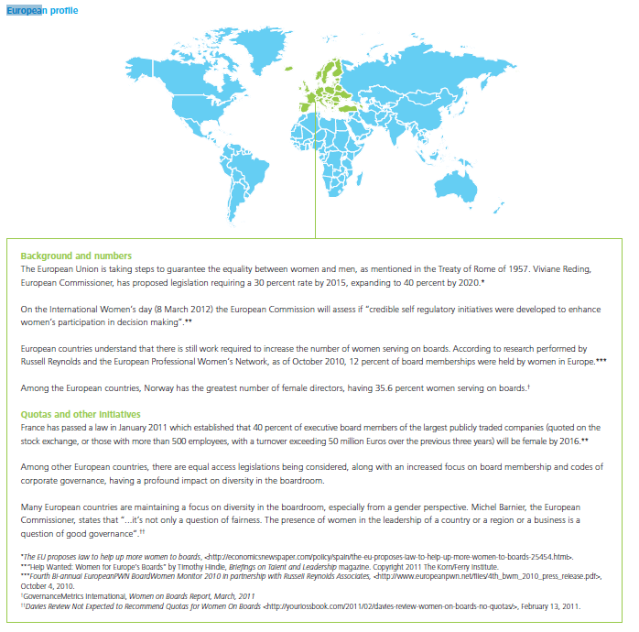
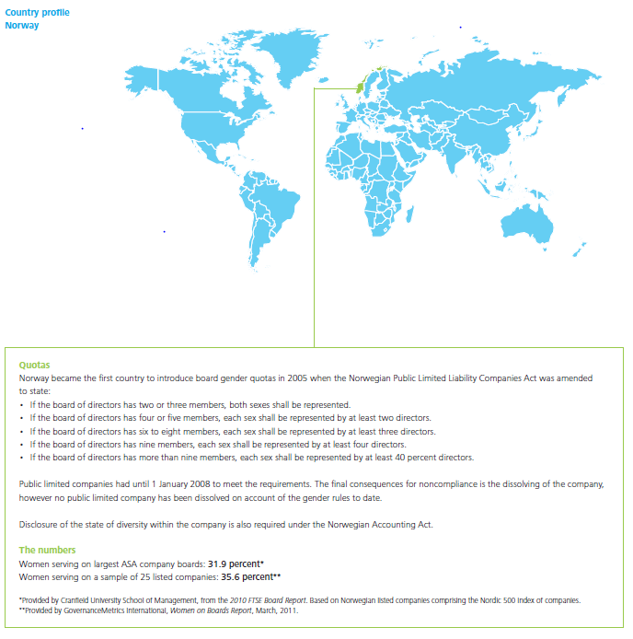
(Source: Deloitte, “Women in the Boardroom, a Global Perspective”( November 2011))

BIBLIOGRAPHY/REFERENCES

REPORTS AND RESEARCH PAPERS
Women in the Boardroom: Symbols or Substance? Charles A O’Reilly III (Stanford University) and Brian Main (The University of Edinburgh) March 2012

The Changing of the Boards: The Impact on Firm Valuation of Mandated Female Board Representation (2011)
Professor Kenneth R. Ahern (University of Southern California, Marshall School of Business), Professor Amy K. Dittmar (University of Michigan, Stephen M. Ross School of Business).
Link to this paper: http://papers.ssrn.com/sol3/papers.cfm?abstract_id=1364470

Deloitte, “Women in the Boardroom, a Global Perspective”( November 2011)

ARTICLES

Women on Board: Does Forced Diversity Hurt Firm Performance? (15/02/10)
http://www.bus.umich.edu/NewsRoom/ArticleDisplay.asp?news_id=18682

Norwegian Equality Policy has Failed (Science Nordic, 25th October 2012)
http://sciencenordic.com/norwegian-equality-policy-has-failed

The Guardian; ‘Norway’s Female Boardroom Pioneer Rejects Quotas for Women’
(24th January 2013)

ANDREW’S AND GERAINT’S NOTES
Stephanie Bird – HR Capability Director for the CIPD:-

You’ve lifted performance – but we still don’t want you!
Posted by Stephanie Bird, 08 March 2011 at 17:46
I was fascinated to see the ‘Evershed’s board report’ which analysed the performance of around 250 top companies over a 3 year period. Following on from the Davies review, it was hardly surprising that FT.com headlined this as ‘Women at the top lift shares, study shows’.
- It’s great that this report helps to build up the evidence base. But if I’m being picky, this came 3rd in the list of influences! The first two were other governance related issues – first up being board size – a smaller board was more effective, with 11 being the optimum. The second was having shareholders with substantial holdings, which has key relevance for emerging themes on stewardship. Then came the number of women directors – those with them performed better through the financial crisis, particularly in the UK and in the banking sector.
Clues to the struggle ahead
- The sting in the tail? Despite all that, interviews showed that only 55% of Directors thought that diversity was beneficial for board and company performance; and only half of those supported positive action to support it. So, clues to the struggle ahead for the 25% target then, I think.
- U.K. Prime Minister David Cameron’s government has ruled out imposing quotas. A 2011 report by Mervyn Davies, a former banker, called for a target of 25 percent female representation at the biggest businesses.
Stock of Pioneering Law: Have Gender Quotas Really Helped Norwegian Women?
http://www.spiegel.de/international/europe/taking-stock-of-pioneering-law-have-gender-quotas-really-helped-norwegian-women-a-745664.html
Not Driven to Ruin
Now, about five years after the introduction of the quota, Norwegian academics are taking stock for the first time. "Neither the worst fears of opponents nor the greatest hopes of proponents have come true," says Marit Hoel, director of the Oslo-based Center for Corporate Diversity. She has just presented her findings to German Justice Minister Sabine Leutheusser-Schnarrenberger in Berlin.
Hoel's conclusions suggest that the restructuring of corporate boards has not driven companies to chaos or ruin. The balance sheets of successful companies suffered a little in the short term but recovered quickly, says Hoel. "By contrast, companies that weren't doing so well tended to benefit from having women on their boards."
Norwegian companies clearly succeeded in finding sufficient numbers of competent women to serve on their boards. "The people who were replaced were mainly older board members," says Hoel, adding that their positions were taken by women with substantially better education levels. According to surveys of corporate CEOs, women have hardly changed the working style on boards. "Only a few report that the culture of discussion has become more open," says the social scientist.
A different study made headlines last fall when it revealed that more than 100 companies had transformed themselves from publicly held corporations (ASAs) to privately held companies (ASs), precisely at the time when the threat of punishment under the new law took effect. (The law only covers state-owned and publicly listed firms.) "We were all quite surprised," says Hoel.
Upon closer examination, however, it became clear that the key reason for the change in most of the cases was a different law that took effect at the same time, and which no longer required financial firms to be registered as publicly held corporations.

European Union postpones women quota on boards plan
Several countries in the EU now have quota rules for the composition of their boards
EU commissioners have postponed plans to impose quotas for women on company boards.
EU Justice Commissioner Viviane Reding was pushing for a vote on Tuesday to make it mandatory for companies to keep 40% of seats for women.
But the proposals will now not be debated until November.
The quota had already run into problems after EU lawyers said the proposed law might go too far and countries could not be forced to meet the target.
Several countries, including the UK, are opposed to Ms Reding's plans.
"Gender balance directive postponed," Ms Reding said on Twitter.
"I will not give up. [Commission President Jose Manuel Barroso] will put this on the Commission agenda again before the end of November."
On Monday, the European Parliament criticised the lack of female candidates for the European Central Bank (ECB).
A parliamentary committee - in a resolution passed by 21 votes to 12, with 13 absentions - called on the European Council to withdraw the candidacy of Luxembourg's Yves Mersch for the ECB executive board, saying his appointment would mean that the board would be all male up until 2018.
'Time is now'
The debate on Ms Reding's plan was due in Strasbourg on Tuesday, which could have led to a vote in the European Parliament to make gender quotas mandatory across the 27 countries in the European Union.
But lawyers told the Commission that the 40% quota plan, including hefty sanctions on companies in EU countries that did not meet the target, could not be enforced under EU treaties.
Earlier reports had suggested the directive was being diluted, before a decision was made to postpone it.
At the moment, less than 15% of board positions in EU member states are currently held by women, according to the Commission.
Opponents argue voluntary targets and increased efforts to change attitudes would be more effective in the long run.
UK Business Secretary Vince Cable is leading a campaign against the quota proposals, backed by ministers from eight other countries.
In the UK, the percentage of women on the boards of FTSE 100 companies has risen over the past year to a record 16%, but the UK government wants the biggest listed companies to have a minimum 25% of female directors by 2015 ?
Surely appointments should be on merit irrespective of Gender? - My quote!!

ANNETTE’S NOTES

Norway's female boardroom pioneer rejects quotas for women
We don't need law to break glass ceiling, says Mai-Lill Ibsen who at one point held 185 Norwegian directorships
  - Jill Treanor, City editor
  - The Guardian, Thursday 24 January 2013 21.00 GMT
Mai-Lill Ibsen who at one point held 185 Norwegian directorships, and was undisputed queen of the so called "golden skirts" – experienced executive women who found themselves in demand when Norway in 2006 passed a law requiring 40% of boardroom seats to go to women (or men in the rare case of a female-dominated directors' suite).
Ibsen opposes the quota system as a way to get women into the highest echelons of business. "I've never seen the glass ceiling," she says, raising her arms against an imaginary barrier. "I'm against quotas. They are discriminatory in a way. I feel we [women] are so strong we don't need that.
"If someone wants to have me as a token, they would get more than they bargained for."
She draws gasps from her audience in a packed parliamentary committee room as she explains how 40% of businesses avoided the new quota law by converting into private limited companies. Two-thirds of them admitted the quota rules were behind their decision to delist from the stock exchange.

October 23, 2012 4:56 pm

Déjà-vu in Norway over EU’s women quotas
By Richard Milne in Oslo – www.ft.com
But there is one big problem still in Norway: the lack of female executives.
McKinsey’s Women Matter study this year showed that while women accounted for 35 per cent of all non-executive board members in Norway (the quota does not apply to small unlisted companies), they only represent 15 per cent of executive management.

The telegraph online
By Harriet Alexander
7:00AM GMT 18 Mar 2012
Mimi Berdal is a high-profile beneficiary of Norway's pioneering policy, yet despite this, the 52-year-old has mixed feelings about a controversial new EU initiative to spring more women into boardroom roles
"On principle I do not believe in too much regulation on the private sphere," she told The Sunday Telegraph. "It would have been much better if this had happened on a voluntary basis.
"Some women, including myself, feel that law regulation in private companies is a complicated issue," she said, adding that it would be better for the boardroom balance to evolve naturally
"Quotas are not only needless but potentially damaging and actually undermine the very equality the pro-quota lobby seeks," said Helena Morrissey, CEO of Newton Investment Management and founder of the 30 Per Cent Club – an organisation aiming to get more women onto boards.
"Investors don't want quotas; board directors need to be there on merit and there's evidence that shareholder value can be destroyed if quotas are imposed," she wrote in a recent article.
Critics also point out that while Norway has 40 per cent female non-executive directors, only two per cent of its chief executive officers – who wield the real power – are women.
Kenneth Ahern, a professor of finance from the University of Michigan, doubted whether Britain was ready to make the necessary financial sacrifice to push women onto boards. His own research on Norway, published last year, showed that "the quota led to younger and less experienced boards, and deterioration in operating performance, consistent with less capable boards."
He told The Sunday Telegraph: "In Norway, they knew that the value of their companies would drop, but society there cared more about equality than finance. It was a conscious decision.

SEEM TO BE FINDING MORE THINGS IN FAVOUR>>>>>
Gives us an idea of counter arguments to expect though
The law came into full force in 2008. Now that the goal has been reached, the controversy has died down, as many of the suspected problems failed to materialise.
Idar Kreutzer, who sits on the nomination committees of many Norwegian boards, says simply: “It is not a big issue any more. Everybody seems to be happy with the way things have developed.”

RHIANNON’S NOTES
Debate – 6th March 2013
Role of Employer arguing against the quota for 40% of boards to be made up of women in Norway.
Women on boards – Feb 2011 (www.gov.uk)
“At the current rate of change it will take over 70 years to achieve gender-balances borardrooms in the UK”
“Corporate boards perform better when they include the best people who come from a range of backgrounds” – If there are quotas for gender is it fair to not have quotas for other characteristics like race or religion?
“18 out of 323 executive directors within FTSE 100 companies (5.5%) are women”
“US – alternative action – fair inclusion and utilisation of minorities and women in all firms that do business with the government agencies. This requires disclosure of how board nomination committees consider diversity in selecting candidates for board positions.”
“Quotas could increase a sense of tokenism and that good quality male board members would be ousted to make way for poorer quality women candidates” – Perception of females in the work place could be impacted negatively if given jobs without earning them. Training, development and mentoring would be a fairer focus rather than a quota for a specific amount of people.
There could also be a problem with the supply of women to make up the 40% quota.
Women’s views on news (Article by Anna Reitman, 12th Oct 2012)
Helen Morissey has had 9 children while rising through the ranks of the fund management industry and is a firm believer that quotas are unnecessary. She says “As more women join boards without the imposition of quotas, the more they can demonstrate the value they add”.
London loves business – Are boardroom quotas for women patronising or positive? BY Gabriella Griffith, 6th Mar 2012
Claire Wright (MD of Gyro) says:
“It’s degrading and patronising”
“I can’t think of anything worse than women getting a leg up because they’re female, appointment should be about ability, it’s a step back rather than a step forward”
“It’s damaging for the next generation and will undermine women already on boards”
“Would be better to look at childcare and tax relief amendments to help women work”
Shazia Awan (CEO of Peachy Pink) says:
“Quotas only serve to confirm they myth that women are inferior to men”
“It’s absurd that any woman would feel they deserved a spot based on gender alone”
“To be equal women need to compete in the same environment as men”
Maggie Berry (MD of womenintechnology.co.uk) says:
“I agree with the use of targets rather than quotas”
Own words
Use of quotas will give women a considerable advantage in applications to boards which goes against the ideology of equality. If there is a problem with gender inequality on boards, women should be provided with more opportunities to allow them to be on a level playing field with men rather than being provided with favourable treatment.

