Assessment Component One
E-Portfolio
Tree Elements

Cristina Craciunescu

Table of Contents

Contents
Element One Journal Article Summary ……………………………………………………………………………………… 2
Element Two Study Skill Infographic….…….…………………………………………………………………………..4
Element Three Essay Outline…………….………………………………………………………………………….….5
Library Search Screenshot……………………………………………………………………………………..9
Summary of Sources Used………………………………………………………………………………………………10
References……….…………………………………………………………………………..11

Element one Journal Article Summary
How Does Music Make You Feel
Summary
The article "How Does Music Make You Feel" by Zoe Nendick explores the impact of music on our emotions. The author makes several important points, such as how music can unite people, elicit feelings, and function as a kind of therapy, emphasizing how different genres and songs can arouse distinct emotions in their audience. The author also goes through the scientific data supporting music's ability to affect mood and the brain. The key points discussed in the article are music and emotions, therapeutic benefits, brain and music, music as a universal language, and personal experiences.
Exploring the scientific data that supports the physiological effects of music on the brain, Nendick describes how various brain regions react to music by producing neurotransmitters that affect feelings and mood. According to Nendick, there are a few different ways that music might evoke feelings. One way is via the reward system in the brain, where listening to enjoyable music causes the release of dopamine, a chemical linked to pleasure and reward. This helps to explain why listening to music can bring us joy, inspiration, or even nostalgia.
The article discusses how music may unite individuals from all origins and cultures. The author emphasizes how music can help people develop empathy and compassion for one another.
The author illustrates the emotional impact of music and its capacity to elicit responses throughout the journal by sharing both personal tales and tales from other people.
The author talks about how music has therapeutic benefits and emphasizes how it may be utilized to control pain, stress, and anxiety. The article lists music therapy as an accepted method of mental health treatment. The article highlights how music therapy might help with emotion regulation. The author describes how, in her capacity as a music therapist, has helped people to use music as a tool for emotional expression and processing. Through a secure, nonverbal medium for emotional expression, music therapy can help people explore and comprehend their emotions specially.

Reference
The British Psychological Society. (2022, September 12). How does music make you feel?. BPS. https://www.bps.org.uk/psychologist/how-does-music-make-you-feel

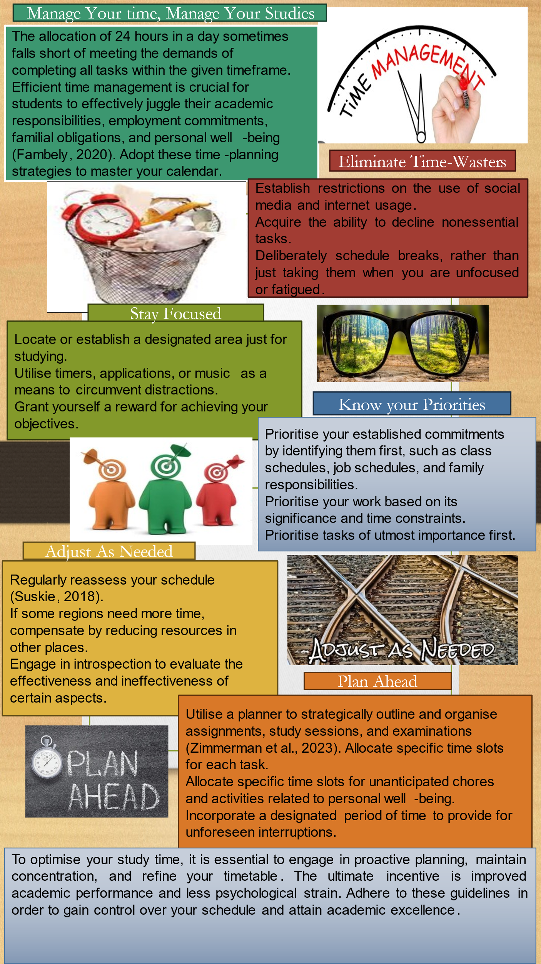
Element three Essay Plan

Psychological, Social, and Physical Benefits of Owning a Pet
Introduction
The introduction will begin by outlining the widely accepted idea of pet ownership in the United Kingdom and recognizing how many homes have adopted it. The discussion will shift to the growing interest in understanding the various advantages of pet ownership. A concise essay statement will be presented in the conclusion of the introduction, serving as the focus point: "This essay aims to explore the profound psychological, social, and physical benefits that individuals in the UK can derive from owning a pet." This lays the groundwork for an in-depth investigation of the numerous benefits of having animals as friends in one's life.
Psychological Benefits of Pet Ownership
- Emotional Well-being
Emotional well-being is the first area of focus when examining psychological advantages. The research demonstrating the substantial benefits pets have on mental health will be discussed in this part. The discussion will emphasize cases when people's relationships with pets lead to improved emotional states based on facts (Grajfoner et al., 2021). Furthermore, the essay will be enhanced by adding first-hand accounts or case studies that eloquently depict people's strong emotional connections with their dogs. The idea that pets provide a unique kind of unconditional support and friendship and that they greatly enhance their owners' emotional stability will be emphasized.
- Stress Reduction and Relaxation
Research shows that spending time with dogs reduces stress. The physiological underpinnings of pet contact, such as endorphin and oxytocin production, will provide a scientific framework for understanding the soothing effects. Incorporating real-world examples will demonstrate situations in which people have felt a palpable reduction in stress (Brooks et al., 2018). This section seeks to highlight dogs' therapeutic function in enhancing psychological well-being by integrating scientific evidence and real-world experiences.
- Companionship and Loneliness
This section will examine the significant influence of pets on reducing feelings of loneliness. The discussion will examine how pets work as companions and offer a unique social connection based on research studies. A comparison study will be conducted, highlighting the unique qualities of the relationship with animals, and comparing the company provided by pets with human interactions (Brooks et al., 2018). The essay will also examine how dogs can give lonely people purpose and accountability. This section will discuss the social elements of pet ownership and how pets reduce loneliness and foster connection.
Social Benefits of Owning a Pet
- Interaction with the Community
This part will examine how pets help communities form social bonds. The intricacies of how pets bring people closer will be thoroughly examined through a thorough analysis of studies and anecdotal data. Furthermore, case studies of pet-related activities or organizations that actively foster social contact will be showcased to highlight the concrete influence of pets on community cohesion (Hoy-Gerlach et al., 2022). The essay will explore how pets help pet owners feel a feeling of community by highlighting the relationships formed through shared experiences with pets that go beyond individual homes.
- Improved Social skills.
This section will highlight research showing how having a pet can increase social abilities, especially in kids. The impact of pet ownership on social skills will be discussed. Personal observations or anecdotes will humanize the scholarly research by providing examples of how people—especially kids—have improved their social skills due to their encounters with dogs. The conversation will also include the possible long-term effects of pet ownership on a person's social skills, considering how these talents might apply in broader social contexts outside the pet-owner connection.
- Lessened Social Isolation
Dividing into lessening social isolation, this part will examine how pets help across various age groups. Based on studies, the conversation will emphasize how pets affect mental health, especially regarding social ties (Grajfoner et al., 2021). One aspect of the investigation is examining the theory that pets serve as social catalysts, bringing individuals together who might not have otherwise connected. This section emphasizes the importance of pets in promoting a sense of belonging and interconnectedness by highlighting their function in dismantling social barriers.
Conclusion
The essay's conclusion will provide a methodical summary of the central ideas covered in each section, highlighting the significant social, psychological, and health advantages of pet ownership in the UK. The thesis statement will be reiterated to provide a cohesive element and highlight the various benefits people receive from having dogs as companions. The comprehensive aspect of these advantages will be highlighted, emphasizing how psychological, social, and physical well-being are interdependent. Moreover, the result will serve as a springboard for further investigation by promoting deeper study into the complex facets of pet ownership and its more comprehensive public health ramifications. The conclusion seeks to advance the existing discussion about the all-encompassing effects of pet companionship on people and communities by igniting new research.

Library Search Screenshot
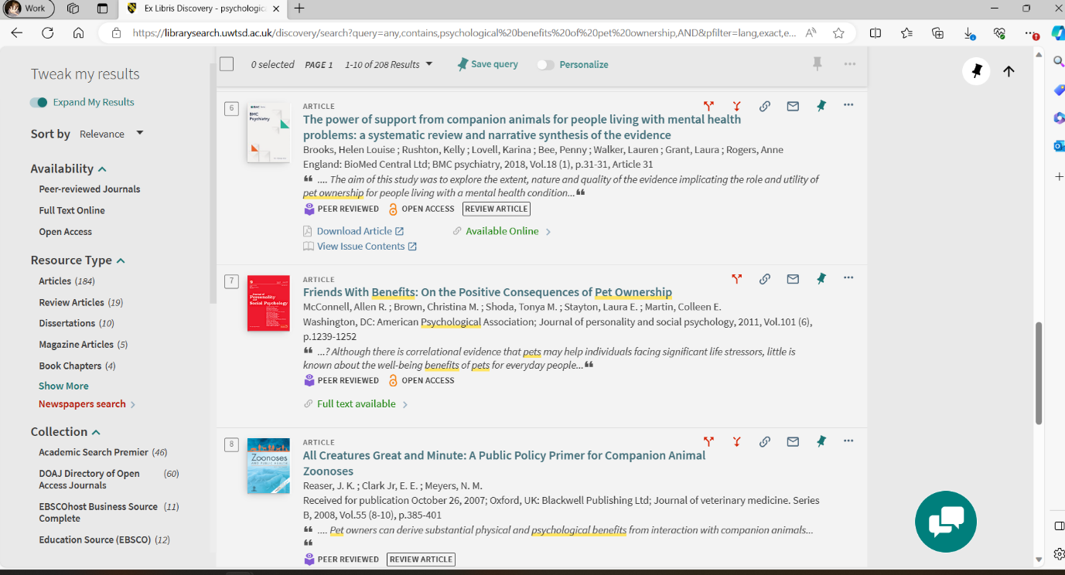
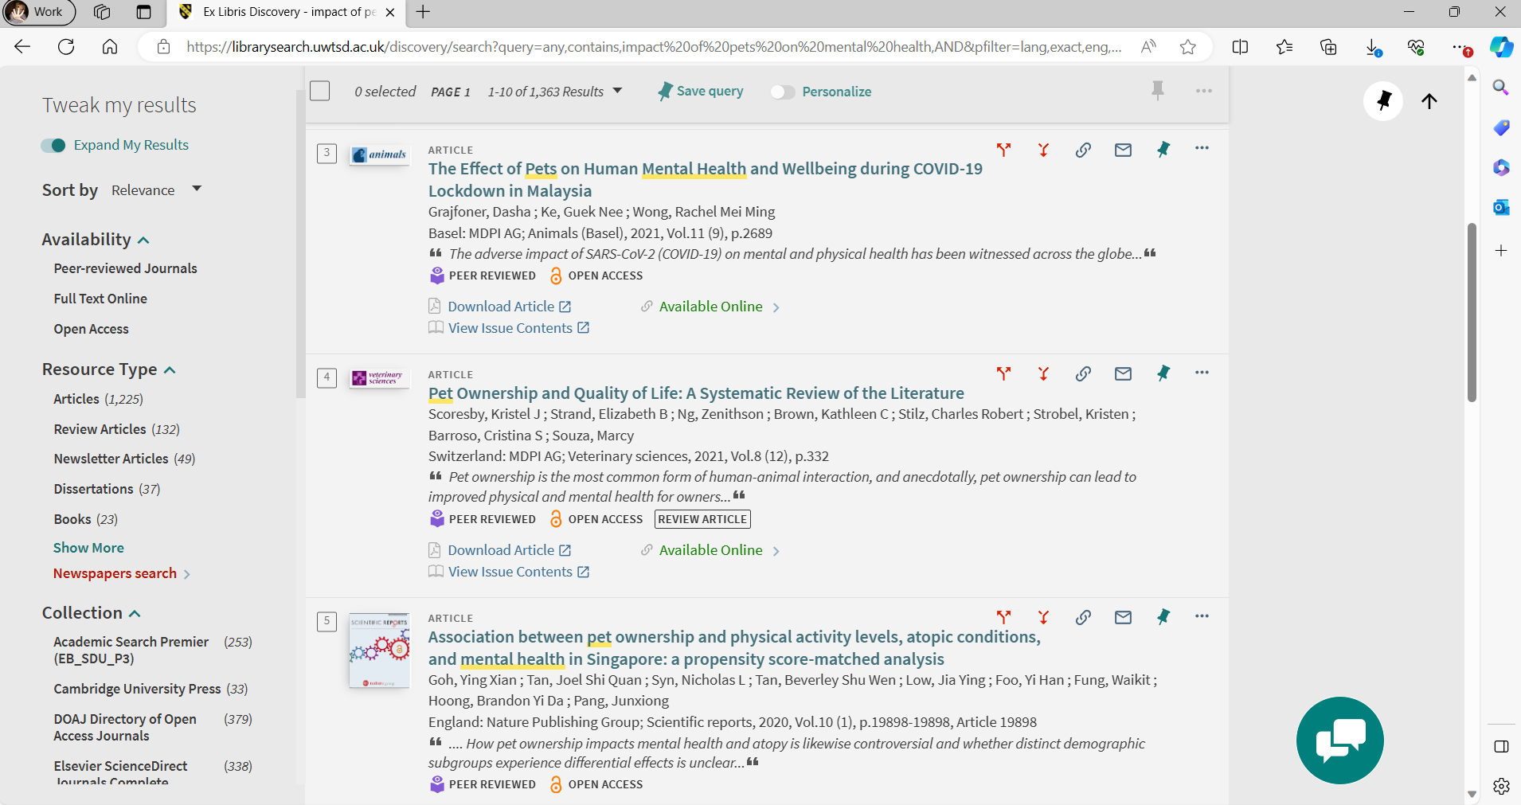

Summary of sources
Explanation of Library Search: To find psychological benefits, a library search query can include specific terms like "pet therapy," "psychological benefits of pet ownership," and "impact of pets on mental health." The screenshots will demonstrate the search procedure, showing how academic databases and specific search phrases are used. The recentness of the sources, the standing of the journals or publishers, and the research's methodological rigour will all be considered when determining relevance and trustworthiness. This methodical methodology guarantees that the chosen sources contribute significantly to investigating the psychological advantages of pet ownership.
Screenshots illustrating the process of searching the library for social advantages using specific queries like "impact of pets on social skills," "pets and community engagement," and "social benefits of pet ownership" will be made available. The explanation will detail the evaluation criteria utilized for sources, which include the methodological rigor of the studies, the reputation of the journals or publishers, and the consideration of recency. This methodical methodology guarantees that the chosen sources contribute significantly to investigating the social advantages of pet ownership.

References (All references for each task)

Article Summary Reference
The British Psychological Society. (2022, September 12). How does music make you feel?. BPS. https://www.bps.org.uk/psychologist/how-does-music-make-you-feel
Infographic References
Fambely, C. A. (2020). Committed to yourself or have yourself committed: Balancing family life with student success. Canadian Journal of Dental Hygiene, 54(1), 16.
Suskie, L. (2018). Assessing student learning: A common sense guide. John Wiley & Sons.
Zimmerman, B. J., Greenberg, D., & Weinstein, C. E. (2023). Self-regulating academic study time: A strategy approach. In D. H. Schunk & B. J. Zimmerman (Eds.), Self-regulation of learning and performance (pp. 181-199). Routledge.
Essay Layout References
Brooks, H. L., Rushton, K., Lovell, K., Bee, P., Walker, L., Grant, L., & Rogers, A. (2018). The power of support from companion animals for people living with mental health problems: A systematic review and narrative synthesis of the evidence. BMC psychiatry, 18(1), 1-12.
Hoy-Gerlach, J., Vincent, A., Scheuermann, B., & Ojha, M. (2022). Exploring benefits of emotional support animals (ESAs): a longitudinal pilot study with adults with serious mental illness (SMI). Human-Animal Interaction Bulletin, (2022).
Grajfoner, D., Ke, G. N., & Wong, R. M. M. (2021). The effect of pets on human mental health and wellbeing during COVID-19 lockdown in Malaysia. Animals, 11(9), 2689.

