
Skills for the Workplace
Module Assignment Submission
Student Name: | Rachel Witheridge
Student Number: | 2106781
Module No: | BMSK5008
Module Title: | Building your Personal Brand for Sustainable Employment

Statement of Confirmation of Authenticity
By the act of making this submission, the student declares that this is the work of the student named above. The work has not, in whole or in part, been knowingly presented elsewhere for assessment, or where assessment has been built on a previous assessment, this has been identified. Where materials have been used from other sources it has been properly acknowledged. If this statement is untrue, the student acknowledges that an assessment offence has been committed.
Attention is drawn to the plagiarism and unfair practice policies of both the University and of ILM.

Table of Contents
INTRODUCTION 3
Section 1: Brand You 3
Section 2: It’s a Small World 3
Section 3: Opportunity Knocks 4
Section 4: The Pursuit of Happiness 5
Section 5: Conclusion 6
References 6

INTRODUCTION
I will be reflection on my learning throughout the module Building your Personal Brand for Sustainable Employment. I will be using the Kolb model of reflection to identify the key lessons I have learned and how this has enabled me to develop my personal brand. I will cover Brand You, It's a Small World, Opportunity Knocks, and the Pursuit of Happiness. Learning how to develop a PDP (personal development plan), an informative CV and create a Zander letter and its benefit.
(Virtanen, 2023)

Section 1: Brand You
This unit covers the following sections:
- Ambition is critical
- What drives you?
- Boundaryless careers
- Boundaryless skills
What I have learnt from this unit is what ambition means to me and this is the desire to achieve personal and professional advancement. Being authentic is what sets me apart from others, remaining loyal to my own character, principles, and spirit despite external pressure to do differently. I will take ownership of my own errors being sincere both with myself and others and I will be prepared to bear the costs of standing by what I think is right. Goal setting and goal through, and how I want things to be, needs to be seen to achieve that goal.
After completing this section, I feel more confident in what my ambition is, setting goals and through goals ideas of how to achieve this.
Next time I am going to set through goal ideas. As I am moving home this year, I will need to better my time management and set realistic time aside for study to help me reach my goal and to complete year five of this degree. This section has helped me complete my PDP (personal development plan) by setting realistic goal ideas in the areas I need to improve on and when I need to review these goals.

Section 2: It’s a Small World
This unit covers the following sections.
- No one is an island
- Variety is the spice of life
- Network society
What I have learnt from this unit is to be able to evaluate my network, such as connections in work or in study. Being able to recognise networking potential, positive links and potential collaboration that is essential to develop. For example, building relationships, being able to discuss work related issues with colleagues and how we can improve our services by sharing information.
I feel I am now more able to better my network in both my professional and educational carer by evaluating and developing awareness.
My future strategy is to implement tactics, such regular reviews with my supervisor and the defined goals I've outlined in my PDP. Also, with the help of my lecturer, analyse assignment feedback and determine how I might improve my learning. I'll be able to improve and develop as a result of this.

Section 3: Opportunity Knocks
This unit covers the following sections.
- Creating your own luck
- Identifying career opportunities
- Open doors
- Me.com
What I have learnt from this unit was The Cynefin Framework and how to create a CV.
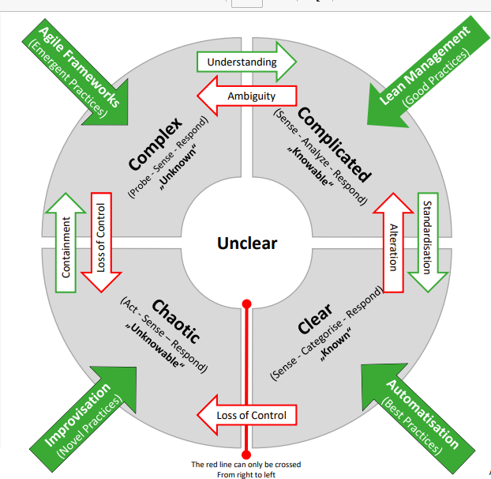
At first, every new issue and duty appears in the middle of (unclear). We are assigned to one of the nearby places based on the information that is currently available. Each of these sections offers a suitable (but optional) method of moving forward. Regular reviews confirm if red factors (irritations) or green ones (learning effecs) are having an impact on the issues and tasks. If necessary, you can relocate them to the next region so they can be managed better there. It illustrates four situations that can help with decision-making.
(Agile process gmbh - cynefin (n.d.)
- Complicated – the known unknowns, facts must be assessed and necessary, in order to apply any appropriate solutions, cause and effect can be established from this.
- Clear – the known. Specific rules in place to maintain stability, cause and effect can be easily established.
- Chaotic – too confusing to form a response based on facts and knowledge and cause and effect cannot be established. Need to act first in order to regain order, then make sense of where stability can be found and respond to resolve.
- Complex – unknown unknows solutions can only be discovered at the end of a process once cause and effect can be established.

I have also learnt how to better my career opportunities through active luck and creating career conversations. Identifying the opportunities that are best suited to me for example what am I good at? what do I enjoy doing? And who’s doing what I want to do? Applying for a for job vacancy with a CV alone will only give the employer a basic outline of my previous workplace history however this module has enabled me to create an introduction where I can sell myself and explain more on what my capabilities are within a workplace for example dealing with difficult customers, able to meet an urgent deadline. All of these things are important information for an employer to know.
I feel more confident putting a CV together following this module especially when it comes to selling myself on paper.
Going forward I am going to use the Cynefin Framework to better myself in making difficult or unclear decisions. I am also going to use this module to help me gain future opportunities within my work workplace by creating career conversation with colleagues who are in a higher position than me to gain their knowledge.

Section 4: The Pursuit of Happiness
This unit covers the following sections.

- Future me
- Passion and perseverance
- Plan, prepare, perform
- Career role models

What I have learnt from this unit is that we all have limited beliefs even though they are not true we let them control our lives. We may think I am not good enough, not smart enough or even I’m too old. Limited beliefs are often acquired in childhood though parenting or school experiences or from our history, culture or religion. I often have these thoughts especially when I was enrolling in university. I finished school and went straight into work I never went to college so the though of starting university was scary and my limited beliefs were, I’m too old, I never went to college, so I’ll never be good in university or even I’m too thick. But I overcame these with a positive mind set and by telling myself unless I tried, I would never know and the reason I wanted to enrol in university was to learn essential skills to better myself and progress in my workplace.
I have also learnt the art of possibility and being able to break free from limited beliefs to become successful. I like the quote from Thomas A, Edison ‘if we did the things, we are capable of, we would literally astound ourselves.’.
I have also learnt Benjamin Zander was face with a dilemma over a period of 25 years that his student was anxious about their performance and were unwilling to take risks creatively. His solutions were to give every student an A grade at the beginning of the course as a tool to encourage them to explore new possibilities. The students were not to slack off their work for the rest of the year instead they were asked to write a letter to themselves in the future within the first 2 weeks of starting the course on how they received an A.
(Ian, 2019)
This unit has helped me create my own Zander letter on how I felt receiving a 1st and what obstacles I have had to overcome to achieved this.
Although I have learnt a lot from this unit, I also had to go through it several times. I read too much into it and don’t end up taking the information in.
In the future I am going to take more notes when going over the units this will help me reflect on what I have read. I will also be reflecting on the positive self-talk I found that an interesting watch.
(Removing negative self talk | Abria Joseph | TEDxYouth@NIST 2015)

Section 5: Conclusion
Throughout this course I have learnt what ambition means to me, to feel more confident in setting goals and though goals. The need to better my time management to help me set time for study. Being able to evaluate my network and build new relationships, to improve services by information sharing and to implement tactics and improve learning.
To improve my career opportunities, creating a better CV, and using the Cynefin framework to make clear decisions. Overcoming limited beliefs and using positive mindset and believing in myself that I can do it!.

References
Agile process gmbh - cynefin. (n.d.). https://www.agile-process.com/wp-content/uploads/2021/05/Agile_Process_Cynefin_EN.pdf
YouTube. (2015, November 2). Removing negative self talk | Abria Joseph | TEDxYouth@NIST. YouTube. https://www.youtube.com/watch?v=teVE3VGrBhM
Ian. (2019, June 5). We’re all “A” grade. orchestra conductor Benjamin Zander’s secret for unlocking greatness. Challenging Coaching. https://challengingcoaching.co.uk/were-all-a-grade-orchestra-conductor-benjamin-zanders-secret-for-unlocking-greatness/
Virtanen, A. (2023, June 20). What is Kolb’s experiential learning theory? Growth Engineering. https://www.growthengineering.co.uk/kolb-experiential-learning-theory/

