Data handling
Student name: Iveta Kazalieva
Student ID: 2024058

Contents
Part 1 3
Determine the decline in sales or profits over the years 3
Evaluate the use of Excel for pre-processing the data, analyzing the data and visualizing the data 3
Excel functions examples 3
Charts 3
Graphs 3
Part 2 4
Analysis 4
Pie 5
Bar 5
Histogram 5
Example of clustering 5
Data mining and text mining methods can be used by business with real world examples 6
Advantages and disadvantages of using SPSS and Excel present you discussion in table 6
Conclusion 6
Referencing list 6

Part 1

Determine the decline in sales or profits over the years

When observing the data from the provided file we can see that the total amount of sales for the whole period is 14915600.82 with the top sale of 8906 and minimum sale of 2.24 and this showing how huge is the difference between the minimum and maximum spend. The provided information can be very useful if observed properly about increasing and more control over the sales and generating maximum profit. In many occasions we can see that management is focused over the revenue, but it is also very important to measure the percentage of profit which are generate from each sale. Observing the profit level we can see that the maximum is 27220.69 and the minimum is -14140.7 this is showing that some of the products or services are sold with very serious discount versus the purchase supplier price and this need to be actioned on time before impacting the company performance and sustainability.

Evaluate the use of Excel for pre-processing the data, analyzing the data and visualizing the data

Excel's Analyze Data feature gives you the ability to ask questions about your data in natural language rather than having to create laborious formulas. Additionally, high-level visual summaries, trends, and patterns are offered by Analyze Data.

In addition to excellent flexibility, superior number crunching abilities, and accessibility Additionally, MS Excel offers its users a number of advantages, such as the ability to easily layout and rearrange data, Analyze data using graphs and charts, identify trends and patterns in large data sets, and perform data processing.
You can configuration your text data in a worksheet or notebook using Microsoft Office Excel, which is designed to give you a thorough understanding of all your information. Excel worksheets and spreadsheet applications can be used to consolidate details and information from different files and locales so that they can be squeezed and analyzed on a single document. Configuration your worksheets simply by using different color shades, bold type, and italics to highlight the most crucial information. Extremely helpful when trying to present a wide range of figures related to the same subject, such as accounting records including pre-tax profit and the firm's stability conducted forward. Additionally, MS Excel gives users the option to choose a suitable color scheme for fast analysis.

Excel functions examples
1.Filters

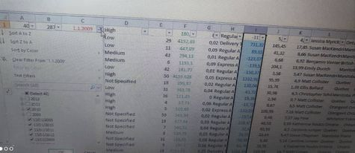

2. Minimum
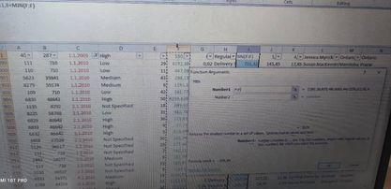
3. Maximum
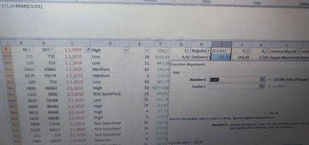

Charts
Profit and sales

Part 2

Analysis

In the provided data there is in total 200 participants which makes the research with good level of participants and the observed data should give good outcomes as need to measure the link between the different scores between the results from game scores ( video ), puzzle scores ( puzzle ) and gender. There is total number of 92 Males and 109 Females into the provided data.
Male | 0 | 92
Female | 1 | 109

If we use excel tools to find out the number of participants which love the different flavors we can see that there is Vanilla preferences of 95 participants, Chocolate – 47 and Strawberry – 58. This showing that Vanilla preferences are much higher compare to other preferences with nearly double results from the total 200 people.
1 | Vanilla | 95
2 | Chocolate | 47
3 | Strawberry | 58

If we observe the maximum preferences of the video and the puzzle using the formula ‘’ max ‘’ we can see that the video max is 74 and for the puzzle the number is 71. This showing more preferences to the video from the total participants.

Video max | 74
puzzle | 71

If we select by criteria out from the total number females and males then we can see that based on the answers and data that all females prefers vanilla flavor and then the males have the other preferences for Chocolate and Strawberry. This can be used as base for advertising the offering more Vanilla flavor to the males so this can increase the interest and preferences there too which will boost this type of sales.
Mean chocolate = total value / total participants = 47 / 200 = 23% ( 0.23 )
Mean strawberry = total value / total participants = 58 / 200 = 29% ( 0.29 )
Median chocolate = 2
Median strawberry = 2

Pie

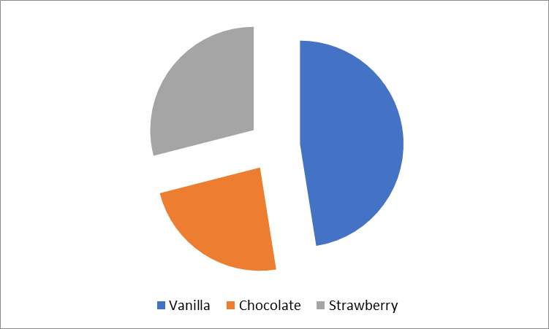

Bar
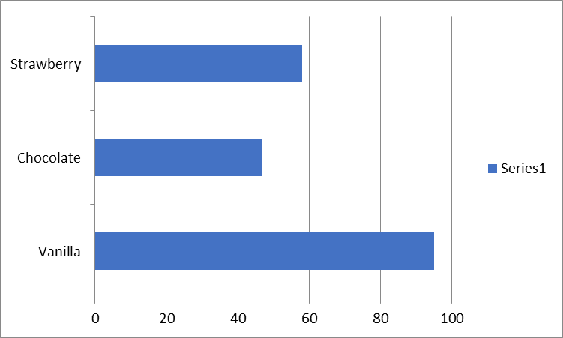

Histogram

Example of clustering

Finding similar examples is the first step in grouping similar instances. By incorporating the extracted features from the instances into a metric—referred to as a similarity can assess how similar instances are. It is simple to gauge similarity when each instance is defined by just one or two characteristics. You can find comparable books by their authors, for instance. The process of developing a similarity metric becomes much more difficult as the number of characteristics rises. Afterward, we'll see how to construct a similarity in various contexts.
In our example of data and target analysis we can see that the most preferences are for the vanilla flavor mostly only across the females and the other choices are preferred by the males. This gives tools and possible strategies for motivating the males to prefer also vanilla flavor or to motivate the females to start prefers the other flavors.

Data mining and text mining methods can be used by business with real world examples

The massive amount of data that is produced each day by companies is both a challenge and a chance. On the one hand, data enables businesses to gain insightful knowledge about consumers' perceptions of a good or service. Consider all the suggestions you could discover by studying emails, review sites, social media comments, client feedback, support tickets, etc. The problem of how to handle all of this information is on the other side. And this is where text mining is crucial. Text analytics may appear to be an abstract idea, like many Natural Language Processing (NLP)-related concepts. But the truth is, it doesn’t need to be.
Mining is important as it can give to the company much more information, data and knowledge about the opportunities, demand, trends and the customer preferences. Many companies firstly create content and post it and then before any decision taken they observe the target group reactions, engagement, feedback from the potential customers and this can be used for generating maximum sales, low cost and high profit from the provided services and products.

Advantages and disadvantages of using SPSS and Excel present you discussion in table

The Statistical Package for Social Science (SPSS) is a software program. When it comes to statistical packaging tools that are effectively used as a substitute for manipulating data and data transfer, SPSS dominates the market. In terms of engaging batches and non-interactive batches, it is primarily used for batch systems. It was a patented invention by SPSS Inc. that was later bought by IBM in 2009 and placed under their umbrella. In the 2015 version, it was given the new name IBM SPSS Statistics. It presently has a V-2015 steady build.
Quantitative data analysis frequently involves the use of statistical software package like SPSS. The research scientist can perform quantitative analysis and classify qualitative data using coding to find themes that relate to the research queries. Because the majority of the methodology is digitalized, SPSS makes it easy for investigators to set up models. Once the data are in, SPSS begins to work its magic. There are countless things we can do with this information. The way that SPSS extracts data from crucial data is also distinctive. Among SPSS's features are trend analysis, suppositions, and make predictions. The Excel system is quite complex. You must be able to maneuver through the graphical interface, which is significantly more difficult than in its original concept, in order to use it effectively. Users could simply point and click to create beautiful charts and graphs in earlier designs. But over the years, Microsoft has added so many functionalities that they now need to be retrieved through various locations and/or gets completed menus. This has led to some misunderstanding and even led to the removal of some functionality that users liked.

Conclusion

From the above part 1 and part 2 tasks we can see how important and efficient is the usage of data handling programs and systems. The management is able to take better and more productive decisions for the short and long terms investments and sales. The decisions based over the fugures and facts are important, because their success can be much more productive versus the decisions taken based over experience. Now a days management is forced to be very precise and correct for achieving maximum profit for the company and this is the reason why the company asking the managers to take decisions mostly based over the data.

Referencing list

Akuns, U. and Okafor, S., 2022. Big data analytics: virtuosity in Lean Six Sigma for quality assurance in supply chain management. Interdisciplinary Journal of Economics and Business Law, 11(2), pp.44-72.
Beckers, J., Birkin, M., Clarke, G., Hood, N., Newing, A. and Urquhart, R., 2022. Incorporating E‐commerce into Retail Location Models. Geographical Analysis, 54(2), pp.274-293.
Charles, V., Gherman, T. and Emrouznejad, A., 2022. Characteristics and Trends in Big Data for Service Operations Management Research: A Blend of Descriptive Statistics and Bibliometric Analysis. In Big Data and Blockchain for Service Operations Management (pp. 1-18). Springer, Cham.
Chen, X., Owen, Z., Pixton, C. and Simchi-Levi, D., 2022. A statistical learning approach to personalization in revenue management. Management Science, 68(3), pp.1923-1937.
Olabode, O.E., Boso, N., Hultman, M. and Leonidou, C.N., 2022. Big data analytics capability and market performance: The roles of disruptive business models and competitive intensity. Journal of Business Research, 139, pp.1218-1230.
Schiessl, D., Dias, H.B.A. and Korelo, J.C., 2022. Artificial intelligence in marketing: a network analysis and future agenda. Journal of Marketing Analytics, 10(3), pp.207-218.
Turgut, Y., Kose, Y., Ustundag, A. and Cevikcan, E., 2022. Business Analytics for Managers. In Business Analytics for Professionals (pp. 3-20). Springer, Cham.
Youssef, M.A.E.A., Eid, R. and Agag, G., 2022. Cross-national differences in big data analytics adoption in the retail industry. Journal of Retailing and Consumer Services, 64, p.102827.
Ziemba, E., Eisenbardt, M., Mullins, R. and Dettmer, S., 2022. Consumer engagement in business process innovation–ICT companies cases from Poland and UK. Journal of Computer Information Systems, 62(2), pp.302-315.

