
Masters of Business Administration: Human Recourse Management
Module Assignment Submission
Student Name: | Yoana Georgieva
Student Number: | 1714886
Module No: | LCMB7000
Module Title: | Human Recourse Management
Lecturer: | Gladius Kulothungan

Statement of Confirmation of Authenticity
By the act of making this submission, the student declares that this is the work of the student named above. The work has not, in whole or in part, been knowingly presented elsewhere for assessment, or where an assessment has been built on a previous assessment, this has been identified. Where materials have been used from other sources, it has been properly acknowledged. If this statement is untrue, the student acknowledges that an assessment offence has been committed.
Attention is drawn to the plagiarism and unfair practice policies of both the University and of ILM.
Table of content

Introduction 3
HRM Strategies in Change Management 3
Recalibrate Duties of Employees 3
Reporting to Managers Regarding Change in Structure 3
HRM Strategies in Leadership Development 3
Part 1 3
Part 2 4
HRM Strategies in Staffing: Retention 4
Development and Training 4
Acquire Correct Rewards and Recognition 4
How Chosen HRM Strategies Make Employees Feel Appreciated and Valued 5
Allow Learning and Growth 5
Boost Confidence 5
Engross Creativity 5
Communicate Benefits and Compensation 6
Offer Meaningful Work 6
Principles of HRM 6
“Principles of Scientific Selection” 6
“Principles of Effective Communication” 6
“Principle of High Morale” 7
Models of HRM and IHRM 7
“The Ulrich Model” 7
The 8-Box Model 8
Concepts of IHRM and HRM 9
Engagement 9
Employee Experience 10
Conclusion 10
References 11

Introduction
HRM plays a vital part in altering, reinforcement and development of a culture of a company. Development and training, performance management and on-boarding are all necessary constituents of the culture of business covered by HRM. HRM basically is the business` division that has the liability to train, recruit, screen and find job candidates, and also administrating programs related to employee benefits as stated by (Uysal, 2019). With no HRM, firms will not be capable to retain and recruit workers efficiently. The department of HRM extracted its basis from the regulation of organisational psychology and has confirmed to be integral practice in organisational management. In present business, the department of HRM has developed to become tactical and has progressed to become an importance force (Uysal, 2019). Researchers intricate that in the business world, as time are passing, rivalry is constantly increasing and the only factor that fastens the competitive benefit of a company is HRM.

Tesco is one of the foremost retailers within the industry of UK, and is moreover one of the core retailers of food at a global level. Tesco was started in 1919 when “Jack Cohen” begins to selling extra groceries from a very small stall within the “East End Market of Brixton” which is present in London. In 1930, the company continues to progress and Mr. Cohen has chosen to construct the company`s headquarter at North London, and in 1932, the company became a PLC. Later in 1947, the stores of the company have floated at the utmost level of a stock market with a price of share of 25p. Tesco was initially started as a store of grocery, but has now enlarged into a broader market with several variety of retail.

HRM Strategies in Change Management

Recalibrate Duties of Employees

Adjusting and assessing liabilities of employees occurs once there is an appropriate alteration on the possibility. Understanding what the change really is will inform how professionals of HR work with every worker and examine their present liabilities (Stone et al., 2020). The result of this particular phase eventually results in various probable adjustments, involving changes to salaries, roles and titles, and also fresh acquisition of talent to fill a fresh requirement.

Reporting to Managers Regarding Change in Structure

With the data attained in Tesco, professionals of HR have an enhanced clutch of how the change will impact workers and surely can accumulate this data to present to such HR who basically is in charge of intending and executing change in Tesco.

HRM Strategies in Leadership Development

Part 1
Decision making and leadership development, highlights the implementation and formulation of HRM strategies that offers value and donate to objectives of the Tesco.

- Understand how value is made via HR
- Draw on several frameworks for driving change and progression through management of HR
- Influence HR to implement strategy of business
- Recognise and approaches of model for making significant decisions under uncertainty and risks
- Significantly assess information to resolute the HR`s ROI and impact on the Tesco
- Enhance making of decisions via the exploitation of scenario planning and business analytics

Part 2

Development of leadership, stresses the cultivation of engrossing relations with external as well as internal stakeholders and also the partnership and trust`s environment within HR teams.
- Progress efficient interpersonal relations crossways boundaries for leadership development
- Train co members towards the attainment of outcomes of leadership
- Endorse shared liabilities and responsibilities throughout Tesco
- Communicate objectives of leadership efficiently and convincingly
- Exploit influence strategies as well as cooperation strategies for competitive benefit
- Exploit adaptive styles of leadership relied on context (Shah, 2019).

HRM Strategies in Staffing: Retention

Development and Training

To meet employees` finest level requirements, employees in Tesco are required to experience personal growth. Professionals of HR can aid this procedure by providing programs of training within Tesco and paying for workers to attend programs and seminars (Ratnawat, 2018). Additionally, many firms provide programs of training compensation to aid workers definitely earn a degree. One of the fast food restaurants in UK provides 15,000 pounds for scholarships of around 3 years to workers working 21 hours per week. Also, there is a waiting time of 7 months, and the workers should continue to work for around 21 hours per week. In an utmost turnover industry, such programs boast one of the finest rates of retention around.

Acquire Correct Rewards and Recognition

Workers who sense appreciated and valued work harder and remain at firms for a longer time, but over 82% of UK workers state that they do not sense rewarded or recognised. Constructing a recognition`s culture is more than recognising employees after every few time. It needs specific, recurrent acknowledgment. “The Brandon Hall Group” found that firms that recognise workers couple of times a month are 39% more possibly to view enhanced retention of employees and 35% more possibly to view enhanced engagement.
To make continual recognition an actuality, the company must prioritise both monetary rewards and social recognition, if possible by exploiting a platform of recognition that aids everybody to get on the action (Ivanov et al., 2020). Such platforms endorse reward systems based on points that let workers accrue and redeem points for extra rewards that really matter to them. And they make viewing recognition very simple whether workers are working from home or from office, as they can simply send appreciation message to anybody at their firm wherever and whatever works best for them.

How Chosen HRM Strategies Make Employees Feel Appreciated and Valued

Feeling appreciated as well as valued at office is something every employee demand to perform their best, whether they do or do not admit it.
In one of the research circulated by “Harvard Medical School”, aiding workers sense appreciated was displayed to have a finest effect on company`s performance. Scholars divided individuals into 2 groups of fundraising and they were told to make calls to ask for donations. The 1st group made call every day as normal; the 2nd group got a “pep talk” to let customers how thankful they were for their donations. In this manner employees sense quite appreciated and valued by the Tesco.

Allow Learning and Growth

(Eker et al., 2018) stated that it is a greatly vital thing to take into consideration when attempting to show appreciation to workers. Does the group of employees give adequate development and learning opportunities? Do they endorse employees to progress personally and professionally? Investing in the development of employees shows that a company really values their competencies. It is specifically factual when somebody is keen in chasing a path of career diverse from wheat their present roles generally are. Are companies clear to providing opportunities of learning beyond employee’s sole role? Are they also ready to accept the truth that individuals outgrow their present positions or might also outgrow the firm?
It could be probable for Tesco to remain on top of the career ambitions of employees and converse opportunities of development 1-on-1. Yet, Tesco or their HR managers must ensure that their employees acquire few support related to career from their mentors or HR managers (Collins, 2021). Endorse 1-on-1 performance reviews, career coaching and goal-setting. Such initiatives will possibly be really rewarding both for employees and for the firm wholly.

Boost Confidence

Tell the team where their capabilities are really shining the most. Tesco exploit few kind of yearly performance review, but do not let that avert them from telling their workers where they are appreciated and why. Rather than just saying “Thank You”, help employees recognise, for instance, why their absolutely polished phone calls or e-mails with customers are vital to the mission of the team.

Engross Creativity

At certain times, people think that their work is really constrained by lawful realities or rules that there is no specific room for innovation. Though, creativity is denoted in each and everything that employees do. Every person exploits their intelligence to associate with customers in means that reverberate with the person, and moreover, optimistically, with customers. The more the Tesco offers their employees the chance to express themselves innovatively, the more engrossed their workers will be.

Communicate Benefits and Compensation

The benefits of strategy related to compensation management just go as far as employees` skills of communication. That is, if workers do not understand they are getting paid fairly, they normally would not make that particular assumption themselves. Some years back, “PayScale” found that many people do not really understand if they are or are not getting paid fairly. Their report displayed that around 61% of employees who were specifically paid at the rate of market and 31% of individuals who were really paid above the rate of market sensed that they were getting underpaid (Boon et al., 2019). Of those workers who were given the pay below the rate of market, 84% yet sensed pleased with their job if their manager communicated efficiently related to the causes of lesser compensation. This means that company`s plan for compensation and communicating strategy is only as vital as the tactic itself. Perception plays a strong role in appreciation of workers, if employees in a company recognises why they are getting paid the means they are paid, that quickly lessens the stress of assuming, wondering and guessing the worst.

Offer Meaningful Work

This final strategy for how to make workers sense appreciate and valued is the least substantial, as this concerns the emotional requirement of workers for carrying out meaningful work. “Gallup” recognised this as a core engagement constituent, though, this particular research displayed that just 43% of the employees of UK agree that they can view the link amid the organisation and their role. When employers aid workers recognise how the work of them donates to the goals of the Tesco, workers are 3.7 times more probably to be engrossed as per to the research of (Anbu, 2019). Executives as well as the managers can aid workers make this particular link by understanding finest work at each degree, specifically such positions that are least visible. For instance, every month the team of executives of “BambooHR” hosts a meeting company-wide and also invite several teams to present their goals and wins. Not just does this offer finest visibility into every department, but this moreover sends the message that every team is a core piece for the Tesco, from IT to customer experience and each and everything in between.

Principles of HRM

“Principles of Scientific Selection”

For an appropriate coordination amid employees and work, it is essential to have correct employee for vocation so that the inability`s question of that employees will not arise and employees will be capable to acquire and perform task as per to their interest. The applicants are to be chosen according to merit candidates` achievement, experience and qualification are to be thought or and incomplete selection is to be averted.

“Principles of Effective Communication”
There should be efficient communication medium amid employees and HR management. Communication significantly means that, higher authorities` orders are expressed in an appropriate manner. If this particular arrangement is not efficient than these things might arise difficult issues such as ill-will, hatred and mistrust and this as a result impact the organisational production.

“Principle of High Morale”

It is necessary to have a finest morale for employees and their work. With this notion, ideal policy of wage must be provided in Tesco. The finest morale would be in specific position to make a feeling of motivation and constructive attitude. These things are really vital for acquiring the goal in timely manner and with more efficiency.

Models of HRM and IHRM

“The Ulrich Model”

Dave Ulrich initiated this model in 1995 and he later elaborated this model in 1996. This particular model concentrates on classifying each influence of the HR policy of Tesco into 1/4th roles.
- Employee champion
- Administrative expert
- Change agent
- Strategic partner
In addition, the senior leadership and the CEO play their part. With this particular model, his entire procedure of HR takes a back seat to the employees of Tesco and the parts that they execute. This specific model is moreover recognised as the “business partner model”.
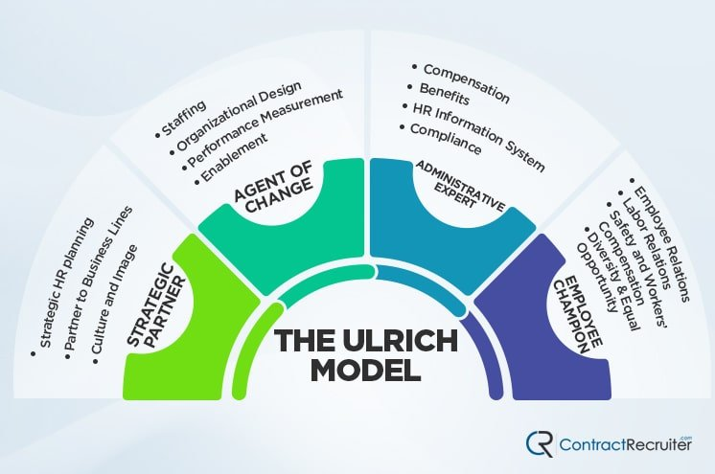

There has been a significant debate in present years as to whether this model is viable or not in present times. Current sensibilities favor that everybody within Tesco has their individual voice instead of some organisational influencers and distinct “champions” (Alomari, 2020). Yet, this model could be a really useful means to consider HR in term of employees included instead of the algorithms and processes in use.

The 8-Box Model

This particular model is a more wide-ranging model progressed by ‘Paul Boselie”, and this model thinks of more exterior factors than numerous of other HRM and IHRM model.
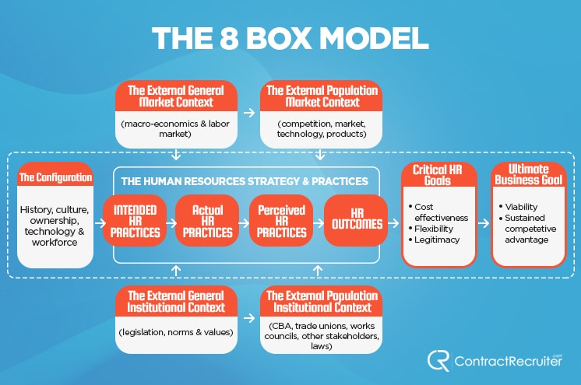

This specific model comprises of the 8 boxes of factors, 1 of which is sub-divided as the heart of the HR processes of business.
- The “Configuration” box is the business` formative influence and involves the workforce, technology, culture and history of the business. This leads into:
- The “HR Strategy and Practice” box includes the planned practices of IHRM, the real practices of HR of the firm, the distinguished practices resolute by how workers view them from the ground up, and the entire outcomes of HR. This particular box later feeds into:
- The “Critical HR Goals” box described the entire HR goals within the company, involving legitimacy, cost-effectiveness and flexibility (Aburumman et al., 2020). This particular section nourishes into the last one:
- The “Ultimate Business Goals” box, as one could forecast, this particular section examines the entire goals of the company, for example competitive benefit and viability.
According to (Shah, 2019), the above defined 4 boxes are fed by 4 other influences boxes. These actually are the external context of the general market, the external context of population market, the external context of general institutional, and the external context of population institutional. Each of these nourish into the main practice box and HR strategy, manipulating both the perceived and actual practices. Moreover, they nourish into and impact each other (Aburumman et al., 2020). This particular model is one of the difficult models of IHRM and HRM, and whilst it could be efficient, it takes more particular consideration, analysis and training to put into practice efficiently. This model is widely more useful as a theory than normal practice of Tesco.

Concepts of IHRM and HRM

Engagement

Let’s begin simple. The primary concept each professional of HRM must understand is engagement. Engagement really has been the “holy grail” of IHRM for a very long time (Eker et al., 2018). Many of us are recognisable with engagement. This is said to guide to more productivity lesser defects in products, finest quality of the product and less turnover of employees (Eker et al., 2018). Engagement is basically the burnout`s polar opposite. When employees who categorise as being really burned out have reduced energy, are expressively disengaged from office and are skeptic, employees who are engrossed in IHRM have finest energy, devoted to their workplace, and frequently lose their “sense of time” when performing.

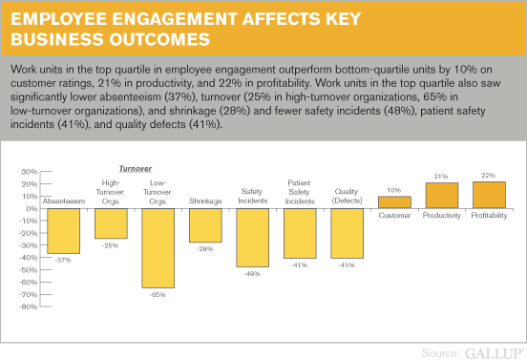
The picture above displays the differences amid business outcomes and work of the 25% in engagement of employees in contrast to bottom 25%. This explains why HRM has put loads of attention on attempting to gauge and endorse engagement of employees.

Employee Experience

One of the core concepts of HRM that has coined more frequently is experience of employees. Experience of employees is the means employee’s sense related to what they deal with and views over the course of organisational journey as employees. Experience of employees at Tesco provides a rather fresh viewpoint to performing HRM (Boon et al., 2019). When engagement of employees is viewed as a finest result for employees, experience of employees is the means HRM as well as IHRM is perceived. Hence, this is viewed as the core driver for Tesco and employee outcomes.
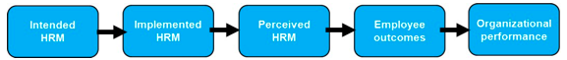

Conclusion
As a conclusion, HRM is no longer a supporting operation or a backroom. HRM is in the front line of companies` strategy, much similar to marketing and sales. The competitiveness of HRM is resolute and offered to an enhancing degree. Yet, there is still a finest means to go for HRM to become tactical partners; it requires to coach itself on program or agency permission to recognise what is vital to the company and be capable to offer effective, creative solution or alternative to issues present in the company.

References
Aburumman, O., Salleh, A., Omar, K. and Abadi, M., (2020). The impact of human resource management practices and career satisfaction on employee’s turnover intention. Management Science Letters, 10(3), pp.641-652.

Alomari, Z., (2020). Does human capital moderate the relationship between strategic thinking and strategic human resource management?. Management Science Letters, 10(3), pp.565-574.

Anbu, D., (2019). A review on human resources management (HRM) theories and effective human resource management models. Asian Journal of Multidimensional Research (AJMR), 8(5), pp.81-93.

Boon, C., Den Hartog, D.N. and Lepak, D.P., (2019). A systematic review of human resource management systems and their measurement. Journal of management, 45(6), pp.2498-2537.

Collins, C.J., (2021). Expanding the resource based view model of strategic human resource management. The International Journal of Human Resource Management, 32(2), pp.331-358.

Eker, S., Rovenskaya, E., Obersteiner, M. and Langan, S., (2018). Practice and perspectives in the validation of resource management models. Nature communications, 9(1), pp.1-10.

Ivanov, M., Ivanov, S., Terentieva, N., Maltiz, V. and Kalyuzhnaya, J., (2020). Fuzzy modeling in human resource management. In E3S Web of Conferences (Vol. 166, p. 13010). EDP Sciences.

Ratnawat, R.K., (2018). Competency based human resource management: Concepts, tools, techniques, and models: A review. Competency.

Shah, M., (2019). Green human resource management: Development of a valid measurement scale. Business Strategy and the Environment, 28(5), pp.771-785.

Stone, R.J., Cox, A. and Gavin, M., (2020). Human resource management. John Wiley & Sons.

Uysal, G., (2019). Quantitative Methods in Human Resource Management. Journal of Modern Accounting and Auditing, 15(7), pp.367-370.

