Jessica Dudusova
Peterborough PE1 2TX
+44 7878312958
Jessicadudusova123@gmail.com
PROFESSIONAL PROFILE

A motivated and hard-working business management student with a strong interest in beauty industry particularly nail technology and lash artistry. Flew on in both English and Slovakia I have excellent communication skills and enjoy interacting with other people from diverse backgrounds. I have achieved a distinction in level three businesses studies, I have developed strong organised teamwork and problem-solving abilities. I am reliable and eager to work and learn with positive attitude and commitments to provide expectational customer service, while contributing positively to many team or business environment.
EDUCATION
~University of Wales Trinity Saint David (Birmingham) | 2024 – Present
Business Management
~Developing knowledge of business strategy, marketing, leadership, and organisational behaviour.
~Strengthening analytical, communication, and decision-making skills through coursework and group projects.
~Building an understanding of how businesses work in competitive environments.
SCL College | 2023 – 2024
Level 3 BTEC in Business Studies
Result: Distinction
~Gain knowledge of business principles, marked in finance and customers relations
~Developed strong presentation, research, and teamwork skills
~Improved time management and the ability to work effectively under pressure.

Joseph Leckie Academy (2018-2023)
GCSE including maths, English, science, and PE

Key skills
Communication skills
- Active listening
- Team collaboration
- Verbal and writing communication

Problem solving skills
- Multitasking
- Time management
- Prioritisation
Key skill
- Good at talking and working with other people.
Able to manage time and stay organised.
• Comfortable using Microsoft Office and basic computer programs.
• Can work well alone and with a team.
• Good at solving problems and paying attention to details.
• Reliable, flexible, and always aim to do an excellent job.

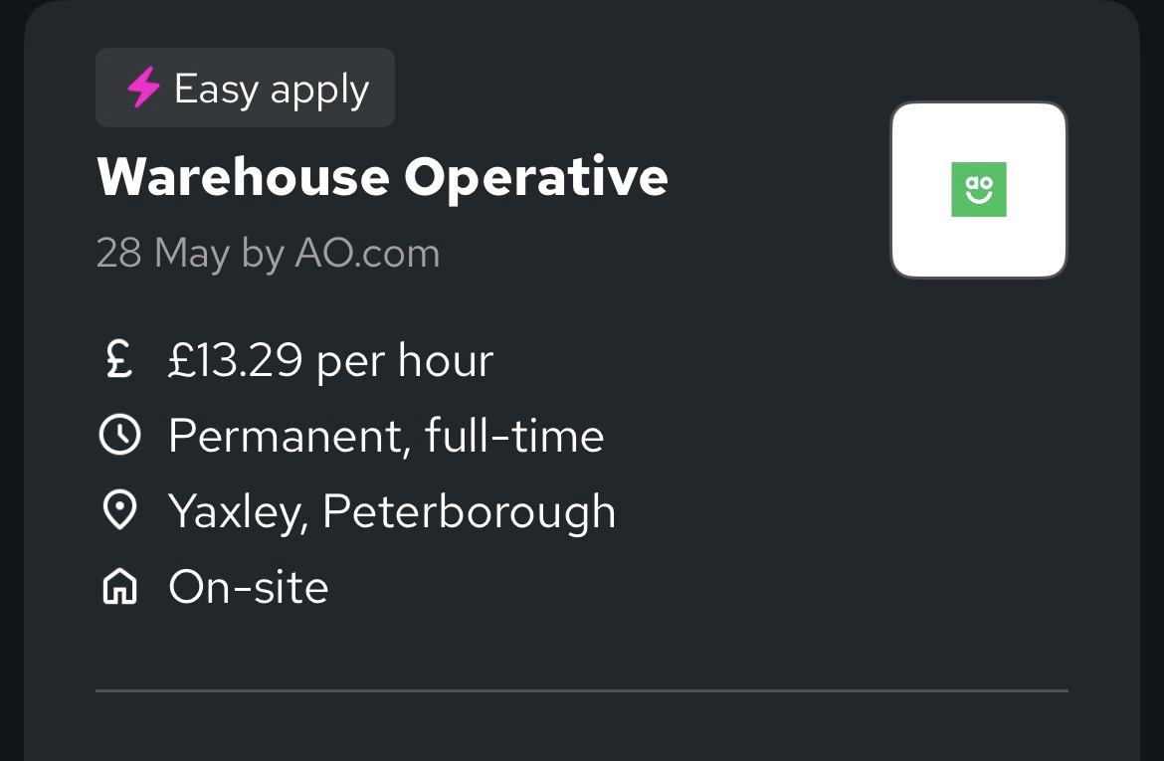

Jessica Dudusova
Peterborough PE1 2TX
+44 7878312958 | jessicadudusova123@gmail.com

21 June 2026
Hiring Manager
AO.com
Yaxley, Peterborough

RE: Application for Warehouse Operative Role

Dear Hiring Manager,

I am writing to apply for the permanent full‑time Warehouse Operative position at AO.com in Yaxley, Peterborough, as advertised. I am reliable, ready to travel, and available to start work immediately.

I am a highly motivated, hard‑working individual with a strong work ethic and a “can‑do” attitude. Currently studying BA Business Management at the University of Wales Trinity Saint David, I have gained knowledge of operations, logistics, and efficiency.
Distinction in my Level 3 BTEC Business Studies, and I am bilingual in English and Slovakia, which helps me communicate clearly and work well within diverse teams.

Although my background is academic and retail‑focused, I am comfortable with physical, hands‑on work. I am quick to learn new tasks, follow instructions accurately, and understand the importance of safety, speed, and accuracy when picking, packing, sorting, and moving stock. I work well independently or as part of a team, I am always punctual, and I am fully committed to meeting targets and keeping work areas tidy and safe.

I am available for full‑time hours and flexible for shift patterns as needed. I bring reliability, attention to detail, and the willingness to work hard every day.

Thank you for considering my application. I would welcome the chance to discuss how I can contribute to your team and am available for an interview at your convenience.

Yours sincerely,

Jessica Dudusova

