UWTSD

ACDB 4011: Rate of reaction

Alun Morris

Lab partner:
Emma Lane
Henry Whittington

Contents
Introduction: 3
Results and discussion: 5
Conclusions: 8
References: 9
Appendix: Materials and methods: 9

Academic integrity declaration
I declare that:
- the assignment submitted has been written by me alone.
- the assignment submitted has not been previously submitted to this university or any other.
- that all content, including primary and/or secondary data, is true to the best of my knowledge.
- that all quotations and references have been duly acknowledged according to the requirements of academic research.
I understand that to knowingly submit work in violation of the above statement will be considered by examiners as academic misconduct.

Introduction:

The aim of the experiment is to determine the effect of concentration, temperature and surface on the rate of reaction for magnesium (Mg) in hydrochloric acid (HCl). By measuring the rate at which hydrogen gas (H₂) fills the gas syringe using a stopwatch it should be possible to calculate the effect concentration, temperature and surface area has on the rate of reaction.

Hypothesis:
A higher concentration of acid will result in a faster rate of reaction because there will be more molecules of HCl which means a higher chance for the reactants to collide.
A higher temperature will result in a faster rate of reaction as chem.libretexts.org notes:
The collision model explains why chemical reactions often occur more rapidly at higher temperatures. For example, the reaction rates of many reactions that occur at room temperature approximately double with a temperature increase of only 10°C [1, p. 1].
A higher surface area will also provide a higher rate of reaction as there will be a higher chance for reactants to collide.

Variables:
Independent:
- concentration HCL; 0.5 M, 1.0 M, 1.5M 2.0M
- Temperature
- Surface area
Dependant:
- Rate of reaction (speed at which H₂ is produced)
Controlled:
- Volume of HCl mixture
- Length of Mg
- Mass of Mg strip equal to Mg shavings (within 0.005g tolerance)
- Pressure (was not altered as part of the experiment although it is difficult to say if it remained exactly constant between tests)
- Molarity of HCl 1.0 M for temperature and surface area tests.

Rate of reaction theory:
rate = k[A]^{n}
(EQ.1)
Rate of a chemical reaction can be expressed by EQ.1. (k) is the rate constant, [A] is the concentration of reactant A and (n) is the order of the reaction with respect to A.
(k) the rate constant can be expressed using the Arrhenius equation:
K = Ae^{-Ea/RT}
(EQ.2)
(A) the constant for the frequency that the particles collide to the order of the negative of the energy of activation (-Ea) divided by the gas constant(R) multiplied by the Temperature (T). Looking at this equation it is evident that increasing the temperature will increase the rate constant and therefore increase the rate of reaction.
For particles to react they must collide (collision theory). Therefore, the rate of reaction could be defined as the frequency of successful collisions over time. In this experiment the following equation will be used to calculate rate:
Rate = ΔV_{H2} / Δt
(EQ.3)
When more hydrogen gas is produced over a shorter period (t) is means that more successful collisions occurred during that time.
For this experiment a solid reactant is being used. Only the atoms on the surface of a solid can collide and react.
Importance of rate of reaction (kinetics) in OME
Kinetics of explosive materials can be used to determine their energy of activation. An explosive that requires less energy of activation to reach a high energy activated state is more sensitive. More sensitive explosives tend to be primary explosives, but this means they are more susceptible to external stimulus such as friction and impact [2]. This must be considered when storing the explosives. Even if they don’t reach activation energy explosives undergo thermal decomposition which affects their stability and shelf life. By knowing the effect of temperature on the rate of reaction in that it roughly doubles every 10 °C the same can be said for the rate of decomposition. This has implications for the climate in which explosives materials are stored if the desire is to extend their shelf life [2].

Results and discussion:

Table recorded during lab:
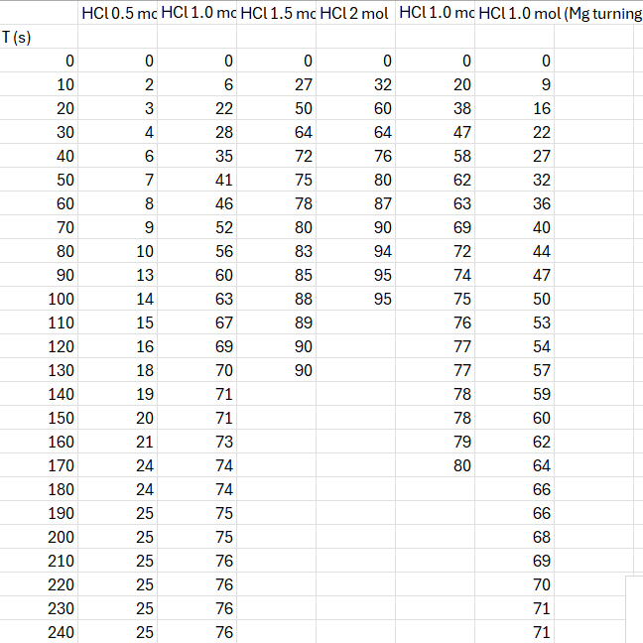

For all calculations t=0 will be 0 seconds and t=1 will be the point that the volume of H₂ being produced slows down.
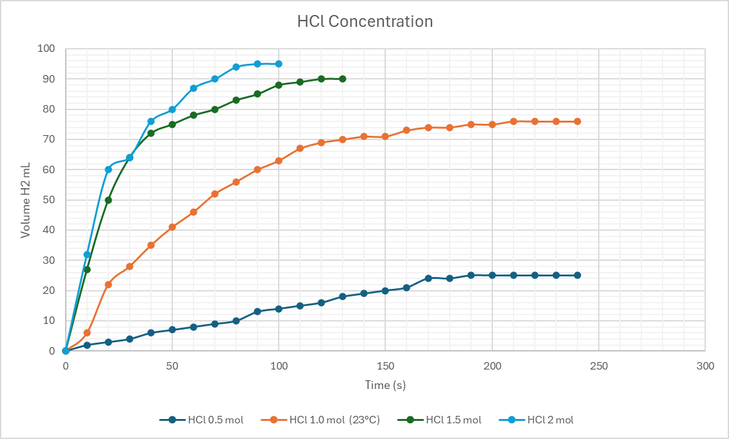
A higher concentration of reactant appears to increase the rate of reaction.
Rate 0.5 M = 14 mL / 100 s = 0.14 cm³ / s
Rate 1.0 M (23°C) = 69 mL / 120s = 0.58 cm³ / s
Rate 1.5 M = 72 mL / 40s = 1.8 cm³ / s
Rate 2.0 M = 76 mL / 40s = 1.9 cm³ / s
There is almost a 3 times difference in rate between 0.5 M to 1.0 M and 1.0 M to 1.5 M solutions. However, the increased in rate for 2.0 M is not so substantial. This is potentially due to the reactable atoms on the surface of the Mg strip having already reacted, but it did not dissolve quickly enough to provide enough atoms to maintain the rate of reaction.
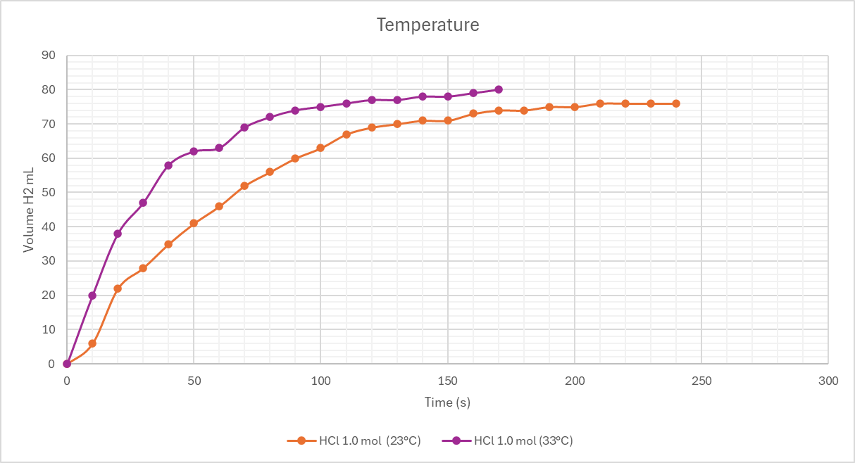
An increase of 10°C appears to increase the rate of reaction.
Rate 1.0 M (23°C) = 69 mL / 120s = 0.58 cm³ / s
Rate 1.0 M (33°C) = 69mL / 70s = 0.99 cm³ / s
A 10°C increase appears to almost double the rate of reaction. While this aligns with the hypothesis, further testing at 40°C and 50°C are needed to confirm the results.

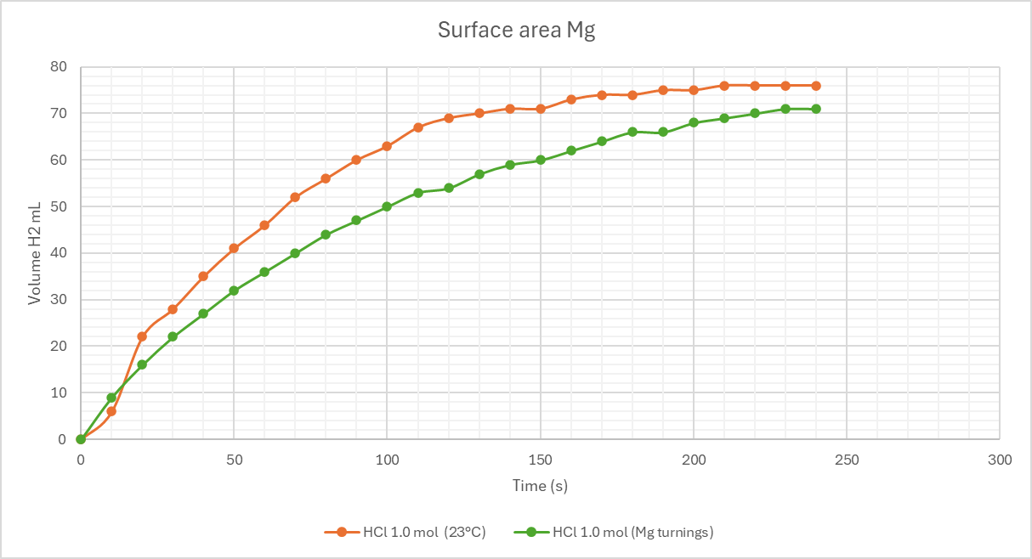
These results do not align with the hypothesis that an increase in surface area will increase the rate of reaction.
Rate 1.0 M (23°C) strip = 69 mL / 120s = 0.58 cm³ / s
Rate 1.0 M turnings = 60 mL / 150s = 0.4 cm³ / s
The hypothesis is that a larger surface area of reactable atoms would be increase the rate of reaction. Potential sources of error that caused the above results could be:
- Temperature of the HCl that was used to react with turnings was less than 23°C. To fix this both solutions should have had their temperature recorded.
- While weighing and transporting the turnings into the sample tube a small amount could have been neglected. This could be overcome by using separate sample tubes for both and checking the weight.
- The Mg used for the turning sample may have had more impurities or had undergone more oxidation causing less Hydrogen gas to be produced. A potential solution could be to use magnesium powder instead of turnings for the surface area test to avoid any impurities / changes to the magnesium that would be caused when producing the turnings.

Conclusions:
Kinetics is valuable in its application to OME. Understanding activation energy and the rates products are formed are relevant to performance and safety of energetic materials.
It’s important to consider the potential sources of error during lab work and ensure there is enough time to make the experiments as accurate as possible.

References:

[1]
LibreTexts Chemistry, “14.9: The Effect of Temperature on Reaction Rates,” Chemistry LibreTexts, Jun. 03, 2019. https://chem.libretexts.org/Bookshelves/General_Chemistry/Map%3A_General_Chemistry_(Petrucci_et_al.)/14%3A_Chemical_Kinetics/14.09%3A_The_Effect_of_Temperature_on_Reaction_Rates

[2]
J. Akhavan, The chemistry of explosives, Fourth edition. London: Royal Society of Chemistry, 2022.

‌

Appendix: Materials and methods:

Tools and materials:
- Long test tube with arm + bung to fit the tube and delivery tube
- Gas syringe
- Two large beakers for water bath and reaction mixture
- Pipette and pipette filler
- Two clamp stands
- Test tube holder
- Thermometer
- Ring stand, Bunsen Burner and clay triangle to support beaker
- Stopwatch
Chemicals:
- Magnesium ribbon cut into 4 cm length and weighed
- Magnesium turnings (same mass as ribbon)
- Hydrochloric acid 2.0 M and 1.0M
- DI water

Before beginning make sure the test tube with the arm and the gas syringe are connected to the stands with clamps and joined by the delivery tube. To avoid gravity having a significant effect on the results ensure the gas syringe is horizontal.

Method 1: Concentration
- Prepare 4 20mL solutions of HCl with the following concentrations: 2.0M, 1.5M, 1.0M, 0.5M.
- Start with the lowest concentration and pour it into the test tube arm.
- Add the 4cm strip of magnesium, quickly put the bung onto the test tube and start the stopwatch.
- Record the volume of H₂ gas given off at intervals of 10 seconds until no more gas is being produced.
- Before continuing with the other solutions measure the temperature of the 1.0M solution to save time during the temperature test.
- Repeat this process with the remaining concentrations.

Method 2: Temperature
- Prepare 3 20mL 1.0M solutions of HCl.
- Heat 1 solution to 10 °C higher than the temperature of the first 1.0M solution that was measure in during the Concentration test.
- Once the desired temperature is reached pour the solution into the test tube arm.
- Quickly add the 4cm strip of magnesium and begin the timing and volume recording process as in Method 1.
- Repeat this process for each remaining solution increasing the temperature of the solution by 10 °C for each solution.
Method 3: Surface area
- Prepare 1 20mL 1.0M solution of HCl.
- Ensure it is the same temperature as the room temperature solution in method 1.
- Add the solution and Mg turnings to the test tube arm and perform the timing and measuring the rate of H₂ gas produced as performed previously.
Plot all the data gathered into graphs comparing V_{H2} to time.

