MODULE CODE/ COD Y MODIWL: BMSW4002
TITLE OF THE ASSIGNMENT- EFFECTIVE TEAM WORKING AND COMMUNICATION
STUDENT NAME- PETER SEPNICKA
STUDENT ID –1921688

Table of Contents
Introduction 3
Evaluation of efficient communication in the business organization 3
Discussion on relevant models of communication and team working in the context of business organization 5
Theories of the team working 5
Models of communication 6
Discussion on the personal case study highlighting the concept of efficient communication working environment 7
Conclusion 8
References 9
Appendices 11

Introduction
Communication has a wide range of definitions from which the appropriate one can be depicted as the exchange of message, thoughts or information via the mode of speech, behaviour, gesture, signals, written or oral method to convey the right idea and content among the parties involved in the two-way process of interaction. Communication is considered as the foundational skills in the academic and employability situation when a scholar is preparing for the final year of higher education and looking for the job prospect. The methods of communication like verbal and written, are the highlight of discussion along with the application of models like Shannon and Weaver, Schramm and Berlo. Bruce Tuckman's Theory of teamwork and Belbin's Theory of teamwork comprises the relevant, effective theories applied in the team working in business organizations.
The report envisages the models and theories of communication to enhance the significance of teamwork and communication in the workplace environment. A personal case study envisions the theories and models into practical application is also the focus of this report that supports in the personal growth and development with encompassing communication as the driving force to create a positive impact on the tutors, employers and team with the opportunity of future enrichment to personal and career upgrades.

Evaluation of efficient communication in the business organization
The fundamental role played by the communication process in an organization helps in determining the skills efficiently used by the employees. At the same time, the managers get the scope of enhancing their essential functions of planning and organizing the tasks, motivating the employees and controlling the workplace environment. The strategic communication used by the organization is generally the verbal form of communication found to be apt to inform the employees followed by written communication or electronically communicating the content to the employees as researched by the authors (Stachova et al. 2017) (Table 1 attached in the appendices). The least popular method deciphered in this study is communicating the message through any employee of union members.
The process of communication can be made useful in the workplace environment by arranging open meetings among the management and the employees, informing the necessary message through work emails, ensuring proper training on communication and active listening of the intended Message (EBIA and JOHN, 2019). The significant role played by the forms of communication in the workplace environment includes public speaking, oral communication, written communication, active listening and adaptability to all kind of interactions (Yeomans and FitzPatrick, 2017). Effectual communication can be ensured through encouraging two-way communication, using better tools for communication like Zoom or Proof Hub, arranging the team building activities, and providing feedback on efficient communication. Analytical communication, Personal communication, Intuitive communication, and Functional communication are the few styles of communications that are practised in the workplace environment, engaging the management and employees efficiently.
The regular communication and interaction among the management and the employees are ensured through SMS alerts, emails, or video conferences. The tone of the discussion is generally kept formal inclusive of all the participants in the communication. At the same time, the language chosen is the official and formal language of communication benefitting all involved in the process (Osborne and Hammoud, 2017). It is essential that the managers and the employees equally pay attention to the information communicated to avoid any gap or misunderstanding in the level of communication; hence, active listening is highly recommended.
Proxemics in non-verbal communication is significant in communication in the workplace where the employees and the managers must understand the use of distance and space including personal space, public space, intimate space, and social space (Grønbæk et al. 2017). Proxemics also addresses the territoriality that supports and defends the comfort of areas. Kinesics in communication refers to the body language and gestures followed in the non-verbal form of dissemination. The word kinesics means movement, which refers to the movement of the body, facial expressions, postures, eye contact and gestures used to communicate in the formal workplace environment (Rahmat et al. 2019). Similarly, personal awareness in the structured environment needs an individual t to be a good listener as well as promote listening to the content when one is speaking or trying to deliver the information. This assures better communication without any interruption or discrepancy in the flow of data from the sender to the receiver.

Discussion on relevant models of communication and team working in the context of business organization
The pivotal role is played by communication in managing a team efficiently in the context of the business organization. The report focuses on the theories of the organization working by elaborating Bruce Tuckman's Team Model and Belbin's Theory of team building. The communication models concentrate on the Shannon and Weaver, Schramm and Berlo’s model of communication in the workplace environment.

Theories of the team working
Bruce Tuckman’s Team Model
The team development process that promotes a team building in the organization and supports the working of the team involves five stages, namely:
Forming- The first stage of team formation where every member is new to each other, they tend to be polite and pleasant in behaviour, and they remain excited to know their position and contribution towards the teamwork (Tripathy, 2018). The members generally take an interest in each other, tend to know their skills, experience and qualifications to make a bond while undertaking a task while evaluating the qualities to complete the task successfully.
Storming- Every individual in a team has a specific way of handling an issue. These are mostly the outcomes of the person's strengths. Every person in the group has different strengths leading to conflicts. This stage is pivotal as this is the place where the leader needs to resolve the intra-team conflict and bring upon the best for the team.
Norming – The resolving of the mutual disputes of a team and the settlement of the team members with each other with the able guidance of the leader is called norming. Here the members actively support each other’s' strengths and show acceptance to each other's working style. They were thereby enhancing the team effort as a whole.
Performing – Here, most of the team members are acceptable and are striving to achieve the team goal with each other's support. They are fully aware of each other’s strength and weaknesses and therefore form a stronger bond with the team (KHAMIS, 2019). Team members are proud to be part of the team and are giving their Ent per cent towards the team goals. However, a few members may not be so conducive and will fail to achieve the personal goals, let alone team goals.
Adjourning – When a project of the team is finished, the team is disbanded, and the members scatter. There is a sense of deprivation among members of the team who have until now toiled with other members for the achievement of the team objective. The bonding with team members is severed, and a stage of mourning is observable.
Belbin’s Theory of team building
Belbin’s team building theory explains building the team with new benchmarks while sometimes the team builds up fails. The successful team is made up when the entire team knows what each other qualities comprise of like their strength, weaknesses, personalities, aspirations and ambitions (Fekry et al. 2019). Belbin being a management psychologist, proposed what individuals tend to act in a team. As stated by Omar et al. (2016), the implementers convert the ideas into briefs, the resource investigator searches new opportunities and plans to form new networks, the plant deems in overcoming challenges of intellectual nature and promote creative solutions, the monitor evaluator analyses every idea in the team and ensure to implement right decisions, the specialist offers in-depth knowledge on the subject matter, the coordinator brings harmony in the team by delivering the members and working together on the shared goals and the shaper believes in making things happen in the team by overcoming the barriers and obstacles.

Models of communication
Shannon Weaver model of communication
The model of Shannon and Weaver occurs in five parts involving the sender, encoder, channel, decoder and receiver. The sender is the Source of the information who chooses the message to be conveyed to the receiver (Wang and Li, 2017). The encoder or the transmitter can be a machine or person who uses the device to convert the message in signal or through binary data. The channel is the medium of sending the message while the decoder is the machine that converts the signal or the message and translates the signal into the message. The receiver or the people at the destination receives an accurate message and provide feedback to the sender in a similar way. The noise is also part of this process that is observed as the disturbance created and not letting the actual message to be transferred.

Berlo’s SCMR model
The SCMR model depicts four stages as proposed by Berlo in the communication model. The steps comprise of the Source where the skills, experience and the cultural elements of the sender are observed (Baecker, 2017). The message consists of the content, code and structure. The channel comprises of hearing, smelling, seeing, tasting and touching elements. The receiver at the receiving end comprises of the attitude, culture and knowledge.
Osgood Schramm model
The model proposed by Osgood and Schramm is Circular model with the presence of encoder, decoder and interpreter. The origination of the message is observed and sends by the encoder, the decoder receives the intended message, and the interpreter helps in interpreting or analyzing the Message (Petersons and Khalimzoda, 2016). This model helps in simultaneously sending and understanding the message. The semantic noise is created in the process when the sender and the receiver differently interpret the same message. This happens because of the technical language used in the process.

Discussion on the personal case study highlighting the concept of productive communication working environment
The communication process is essential in the classroom session when the lecturer takes the lesson and helps in interpreting the modules. When we apply the Shannon Weaver model, we can understand the implication of the model of communication. The personal experience which I had in the classroom session, and it reflects the concept of proxemics used by the students. The first class was of introduction where students from various cultures were together and standing in the conference room (Elleström, 2018). I observed that the groups of different culture belonging from Australia, America, Vietnam, and London had a different way of interacting. Some were loud, while some were soft-spoken. The lecturer entered the conference room and passed on the instructions for taking our seats as per the alphabetical order. However, the message at the end of the conference hall was not adequately heard disrupted by the noise and commotion, which made a mess of the situation (Soter, 2016). Then the sender of the message as perceived as the lecturer took the microphone device and announced the same message, which now was evident at the end of the hall. At the end of the session, we got to know each other through the interaction conducted one by one introduction on the platform.

Conclusion
In conclusion, it may be summarized that communication being the fundamental aspect of creating long term bond between the team members, it is essential that the flow of the message through communication must not get hindered. The models and theories help in interpreting the essence of communication required to build teams in business organizations and manage them efficiently to gain productivity. The flow of communication appropriately through right channels and mediums eases the confusion and unwanted disputes among the team members. Hence it is significant to enhance this interpersonal skill in academic and employability situations.

References
Baecker, D., (2017). Systemic Theories of Communication. REVISTA MAD-REVISTA DEL MAGISTER EN ANALISIS SISTEMICO APLICADO A LA SOCIEDAD, (37), pp.1-20.
EBIA, I.E. and JOHN, G., (2019). ORGANIZATIONAL COMMUNICATION AND WORKPLACE EFFICIENCY: A STUDY OF FLOUR MILLS NIGERIA LIMITED. International Journal on Transformations of Media, Journalism & Mass Communication (Online ISSN: 2581-3439), 4(3).
Elleström, L.,( 2018). A medium-centered model of communication. Semiotica, 2018(224), pp.269-293.
Fekry, A., Dafoulas, G.A. and Ismail, M., (2019). The Relation between Student Behaviours in Group Presentations and their Teamwork Modalities Using Belbin and MBTI Analysis. Procedia Computer Science, 164, pp.292-300.
Grønbæk, J.E., Korsgaard, H., Petersen, M.G., Birk, M.H. and Krogh, P.G., (2017), May. Proxemic transitions: designing shape-changing furniture for informal meetings. In Proceedings of the 2017 CHI Conference on Human Factors in Computing Systems (pp. 7029-7041).
KHAMIS, H.I., (2019). THE RELATIONSHIP BETWEEN TEAMWORK AND ORGANIZATIONAL PERFORMANCE: EXPERIENCE FROM COMMUNITY BASE SECONDARY SCHOOLS IN DAR-ES-SALAAM.
Omar, M., Hasan, B., Ahmad, M., Yasin, A., Baharom, F., Mohd, H. and Muhd Darus, N., (2016). Applying fuzzy technique in software team formation based on Belbin team role. Journal of Telecommunication, Electronic and Computer Engineering, 8(8), pp.109-113.
Osborne, S. and Hammoud, M.S., (2017). Effective employee engagement in the workplace. International Journal of Applied Management and Technology, 16(1), p.4.
Petersons, A. and Khalimzoda, I., (2016), May. Communication Models and Common Basis for Multicultural Communication in Latvia. In Proceedings of the International Scientific Conference. Volume IV (Vol. 423, p. 433).
Rahmat, N.H., Roslan, M.A., Othman, N.A. and Ramli, N.F.M., (2019). The Influence of Kinesics and Vocalic in ESL Oral Presentation among Undergraduates. Studies, 5(1), pp.1-13.
Soter, M., (2016). Theoretical Modelling of Intercultural Communication Process. Journal of Advocacy, Research and Education, (2), pp.87-92.
Stachova, K., Stacho, Z. and Vicen, V., (2017). Efficient involvement of human resources in innovations through effective communication. Business: Theory and Practice, 18, p.33.
Tripathy, M., (2018). Building quality teamwork to achieve excellence in business organizations. International research journal of management, IT and social sciences, 5(3), pp.1-7.
Umeozor, S.N., (2020). Information Retrieval: A Communication Process in the 21st Century Library. International Journal of Knowledge Content Development & Technology, 10(2), pp.7-18.
Wang, N. and Li, B., (2017). A Model of Deceitful Information Communication: Some Views on Theory and Practice of Semantic Information. In Multidisciplinary Digital Publishing Institute Proceedings (Vol. 1, No. 3, p. 127).
Yeomans, L. and FitzPatrick, L., (2017). Internal communication.

Appendices
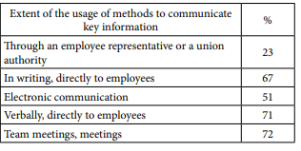
Table 1: The authors used their own research to find the extent of communication method to inform the major aspects of the content that has to be discussed with the employees of the concern
(Source: Stachova et al. 2017)

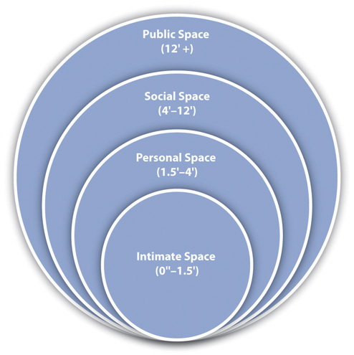
Figure 1: The Proxemics representing the zones of spaces dedicated to social, personal, public and intimate while initiating any non-verbal communication
(Source: Grønbæk et al. 2017).
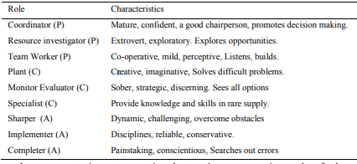
Table 2: The role and characteristics of the team members as proposed by Belbin
(Source: Fekry et al. 2019)
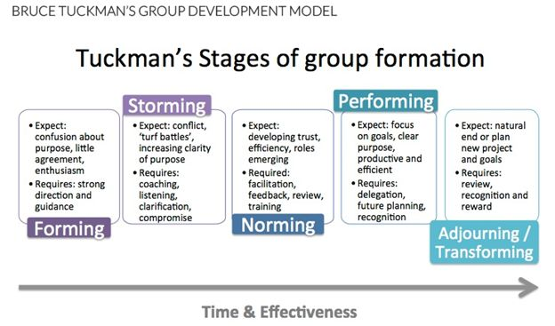
Figure 2: The Theory proposed by Bruce Tuckman in team development
(Source: KHAMIS, 2019)
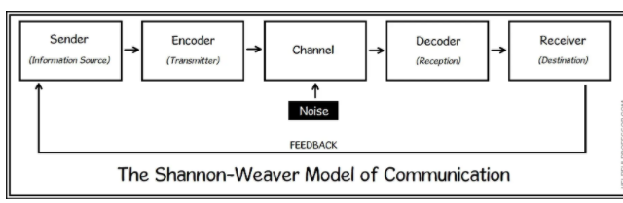
Figure 3: The Shannon Weaver Model
(Source: Wang and Li, 2017)
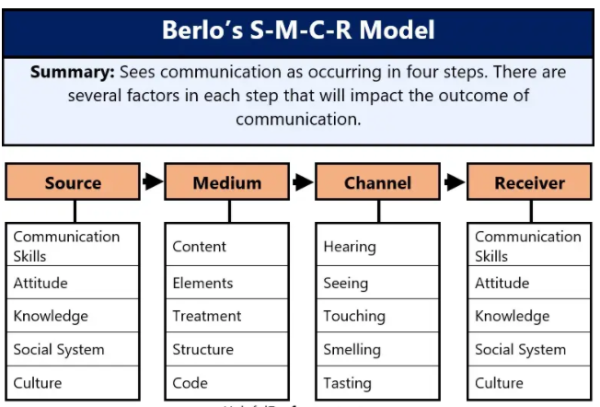
Figure 4: The Berlo’s Communication model
(Source: Umezoar, 2020)
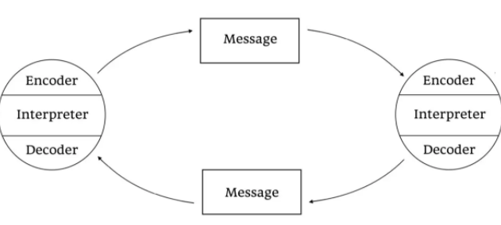
Figure 5: The communication model proposed by Osgood and Schramm
(Source: Petersons and Khalimzoda, 2016)

