Task 1
During my time on PTE 2, I was placed in a Year One setting with 23 children of mixed ability. Throughout the first week I was able to observe the language patterns and incidental Welsh that was being used in the class. As observed, the Welsh topic for the term was ‘Tywydd’ and the previous term had been ‘Dillad’. Through these observations I decided to use ‘Dillad Tedi Twt’, as this book includes both ‘Dillad’ and ‘Tywydd’ and meant the children had prior knowledge to start the task. I also chose this book because the language and use of pictures was suitable for their age and understanding of Welsh. The main learning objective was for the children to be able to confidently use the phrase ‘Mae Tedi twt yn gwisgo...’. Alongside this, the children are also making a link between what clothes are suitable to wear in different weather. The resource I created to support the story was a sheet that had a picture of the type of weather on one side and pictures of Tedi Twt wearing different types of clothes which the children had to match. For higher level children it used the same principle where Tedi Twt would be on one side and the Welsh words for different types of clothing were on the other side. By using words instead of pictures, the higher ability children would be challenged as it would be bringing them out of their comfort zone as referred to in Vygotsky’s theory on the Zone of Proximal Development as stated by Brown (2008).
Task 2
https://www.youtube.com/watch?v=4iZqM-xqtto&feature=share
Task 3
My overall thoughts regarding task two are mostly positive. This is mainly because I had planned what I wanted to achieve personally during the task but also what I wanted the children to achieve during the task. Having this main goal in mind, I was able to focus on the different mini goals I had set during my planning when delivering this task. Estyn (2013) state that a teacher needs to have enough understanding of new vocabulary and sentence patterns for the pupils to use them independently and confidently. By making a secure plan for the task it ensured that I was able to model the correct vocabulary for the children. I was also pleased with the lead up activities during the week that I had created for the children so that they already had a slight understanding of what the book was going to be about. As the children had previously learnt about the weather and clothes, as part of the Welsh second language scheme of work set up by the Central South consortium, I decided to create activities that incorporated both themes in to them. I made sure that these activities incorporated the VAK rationale where all pupils have different learning styles. By doing this it ensured that all learners could work at an effective personal level. During the story I found that the children were able to activate prior knowledge as a result of taking part in the lead up activities. During my time on PTE2 I read another book to the class and found that when I was asking children questions about the book, they were far more hesitant in answering any questions because they had no prior knowledge. This is one reason as to why I decided to create lead up activities so that it would be far more effective for the children's learning and understanding.
One aspect of the learning experience that I felt went well was the fact that most of the children were engrossed in the book. As the children enjoyed ‘Dillad Tedi Twt’ and were so focused on the book and the content I was able to ask questions that helped further my understanding of the children’s knowledge. As I chose my groups based on ability, I used different types of questions for the lower ability children compared to the higher ability groups. When planning my lesson and resource I took in to consideration Bloom’s Taxonomy theory. Bloom (1956), suggests that lower level questions help children to remember and recall information whereas, higher level questions enable children to justify or challenge a decision.
To introduce the book to the children I chose to use Welsh commands such as ‘Edrychwch’ and ‘Gwrandewch’ so that they become familiar with Welsh commands. These commands are common throughout the school environment and by getting them familiar with these commands from a young age will not only benefit them in the future, but it will also benefit the school as they can use these commands themselves. Donaldson (2015) suggests that children's ability to speak Welsh confidently in everyday settings needs to be a focal point for the new curriculum. Using language like this is most effective when it is used in a whole school approach where the school has an ethos promoting Welsh.
During the task, positive reinforcement was used as much as possible to try and encourage the children to have more confidence when answering. Both Ivan Pavlov and Skinner (1953) observed that behaviour that was followed with a pleasant consequence is more likely to be repeated. When the children were answering questions, it was as simple as saying ‘Da iawn’ or ‘Bendigedig’. I tried to use positive reinforcement as soon as possible so that the children felt more comfortable knowing they were in a safe environment. One expert that acknowledges this is Urie Bronfenbrenner. After analysing his Ecological system Theory Model, it is clear to see that a child’s microsystem (immediate environment), will have the greatest effect on its learning.
As well as using positive reinforcement, to create a safe and conducive environment, I decided to take smaller groups out of the classroom to read to. The choice was also made to base the groups on ability level after taking in to consideration Vygotsky’s Zone of Proximal Development Model. As the children were all a similar level, I was able to use work sheets that both challenged and developed their Welsh independently. I found that the children were all able to complete the work sheet to a high standard independently without becoming stressed. On the other hand, it might have been beneficial to the children if I had placed them in mixed ability groups. One reason behind this is Vygotsky’s theory of The More Knowledgeable Other (MKO). If the children were in mixed ability groups, the children that have a lower level of Welsh would benefit from the children that have a greater understanding. This is because they would be learning from someone of their own age and may be able to explain in in more familiar terms. This theory also benefits the MKO because they have the chance to test their knowledge out and use it in a different context. As well as this, it would have also given me the chance to gauge whether the children understand the Welsh in a different context.
Another aspect of my teaching that I felt was effective during the task was my use of actions in relation to the words. Whilst talking about the weather I would use actions to link the children’s understanding of the word to an action. An expert that believes in this technique is James Asher (1996), who developed a language teaching method referred to as Total Physical Response which states that teachers should give commands with body movements and the children respond with the same movement. In agreement with this method is Stephen Krasher (1981), who associates his work in line with the Comprehension Approach which emphasises the understanding of a language rather than the speaking. By incorporating this method in to my teaching, an advantage of it is that the children will be able to use the language more effortlessly.
Upon reflection of the task, one of the more disappointing aspects was that I did not start by giving commands in Welsh consistently from the start of the activity. As a result of this it might have meant that some of the children may have become confused because there was a lack of fluency and consistency during the task. Moving forward, I would ensure that my Welsh spoken was far more consistent from start to finish. To achieve this, I would create a tick list of commands and phrases that I would have next to me during the task to help me get the most out of my use of incidental Welsh.
Another negative of the task that I identified was a slight lack of guidance as to what the children were to do. I introduced the resource to the children after I had read the story and briefly explained what I wanted them to accomplish. I expected the children to be able to start the task a lot more independently but at the time I did not realise the competence level of the Year one class. As a target for next time I would make sure that I model what I want the children to do especially because of the age their age. In a more recent piece of work on Vygotsky’s Scaffolding Theory, Van der Veer, R., & Valsiner, J. (1991) state that a teacher needs to become a facilitator. During my task I should have shown the children an example of what they needed to do and then let them carry out the rest of the task.
A further improvement that I could have made to the task is to have a number of behaviour management strategies. Even though there was no major disruption, there was the occasional low-level disruption that I could have managed more effectively. I did use strategies such as placing my finger on my lips and waiting for the children to copy me and by saying ‘Byddwch yn dawel’. If I was to carry this task out again, I would use the command ‘un, dau, tri...Edrychwch arna I' as the class teacher uses this strategy.

Reference List
Asher, James (1996). Learning Another Language Through Actions (5th ed.). Los Gatos, CA: Sky Oaks Productions
Bloom, B. S et al. (1956). Taxonomy of educational objectives: The classification of educational goals. Handbook I: Cognitive domain. New York: David McKay Company.
Bronfenbrenner, U. (1979). The ecology of human development: Experiments by nature and design. Cambridge, MA: Harvard University Press.
Brown, C. (2008). Developmental psychology. Los Angeles: SAGE.
Donaldson, G. (2015). Successful Futures. Cardiff: Crown.
Estyn (2013) Supplementary Guidance: Welsh. Cardiff: Crown. https://www.estyn.gov.wales/sites/default/files/documents/Supplementary%20guidance%20 -%20Welsh.pdf
Krashen, Stephen D. (1981). Second Language Acquisition and Second Language Learning. Oxford: Pergamon.
Skinner, B. F. (1953). Science and human behavior.
Van der Veer, R., & Valsiner, J. (1991). Understanding Vygotsky. A quest for synthesis. Oxford: Basil Blackwell.

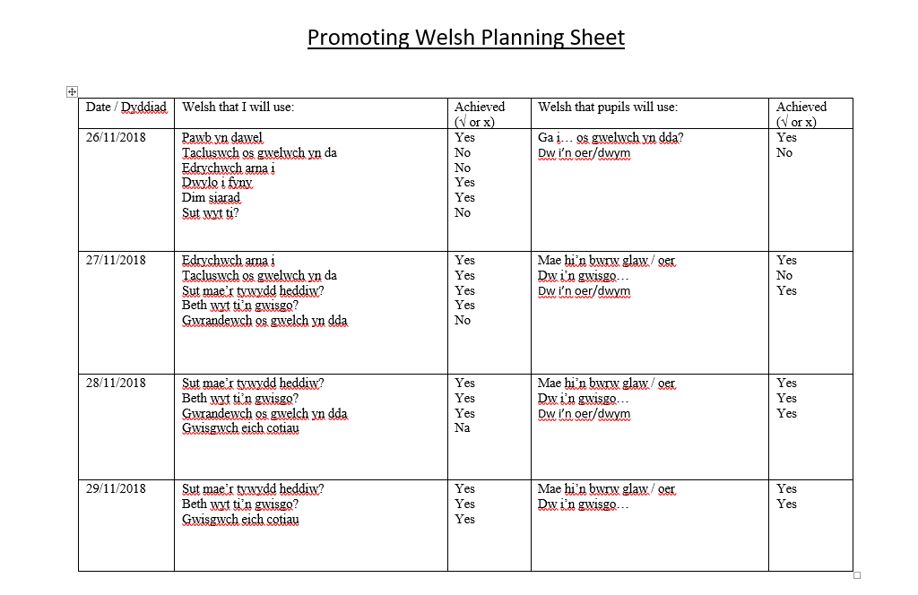
Appendix

