Student Name: Ewan L Coombs
Student Number: 2003649
BA Course Title: Fine Art – Studio, Site, & Context
Module Title: Research in Context
Module Code: (ADAD5003)
Lecturers Titles: Gwenllian Beynon & Alex Duncan

Essay word count – 2793 Words

‘Question 3: Analyse the impact of the environment and sustainability on art practice by describing how artists have responded to these issues in their work. You may wish to focus on more than one example in this question’

Figures List:

Figure 1. Haacke. H, (1972), Rhine Water Purification Plant, 1972, Glass and acrylic containers, pump, polluted Rhine water, tubing, filters, chemicals, goldfish, drainage to garden. Museum Haus Lange, Krefeld, Germany.

Figure 2. Mosher. E, (2018), Making Time for Curiosity, Line Marker Machine, blue-tinted, water-soluble chalk.

Figure 3. Mosher. E, (2007) HighWaterLine, NYC, 2007, Line Marker Machine, blue-tinted, water-soluble chalk.

Figure 4. Watts. A, (2021), Untitled, Digital Photograph

Within this essay I will be analysing how two artists have responded to environmental and sustainability issues and considering within this, whether they could be considered ‘futile acts’ in their aim to achieve the communication between subject and audience. Via creating a change to the very issue at the heart of the work; and with this a focus on their ability to communicate the issues explored in the work to a greater audience or if not, why not? For this I will be comparing Hans Haacke (1972),‘Rhine water purification Plant’, (Figure 1.) and Eve Mosher’s (2007) ‘HighWaterLine NYC’, (Figures 2. & 3.) and with this looking at the issues explored within the work against the current Climate Crisis.

What one takes from the environment, this abuse of resources and in its place, waste is left, this action of consumption and usage of the environment reflects the view that this natural system is an endless source. “The destruction of the natural takes place every second and has been taking place for millennia in the process of reproduction, settlement, and survival – the role of human intervention in dramatic environmental change is undeniable” (Agrest, 2021). With this, is the view that humans are the hierarchy or pinnacle of evolution, this may stem from the basis that the more complex the ‘being’ the more important it is, as denoted by farmer and philosopher (Fukuoka, 2021) below:

There are no grounds for the discriminatory view that underlies Darwin’s view of superiority and inferiority that deems single-celled organisms as lower and more complicated life forms are higher. It would be more appropriate to say we are all one continuous life-form.

The very nature of this destructive cycle is reflected within the first artists work analysed within this essay. Haacke’s (1972) Rhine Water Purification Plant, created in response to the dumping of untreated waste in the Rhine River, “At the time of the exhibition, the city of Krefeld annually discharged 42 million cubic metres of untreated household and industrial wastewater in the Rhine” (Grasskamp, 2004). Within this work, Haacke collected heavily polluted Rhine water and subjected it to a series of filters which filled a large transparent basin with goldfish. The overflow of cleaned water was then siphoned out into the Museums Garden adjacent, and visible to the pond within (Figure 1.).

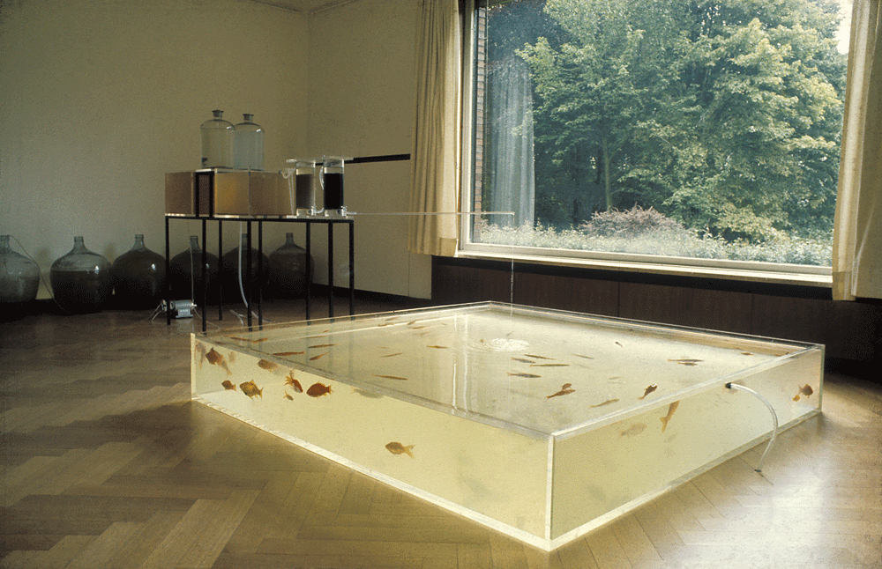

Figure 1. Haacke. H, (1972), Rhine Water Purification Plant.

With each step of the process, one feeds into the next, this action of doing so, becomes a form of conversation on the cycle of damage and repair and passage of water; but with this also highlights the actual capability of returning the heavily polluted wastewater to its original state; through “greywater reclamation” (Lamb, 2020) this act, reflects the futility of Haacke’s actions as the purified water is returned to the environment and state in which it was collected. However, a contradictory point by Haacke in his own short manifesto opening “… make something which experiences, reacts to its environment, changes, is nonstable …” (Kastner et al., 2015); thus, maybe this futile act of the water returning to its polluted state, is then more of a greater reflection of Haacke’s exploration of systems as denoted below:

… an understanding of the environment as a system; that is, a set of interrelated objects and processes defined in relationship to a focal individual, community, or population. This was the environment of something or someone.
(Cheetham, 2018)

This return to a damaged state can reflect a predisposed conception, and ‘step’ in the system, that this state has become the new normality and thus as defined by (Massumi, 2011) “The horror is alloyed, its impact archived. Another event has been affectively conveyed with irruptive, interruptive force, only to subside into the background of everyday life.” Reactions to such events as the polluting of the Rhine either intentional or accidental, such as the 1986, ‘Schweizerhalle disaster’ (Giger, 2009) become footnotes of the past and their longer lasting effects and pollution blurring into the background.

In addition to this, Haacke’s exploration of systems which are not entirely based on perception, but instead explore “… physical, biological or social entities which, I believe, are more real than perceptual titillation” (Haacke & Kastner, 2012). Thus, including the chemical process within the physical installation creates a dialogue with the audience. Once processed water fills into a tank of goldfish, this trust of action and process ensures a rectification of past actions, but not without a trust in the process itself; this may highlight then that the source of the problem must change for any good to come of it. Whilst also being aware of the necessity of clean water, but this is not without its issues as denoted below:

Human settlements require clean water in sufficient quantity with constant supply and at the same time produce continuous wastewater flows loaded with pathogens, organic and mineral matter, nutrients, and pollutants (Ceola et al., 2019; HDR, 2002).

(Yang et al., 2022)

A counterpoint to this, is the artwork analysed become ever more relevant as the ecological events explored are reflected in our current times often in a far dire state, and thus the issue is embedded not within the works themselves but the way these issues are still ongoing and the public’s reaction too and ignorance of what is conveyed is then reflected in current climate issues. One example outlined is the constant fight nature takes in returning to ‘normality’ as denoted by Giger: “The biocenosis of the Rhine is continuously striving for a new equilibrium, and these efforts are repeatedly disturbed by anthropogenic impacts.” (Giger, 2009).

By bringing this work into the gallery/museum context, exhibiting this process in transparent acrylic container, it directly reveals the real time effect of the pollutants removed from the water and evidenced through the fish still living and the water quality becoming clearer than its original milky slurry. The ‘fish tank’ as defined by Reed, one can view these objects in the sense that these “Objects can spark slow looking in multiple ways”, either triggering a “personal”, “perceptual” or “behavioural” (Reed, 2019) response to the work, when taking this into consideration within Haacke’s usage of the gallery as both conduit and influence on the work itself, “The walls of the museum or gallery are as much a part of his work as the items displayed on them. These works also need the “impregnation” of the gallery to set them apart in opposition to other contemporary art” (Buchloch et al., 1977).
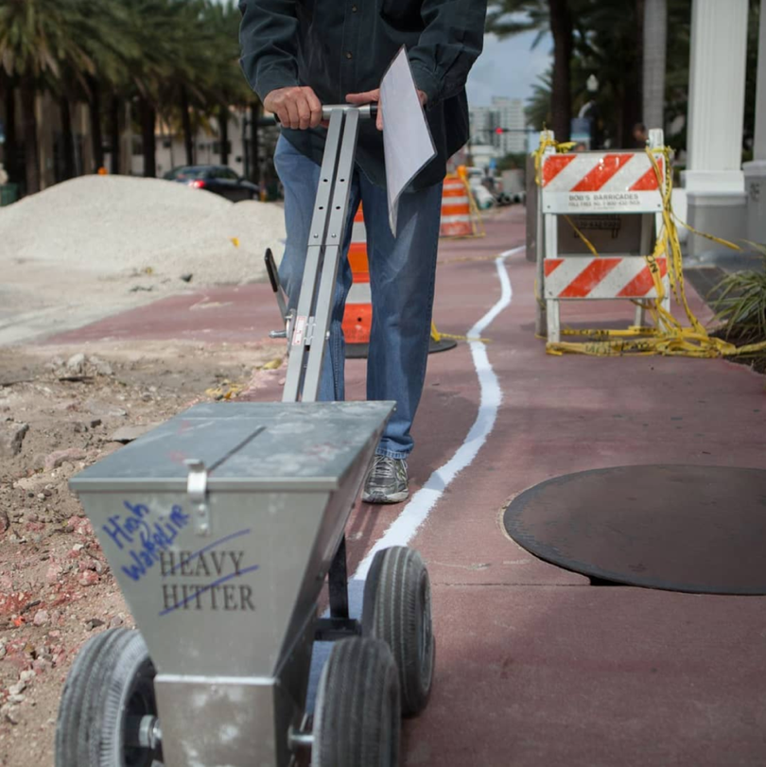
Figure 2. Mosher.E, (2018), Making Time for Curiosity.

Mosher’s performance and act of outlining the rising coastline using a white line marking machine and a soluble light-blue chalk, occasionally stencilling the projects title, as evidenced in (Figure 2.) above. This interaction with people going about their everyday life, presents a disruption to a perceived normality, thus introducing doubt into the ‘everyday’, through highlighting a new reality where peoples actions and contribution to pollution can drastically alter their lives. Mosher described the waters surrounding New York as being “edges are always changing and the water will go where it wants to go” (Mosher, 2020), but with the contribution of climate change has accentuated this truth.

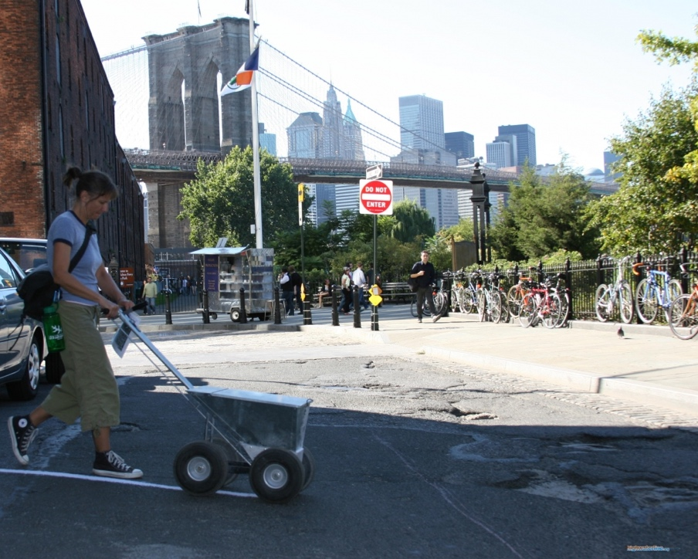
Figure 3. Mosher. E, HighWaterLine, NYC, 2007

This disruption is key in introducing this information to a wider audience possibly unaware of such issues; to further this Mosher often interacted with people reacting in real time to her actions, this transfer of information on a human level via sharing of information on a one-to-one basis, “As the project is based on curiosity-driven learning, the act of marking the line should engender curiosity in the public.” (Mosher, 2018). By traveling through multiple areas, the audience which would not often be in direct contact with galleries and of lower income communities introduces an equality of information, as denoted below with Mosher’s insistence on explaining the project ‘pushes’ the idea directly in a public consciousness:

Her drawing, by necessity, cannot be continuous or even particularly lovely in an artistic sense. …. (In parks and other grassland, the line is replaced by temporary, solar-powered light beacons.) And the drawing takes a lot of time because she insists on explaining her mission, even to people who do not seem particularly interested in hearing about it.
(Kennedy, 2007)

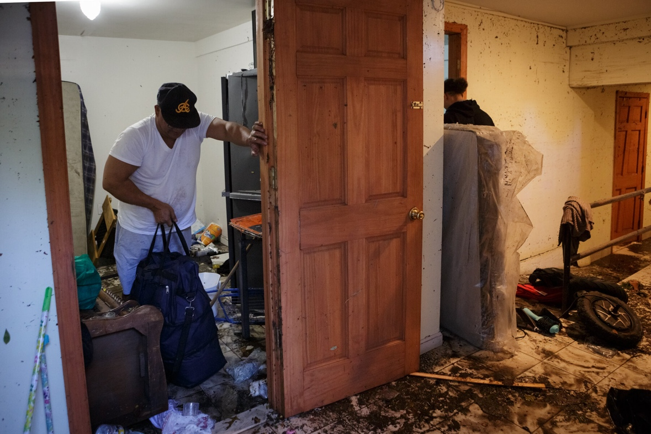

Figure 3. Anna Watts, (2021), Untitled

A key event reflecting the importance of Mosher’s act was the destruction caused by Hurricane Ida in 2021, with the level of destruction caused mirrored the outline of Mosher’s ‘HighWaterLine’ project, with the death toll reaching 43, “at least 15 people had been found dead in New York State, at least 23 people had been killed in New Jersey, four were found dead in Pennsylvania and one person died in Connecticut.” (Nir, 2021) with the majority often living in basement apartments and lower income, thus the worst effected of climate change being the poorest of communities, as evidenced within (Figure.3).

Ms. Hochul stressed that the staggering amount of rainfall that drenched the state in such a short window of time caught officials and meteorologists off guard on Wednesday night. “I think the meteorologists are surprised,” she said, adding that “Mother Nature does what she wants.”
(Keith & Ferré-Sadurní, 2021)

As highlighted within this text above, taken from the report on the aftermath of the events, the issue is not ‘mother nature’, but the actions of the greater capitalist systems that create and output major pollutants, causing the knock-on effects, of rising water, this storm may not have been so destructive if these issues were not at play, as emphasized by Massumi, “The periodic heartwarming return to the personal level and human scale obscures the reality that there is, in fact, a strange complicity at work between the human-caused and the naturally occurring.” (2011). This is not natures action entirely but humans’ intervention too. Thus, within this, it begs the question, is ecological art beneficial in any manner when the greater public may make a change, but the work is futile, when we consider the understanding laid out by Morton, “a geological period in which human-made stuff has created a layer in Earth’s crust, all kind of plastics, concretes and nucleotides, for example, have formed a discrete and obvious stratum” (Morton, 2021) that the Anthropocene as described previously, would be more accurately titled the ‘Capitalocene’ as the actions at play here are not the actions of the greater populations but a percentage play, as witnessed within Haacke’s work, it is not the actions of small groups leaving waste into the water ways, but the larger industrial polluters Krefeld Sewage waste contaminates dumping higher percentages of unprocessed waste, under the view that these actions are okay as the environment is below humans, as outlined by “Existing overriding any quality of existing – human existing that is, and to hell with lifeforms that aren’t our cattle” (Morton, 2021), with this, it would be costlier and thus to a loss of the company’s profit thus not worth the actions of processing and cleaning the waste more thoroughly, and such, it is not the actions of the many but the few which has the greatest of impacts:

The problem today is not one of humanity “overwhelming the great forces of nature” in a binaristic opposition (Steffen, McNeil and Crutzen, 2007), but rather one of capitalism exhausting the capacity of uncommodified natures to perform unpaid work for capital accumulation.
(Moore, 2014)

Though we can make a difference, it is currently not swaying the greater effect on the issue and so the work in such is futile, but that is not to say that it is without importance, as through the act of creating and exhibiting it is shares information with different communities, and as the greater population begin to change their ways, an effect can come to fruition and sway possibly the greater government and industries to change their ways and humans can instead change and take on a symbiotic quality, instead of a parasitic quality as denoted by (Wapner et al, 2005):

It does little good to blame individual choices for environmental degradation, and thus to look to individual choice alone as the best route to environmental well-being. If we had effective public policies that redistributed income, forced polluters to pay for the harm they cause, mandated more environmentally friendly technologies.

Both works can be seen as acts of futility, both bringing to different focal points existing issues, each worsening with time, as the very factors which cause each issue; from the consistent dumping of sewage and degradation of micro plastics in waterways which itself feeds into, and pollutes the environment which draws ‘sustenance’ from the water, and in turn leads to deterioration of plant life, alongside human involvement in deforestation all of which aid to the “Great Acceleration”, as denoted by Steffen et al as “The pursuit of growth in the global economy continues, but responsibility for its impacts on the Earth System has not been taken.”(2015). Developing this point further, these works then become examples of impending deterioration and destruction of our very environment, this traversing of time embeds itself in the ecological issues and ongoing and worsening times, thus both works look to expose something hidden.
To conclude, to reveal something hidden, should look to make aware that it’s ending is undetermined and lies in the unknown, but the cause and effect which set the issue in motion is key in understanding that there is something much greater at hand. As denoted by Fukuoka, one must be aware of the embodiment of a prevailing western perspective on change and ignorance of a systems entirety at play, thus one must take into constant consideration what has caused each reaction and study the consequences in detail to truly understand the factor at play:
… as with Western medicine, they devise a swift localised treatment of the symptoms. But the causes they base their solutions upon are not the fundamental causes. Their countermeasures serve not to heal, but rather magnify the scope of the problem.
(Fukuoka, 2021)
The issue then arises to the public limitation and approachability of the gallery world/system whilst in contrast Mosher’s usage of taking this work not just New York but Philadelphia, Miami, Delray Beach, Florida and the UK, Bristol and Avonmouth, (2015). The gallery bridges then the issue and the natural world, with a world which is becoming a means to way to broadcast a message, the communication of the work with the use of the window as a device to visually connect the message of the work, within the process the water of the tank overflows into the garden area of the museum supporting the growth of the natural organisms adjacent, but equally this water would return to the water table and eventually the same polluted source it was collected from, so for the more audacious the act, the less futile the action.
These works though separated by time and place are both intrinsic examples of what Haacke outlined as, “The world does not break up into neat university departments. It is one supersystem, each one more or less affected by all the others” (Haacke et al., 2012), as the pollution of the waterways and marine life continues now, this effects the wildlife. To quantify such issues via the act of processing the water and returning ‘life’ to something that was rendered dead by human intervention initially, highlights the true scale of the problems at hand, and the process that must get underway to improve the environment as highlighted within the essay.
In addition to this, Mosher and Haacke were equal then in what they said and how they communicated it, but the usage of the gallery as a device to transmit message was a limiting factor in the sharing of the works message, yet the usage of the gallery is important, in that the meaning of the work needs to permeate all areas of culture and society for a difference to be made. With this, analysing these works ‘futility’ is done not to undermine the work for what they are, but there should be no work without the intention of communicating to an audience the very issues which drive them, and the truth that these issues are in need of interaction and change. The act of focusing on these issues within the work is beyond important and is reflective of the artist putting meaning of the work before the artist as focal point, placing the community before the individual; showing the message and issue matters beyond the person as artist, and with this the next step in creating change through this work, countering the futility as outlined, is via the creation of projects which aim to create a physical change in the environment as evidenced in the teachings of Masanobu Fukuoka.

Bibliography:

Image:

Haacke, H. and Cohn, T. (2016) Rhine Water Purification Plant, 1972, sfaq.us. Krefeld. Available at: https://www.sfaq.us/2016/06/hans-haacke-in-conversation-with-terri-cohn/ (Accessed: October 24, 2022).

Mosher, E. and Quante, H. (2018) HighWaterLine NEW YORK CITY, 2007, ArtPlace America. New York City. Available at: https://www.artplaceamerica.org/blog/how-art-can-localize-and-personalize-climate-change (Accessed: October 24, 2022).

Mosher, E. and Gershen, J.K. (2018) Making Time for Curiosity , Instagram. Eve Mosher. Available at: https://www.instagram.com/p/BhO0vtGlhxS/ (Accessed: November 19, 2022).

Watts, A. (2021) Brooklyn, NY — Sept. 2, 2021. Resident Ricardo Garcia salvages items in his basement apartment. Extreme flooding from Hurricane Ida on Wednesday evening flooded the basement at 491 Ridgewood Avenue and was the cause of the death of another tenant, Roberto Bravo, who lives down the hall to the right., The New York Times. The New York Times. Available at: https://cn.nytimes.com/slideshow/20210902/c02xp-nycstorm/en-us/#6 (Accessed: December 13, 2022).

Books:

Agrest, D. (2021) Architecture of Nature : Nature of Architecture . New York, NY: Applied Research and Design Publishing. p.11

Bois, Y.-A. (2015) Hans Haacke. Edited by R. Churner. Cambridge , MA: The MIT Press (October Files). p.73

Buchloch, B.H.D., Burnham, J. and King, J. (1977) “Michael Asher and the Conclusion of Modernist Sculpture ,” in Hans Haacke: Framing and Being Framed. Halifax, N.S.: Halifax: Press of the Nova Scotia College of Art and Design, p. 137.

Cheetham, M. 2018. Landscape into Eco Art: Articulations of Nature Since the ’60s. University Park, USA: Penn State University Press. (Accessed: October 25, 2022).

Fukuoka, M. (2021) The Dragonfly Will Be the Messiah. Translated by L. Korn. London: Penguin Books (Green Ideas).

Grasskamp, W. (2004) Hans Haacke. New York, NY: Phaidon Press Limited (Phaidon Contemporary Artists). p.53

Godfrey, T. (2011) Conceptual Art. 8th edn. London: Phaidon Press Limited. p.208

Haacke, H. and Siegel, J. (a2012) “Hans Haacke - Systems Aesthetics: Conversations with Jeanne Siegel//1971,” in J. Kastner (ed.) NATURE. London: Whitechapel Gallery (Documents of Contemporary Art), pp. 28–30.

Kastner, J., Wallis, B. and Burnham, J. (1998) “Hans Haacke - Wind and Water Sculpture (1967),” in Land and environmental art. London: Phaidon Press Limited (Themes and Movements), pp. 251–254.

Morton, T. (2021) All Art is Ecological. 2nd edn. London: Penguin Books (Green Ideas). p.6, p36

Reed, A. (2019) Slow Art: The Experience of Looking, Sacred Images to James Turrell. Oakland, CA: University of California Press.

Research Article:

Yang, S., Büttner, O., Kumar, R., Basso, S., & Borchardt, D. (2022). An analytical framework for determining the ecological risks of wastewater discharges in river networks under climate change. Earth's Future, 10, e2021EF002601. https://doi.org/10.1029/2021EF002601

Wapner, P. & Willoughby, J. 2005, "The Irony of Environmentalism: The Ecological Futility but Political Necessity of Lifestyle Change", Ethics & International Affairs, vol. 19, no. 3, pp. 77-89,119.

Journal:

Steffen, W. et al. (2015) “The trajectory of the anthropocene: The great acceleration,” The Anthropocene Review, 2(1), pp. 81–98. Available at: https://doi.org/10.1177/2053019614564785.

Website:

Giger, W. (2009) The Rhine red, the fish dead—the 1986 Schweizerhalle disaster, a retrospect and long-term impact assessment, ResearchGate.net. PubMed.Gov. Available at: https://www.researchgate.net/publication/26250373_The_Rhine_red_the_fish_dead-the_1986_Schweizerhalle_disaster_a_retrospect_and_long-term_impact_assessment (Accessed: December 5, 2022).

Keith, S. and Ferré-Sadurní, L. (2021) New York Storm updates: As Ida Deaths Rise, N.Y. leaders look toward future storms (published 2021), The New York Times. The New York Times. Available at: https://www.nytimes.com/live/2021/09/03/nyregion/nyc-flooding-ida (Accessed: November 25, 2022).

Kennedy, R. (2007) The handwriting on the road: An artist draws the flood line, The New York Times. The New York Times. Available at: https://www.nytimes.com/2007/06/16/arts/design/16chal.html (Accessed: November 14, 2022).

Lamb, R. (2020) How Gray Water Reclamation Works, science.howstuffworks.com. HowStuffWorks. Available at: https://science.howstuffworks.com/environmental/green-science/gray-water-reclamation.htm (Accessed: December 9, 2022).

Massumi, B. (2011) The half-life of disaster | Brian Massumi, The Guardian. Guardian News and Media. Available at: https://www.theguardian.com/commentisfree/2011/apr/15/half-life-of-disaster (Accessed: October 31, 2022).

Moore, J.W. (2014) The Capitalocene, part II: Abstract social nature and the limits to capital, http://naturalezacienciaysociedad.org/. Fernand Braudel Center and Department of Sociology Binghamton University. Available at: http://naturalezacienciaysociedad.org/wp-content/uploads/sites/3/2016/02/The-Capitalocene-Part-II-REVISIONS-July-2014.pdf (Accessed: December 2, 2022).

Mosher, E. (2015) Category: Locations, HighWaterLine. Available at: http://highwaterline.org/category/locations/ (Accessed: November 14, 2022).

Mosher, E. (2018) Eve Mosher on Instagram: "Making time for curiosity"|, Instagram. Eve Mosher. Available at: https://www.instagram.com/p/BhO0vtGlhxS/ (Accessed: November 19, 2022).

Nir, S.M. (2021) Trapped in basements and cars, they lost their lives in savage storm, The New York Times. The New York Times. Available at: https://www.nytimes.com/2021/09/02/nyregion/nyc-flooding-deaths.html (Accessed: November 25, 2022).

Video:

Mosher, E. (2020) Walking the Edge : Inside Your Head with artist Eve Mosher, YouTube. WorksOnWater TV. Available at: https://youtu.be/MU95P68nj4c (Accessed: October 31, 2022).

