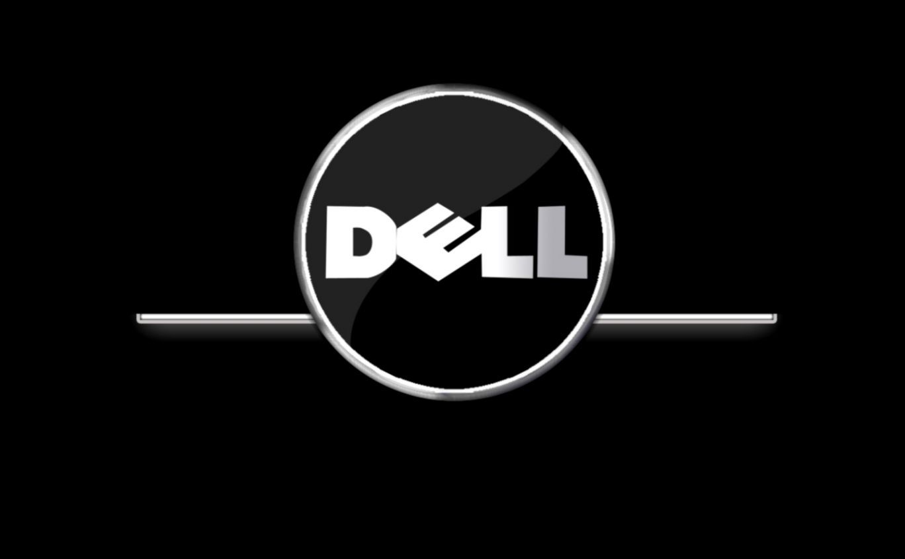

DELL TECHNOLOGIES
Analysis and Evaluation
Assessment 2

Student : Dimitar Gadov
Student Number : 1913486
Tutor’s Name : Tushara Balendran
Module : Marketing Fundamentals
Module Number : LCBB4004
2020

Introduction
Dell is an international technological company that creates, sells, mend, and supports computers and similar products and services. The corporation, founded by M. Dell, is among the major high-tech firms in the world, having more than 160 thousand workers in its branches. (Dell Annual report 2020).
Dell creates a fantastic long-market term growth strategy and marketing concept and centre its attention with pertinacious motive on customers. It was among the primary companies, who offered customization of laptops. (Marketing strategy of Dell, Bhasin, Sept 2018)

Marketing Concept
Marketing is described by the American Marketing Association as "the activity, set of institutions, and processes for creating, communicating, delivering, and exchanging offerings that have value for customers, clients, partners, and society at large". (Marketing definition approved in October 2007 by the American Marketing Association, Archived 9 July 2014)
The “marketing concept” suggests that organization should predict the customers’ requirements and satisfy them more than rivals. (The 5 marketing concepts explained,2019)
Marketing and Marketing concept are instantly related.
By Kotler, marketing concept reckons that achieving organizational aim depends of knowing the necessaries and desires of target markets and bringing the acceptable fulfilment better than contestants do.
That are the following concepts that corporates use to hold out their marketing plan of action.

Societal Market Concept
The societal marketing concept carries out that the organization's mission is to direct the wants and attentiveness of a target audience and to send the desired pleasure more precisely than competitors in order to boost welfare of the individual purchaser and society in particular. (Handelman, Jay M. and Arnold, Stephen J, 1999)
Many leading businesses, Dell including, are now using the concept of shared value, which recognise that societal needs, not just economic needs. It focuses on creating economical value in a way that also create value for society. (Principles of Marketing, Seventeenth edition, Phillip Kotler, Gary Armstrong)
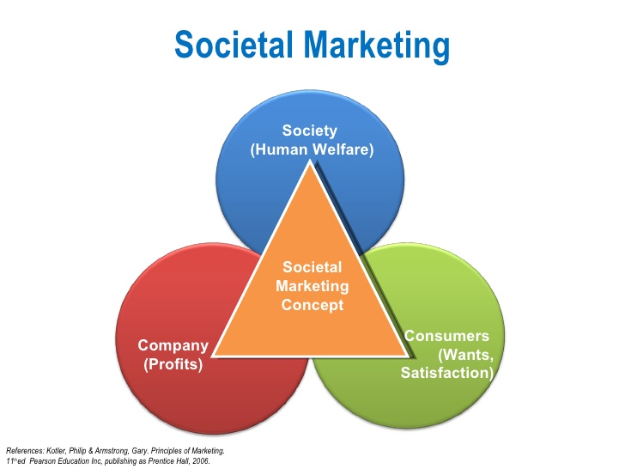

Dell International Services Private India Limited, for instance, evolve the society with its reach and consistently, catch enterprise to provide well-being of assorted segments of society by assuming ecologically and economically helpful programs for stable progress of the society as a whole. The corporation gives grant funding and newest techs for improvement of the society. In addition, it believes that joint responsibility between Dell India and the community provides essential learning possibilities and inscription into the firm’s operational type. (Corporate social responsibility policy of DELL)
Branding Advantages
- Dell has strong and recognizable internationally brand name. Dell sells products all over the world through their website and has retail stores in many countries as US, Australia, Canada, Asia, Japan and Europe.
- Reliability for the Long Run – Dell has covered their customers with the most reliable devices around backed by the award-winning ProSupportPlus technology. With this application customer has a lots of benefits: real-time assistance, predictive analysis and protection and less time on the phone. (Why choose Dell, dell’s website)
- Better security – Dell offers most of the save business laptops, which have multiplex encryption, high-tech identification and complex virus protection. (Why chose Dell, dell’s website)

The Ansoff Matrix
That is a tool, utilized by companies, to research and organise their strategies for growth. The matrix represents four types of tactics that may be used to grow the firm and analyse the potential menace. (What is the Ansoff Matrix?, Corporate Finance Institute )
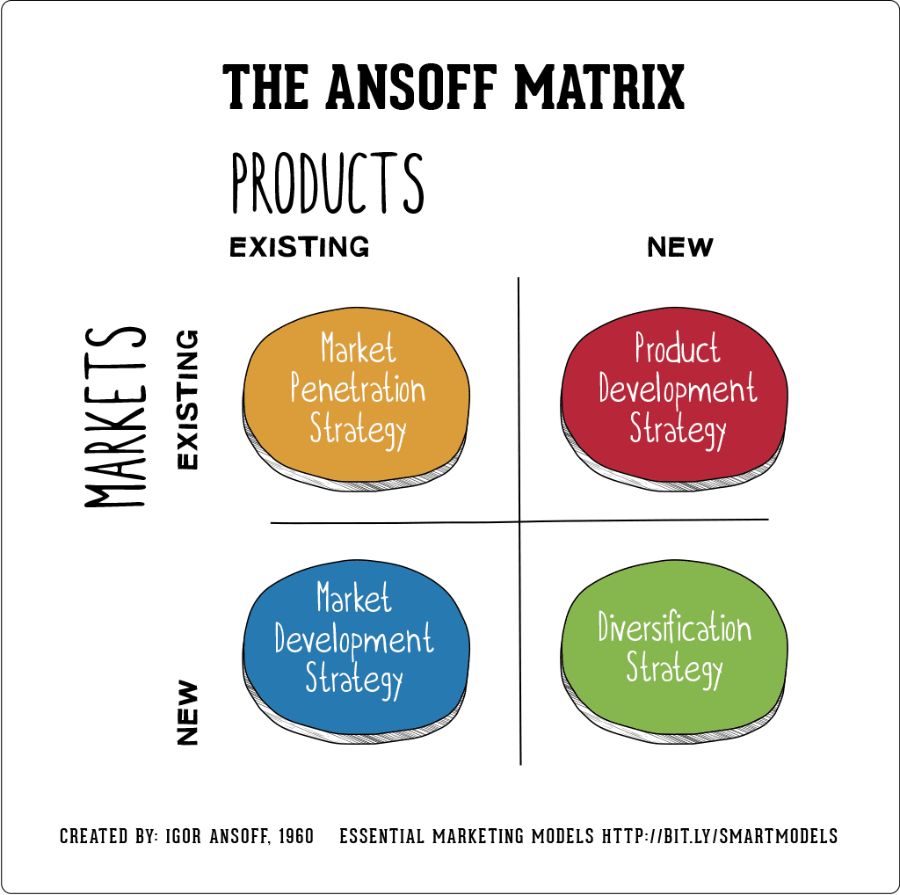
Source: The Ansoff Model, Author's avatar By Annmarie Hanlon 08 Oct, 2019
Marketing penetration is a trial to extend firm trading without running away from an explicit product-market strategy. The corporation seeks to enhance business performance either by increasing the quantity of sales to its recent clients or by finding brand new ones. (Strategies for diversification by Igor Ansoff, Harvard Business Review. (Vol. 35 Issue 5, Sep/Oct)
With Market development the company tries to adjust its existing product portfolio, might be with some modifications, to new missions.
A Product development strategy, on the opposite hand, holds on to the present mission and evolve items that have new and remarkable elements, which will create a better performance of the mission.
Diversification is the last option. It presents market composition and creation of new product. It stands except for the opposite ones. Diversification requires new abilities, methods and provisions in general. That leads to physical and commanding changes, which present with well-defined break and existing business grounding. (Strategies for diversification by Igor Ansoff, Harvard Business Review. (Vol. 35 Issue 5, Sep/Oct).
Dell might use Market development strategy to adapt its present product line to some developing countries. A product development strategy can be used for creating a new product as a smartphone or e-reader, similar to Kindle.
How Dell create value to the customers
There are operations performance objectives, that are used to assess the gratification points of value carry out to customer best implementation. There’re, which giant corporations and their professional clients, seek for PCs and related equipment. (OPERATIONS MANAGEMENT, by Nigel Slack) They are:
- Quality - is the most significant feature. Dell suppliers need to bear strict management procedure and only those who can match the criteria of consumer centre of attention, could work with the firm. (Dell.com)
- Speed – Regarding speed, Dell became one of the topmost companies in the industry. It shows the time spent in accomplishing the clients’ desires, order and delivery. The quicker a customer pick up an item, the happier is going to be. Its JIT (just-in-time) description system remarkably strengthen this essential element in operational effectiveness. With PremiumDell company creates direct relationship with the customers and faster response time. (OPERATIONS MANAGEMENT, by Nigel Slack), (Dell.com/Premiumdell)
- Dependability – Shoppers can easily track their purchases by PremierDell.com. Direct distribution system gives information in real time, which is great benefit for the customer.
- Flexibility - is the main strategy of Dell technologies. Consumer can customise its PC and add related equipment. PremierDell.com gives opportunity to access the relevant information, shop for notebooks, desktops, servers, storage devices and more, view past purchases, accessories or contracted prices.(Dell.com/Premium Dell)
- Cost – The direct selling model, with skipping the distributors and retailers, is a perfect example for cost reduction.
Value Chain Analysis
A value chain is a group of activities that a company running in a particular industry conduct in order to deliver a valuable product for the market. The idea comes through business management and was first classified by Michael Porter in 1985. (Porter, Michael - 1985, Competitive Advantage: Creating and Sustaining Superior Performance. New York.: Simon and Schuster, Retrieved 9 September 2013)

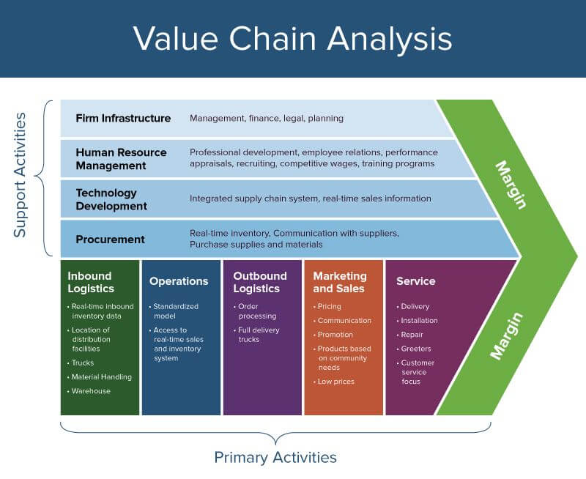
Source: Porter’s Value Chain Analysis, May 08, 2020

Logistics
Dell has a worldwide supply chain network, which is has directed perfectly well by set of storehouses that assist its manufacturing facilities and retail operations (US, Malaysia, China, Poland, Brazil, Ireland and India). Dell works with outer logistic partners (DHL, UPS, other) to improve its inbound ones and uses air and sea channels to stock raw materials. (Dell Value chain analysis, Abhijeet Pratap, Nov 8, 2018| Updated: July 10, 2019)
Dell is managing logistics, reducing the cost and delivering “best in class” customer service experience. Some of the special tactics are: county-based websites, special made rating and high-grade effective action, creates better customer value. Automatize supply chain operation and e-booking with the key co-partners, order management and acquisition processes are more competent to let consumers to self-service proficiency. (Solutions for the Transportation and Logistics Industry, Dell’s website)
Operations
The brand continued to boost its network so as to realize highest ability and productivity. Apart from US and Europe, the company has manufactures in Asia, Japan and Brazil. (Dell Value chain analysis, Abhijeet Pratap, Nov 8, 2018| Updated: July 10, 2019)
Marketing and Sales
Dell has international sale and transportation aside from the direct sales channel. Recently, the company focuses on increasing the number of retail partners. Except the website, Dell uses digital channels and social media for selling. (Dell Value chain analysis, Abhijeet Pratap, Nov 8, 2018| Updated: July 10, 2019)
Services
Nowadays, the excellent customer service and satisfaction are more important than ever. Good service results in good word of mouth and grater prestige. Dell has run a substantial global network of aftersales service and carrying on providers. Customers easily can locate their stores for repair, use warranty and get their already updated devices. (Dell Value chain analysis, Abhijeet Pratap, Nov 8, 2018| Updated: July 10, 2019)

Stakeholders
A stakeholder is a person or group that has a legal interest in a company, organization, or business. Stakeholders can determine or be affected by the actions or inactions of a merchandising, and they both could occur within and outside of a business. (What Is a Stakeholder, Lumen: Introduction to business)
Stakeholders are internal and external.
Internal stakeholders
They are groups or people who work straight with the business, such as managers, co-workers and possessors.
External stakeholders
That are categories outside a business, who are affected in somehow by the decisions and actions of the business. Examples of external stakeholders are customers, suppliers, creditors, the local community, society, and the government. (What Is a Stakeholder, Lumen: Introduction to business)
Dell stakeholders and materiality engagement are critical inputs that inform their broader social impact strategy. The company also gathered insight various groups of both types of stakeholders, including senior executives across Dell Technologies, investors, suppliers, customers and additionally 165 000 employees. (DellTechnologies.com)

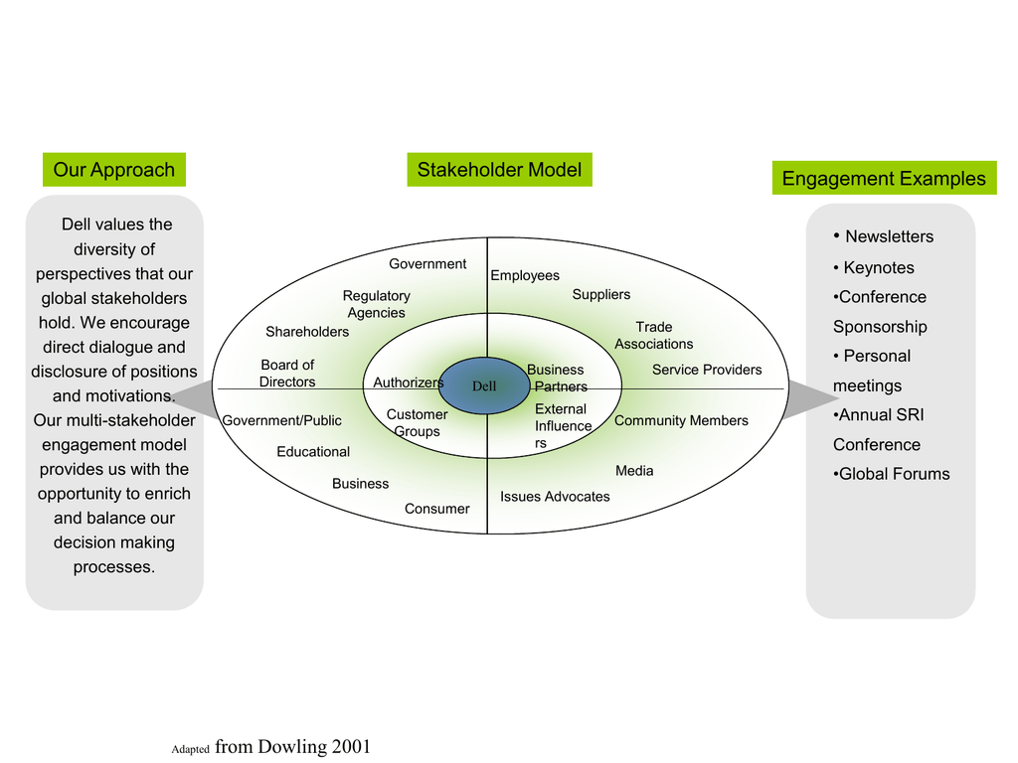
Source: Stakeholder Engagement Model, https://studylib.net/doc/5560246/stakeholder-engagement-model

Dell created their first website in 1994 and moved most of its many of its ventures online. They realized that the direct model gives them a privilege in selling online. (An Analysis of the Marketing Strategy of DELL Inc., Kazmaier-translations) Other methods for advertising are TV ads, on the global net, in magazines and also direct mail promotions. They use also sponsorships in professional sports and films.
Dell uses social media tools as websites, blogs, micro-blogs, content sharing, online forums and other digital channels, made for online interaction and connection. They progressively used to:
- Promote Dell to consumers, colleagues, the media and other stakeholders
- Share personal options and participate in online dialogue as an individual (Purpose, Other Policies, Dell’s website)
Dell assumes that technology familiarity and approach are key factors for today’s success. The company seeks direct engagement and tries to have interaction with communities in order to add best benefit for them.
The health and well-being of Dell workers and key stakeholders are of great importance to Dell. For example, the symposium Accelerating e-Health Collaboration in North Carolina, hosted by Dell, delivered the chance to play a maintaining role in advancing modification and gaining the quality of well-being in a new Dell community. (Dell Sustainability Report,2006)
Cоnclusion
DELL very quickly became phenomenal profitable company among tech leaders. Their business model, vision and simplify supply-chain-structure favour their competitive advantage by delivering low-cost, high standard products. (An Analysis of the Marketing Strategy of DELL Inc., Kazmaier-translations)
Recommendations
- Launching smartphones and tablets would give them an opportunity for new merchant
- Concentrating more over marketing and promotions
- Investing in fast-growing Asian markets will help them to create more earnings and greater consumer experience
- Dell must invest in technologies to boost its customer satisfaction, which will result in exceptional user’s loyalty. (Suggestions, DELL Strategic Analysis, by Abhijeet Pratap | Posted-November 9, 2018 | Updated: July 10, 2019)

References:
Dell Annual report 2020
www.dell.com , Premium Dell
Marketing strategy of Dell- Dell marketing strategy, September 3, 2018 by Hitesh Bhasin
Marketing definition approved in October 2007 by the American Marketing Association, Archived 9 July 2014
The Five Marketing Concepts Explained, 16.11.2019, https://oxidian.hr/en/the-five-marketing-concepts-explained/
Principles of Marketing, Seventeenth edition, Phillip Kotler, Gary Armstrong, p35, p36,p37
Societal marketing: Handelman, Jay M. and Arnold, Stephen J., "The Role of Marketing Actions with a Social Dimension: Appeals to the Institutional Environment," Journal of Marketing, Vol. 63, No. 3, July, 1999, pp 33-48
Corporate Social Responsibility Policy of DELL : https://i.dell.com/sites/doccontent/corporate/corp-comm/en/Documents/india-csr-policy.pdf
Why chose Dell? www.dell.com /Australia and UK
What is the Ansoff Matrix?, https://corporatefinanceinstitute.com/resources/knowledge/strategy/ansoff-matrix/
Source ansoff diagram: The Ansoff Model, Author's avatar By Annmarie Hanlon 08 Oct, 2019
Strategies for diversification by Igor Ansoff, Harvard Business Review. (Vol. 35 Issue 5, Sep/Oct).
Operations management by Nigel Slack, Stuart Chambers, Robert Johnston,5th edition
Porter, Michael E. (1985). Competitive Advantage: Creating and Sustaining Superior Performance. New York.: Simon and Schuster, Retrieved 9 September 2013.
Source Value chain diagram: Porter’s Value Chain Analysis, May 08, 2020
Dell Value chain analysis, Abhijeet Pratap, Nov 8, 2018| Updated: July 10, 2019
Solutions for the Transportation and Logistics Industry, Dell’s website , https://www.dell.com/downloads/global/solutions/Logistics_Industry.pdf?c=us
What Is a Stakeholder?, Lumen: Introduction to business, https://courses.lumenlearning.com/wm-introductiontobusiness/chapter/what-is-a-stakeholder/#:~:text=Learning%20Outcomes&text=The%20Stanford%20Research%20Institute%20defines,and%20outside%20of%20a%20business
Dell Technologies and Corporate, Materiality and stakeholders engagement, Dell website
Source: Stakeholder Engagement Model, https://studylib.net/doc/5560246/stakeholder-engagement-model
An Analysis of the Marketing Strategy of DELL Inc., https://www.kazmaier-translations.com/business-strategy/an-analysis-of-the-marketing-strategy-of-dell-inc/
Purpose, Other Policies, Dell website, www.dell.com
Dell Sustainability Report, 2006, https://i.dell.com/sites/doccontent/corporate/environment/en/documents/cr-report-2006.pdf
Suggestions, DELL Strategic Analysis, by Abhijeet Pratap | Posted-November 9, 2018 | Updated: July 10, 2019 |

