

International Business Concepts (LCMB7034)
Master of Business Administration
Entering an Untapped Market: A Critical Evaluation of Apple Inc.'s Potential Market Entry into Bangladesh
Report
Student Name: Tania Sultana
Student ID Number: 2516332
Lecturer's Name : Akshay Narayanan
Submission date: 14 August 2026
Word Count: 5420

Table of Contents
1. Introduction 4
2. Organisational Classification and Global Strategy 5
2.1 Strategic Categorisation Using the Bartlett and Ghoshal Framework 5
2.2 Global Configuration and the Sources of Competitive Advantage 6
3. Macro-Environmental Appraisal and Market Attractiveness 8
3.1 Political Environment: From Transition to an Untested Majority 8
3.2 Economic Environment: Scale Without Depth 9
3.3 Legal and Regulatory Environment: The Decisive Variable 11
3.4 Cultural and Social Environment 13
3.5 Synthesis Through Dunning's Eclectic Paradigm 15
3.5.1 Ownership Advantages 15
3.5.2 Location Advantages 16
3.5.3 Internalisation Advantages 17
4. Entry Mode Strategy and Strategic Synthesis 19
4.1 Historical Pattern Recognition 19
4.2 Strategic Fit and Justification 19
4.3 Conclusion and Recommendations 21
5. Section 2: Reflective Account 23
5.1 Description 23
5.2 Feelings 23
5.3 Evaluation 24
5.4 Analysis 24
5.5 Conclusion 25
5.6 Action Plan 25
Reference List 26

List of Figures
Figure 1: Positioning Apple on the integration-responsiveness grid
Figure 2: Apple net sales by reportable geographic segment, FY2023-FY2025
Figure 3: Bangladesh real GDP growth and headline inflation, FY2023-FY2027 (forecast)
Figure 4: Rebuilding of Bangladesh's gross foreign exchange reserves, 2023-2026
Figure 5: Tax incidence on imported handsets and on components for local assembly, before and after the January 2026 reform
Figure 6: Official versus grey-market retail pricing for flagship handsets in Bangladesh
Figure 7: Hofstede cultural dimension scores, Bangladesh compared with the United States
Figure 8: Mobile and internet connectivity in Bangladesh, April 2026
Figure 9: Comparative location advantages for premium consumer electronics, Bangladesh, India and Vietnam
Figure 10: Synthesis of Apple's ownership, location and internalisation position in Bangladesh
Figure 11: Entry mode options mapped by control and resource commitment
Figure 12: Phased entry roadmap with conditional decision gates
Figure 13: Gibbs' reflective cycle applied to this assessment

1. Introduction
Apple Inc. is the most valuable company in the world in consumer electronics, but it doesn't have any incorporated entity, retail store or manufacturing base in Bangladesh. Its products are not available directly to the Bangladeshi consumers but rather through independent local companies that purchase inventory and act as Apple Authorised Resellers (Executive Machines, 2026; iCenter, 2026). Apple is not an equity partner in these companies and does not have local employees or operate a localised online store. This report is therefore considered an indirect export and does not constitute market entry, since there is no substantial operational presence. This report therefore asks under what conditions, and through which mode, Apple could convert Bangladesh from an indirect-export market into a formally managed one. Three objectives follow: to classify Apple's international strategy; to appraise the Bangladeshi environment against the requirements of a premium brand; and to justify an entry mode. The first section classifies the Apple's international strategy and appraises the macro-environment of Bangladesh, then synthesises the findings through Dunning's eclectic paradigm and recommends the entry mode. Second Section reflects the research process using Gibbs' cycle.

2. Organisational Classification and Global Strategy

2.1 Strategic Categorisation Using the Bartlett and Ghoshal Framework
Multinationals according to Bartlett and Ghoshal (1989) can be classified based on the relative strength of the pressures for global efficiency and local adaptation. Apple is well entrenched in the global quadrant. The hardware architecture, operating system and design language are exported globally, research and development are focused on Cupertino, and the company claims to run the business on a geographic basis for sales and distribution, not product differentiation (Apple Inc., 2025). Country organisations are the implementers of strategy, not designers.
The classification should be qualified. The typology is criticized as ‘normative and empirically thin' and the transnational form is presented as a desired situation, rather than a real one (Growth Shuttle, 2024). Two counter currents can be seen. Services are necessarily local as App Store curation, payment systems, content licensing and compliance are jurisdiction based, and the data protection regime in Bangladesh would require further localisation (Securiti, 2026). The manufacturing layer, too, is now geopolitically aware, with about 25% of the iPhones now being manufactured in India (The Japan Times, 2026). Apple is thus a global company with a developing transnational periphery, and any decision towards Bangladesh would happen at that periphery.
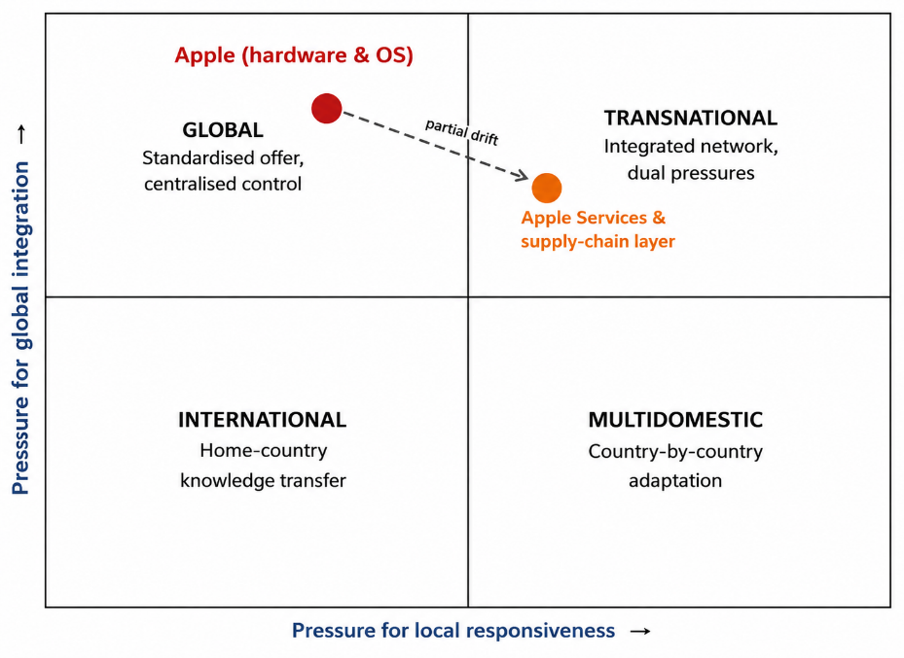
Figure 1: Positioning Apple on the integration-responsiveness grid. Source: Author's own, constructed from the Bartlett and Ghoshal (1989) typology as discussed in Growth Shuttle (2024) and applied to evidence in Apple Inc. (2025).

2.2 Global Configuration and the Sources of Competitive Advantage
Apple's geographical set-up is intentionally skewed. The Americas accounted for US$178.4 billion in net sales (42.8 per cent of total), Europe (including India) and the Middle East/Africa for US$111.0 billion, Greater China for US$64.4 billion, Japan for US$28.7 billion, and the Rest of Asia Pacific for US$33.7 billion in fiscal 2025 (Apple Inc., 2025; Bullfincher, 2026). Bangladesh would be included in the smallest reported segment, Rest of Asia Pacific, which grew in a steady manner.
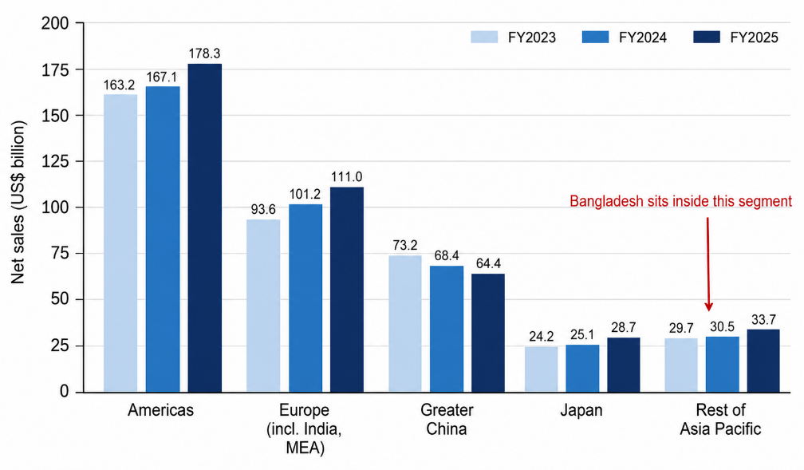
Figure 2: Apple net sales by reportable geographic segment, FY2023-FY2025. Source: Author's own, compiled from Apple Inc. (2025) and Bullfincher (2026).
Value creation is delinked from value capture. The high-margin silicon design, operating systems, industrial design and services are done in the USA, and the assembly is outsourced to contract manufacturers. Services generated US$109.2 billion in FY2025, about a quarter of total sales, at a gross margin of 75.4 per cent against 36.8 per cent on products, lifting the company margin to a record 46.9 per cent (Apple Inc., 2025; Statista, 2026). Roughly US$35 billion of annual research and development is spread across one global product line, so each additional market carries almost no design cost.
This setup is nonetheless under stress. The revenue share of Greater China is the only area to experience two consecutive years of decline, dropping from nearly 20 per cent to 15.5 per cent (Apple Inc., 2025; Bullfincher, 2026). Trade tension has, at the same time, prompted Apple to shift production, with more than US$50 billion of in India-assembled iPhones shipped by December 2025 (Manufacturing Today, 2026). The evidence suggests it is a pattern that is not firm-specific, but multinational firms react to geopolitical risk by diversifying, not decoupling (Yang et al., 2025; CEPR, 2025). Hence, Apple's demand for incremental growth in South Asia is growing at the same time its traditional growth engine is faltering.

3. Macro-Environmental Appraisal and Market Attractiveness
It focuses on the political, economic, legal and cultural factors that go a long way in defining whether premium electronics brand can establish a defensible position in Bangladesh or not.

3.1 Political Environment: From Transition to an Untested Majority
Bangladesh has experienced the biggest political break in its modern history. Sheikh Hasina, who had been in power for the past 15 years, was overthrown in a coup in July 2024, leading to the formation of an interim government headed by Muhammad Yunus (IFES, 2026). The Bangladesh Nationalist Party (BNP) won 209 of the 299 seats and the Jamaat-e-Islami (JI) led alliance won 77 seats and became the major opposition in the 13th parliamentary election, which was held on 12 February 2026 at the same time as a referendum on the July Charter (ICWA, 2026; Australian Institute of International Affairs, 2026).
This for an investor is a real decrease in short-term uncertainty, as two-thirds of the vote allows coherent policy decisions to be taken, while international observers deemed the vote broadly credible (Asia Pacific Foundation of Canada, 2026). There are three caveats to that reading. No less, the Awami League was barred and Jamaat complained about irregularities in counting, casting doubt on the legitimacy of the settlement (Perry World House, 2026). Lastly, the government's Bangladesh First policy is an indication of strategic autonomy and strategic disengagement from India (Australian Institute of International Affairs, 2026).
The third point is relevant to Apple. Any efficient supply route into Bangladesh would have to rely on Indian assembly and logistics – and Dhaka-Delhi friction becomes an operational one. At a larger scale, it is not expropriation, but regulatory uncertainty that poses a political risk for Apple. There were two changes in the taxation of handsets within a span of about six weeks, first by a ministerial decision in December 2025 and then by the Council of Advisers' approval and National Board of Revenue's notification in January 2026 (The Financial Express, 2025; The Business Standard, 2026a; bdnews24, 2026). The direction of travel is favourable, but the velocity indicates a situation of tariffs as a political tool of management and not a steady planning parameter. In a business with worldwide pricing, revised annually, 18% fluctuations in landed cost makes the case for an entry path where a local partner would absorb the duty volatility.

3.2 Economic Environment: Scale Without Depth
Bangladesh has the demographic weight and at the same time the purchasing power is limited. There is a population of approximately 173 million, with some US$450-510 billion in gross national income, but gross national income per capita is approximately US$2,820 in 2024 (World Bank, 2025). Since FY23, growth has slowed down to 4.2 per cent in FY24 and 3.7 per cent in FY25 (IMF, 2026).
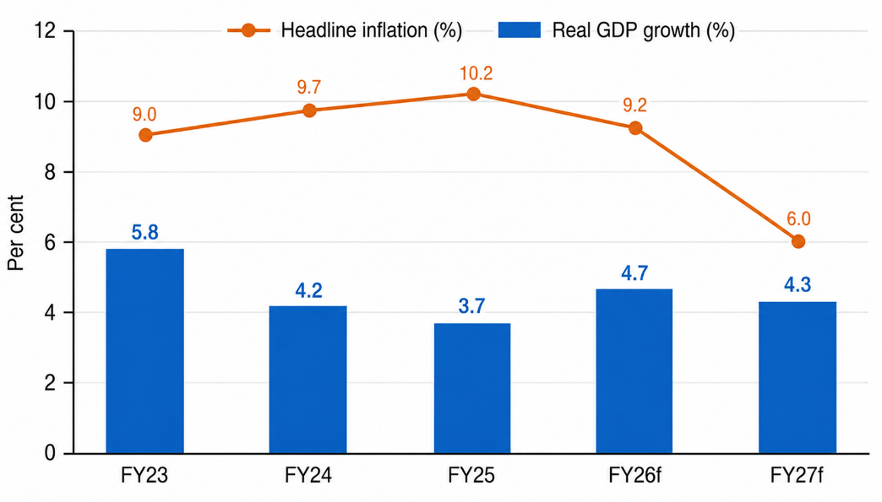
Figure 3: Bangladesh real GDP growth and headline inflation, FY2023-FY2027 (forecast). Source: Author's own, compiled from IMF (2026) and The Business Standard (2026b).
The divergence in forecasts is a clue. The projections of the IMF, Asian Development Bank and World Bank encompass a range of uncertainty with regards to the rate of recovery of private investment, ranging from 4.7 per cent to 3.9 per cent in FY26 (The Business Standard, 2026b). The situation is exacerbated by inflation, which is projected to hover around 9.2 per cent in FY26; moreover, price growth outpaced wage growth in November 2025 (8.29 per cent compared to 8.04 per cent), resulting in a decline in real incomes (LightCastle Partners, 2026).
The outside numbers are more positive. Reserves stood at USD 29 billion as of February 2026, which is equivalent to about 3.8 months of import cover, and were boosted by the highest ever monthly remittances of USD 3.75 billion in March 2026 (World Bank, 2026; LightCastle Partners, 2026). Importers were subjected to dollar rationing in 2022-2024 and any company that sells imported products, particularly multis, needs to be sure that it can pay its bills and bring in profits.
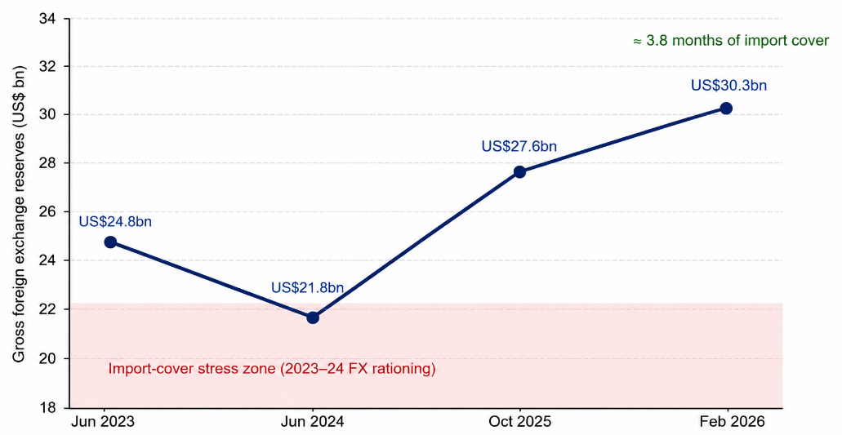
Figure 4: Rebuilding of Bangladesh's gross foreign exchange reserves, 2023-2026. Source: Author's own, compiled from World Bank (2026), IMF (2026) and LightCastle Partners (2026).
There is a precise definition of affordability. The official price of iPhone 17 Pro Max is roughly Tk250,000, which is equivalent to the average monthly earnings of a typical person of roughly Tk27,000, or some nine months of the average gross earnings, while the same device in the USA absorbs only a fraction of the income. (The Business Standard, 2025a). This is not a national middle class, but a narrow band of urban professionals that this ratio, not any overall growth number, does explain Apple's historic neglect of Bangladesh.
The determining constraint is the demand structure. In South Asia, the ultra-low and low-end tiers combined make up approximately 84 per cent of units and the average selling price (ASP) is close to US$152 (IDC, 2024), meaning that the premium tier is thin. However, it is important to understand that the numbers that come out of absolute arithmetic are different: handset makers estimate the demand for their products is about 32 million per year, and even two per cent premium share would mean more than 600,000 handsets (Mobile ID World, 2025). The market is also bigger and faster moving than the income figures alone suggest. IDC recorded five million handsets shipped in the July-September quarter of 2025, up 5.3 per cent year on year, with smartphones reaching 46.5 per cent of shipments against 36.2 per cent a year earlier and mid-range models growing at triple-digit rates (Daily Sun, 2025). Local assembly is scaling behind that shift, at 6.5 million smartphones in the first nine months of 2024, 27.6 per cent up on the year, across seventeen plants (The Business Standard, 2024; bdnews24, 2025), and smartphone volumes are forecast to grow by about 8.5 per cent a year to 2031 (6Wresearch, 2025). Attractiveness therefore rests less on premium value today than on the price- and channel-responsiveness of a market that is formalising from the bottom up.
Lastly, Bangladesh will be outgrowing of LDC status on 24 November 2026 (UN OHRLLS, 2026). The indirect effect is more relevant here: first, graduation is an indicator to investors of the middle-income status; second, it limits the concession of financing, which in turn limits the fiscal space for consumer-friendly tax policy (Stein and Partners, 2026).

3.3 Legal and Regulatory Environment: The Decisive Variable
There are three legal documents that will dictate the economics of any Apple entry, with each making significant moves in 2025/2026.
The first is the tariff regime. In January 2026 the Council of Advisers has reduced the total tax incidence on imported handsets from 61.8 to 43.43 per cent, where customs duty has been reduced from 25 to 10 per cent and import duty and VAT on assembly components are 12.20 per cent which was once 17.20 per cent (Prothom Alo, 2026; The Business Standard, 2026c; Bonik Barta, 2026). The reform is important, but it's not done. However, the local assembled devices still have a competitive edge with a margin of 16-24 per cent to 40-45 per cent for imports (Bangladesh Pratidin, 2025), leaving a margin of around 30 percentage points to favor domestic assembly.
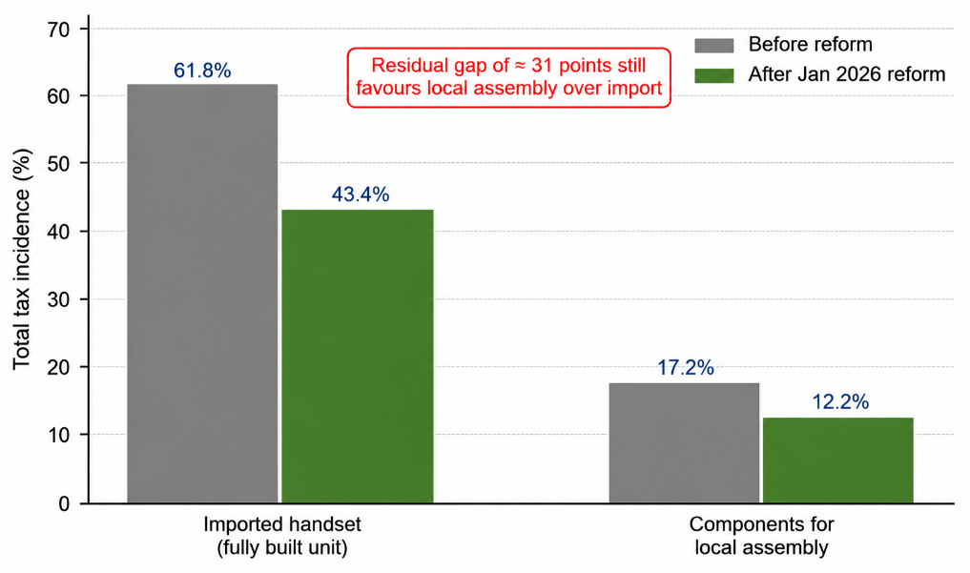
Figure 5: Tax incidence on imported handsets and on components for local assembly, before and after the January 2026 reform. Source: Author's own, compiled from Prothom Alo (2026), bdnews24 (2026) and The Business Standard (2026c).
The second is the National Equipment Identity Register (NEIR), which has been introduced from 16th Dec 2025, and which will register device IMEI numbers and block unregistered ones from the network (The Business Standard, 2025a). Its impact cannot be over emphasised: it has engulfed approximately half the handset market, and as much as 90 per cent of premium volume (Mobile ID World, 2025) as unauthorised imports. The price difference is significant, ranging from the official price of Tk250,000 for the iPhone 17 Pro Max to the unofficial offering of approximately Tk165,000 (Startech, 2026). Much of grey volume is currently formalisable demand if there were effective enforcement. The counter argument is that the register was set up in 2021, and was delayed repeatedly, enforcement capability hasn't yet been proven and there continues to be diplomatic pressure (The Daily Star, 2023; BSS, 2026). The stakes are measurable and the enforcement is contested. Industry and regulator data value the handset market at roughly US$1.7 billion, with the grey channel above US$0.7 billion in 2025 and unofficial imports rising from 24 to 40 per cent between 2022 and 2024 on Samsung's own tracking (The Daily Star, 2026). The register's first week, however, tested politics rather than technology: traders closed shops nationwide, the regulator's headquarters was attacked on launch day, and a three-month grace period for duty-evaded stock was conceded (The Business Standard, 2026d). For Apple this outweighs the tariff cut, because without closure of the grey channel a 43.43 per cent duty simply prices official stock out of the market.
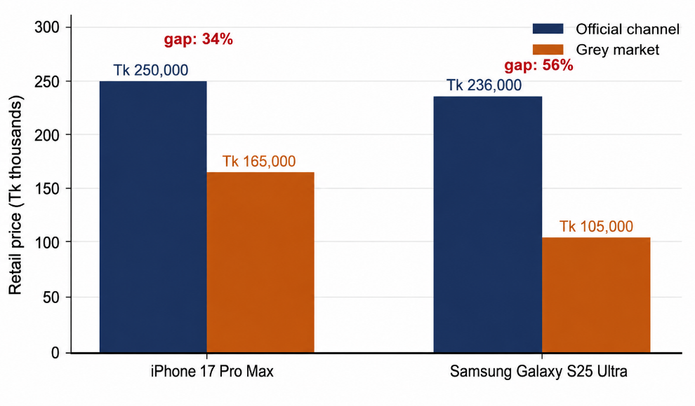
Figure 6: Official versus grey-market retail pricing for flagship handsets in Bangladesh. Source: Author's own, compiled from The Business Standard (2025a) and Startech (2026).
The third is Data Protection. Personal Data Protection Ordinance (PDPO) came into effect on 6 November 2025, was amended in February 2026 and was enacted as the Personal Data Protection Act 2026 (Securiti, 2026; Jural Acuity, 2026). It has extraterritoriality provisions that apply to foreign entities processing the data of Bangladeshi individuals, personal data categorization, as well as provisions to store the processing of confidential and restricted personal data within national jurisdiction (Mahbub and Company, 2025). For Apple, this isn't just a compliance issue, it's a strategy, because iCloud, Apple ID and payment would all likely need in-country storage. The ordinance's drafting has come under fire from civil society groups while Apple’s similar facilities in China have been subject to constant criticism (Tech Global Institute, 2025). Weak enforcement of intellectual property rights adds to this problem, putting Apple at risk for counterfeit accessories and refurbished devices being sold as new (US Department of State, 2025).
The regime is fairly open when it comes to investments. Foreign investment is allowed in almost all sectors under the Foreign Private Investment Act 1980 and Companies Act 1994 and the Bangladesh Investment Development Authority offers one-stop registration, (US Department of State, 2025). The enforcement of contracts is still slow in court, however, and the importance of self-enforcing commercial arrangements is accentuated.

3.4 Cultural and Social Environment
Bangladesh has a power distance score of 80, individualism score of 20, motivation towards achievement score of 55, uncertainty avoidance score of 60, long-term orientation score of 47, and indulgence score of 20 (The Business Standard, 2025b; Simply Psychology, 2025). As a result, there are three implications for a premium brand.
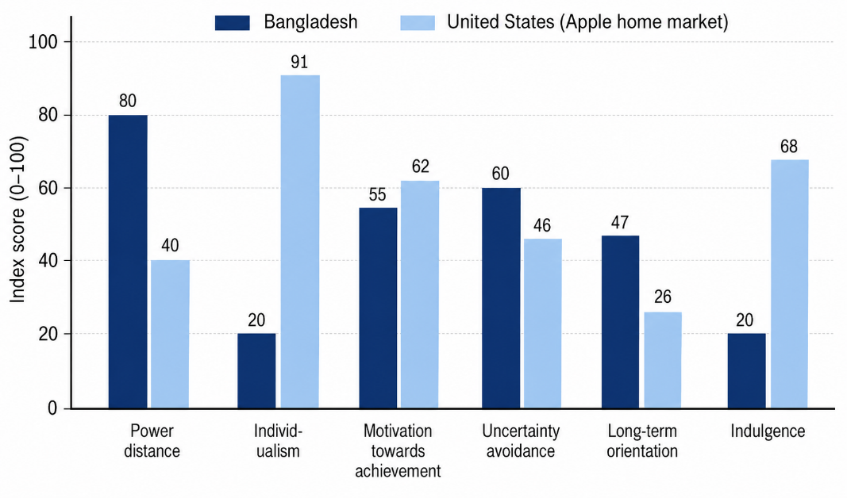
Figure 7: Hofstede cultural dimension scores, Bangladesh compared with the United States. Source: Author's own, compiled from The Business Standard (2025b) and Simply Psychology (2025).
High power distance and strong collectivism mean that, visible consumption can be a good indicator of social standing, and that family and peer referents can be particularly powerful. So, an iPhone is a “positional” product, not just “a device.” The same applies to high uncertainty avoidance, in which authenticity and official warranty, and readily available service, become important, not secondary, factors, making for any premium that authorised resellers can charge on cheaper grey imports. The very low indulgence score points in the other direction – towards messages of durability and reusability and family usefulness rather than to self-expression.
Research by the Bangladeshi consumers reveals that price, peer influence, and product features are the top drivers of purchase intention, Samsung/Android is the preferred combination, and brand image is not always a key factor (Khan, Arif and Ali, 2024). This gives strength to Samsung's incumbency, which has been strengthening since 2017, when Samsung Electronics started assembling locally through Fair Electronics (BSS, 2026).
The infrastructure situation is good. As of April 2026, there were 187.1 million mobile connections and 131.4 million internet subscribers, 119.3 million of which are through mobile connections (AMTOB, 2026; Dhaka Tribune, 2026; New Age, 2026). The percentage of households with smartphones increased from 63.3 to 72.8 per cent between 2023 and 2025, while 4G coverage is near ubiquitous, albeit with minimal 5G deployment to undermine any next-generation connectivity offering (Future Startup, 2026). Payment infrastructure is the big limiting factor when it comes to services – penetration of credit cards is about 0.6 per cent of adults, so mobile financial services is the realistic settlement mechanism (The Daily Star, 2025).
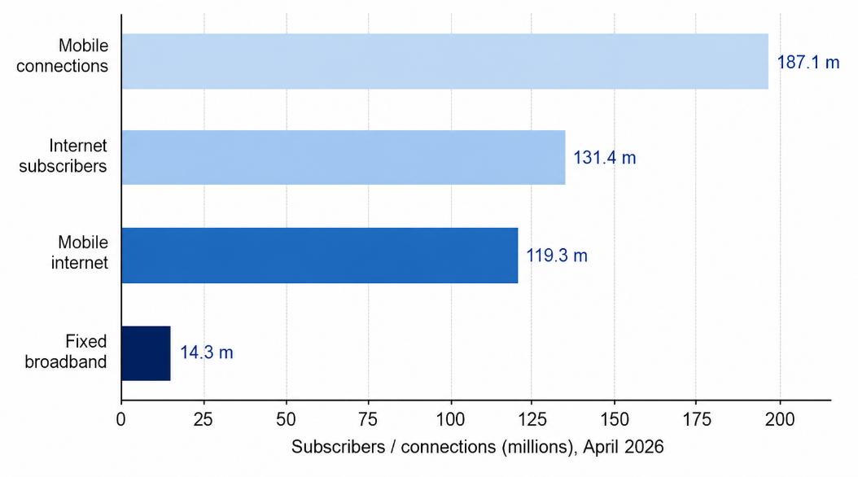
Figure 8: Mobile and internet connectivity in Bangladesh, April 2026. Source: Author's own, compiled from AMTOB (2026), Dhaka Tribune (2026) and New Age (2026).
There's a big caveat in all this. Apple's realistic prospect is not Bangladesh, but the professional elite of Dhaka and Chattogram, whose consumer behaviour is more like other South Asian cities' professional classes than to the national average. A country score should not be used as a description of a segment.

3.5 Synthesis Through Dunning's Eclectic Paradigm
Dunning's eclectic paradigm postulates the simultaneous presence of ownership, location and internalisation advantages for foreign direct investment to take place, and it still stands as the predominant model to explain why firms prefer to produce abroad than export or license. It gives an asymmetric result when applied to apple in Bangladesh.

3.5.1 Ownership Advantages
The ownership advantages of Apple are outstanding. Silicon, iOS, and the combination of hardware, software, and services is a proprietary technology that can be exported to any country, and that can be done at virtually no incremental cost. There are also transaction-based benefits, such as the supply chain orchestration and retail management skills that have been built up over 20 years.
The catch is that a lot of this isn't usable in Bangladesh. Apple's margin model requires them to tie in services revenue with hardware, and all the App Store payments, Apple Pay, Apple Music and Apple TV+ are dependent on card infrastructure and content licensing the country lacks (The Daily Star, 2025). Apple would come in with hardware strengths unscathed, and services strengths compromised, thereby making the lifetime-value argument less compelling.

3.5.2 Location Advantages
Location advantages are not lacking. In a positive light, Bangladesh has a population of 173 million, near universal coverage of 4G systems, rapid formalisation of the retail channel, the tariff on imported handsets has been lowered by over eighteen percentage points and soon, Bangladesh will be a middle-income country with a graduation from LDC status (Prothom Alo, 2026; UN OHRLLS, 2026). On the other hand, per capita income is low, inflation is causing real income to decline, the enforcement of contracts is weak and there are data localisation requirements which incur cost.
Location advantages for efficiency purposes are virtually nonexistent for the medium term. There are about 18 companies that assemble handsets in Bangladesh, but at just half the capacity and on comparatively simpler devices, and there is no precision component ecosystem or equivalent to India's production-linked incentive (PLI) scheme (Mobile ID World, 2025; The Business Standard, 2025a). The comparison with India, which after a decade of incentives has created a foundation to assemble the Pro-tier iPhone, is instructive, not encouraging. Bangladesh is not an efficiency-seeking location, it is market-seeking.
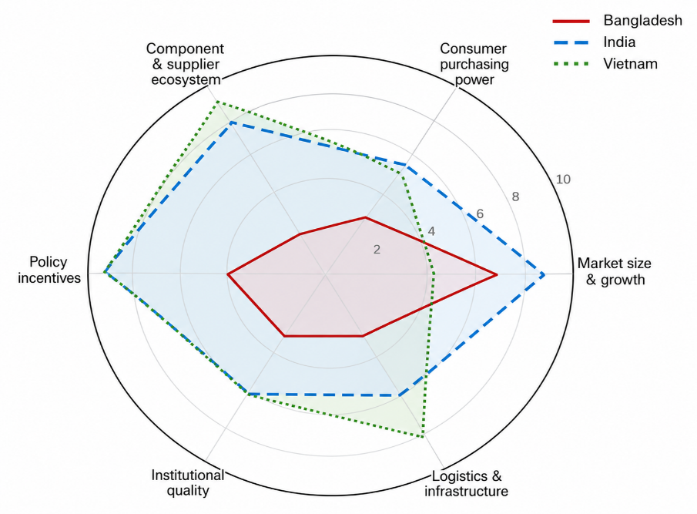
Figure 9: Comparative location advantages for premium consumer electronics, Bangladesh, India and Vietnam. Source: Author's own assessment, scored from evidence in US Department of State (2025), Mobile ID World (2025), The Japan Times (2026) and Gadget Hacks (2025).

3.5.3 Internalisation Advantages
Internalisation benefits are not universal. Each of these is a dimension of brand presentation that is reputational in nature and cannot be contractually tied down, and Apple has a compelling interest in maintaining these attributes in-house. Its motivations to do physical retail, importation and after-sales logistics are weak, as an owned outlet would incur high fixed expenses against low premium volume, plus Apple would have to work years to build the distribution reach that already exists with local partners.
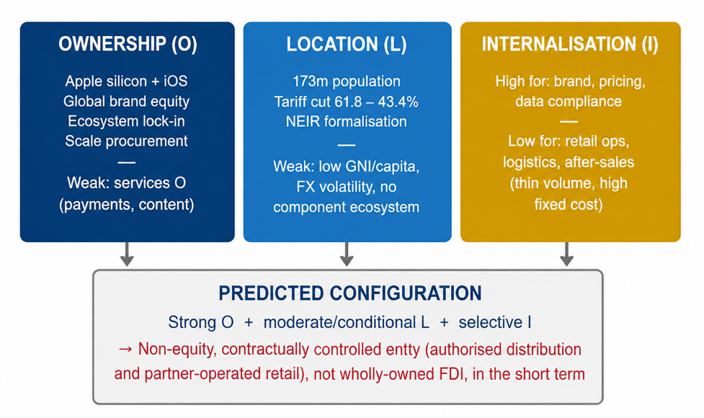
Figure 10: Synthesis of Apple's ownership, location and internalisation position in Bangladesh. Source: Author's own, applying the eclectic paradigm as discussed in Ren (2024) and Silva, Ogasavara and Pereira (2024) to evidence cited in Sections 3.1-3.4.
The paradigm thus holds that the ownership advantages are likely to be strong, the location advantages are conditional, and the internalisation advantages are only partial, which will result in non-equity or low-equity modes rather than FDI. The main drawback of the framework is its stateless: It determines the best configuration at a given moment but does not specify how the commitments should be made as circumstances shift (Silva, Ogasavara and Pereira, 2024).

4. Entry Mode Strategy and Strategic Synthesis

4.1 Historical Pattern Recognition
It never owned handset assembly shops, always worked with contract manufacturers. In high-value markets it has 100 percent marketing and retail subsidiaries. In developing markets, it starts with independent authorised resellers, distributors, and then a localised online store, and finally owned retail.
India exemplifies the whole process. Apple has been selling through distributors for 20 years and introduced its online retail store in 2020, opened its first two retail stores in Mumbai & Delhi in April 2023 and had five stores by the end of 2025 with sales nearing US$9 billion (TechCrunch, 2023; Gadget Hacks, 2025; The Tech Portal, 2026; IBEF, 2026). A policy change was a prerequisite for each escalation, in particular the single-brand retail rules and the production-linked incentive scheme. The policy was not for Apple; it was by Apple.
Bangladesh is at the very first step of that process and even less. Since 2008 and 2011, respectively, independent resellers like Executive Machines and Gadget & Gear have been selling Apple products, with Gadget & Gear opening the nation's first Apple mono-store in Gulshan in 2025 (Executive Machines, 2026; The Financial Express, 2026). Apple doesn't get any equity, local cost base or market intelligence from these deals: the mode is indirect exporting with a reseller badge, and that is all.

4.2 Strategic Fit and Justification
There are four options that can be evaluated based on risk, resources commitment, control, long term strategic fit.
The status quo reduces political and financial risk but on three counts it fails. The grey channel has no control over the price, and it is about a third cheaper than the official stock, so most high-end volume is going through the grey channel. There are different levels of service among unaffiliated resellers, which has an impact in a culture where high uncertainty avoidance has become the primary motivator for purchase and credibility of the warranty is a key issue.
A marketing subsidiary and owned Apple Store is too early. At present, there's insufficient formal premium volume to justify the investment, the political accord is still in its infancy and data localisation requirements would have to be fixed before Apple could provide services locally. Creating an owned presence before the registered identity in the National Equipment Identity Register is proved would result in a cost of formalities but would be competing with an untaxed parallel market.
There is an attractive superficial appearance around a licensed local assembly arrangement that is like Samsung's partnership with Fair Electronics, in that it would capture the 30% tax benefit referred to in Section 3.3 (BSS, 2026). It is nevertheless to be rejected. Apple's quality governance relies on a highly developed supplier base that Bangladesh lacks, volumes of semi-knocked-down goods at high prices would be too small to support the amortisation of tooling, and poor IP enforcement brings leakage risks to precisely what makes Apple uniquely valuable (US Department of State, 2025).
Political risk is moderate, and decreasing, but the form that remains is regulatory and not expropriatory, which hurts irreversible commitment more than presence. The financial risk is held in exchange rate exposure/repatriation, which is minimised if inventory is held and taka is settled with a local partner. The grey channel dominates the operational risk and only the state acting on the device register can neutralise it. However, long-term strategic fit says that 'eventual presence' is a better option, as Bangladesh will slowly and surely have more affluent consumers in the urban area and Apple cannot just leave it to Samsung to have that segment.
The recommended way is escalating commitment using contractual controls and not equity controls – with predefined decision gates.
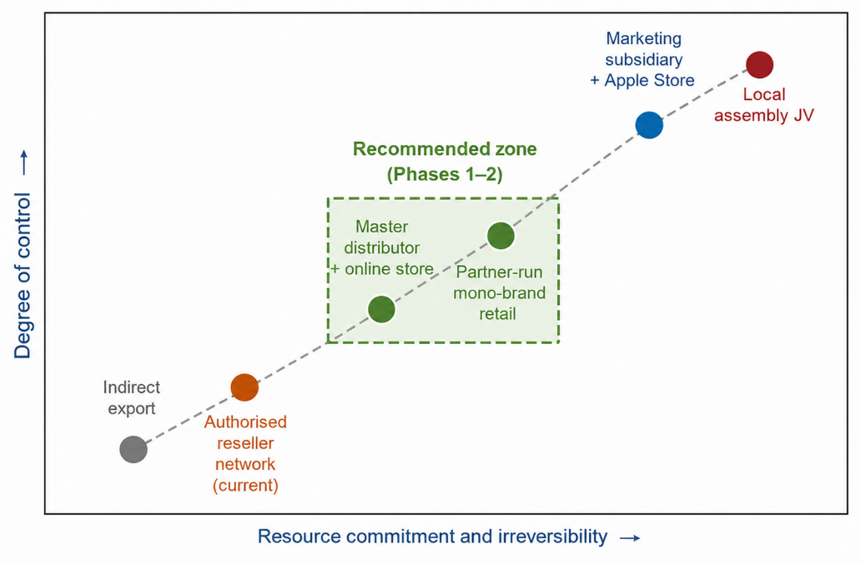
Figure 11: Entry mode options mapped by control and resource commitment. Source: Author's own, informed by entry mode literature reviewed in Silva, Ogasavara and Pereira (2024) and Depperu, Galavotti and Baraldi (2024).
Phase 1, the first 12 months, frames the substitution of the engineered reseller system with only one Apple Authorised Distributor that is subject to contractual price floors, service level agreements and merchandising standards; a localised online store with Bangla language, mobile financial services and instalment payment integration. Phase 2, which runs from month 12 to 30, introduces a certified Apple Authorised Service Provider network and Apple Premium Partner stores with trade-in and zero-interest instalments being affordability options instead of discounts in Dhaka and Chattogram.
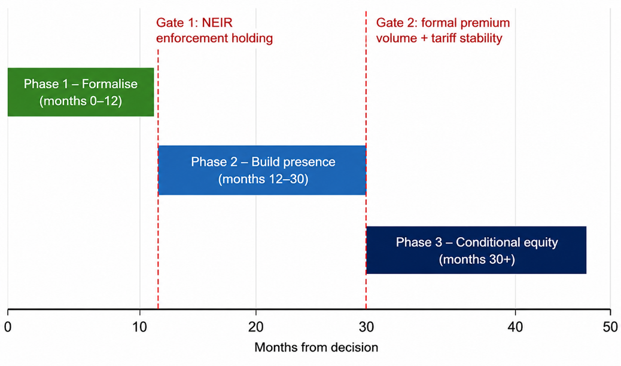
Figure 12: Phased entry roadmap with conditional decision gates. Source: Author's own.

4.3 Conclusion and Recommendations
Bangladesh is a market that is attractive to Apple, in large part because it is a regulatory, not economic event. The tariff reform of January 2026 brought the official-grey price difference down and the National Equipment Identity Register (NEIR) has the potential to further reduce the difference, yet their efficacy remains to be tested. The application of Dunning's paradigm indicates the presence of strong ownership advantages, conditional location advantages and only partial internalisation advantages, which speaks against the case for foreign direct investment in the short run.
The recommendation is therefore to enter deliberately but without equity. Apple should unify distribution under a single contractually managed master distributor, open a localised online store and create a certified servicing network, and appoint a local data compliance officer before the Personal Data Protection Act comes into force. Specifically, Apple should appoint a single master distributor by the first quarter of 2027 under contractual price floors within five per cent of dollar list price, a 60-day parts inventory and a 72-hour repair standard; settle a Bangla-language online store through mobile financial services with twelve-month zero-interest instalments, given card penetration of 0.6 per cent; certify at least four authorised service providers across Dhaka and Chattogram; and place a resident data protection officer in post before the compliance deadline. Equity should be released only once official premium shipments exceed 100,000 units a year, grey share falls below 25 per cent on regulator data, and the tariff schedule holds across two budgets. The biggest danger is that it will be another failure, with Bangladesh being the grey market that Apple is able to sell profitably but cannot legally claim.

5. Section 2: Reflective Account
The six-stage cycle of Gibbs (1988) was selected for this reflection, as it is more explicit in discussing feelings and evaluations, which were important in the decisions I made in the analysis of this assignment, where there was uncertainty in the quality of evidence (Structural Learning, 2023; Morris, 2020).
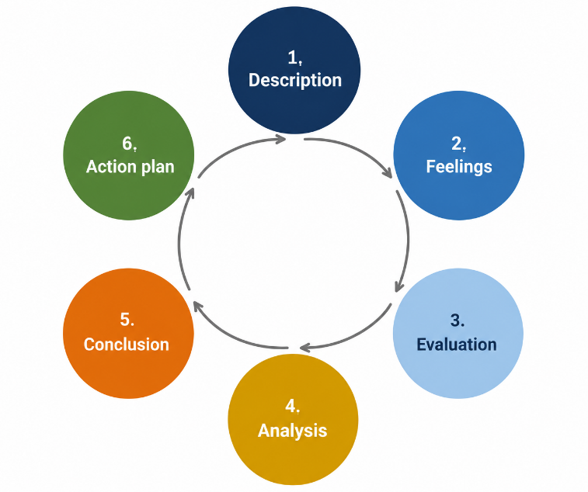
Figure 13: Gibbs' reflective cycle applied to this assessment. Source: Author's own, based on the six-stage model as described in Structural Learning (2023) and Ezezika and Johnston (2023).

5.1 Description
This task involved choosing a multinational and a country in which it was not yet operating and to analyse the entry decision. I selected Apple and Bangladesh. The absence part took longer than expected because when I searched, there were many Apples Authorised Reseller stores and I had to research these were separately owned stores with reseller status rather than subsidiaries before the case could be defensible.

5.2 Feelings
My first thought was confidence since Apple is well documented. That confidence eroded quickly. Political and fiscal conditions in Bangladesh kept shifting while I was doing the research, and I didn't know if any of the numbers I noted were up to date. It was frustrating when three institutions came up with three different GDP estimates for one year.

5.3 Evaluation
My greatest success with my approach was source triangulation. If a claim was pertinent to the recommendation, such as the shift in handset tax incidence, I made sure to check it with a government-related outlet, a business daily and a trade magazine before incorporating it into my report. I also built my own figures based on underlying data rather than charts published by others, which led to proper understanding of each set of data.
The one thing I did wrong the most was my opening frame. The first thing I tried was a "traditional" environmental survey, each dimension one by one and the result was more like a description than an analysis. It also failed to provide attention to factors pertinent to the firm's industry. The second was that I drew almost exclusively from English-language sources, ensuring that my evidence was probably more weighted towards urban and elite views.

5.4 Analysis
The third observation is of balance. The tariff reform was described as a clear-cut success by government-backed sources and as a lack of protection by industry sources. Keeping both the readings together, but not choosing one, led to the more defensible conclusion that the reform constituted a narrowing but not a closing of the gap in favour of domestic assembly.
The turning point was when I set aside the question of whether Bangladesh was pretty or not and instead began the question of what would have to be true for Apple to invest capital. That reconfiguration turned out to be the difference-maker: not income or people, but the enforcement of the National Equipment Identity Register, which means that the grey market - not local competition - is the real factor in dampening Apple's formal volume. I came to understand this through the module material on institutional voids and by learning from the entry mode literature: institutional quality has a greater influence on ownership decisions than does market size (Depperu, Galavotti and Baraldi, 2024; Silva, Ogasavara and Pereira, 2024).
The second area of development was for the frameworks to be applied critically and not mechanically. The advantages of owning services that Apple can do are not applicable in a market with 0.6 per cent card penetration, and that made a checklist an argument. I also learned how to articulate the boundaries of a framework, since Dunning's paradigm does a good job of explaining the current configuration, but not sequencing, so I added a staged options-based recommendation.
I was not as successful in the quantification arena. Unfortunately, I was unable to get premium segment shipment data for Bangladesh and made some assumptions based on the regional averages and national demand estimates.

5.5 Conclusion
Three lessons are noteworthy. Estimated too short a time for confirming an absence is more difficult than for confirming a presence. The fundamental problem was that the market was changing much faster than the market reporting was, and there were discrepancies between data published within weeks of each other and each fact had to be dated and traced back to the latest primary statement to which it belonged. What I got out of that is that the credibility of a recommendation in a volatile market isn't necessarily determined by the number of evidence it has, it's determined by how it treats disagreement between evidence. I also discovered that I should look for a local constraint to each purported firm-level advantage, and that's what made Apple's services strength a qualification, rather than a selling point.
This was more influenced by Course material than I expected. Lectures on internalisation theory helped me to understand that Apple outsourcing the assembly of their products while keeping retail experience in-house is not a step down from equity control, and case discussion about firms entering institutionally weak markets equipped me to value contractual control as an alternative to equity control.

5.6 Action Plan
For future assignments I will implement 3 changes. Before I collect evidence, I will state the question I am trying to answer: My first draft failed to do this, which was a cost. I will have a dated source log of when each statistic was published/retrieved, which would have reduced the inconsistencies I corrected in 3.2. Lastly, in analysing an unfamiliar market I will try to look to at least one source that is in the local language or from a local institution as my dependency on English-language sources limited my perspectives.

Reference List
6Wresearch (2025) Bangladesh smartphone market (2025-2031): outlook and forecast. Available at: https://www.6wresearch.com/industry-report/bangladesh-smartphone-market-2020-2026 (Accessed: 28 July 2026).
AMTOB (2026) Industry statistics: mobile phone subscribers in Bangladesh. Association of Mobile Telecom Operators of Bangladesh. Available at: https://www.amtob.org.bd/home/industrystatics (Accessed: 28 July 2026).
Apple Inc. (2025) Annual report on Form 10-K for the fiscal year ended 27 September 2025. Washington, DC: US Securities and Exchange Commission. Available at: https://www.sec.gov/Archives/edgar/data/320193/000032019325000079/aapl-20250927.htm (Accessed: 28 July 2026).
Asia Pacific Foundation of Canada (2026) Bangladesh's 2026 election: BNP landslide ends 'two begums' era. Available at: https://www.asiapacific.ca/publication/bangladeshs-2026-election-bnp-landslide-ends-two-begums-era (Accessed: 28 July 2026).
Australian Institute of International Affairs (2026) Bangladesh's 2026 election and the prospects for democratic renewal. Available at: https://www.internationalaffairs.org.au/australianoutlook/bangladeshs-2026-election-and-the-prospects-for-democratic-renewal/ (Accessed: 28 July 2026).
Bangladesh Pratidin (2025) 'Govt to cut smartphone import duty, prices to fall', 4 December. Available at: https://en.bd-pratidin.com/economy/2025/12/04/52040 (Accessed: 28 July 2026).
Bartlett, C.A. and Ghoshal, S. (1989) Managing across borders: the transnational solution. Boston, MA: Harvard Business School Press.
bdnews24 (2025) 'Unsold handsets worth billions linger as NEIR launch nears', 4 December. Available at: https://bdnews24.com/business/7452f2a1756c (Accessed: 28 July 2026).
bdnews24 (2026) 'Government cuts import, production duties for mobile phones', 1 January. Available at: https://bdnews24.com/business/7e5395ee0c32 (Accessed: 28 July 2026).
Bonik Barta (2026) 'Bangladesh cuts import duty for mobile phones, assembly components'. Available at: https://en.bonikbarta.com/technology/DxclNodGddiqcBcy (Accessed: 28 July 2026).
BSS (2026) 'Korean envoy backs Bangladesh manufacturing, urges stronger NEIR enforcement', Bangladesh Sangbad Sangstha, 22 July. Available at: https://www.bssnews.net/others/408024 (Accessed: 28 July 2026).
Bullfincher (2026) Apple revenue breakdown by region. Available at: https://bullfincher.io/companies/apple/revenue-by-geography (Accessed: 28 July 2026).
CEPR (2025) Geopolitical risk and supply chain diversification. Centre for Economic Policy Research. Available at: https://cepr.org/voxeu/columns/geopolitical-risk-and-supply-chain-diversification (Accessed: 28 July 2026).
Daily Sun (2025) 'Value for money redefines Bangladesh's smartphone market', 6 November. Available at: https://www.daily-sun.com/other/838292/value-for-money-redefines-bangladesh-s-smartphone-market (Accessed: 28 July 2026).
Depperu, D., Galavotti, I. and Baraldi, F. (2024) 'Institutional distance and cross-border acquisitions into emerging markets: the moderating effect of context experience', International Journal of Emerging Markets, 19(5), pp. 1449-1472. https://doi.org/10.1108/IJOEM-12-2021-1897.
Dhaka Tribune (2026) 'Internet users surge by 1.8 million in April as Bangladesh rebounds', 14 June. Available at: https://www.dhakatribune.com/bangladesh/412615/ (Accessed: 28 July 2026).
Dunning, J.H. (1988) 'The eclectic paradigm of international production: a restatement and some possible extensions', Journal of International Business Studies, 19(1), pp. 1-31. https://doi.org/10.1057/palgrave.jibs.8490372.
Executive Machines (2026) Apple authorized reseller in Bangladesh. Available at: https://executivemachines.com/ (Accessed: 28 July 2026).
Ezezika, O. and Johnston, N. (2023) 'Development and implementation of a reflective writing assignment for undergraduate students in a large public health biology course', Pedagogy in Health Promotion. https://doi.org/10.1177/23733799211069993.
FES Asia (2025) Adapting to new realities: Bangladesh prepares to graduate from Least Developed Country status amid geoeconomic disruptions. Friedrich-Ebert-Stiftung. Available at: https://asia.fes.de/news/adapting-to-new-realities.html (Accessed: 28 July 2026).
Future Startup (2026) The state of Bangladesh's digital economy at the beginning of 2026. Available at: https://futurestartup.com/2026/02/23/the-state-of-bangladeshs-digital-economy-at-the-beginning-of-2026/ (Accessed: 28 July 2026).
Gadget Hacks (2025) Apple opens 5th India store as manufacturing hit $14B. Available at: https://apple.gadgethacks.com/news/apple-opens-5th-india-store-as-manufacturing-hit-14b/ (Accessed: 28 July 2026).
Gibbs, G. (1988) Learning by doing: a guide to teaching and learning methods. Oxford: Further Education Unit, Oxford Polytechnic.
Growth Shuttle (2024) Bartlett and Ghoshal's matrix: mastering global dynamics. Available at: https://growthshuttle.com/frameworks/bartlett-ghoshal-matrix/ (Accessed: 28 July 2026).
Hofstede, G. (2001) Culture's consequences: comparing values, behaviors, institutions and organizations across nations. 2nd edn. Thousand Oaks, CA: Sage.
IBEF (2026) Apple posts record sales in India with strong growth across iPhone, Mac, iPad and services. India Brand Equity Foundation. Available at: https://www.ibef.org/news/apple-posts-record-sales-in-india-with-strong-growth-across-iphone-mac-ipad-and-services (Accessed: 28 July 2026).
iCenter (2026) Apple authorised seller and service provider in Bangladesh. Available at: https://www.icentre-bd.com/ (Accessed: 28 July 2026).
ICWA (2026) A new chapter in Dhaka: outcomes of the 2026 Bangladesh elections and key takeaways. Indian Council of World Affairs. Available at: https://www.icwa.in/show_content.php?lang=1&level=3&ls_id=14280&lid=8687 (Accessed: 28 July 2026).
IDC (2024) Samsung and Apple Grew in Q1 2026 As the Global Smartphone Shipments Declines 2.9% amid memory constraints, according to IDC. Available at: https://www.idc.com/promo/smartphone-market-share/ (Accessed: 28 July 2026).
IFES (2026) Elections in Bangladesh: 2026 parliamentary elections and national referendum. International Foundation for Electoral Systems. Available at: https://www.ifes.org/tools-resources/election-snapshots/elections-bangladesh-2026%20Parliamentary-Elections-National-Referendum (Accessed: 28 July 2026).
IMF (2026) IMF Executive Board concludes 2025 Article IV consultation with Bangladesh, Press Release No. 26/029. International Monetary Fund. Available at: https://www.imf.org/en/news/articles/2026/01/30/pr-26029-bangladesh-imf-executive-board-concludes-2025-article-iv-consultation (Accessed: 28 July 2026).
Jural Acuity (2026) Personal Data Protection Ordinance 2025. Available at: https://juralacuity.com/personal-data-protection-ordinance/ (Accessed: 28 July 2026).
Khan, M.R.K., Arif, M.Z.U. and Ali, M. (2024) 'Consumers' perceptions towards cell phone brand preference: the case of Bangladesh', International Journal of Management Studies, 31(1), pp. 137-170. https://doi.org/10.32890/ijms2024.31.1.6.
Kolb, D.A. (1984) Experiential learning: experience as the source of learning and development. Englewood Cliffs, NJ: Prentice Hall.
LightCastle Partners (2026) Bangladesh's macroeconomic and growth outlook 2026. Available at: https://lightcastlepartners.com/insights/2026/01/bangladesh-macroeconomic-outlook-growth-investment-2026/ (Accessed: 28 July 2026).
Mahbub and Company (2025) Key highlights of the Personal Data Protection Ordinance 2025 for businesses. Available at: http://mahbub-law.com/key-highlights-of-the-personal-data-protection-ordinance-2025-for-businesses/ (Accessed: 28 July 2026).
Manufacturing Today (2026) Apple moves quarter of iPhone production to India as exports surge. Available at: https://manufacturing-today.com/news/apple-moves-quarter-of-iphone-production-to-india-as-exports-surge/ (Accessed: 28 July 2026).
Mobile ID World (2025) Bangladesh delays NEIR implementation as grey market threatens local mobile manufacturing. Available at: https://mobileidworld.com/bangladesh-delays-neir-implementation-as-grey-market-threatens-local-mobile-manufacturing/ (Accessed: 28 July 2026).
Morris, T.H. (2020) 'Experiential learning - a systematic review and revision of Kolb's model', Interactive Learning Environments, 28(8), pp. 1064-1077. https://doi.org/10.1080/10494820.2019.1570279.
New Age (2026) 'Number of mobile, internet subscribers rise', 9 May. Available at: https://www.newagebd.net/post/telecom/299264/number-of-mobile-internet-subscribers-rise (Accessed: 28 July 2026).
Perry World House (2026) The 2026 Bangladesh elections: a Q&A with Muhib Rahman. University of Pennsylvania. Available at: https://perryworldhouse.upenn.edu/news-and-insight/the-2026-bangladesh-elections-a-qa-with-muhib-rahman/ (Accessed: 28 July 2026).
Prothom Alo (2026) 'Mobile phone import, manufacturing taxes lowered', 1 January. Available at: https://en.prothomalo.com/bangladesh/government/f1bqasssxi (Accessed: 28 July 2026).
Ren, Y. (2024) 'A review of the determinants of outward foreign direct investment (FDI): from the perspective of the eclectic paradigm', Academic Journal of Business & Management, 6(11), pp. 128-132. https://doi.org/10.25236/AJBM.2024.061119.
Securiti (2026) An overview of Bangladesh's Personal Data Protection Act, 2026. Available at: https://securiti.ai/bangladesh-personal-data-protection-act-overview/ (Accessed: 28 July 2026).
Silva, F.M., Ogasavara, M.H. and Pereira, R. (2024) 'Institutional distances and equity-based entry modes: a systematic literature review', Management Review Quarterly, 74(3), pp. 1723-1790. https://doi.org/10.1007/s11301-023-00346-4.
Simply Psychology (2025) Hofstede's cultural dimensions theory. Available at: https://www.simplypsychology.org/hofstedes-cultural-dimensions-theory.html (Accessed: 28 July 2026).
Startech (2026) How to check official and unofficial phones in Bangladesh. Available at: https://www.startech.com.bd/blog/how-to-check-official-and-unofficial-phone (Accessed: 28 July 2026).
Statista (2026) Services boost Apple's profit margin. Available at: https://www.statista.com/chart/33869/apple-gross-profit-margin (Accessed: 28 July 2026).
Stein and Partners (2026) Bangladesh's 2026 LDC graduation: key risks, export impact and recommended actions. Available at: https://www.steinandpartners.com/investment-finance/bangladeshs-ldc-graduation-key-risks-recommended-actions/ (Accessed: 28 July 2026).
Structural Learning (2023) Gibbs' reflective cycle. Available at: https://www.structural-learning.com/post/gibbs-reflective-cycle (Accessed: 28 July 2026).
Tech Global Institute (2025) Statement on the draft Personal Data Protection Ordinance 2025 and the draft National Data Management Ordinance 2025. Available at: https://techglobalinstitute.com/announcements/tgis-statement-on-the-draft-personal-data-protection-ordinance-2025-and-the-draft-national-data-management-ordinance-2025/ (Accessed: 28 July 2026).
TechCrunch (2023) 'Apple to open first India retail stores next week, signaling growth ambitions in emerging market', 10 April. Available at: https://techcrunch.com/2023/04/10/apple-to-open-two-retail-stores-in-india-next-week (Accessed: 28 July 2026).
The Business Standard (2024) 'Smartphone production surges 27.58% in Jan-Sep', 4 November. Available at: https://www.tbsnews.net/economy/smartphone-production-surges-2758-jan-sep-983741 (Accessed: 28 July 2026).
The Business Standard (2025a) '16 December countdown: can Bangladesh shut down 90% grey phone market?', 22 November. Available at: https://www.tbsnews.net/bangladesh/16-december-countdown-can-bangladesh-shut-down-90-grey-phone-market-1290216 (Accessed: 28 July 2026).
The Business Standard (2025b) 'Understanding Bangladesh's political crisis through Hofstede's cultural dimensions', 6 April. Available at: https://www.tbsnews.net/thoughts/understanding-bangladeshs-political-crisis-through-hofstedes-cultural-dimensions-1109251 (Accessed: 28 July 2026).
The Business Standard (2026a) 'Govt cuts mobile phone import tax from 61% to 43.4%', 1 January. Available at: https://www.tbsnews.net/bangladesh/govt-cuts-mobile-phone-import-tax-61-434-1324101 (Accessed: 28 July 2026).
The Business Standard (2026b) 'Bangladesh's economy to grow 4.7% in FY26, slow further to 4.3% in FY27: IMF', 16 April. Available at: https://www.tbsnews.net/economy/bangladeshs-economy-grow-47-fy26-slow-further-43-fy27-imf-1411496 (Accessed: 28 July 2026).
The Business Standard (2026c) 'Mobile phone prices likely to fall as NBR slashes import taxes by 30%', 14 January. Available at: https://www.tbsnews.net/nbr/mobile-phone-prices-set-fall-nbr-slashes-import-duty-1333056 (Accessed: 28 July 2026).
The Business Standard (2026d) 'Phone traders reject NEIR rollout, call tax cut insufficient', 1 January. Available at: https://www.tbsnews.net/bangladesh/phone-traders-reject-neir-rollout-call-tax-cut-insufficient-1324476 (Accessed: 28 July 2026).
The Daily Star (2023) 'Local handset making plunges'. Available at: https://www.thedailystar.net/business/economy/news/local-handset-making-plunges-3378706 (Accessed: 28 July 2026).
The Daily Star (2025) 'The digital evolution: challenges and opportunities'. Available at: https://www.thedailystar.net/supplements/anniversary-supplement-2025/towards-equality/news/the-digital-evolution-challenges-and-opportunities-3832886 (Accessed: 28 July 2026).
The Daily Star (2026) 'BTRC to resume drives against illegal handsets'. Available at: https://www.thedailystar.net/business/economy/news/btrc-resume-drives-against-illegal-handsets-4173466 (Accessed: 28 July 2026).
The Financial Express (2025) 'Govt set to slash mobile phone import duty to curb illegal market', 4 December. Available at: https://thefinancialexpress.com.bd/trade/govt-set-to-slash-mobile-phone-import-duty-to-curb-illegal-market (Accessed: 28 July 2026).
The Financial Express (2026) 'G&G becomes Apple authorised reseller in BD'. Available at: https://today.thefinancialexpress.com.bd/trade-market/g-g-becomes-apple-authorised-reseller-in-bd-1760290967 (Accessed: 28 July 2026).
The Japan Times (2026) 'Apple now makes about 25% of iPhones in India after China pivot', 10 March. Available at: https://www.japantimes.co.jp/business/2026/03/10/apple-iphones-india-china/ (Accessed: 28 July 2026).
The Tech Portal (2026) 'Apple could open its second retail store in Bengaluru to strengthen India presence', 19 May. Available at: https://thetechportal.com/2026/05/19/apple-could-open-its-second-retail-store-in-bengaluru-to-strengthen-india-presence/ (Accessed: 28 July 2026).
UN OHRLLS (2026) Bangladesh graduation readiness assessment. United Nations Office of the High Representative for the Least Developed Countries. Available at: https://www.un.org/ohrlls/news/bangladesh-graduation-readiness-assessment (Accessed: 28 July 2026).
US Department of State (2025) 2025 investment climate statements: Bangladesh. Available at: https://www.state.gov/reports/2025-investment-climate-statements/bangladesh (Accessed: 28 July 2026).
World Bank (2025) GNI per capita, Atlas method (current US$) - Bangladesh. Available at: https://data.worldbank.org/indicator/NY.GNP.PCAP.CD?locations=BD (Accessed: 28 July 2026).
World Bank (2026) Macro poverty outlook: Bangladesh. Available at: https://thedocs.worldbank.org/en/doc/5d1783db09a0e09d15bbcea8ef0cec0b-0500052021/related/mpo-bgd.pdf (Accessed: 28 July 2026).
Yang, B., Song, J. and Wei, Y. (2025) 'Navigating geopolitical risks: how U.S. firms adjust supply chains amid U.S.-China rivalry', Journal of International Business Studies, 56, pp. 937-949. https://doi.org/10.1057/s41267-025-00800-3.

