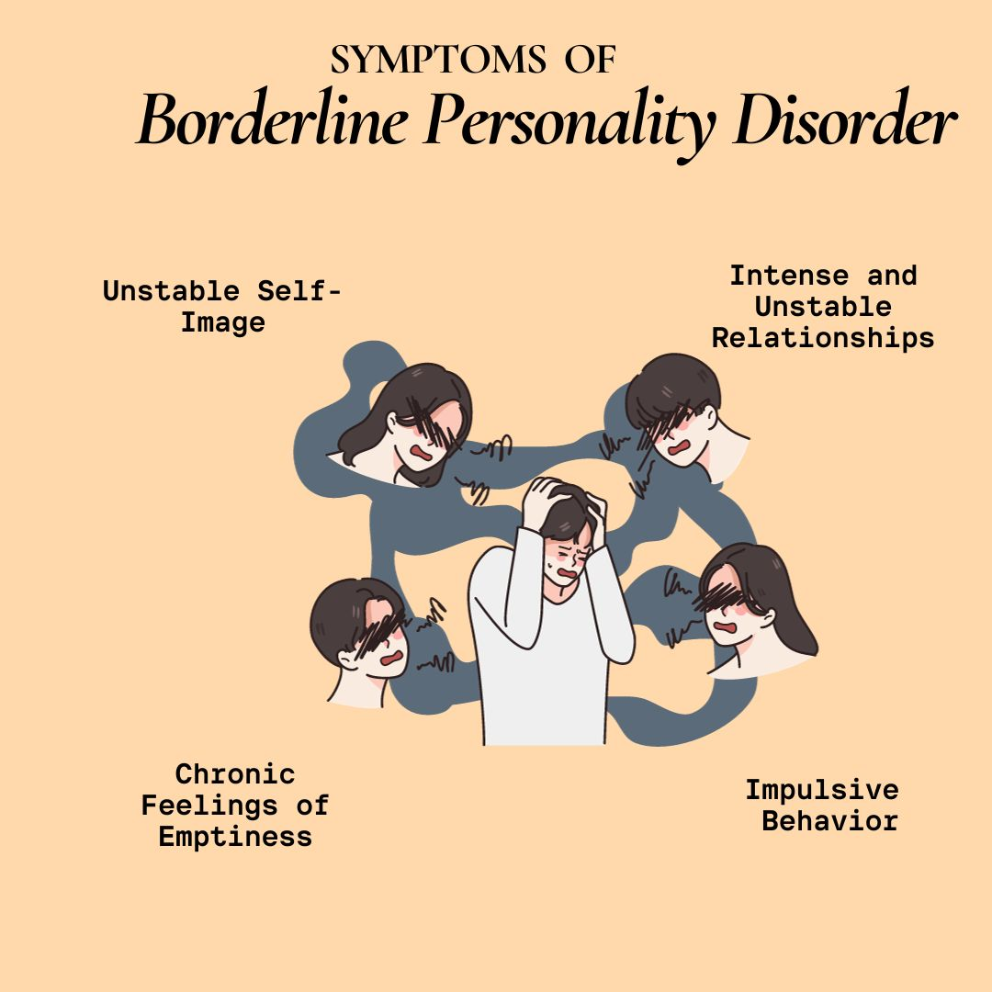(sourced from:scontinentalhospitals.com, n.d.)

ASSIGNMENT NAME: BORDERLAND PERSONALITY DISORDER REPORT.
MODULE NAME: PSYCHOPATHOLOGICAL CLASSIFICATIONS & PROVISIONS.
MODULE CODE: BMHP 6029
STUDENT NAME: LUCRESHA LEWIS
STUDENT: 2315413
LECTURER NAME: NEALE HADDON

CONTENT

INTRODUCTION....................................................................................................................1
CLASSIFICATION AND DIAGNOSIS....................................................................................2
TREATMENT REHABILITATION..........................................................................................3
CURRENT DEBATES EMERGING ISSUES.........................................................................4
RECOMMENDATIONS..........................................................................................................5
CONCLUSION.......................................................................................................................6

Introduction

Borderline Personality Disorder (BPD) (6D11.5) is one of the most challenging disorders
from both research and clinical perspectives, leading to intense debates, shifting diagnostic criteria, and evolving diagnostic criteria (Leichsenring et al., 2024). Even so, the continues to affect an estimated 2% of the population with severe consequences, if not effectively managed (Thadani et al., 2020). According to white al. (2025), up to 75% of BPD patients engage in self-harm, while10% die by suicide, among the highest rates of any condition. Despite the detrimental impact, Klein et al. (2022) state that persons with BPA continue to experience fragmented care, misdiagnosis, and pervasive stigma across health and social care settings. The following report critically examines borderline personality disorder from the lenses of classification and diagnosis, evidence-based treatment, and rehabilitation strategies, before exploring the current debates. Unmasking emerging issues and strengthening evidence-based management through recommendations is critical to delivering the highest quality of person-centred care for individuals with the condition.
Classification and diagnosis
Stern and Knight introduced the term “borderline” to identify a patient group exhibiting levels of functioning that were not well-defined but situated between neuroses and schizophrenic disorders (Leichsenring et al., 2024). The 11th revision of the international Classification of diseases (ICD-11) introduces a dimensional and hybrid model that now required health professionals to assess the severity of personality disorder (e.g. mild, moderate or severe) and describe the prominent personality traits presents in the patient, from the five core domains (negative, affectively detachment, dissocialise, disinhibition and anankastia (WHO, 2019). For example, A presentation that would have been classified as BPD under the old system would typically be diagnosed in ICD-11 as a “Personality Disorder, Moderate or Severe, with prominent Borderline pattern” (or features), characterised by a combination of negative affectively, disinhibition, and potentially disorders, including BPD as a distinct diagnosis with nine criteria, of which five must be present for diagnosis (American Psychiatric Association [APA], 2013). Newson et al. (2021) cautioned that DSM-5's approach can reinforce heterogeneity, because two individuals may share only one symptom and still both receive a BPD diagnosis. This is addressed by the ICD-11, by perceiving BPD not as a discrete entity but rather a “borderline pattern qualifier” that focuses on severity and traits. Still, Jantzi and Moulin (2025) point out that the persistence of the “borderline pattern” qualifier suggests that clinicians and researchers continue to find categorical labelling useful.
The diagnostic criteria currently include chronic feelings of emptiness, intense and unstable relationships, fear of abandonment, affective instability, and recurrent self-harming or suicidal behaviours. The language used is still significant. The term “disorder “is retained, affirming its status as a medical condition within the classification system. However, Leichsenring et al., (2024). Note that the shift from a categorical label to a descriptive formulation aims to be less stigmatising and more clinically useful by prioritising the individual’s specific profile of difficulties. This is contrary to Seal et al. (2024), who argue that the use of “disorder” pathologies personality functioning and promotes stigma. Alternative framings such as “emotional regulation difficulties” or “complex trauma response” are increasingly championed by service user groups. Gender bias also complicates diagnosis. Bozzatello et al., (2024) state that women are disproportionately diagnosed, leading to the stereotypes of “manipulative” or “attention-seeking” patients. On the other hand, men with similar traits are underdiagnosed or misdiagnosed with antisocial personality disorder (Broad bear et al., 2025). Cultural differences also complicate pathological concepts in Western psychiatry, such as intense emotional expression, which may be normative in collective cultures, hence underscoring the tension between clinical utility, scientific validity, and ethical responsibility during classification (Munson et al., 2022).
Treatment and Rehabilitation
Over the past three decades, the treatment approaches for BPD have evolved considerably, from therapeutic nihilism to a recognition that structured, evidence-based interventions can significantly improve clinical outcomes and quality of life of patients (Choi-Kain et al., 2017). Individuals with BPD were historically excluded from services, since they were considered untreated. The trend has since changed with a focus on psychological therapies as first-line treatment. According to the guidelines provided by the National Institute for Health and Clinical Excellence (NICE), Dialectical Behaviour Therapy (DBT), developed by Linehan (1993), is the most widely researched intervention and is recommended for BPD. The intervention combines cognitive behavioural techniques with mindfulness and distress tolerance skills, targeting emotional dysregulation and self-harming behaviours (Linehan,1993). A randomised controlled trial conducted by Linehan et al. (2006) found that DBT demonstrated high levels of effectiveness in reducing self-harming suicidal behaviour and hospitalisations, while improving emotional stability. Nevertheless, the intervention requires a comprehensive program (including individual therapy, skills group, phone coaching, and therapist consultation team), which many services cannot sustain. Steuwe et al., (2023) also raised concerns about engagement and accessibility due to the high drop-out rate of 25-35%.
Mentalisation-based Therapy (MBT) is another intervention that is highly effective in the management of BPD. MBT was developed by the Anna Freud Centre and prioritises strengthening the patient’s capacity to understand mental states in themselves and others. Compared to DBT, Stoffers-Winterling et al., (2022) demonstrated that MBT is more effective in reducing interpersonal conflict and strengthening attachment security. Still, Sondergaard et al., (2023) MBT exhibits slower symptom reduction in the short term, compared to DBT, through the benefits may consolidate in the long run. Other therapies, such as Schema Therapy and cognitive Analytic Therapy, also exhibit significant promise in the management of BPD. Even so, psychotropic drugs such as mood stabilisers, antipsychotics, and antidepressants are frequently prescribed to manage co-occurring conditions such as depression or anxiety (NICE, 2009). This raises pertinent questions about overmedicalisation, polypharmacy, and the limited evidence base for pharmacological efficacy in BPD.
Rehabilitation and recovery in BPD extend beyond symptom management to social functioning, self-identity, and quality of life (Solof, 2019). The ICD-11 prioritises functioning and participation, which is consistent with the recovery-oriented approaches in the UK NHS.For example. Supported employment programs have found highly effective in helping BPD patients to build a stable and meaningful life while gaining a sense of purpose (Kernot et al., 2023). Patients should also be connected to peer support because lived-experience support groups provide validation, reduce isolation, and model the recovery of patients. While patients can be involuntarily detained for mental health evaluation and treatment under the Mental Health Act of 1983, Ware (2020) noted that health professionals should follow the principles of positive-risk taking, person-centred approaches, and strength-based decision-making. In line with the Care Act of 2014, the Equality Act of 2010, all decisions should be congruent with the biomedical principles of autonomy, beneficence, non-maleficence, and justice (Varkey, 2021). Service user perspectives also stress the need for therapeutic relationships and community-based rehabilitation. Even so, there are significant limitations and gaps in rehabilitation. Long waiting lists for DBT and MBT programmes, inconsistent provision across NHSTrusts, and exclusionary service thresholds leave many without adequate support (Stoffers-Winterling et al., 2012). The MHA 1983 has also been criticised for being used disproportionately to detain BPD patients due to prioritization of risk management over patient autonomy (Hofmann et al., 2022).
Current Debates and Emerging Issue.
The validity of the diagnosis itself is one of the most hotly contested concerns. Caspi et al., (2015) argued that BPD lacks a clear empirical boundary and thus functions as a “wastebasket” diagnosis for patients who do not fit neatly into other categories. This was supported by Berge (2014), who affirmed that diagnosis is flection of the cultural constructions of femininity and emotional excesses since up to 75% of BPD patients are women. Defining traits of BPD like instability, intense attachment needs, and fear of abandonment are often interpreted as pathological exaggerations of culturally coded feminine qualities (Berger, 2014) Tasca et al.,(2012) reinforced the concept, noting that the traits mirror historical traditions, such as the medicalisation of “hysteria,” where women’s emotional suffering was framed as irrational or manipulative rather than as legitimate responses to trauma or inequality. still, it should be noted that this BDP label stigmatizes women and undermines clinical credibility by obscuring the structural causes of stress.
Another key debate is the relationship between BPD and trauma. High rates of childhood abuse, neglect, and attachment disruption among people diagnosed with BPD suggest that the label may medicalise trauma responses rather than recognise social determinants (Leichsenring et al., 2024). This has culminated in trauma-informed practitioners arguing that BPD should be reconceptualised as complex post-traumatic stress disorder (C-PTSD), which ICD-11 now lists separately. Nevertheless, empirical studies show that although BPD and C-PTSD share features, they are distinct constructs (Leichsenring et al., 2024). BPD encompasses more pervasive identity disturbance and interpersonal dysfunction compared to PTSD. The intersection of BPD with neurodivergence. Cheney et al., (2024) argue that due to the overlapping symptoms, BPD may represent a form of neurodiversity rather than pathology. From this perspective, behaviours labelled as disordered are reframed as adaptive responses to adversity or as expressions of atypical neuro cognitive processing (Cheney et al., 2024). Such perspectives challenge the deficit-oriented model of psychiatry and call for strengths-based, person-centred approaches. Even so, Thadani et al., (2022) cautioned that overemphasizing neurodivergence risks minimising the real distress and functional impairment associated with BPD.
Stigma remains one of the continuous challenges. Clinicians sometimes view BPD patients as “difficult” or “manipulative,” resulting in therapeutic pessimism and exclusion from services (Klein et al., 2022). The cross-cultural differences further inadvertently support the stigma. Although Western psychiatry heavily prioritizes pathology, collectivist cultures may attribute symptoms to spiritual imbalance or familial disruption, which can reduce medical stigma but increase community blame (Klein et al., 2022). Furthermore, Black women in the UK are more likely to experience coercive psychiatric interventions and less likely to receive psychological therapy compared to their white counterparts (Schlief et al., 2023). Service-user activism has been pivotal in challenging negative stereotypes and advocating for alternative framings such as “emotional intensity disorder.” Policy is slowly responding to this. The NHS England Personality Disorder Capabilities Framework promotes champions for the delivery of compassionate, trauma-informed care. However, the effectiveness of the policy has been compromised by implementation lags and a lack of specialised training among healthcare staff (Brown and Crawford,
2007). While the NHS Long-Term Plan and Equality act of 2010 have been effective to an extent in curbing stigma and discrimination while promoting quality care delivery for BPD patients, unequal service provision, lack of culturally competent services among health professionals, and systemic biases still hinder effective care delivery (Klein et al., 2022).
Recommendations
Following the comprehensive analysis of the subject of borderline personality disorders, several recommendations emerge. The first recommendation is that classification should integrate dimensional and trauma-informed perspectives. While ICD-11 demonstrated progress through the dimensional model, greater emphasis should be put on trauma histories and psychosocial determinants to avoid pathologising survival responses. Policymakers should also consider renaming the disorder to reduce stigma, as it has been trialled with emotional regulation disorder. Furthermore, there is a need for improved methods through structured assessments that minimise gender and cultural bias (Munson et al., 2022). Healthcare professionals should also receive person-centred training focused on differential diagnosis with C-PTSD, ASD, and ADHD, alongside awareness of systemic inequalities that shape presentation. Guideline bodies such as NICE should co- produce diagnostic guidelines with service users to strengthen validity and acceptability. The NHS and all health systems also have a responsibility to expand the provision of DBT, MBT, and SFT by ensuring all patients have equitable access to healthcare across their socioeconomic and geographic contexts. Through the NHS, the government should ensure sound investment in workforce training, funding for community-based programs, and the integration of digital modalities where necessary and required. Also, rehabilitation should not be an afterthought, but a core component of care. Developing policies that either establish or support supported housing, employment initiatives, or peer-led services will promote long-term recovery and social inclusion. Healthcare professionals should also undergo training on how to challenge stereotypes of BPD as manipulative or untreatable. Anti-stigma campaigns and cultural competence frameworks are needed to ensure equitable care for marginalised groups, while structural reforms should be incorporated to psychological therapies (Klein et al., 2024).

Conclusion
The report explored borderline personality disorder as a highly contested condition that has waxed and waned the public domain for decades. It was evident that years of research have culminated in better understanding of the condition, more specific classification, clear diagnostic criteria and evidence-based treatment, founded on DBT and MDT, among others. Even so, there continues to be unending debate surrounding trauma, neurodivergence, stigma classification and service user identity. Moving forward, robust reforms in classification, investments in accessible treatment, tackling structural stigma, and stronger rehabilitation frameworks will genuinely create a conducive environment for recovery, inclusion, and dignity in BPD.

References
American Psychiatric Association (APA). (2013). Diagnostic and statistical manual of mental disorders (5th ed.). Washington, DC: APA.
Berger, B., 2014. Power, selfhood, and identity: A feminist critique of borderline personality disorder. In Advocates' Forum, 2014. https://crownschool.uchicago.edu/student-life/advocates-forum/power-selfhood-and-identity-feminist-critique-borderline-personality
Bozzatello, P., Blua, C., Brandellero, D., Baldassarri, L., Brasso, C., Rocca, P. and Bellino, S., 2024. Gender differences in borderline personality disorder: a narrative review. Frontiers in Psychiatry, 15, p.1320546. https://doi.org/10.3389/fpsyt.2024.1320546
Broadbear, J.H., Bhagwandas, M.G., Crowley, S., Cheney, L. and Rao, S., 2025. Exploring the pathways to diagnosis for men with borderline personality disorder: a qualitative study. International Journal of Mental Health Nursing, 34(1), p.e13413. https://doi.org/10.1111/inm.13413
Brown, B.J. and Crawford, P., 2007. Personality Disorder in UK Mental Health Care: Language, Legitimation and the Psychodynamics of Organized Surveillance. In The Discourse of Hospital Communication: Tracing Complexities in Contemporary Health Care Organizations (pp. 109-137). London: Palgrave Macmillan UK. https://link.springer.com/chapter/10.1057/9780230595477_6
Caspi, A., Houts, R.M., Belsky, D.W., Goldman-Mellor, S.J., Harrington, H., Israel, S., Meier, M.H., Ramrakha, S., Shalev, I., Poulton, R. and Moffitt, T.E., 2014. The p factor: one general psychopathology factor in the structure of psychiatric disorders?. Clinical psychological science, 2(2), pp.119-137. https://doi.org/10.1177/2167702613497473
Chapman, A.L., 2010. Borderline personality disorder. https://www.ncbi.nlm.nih.gov/books/NBK430883/
Leichsenring, F., Fonagy, P., Heim, N., Kernberg, O.F., Leweke, F., Luyten, P., Salzer, S., Spitzer, C. and Steinert, C., 2024. Borderline personality disorder: a comprehensive review of diagnosis and clinical presentation, etiology, treatment, and current controversies. World psychiatry, 23(1), pp.4-25. https://doi.org/10.1002/wps.21156
Linehan, M.M., 1993. Cognitive-behavioral treatment of borderline personality disorder. New York: Guilford Press.
Linehan, M.M., Comtois, K.A., Murray, A.M., Brown, M.Z., Gallop, R.J., Heard, H.L., Korslund, K.E., Tutek, D.A., Reynolds, S.K. and Lindenboim, N., 2006. Two-year randomized controlled trial and follow-up of dialectical behavior therapy vs therapy by experts for suicidal behaviors and borderline personality disorder. Archives of general psychiatry, 63(7), pp.757-766. https://doi.org/10.1001/archpsyc.63.7.757
Munson, K.A., Janney, C.A., Goodwin, K. and Nagalla, M., 2022. Cultural representations of borderline personality disorder. Frontiers in Sociology, 7, p.832497. https://doi.org/10.3389/fsoc.2022.832497
Newson, J.J., Pastukh, V. and Thiagarajan, T.C., 2021. Poor separation of clinical symptom profiles by DSM-5 disorder criteria. Frontiers in Psychiatry, 12, p.775762. https://doi.org/10.3389/fpsyt.2021.775762
NHS England, 2019. The NHS Long Term Plan. London: NHS England. Available at: https://www.england.nhs.uk/publication/the-nhs-long-term-plan/ (Accessed: 29 September 2025).
NICE, 2009. Borderline Personality Disorder: Recognition and Management. NICE Clinical Guideline CG78. London: National Institute for Health and Clinical Excellence. Available at: https://www.nice.org.uk/guidance/cg78 (Accessed: 29 September 2025).
Schlief, M., Rich, N., Rains, L.S., Baldwin, H., Rojas-Garcia, A., Nyikavaranda, P., Persaud, K., Dare, C., French, P., Lloyd-Evans, B. and Crawford, M., 2023. Ethnic differences in receipt of psychological interventions in Early Intervention in Psychosis services in England–a cross-sectional study. Psychiatry research, 330, p.115529. https://doi.org/10.1016/j.psychres.2023.115529
Seal, E.L., Kokanović, R., Flore, J., Borovica, T., Broadbear, J.H., McCutcheon, L. and Lawn, S., 2024. Talking about borderline personality disorder, shaping care: The multiple doings of narratives. Sociology of Health & Illness, 46(8), pp.1709-1729. https://onlinelibrary.wiley.com/doi/am-pdf/10.1111/1467-9566.13804
Soloff, P.H., 2021. Bridging the gap between remission and recovery in BPD: Qualitative versus quantitative perspectives. Journal of personality disorders, 35(1), pp.21-40. https://doi.org/10.1521/pedi_2019_33_419
Søndergaard, A.A., Juul, S., Poulsen, S. and Simonsen, S., 2023. Mentalizing the therapist–Therapist experiences with short-term mentalization-based therapy for borderline personality disorder: A qualitative study. Frontiers in psychiatry, 14, p.1088865. https://doi.org/10.3389/fpsyt.2023.1088865
Steuwe, C., Berg, M., Driessen, M. and Beblo, T., 2023. Therapeutic alliance and dropout in patients with borderline pathology receiving residential dialectical behavior therapy. BMC psychiatry, 23(1), p.605. https://doi.org/10.1186/s12888-023-05061-8
Stoffers-Winterling, J.M., Storebø, O.J., Simonsen, E., Sedoc Jørgensen, M., Pereira Ribeiro, J., Kongerslev, M.T. and Lieb, K., 2022. Perspectives on dialectical behavior therapy and mentalization-based therapy for borderline personality disorder: same, different, complementary?. Psychology Research and Behavior Management, pp.3179-3189. https://doi.org/10.2147/PRBM.S342257
Tasca, C., Rapetti, M., Carta, M.G. and Fadda, B., 2012. Women and hysteria in the history of mental health. Clinical practice and epidemiology in mental health: CP & EMH, 8, p.110. https://doi.org/10.2174/1745017901208010110
Thadani, B., Pérez-García, A.M. and Bermúdez, J., 2022. Functional impairment in borderline personality disorder: The mediating role of perceived social support. Frontiers in Psychology, 13, p.883833. https://doi.org/10.3389/fpsyg.2022.883833
Thadani, B., Pérez-García, A.M. and Bermúdez, J., 2022. Functional impairment in borderline personality disorder: The mediating role of perceived social support. Frontiers in Psychology, 13, p.883833.
UK Parliament, 2010. Equality Act 2010. c.15. London: The Stationery Office. Available at: https://www.legislation.gov.uk/ukpga/2010/15/contents (Accessed: 29 September 2025).
UK Parliament, 2014. Care Act 2014. c.23. London: The Stationery Office. Available at: https://www.legislation.gov.uk/ukpga/2014/23/contents (Accessed: 29 September 2025).
Varkey, B., 2021. Principles of clinical ethics and their application to practice. Medical principles and practice, 30(1), pp.17-28. https://doi.org/10.1159/000509119
Ware, A.J., 2020. Perspectives on positive risk taking from people diagnosed with a borderline personality disorder: an interpretative phenomenological analysis (Doctoral dissertation, University of Surrey). https://doi.org/10.15126/thesis.00849069
White, C., Rose, S.S., Dwyer, J.B., Palmer, E.O., Yeow, J., Griffiths, K., Chee, B., Oyesanya, M. and Patel, R., 2025. Demographic and clinical characteristics of patients with borderline personality disorder: Real-world insights from a retrospective observational study. Journal of Affective Disorders, p.120008. https://doi.org/10.1016/j.jad.2025.120008
World Health Organization (WHO), 2019. International Classification of Diseases for Mortality and Morbidity Statistics, 11th Revision (ICD-11). Geneva: WHO. Available at: https://icd.who.int/

