Sophie
[Email address]
Portfolio
Sophie Willett

Contents
Introduction 2
Learner and Programme 3
Evidence of Observations 5
Theory framework 5
Reflective Log 7
Evaluation 8
Reference 11
Appendix 14
Appendix B – Record of Progression 15
Appendix C – Lesson Plan 16

Introduction
The main focus of the portfolio is based upon literacy and the barriers and challenges that children with Additional Learning Needs can face. Literacy can be most defined as the ability to read and write in order to, understand and communicate to others (Best, 2021). Some learners may have barriers that prevent them from succeeding in their literacy learning, for example, learning difficulties, cultural barriers, poverty barriers and home situations. This is why literacy learning is important because it involves learning over time to improve reading, writing and spelling because children and young people learn more each time they do these (Reading Recovery, 2021). Rassool (1999, p.1) describes literacy as, ‘multidimensional’ because it is seen for different purposes, such as; social, economic, ideological and political purposes. This emphasises the importance of literacy as it is used for everyday life for children, young people and adults to read information, learn and enjoy (Rassool, 1999, p.1).
The writer will focus on the impact of a specific literacy resource or programme to support literacy learning. The literacy programme is used by a teaching assistant to support a primary school learner and the learner will be regularly assessed. Assessments are important because they outline the learner’s strengths and weaknesses to understand what progress the learner has made and how to help support them to make further progress. Reid (n.d., p.6) stated, one of the most important factors for schools, is to provide efficient and effective monitoring strategies to ensure all aspects are being progressed in the learner’s development. The writer will discuss the aims of the literacy programme, write how the programme is beneficial to children and young people and state the effectiveness of the programme. The portfolio also includes two different theorists; Vygotsky (1978) and Bernstein (1971) as the writer believes both theorists relate to the chosen programme. To prove the effectiveness of the programme, the writer has included evidence of observations and a reflective log from one of the lessons the learner participated in. The writer has also included feedback and results from several sources that state how the programme has been effective.

Learner and Programme
The writer has chosen a learner who attends a primary school that is situated in a deprived area. This can have a negative impact on the learner because living in a deprived area can be damaging for a learner’s learning and development. The learner is ten years old and has significant difficulties in understanding and use of language. All learners are given a National Curriculum level that scores them to their ability and these are determined by testing and assessments (Paterson, 2021). The learner is currently at level 2, which is the expectant level of a 7-year-old. The learner also experiences difficulties with his learning and behaviour in the classroom and has been referred to the Educational Psychologist in order to further his learning needs. The learner needs universal language and communication every day at school and home and also receives a variety of support, resources and programmes, such as, Sound Discovery, Read Write Inc, Language Link and Speech and Language support.
However, for the purpose of this portfolio the writer will focus on one programme called, ‘Sound Discovery’ which was founded in 1999 and developed by Rideghill Publishing (Synthetic Phonics, 2007). Sound Discovery is a ‘high quality synthetic phonics literacy programme’ that was designed for teachers support children and young people in reading, spelling and writing (Synthetic Phonics, 2007). The classroom teaching assistant delivers the programme to the learner every morning and follows the specifically designed lesson plans that are matched to the learner’s ability. The methods of teaching are based upon ‘snappy lessons’, that are short and quick lessons (Synthetic Phonics, 2007). The teaching assistant assesses the learner regularly to ensure they are getting the correct support that is needed.
The programme uses a synthetic approach to blend sounds so learners have to break the word into phonemes, in order to read, speak and listen to the word (Synthetic Phonics, 2007). The aim of the programme is to teach the letter sounds first and then blend the sounds together to form words and eventually, be able to achieve full pronunciation of the words. The programme is helpful for teachers because the programme and lessons are detailed and also, show how progression can be achieved for all learners and what the next steps are (Synthetic Phonics, 2007). The programme is effective because the learner is engaged throughout as lessons can be multi-sensory and some activities involve physical movement, for example, physically forming letter shapes (Synthetic Phonics, 2007). The lessons are fully compatible with a broad curriculum so that children can benefit from the different materials (Synthetic Phonics, 2007). Most importantly, the programme is effective for the learner because there are different adaptions that can be specialised for children with Additional Learning Needs (Synthetic Phonics, 2007).

Evidence of Observations
(See Appendix A – Individualised Education Program)
This was taken from the learner’s Individualized Education Program (IEP) that was developed in September 2020 and confirms the progress that the learner has made through the ‘Sound Discovery’ programme. The phonics target was to read and spell certain phonemes by March 2021. However, not all four phonemes were learnt because the learner missed online lessons and so, the teaching assistant will revisit the lesson.

(See Appendix B – Record of Progression)
The table shows the progress that the learner has made from September 2020 to March 2021. The progress has been quite minimum because of unforeseen circumstances because the learner has not attended school, the school has been closed and also the learner has not attended all the online lessons. However, the learner has learnt 3 new phonemes, which is better than nothing.

Theory framework
The literacy programme corresponds to the theorist Vygotsky (1978) and his theory ‘the zone of proximal development’. Vygotsky (1978) believed that, when a learner has been given suitable assistance, this when then allow them to achieve further progress and complete tasks effectively (McLeod, 2019). There are three important factors that support learning to help the learner through ‘the zone of proximal development’ (McLeod, 2019). Firstly, the company of a knowledgeable other, this is achieved because the teaching assistant is always alongside the learner throughout each ‘snappy lesson’ (McLeod, 2019). Secondly, social interaction with an experienced and trained adult that allows learners to observe and practice their skills (McLeod, 2019). This is achieved because the teacher assistant demonstrates how to pronounce the phoneme and the learner will then copy the phoneme. Thirdly, an educator support supporting or ‘scaffolding’ the activities can support the learner (McLeod, 2019). This is accomplished because the teaching assistant receives the lesson plans from the ‘Special Educational Needs Co-Ordinator’ (SENCO) and can refer to them for further support. This emphasises the effectiveness of the programme because the teaching assistant is maximizing the learner’s development through the interactions of the programme and the most important learning for a learner is through a ‘more knowledgeable other’ (McLeod, 2019).
Bernstein (1971) believed that there are differences between ‘sub-cultural and social class influences upon children and young people’s learning’ (Bernstein, 1971, p.30). This meaning that learners from deprived areas are more than likely to have a negative effect on their education from an early age (Cook, 2014, p.35). Bernstein (1971) displayed evidence to show the difference in language between learners from a sub-cultural class and a social class (Cook, 2014, p.35). The theory corresponds to the learner who is currently undertaking the ‘Sound Discovery’ programme as they are from a deprived area and currently not achieving at an expected National Curriculum level.

Reflective Log
(See Appendix C – Lesson Plan)
What went well?
What went well? | The lesson was quick and ‘snappy’
What were the main challenges / problems/ difficulties you faced? | The activity seems quite young and not age appropriate
How did you react to the challenges? | Praised the learner consistently
How did you feel? | Confident and happy as the learner was actively engaged throughout
What surprised you? | The learner was able to read all words fluently but cannot break the words down into phonemes
What were you familiar with? | The focus sounds and oral blending as it is quite repetitive.
Have your beliefs and expectations changed or been challenged? | No because the learner has made steady progress throughout

Critiquing your experience

How well did you think you managed the challenging situation? | Quite well as the learner was engaged as they enjoy the constant praise
Has this experience changed your mind or opinion in any way? | Possibly the new words should be age appropriate and more challenging
Were you given any feedback (formal or informal)? Can you seek further advice from anyone in order to give you another perspective? | Will seek further advice from the Special Educational Co-Ordinator
Is there any other reading or research you could follow up regarding the subject matter? | Will research an alternative literacy programme to support the learner’s phonic sounds
What skills do you need to develop to address this incident more effectively in the future? | Further training on phonic lessons to ensure the words are age appropriate
What conclusions have you drawn? | As the learner has gaps in their literacy, the phonics work will not be age appropriate as they are for young learners

What next?

Given the same event; would you do anything different next time? | Use age appropriate words that use the new phonic sound in
What are the key lessons learned for future use? | Change the lessons plans to ensure there are age appropriate words
How might your learning feed into your assignment/s? | Reflect on the activity and how to improve the lessons in the future

Evaluation
The programme ‘Sound Discovery’ is a high quality synthetic phonics literacy programme and is suitable for all learners (Synthetic Phonics, 2021). The portfolio has stated the impact of the programme and how it has supported the learner with their literacy learning. The programme is practical and helpful for schools and teachers because ‘Synthetic Phonics’ produces the materials for them and the programme includes; a manual, a handbook, snappy lesson plans, snappy lesson resources, tests, decodable texts, activity books and monitoring books (Synthetic, 2021). Although, the programme has many useful resources, the programme costs £600 for the full package. Some schools may not fund the programme because of lack of funding as Lewis (2020) reported, ‘funding was not increased as much as expected in Wales’ most deprived schools’ and funding for schools in England was higher than in Wales. This is another barrier that can influence a learner’s literacy development because schools in deprived areas may not be able to afford to fund new programmes. This can have a negative effect on learners because Bernstein (1971) argued that, learners from a deprived area are in need of further support regarding their literacy development as they are evidently not as developed as learners from a ‘middle class’. Although, the learner in this portfolio has been fortunate because the school has paid for the programme, but other learners and schools may not be as fortunate. Also. sound Discovery have stated they are highly cost effective because some of the reading materials can be photocopied and the programme has a high advantage (Synthetic, 2014). There are also assessments and tests included in the programme, ensuring they are quick and easy for the teaching assistant to follow. The Welsh government states the importance of assessments as they ‘play a fundamental role’ for learners to be ‘supported and challenged’ to ensure learners can progress in their development (Hwb, 2021). Assessments are vital for schools because it is essential to follow the learner’s development and to ensure they are receiving the appropriate work.
The programme uses a variety of activities, such as, multi-sensory, visual, auditory and active activities to ensure children are actively engaged (Synthetic Phonics, 2021). By using a variety of activities, teachers are using the ‘whole brain learning’ and can be described as, the ‘best way to teach’ because it involves all areas of the brain (Waterford, 2019). Changing lessons and making them more fun and engaging, is essential for effective teacher because ‘lessons do not have to only include worksheets and lectures’ (Cox, 2019). Even though teachers may have more planning and preparing to do, learning is most effective if children and young people are engaged and enjoying through a variety of different activities and lessons (Cox, 2019). The learner who is stated in the portfolio has remained engaged throughout the lessons and has enjoyed each lesson.
The ‘snappy lessons’ are successful because they are quick and interactive, therefore, more memorable for learners keep learners focused. The learner is always actively involved and engages well with the teaching assistant in each ‘snappy lesson’. They are structured so this allows the teaching assistant to follow each lesson easily and clearly. There is also phonic progression so the programme states what words the learner should be expected to read and write. This is extremely useful for the teaching assistant to be able to follow the learner’s development.
The programme is also effective because of the flexibility because it can be adapted to all ages and group sizes, not just as an individual programme. The learner is currently on an individual programme as he is on a different stage to the others. The teaching assistant will also re-deliver the lesson to any learner who has fallen behind because additional lessons can be given at any time (Synthetic Phonics, 2014). This emphasises the effectiveness because this means that all learners can succeed whilst undertaking the programme (Synthetic Phonics, 2014). However, it can be quite time consuming for the teaching assistant to re-deliver the lessons.
The programme also has an emphasis on reading, writing and spelling so learners are given opportunities to succeed in all areas in their literacy learning. Sound Discovery includes a handwriting guide and models every stage of a learner’s writing process (Synthetic Phonics, 2014). There is also vocabulary and reading comprehensions included so learners are able to develop their literacy learning. This ensures progression for all learners because once the teaching assistant has completed the phonic lessons, they will move onto the reading comprehensions. Progression is essential, including expectations of how the learner should progress for the reason that, it helps teaching staff to understand the pace at which the learner can progress (Hwb, 2021).
There has also been great evidence as the programme has received, ‘remarkable results’ because it was trialled by the author over eight years’ as he followed and observed every child in the classes from the beginning to the end of their primary education (Synthetic Phonics, 2014, p.2). At the end of the programme, all learners were able to read and write, regardless of any barriers that they were faced (Synthetic Phonics, 2014, p.2). There was also a grant study to show the effectiveness of the programme which showed tremendous results (Synthetic Phonics, 2014, p,2). The programme has been used by various by various Local Education Authorities and independent data has been collected to show substantial progress from the learners in the literacy development and also their motivation (Synthetic Phonics, 2014, p.3). In 2017, the Department for Children, Schools and Families scrutinised the programme and confirmed they were satisfied enough to name the programme, ‘a high quality synthetic phonics programme’ (Synthetic Phonics, 2014, p.3). The programme was also approved by the Department for Education in 2011 and refereed again as high quality (Synthetic Phonics, 2014, p.3). The website has also cited several feedback reports from reliable sources, such as; schools, head teachers and teachers (Grant, 2004, p.1). One head teacher reported, ‘Sound Discovery has a variety of attractions’ and has also included an average ratio gain, that included results from, ‘3.8 to 2.7’ (Grant, 2004, p.2). All the evidence emphasises how effective the programme has been because it has been reviewed by reliable sources and departments.
The portfolio can argue that the programme is effective because of the many benefits to improve a learner’s literacy learning. The programme ensures all materials are ready for teaching staff to deliver the ‘snappy lessons’ and all resources are ready, this is extremely time effective for teaching staff. The ‘snappy lessons’ are also beneficial because they are interactive and quick to ensure all learners are engaged and enjoying the lesson. Despite the fact that the programme can be costly for schools and time consuming for some teaching staff, it can be worthwhile if the learner has progressed in their literacy learning.
However, in the learner’s case it has not been successful, although, the learner has learnt 3 new phonemes which is still better than nothing. All things considered, the learner will still be able to make good progress from the programme because of the flexibility as the teaching assistant will be able to re-deliver the lessons to the learner and hopefully with better lesson attendance, the learner will now make great progress in their literacy learning. Overall, the programme is extremely effective as emphasised by the reliable sources and departments included, that state, ‘Sound Discovery is a high quality synthetic phonics literacy programme’. This can ensure that children and young people are able to read and write as this is important for them to understand and communicate with others (Best, 2021).

Reference
- Bernstein. B. (1971). Class, Codes and Control. London: Routledge and Kegan Paul
- Best, J (2021). What is Literacy and Why is it Important. Available from: https://www.3plearning.com/blog/literacy-important/ (Accessed on: 16th April 2021)
- Cox, J. (2019). 10 Ways to Keep Your Class Interesting. Available from: https://www.thoughtco.com/ways-to-keep-your-class-interesting-4061719 (Accessed on: 19th April 2021)
- McLeod, S. (2019). The Zone of Proximal Development and Scaffolding. Available from: https://www.simplypsychology.org/Zone-of-Proximal-Development.html (Accessed on: 17th April 2021)
- Cook, R., Rutt, S. and Sims, D. (2014). Deprivation in Education. Slough: NFER
- Grant, M. (2004). Feedback from Schools using Sound Discovery and Snappy Lesson. Available from: https://www.syntheticphonics.net/pdf/Snappy-lesson-results.pdf (Accessed on: 21st April 2021)
- Hwb (2021). Supporting learning progression: assessment guidance. Available from: https://hwb.gov.wales/curriculum-for-wales/supporting-learner-progression-assessment-guidance (Accessed on: 21st April 2021)
- Lewis, B. (2021). School funding: Calls to overhaul system in Wales. Available from: https://www.bbc.co.uk/news/uk-wales-54551517 (Accessed on: 17th April 2021)
- Paterson, W. (2021). Understanding National Curriculum Levels. Available from: https://www.edplace.com/blog/edplace-explains/understanding-national-curriculum-levels (Accessed on: 16th April 2021)
- Rassool, N. (1999). What is Literacy? What are ‘Difficulties in Literacy’? Available from: https://moodle.uwtsd.ac.uk/pluginfile.php/56029/mod_resource/content/2/Scan_Judith%20Lee_20170830-150019_0169_001.pdf (Accessed on: 20th April 2021)
- Reading Recovery (2021). Early Literacy Learning. Available from: https://readingrecovery.org/reading-recovery/teaching-children/early-literacy-learning/#:~:text=Literacy%20learning%20involves%20reading%20and%20writing%20continuous%20text.&text=Reading%20and%20writing%20continuous%20text%20requires%20the%20integration%20of%20many,involves%20continuous%20change%20over%20time. (Accessed on: 16th April 2021)
- Reid, G. (n.d.). Dyslexia and the inclusive classroom. Available from: https://moodle.uwtsd.ac.uk/pluginfile.php/56189/mod_resource/content/1/Reid%20article%20-%20dyslexia-and-inclusion.pdf (Accessed on: 20th April 2021)
- Synthetic Phonics (2014). Sound Discovery. Available from: https://www.syntheticphonics.net/pdf/2014-SD-Article.pdf (Accessed on: 19th April 2021)
- Synthetic Phonics (2017). Sound Discovery. Available from: https://www.syntheticphonics.net/sound-dicovery.php (Accessed on: 15th April 2021)
- Waterford (2019). Why Multisensory Learning is an Effective Strategy for Teaching Students How to Read. Available from: https://www.waterford.org/education/why-multisensory-learning-is-an-effective-strategy-for-teaching-students-how-to-read/ (Accessed on: 19th April 2021)

Appendix
Appendix A – Individualised Development Plan
Things learner finds difficult: | Targets: | Teacher/Support Staff | Recommendations
Phonics | To read and spell words with the phonemes: ee, ie, oa and ue | Partially achieved. Learner attended online lessons and is confident with ee and ie. He missed the lessons on the phonemes oa and ue so was unsure of spellings. | To read and spell words with the phonemes ai, oa, ue (Step 2.2) and  er, or (Step 2.3)

Appendix B – Record of Progression
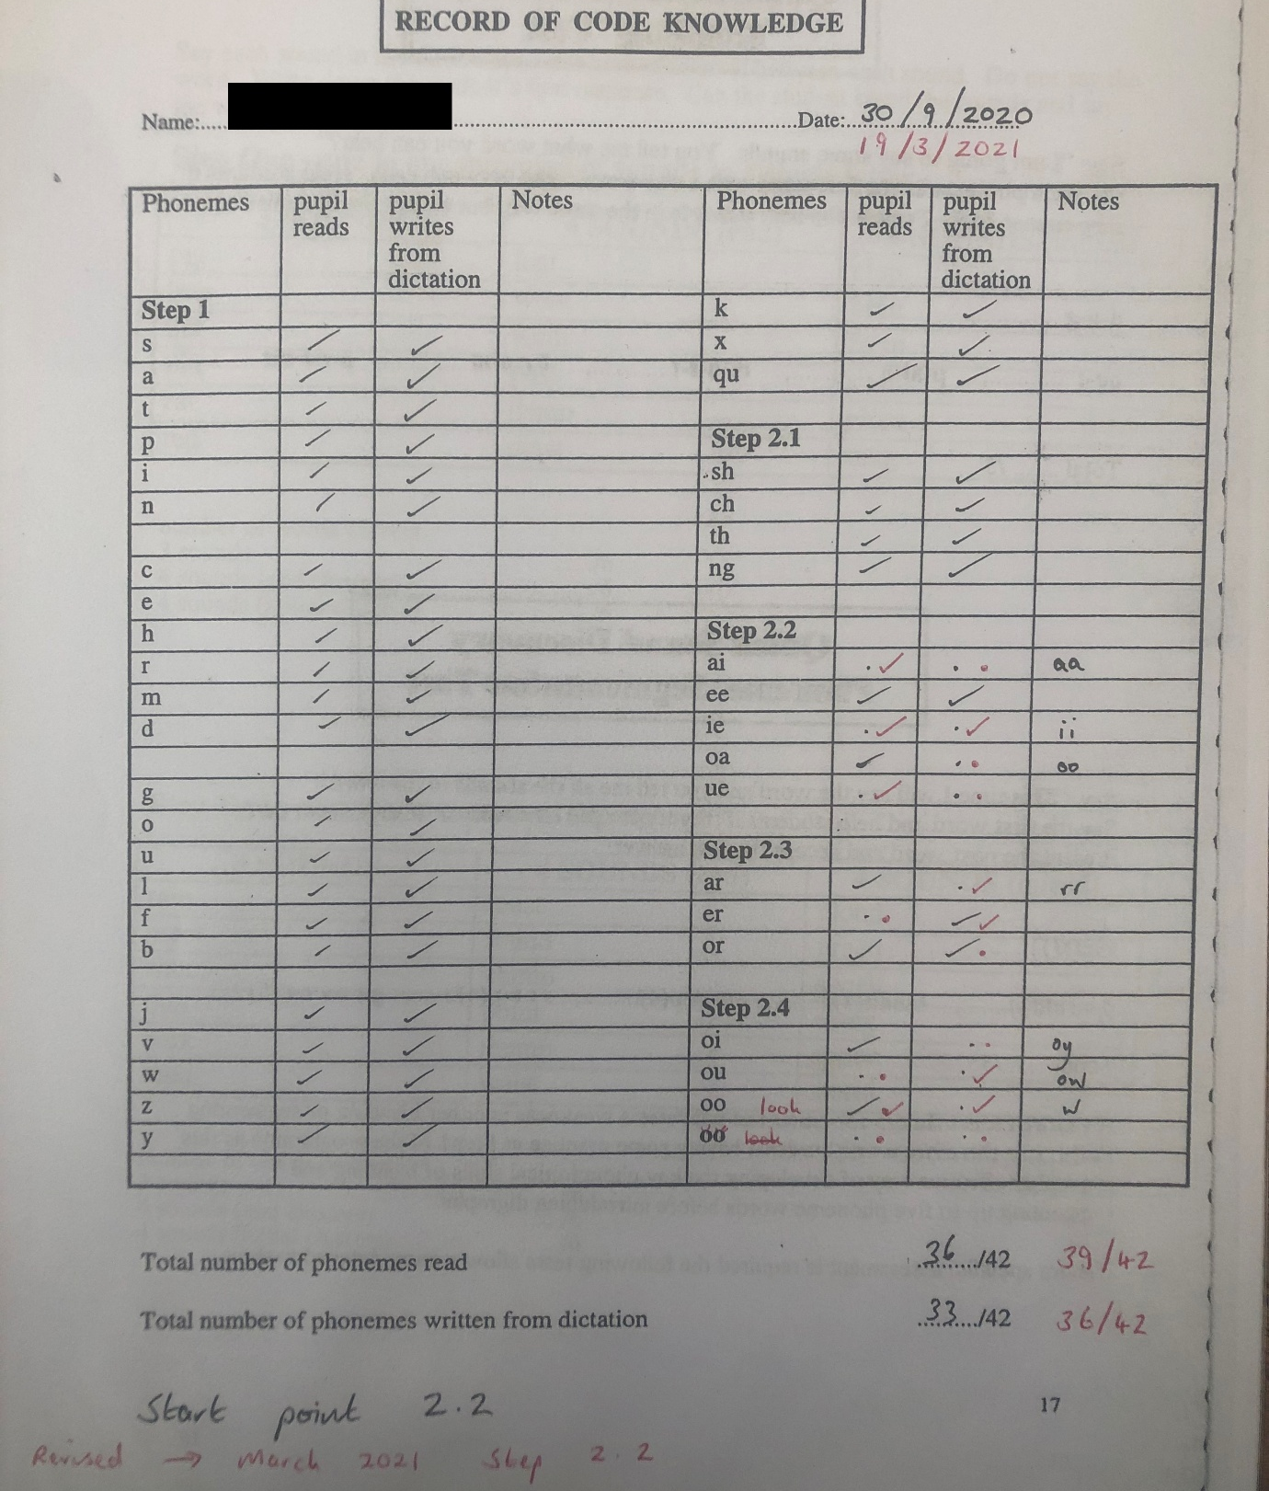

Appendix C – Lesson Plan


