

INTERNATIONAL MARKETING (LCMB7006)

INTERNATIONAL MARKETING (DOMINO’S PIZZA)



Student name: Siddhi Raut
Student Number: 2210107
Lecturer: TUSHARA
Word count: 6000
Submission Date: 21/08/2023

INDEX

1) INTRODUCTION

2) BACKGROUND INFORMATION ABOUT THE COMPANY

3) THE MACRO ENVIRONMENT

4) DIAGRAM : THE MICRO AND MACRO ENVIRONMENT

5) THE MAIN ELEMENTS IN THE MACRO ENVIRONMENT
5.1. Social / Cultural forces
5.2. Legal forces
5.3 .Economic forces
5.4.Political forces
5.5. Technological force
5.6. Environmental

6) CONCLUSION
6.1. Environmental scanning
6.2. Environmental analysis

7) PORTERS 5 FORCES MODEL
7.1. Diagram

8) PORTAL 5 FORCES

9) SWOT ANALYSIS
9.1. Strength
9.2.Weakness
9.3.Opportunities
9.4.Threats

10) MARKETING MIX ELEMENTS (7 Ps)

11) SEGMENTATION TARGETING AND POSITIONING
11.1. Segmentation
11.2. Targeting
11.3. Positioning

12) PERCEPTUAL MAP (Diagram)

13) PRODUCT FAMILY BRANDING / UMBRELLA BRANDING

14) INDIVIDUAL PRODUCT BRANDING

15) PRODUCT BRANDING STRATEGIES

16) PRODUCT FACTORS THAT MAY CHANGE DUE TO INTERNATIONAL MARKETING

17) PRICE

18) FACTORS THAT MAY CHANGE THE PRICE WHEN MAKING PRODUCT/ SERVICE AVAILABLE IN DIFFERENT COUNTRIES

19) PLACE

20) MARKET ENTRY METHODS
20.1.Licensing
20.2. Franchising
20.3. Joint venture
20.4. Strategic alliance

21) PROMOTION

22) THE EXTENDED MARKETING MIX
19.1. People
19.2. Process
19.3. Physical evidences

23) ANSOFF MATRIX DIAGRAM

24) MARKET PENETRARTION

25) PRODUCT DEVELOPMENT

26) MARKET DEVELOPMENT

27) DIVERSIFICATION

28) DIFFERENT TYPES OF DIVERSIFICATION

29) VERTICAL INTEGRATION

30) TOWS FRAMEWORK (DIAGRAM)

31) PRODUCT LIFE CYCLE MODEL (DIAGRAM)

32) DEFENCE STRATEGIES FOR PIONEERS IN THE GROWTH STAGE OF THE PLC
32.1.Fortress or position defence strategy
32.2. Flanker strategy
32.3.Confrontation strategy
32.4.Market expansion strategy

33) ATTACK STRATEGIES FOR FOLLOWERS IN THE GROWTH SYAGE OF THE PLC
33.1.Frontal attack strategy
33.2. Leapfrog strategy
33.3. Encirclement strategy

34) STRATEGIES IN THE MATURITY STAGE OF THE PLC
34.1. Increased penetration strategy
34.2. Extended use strategy
34.3. Global market expansion strategy

35) CONCLUSION

36) RECOMMENDATION

37) REFERENCES

INTORDUCTION

Introduction of company Domino’s Pizza

Domino's Pizza, a leading player in the fast-food chain worldwide, has dramatically changed the perception and consumption of pizza, the culinary delight much loved by Domino's, a pizza establishment that started in 1960 with only pizza The Ypsilanti, Michigan , has since developed into a widely recognized organization known for its strong commitment to providing exceptional customer service, advanced technology, and exciting food options . . . .

Since the founding of Domino's Pizza, the goal of delivering high-quality, fresh pizza to customers was established by Tom Monaghan, Domino's has quickly gained recognition for its delicious pizzas and pioneering concept of pizza delivery go to the ho. The nickname "Dominos" is a tribute to the traditional game of dominoes, reflecting the company's emphasis on accuracy, efficiency and interdependence

Over the decades, Domino's Pizza has actively embraced and applied technological advances to greatly influence both individual interactions with food and their eating habits through the integration of technological advancements, such as design online ordering, real-time order tracking capabilities, mobile and friendly applications, have significantly increased overall customer satisfaction

In modern life, Dominos has changed the concept of convenience. The company’s commitment to leveraging technology to improve customer experience has given it a dominant position in the highly competitive fast-food industry

In addition to their famous pizzas, Dominos Pizza offers a variety of products. The restaurant has diversified its menu to cater to a wide variety of culinary tastes, as well as honed its expertise in the art of creating unique pies with a variety of crusts, sauces and toppings In addition to pizza, pasta entrees delicious for patrons, delicious chicken -An opportunity to enjoy a selection of produce, delicious sandwiches, refreshing salads and tempting desserts, all carefully prepared with the same dedication the same unwavering efficiency that sets this program apart

Domino’s Pizza, a multinational company with a presence in more than 90 countries, expands beyond just serving pizza. It symbolizes congregational gatherings, cultural celebrations, and the joy of sharing a satisfying meal. The franchise model used by the company has made it easier to extend the Domino brand to more global locations, enabling entrepreneurs to offer unique Domino experiences in their communities Meanwhile the company’s unwavering commitment to maintain high standards it is about quality and enabling innovation remains central to its business model.

Dominos Pizza is uniquely positioned in the dynamic global marketplace, skilfully combining traditional practices with design ideas. This ongoing commitment to excellence stems from an unwavering commitment to delivering exceptional taste and quality

BACKGROUND INFORMATION ABOUT THE COMPANY
Domino’s Pizza corporate history includes historical development, organizational structure, and important milestones.

Dominos Pizza is a globally recognized pizza delivery, carryout restaurant brand that has gained tremendous recognition and admiration in various industries A complete account of the historical background and history of the company is provided below.

Origins and early history:

The organization was formed. Tom Monaghan and his brother James founded Domino’s Pizza in 1960 in Ypsilanti, Michigan, USA.

- **New Title: ** The company was originally known as "Domino’s", but in 1965 it was decided to change its name to "Domino's Pizza" to avoid confusion with other businesses

In many industries, the franchise model has been widely used as a means of rapid growth.

Adoption of Franchising as a Phenomenon Domino’s Pizza’s early adoption of the franchise model proved critical to accelerate its expansion. The aforementioned approach allowed local entrepreneurs to own and run Domino’s Pizza stores while also ensuring compliance with the company’s business standards and branding requirements

The topic under discussion is company development both domestically and globally. During the 1970s and 1980s, Domino’s Pizza enjoyed tremendous growth in the US. and internationally, bringing the world to many countries

The issue of design and technology is very important in modern society.

The 30 Minute Promise is a policy that guarantees the task will be completed within 30 minutes. In the 1980s and 1990s, Domino's Pizza used a marketing strategy called the "30 minutes or free" promise, aimed at providing their customers with faster delivery services

The topic at hand is online policy. Domino’s Pizza was a pioneer in online ordering, making it easier for customers to place orders digitally and track deliveries digitally

Domino's Tracker is a service provided by Domino's Pizza that allows customers to track the status of their pizza orders from the time they are placed to the time they are delivered With the launch of the company's Domino's Tracker, customers have the opportunity to track progress which has their orders in real time.

The Menu's Evolution:

Beyond pizza: While pizza remains a staple on Domino's menu, the company has expanded its menu to include items such as spaghetti, chicken wings, sandwiches, salads and desserts in order to cater to a wider variety of tastes which they want

A pizza manufacturer launched a pizza revolution campaign as a marketing campaign. In 2010, Dominos Pizza acknowledged customer feedback on the quality of its pizzas. As a result, the company launched a "Pizza Turnaround" campaign, in which its menu and ingredients were completely reworked.

The issue under discussion is globalization.

The topic under discussion is globalization. Domino’s Pizza is present worldwide in over 90 countries, with a significant number of outlets around the world. The company's franchise concept has been instrumental in supporting its global growth, enabling regional business owners to bring the brand into previously unexplored territories

The discovery and use of new ideas, methods, or devices that seek to improve or modify current technology are called technological innovations and these developments are often used

Online systems or apps that allow the exchange of information, services and goods between users are called digital platforms. These sites are often accessed using electronic devices such as PCs, cell phones and tablets. Domino’s takes advantage of continuous technological advancements with cutting-edge technologies such as smartphone apps, online ordering systems and voice ordering enabled by devices like the Amazon Echo

In-house technology teams are a concept in technology development. The company uses in-house technology teams to make improvements and increase customer satisfaction.

It’s important to be committed to maintaining high standards and providing great customer service.

- **Customer Feedback Analysis: ** Domino's Pizza is committed to appreciating customer feedback and making appropriate changes, such as improving pizza recipes and improving delivery.

Quality assurance is the process of ensuring that a product or service complies with predetermined specifications and standards. It involves the process of monitoring, analysing, and improving many aspects of a product or service to ensure quality and reliability. The company places great value on consistently upgrading its products, ensuring that its materials and manufacturing processes meet stringent requirements

The principles of sustainability and social responsibility are important in modern life.

Environmental policies are practices and strategies that address and mitigate environmental problems, while promoting sustainability. These policies include a range of activities aimed at conserving natural resources, reducing pollution and encouraging environmentally friendly practices in many areas of sustainability such as use of substandard packaging materials
and the development of waste reduction programmes, have been successfully implemented by Domino's.

Individuals who actively participate in a community are called upon to participate. As a way of giving back to the communities it serves, the business is actively involved in philanthropic efforts and projects.

The growth of Domino's Pizza from a single store to a large multinational pizza business demonstrates the company's commitment to innovation, technological advancement and customer satisfaction The long-term success of the company can be attributed to its ability to adapt to customers changing aspirations and make better use of technological advances

THE MACRO ENVIORNMENT
There are external factors in Domino’s Pizza’s macro environment that can have a significant impact on the company’s operations, strategy and overall business success These factors are beyond the company’s control, but play an important role in determining its strengths and challenges. Let’s take a look at the larger environmental factors affecting Domino’s Pizza:

**1.1. Political elements: ** .

- **Regulations and Health Standards: ** Federal regulations regarding food safety, sanitation, and labelling impact how Domino's operates and serves customers.

- **Employment Laws: ** Labour laws, minimum wage laws, and working conditions all have an impact on a company's labour costs and employee management.

**2.1. Financial Instruments: ** .

- **Consumer spending: ** Economic factors influence the amount of money consumers have for eating out. During a recession, people may opt for cheaper foods, such as fast food.

- **Currency exchange rates: ** Domino's operates in many countries, currency exchange rates can affect the price of imported goods.

**3.1. Social factors: ** .

- **Dining Trends: ** Changing customer demands for convenience and fast service are in line with Domino's approach to delivery and delivery.

- **Health and Wellness: ** Increased health consciousness may drive demand for healthier pizza options or affect consumer attitudes towards fast food.

**4.1. Technical Features: ** .

- **Digital Ordering and Delivery: ** Technological advances in online ordering, smartphone applications, and delivery tracking have changed how customers interact with Domino's.

- **Automation: ** Automation in food processing and supply chain management improves efficiency and reduces costs.

**5.1. Environment ** .

- **Sustainability: ** Increased environmental awareness may influence consumer decisions. Domino’s policy of adopting sustainable practices and environmentally friendly packaging may have an impact on customer perceptions.

- **Supply risks: ** Climate change and environmental upheavals may impact availability and pricing.

**6. Legal Features: ** .

- **Food Safety Regulations: ** Compliance with food safety regulations and labeling regulations is essential to maintaining quality and consumer confidence.

- **Intellectual Property: ** Legal protections for trademarks, recipes, and unique technology protect Domino's brand and design.

**7. Competitive status: ** .

- **Competition: ** Intense competition in the fast-food industry, including competing pizzerias and food delivery locations, is impacting Domino's market share and pricing strategies

**8.1. Cultures: ** .

- **Local preferences: ** Different cultures influence menu choices and preferences in different areas. Adapting Domino to local priorities is critical to its success.
Understanding and adapting to these macroenvironments is essential for Domino's Pizza to overcome obstacles, exploit growth opportunities and maintain its competitive advantage Identifying these external pressures allows Domino's to change its strategy, food offerings and customer experience to remain relevant and profitable in a constantly changing business environment.

THE MACRO ENVIRONMENT ABOUT COMPANY DOMINOS PIZZA, STATE WHETHER EACH OF THESE FORCES ARE FAVOURABLE OR UNFAVOURABLE AND WHY FOR THE COMPANY IN RELATION TO THE TWO COUNTRIES UK AND INDIA CHOSEN. THE SIMILARITIES AND DIFFERENCES COULD BE EXPLAINED.

**1. Political Factors: **
UK: | INDIA:
Generally favourable. Stable political environment, supportive of businesses and foreign investments. | Mixed. Political instability in some regions might pose challenges. However, the Indian government has been promoting foreign investments, which can be favourable.

2. Economic Factors:
UK | INDIA
Generally favourable. Strong economy, disposable income, and a mature market for fast food. | Favourable in the long term. Growing middle class and increasing disposable incomes, but there might be short-term challenges due to economic fluctuations.

3. Social Factors:
UK | INDIA
Favourable. Pizza consumption is well-established, and the brand is recognized and embraced. | Favourable with challenges. While the INDIAN market is becoming more open to western fast food, dietary preferences and cultural differences might require localized offerings.

4. Technological Factors:
UK: | INDIA:
Favourable. Advanced technology adoption, including online ordering and delivery platforms, supports Domino's e-commerce strategy. | Favourable. Rapid technological advancements and a growing online market offer opportunities for expansion in digital sales.

5. Environmental Factors:
UK: | INDIA:
Unfavourable. Increasing awareness of environmental issues may lead to concerns about fast food's impact on health and the environment. | Unfavourable. Similar to the UK, there's a rising consciousness about health and sustainability, potentially affecting fast food sales.

6. Legal Factors:
UK: | INDIA:
Favourable. Generally stable legal environment, with well-defined regulations for business operations. | Mixed. Complex regulatory landscape that might pose challenges, but the government's efforts to improve ease of doing business can be seen as favourable.

Similarities: | Differences:
Economic Factors: Both the UK and INDIA have growing middle-class populations with increasing disposable incomes, offering potential markets for Domino's.  Technological Factors: Both countries are embracing online ordering and delivery, which aligns with Domino's digital strategy.  Environmental Factors: Both countries are experiencing increased awareness of health and environmental concerns, which could impact fast food consumption. | Social Factors: While both markets are receptive to fast food, INDIA's preferences might require more adaptation due to cultural and dietary differences.  Political Factors: The UK has a stable political environment, while INDIA's political landscape might have more variability.  Legal Factors: INDIA's complex regulatory landscape presents more challenges compared to the UK's well-defined regulations.

To summarize, Domino's Pizza may see advantageous situations between UK and India due to economic growth, technological development and changing customer tastes but problems such as cultural fit, environment concerns and regulatory complexity differ in the two markets. These factors will need to be negotiated as Domino strategies are adapted to better capture the power of each state.

THE HOFSTEDE CULTURAL DIMENSIONS MODEL COULD BE INCLUDE AND RELATED FOR SOCIAL/CULTURAL FORCES. (DOMINO’S PIZZA).

Hofstede's Cultural Theory model can provide useful insights into the sociocultural factors that Domino's Pizza may face in the UK and INDIA. The model consists of six cultural dimensions: power distance, individualism and collectivism, masculinity and femininity, uncertainty avoidance, long-term and short-term orientation, and hedonism vs. masculinity. moderation Let us see how each parameter can affect the performance of Domino in two countries :

**1. Power Distance:
UK: | INDIA:
Low power distance. The society is relatively egalitarian, and employees and customers expect to be treated fairly and with respect. Domino's management style should reflect this. | High power distance. Hierarchical structures are common, and respect for authority is important. Domino's might need to ensure clear communication channels and appropriate management styles to accommodate this cultural trait.

**2. Individualism vs. Collectivism:
UK: | INDIA:
Individualistic. People value personal achievements and autonomy. Domino’s can emphasize customization and personal choices in its offerings. | Collectivist. Relationships and group harmony are important. Domino's might consider promoting group deals or family-oriented packages.

**3. Masculinity vs. Femininity: **
UK: | INDIA:
Moderately masculine. Achievement, success, and competitiveness are valued. Domino’s could highlight high-quality ingredients and innovative menu items. | Moderately feminine. Quality of life, care for others, and work-life balance are important. Domino's might focus on promoting family-friendly dining experiences.

**4. Uncertainty Avoidance:
UK: | INDIA:
Low uncertainty avoidance. People are generally comfortable with ambiguity and change. Domino’s can introduce new menu items and promotions more freely. | High uncertainty avoidance. People prefer structured environments and familiar experiences. Domino's might need to introduce changes gradually and clearly communicate benefits.

**5. Long-Term vs. Short-Term Orientation:
UK: | INDIA:
Short-term orientation. Consumer preferences can change quickly. Domino's should be responsive to market trends and preferences. | Long-term orientation. Traditions and long-lasting relationships are valued. Domino's might emphasize its commitment to quality and reliability over time.

**6. Indulgence vs. Restraint:**

-
UK: | INDIA:
Indulgent. Enjoying life and experiences is emphasized. Domino’s can offer a variety of indulgent menu options. | Moderate restraint. People exercise self-control and avoid excess. Domino’s could consider healthier menu options to align with this cultural trait.

Similarities: | Differences:
- Both countries exhibit a mix of individualistic and collectivist traits, requiring Domino's to offer options that cater to both personal preferences and group dynamics.  - Both countries value quality and reliability, suggesting that Domino's commitment to consistent service and products would be well-received. | - In the UK, individualism and short-term orientation may be more pronounced, necessitating rapid adaptation to changing trends.  - In INDIA, high power distance and uncertainty avoidance could require clear communication and gradual introduction of changes to maintain consumer trust.

Dominos Pizza can better adapt its offerings, marketing efforts and business strategies to engage with customers in the UK and India by integrating data from Hofstede's Cultural Diagnostic Model into its strategy.

CRITICAL ANALYSIS OF THE HOFSTEDE MODEL, DETERMINE THE ADVANTAGE & DISADVANTAGES OF THE MODEL.

**The Hofstede Model's Advantages for Domino's Pizza:**

1. **Cross-Cultural Awareness:** The concept helps Domino’s Pizza understand the cultural diversity of the communities in which it operates. This knowledge is essential for adapting menus, marketing strategies and customer interactions to local tastes.

2. Adaptation to Cultural Preferences: The model illustrates the adaptation of Domino's own merchandise to cultural norms and preferences. Vegan or culturally appropriate toppings to be served, as per different countries.

3. **Employee management:** Understanding cultural characteristics can help Domino's manage its employees across boundaries. Communication styles, leadership styles, and motivational strategies are all examples of this.

4. **Marketing locally:** By exploring the masculine-feminine characteristics of personal-engagement, Domino's can create marketing campaigns that align with local perspectives, and promote positive customer relationships.

5. **Reducing corruption:** The cultural dimension can help Domino anticipate and manage misunderstandings or disagreements due to cultural differences.

**Disadvantages of the Hofstede Model for Domino's Pizza:**

1. **Stereotyping:** Relying solely on the positive has resulted in a culture of stereotyping, ignoring nuances in different countries or regions. Not all individuals in different cultures exhibit the same behavior.

2. **Cultural Complexity:** The model reduces complex cultural dynamics to a few variables, and ignores the weaker influences of history, religion and social influences on historical processes on.

3. **Individual Variation:** The model treats entire societies as homogeneous entities, and ignores the fact that people can have different origins and perspectives within a society.

**Changing cultures:** Cultures change over time due to globalization, migration, and other factors. It may not reflect current changes in cultural values ​​and attitudes.

5. **Ignoring External Factors:** The model does not consider external factors such as technological advances or economic changes that may change consumer behavior and preferences.

**Domino's Pizza App: **

Hofstede’s model can help Domino’s Pizza adapt its menu, marketing, and personnel management practices to local cultural characteristics. However, it is important to complement the model with additional analytical methods and to monitor for contingencies that may influence consumer behavior and expectations.

Finally, although Hofstede's cultural dimensional model provides a valuable framework for understanding cultural differences, it must be combined with other models and methods to gain a fuller understanding of cultural dynamics at Domino's Pizza global activities

MACRO ENVIRONMENT CONSIST OF EXTERNAL FORCES OUTSIDE OF ORGANISATION THAT CAN CREATE OPPORTUNITIES / THREATS.
(DOMINO’S PIZZA).

**opportunity: **

1. **Online Ordering and Technology: ** Domino's Pizza now offers online ordering, smartphone applications, and delivery tracking to provide customer convenience and engagement.

2. **Global Expansion: ** Domino's Pizza's global footprint allows them to enter new countries due to increased consumer demand for their fast and convenient food options.

3. Changes in consumer preferences: The increasing trend towards healthy eating habits and environmentally friendly methods provides an opportunity for Domino's to develop new menu offerings a appealing to health-conscious and environmentally conscious consumers.

4. **Delivery and Convenience: ** The increasing demand for home delivery services aligns with Domino's core business strategy, allowing the company to reach customers who prefer to eat at home.

5. Digital Marketing: Domino’s can interact with customers and promote their businesses at a lower cost through social media and digital marketing platforms.

**THREATS: **

1. **Health Concerns: ** The increased emphasis on health and nutrition may have an impact on Domino's sales as consumers seek healthier options and limit fast food intake.

2. **Competition: ** Intense competition in the fast-food industry, including other pizza companies and food delivery services, threatens Domino's market share and profitability.

3. **Economic Change** An economic downturn could lower the cost for customers to eat out, potentially hurting Domino's sales.

4. **Legislation and Compliance: ** Changes in regulations regarding food safety, labelling, and employee practices may cause problems with Domino's operations and profitability.

*Environmental concerns: ** Consumer understanding of environmental concerns may drive demand for sustainable practices and environmentally friendly packaging how has been enlarged.

*Rapid technological change: ** The need to constantly adapt to emerging technological developments can be a barrier for Domino to invest and remain competitive.

Understanding and analysing these macro environments is essential for Domino's Pizza to create successful strategies, respond to change, and stay ahead of the competition Domino's can seize opportunities, reduce threats, overcome obstacles, and has maintained its position in the highly competitive fast food sector.

DIAGRAM: THE MICRO AND MACRO ENVIRONMENT
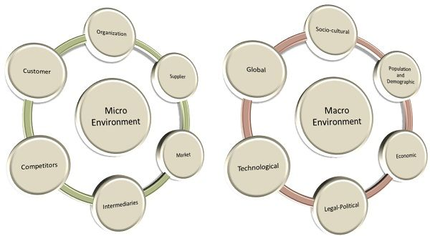

THE MAIN ELEMENTS IN THE MACRO ENVIRONMENT (DOMINO’S PIZZA).

**SOCIAL/CULTURAL FORCES: **
1. **Consumer Preferences: ** Cultural stereotypes and preferences influence menu choices and preferences at different locations. Domino’s tailors its offerings to local tastes and preferences.

2. **Health Awareness: ** Changing societal attitudes towards health and wellness affect consumers’ desire for better and more transparent choices in sourcing ingredients.

3. **Demographic Diversity: ** Due to cultural diversity in different markets, Domino's needs to adapt its marketing and menu to accommodate different ethnic groups.

**Lifestyle Improvement: ** Busy lifestyles and the trend toward convenience are increasing the demand for prompt service and delivery options, in line with Domino's business strategy

5. **Urbanization: ** Increasing urbanization increases the demand for distribution services, increasing the use of dominoes in densely populated areas.

**LEGAL FORCES: **

1. Food Safety Regulations: Compliance with food safety and hygiene regulations is essential to ensure consumer confidence and avoid legal challenges.

**Employment Laws: ** Compliance with employment laws and employment policies is essential to ensuring fair treatment of employees and avoiding legal issues.

3. **Intellectual Property Protection: ** Legal protection for trademarks, recipes and unique technologies for Domino's brand and products are protected.

4. **Consumer Protection: ** Compliance with consumer protection laws assures openness in advertising, pricing and product quality.

5. **Health and Nutrition Regulations: ** Adherence to transparent nutrition labeling allows Domino's to provide accurate information to customers.

**ECONOMICAL FORCES: **

1. **Consumer Spending: ** Economic conditions affect consumer spending on eating out, affecting Domino's sales.

2. **Currency Exchange Rates: ** Because Domino's operates globally, currency fluctuations may affect imports and overseas operating costs.

3. **Income: ** Increased disposable income in specific areas may increase demand for outdoor dining and food delivery services.

4. **Inflation and Interest Rates: ** Economic variables such as inflation and interest rates affect Domino's costs, prices, and profits.

5. **Economic Growth: ** The expanding economy gives Domino's the opportunity to enter new territories as customer demand increases.

**POLITICAL FORCES:

1. **Regulations and Health Standards: ** Federal regulations regarding food safety, sanitation, and labelling impact how Domino’s operates and serves customers.

2. **Labour Laws: ** Labour laws, minimum wage laws, and working conditions all have an impact on Domino's labour costs and labour management.

3. **Trade policy: ** International trade agreements and tariffs may affect the price and availability of products used by Domino’s.

4. **Political Status: ** Political stability in the host countries where Domino operates is very important for the company to continue and successfully enter the market.

5. **Tax Law: ** Tax law and incentives may impact Domino’s financial performance and investment strategies.

**TECHNOLOGICAL FORCES: **

1. **Online ordering and delivery: ** Technological advances enable Domino's to offer online ordering, smartphone applications, and real-time delivery tracking.

2. **Digital Marketing: ** Domino’s can reach and engage customers effectively through social media and digital platforms.

3. **Automation and Efficiency: ** Technological advances can improve Domino’s supply chain management and order processing efficiency.

**Data Analysis: ** Data analysis helps Domino's analyse customer preferences, trends, and growth opportunities.

**Digital Innovation: ** Embracing new technologies such as AI and automation improves customer experience and streamlines Domino’s operations.

**ENVIRONMENTAL FORCES: **

1. **Sustainability: ** Increasing environmental consciousness is influencing consumer behaviour. Domino’s efforts to develop sustainable practices and environmentally friendly packaging are becoming increasingly important.

2. **Effects of Climate Change: ** The impacts of climate change may affect the availability and pricing of products used by Domino.

3. **Waste Management: ** Complies with environmental concerns and regulations to prevent waste issues and encourage recycling.

4. **Sourcing Practices: ** Environmental ethical concerns affect Domino’s ingredient sourcing choices, affecting supply chain practices.

5. **Energy Efficiency: ** Using energy efficiency and technology can help Domino's reduce its operating costs and the environment.

Understanding and adapting to these larger environmental impacts is important for Domino’s Pizza to address obstacles, exploit opportunities, and maintain its competitive position in the fast-food segment

conclusion:

Finally, environmental assessment and analysis is critical to all those external factors that affect the company's operations, structure, and business environment Companies like Domino's Pizza can gain important insights into environmental factors of our greater environment through rigorous environmental assessment and research. The macro environment contains many external influences that present opportunities and threats.

SCANNING OF THE ENVIRONMENT

Environmental assessment is the systematic collection of information about the external environment, including social, cultural, economic, political, technological, legal, and environmental factors including information This system helps businesses identify trends, developments and factors that could affect their operations. Environmental assessment is the systematic collection of information about the external environment, including social, cultural, economic, political, technological, legal, and environmental factors including information This system helps businesses identify trends, developments and factors that could affect their operations.

ENVIRONMENTAL ANALYSIS

Environmental analysis involves reviewing and interpreting data collected to analyse its impact on the firm. Companies can use techniques such as the PESTEL framework to examine the political, economic, social, technological, environmental and legal aspects of their environment. This analysis helps them understand how variables interact and define the business environment.

This approach is important for organizations like Dominos Pizza. Sociocultural variables influence menu research and marketing strategies to appeal to locals. Regulatory powers assure compliance with laws relating to food safety, operations and consumer protection. Economic factors affect prices, consumer spending, and all development choices. Technological impact affects online ordering, post-delivery, and customer engagement. The environment gets the sustainability policies and the ways to access the space. Political influences affect regulations, trade policy, and market stability.

Comprehensive environmental assessments enable companies to develop informed policies, adapt to change, and make choices that are compatible with the external environment. It helps identify potential improvements, anticipated problems and mitigate potential risks. Ultimately, the success of companies like Domino’s Pizza lies in its ability to manage the challenging environment and leverage its growth to achieve sustainable growth and competitive advantage

DIAGRAM: PORTERS 5 FORCES
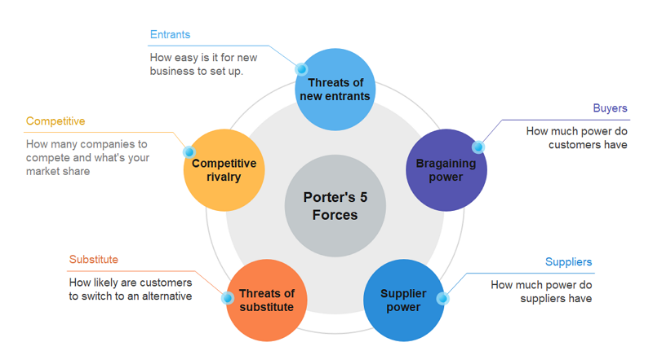

RELATE THE PORTER 5 FORCE MODEL OF COMAPNY IN BOTH COUNTRIES IN UK AND INDIA STATING WHETHER EACH FORCE IS HIGH, MEDIUM OR LOW AND WHY (INCLUDE FACT AND FIGURE TO SUPPORT STATEMENTS MADE? SIMILARITIES AND DIFFERENCES CAN BE STATED?

The Porter's Five Forces model analyses the competitive environment of a company by examining five key forces:

1. **Threat of New Entrants**
2. **Bargaining Power of Suppliers**
3. **Bargaining Power of Buyers**
4. **Threat of Substitute Products or Services**
5. **Intensity of Competitive Rivalry**

**1. Threat of New Entrants:**
- **UK:** Low to Medium
- **India:** Medium

**Explanation:**
- High barriers to entry in the fast food industry due to high investment requirements, high economies of scale and strong brand presence Although UK and India are established industries and although the presence of local competitors and the potential for new entry holds a moderate risk in the India

**2. Bargaining Power of Suppliers:**
- **UK:** Low to Medium
- **India:** Medium

**Explanation:**
- McDonald’s global footprint gives it some negotiating power with its suppliers. However, changes in prices and their dependence on suppliers for quality can give suppliers greater bargaining power.

**3. Bargaining Power of Buyers:**
- **UK:** Medium
- **India:** Medium

**Explanation:**
- The variety of fast food options gives consumers some bargaining power. McDonald’s brand loyalty, food value and convenience neutralize its power to some extent.

**4. Threat of Substitute Products or Services: **
- **UK:** Medium
- **India:** Medium

**Explanation:**
- The fast-food industry is competing for a variety of food options, including healthy and regional foods. This carries a small risk as customer tastes may vary.

**5. Intensity of Competitive Rivalry:**
- **UK:** High
- **India:** Medium to High

**Explanation:**
- Both the United Kingdom and India have highly competitive fast food markets, with many competitors fighting for consumer attention. The strength is enhanced by the presence of global chains as well as local competitors.

**Similarities:**
- The United Kingdom and India have a competitive fast food market, leading to fierce competition. - Communicating the power of customers and suppliers to influence global brand visibility.

**Differences:**
- With a growing economy and the presence of local competitors, the threat of new entrants is much stronger in India. Due to the complexity of the supply chain and local sourcing, the bargaining power of suppliers can be somewhat stronger in India.
It is important to remember that these decisions are based on broad market patterns and may change based on unique circumstances and times. The actual drivers of competition may change according to changes in the industry, economic conditions, regulations and consumer preferences.

PORTER 5 FORCE MODEL USED TO UNDERSTAND HOW PROFITABLE AN INDUSTRY/ MARKET IN WHICH CAN BE USED TO DECIDE WHETHER TO ENTER OR EXIT THE MARKET (DOMINO'S PIZZA).

Porter’s Five Forces Model is a useful tool for analysing the profitability and attractiveness of an industry or market. It helps companies make strategic choices, such as joining, staying or exiting a market. Here is how the model can be used to do this. Porter’s Five Forces Model is a useful tool for analysing the profitability and attractiveness of an industry or market. It helps companies make strategic choices, such as joining, staying or exiting a market. Here is how the model can be used to do this. Porter’s Five Forces Model is a useful tool for analysing the profitability and attractiveness of an industry or market. It helps companies make strategic choices, such as joining, staying or exiting a market. Here is how the model can be used to do this.
1. **Benefit Analysis: ** .

In the model, five factors (threat of new entrants, bargaining power of suppliers, bargaining power of customers, threat of substitution , and competitive rivalry) together define the level of competition and potential profitability in the market.

2. **Market decision: ** .

If Porter’s Five Forces survey shows relatively weak forces and stronger industry returns, it could be an indication that this is a good time to get involved in the market. Fewer barriers to entry, potential for supplier-user interaction, less threat of substitution, and less competition can provide a the new entrant has got a chance to gain a foothold and gain market share

3. **The decision to stay in the market: ** .

Porter’s analysis of five forces can help incumbent organizations decide if they can sustain themselves in a market. If the forces are somewhat balanced and the company is still making respectable profits, it may make sense to stay and compete.

4. **Deciding to Leave a Market: **
If Porter’s Five Pressures study indicates high competitive pressures and low profitability, it may be time to consider abandoning the market. It may be difficult for firms facing more intense competition, greater bargaining power among suppliers or customers, and weaker profit margins to remain viable and profitable

5. Identify potential improvements:

The study can also help organizations identify areas where they can strengthen their competitive position. Understanding the factors at work enables companies to develop a strategy to eliminate errors, enhance their positioning, and increase profitability.

Specifically, Porter's Five Forces Model provides a framework for measuring the growth of an industry or market, enabling organizations to make educated choices about entry markets, promotions, or homes based on levels of competition and potential profitability on

BY FIRMS OPERATING IN THAT INDUSTRY TO UNDERSTAND THE FORCE IMPACTING UPON INDUSTRY PROFITABILITY AND CHANGE HOW THEY OPERATE TO BECOME MORE PROFITABLE THEMSELVES.

Companies in the sector can use Porter's Five Factors analysis to not only understand the factors affecting industry profitability, but also to identify areas where they can maximize profitability to enhance their competitive position.

1. **Competitive Policy Development: ** .

Understanding the nature of competitive competition is important for organizations developing strategies to compete successfully. When competition intensifies, companies may need to differentiate their products or services, focus on cost leadership, or find new ways to create a unique value proposition it sets them apart from competitors

2. **Salesman and Customer Management: **

Companies can realize how much influence suppliers and users have on their company by studying their negotiating power. If suppliers have sufficient capacity, companies may aim to build stronger supplier relationships or explore alternative sourcing options. Similarly, when customers have greater bargaining power, companies can focus on customer retention strategies or offer loyalty programs to increase customer loyalty.

3. **Market expansion and diversification: ** .

Knowing the threat of new and substitute competitors can lead companies to explore new markets or product lines. If the risk of new entrants is relatively low, the company can seek growth elsewhere. On the other hand, if there is a strong risk of substitution, new products or services may be developed to reduce customer dependence on new products.

4. **Innovation and R&D:**

The survey can identify areas where more innovation and research and development (R&D) is needed. To compete in an environment of disruptive change or technological advancement, businesses must adapt and invest in innovation.

5. **Efficiency and cost savings:**

A thorough investigation should reveal some areas of cost efficiency. Companies can improve their cash flow and increase profitability by managing costs. This may involve streamlining manufacturing processes, improving supply chain management, or implementing new technologies to save costs.

**Strategic Agreement & Merger:**

Joint ventures through strategic agreements or mergers and acquisitions can sometimes help companies increase their competitive position and gain market share, especially if there are major barriers in the region.

7. **Legal and Political Analysis:**

External variables such as government regulation and political stability can have a significant impact on the profitability of the sector. Companies need to monitor politics and anticipate regulatory changes to change their operations accordingly.

Companies can gain key insights into the competitive dynamics of their industry by examining Porter’s Five Forces model and using this information to influence their strategies, operations and decision-making processes. The goal is to improve their position in the industry, improve their competitiveness, and ultimately increase their profitability.
DIAGRAM: SWOT ANALYSIS 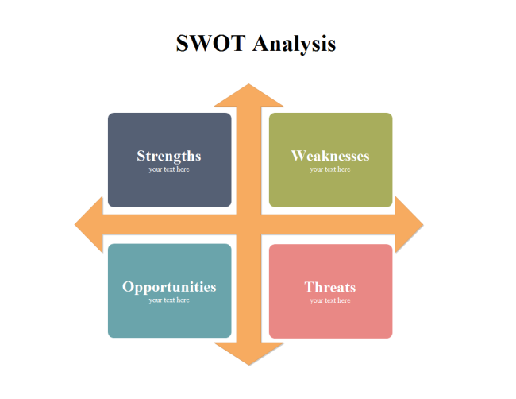

RELATE A SWOT ANALYSIS TO DOMINO’S PIZZA THE UK AND INDIA STATING MAIN STRENGTH, WEAKNESS, OPPORTUNITIES AND THREATS.( INCLUDE FACTS AND FIGURES TO SUPPORT STATEMENTS MADE )

SWOT analysis for Domino's Pizza in the UK and INDIA, highlighting the main strengths, weaknesses, opportunities, and threats for each market.

Domino's Pizza in the UK

Strengths: | Weaknesses:
1. **Market Leadership:** Domino's is one of the leading pizza chains in the UK, with a significant market share and a strong brand identity.  2. **Efficient Delivery System:** The company has a well-established delivery system that ensures prompt and reliable delivery, contributing to customer satisfaction and loyalty.  3. **Menu Innovation:** Domino's continuously introduces new and innovative menu items, such as its popular "Brooklyn Style" and "Handmade Pan" pizzas, to cater to diverse customer preferences. | 1. **Perception of Low Quality:** In the past, Domino's faced criticism for the taste and quality of its pizzas. Though the company has improved its recipes and addressed these concerns, some customers may still perceive its offerings as lower quality compared to other pizza chains.

Opportunities: | Threats:
1. **Digital Growth:** The UK's highly digitized market presents an opportunity for Domino's to leverage its user-friendly mobile app and website to enhance customer engagement and boost online orders.  2. **Menu Diversification:** Introducing new food items and expanding into complementary categories could attract a broader customer base and increase average order value. | 1. **Intense Competition:** The pizza market in the UK is highly competitive, with several well-established players like Pizza Hut, Papa John's, and Little Caesars vying for market share.  2. **Health and Dietary Concerns:** The increasing focus on health and nutrition could lead some customers to choose healthier alternatives or reduce their fast-food consumption.

Domino's Pizza in INDIA:

Strengths: | Weaknesses:
1. **Rapid Expansion:** Domino's has experienced significant growth in INDIA, expanding its presence to over 1,300 stores in various cities and towns across the country  .  2. **Localized Menu:** The company successfully adapted its menu to cater to Indian tastes and preferences, offering vegetarian options and unique toppings like paneer and chicken tikka. | 1. **Limited Non-Pizza Options:** While Domino's has made efforts to diversify its menu in INDIA, its offerings are still primarily focused on pizzas, potentially limiting its appeal to customers seeking alternative food options.

Opportunities: | Threats:
1. **Continued Market Growth:** INDIA's fast-food industry is growing rapidly due to urbanization, changing lifestyles, and an expanding middle class, providing ample opportunities for Domino's to capture a larger share of the market.  2. **Digital Penetration:** With the increasing penetration of smartphones and the internet in INDIA, Domino’s can further leverage its digital platform to enhance customer convenience and loyalty. | 1. **Competition from Local Players:** Domino's faces competition from local pizza chains and regional food establishments, which are often deeply rooted in the Indian culture and preferences.  2. **Economic Factors:** Economic fluctuations in INDIA, such as inflation or changes in consumer spending patterns, could impact the demand for fast food.

DISCUSS ANY SIMILARITIES AND DIFFERENCES WITH THE UK AND INDIA IN RELATION TO STP. (DOMINO'S PIZZA)

**STP Similarities**

**Designation:**

- In both the United Kingdom and India, Domino’s Pizza separates its markets based on demographic criteria such as age, income and family size. They cater to young people, families and individuals looking for convenient and affordable dining options.

- Both markets examine psychological factors such as lifestyle and preference, since Domino’s seeks customers who value convenience, speed and quality in their dining experience.

**Targeting:**

- The presence of Domino's in both countries focuses on urban and semi-urban customer bases, as strong demand for fast food delivery is high in these areas

- Targets customers looking for a quick and easy dinner, and promotes themselves as the go-to pizza delivery service.

**Schedule :**

- Domino's in both the UK and India advertise themselves as a reliable and convenient pizza delivery service, emphasizing their "30 minutes or free" and "You got 30 Minutes" guarantees though ensure that the customer performs their deliverables on time.

- Two emphasize low cost and value, and promote themselves as a convenient way to enjoy a quick and delicious lunch.

**DIFFERENCES IN STP:**

**Designation:**

- Domino's in India adapts its menu to local tastes, preferences and cultural conventions. They offer vegan pizzas and use regional toppings to cater to the INDIA market, where veganism is more prominent.

- Menus in the United Kingdom may include more vegetarian options, reflecting the appeal of the American market

**Targeting:**

- Domino's in India caters to a wider demographic including families and groups by offering value-oriented product combinations that reflect the INDIA trend of sharing food with loved ones.

- In the United Kingdom, Domino's can focus more on young people and those who want fast and convenient food options.

**Schedule :**

- Domino’s in India proves itself to be a cosmopolitan source of Indian cuisine, tailoring its offerings to local tastes while offering recognizable international options.

- In the United Kingdom, Domino’s can focus more on positioning itself as an innovative and tech-savvy brand by leveraging its digital platform and technology to improve customer experience

Companies like Domino’s Pizza need to adapt their STP strategies to the unique characteristics and preferences of each market. Domino’s can identify similarities and differences in its STP strategy between the UK and India in order to reach and engage its target audience in each country.

MARKETING MIX ELEMENTS (7PS) DOMINO'S PIZZA.

1. Production:
Dominos Pizza offers a wide variety of pizzas, pastas, chicken dishes, sandwiches and desserts. They're known for their extensive menu of different pizza toppings and dough, as well as their "30-minute or free" delivery promise (in select cities). To appeal to customers, the company constantly updates its menu by introducing new favourites and options.

**2.1. value:**

Domino’s Pizza uses competitive pricing strategies to attract customers, often offering pricing, combinations, and discounts. Their prices tend to be affordable while still reflecting quality food and service.

**3.1. place:**

Through the locations the company owns and franchises, Domino’s has a significant global presence. They want to be easily accessible, and offer online and mobile app ordering options, as well as traditional phone orders. The company's locations are generally conveniently located in cities and towns.

**4.1. advance:**

Dominos uses various advertising and promotional strategies. Their advertising efforts include new menu offerings, promotions, and easy delivery. In order to reach a wider audience, they use social media, broadcast advertising and online advertising.

**5.1. people:**

Domino’s invests heavily in the quality of its employees and in-store products. Efficient and courteous customer service is key to their brand experience. Employee training ensures that customers receive consistent quality service across locations.

**6. approach**

Ordering and delivery is an important part of Domino’s business. They are investing in technology to speed up the process, allowing customers to place orders through their website or mobile app. Domino's has a tracking system that allow

Overall, the Domino’s Pizza marketing strategy aims to provide a strong customer experience that combines quality, convenience and value. The company’s emphasis on innovation, technology and efficient delivery methods sets it apart from the competitive fast food industry. It is important to note that the approach may vary depending on specific market characteristics, as described in previous comments on the UK and India

AN EXPLANATION AND COMPARISON OF THE MARKET ENTRY METHODS UTILISED IN THE DIFFERENT COUNTRIES COULD BE INCLUDED IN THE "PLACE" ELEMENT OF THE MARKETING.

**Location (distribution channels and market access):**

Various go-to-market strategies have been used at Domino’s Pizza to build a presence in different countries. These options include franchises, joint ventures, and acquisitions. Let’s take a look at how these techniques have been implemented in the UK and India, followed by a comparison:

**UK:**

Domino’s Pizza often uses a franchise model to enter the market in the United Kingdom. It has a strong network of franchisees operating in locations across the country. This approach allows Domino’s to leverage local knowledge, build on existing customers and manage operations more efficiently.

*Franchising in the United Kingdom:*

- **Pros:** Domino's uses franchises to rapidly expand its reach, split operating costs with franchisees, and better adapt to local priorities. This also reduces the company’s financial risk.

- **Challenges:** Maintaining consistent quality across franchise sites can be difficult. Stakeholders may have varying degrees of commitment to the brand.

**India:**

Dominos Pizza in India follows a franchise model, but the company also tailors its food to local tastes. Additionally, due to regulatory restrictions on foreign direct investment (FDI) in the food business, Domino’s has partnered with local partner Jubilant Food works to set up its stores in the country

*Franchising and local partnerships in India:*

- **Benefits:** Working with local businesses like Jubilant Food Works helps Domino's overcome legal challenges and ensure compliance with local laws. The franchise model continues to offer the benefits of local expertise and shared risk.

- **Challenge:** Adapting food and service to local tastes while k

SEGMENTATION, TARGETING AND POSITIONONG (STP):

SEGMENTATION:
1. **Demographics:** - Age: Domino's caters to a wide range of age groups including teens, young adults and families. They also offer specials and promotions to attract younger shoppers, as well as family-friendly restaurants.
- Gender: Dominoes do not target gender specifically; His products are designed for everyone.

- Family size: A variety of pizza sizes are offered to accommodate a variety of family sizes or group gatherings.

- Income: Domino's offers a variety of income-friendly merchandise, including easy budget options like "value pizza" and premium selections for those willing to pay more

2. **Geographical Classification:** .

- Urban and semi-urban areas: Domino’s is concentrating on urban and semi-urban areas where population is high and demand for fast food is high

- Locations near colleges and universities: Locations near academic institutions are targeted to attract students and youth.

3. **Conceptual Breakdown:**

- Demand for convenience: Domino’s caters to customers who want fast and convenient restaurants. To accommodate busy consumers, they advertise their fast shipping and online ordering options.

- Tech-savvy customers: Domino's caters to tech-savvy customers who prefer to shop through mobile applications or online platforms.

- Value Finders: Attract value-oriented customers by offering value and product combinations.

4. Classified socioeconomic status (SES):

- Middle and middle class: Domino's offers affordable but upscale restaurants for the middle class and middle class.

- Budget-conscious: Cater to those who want to eat inexpensively without sacrificing taste or quality.

**Geo-demographic section

TARGETING:
1. **Undifferentiated targeting (mass marketing):** The company uses this strategy to target the entire market with a single marketing mix. The company believes that the needs and interests of its target customers are comparable, and that one product or marketing message can effectively reach all of them.

-This method is best suited for broad attractions, such as essential requirements or generally recognized products.

2. **Differentiation targeting (multi-level marketing):**

- A uniquely targeted approach involves a company targeting multiple market groups with a separate marketing mix. The company recognizes that different consumer groups have specific desires and preferences and adapts its merchandise and marketing messages accordingly.

-This approach enables the organization to better serve different customer segments, increasing customer loyalty and market growth.

3. **Focus (Niche Marketing):**

- In a targeted approach, a company focuses its efforts on addressing one subset of the market. The company targets a niche market with specific needs and wants and creates products and marketing specifically for that group.

- This approach is useful when a company does not have the resources to compete in a larger market or when a narrow niche offers significant growth.

**Domino's Pizza's Targeting Strategy:**

Dominos Pizza has a very specific targeting strategy. Rather than using a one-size-fits-all approach, Domino’s recognizes that different customer groups have different tastes and preferences. Domino’s offers menus with different types of pizzas, different crusts and side dishes to incorporate specific customer preferences and market segments.

DIAGRAM: PERCEPTUAL MAP FOR FOOD

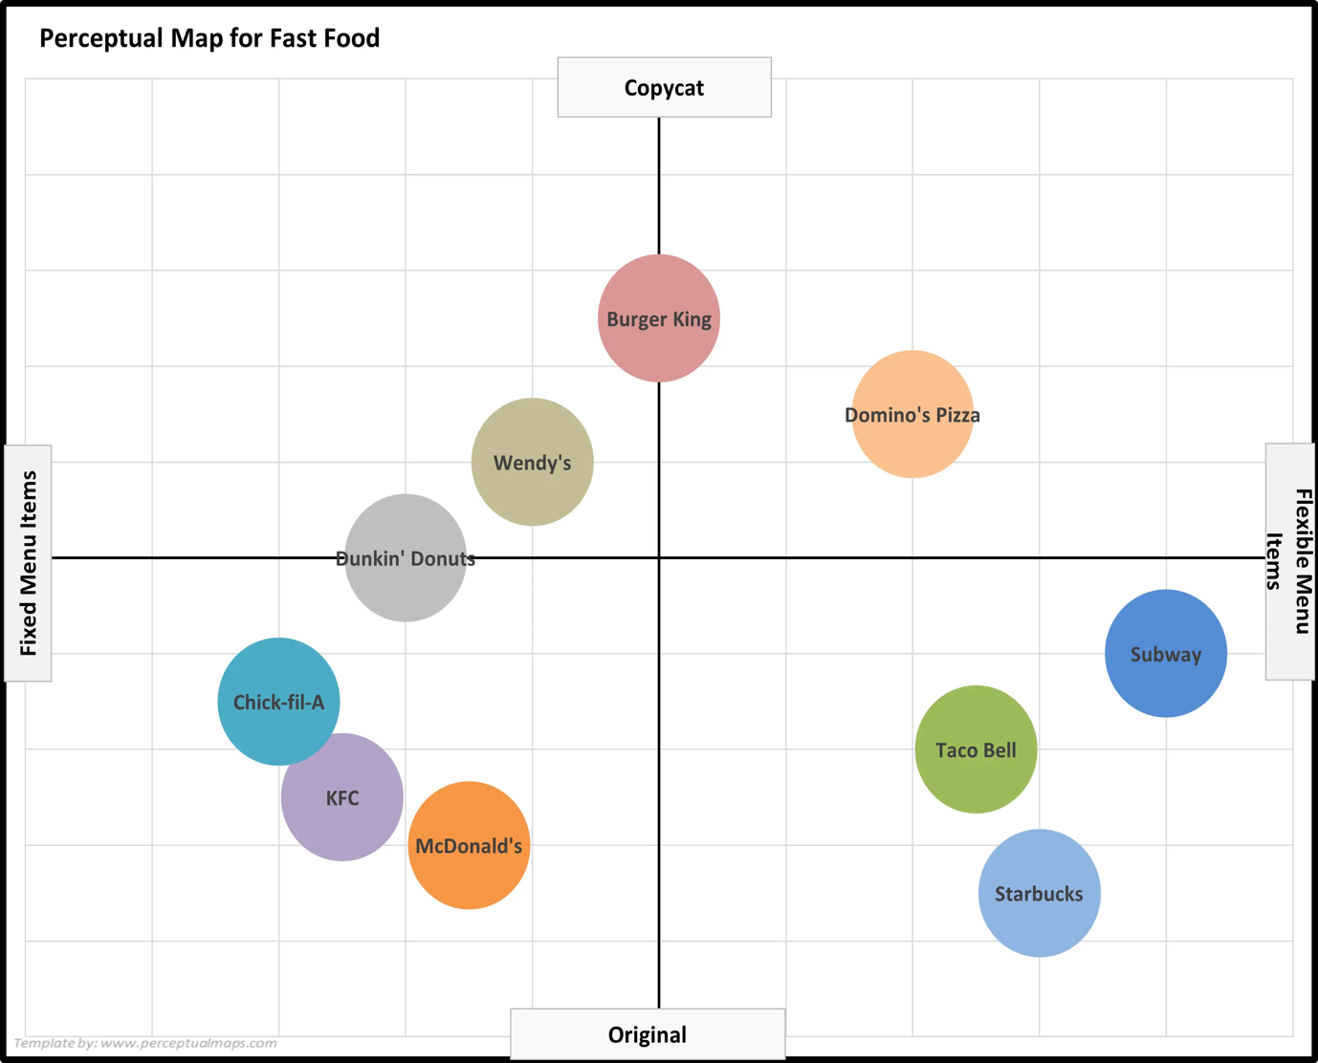
CORPORATE UMBRELLA BRANDING:
Dominos Pizza is an example of a corporate umbrella brand. A corporate umbrella logo, also known as a family logo or corporate logo, is a marketing strategy in which a company uses its brand name to cover and promote various products or services under its roof

In the Domino's Pizza example, the corporate logo "Domino's" is an umbrella logo that encompasses and symbolizes all of the company's pizza products. When people think of Domino’s, they think of pizza delivery and quality fast food. This strong brand link contributes to brand loyalty and awareness.

Benefits of a corporate umbrella for Dominos Pizza:

1. **Brand Equity:** The corporate brand "Domino's" has accumulated huge brand equity over the years. This perfection extends to its entire pizza offering, benefiting every product or service under the umbrella.

2. **Consistency and Reliability:** By using a corporate brand, Domino's assures, and provides, customers with consistent product quality, service, and customer experience at all of its locations confidence.

3. **Cost Efficiency:** Using marketing activities for new pizza products or menu items can leverage existing brand knowledge and customer demographics , which is associated with the company brand, thereby reducing marketing costs.

4. **Brand Expansion:** If Domino's chooses to expand into the food segment or related industries in the future, a strong corporate brand can help expand into other products.

5. **Benefits of Name Recognition:** A positive experience with a Domino product or service can motivate customers to look for other products under the same name.

Organizations using corporate umbrella branding to protect the overall brand image must maintain a consistent quality and consistent customer experience across all products and services Domino's Pizza has built a strong and recognizable brand on fast food business by successfully implementing this branding strategy has become one of the most successful pizza franchises in the world

PRODUCT BRANDING STRATEGIES ( DOMINO’S PIZZA):
Dominos Pizza is a world famous pizza delivery truck business that has used many branding strategies to expand their product selection and attract more audience Line filing, line extension, line extension, and brand extension are some of the strategies used . . . . Let’s look at each of these options in the context of dominoes:

1. **Line Filing:**

Line filing provides minor modifications to currently available products to target customer segments or preferences. To respond to a variety of preferences and nutritional considerations, Domino's has used queue files to offer pizza crust options (e.g., thin crust, hand-tossed, pan, gluten-free ) and by doing so, Domino's can generate more appeal by customers and stay true to its core product .

2. **Line Extension:**

Line extension refers to the introduction of new products in the same product line to meet specific customer requirements or preferences. Domino’s planned to expand line to include new side items and desserts such as breadsticks, chicken wings, spaghetti, lava cake and other desserts. These additions complement their specialty pizza offerings and give customers additional options when ordering.

3. **Line Stretching:**

Range stretching expands the range of products to fit new market niches, often by adding products that are more expensive or more expensive than currently available options. Domino's has embraced queue expansion with non-budget friendly features (such as their higher prices) and luxury features (such as their delicious pizza specials) This strategy allows Domino's to reach many different customer segments their budgets and preferences.

4. **Brand Expansion:**

Brand extension means that the current brand name can be used to offer new products or services in different product categories. Dominos experimented with brand expansion by expanding outside of its core pizza business. For example, they opened a "Domino's Pizza Theatre" where diners could watch their pizza being made in an open kitchen. In addition, they are experimenting with technology-focused services such as online ordering, smartphone applications and delivery tracking, in order to expand their brand into the digital realm

While these strategies can be useful for increasing brand engagement and service, they must be carefully managed to ensure brand consistency, quality and customer loyalty Domino's success in using these strategies implementation means that they are able to respond to changing customer interests and market trends

PRODUCT FACTOR MAY CHANGE DUE TO INTERNATIONAL MARKETING: (DOMINO’S PIZZA)
When a business like Domino's enters foreign markets, numerous variables might impact how they adjust their product features and branding to accommodate to local tastes and cultural variations.

1. **Functions and Advantages:**

The quality and utility of Domino’s products may vary depending on local flavours and food choices. For example, in areas where particular products are more popular or more frequent, Dominos may offer local pizza toppings to better suit local palates. Additionally, dietary restrictions and preferences may require the inclusion of vegetarian and vegan options, as well as a variety of spice levels or flavours

2. **Branding ** .

Domino’s branding may need to be adapted to reflect the cultural and linguistic differences of each foreign region. This includes translating brand names, slogans and marketing materials into the local language. Advertising messages and images may also need to be adapted to local traditions and beliefs.

3 *Product Design/Types:**

Production and design can be adapted to regional tastes. Dominos is launching unique pizza combinations influenced by regional cuisine at various locations. They can also offer a variety of pizza sizes based on locals’ favourite portions. Also, considering dietary requirements, gluten-free snacks or other options can be offered.

4 *Packaging Design and Labelling:**

Packaging and labelling may need to conform to local codes and cultural sensibilities. This includes ensuring that all ingredients are properly labelled in accordance with local food labelling regulations. In addition, the box design can incorporate familiar images or colours that are popular with locals.

5. **Size:**

Portion sizes can be adjusted to suit local eating patterns. Some markets may prefer larger drinks, while others prefer smaller, more manageable packages. Domino’s needs to create the right mix between its brand and value proposition to meet local needs.

6. **Community Outreach and Discussion:**

In some cases, Domino’s may enter into agreements with local vendors to acquire popular and readily available products locally. This gives their products authenticity and freshness, as well as a sense of community connection.

**Cultural Sensitivity:**

Understanding and respecting local cultural values ​​is important. Some products or foods that are acceptable in one culture may not be acceptable in another. To avoid offending or criticizing customers, Domino’s had to carefully examine religious, nutritional, and cultural concerns.

8. **Marketing and Advertising:**

Marketing strategies had to be tailored to the local media environment, communication channels and consumer characteristics. What works in one market may not work in another, so Dominos would have to adjust its advertising accordingly.

In short, overseas business requires a thorough knowledge of local cultures, tastes, and regulations. Domino's, like any global brand, will need to be flexible and adaptable in their approach to ensure that their brands meet the expectations and demands of each country, while keeping their identity if it is on the bottom.

PRICING STRATEGIES: (DOMINO’S PIZZA)

1. **Premium Pricing:**
Domino’s uses attractive pricing for its unique pizza and premium crust options. These products are made more expensive due to unique features or innovative blends. For example, their "Gourmet" or "Specialty" pizzas tend to be more expensive due to their high-quality toppings and flavours.

2. **Penetration Pricing:**
In the past, Domino’s used entry pricing strategies when entering new territories. They offer affordable start-up costs to quickly establish a broad customer base. They can establish a significant presence and customer loyalty and gradually increase their prices.

3. **Economic Pricing:**

Domino's also uses economic pricing techniques, especially with their "high price" or "everyday price" offers. These selections aim to provide budget-friendly solutions for price-conscious customers, appealing to a wide range of customers.

4. **Price skimming:**

While uncommon in the pizza industry, price searches establish a high initial price for new, unique, or expensive items and gradually reduce prices over time could Domino's use this strategy for limited time offers or new products to target a specific group of people who are eager to pay a premium to be among the first to try something new.

5. **Psychological Pricing:**

Dominos uses psychological pricing to make prices seem more appealing to customers. For example, pricing a pizza at $9.99 instead of $10 gives the impression that it is much cheaper. Unusual or deceptive pricing techniques can also be used to mix deals.

**Bundle Pricing:**

Domino's typically uses bundled pricing, offering pizzas, sides, and drink combinations at a cheaper combined price than individual costs This encourages customers to purchase additional products and gives them the full value of their orders spike.

These pricing strategies allow Domino’s to cater to different customer segments and market conditions while increasing revenue and maintaining its competitive position in the pizza delivery segment. Keep in mind that pricing methods may change over time due to changes in the market, customer preferences, and other considerations.

FACTORY THAT MAY CHANGE THE PRICE WHEN MAKING PRODUCT/ SERVICE AVAILABLE IN DIFFERENT COUNTRIES, DEMAND, COMPETITION, INFLATION/DEFLATION, THE ECONOMIC STABILITY OF THE COUNTRY TAXES, THE BUYING POWER OF THE TARGET MARKET .
(DOMINO’S PIZZA)

1. **Demand:**
The demand for dominoes in each country can greatly influence price choices. If demand is strong, they should be able to maintain high prices. Conversely, in areas where demand is low, prices may need to be adjusted to attract customers and increase sales.

2. **Competition**

The competitive environment of each country will have a significant impact on the pricing strategy. If there are many competitors offering comparable products, Dominos may have to accept more aggressive pricing to gain market share. On the other hand, if they have a different value proposition, they may maintain a higher price.

3. **Inflation/Depreciation:**

Economic factors such as inflation and deflation can affect material, labour and other operating costs. If inflation is high in a country, Domino’s may need to raise prices to cover the cost increase. They should have more freedom to cut prices in situations of falling prices.

4. **National economic stability:**

Pricing can be influenced by a country’s overall economic stability and wealth. People in stronger economies may have more disposable wealth, allowing Domino to charge perhaps higher prices. Economic instability may require price adjustments to reflect weaker purchasing power.

5. **Taxes** .

Tax systems such as value-added tax (VAT) or other consumption taxes can affect the final price of a product. In order to be competitive in order to meet tax requirements, Domino’s must take this tax description into account when setting pricing.

6. **Buying power of the target market:**

It is important to understand the specific income and purchasing power of the target market. Prices that are too high for local incomes can lead to bad sales, while pricing that is too low can create profitability issues

7. **Cultural and regional preferences:**

Cultural changes can also affect pricing. Some cultures may be more prepared to pay a premium for convenience or quality, while others will prioritize lower prices. Domino’s needs to adapt its pricing strategy to each country’s culture and preferences.

8. **Exchange Options:**

Fluctuations in exchange rates may affect the value of goods or equipment imported in foreign operations. To maintain stability and profitability, Domino’s must consider currency fluctuations when setting prices.

**Local administration fees:**

The cost of doing business within a country such as labour, rent, utilities and transportation can vary greatly. These local administrative costs will have an impact on the overall cost structure and, consequently, the pricing strategy.

In summary, when Domino's Pizza is expanding into new countries, it should conduct extensive market research and analysis to understand local economic conditions, competition, consumer preferences, and regulatory environment This information is crucial to a learned price has been chosen that corresponds to the reality of each market.

PLACE:
1. **Location (Distribution): ** .
Distribution channels are the channels and channels through which a company’s products reach the end customer. Domino’s Pizza must deliver their pizza from the kitchen to the customer’s door or to these aisles. This is done through direct and indirect distribution methods.

2. **Direct distribution method** .

The direct distribution method involves selling directly to customers without the need for intermediaries. In Domino’s example, their online ordering (website and mobile app) acts as a direct channel. Customers can ship items directly to Domino’s, and the company will handle delivery or pickup.

3. **Indirect distribution method** .

In indirect distribution, intermediaries or intermediaries help distribute goods to customers. Delivery services like UberEATS or Door Dash can act as an indirect strategy for Domino’s. Customers place orders through these channels, and intermediaries manage the delivery.

**Strong classification: **

Strong distribution allows for as many channels as possible to maximize market penetration. In Dominos example, their goal is to make their pizza convenient for customers. This is accomplished through a variety of physical retail locations, online shopping, and coordinated delivery services.

5. **Separate Distribution** .

Distribution only allows you to restrict the number of outlets or intermediaries. This method is typically used for high-end products or luxury products. Perhaps personalized delivery is not as important to Domino’s because they emphasize accessibility and convenience, catering to a wide range of customers.

**Selective classification
Classification selection requires a compromise between intensive and extensive wells only. This includes working through a limited number of intermediaries to maintain product quality and brand control. Domino’s can use a selective distribution strategy, carefully selecting third-party distributors that meet their quality and service standards.

In summary, Domino's Pizza uses a combination of direct and indirect distribution strategies, with a strong focus on moving their products through multiple locations Their primary objective is customer availability access and convenience and maintain control over the quality and consistency of their products . The chosen distribution strategy is determined by variables such as market reach, customer preferences, and overall business objectives of the firm.

MARKET ENTRY METHODS (DOMINOS PIZZA):

LICENSING:
A license allows a third party (the licensee) to use the company’s intellectual property, such as a brand name, trademark, design, or technology, for monetary or royalty payments This allows the licensee to manufacture and sell products under the licensed trademark or use the licensed technology.

In the case of Dominos Pizza, licenses can be used as market access in the following ways.

1. **Brand License: ** .

Domino’s can license its brand name, logo and trademark to local businesses or entrepreneurs in the new market. The licensee would then operate a pizza restaurant bearing the Domino name, menu and recipe. This allows Dominos to expand its brand exposure without any individual controlling operations in that area.

2. **Business License: **

Domino’s can license patented pizza technology and recipes to local food manufacturers or restaurants. This allows these companies to produce Dominos-like pizzas with the same quality and taste, which can then be delivered to customers through multiple channels

3. **Technical License: ** .

If Domino’s has developed a unique technology solution for order processing, post-delivery, or customer communication, this technology can be licensed to local businesses. This will allow the licensee to leverage this technology to improve its business and customer experience.

**Royalty payments: **

In return for the license, the licensee usually paid Domino’s a certain amount or a portion of its revenue in royalties. This provides Domino’s with a steady revenue stream and encourages the licensee to maintain high quality and product standards.

Licensing can be a profitable route to market for companies like Domino's because it allows them to grow into new territories with comparatively lower financial risks and costs

By licensing its brand, processes, or technologies, Domino’s can leverage the knowledge and resources of local partners while benefiting from an expanded market and revenue potential

FRANCHISING:
A franchise is a market entry strategy whereby a company (franchisor) grants a third party (franchisor) the right to use its established brand, business model, and established support system though paid cash, royalties, or a participation in sales .

For Domino’s Pizza, the franchise has been a cornerstone of their expansion strategy, allowing them to rapidly expand their footprint globally. Here’s how Domino’s franchises work:

1. **Demonstrated Corporate Concept: ** Domino's has a well-established and successful corporate concept, which includes recipes, menus, strategies and a logo for he has won all over the world.

2. **Training and Support: ** Franchisor provides full training and ongoing support to franchisees to ensure they understand and can successfully execute Domino's business plan.

3. **Brand name use: ** Franchisees have the ability to use Domino's brand name, logo and trademarks, allowing them to benefit from the brand name and reputation.

**Shared Revenues: ** Franchisees pay an initial franchise fee and an annual royalty based on their sales in return for the right to use the brand and business model. This creates a mutually beneficial synergy with both the franchisor and franchisee having a major stake in the success of the company.

5. **QUALITY CONTROL: ** Domino's adheres to strict quality control standards to ensure consistency across all franchise sites. This helps to maintain the brand’s reputation and assures that customers have a consistent experience no matter where they shop.

6. **Local Customization: ** While maintaining original brand values, franchisees can customize menu offerings for local tastes and preferences, allowing Domino's to serve different markets.

7. **Expansion and Investment: ** Franchisees often contribute to the start-up and maintenance costs, allowing Domino to grow rapidly around the world without the company having to make a significant financial commitment lead.

8. **Risk Sharing: ** Franchisees assume certain risks and responsibilities, which can help Domino's reduce certain financial and operational risks associated with entering new markets.

Domino's franchising program allows them to grow quickly into new territories while leveraging the local knowledge, skills and entrepreneurship of their franchise partners. This initiative has contributed significantly to Domino’s global reach and ability to deliver its merchandise and brand experiences to a wider variety of customers around the world

JOINT VENTURE:
A joint venture is a business agreement in which two or more parties cooperate in a particular business, profession, or business activity. In a joint venture, partners combine their skills, experience, and finances to achieve a common goal. They agree on the division of income, expenses and management.

Domino’s Pizza may use the combined business as a market entry in the following ways.

1. **Local Partner Expertise: ** Domino's can partner with a local company, investor, or entrepreneur that is well known in the target market. This local partner provides insight into local interests, regulations, and consumer behavior that can be critical to successful market penetration.

2. **Shared resources: ** Joint ventures combine their resources, which may include financial investments, business plans, distribution networks and community networks.

3. **Risk Sharing: ** By going into a joint venture, Domino's shares both financial and operational risk with a local partner. This in itself can reduce the financial burden of entering new markets.

4. **Shared control: ** A joint venture shares control and decision-making power over the board. When choosing options, this collaborative approach assures that the interests of both parties are met.

5. **Local Initiatives: ** With the help of a local partner, Dominos can tailor its menu, offerings, and marketing strategies to local tastes and preferences, and provide opportunity to win is effective.

6. **Gaining Market Knowledge: ** The local partner provides insight into local market conditions, consumer behavior, cultural nuances and legal requirements. This information can help Domino’s to enter the market more effectively.

7. **Mutual Benefit: ** A successful joint venture benefits both parties. Domino’s gains the experience and resources of the local partner, while the local partner benefits from Domino’s global brand awareness and established business strategy

It is important to emphasize that joint ventures require careful planning, clear agreements and good communication between the parties. Legal, financial and operational issues must be clearly communicated to avoid misunderstandings and problems later on.

A joint venture approach can be particularly useful when entering markets with complex regulatory regimes, cultural differences, or unique issues that require support from a local partner Joint venture with the launch enables Dominos to leverage local expertise through its global brand strength, resulting in a larger market and improved efficiency

STRATEGIC ALLIANCE:

Strategic partnerships are certainly another go-to-market strategy that can be used.

A strategic alliance is an agreement between two or more companies that work together in pursuit of a common goal. These networks combine resources, experience and skills to gain competitive advantage and increase market presence. Strategic agreements can take many forms, including joint ventures, partnerships, collaborations, and joint ventures.

Domino’s Pizza may use strategic partnerships as a route to market in the following ways.

1. **Strengths included: ** Domino's may partner with a local company that has similar characteristics, such as an established distribution system, large number of customers, or technical expertise.

2. **Shared resources: ** Alliance partners combine their resources, which may include financial investments, business plans, marketing activities, or technology initiatives.

**Risk reduction: ** Domino's shares the risks of entering a new market by working with a local partner. The experience and insight of a local partner can help you successfully overcome problems and uncertainties.

**Local Knowledge: ** A local partner provides insight into interesting market trends, cultural preferences, and regulatory requirements, enabling Domino’s to make educated decisions and adapt its operations accordingly.

5. **Market expansion: ** Through collaboration, Domino’s gains access to local partner customers and distribution networks, allowing faster market penetration.

**Co-marketing and promotion: ** Alliance partners can collaborate on marketing strategies, promotions and events that leverage each other’s capabilities. This can lead to improved brand exposure and customer interaction.

7. **Joint research and development: ** When appropriate, collaborating partners may collaborate on R&D activities to develop new products or services that meet local needs.

8. **Collaboration: ** Collaboration provides the benefits of collaboration by combining the capabilities of both parties. This can result in cost savings, increased operational efficiency and improved competitiveness.

Strategic conversations require thorough preparation, open communication, and clear knowledge of each partner’s duties and contributions. It is important to specify the contractual parameters, including how resources are allocated, how decisions are made and how risks and benefits are allocated

Through a collaborative approach, Domino’s Pizza can leverage the resources and expertise of the local partner, adding to its global brand expertise, established business strategy and industry expertise. This approach can lead to profitable synergies that enhance the market position of both organizations and lead to success in the new market.

PROMOTION:
Undoubtedly, Dominos Pizza uses various promotional strategies to effectively reach the target demographic and generate sales.

1. **Advertisement: ** .

Domino’s displays its menu items, specials, and value offerings through traditional advertising channels such as television, radio, and print media. Their advertising efforts tend to emphasize the ease of ordering online, fast delivery, and their stylish pizza photos.

2. **Sales Promotion** .

Domino's often runs "Buy One, Get One Free" deals, discounts on select pizzas, product combinations and sales promotions to entice customers to buy more These campaigns for customers have the enthusiasm and urgency to take advantage of temporary offers.

3. **Public Relations (PR): ** .

Dominos has strong public relations through news releases, media interviews and community involvement. News of new product releases, philanthropic endeavors, and innovations is shared to generate positive feedback and community engagement.

**Sponsorship: **
Domino’s sponsors events, sports competitions and community activities to improve brand awareness and connect with their target demographic This sponsorship strategy associates the brand with engaging experiences and ideas.

5. **Direct Trading: ** .

Domino’s communicates with customers through direct marketing through mail, email, or SMS. They send out promotions, new product launches, and special deals to their customer database in hopes of speeding up action.

6 *Digital Marketing: **

Dominos places a high value on digital marketing. They use many digital channels such as social media, websites, mobile applications, online advertising to interact with customers, share communications and provide a flawless online shopping experience

7. **Social Media Communication: **

Dominos maintains an active social media presence on platforms such as Facebook, Twitter and Instagram. They interact with their fans through interactive posts, surveys and contests, and answer customer questions immediately.

8 Content marketing: **

Domino’s uses content marketing to provide educational and engaging information about their merchandise, industry trends, and customer preferences. This approach allows them to connect with their audience and establish themselves as experts in the pizza industry.

* Influencer Collaborations: ** .

In some cases, Dominos partners with social media influencers or bloggers to promote their products, create engaging content, and reach a wider audience with real help

**Mobile App Engagement: **

Customers can use Domino’s mobile app to place orders, track deliveries and receive personalized deals. The app also has a rewards system and special app-only incentives.

These multiple promotional strategies work together to create a cohesive marketing strategy that is consistent with Domino's brand identity, appeals to their target demographic, and positions Domino's Pizza as the leader in food driven to market through a combination of traditional and digital advertising channels that foster customer engagement and loyalty.

THE EXTENDED MARKETING MIX (DOMINOS PIZZA):
**people: **
The "people" element of the marketing mix refers to the interaction between employees and customers, and the impact employees have on the customer experience In the case of Domino's Pizza:

1. **Customer Service: ** Domino's places great emphasis on providing excellent customer service. Employees, whether they are in-store employees, delivery personnel, or customer service representatives, play an important role in providing a positive customer experience. Friendly, helpful and efficient customer service contributes to customer satisfaction and loyalty.

2. **Training: ** Domino's invests in training programs to ensure employees are familiar with company values, product offerings, and business practices. This helps to maintain consistency of service across locations.

3. **Delivery Drivers: ** Delivery drivers represent the Domino’s brand as they interact directly with customers during the delivery process. Their professionalism, punctuality and friendliness contribute to the overall customer experience.

4. **Online Support: ** Customer service has expanded to the internet, where customers interact with the brand through websites, apps and social media. Responding and helping to address online questions and concerns helps build a positive brand perception.

**Process: **
The "strategy" element of the marketing mix includes the processes and systems in place to ensure that goods and services are delivered to customers In the case of Domino's Pizza:

1. **Ordering Process: ** Domino's has simplified its ordering process, allowing customers to quickly place orders through multiple channels including website, mobile app and phone. The process is designed for ease and speed, in line with the brand’s promise of fast delivery.

2. **Monitoring and Transparency: ** Domino's offers tracking options for orders, allowing customers to view the status of their deliveries in real time. This transparency builds trust and expectation, enhancing the overall experience.

3. **Efficiency: ** Domino's operations are designed for efficiency, from pizza making to distribution logistics. Manufacturing efficiencies ensure that orders are prepared and delivered quickly, meeting customer expectations for speed.
**Physical Evidence: **
The "physical evidence" element of the marketing mix refers to the tangible aspects that consumers experience when interacting with the brand. For Dominos Pizza:

1. **Store Design: ** Domino's physical store layout, including layout, signage and logo, creates a recognizable and consistent environment across locations.

2. **Packaging: ** The packaging of menu items such as pizza is a visible sign of a brand’s quality and attention to detail. Sturdy, well-designed packaging ensures orders arrive seamlessly and visually appealing.

3. **Attire and Presentation: ** The attire worn by employees contributes to the image of the brand. Clean, professional attire reflects a commitment to quality and hard work.

4. **Delivery Vehicles: ** The look and condition of the delivery vehicles helps to make a first impression on the customer at the time of delivery of the order. Well-equipped vehicles with the Domino logo reinforce the brand’s presence.

5. **Online Presence: ** Website and mobile application design, as well as clear menu options and online order tracking support customers’ overall digital experience of the brand.

By focusing on these expanded marketing mix elements, Domino's Pizza ensures that every touchpoint, from customer interactions to business processes, is in line with its brand promise of convenience, quality and customer experience delivery the satisfaction is consistent.

PROVIDE A DEFINITATION OF DIRECTIONAL DEVELOPMENT STRATEGY RELATE THE ANSOFF MATRIX:

In the context of the Ansoff Matrix, a directed growth strategy refers to a growth strategy that focuses on expanding the company’s current products or services into new markets. This approach explores potential expansion by bringing known products into new customer segments or geographies. The goal is to leverage the company’s current strengths and experience while expanding into new areas.

The Ansoff Matrix, developed by Igor Ansoff, is a practical tool for analysing and planning corporate development strategies. It consists of four development stages:

1. **Market Penetration ** Many of a company’s existing products or services are sold to current customers in current markets.

2. **Product Development: ** The creation and delivery of new products or services to the company’s current customers.

3. **Market Growth ** The expansion of a company’s current products or services into new markets or customer segments.

4. **Variety: ** Introduction of entirely new products or services into new markets or customer segments.

The "market development" quadrant of the Ansoff matrix relates to the directed growth path. This approach involves exploring the possibility of expansion by entering new markets while retaining the same product or service offering. This may include exploring foreign markets, targeting different demographic groups, or moving into underdeveloped areas.

Specifically, a strategic growth strategy, as defined by the Ansoff matrix, is to expand the firm’s current products or services into new markets in order to maximize the firm’s existing capabilities and resources in order to provide development has been achieved

ANSOFF MATRIX
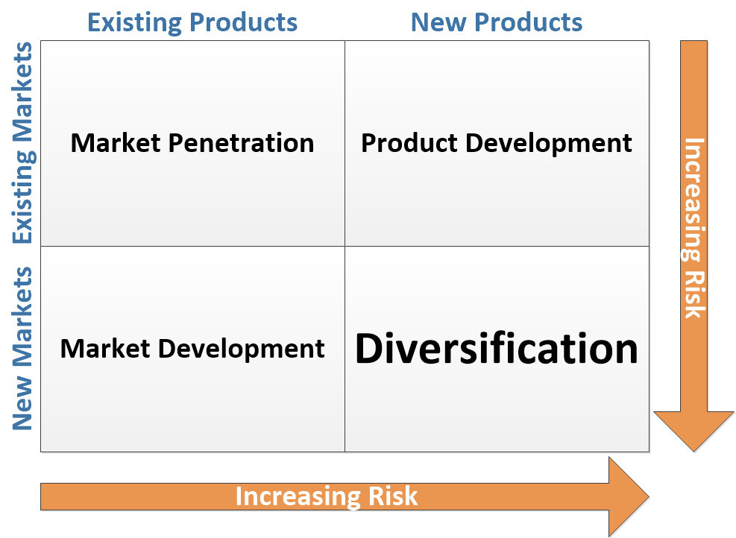
DIAGRAM: ANSOFF MATRIX

MARKET PENETRATION:
Market Penetration for Domino's Pizza:
1. **Existing Product (Pizza): ** Pizza is Domino's flagship product. Domino’s relies on several strategies to entice current consumers to buy more pizzas in order to gain market access through its existing offerings

2. **Existing Market (Current Customers): ** Domino's wants to increase the frequency of orders from its current customers. This strategy includes retaining existing customers and motivating them to buy pizza more often.

Special Methods: ** .

1. **Relationship marketing: ** Domino's prioritizes strong customer relationships. They have loyalty programs like "Piece of the Pie Rewards", where customers accumulate points for every order, which can lead to free pizza or other goodies This encourages repeat business and fosters customer loyalty.

2. **Promotions and Discounts: ** Domino's uses specials and incentives to entice current customers to shop regularly. Offers like "Two for Tuesday" or "Weekend Specials" entice customers to buy pizza multiple times a week.

3. **Email and SMS Marketing: ** Domino's communicates directly with its current customers through email and SMS marketing. To encourage repeat purchases, they offer exclusive deals, special prices and reminders.

4. **Short-Term Offers: ** Introducing limited-time incentives, such as seasonal or holiday specials, gives current customers an urgency to shop ahead of contract has come to an end.

**Referral Programs: ** Domino's encourages current customers to encourage their friends and family by offering referral discounts or incentives. This approach expands their customer base as it recommends and rewards loyal customers.

6. Using social media: Domino’s is active on social media channels, where they interact with customers, provide information and promote their products. This network attracts customers and encourages them to supply.

7. **Cross-Selling and Upselling: ** Domino's uses cross-selling to supplement pizza orders by offering drinks, desserts and breadsticks. Upsell strategies are also used to encourage customers to increase their orders for attractive sizes or packaging.

Domino’s increases revenue potential and improves customer loyalty by focusing on the market among their current customers and encouraging repeat purchases. This strategy is in line with their objective of maintaining a strong market position in the highly competitive pizza delivery segment.

PRODUCT DEVELOPMENT:
Product Development for Domino's Pizza:

1. **Existing Market (Current Customers): ** Domino's product development strategy focuses on their current customers. They strive to improve their current product offerings to meet the changing tastes and expectations of their devoted customers.

2. **New Product Development: ** Domino's is striving to enhance the quality, flavour and technology of its current pizza offerings to provide better customer experience and remain competitive.

**Special Ideas**

1. **Menu Innovation: ** Domino's is constantly adding new pizza variations, toppings and combinations to their menu. This keeps their services fresh and attractive to current customers, pushing them to look for new prospects.

2. **Ingredient Upgrade: ** To make their pizzas all taste better and more interesting, Domino's can improve their ingredients by using premium cheeses, fresh vegetables and high quality meats will carry out the function.

3. **Technology Integration: ** Domino's has invested in technology to enhance the customer experience of ordering. Customers can customize their orders, view deliveries in real time, and send messages using their digital platform and mobile app.

**Health-related trends: ** Domino’s could introduce healthier pizza options, such as whole wheat, low-fat cheese and low-protein versions, to appeal to changing consumer demand.

**Sustainability Initiative: ** Domino's can explore its products by incorporating sustainable and environmentally beneficial practices, such as eco-friendly packaging use of organic matter or purchasing from ethical suppliers.

**Allergen-Friendly Options: ** Domino's should offer allergen-friendly options or provide clear allergen information on its menu to assist customers with food searches.

7. **Premium Selection: ** Introducing a premium pizza selection with high-quality special ingredients may appeal to customers looking for a more enjoyable dining experience.

8. **Short-term Offers: ** Domino's can create short-term specials that highlight product improvements and encourage customers to explore new offers.

Domino’s Pizza keeps its menu interesting and relevant by constantly improving current products and offering new products, flavours and options. This approach aligns with their goal of keeping customers happy while competing in the cluttered pizza delivery market.

MARKET DEVELOPMENT:
Domino's Pizza Market Expansion:

1. **New Market Expansion: ** Domino's uses market growth to bring its current products, pizza in general, into new geographic areas or customer segments.

2. **Current Products: **Domino's uses its current menu options and knowledge to attract customer interest in new markets.

Important Method: ** .

1. **Global Expansion: ** Domino's Pizza has successfully developed in many countries around the world, adapting its menu and operations to local tastes and preferences while retaining its core offerings

2. **Cultural Adaptation: ** Domino's adapts its menu to the cultural tastes and nutritional requirements of the new market. For example, they may offer pizzas with regional flavours or toppings that locals love.

**Location: ** In other cases, Domino's enters into strategic alliances with local businesses or entrepreneurs who have a good understanding of local market dynamics, helping them navigate barriers to entering new markets . . . .

**Local Advertising: ** Domino's may run region specific promos or specials to attract customers in the new region. These promos can be related to local holidays, festivals, or cultural celebrations.

5. Distribution: As part of its strategy to enter new markets, Domino’s is developing distribution systems to ensure efficient and timely delivery of its products to customers in those areas.

**Understanding Customer Behavior: ** Domino's conducts market research to understand customer interests and behavior in the new market. This allows them to fine-tune their marketing and product development.

7. **Community Partnerships: ** Working with local influencers, organizations, or businesses can help Domino’s increase brand awareness and connect with the community.

8. **Market Specific Offerings: ** Domino's may create new menu items or attractive additions for specific favourites that are popular in new markets, demonstrating the company's commitment to meet local requests role.

Dominos Pizza is expanding its presence in new geographies and customer segments by offering popular pizza products while adapting to the culture and consumer habits of each new market through various market development strategies. This strategy allows Domino’s to move into previously untouched areas and drive growth through its brand knowledge and proven product quality.

DIVERSIFICATION:
Diversification for Domino's Pizza:
1. **Entering New Markets: ** Domino's Pizza chose to enter new markets unrelated to its core pizza delivery business. This allows you to enter a whole new field of work.

2. **New Products: ** Instead of just focusing on pizza, Domino's is introducing new products for selected brands in the new market.

*Main idea: **

1. **Diversity: ** Domino's may choose to shift diversity to a comparable location that is somewhat similar to its current operations. For example, they can branch out into pasta dishes or salads to complement their main pizza offerings.

2. **Unrelated product diversity: ** On the other hand, Domino's can achieve unrelated product diversity by incorporating a business unit unrelated to its pizza operations. This includes the introduction of new brands such as candy or beverages.

3. **Market Analysis: ** Domino's will conduct extensive market research to create a suitable new location for the introduction of new products effectively. Customer preferences, competition and growth possibilities would be examined.

4. **New Supply Chain Development: ** Entering a new line of business may require the formation of new supply chains, and the acquisition of specialized products or materials for new product units.

5. **MARKETING AND BRANDING: ** Domino's will need to establish a marketing and branding strategy to introduce their new products to the target market, and leverage the brand awareness created as a pizza delivery firm.

**Manufacturing Changes: ** A variety of factors may require operational changes, such as new cooking equipment, employee training, and distribution systems.

7. **Test and Iterate: ** Domino's can start by testing new products in limited capacity to gauge customer reaction. They redesigned and modified their offerings in response to feedback and feedback.

8. **RISK MANAGEMENT: ** There are risks inherent in diversification, especially when it comes to a completely new business. Before moving forward, Domino carefully weighed the risks and benefits.

Overall, the diversification plan marks a major shift for Domino’s Pizza, as they enter new markets and offer new products that may or may not be related to their core pizza business. These strategies include identifying untapped prospects, leveraging their brand recognition and applying their skills in new situations. Diversification provides Dominos with additional revenue and growth opportunities, as well as expansion of their company’s operations.

DIFFERENT TYPES OF DIVERSIFICATION:

connected DIVERSIFICATION: connected diversification is to join a new business or industry that is related to or complements the current core business of the company. The goal is to use current talent, resources and experience to generate new prospects and improve overall company performance.

**Example of Domino's Pizza (related): **

Consider expanding the Domino’s Pizza menu to include pasta dishes and salads. It involves a variety of products as it compliments their core business of pizza delivery. The important differences in this scenario are as follows.

- **Synergy: ** Domino's can leverage its current distribution network, kitchen equipment, and customer base to offer pasta and salad options to its pizza customers.

- **Cross-promotion: ** Dominos should cross-promote their pizza and pasta/salad products, encouraging customers to try different foods in one purchase.

- **Business Improvements: ** More pizza-making and delivery characteristics can also be used to cook and deliver pasta dishes and salads, allowing Domino's to benefit from increased economies of scale.

- **Brand trust: ** Existing customers who trust the quality of Domino's pizza may be more willing to try their pasta and salad options, driving the initial success of the new products high

UNRELATED DIVERSIFICATION:

Unrelated diversification requires involvement in a new business or operation that has no direct or indirect connection to the company’s current principal activities. This approach to diversification by spreading assets across multiple sectors can generate additional revenue and reduce risk.

**Example for Dominos Pizza (unrelated brands): **

Suppose Dominos Pizza chooses to enter the retail apparel market by producing branded casual clothing. This will lead to an unrelated range of products as it is a major departure from their core pizza business. The most important features of uncorrelated variables in this situation are as follows.

- **Skills: ** Clothes require very different skills and resources than those needed to deliver a pizza.

- **New Customers: ** Domino's will need to target a new group of customers interested in buying clothes, which may not overlap much with its pizza customers.

- **Business Challenges: ** Unlike a pizza company, starting a clothing store requires specific product offerings, distribution channels and marketing strategies

- **Risk and Reward: ** While unrelated sources can generate additional revenue, they also involve more risk due to lack of engagement with the current organization.
A variety of interventions, both related and unrelated, can lead to improvements, but they do so with varying degrees of complexity, risk, and potential benefit. For a company like Dominos Pizza, diversification may well align with their core strengths and customer base, but diversification may expose them to entirely new areas with their unique challenges and capabilities Decision a between such variables will be differentiated based on their strategic objectives, skills and risk.

VERTICAL INTEGRATION:
Vertical integration is a strategy in which a company improves its performance by owning and managing different stages of its supply chain, either front-end or back-end

Other vertical combinations:
Another form of vertical integration refers to a company growing downstream by acquiring or gaining ownership of companies closer to the final customer. This approach seeks to expand distribution control, improve customer experience and capture more value in the supply chain.

**Domino's Pizza (Forward Vertical Integration) Example: **

Suppose Dominos Pizza chooses to remain consolidated by building its distribution fleet and infrastructure. This means that Domino’s will manage its distribution business directly instead of relying on third-party distribution companies. Following are the main features of forward vertical integration in this situation.

- **Control of Delivery: ** Domino's enjoys good control over the delivery process, periodically assuring reliable delivery in line with their brand promise.

- **Customer Experience: ** Domino's can assure exceptional customer service and brand consistency by leveraging its delivery fleet.

- **Cost Efficiencies: ** Doing your own distribution in the long run can result in cost savings compared to outsourcing to third-party distributors.

- **Data and Insights: ** Domino's will have direct access to distributed data, enabling them to measure customer preferences, optimize distribution channels and improve overall performance.

BACKWARD VERTICAL INTEGRATION:
Backward vertical integration occurs when a firm expands upstream operations by acquiring or acquiring firms that supply raw materials, inputs, or materials to the firm This approach seeks to provide resources improve supply chain management, improve product quality, and eliminate supply chain bottlenecks.

**Domino's Pizza Back Vertical Integration Example**

Suppose Dominos Pizza intends to bounce back by buying a company that specializes in making high-end cheeses and other pizza products. Highlights of external vertical integration in this scenario include:

- **Supply Chain Control: ** Domino's gets better control over source and quality of materials, ensuring that company quality requirements are met.

- **Quality Assurance: ** Through critical manufacturing processes, Domino's can ensure the consistent quality and taste of its pizzas.

- **Stability of Supply: ** Backward integration can help reduce the risk of supply disruptions caused by external factors such as price fluctuations or shortages of components.

- **Cost Savings: ** Manufacturing controls can result in long-term cost savings because Domino's can improve production processes and reduce reliance on external suppliers on the snow.

Vertical integration, forward or backward, enables organizations like Domino's Pizza to increase their control over critical elements of their company, improve operational efficiency, and possibly create a competitive advantage but these strategies are not the ones no problems and worries The choice is influenced by the company's strategic goals , products and services development

TOWS FRAMEWORK

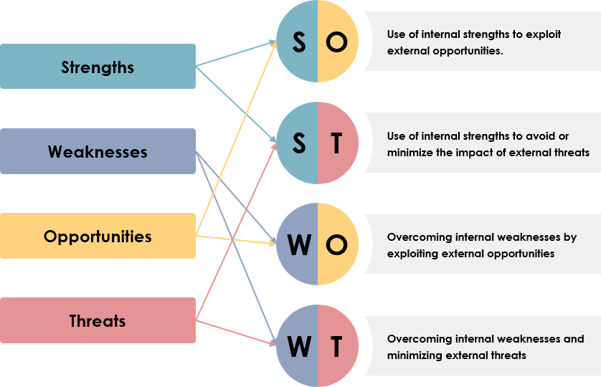
DIAGRAM: TOWS FRAMEWORK

PRODUCT LIFE CYCLE MODEL
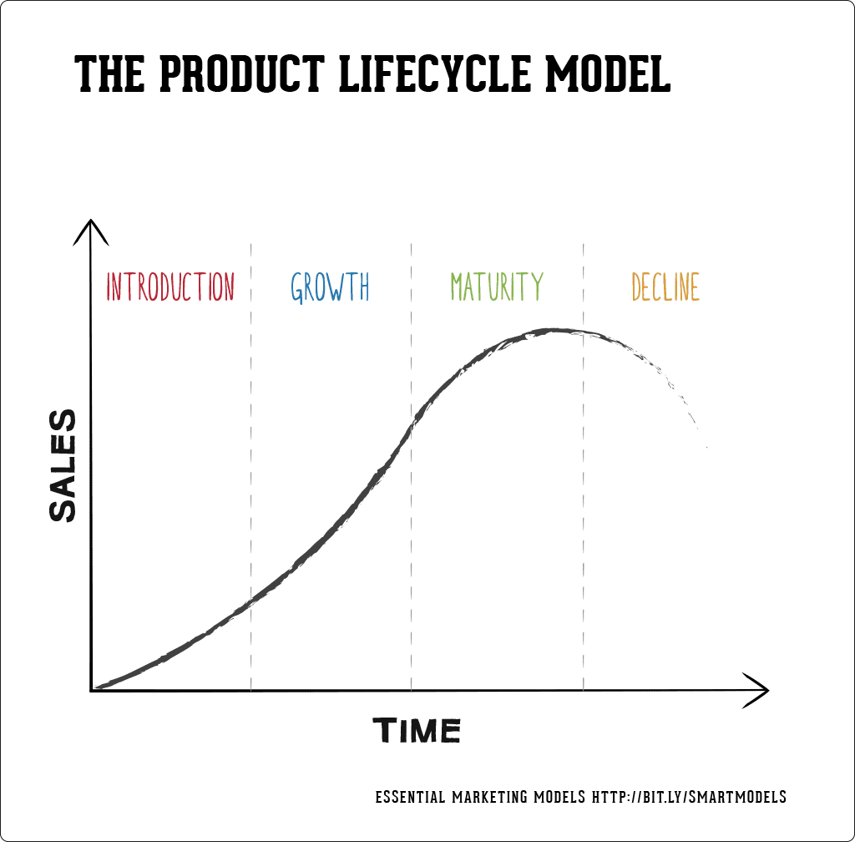

Defence Strategies for Pioneers in the Growth Stage of the PLC:
In the expansion stage of the Product Life Cycle (PLC), pioneering firms like
Dominos Pizza faces increased competition as other competitors join the market. Pioneers could use defensive strategies to maintain their status and progress.

**1.1. Position Safety Policy:**

In this way, the company’s current market position is strengthened by emphasizing its unique value proposition, brand image and competitive advantage For Domino’s Pizza:

- **Emphasis on Quality:** To promote a positive image of its company, Domino's can emphasize the quality of its ingredients, fast delivery and exceptional customer service.

- **Consistency:** Maintaining a consistent taste and experience across all locations will help Domino's position as a trusted pizza delivery option.

**Second sidebar:**

The flanker strategy involves developing new products or versions to counter competitive threats by targeting certain market segments. For Dominos Pizza:

- **New Menu Items:** Domino's may introduce different pizzas, sides, or desserts to appeal to different customers and increase their selection.

- **Healthy Choices:** Adding healthy menu items can help meet the increased demand for healthy food options.

**3.1. Methods of contention:**

This approach involves direct confrontation with competitors and active participation in market struggles. For Dominos Pizza:

- **Competitive Pricing:** Domino's uses competitive pricing strategies to provide value for money, attracting customers away from other businesses.

- **Aggressive Marketing:** Initiating marketing efforts that directly compare Domino's products and services with those of competitors can highlight their strengths.

**4.1. Market Expansion Strategy:**

When pioneers expand into new areas or fragmentation, it can help fight competition and maintain success. For Dominos Pizza:

- **International Expansion:** Domino's can continue to grow in new countries by implementing its strong business model and adapting to local tastes.

- **UNCREATED AREAS:** Entering underdeveloped areas in established markets can help Domino's reach new customers and build dominance.

Implementing these defensive strategies requires a deep understanding of market, competitor, and customer dynamics. Domino’s Pizza Plc can adapt and integrate these strategies to successfully overcome the obstacles of increasing competition in its growth phase and strengthen its market position.

ATTACK STRATEGIES FOR FOLLOWERS IN THE GROWTH STAGE OF THE PLC:
In the expansion phase of the product life cycle (PLC), followers face the challenge of competing with market pioneers and new entrants. Followers can use several aggressive strategies to gain a competitive advantage and meet pioneers like Domino’s Pizza. For Domino's Pizza, let's look at how these attack tactics apply to fans:

**1.1. Frontal attack tactics:**

A frontal attack strategy involves aggressively competing with the leader (in this example, Domino’s Pizza) by emphasizing comparable products, and fighting head-on for the likes of:

- **Quality and Price Parity:** Followers can match Domino's quality standards and prices to attract customers looking for a familiar experience at comparable prices.

- **Promotions:** Promotions such as "two for Tuesday" or "family dinner deals" may draw customers away from Domino's.

**2.1. Leapfrog Guide:**

The jumping method introduces innovations that outperform the pioneers, giving fans a competitive advantage. For the fans:

- **Technology Integration:** Creating a better online ordering system, an easier to use mobile app, or a new delivery tracking system can set them apart from Domino . . . .

- **New Delivery Models:** Using alternative delivery methods such as drones or driverless cars may appeal to tech-savvy customers.

**3.1. Flank Attack Strategy:**

In side attacks, followers are looking for a specific market segment or niche that the pioneer has missed. For the fans:

- **Special Menu:** They offer attractive specialty, gourmet, or niche pizza options for certain dietary requirements (e.g., vegan, gluten-free), which can appeal to customers that Domino's current menu does not works well.

- **Local Partnerships:** Local interests can be utilized by collaborating with local restaurants or chefs to create unique locally made pizzas.

**4.1. Method of Siege:**

The inclusive approach allows them to attack from multiple angles, offering a wide range of products or services to satisfy a wide range of consumer desires For fans:

- **Expanded Menu:** Fans can be treated to a larger menu that includes not only pizza but also more sides, desserts and drinks.

- **Customization:** Extensive customization possibilities, such as the build-your-own-pizza concept, can be appealing to customers who want a personalized experience.

Implementing these attack tactics requires a thorough analysis of Domino’s strengths and limitations, as well as a thorough understanding of customer preferences and market dynamics, the successful use of these tactics enables followers to bypass the leader’s dominance challenge and develop a competitive position in the PLC development phase.

STRATEGIES IN THE MATURITY STAGE OF THE PLC:
Companies like Domino's Pizza must adjust their tactics at the maturity stage of the
Product Life Cycle (PLC) to maintain market share, face competition, and generate revenue. Let’s see how the strategies you mentioned—increased penetration, longer tenure, and global market expansion—relate to Domino’s Pizza at this point:

**1.1. Optimized Admission Strategy:**

This strategy focuses on expanding market share across current customers and market segments. For Dominos Pizza:

*Customer Retention:** Domino's may adopt loyalty programs, discounts and special offers to retain current customers and encourage repeat purchases.

- **Market Segmentation:** It can be helpful for Domino's to tailor its marketing campaigns and promotions for certain groups by analysing customer preferences and behaviours.

- **Service Improvements:** Consistently increasing delivery speed, customer service, and order efficiency can increase customer satisfaction and loyalty.

**2.1. Expanded Application Method:**

A sustained use strategy encourages customers to use the product in new ways or more often. For Dominos Pizza:

- **Different food options:** Promoting pizza as an after dinner snack can increase sample consumption. An emphasis on breakfast, lunch and night offerings can help you reach a wider audience.

- **Parties and Events:** Positioning Dominos as a convenient choice for parties, meetings and events helps improve order size and order frequency.

**3.1. Global Market Expansion Strategy**

Expansion into new foreign markets can extend product life and promote growth. For Dominos Pizza:

- **Untapped Markets:** Domino's can continue to expand into new countries where pizza delivery may be required, and adjust to local tastes and cultural nuances.

- **Internationalization:** Creating culturally appealing marketing efforts by tailoring menu items to local preferences can help businesses succeed in new markets.

These strategies aim to expand the mature footprint by recruiting new customers, increasing features, and extending brand visibility In order to overcome mature platform constraints handle it effectively, Domino's Pizza must strike a balance between product innovation, customer satisfaction, and efficiency.

CONCLUSION:
In summary, Domino’s Pizza is a well-known example of strategic management across multiple stages of the product life cycle (PLC). Dominos was a leader in the pizza delivery market, implementing a cutting-edge pizza delivery system. As the business expanded, the company adopted a production strategy, upgrading its food and technology to meet changing customer needs.

To maintain its competitive advantage throughout the expansion, Domino’s implemented market penetration and market development strategies. Leveraging its strong brand and customer relationships, Domino’s grew internationally, penetrated new countries and changed cultures. As competition increased, the company strategically used defensive and offensive measures to defend its market position and fight off competitors.

As the PLC evolved, Domino's incorporated it into programs that emphasized customer retention and high product utilization, strengthening its industry dominance Domino's communicates with customers and adapts to adapting to changing trends by exploring new market segments and showcasing their product range.

Throughout its history, Domino’s has demonstrated flexibility, innovation and a keen sense of customer demand. The company's emphasis on quality, convenience and technology, as well as its willingness to explore, has helped it become a player in the highly competitive food service Domino's Pizza, as a matter of fact analysed, demonstrates the importance of strategic management and management to sustain success that occurred during active phases of the product life cycle.

RECOMMENDATION:
Here are some
suggestions for Domino’s Pizza to set the right strategy and grow:

1. **Ongoing Innovation:** Continue to innovate on menu items, delivery methods and technology. Staying ahead of customer preferences and trends will keep Domino current and engaging.

2. **Emphasis on Health and Wellness:** Combined with healthy food choices and accurate nutrition information, it can attract health-conscious consumers, increase customer volume and conversion for changing food preferences.

3. **Sustainability:** Sustainable practices such as eco-friendly packaging and purchasing responsible products. This is in line with current consumer sentiment and could be a market differentiator.

4. **Digital Experience Improvement:** Continue to enhance the online ordering experience, mobile application, and delivery tracking system. Intuitive and user-friendly interfaces increase customer satisfaction.

5. **Local Partnerships:** Work with local suppliers, farmers and food artisans to offer unique and region specific products. This can give you a competitive edge in terms of quality and authenticity.

6. **Expansion into emerging markets:** Identify and enter emerging markets with strong growth. Maintain quality standards at all times and act in accordance with the interests of the community.

7. **Types of Revenue:** Look for ancillary products or services that will benefit the primary company, such as food packaging, cooking classes, or branded clothing.

8. **Social and Community Involvement:** Connect with the community through philanthropic efforts, collaborations and events. Building deeper connections builds loyalty and better brand perception.

**Data-Driven Decision Making:** Use data analytics to gain insights into customer behavior, preferences and market trends. This can help influence strategic choices and individual trading strategies.

10. **Employee Training and Development:** Invest in training programs that enable employees to deliver great customer service, thereby improving the overall customer experience.

11. **Digital Marketing Strategies:** Use digital marketing platforms such as social media, influencer relationships and online advertising to reach and engage a large audience.

12. **Regular Menu Refreshes:** Always introduce new limited-time menu items to pique customer interest and encourage sampling variety.

13. **Customer Feedback: Integration:** Actively listen to customer feedback and incorporate it into the decision-making process. This refers to how responsive and engaged they are to meet the customer’s requirements.

These recommendations can help Domino’s Pizza continue to grow, compete and delight customers in an ever-changing industry. The right strategy and customer-focused approach will be critical to maintaining its market leadership.

References :

Samnani, A., 2014. Macro-environmental factors effecting fast food industry. Food Science and quality management, 31(1), pp.37-40.

Frederick, D.P. and Bhat, G., 2021. Review on customer perception towards online food delivery services. International Journal of Creative Thoughts (IJCRT), 9(7), pp.b301-b314.

Vaddadi, K.M. and Thandava, S., 2019. Cross-cultural marketing challenges in global environment. International Journal of Economics and Management Studies, 6(12), pp.74-83.

Catalin, P. and Cerasela, S., 2012. A critical approach to hofstede’s model on cultural dimensions. Ovidius" University Annals, Economic Sciences Series, 12(1), pp.644-649.

Rattaya, J., 2021. RELATIVE VALUATION OF DOMINO’S PIZZA, INC (Doctoral dissertation, Mahidol University).

Samnani, A., 2014. Macro-environmental factors effecting fast food industry. Food Science and quality management, 31(1), pp.37-40.

Xu, X.Z. and Kaye, G.R., 1995. Building market intelligence systems for environment scanning. Logistics Information Management, 8(2), pp.22-29.

Wang, C.K. and Lamb, C.W., 1983. The impact of selected environmental forces upon consumers' willingness to buy foreign products. Journal of the Academy of marketing Science, 11, pp.71-84.

Sethi, S.P., 1979. A conceptual framework for environmental analysis of social issues and evaluation of business response patterns. Academy of management review, 4(1), pp.63-74.

Grundy, T., 2006. Rethinking and reinventing Michael Porter's five forces model. Strategic change, 15(5), pp.213-229.

Shetty, S.S. and Kale, K.S., Industry Analysis of Food Delivery Applications using Porter’s Five Forces Model.

Porter, M.E., 2008. The five competitive forces that shape strategy. Harvard business review, 86(1), p.78.

Katsioloudes, M. and Abouhanian, A.K., 2009. Strategic management. Routledge.

Choudhury, R.G., 2020. Marketing Mix and Customer Loyalty in Services Marketing. Services Marketing Issues in Emerging Economies, pp.167-177.

Anderson, E. and Coughlan, A.T., 1987. International market entry and expansion via independent or integrated channels of distribution. Journal of marketing, 51(1), pp.71-82.

DeSarbo, W.S., Blanchard, S.J. and Atalay, A.S., 2017. A new spatial classification methodology for simultaneous segmentation, targeting, and positioning (STP analysis) for marketing research. In Review of marketing research (pp. 75-103). Routledge.

Farquhar, P.H., Han, J.Y., Herr, P.M. and Ijiri, Y., 1992. Strategies for leveraging master brands. Marketing Research, 4(3).

Srivastava, R.K., 2009. Measuring brand strategy: can brand equity and brand score be a tool to measure the effectiveness of strategy?. Journal of Strategic Marketing, 17(6), pp.487-497.

Ruma, Z., 2023. International Marketing and Implementation in Business: Case Study in Dominos Pizza. International Journal of Humanity Advance, Business & Sciences, 1(1), pp.1-8.

Kumar, R., 2015. A comparative study between on pizza hut and Domino's Pizza. International Journal of Marketing and Technology, 5(9), pp.89-123.

Whitehouse, E., 2009. Pensions, purchasing-power risk, inflation and indexation.

Demangeot, C., Broderick, A.J. and Craig, C.S., 2015. Multicultural marketplaces: New territory for international marketing and consumer research. International Marketing Review, 32(2), pp.118-140.

Olszewski, A.P., 2015. International Marketing Strategies of US Fast Food Franchises. In Proceedings of the 1989 Academy of Marketing Science (AMS) Annual Conference (pp. 123-127). Springer International Publishing.

O’Rourke, T., 2012. Sales, licensing and marketing. Academic and Professional Publishing, pp.289-314.

Merrilees, B., 2014. International franchising: Evolution of theory and practice. Journal of Marketing Channels, 21(3), pp.133-142.

Julian, C. and O’Cass, A., 2002. The effect of firm and marketplace characteristics on international joint venture (IJV) marketing performance. Asia Pacific Journal of Marketing and Logistics, 14(1), pp.19-39.

Gibbs, R. and Humphries, A., 2009. Strategic alliances and marketing partnerships: gaining competitive advantage through collaboration and partnering. Kogan Page Publishers.
Rowley, J., 1998. Promotion and marketing communications in the information marketplace. Library review, 47(8), pp.383-387.

Rafiq, M. and Ahmed, P.K., 1995. Using the 7Ps as a generic marketing mix: an exploratory survey of UK and European marketing academics. marketing intelligence & planning, 13(9), pp.4-15.

Watts, G., Cope, J. and Hulme, M., 1998. Ansoff’s matrix, pain and gain: growth strategies and adaptive learning among small food producers. International journal of entrepreneurial behavior & research, 4(2), pp.101-111.

Krishnan, V. and Ulrich, K.T., 2001. Product development decisions: A review of the literature. Management science, 47(1), pp.1-21.

Praxedes, S.G.S.F., 2016. Domino’s Pizza Portugal: a case study on the price disclosure strategy of a late entrant (Doctoral dissertation).

Mudambi, R. and Mudambi, S.M., 2002. Diversification and market entry choices in the context of foreign direct investment. International Business Review, 11(1), pp.35-55.

Chatterjee, S. and Wernerfelt, B., 1991. The link between resources and type of diversification: Theory and evidence. Strategic management journal, 12(1), pp.33-48.

Bresnahan, T.F. and Levin, J.D., 2012. Vertical integration and market structure (No. w17889). National Bureau of Economic Research.

Parrish, E.D., Cassill, N.L. and Oxenham, W., 2006. Niche market strategy for a mature marketplace. Marketing Intelligence & Planning, 24(7), pp.694-707.

Ahmadi, F., 2019. Marketing strategies in the product life cycle. Journal of Management and Accounting Studies, 7(02), pp.32-36.

Parrish, E.D., Cassill, N.L. and Oxenham, W., 2006. Niche market strategy for a mature marketplace. Marketing Intelligence & Planning, 24(7), pp.694-707.

