Organisational Consultancy of Uniqlo


February 2020

MODULE NAME | Organisational Consultancy
MODULE CODE | M6X01422
STUDENT NAME | YaNan Zheng
STUDENT NUMBER | 1900319

Table of Contents
1.0 Introduction 2
2.0 Project justification 2
2.1 Aims and objectives 2
2.2 Rational 2
2.2.1 PESTEL analysis 3
2.2.2 Porter’s Five Forces 4
3.0 Business case and project approach 5
3.1 Benefits to the organization 5
3.2 Background literature 5
3.3 Potential risks/Limitations 6
4.0 Research Methodology 6
5.0 Project plan 7
5.1 Gantt Chart 8
6.0 Reference 9

1.0 Introduction
This report aims at introducing the marketing plan of Uniqlo, which is a Japanese-based fast fashion brand. Uniqlo was founded in 1949, and in 2005, the company became one of the subsidiaries of Fast Retailing Co. Ltd. Furthermore, more than 700 physical retail stores are operated by Uniqlo in Japan, more than 1400 retail outlets are operated all over the world. In the UK market, Uniqlo operated 10 physical retail stores. Uniqlo’s overall corporate strategy is to provide clothing products with superior attribute in affordable prices, which is considered as an approach that focuses low-cost strategy in order to satisfy market needs and demands. However, in the field of UK fast fashion industry, there is a competitive contest. As for Uniqlo, in order to stand out from the competitive marketing environment, it is suggested that Uniqlo to develop and implement effective marketing plan in order to raise the sales volume as well as expand shares in the field of fast fashion in the UK market.

2.0 Project justification

2.1 Aims and objectives
The goal of the proposed marketing project is to enable Uniqlo to stand out from its competitors and win more sales to further expand the market share in this field. In order to achieve this aim, following objectives will be taken. Firstly, it is to analyze the market condition of UK fast fashion industry through industry report and statistics. Secondly, it is to identify the needs that Uniqlo should adapt effective marketing plan in order to maintain its position in the competitive environment. Thirdly, it is to explore how effective marketing elements (4P) can develop proper marketing projects for Uniqlo. Moreover, through analyzing 4P strategy, marketing solutions and detailed marketing project will be established and provided.

2.2 Rational
Over the past few years, in the UK market, the fast fashion industry grew rapidly. By reviewing the industry report from Statista (2019), a growth rate at 21.5% is expected in terms of the revenue of the whole fast fashion industry every year. In addition, it is assumed that $1.8 billion revenue will be reached (Statista, 2019). When it comes to the market position of Uniqlo, the company only made up of 12.9% of the industry market in the UK (Statista, 2019). Comparing with global fashion brands (i.e. Zara, H&M), the brand performance of Uniqlo is less competitive due to low brand awareness, in particular UK market (Statista, 2019). Therefore, effective marketing strategies should be employed, which ensures to enhance brand awareness as well as overall brand functioning in this field.
In addition, PESTEL analysis and Porter’s five forces will be further analyzed in order to support the marketing strategies of Uniqlo.

2.2.1 PESTEL analysis
PESTEL analysis is a framework that analyzes and monitors the macro market environment, and six factors are incorporated, including political, economic, social, technological, environmental and legal (Yüksel, 2012).
To begin with, according to Felbermayr et al. (2019), political factor enables Uniqlo to enter the UK market effectively. In 2018, an Economic Partnership Agreement was signed off between EU and Japan. That is to say, two-sided trade between Japan and the UK has been encouraged and fostered significantly. In terms of Uniqlo, the company is able to be beneficial from this policy, in order to export clothing products with high quality to the UK market. In addition, this policy also offers opportunities for Uniqlo to enter the UK market in a relatively low cost.
Secondly, nowadays, the economic environment of UK is stable and a growing trend is presented (Kuznets, 2019). In addition, under the steady economic background, UK consumers are having increasing disposable income. In other words, UK customers are able to increase their spending on fast fashion. Therefore, international fast fashion retailers can be confident when forming brand presence in the UK market. Moreover, as stated previously, a predictable annual growth of 21.5% of industry revenue has been recognized in the field of fast fashion.
Thirdly, when it comes to social perspective, Uniqlo deals with social concerns in an ethical manner and the company is regarded as a social corporation in the industry. For instance, in Bangladesh, the company sets up a social corporation, which aims at helping local government to deal with the problems of children’s problems regarding health and education (Ahmed and Tinne, 2017). Additionally, Uniqlo established collaboration relationships with celebrity endorsements to set up charity organizations to help children all over the world.
In addition, Uniqlo is famous for its high technology product, which is called HEATTECH. HEATTECH is one of the signature products of Uniqlo, and it uses the technology that is able to absorb and retain the body temperature, in order to keep consumers warm when wearing this product (Uniqlo, 2017). Furthermore, Uniqlo utilizes digital platforms (i.e. mobile application; official website) to promote the brand and distribute products. By engaging with digital platforms, Uniqlo can reach its customers more effectively.
Lastly, regarding the environmental factor, Uniqlo places emphasis on reducing environmental impact generated from its supply chain, including manufacturing and transportation process (Usui et al., 2017). For instance, Uniqlo tries its best to minimize the chemical emissions. Most importantly, Uniqlo controls and monitors the coordination process strictly.

2.2.2 Porter’s Five Forces
Porter’s Five Forces is a strategic tool to analyze the competitiveness of the business environment, which enables the business to identify the market position systematically (Dobbs, 2014). To be exact, five forces include threats of new entrants, bargaining power of suppliers, bargaining power of buyers, threats of substitutes, and the intensity of competitive rivalry.
Firstly, the threats of new players are relatively low in the case of Uniqlo. For instance, in the field of fast fashion, companies find it difficult to reach economies of scale. Therefore, if fast fashion companies are manufacturing clothing products in a large capacity, they are more easily to gain the competitive advantages in terms of production cost. That is to say, the manufacturing cost for new entrants will be relatively low. Hence, it lowers the threats of new entrants in a certain extent. Moreover, because of the fast changing nature of this industry, companies are more willing to manufacture and produce various styles of products, which further reduces the threats of new entrants.
Secondly, the bargaining power of Uniqlo’s suppliers are relatively low. It is because Uniqlo establishes collaboration relationships with suppliers in various geographical locations that offers opportunities for Uniqlo to change different vendors in a flexible manner. In addition, suppliers of Uniqlo provide standardized production services, and thus, Uniqlo can switch from different suppliers at a relatively low cost.
Thirdly, when it comes to the bargaining power of buyers, Uniqlo’s target customrs have low bargaining power. Uniqlo provides basic causal wear products to its customers with high quality at affordable prices. It is relatively difficult for the customers to find the similar brands and products in similar quality and similar prices in the market. In addition, in the fast fashion industry, companies are focusing on product differentiation strategy, in order to attract more customers. As a consequence, for Uniqlo’s customers, their bargaining power is relatively low.
Fourthly, in view of threats of substitutes, as discussed previously, because of the differentiation characteristics of fast fashion industry, alternative brands are not likely to design and produce similar products when comparing with its competitors. Therefore, the threats of substitutes are low.
Last but not the least, in the fast fashion market, there are only few competitors and major players. However, most of the competitors are operating at a large scale and most of them are giant global companies when comparing with Uniqlo. As a consequence, these competitors are able to utilize more financial and resource power to increase their market share in this field. In this way, these companies are more probable to become major market players in the fast fashion industry. That is to say, the market competition is fierce for Uniqlo.

3.0 Business case and project approach

3.1 Benefits to the organization
After understanding the rational of the marketing project of Uniqlo, it can be concluded that in order to enhance market share and gain more revenue in the market, Uniqlo should be implementing effective marketing programme. To be specific, effective marketing programme enables the company to reach a larger target market. Secondly, the sales of Uniqlo can be increased. Lastly, the brand image of Uniqlo will be further enhanced with its target customers.

3.2 Background literature
Yoo et al., (2000) stated that marketing mix was an essential and fundamental model in managing marketing issues in academic field. Moreover, 4 strategic elements are incorporated in this theory, such as product, price, promotion and place (Borden, 1964). To begin with, a product refers to an initiative product, which is able to satisfy customers’ needs (Singh, 2012). In the case of Uniqlo, young customers are the largest segment of the company. Therefore, it is suggested that Uniqlo can actively take part in marketing research in terms of fashion trends, which are able to simulate young customers’ purchasing intentions. Moreover, as Uniqlo is a Japanese brand, in designing products, the company can integrate Japanese elements into products. In addition, when entering UK market, Uniqlo can launch some UK limited edition in order to attract customers. When it comes to price, it is the essential marketing portfolio, which influences company’s sales and market share significantly (Abril and Rodriguez-Cánovas, 2016). In the case of Uniqlo, the company should set the prices at the level that young generations can accept, as young generations are the strongest segment. However, as Uniqlo is a Japanese brand, when operating in the UK, the retail prices in UK market should be higher than the price in Japanese market, in order to cover the operational cost. In addition, psychological pricing strategy should be employed by Uniqlo. That is to say, odd or even numbers can be indicated at the endings of the retail prices, which simulate customers’ purchasing intention (Hara and Naipaul, 2008). Regarding place, it refers to the distribution channel. In fast fashion industry, distribution channel is critical for the brand to reach target market effective in order to generate more sales and expand the market share (Sheridan et al., 2006). Physical retail stores and official online stores are two major distribution channels for Uniqlo. However, in order to increase brand awareness and reach a large target market, Uniqlo can authorize some selected department stores in UK (i.e. Selfridges) to distribute their products widely. Furthermore, Uniqlo can launch some exclusive products through the selected department stores to increase the attractiveness of the product. Lastly, effective marketing promotion activities enable the brand to achieve marketing objectives systematically (Liao et al., 2009). For example, traditional media (i.e. Television, magazine, billboard) are used in corporate branding and promoting products. Digital media can further improve the influential level of marketing activities (Stokes, 2011). As a consequence, Uniqlo is suggested to be engaged in social media (i.e. Facebook, Instagram) to be more connected with its target customers. In this way, relationships with existing customers can be further enhanced.

3.3 Potential risks/Limitations
However, there are some potential risks and limitations when conducting this marketing project to Uniqlo. For example, the researcher is not an industrial practitioner, it is difficult for the researcher to analyze the entire fast fashion industry systematically. In addition, the researcher fails to access to internal information. As a consequence, it is challenging for the researcher to acknowledge internal issues of Uniqlo, which may influence the effectiveness, execution and implementation of this marketing project.

4.0 Research Methodology
Secondary research is defined as a research method that analyses and discusses existing data (Hox and Boeije, 2005), which is employed in this report. For example, academic scholars are engaged in order to explain the theoretical concepts and models. Official website from Uniqlo is utilized to analyze the corporate information. Besides, industry report is analyzed to indicate the market environment.

5.0 Project plan
In order to finish this report effectively, Gantt Chart is utilized and created as below. By following the Gantt Chart, working progress of this report can be traced, controlled and monitored in a comprehensive manner.

5.1 Gantt Chart
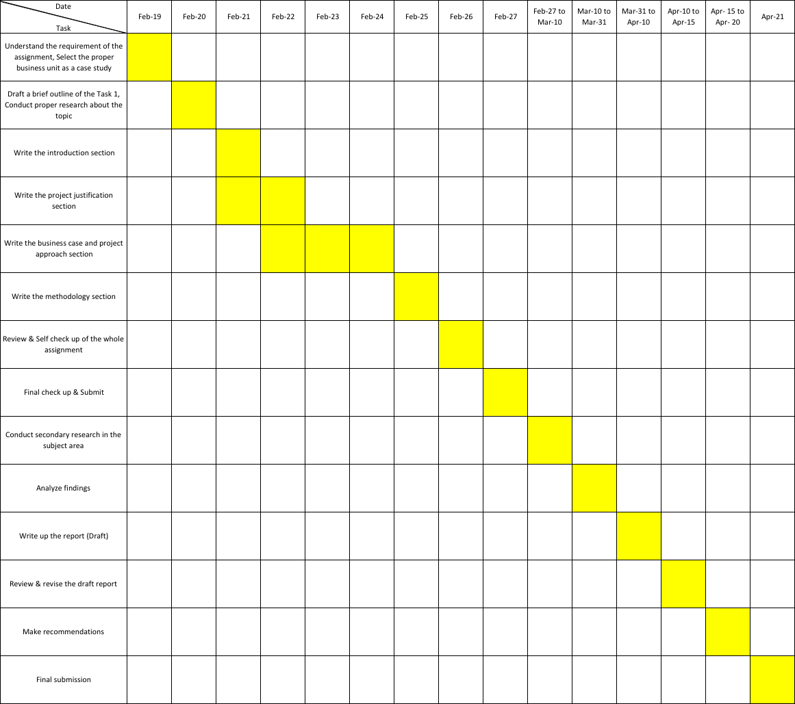

6.0 Reference
Abril, C., & Rodriguez-Cánovas, B. (2016). Marketing mix effects on private labels brand equity. European Journal of Management and Business Economics, 25(3), 168-175.

Ahmed, J. U., & Tinne, W. S. (2017). Grameen UNIQLO: Social business initiatives in Bangladesh. SAGE Publications: SAGE Business Cases Originals.

Borden, N. H. (1964). The concept of the marketing mix. Journal of advertising research, 4(2), 2-7.

Dobbs, M. E. (2014). Guidelines for applying Porter's five forces framework: a set of industry analysis templates. Competitiveness Review.

Felbermayr, G., Kimura, F., Okubo, T., & Steininger, M. (2019). Quantifying the EU-Japan Economic Partnership Agreement. Journal of the Japanese and International Economies, 51, 110-128.

Hara, T., & Naipaul, S. (2008). Agritourism as a catalyst for improving the quality of the life in rural regions: a study from a developed country. Journal of Quality Assurance in Hospitality & Tourism, 9(1), 1-33.

Hox, J. J., & Boeije, H. R. (2005). Data collection, primary versus secondary.

Kuznets, S. (2019). Economic Growth and Income Inequality. In The Gap Between Rich and Poor (pp. 25-37). Routledge.

Liao, S. L., Shen, Y. C., & Chu, C. H. (2009). The effects of sales promotion strategy, product appeal and consumer traits on reminder impulse buying behaviour. International Journal of Consumer Studies, 33(3), 274-284.

Sheridan, M., Moore, C., & Nobbs, K. (2006). Fast fashion requires fast marketing: The role of category management in fast fashion positioning. Journal of Fashion Marketing and Management, 10(3), 301-315.

Singh, M. (2012). Marketing mix of 4P’s for competitive advantage. IOSR Journal of Business and Management, 3(6), 40-45.

Statista (2019). Sales revenue of the Japanese apparel retail Uniqlo Co., Ltd. from fiscal year 2012 to 2018. Available at: https://www.statista.com/statistics/671330/japan-uniqlo-sales/ (Accessed: 23 Feburary 2020).

Stokes, R. (2011). eMarketing: The essential guide to digital marketing. Quirk eMarketing.

Usui, T., Kotabe, M., & Murray, J. Y. (2017). A dynamic process of building global supply chain competence by new ventures: The case of Uniqlo. Journal of International Marketing, 25(3), 1-20.

UNIQLO (2017). Material. Available at: http://www.uniqlo.com/sg/corp/material/ (Accessed: 23 Feburary 2020).

Yoo, B., Donthu, N., & Lee, S. (2000). An examination of selected marketing mix elements and brand equity. Journal of the academy of marketing science, 28(2), 195-211.

Yüksel, I. (2012). Developing a multi-criteria decision making model for PESTEL analysis. International Journal of Business and Management, 7(24), 52.

