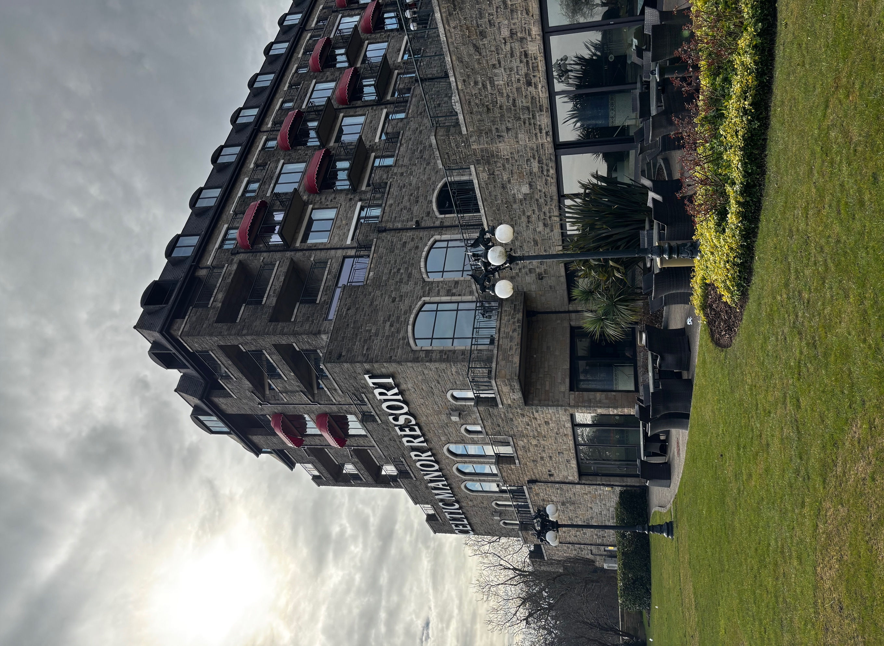

Nia Moores
2200282
Deborah Jenkins
Operations Management for Tourism, Leisure and Events
Word Count – 4,400

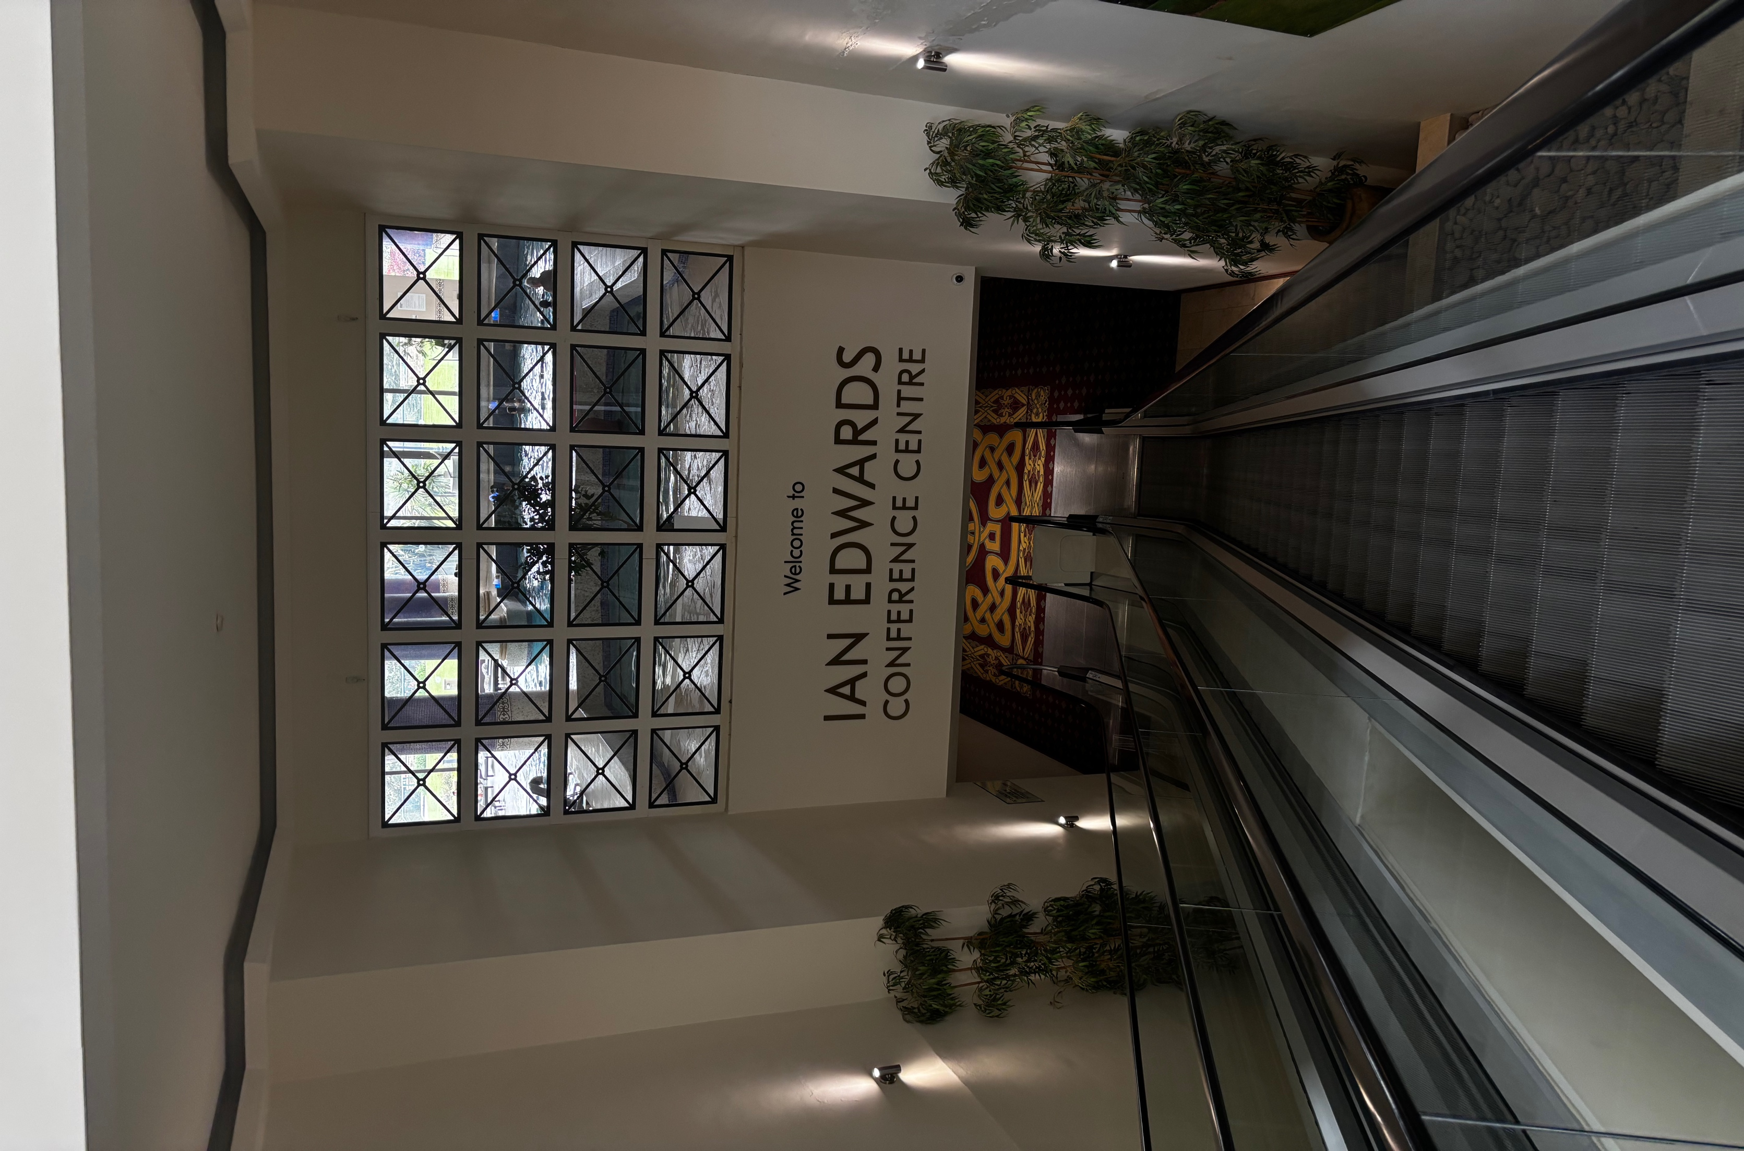

Table of Contents
Operations management practices 2
Introduction 2
Human Resources 4
Finance 5
Legal Policies and Procedures 6
Conclusion 7
Operational Management Plan 8
Executive Summary 8
Human Resources (HR) Management 8
Finance Management 9
Legal Policies and Procedures 11
Operational Logistics 12
Customer Experience and Satisfaction 13
Risk Management 14
Monitoring and Evaluation 15
Conclusion 15
References 16

Operations management practices

Introduction
Celtic Manor Resort is my hotel of choice as it is the first built hotel from the Celtic Collection in 1999. (Celtic Collection,2024) The Celtic collection owns 10 locations with over 1,200 employees. (Celtic Collection, 2024) In 1995 the Celtic Manor opened, the area welcomed the first championship golf course, closely followed by a second in 1999.(Celtic Collection, 2024) The company aims higher than just their brand getting recognition, the founder of the collection Sir Terry Matthews said that the resort is a magnet to draw investment into Wales. (Matthews)

The Celtic Manor has a range of demographics as it is a large resort with a range of activities. It is known for its luxury 5 stars, this can be spotted within the rooms, dining areas and communal areas. (Celtic Manor, 2025 ) The golf course is a main feature for the hotel. It has 3 championship courses and has held large scale events such as the Ryder cup in 2010. It also has a variety of driving ranges and club houses that mix in the luxury. (“Celtic Manor Golf | Premier Golf Courses in South Wales”, 2025) There are also a range of activities, From the spa to the high ropes. The hotels demographic is large and spread out from luxury and golf to family’s and relaxation. (“Celtic Manor Activities | Fun Days out in South Wales”, 2025)

The hotel attracts a large range of diverse customers through a range of events held at the venue. The events and conferences area of operations hold a heavy title within the company as they welcome people from a range of backgrounds. The department hold awards for top UK conference hotel and best UK hotel for multiple years in a row. (“Celtic Manor Meetings & Events | Ian Edwards Conference Centre”, 2025) A diverse group that the events sector brings in are golf tournaments, people will travel far distances to come golf at the facilities. This is similar for the testimonials hosted in the venue. The customers attending these events expect high levels of service.

Human Resources
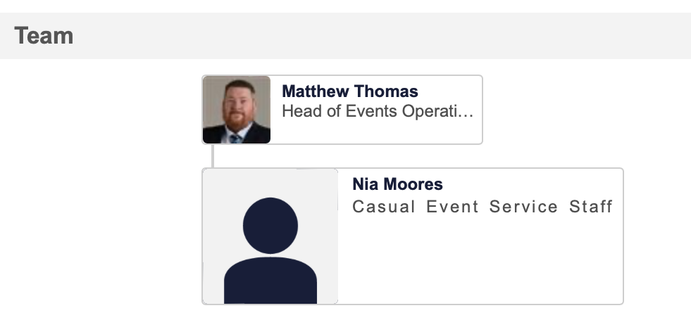
In the last few weeks, there has been a new CEO. This means that currently they are changing the organisational structure. This is very important when it comes to the business as this shows how well the sectors work within each other. (Ahmady et al., 2016) Julie Hammond is currently head of the company.(“Celtic Collection and ICC Wales Appoint New Group CEO - Blog”, 2025) Since there are many sectors within the Celtic collection, there are a range of different people in control. For the conference and events sector, it starts at Ellison Griffiths who is the Event Operations Director then Matthew Thomas who is Head of Events Operations. Matthew is then above all the fulltime and casual event staff. (Learning and Development,2025)
The Celtic Manor have a plan in place when it comes to hiring for peak season in the hotel. They put out the job applications before February half term to get staff in training during the school holiday. (Celtic Careers, 2025) This means that by the time peak season hits in summer staff will have an experience of both busy and quiet periods in the business.
Since the company are hiring for peak seasons, an onboarding day takes place at the start to provide any essential training. From research it has proven that most companies spend the training budget on higher levels such as management. (Saee, 2006) This isn’t the case for the hotel as everyone needs to be able to provide service in the same style to help tie the events together.
Luxury hotels take a different approach to recruitment, instead of advertising through social media they hire through professionals to gain people with interest in the sector. This is because people will have a more positive attitude. This will lead the company to better guest satisfaction. It is a full circle theory as to maintain high service standards from staff creates satisfaction from guests. It has been proven that guest satisfaction links closely with guest loyalty. (K, 2014)
The Celtic Collection are known for their Welsh heritage. However, the company are also trying to welcome in a range of staff no matter their background. They provide any support needed for all staff. (Celtic Journeys, 2025) Having a diverse team onboard helps improve customer experience and also improves innovation. This is because there will be a different point of view on topics and allows a second opinion.

Finance
Since the early days of the business, the Celtic Manor has been partners with Barclays corporation. Since choosing to work with the Manor, Barclays has seen the hotel become a contributor to the local economy in South Wales. (Colcomb, 2025) Barclays assist the hotel with debt financing which is when a company borrows money from a bank. This can either be long term or short term and in Celtic Manor and Barclays instant it is long-term (Onchong’a et al., 2016)
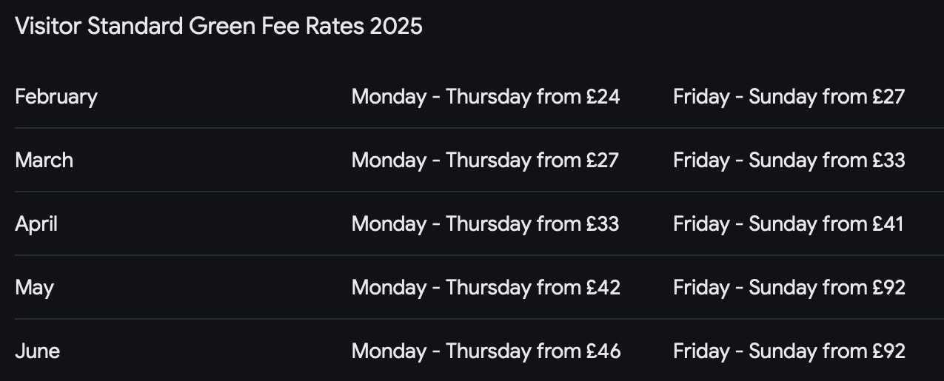
A large offer that is available from the hotel are vouchers for the Golf courses and also the spa. The hotel maximises their profits as they do dynamic pricing during school holidays and also do not allow these vouchers to be spent during this period. (“Book a Spa Treatment | Celtic Manor Resort”, 2025) This will mean more people will spend money in the extra areas rather than just on a room. International tourists have the option to not only buy a membership for the Celtic Manor for the year. They also get to select from a range of golf breaks, within the Manor. (“Golf Breaks - Golf Packages at Celtic Manor Resort”, 2025)This creates a demand with golfers and keeps them coming back.
Even though the Celtic Manor is family friendly and welcomes everyone of all ages. Level 6 of the hotel is dedicated to adults only to create a peaceful area for adults to enjoy. On this level is also a steak restaurant called steak on six. (“Steak on Six - Restaurants - Celtic Manor Resort”, 2024) The hotel offers couple escapes which includes a room and also a table at the restaurant, this helps bring in the adults which will then create word of mouth. The guests will be saving money on the room and will have extra finances to spend on activities such as the spa.

Legal Policies and Procedures
The Celtic Manor has many policies in place to enhance guest stays and keep everyone safe. Such as licensing, employment laws and health and safety standards. An extra bonus found in the Celtic Manor is that you can legally have a civil partnership ceremony. The law came into place in 2019 within Wales and has been in the venue since. (“Civil Ceremonies - Celtic Manor Resort”) This creates a more diverse experience for guests.
Taxation has been taken into consideration when it comes to terms and conditions. As there are a large group of international cliental, this means that taxing laws will be different. (“Resort Terms and Conditions - Celtic Manor Resort”, 2025) Currently being introduced to Wales is a tourism tax, this will be £1.25 per person per night for everyone staying in accommodation in Wales. (Welsh Gov, 2025)
Within the venue is the Celtic Mall, this is a shopping area full of luxury stores. It is also the home of many Welsh brands such as Colgau Gold and Penderyn Whisky. (Celtic Mall, 2025) Since all these stores are individual companies, they have their own procedures to follow. However, since they are all within the Celtic Mall, they provide discount to certain guests. They all provide 10% off for customers within the hotel. They do need to follow the policy regarding no alcohol is included. (Celtic Mall, 2025)
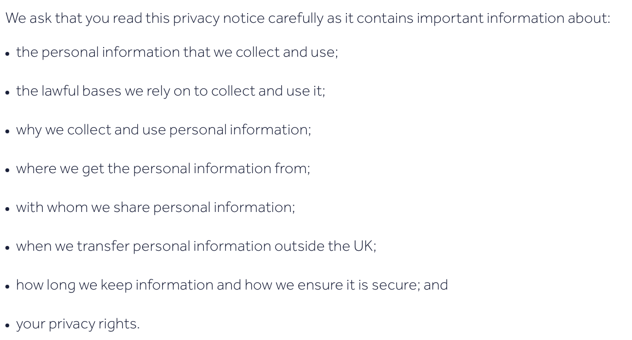
In 2018 General Data Protection Regulation became law in Wales. (G D P,2019 ) This is to protect hotels when it comes to data security, Transparency and guest trust. This stops hotels collecting unnecessary data and processing any data for longer than needed. (Freiherr von dem Bussche and Zeiter,2016) If GDPR wasn’t introduced the digital age would be very different. Social Security would be at an all-time low as you could gather millions of peoples data from around the world. (Dove, 2018) The Celtic Manor are very transparent with the information they gather and also where they have got this information from.
Accessibility ranges from disability access to sustainability. I have gathered from multiple guest stays that need extra facilities/ help, it seems that the Manor do not offer many features when it came to the rooms. However, the hotel does provide access around the resort. (Lewis,2024) In 2010 the disability act 2010 was introduced to stop discrimination. (Lockwood et al., 2012) The Manor have worked towards this slightly but still have a range of standards to meet to help facilitate more people.
The Celtic Manor has corporate responsibilities in place to better the company. This includes a range of areas from energy, transport, landscape and people. The people are the main focus for this report as they are the ones who will make a difference within the Manor. The sustainability team have been around since 2004 and are always improving. They also gather people from different areas of the workforce to generate ideas. The slogan for this is “We make sustainability part of everyday life”. (Flipsnack, 2025)

Conclusion
This report aimed to dig deeper into the operations within the Celtic Manor hotel and how these reach customer standards. I have gathered that the hotel works really well with the marketing different experiences from the same resort to a range of demographics. As this venue has a wide diversity when it comes to customers. Staff are trained to the standard needed to provide the excellent service expected by returning members. They also do a great job with remembering Welsh heritage throughout the collection, this alongside GDPR and honesty creates returning customers for the business.

Since the company are established and know what their goals are for the foreseeable, they are able to strengthen any weak areas. Such as disability access within the rooms, also broadening the hiring scheme to training up more individuals rather than people already in the industry. In conclusion the Celtic Manor is successful with advertising to their audience and also diversifying their operational management schemes to reach the multitude of demographics that staff need to cater to.

Operational Management Plan

Executive Summary
The Celtic Manor resort is a luxury hotel located in Newport, South Wales. It has a range of hospitality environments within the hotel and is known for hosting a range of events and delivering 5-star guest experiences. The frameworks of the resort align with the brand image of Welsh heritage and excellence. The objective of the hotel is to “become a world-class venue with sustainable practices, offering exceptional facilities for business, golf and leisure, and celebrating its history and community”. (Celtic Collection,2024)
There are a range of operational areas covered including Human resources, financial management, legal policies and compliance, risk management, sustainability and customer satisfaction. Each area has its own responsibilities for maintaining the Celtic Manor reputation as a leader in the Welsh hospitality sector for tourism and business travel.

Human Resources (HR) Management
Human Resources need to ensure staffing needs are met, for example the conference and events also known as CNE, area will need to hire a large range of staff around February. As this will ensure staff are trained when it comes to peak season in summer. (Celtic Careers,2025) Majority of the CNE staff are all casual with the department leaders being fulltime. This is because the department fluctuates with peak times, so staff aren’t always needed. If you compare this to front desk it will be largely different as desk staff will be needed every day. You will also already need the social skills in this role as it would be hard to teach. (Shapio, 2004) This means the staffing model when hiring will have different requirements.
Since staff are hired in February, they will get to experience a peak of half term for both England and Wales. All CNE staff must partake in the hospitality academy, this is a form of training that provides all staff with the basic knowledge needed. (Celtic Careers, 2025) 70% of learning takes place while on the job. This means that once you’re in the environment you get to ask questions and understand better. (“Learning Journeys”)
KPI’s will be used intensely in the conference and events sector. The organisers will be able to tell if it was a success and if this event should return and what to change. This could be done through Net Promoter Score to see if the attendees are satisfied and if they would recommend the event to others. A way that KPI’s can be used to monitor staff performance is through efficiency metrics, if we time staff while completing tasks and compare it to what is expected from them it allows employers to see if there are any unnecessary delays in the task.

Finance Management
The Celtic Manor has won the top UK conference hotel five years in a row. (MIA Awards, 2025) One of the criteria to win this award is excellence in service. The Manor do this by financially planning how much training is needed for all staff. It is mandatory that all staff provide the same standard of service. (Celtic Careers, 2025) A good thing about the conferences at the Celtic Manor is that a lot of them are private so won’t need the expenses of marketing the events. However, a lot of the large-scale events will gather their own coverage. Such as the Welsh summit in 2014, there were hundreds of articles written about the event as there were multiple world leaders within the manor. (Meet Wales, 2014) However it cost the Welsh government £81.2 million to hold the event in Newport.
When the venue reaches quieter seasons of the year this means that there will be less expenses in the hotel. This will allow finances to be used in different areas. An example is staff areas could be renovated to create a better staff experience. It has been found that creating a better environment for staff leisure time creates better staff Morale and a positive workplace. (Jennings and Tvaruzka, 2013)
Dynamic pricing takes part in the events in the manor, this strategy is very important when it comes to tourism and hotels as the market and demand is constantly changing and fixed rates would lead to the Celtic manor losing out on a large amount of business and money. (Cho et al. 2018)There is currently a deal on if you make an enquiry for an event by the 31st of march you have access to preferential rates. This will be because market demand is low at this time of year, it encourages organisers to get in touch to start booking. This is a form of RevPAR as they are using pricing strategies. Upselling packages in the deal and also forecasting demand as the deal ends at the end of march, they know what date to stop the offer as they could end up losing money in the long run. (Chen et al.2011)
The hotel are doing a range of different things to stay efficient; this has included streamlined operations. They have taken tasks into consideration and have got rid of unnecessary steps in the process this makes workflows more effective and in the long run will save a lot of time and money for the employers. (R.G, 1987) The collection has improved time savings by reducing stock- taking from 11 days to 1 day. This has improved the accuracy. They have seen a 0.6% food cost savings throughout the company. (KitchenCUT, 2025) The resort has changed their 135 golf carts from petrol based to electric and this has been efficient. Not only are the carts now quieter they have saved 60 thousand pound annual on fuel costs. (GolfBusinessNews.com, 2022)
Key Performance Indicators allows a constant tracking of performance. They can be tailored to best report what is needed in the company. They have different time periods depending on when the results are needed. (Indicators,2021) A cash flow statement would also be beneficial for a company of the Celtic manors size. This will allow an overall understanding of what profit is being made. (otlagh, 2013) This can also be done within different time periods as annual cash flows are created for tax purposes while quarterly can be used to monitor what is coming in and out of the business.

Legal Policies and Procedures
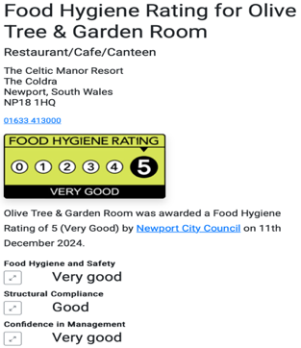
Throughout the Celtic Collection there are a range of different restaurants that have their own safety regulations and also hygiene rating. The Olive Tree and Garden Room has been awarded a 5-star rating. (Scoresonthedoors, 2024) They host a range of different options from afternoon tea to Evening meals. (Olivetree, 2025) It also hosts a buffet dinner service, the hygiene levels will need to be a throughout service as people could see buffet being unhygienic but with the 5-star rating the manor to make it work.
Labor laws within the hotel must be stuck to as there are a large range of different staff members. There are a range of benefits for all staff members. One that is very known within the company is the shining stars awards event which takes place once a year a range of staff members are invited to celebrate achievements. There are also a range of discounts in the spa, golf and activities areas. (Benefits,2025)
The Celtic manor is very transparent when it comes to the usage of data of guests. They provide a point of contact for any concerns regarding the way that individuals data is used.(Privacy Policy,2025) This will create a peace of mind when it comes to data. There are a large range of celebrities who stay within the Celtic Manor hotel. Their protection within the hotel is very vital as these customers stay loyal and can quickly become repeat customers. When all staff start at the Manor, they sign a contract regarding celebrities and privacy. (Celtic Careers, 2025) During the onboarding staff members are taught to not interact with certain guests unless they interact first. At the start of the shift information regarding well known guests are provided to avoid any experiences that are unwanted.
During the health crisis of COVID-19 the Celtic manor were leaders to the hospitality industry. They created the Celtic at home campaign. This was where you could purchase a takeaway meal at restaurant standard. This allowed guest to still experience the quality food they missed while in the comfort of their own home. (Enjovia,2020) There was a range of protocols in place to make this work. This includes health standards and also government law.
There aren’t a large amount of information regarding insurance and liability at the venue. The main information found on the website was the company is not responsible for loss or damage during a stay at the hotel. However, it does mention that the company takes responsibility for death and or personal injury at the result of negligence from the Celtic Manor. This does depend on the jurisdiction within the United Kingdom. (“Resort Terms and Conditions - Celtic Manor Resort”, 2025)This seems to be necessary as hundreds of people stay at the hotel annual and with the range of activities there is more likely to be an accident compared to not.
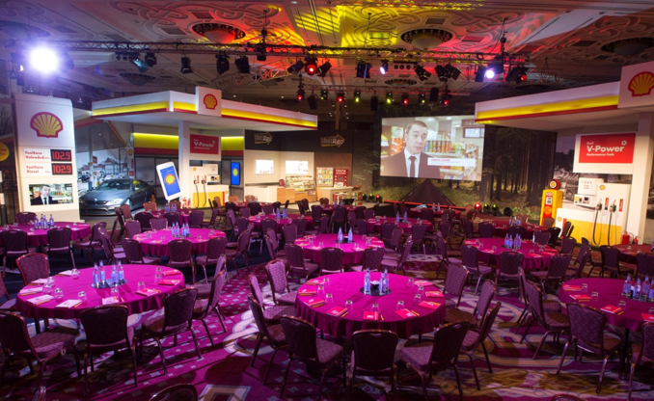
The venue does not have any partners other than Barclays at the venue. However, visit Wales have a significant partnership with the ICC which is next door to the venue. Their goal is to bring major conferences and also exhibitions to Wales. (“Celtic Collection and ICC Wales Appoint New Group CEO - Blog”, 2025) Which will lead to a larger range of people staying in the Celtic Manor. All events held in the Celtic Manor resort are private, this means they are invite only and do not promote on social media. Event Organisers for large companies will use the facilities at the manor. One of the most notable ones found is Shell garage. They created 2 garage forecourts in the hall and created a road in the venue. This included a large range of venue staff and teams to create the image. Health and safety created a large agreement as this was never done before in the venue. (Shell, 2014) Every event that is held in the venue will need a range of a team working on them but also different Agreements and contracts.

Operational Logistics
The Celtic manor are all about creating that special feeling with their guests. They have an area on the website called special touchers, these are to create a memorable experience for the guests. There are a range of options from romantic jesters and also kid friendly packages. (Special Touches, 2025) This incorporates different areas of the resort and might be a lovely gift for someone.
The hotel has made it easy for guests to check out. During their stay they will have full access to the Celtic manor resort app. This provides all information needed throughout the stay regarding booking things to do and general information. There is also the option of express check out. For convenience all room charges are posted through the door before you leave. There will then be an express check-out box in the main lobby for an easy departure.
The resort does use a property management system. In particular they use Opera 3 Payroll. This is the system that seamlessly pays all employees while working alongside HMRC to guarantee all staff members are being paid what’s necessary. (Pegasus, 2025)
The Celtic offer a guest WIFI that is available for everyone to use. This is now seen as a positive throughout hotels as it was common for hotels to charge those staying at the hotel an extra price to access the connection. (Allen, 2017) However, since it has become more normalised, they have swapped out a charge to information. To access the WIFI you need to fill in information about yourself which is then used as a marketing strategy to bring more people into the resort.

Customer Experience and Satisfaction
The Celtic collection have a very high reputation to uphold, this is from them being very traditional and also a luxury brand. (Jones, 2022) Not only are the staff held up to standards with the smart uniform, those partaking in golf must also follow the standards and have a dress code that must be followed to play. (Celtic Manor Golf Club, 2024)
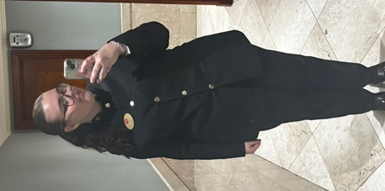
Brand consistency is very vital. Since the resort is 5 stars, they make sure it is imbedded into the service. This includes appearance and also attitudes while “onstage”. (Celtic Journeys, 2025) All CNE staff members are required to wear a Tunik, to create unison throughout all shifts. One key uniform points throughout the Celtic. Every person, no matter their position must have their name badge on their left-hand side of their chest. (Celtic Careers,2025) It has been found that uniforms create a positive encounters in the hospitality industry, this is because it creates the personal feel between an organisation and the customer and the staff member in the uniform are seen as the front line of guest interactions. (Karch and M, 2017)
The Manor take sustainability very seriously they already use 20% less electricity and have been able to recycle 63.5% of waste. The company has made an amazing start since 2017 and have a long way to go. Environmentally conscious travellers have a range of reasons to come to the Celtic Manor Resort such as achieving level 5 green dragon environmentally standards in 2025. (Sustainability, 2022) The main goal for the resort however to reach net zero by 2050 as a whole collection. This shows they aren’t only focusing on one hotel they want to bring the whole collection.

Risk Management
Economic downturns could have a large effect on the hotel compared to others in the area. A number of the clientele are international, if there was a crisis with the UK or even Global economy this could affect guest bookings. Not only would the hotel be affected but the tourism sector as a whole would feel the effects. (Henderson, 2007) Since the hotel is seen as a luxury a lot of the local communities don’t stay in the hotel however they use the facilities that are offered. If international stopped there would still be business at the resort but there would be empty rooms compared to normal. This could be avoided by operations if they create last minute offers that might spark interests in a different range of guests.
Staff shortage could be a major issues when it comes to exam season, as a lot of the staff are local students since the roles are casual. How to avoid shortage is through cross training. Staff will be able to improve their skills in different sectors but also be able to help the hotel provide the service needed to guests from multiple views. Cross training creates more loyal staff members as they are utilised in more ways than one. (Ali et al., 2021)
Crisis communication is important throughout such a large venue, staff within the Celtic manor can be made aware of a situation through the staff mobile app with group announcements. (Celtic Careers, 2025) I do believe that members of staff should know their role in an emergency, to not only keep themselves calm but also guests. This will help the organisations reputation and keeps the brand image together even during crisis. (Barton, 1994)
The resort works very closely with the Welsh government, this means that the media and stakeholders side of the external crisis communication can be held officially if the crisis is of that size. For guests and those within the resort during a crisis this communication can be done through emails as these will reach a large range of guests in a very short amount of time. Emails will be seen by a range of generations and the resort has easy access to majority of their guests email addresses as this is a key form of communication. (Dürscheid, C., et al., 2013)

Monitoring and Evaluation
Key Performance Indicators are a large factor in helping the company reach their goals. During dinners staffed by CNE staff every staff member is required to go to a coworkers table and ask if they have been satisfied with the service throughout the night. This helps everyone know what is expected from a customer relationship standpoint. (Signori and Greenberg, 2002)Data analysis is used for all staff in the venue. Employee Productivity is timed during training sessions to see how fast the team can set up a room. This gives an indicator of how long the team needs to come in before an event and also lets mangers know where any weak areas are.
I believe the Celtic Manor would highly benefit from monthly meetings with staff to create feedback and to better departments, this would allow employee involvement. An example of this is the Conference and Events team are split into two, food and bar. They work completely separately however if these teams came together, it would create a better atmosphere. It has been found that employee involvement creates a successful business as staff are more appreciated. (Obiekwe et al. 2019)

Conclusion
This report has dived into the Celtic Manor Resort and how they not only maintain but also enhance high standards of service, efficiency and guest satisfaction. Some of the key strategies include performance monitoring including KPI’s such as Net promoter scores. Sustainability is also taken into consideration, the manor have targets that need to be reached by 2050. This shows strong environmental leadership and will align with the growing need and expectations of environmentally conscious tourism.
To stay in the position the Celtic Manor Resort is in as a market leader, it is believed that for future growth there is a need of employees voice in the company. This would benefit the Celtic Manor as all employees come from different backgrounds and they see the day-to-day life within the resort. The Celtic Manor is in a very fortunate position to not only figure out future challenges but also help lead the Welsh sector in the years to come.

References
Ahmady, G.A., et al. “Organizational Structure. .” Procedia-Social and Behavioral Sciences, vol. 230, 2016, pp. 455–462.

Ali, El-Hussien, et al. “ISO 10015 Adoption as a Driver for Better Employees’ Performance: Implications for Organizational Excellence in Egyptian Tourism and Hospitality Industry.” International Academic Journal Faculty of Tourism and Hotel Management, vol. 7, no. 1, 1 Apr. 2021, pp. 70–91, https://doi.org/10.21608/ijaf.2021.230769. Accessed 22 Apr. 2022.

Allen, J. “Guest Reviewers, Journal of Classification Volume 34, 2017.” Journal of Classification, vol. 34, no. 3, Oct. 2017, pp. 548–548, https://doi.org/10.1007/s00357-017-9246-6. Accessed 17 Apr. 2025.

Barton, Laurence. “Crisis Management.” Cornell Hotel and Restaurant Administration Quarterly, vol. 35, no. 2, Apr. 1994, pp. 59–65, https://doi.org/10.1177/001088049403500219. Accessed 23 May 2020.

Benefits. “Rewarding Journeys.” The Celtic Collection, 16 Apr. 2025, www.celtic-collection.com/home/careers/rewarding-journeys/.

“Book a Spa Treatment | Celtic Manor Resort.” Celtic-Collection.com, 2025, book.celtic-collection.com/spa?utm_source=adwords&utm_medium=ppc&utm_campaign=&_gl=1. Accessed 6 Mar. 2025.

Celtic Careers. “Talent Journeys.” Csod.com, 2025, celtic-manor.csod.com/ux/ats/careersite/4/home?c=celtic-manor. Accessed 5 Mar. 2025.

Celtic Collection. “Our Story.” The Celtic Collection, 2024, www.celtic-collection.com/home/our-story/.

“Celtic Collection and ICC Wales Appoint New Group CEO - Blog.” Celtic Manor Resort, 2025, www.celtic-manor.com/home/blog/blog-celtic-collection-and-icc-wales-appoint-new-ceo/. Accessed 5 Mar. 2025.

Celtic Journeys. “Celtic Journeys.” The Celtic Collection, 5 Mar. 2025, www.celtic-collection.com/home/careers/celtic-journeys/.

Celtic Mall. “Celtic Mall | Retail & Shopping | Celtic Manor Resort.” Celtic Manor Resort, 15 Jan. 2025, www.celtic-manor.com/home/celtic-mall/. Accessed 10 Mar. 2025.

Celtic Manor . “Home.” Celtic Manor Resort, 4 Mar. 2025, www.celtic-manor.com.

“Celtic Manor Activities | Fun Days out in South Wales.” Celtic Manor Resort, 6 Jan. 2025, www.celtic-manor.com/home/activities/. Accessed 4 Mar. 2025.

“Celtic Manor Golf | Premier Golf Courses in South Wales.” Celtic Manor Resort, 4 Mar. 2025, www.celtic-manor.com/home/golf/.

Celtic Manor Golf Club. “Conditions of Play - Celtic Manor Resort.” Celtic Manor Resort, 22 Aug. 2024, www.celtic-manor.com/home/golf/conditions-of-play/. Accessed 21 Apr. 2025.

“Celtic Manor Meetings & Events | Ian Edwards Conference Centre.” Celtic Manor Resort, 29 Jan. 2025, www.celtic-manor.com/home/meetings-events/. Accessed 4 Mar. 2025.

Chen, J, et al. “ Does the Market Care about RevPAR? A Case Study of Five Large US Lodging Chains.” Journal of Hospitality & Tourism Research, vol. 35(2), 2011, pp. 258–273.

Cho, S, et al. “Optimal Dynamic Hotel Pricing.” in 2018 Meeting Papers , vol. 179, Apr. 2018.

“Civil Ceremonies - Celtic Manor Resort.” Celtic Manor Resort, 10 Sept. 2024, www.celtic-manor.com/home/weddings/civil-ceremonies/. Accessed 10 Mar. 2025.

Colcomb, Mark. “Celtic Manor | Client Stories | Barclays Corporate.” Barclayscorporate.com, 2025, www.barclayscorporate.com/client-experience/client-stories/celtic-manor/. Accessed 6 Mar. 2025.

Dove, Edward S. “The EU General Data Protection Regulation: Implications for International Scientific Research in the Digital Era.” The Journal of Law, Medicine & Ethics, vol. 46, no. 4, Dec. 2018, pp. 1013–1030, https://doi.org/10.1177/1073110518822003.

Dürscheid, C., C, et al. “Email Communication.” Handbooks of Pragmatics [HOPS], vol. 9, 2013, pp. 35–54.

Enjovia. “Case Study: Celtic Manor Resort Gift Cards during COVID-19 - Enjovia.” Enjovia, 15 Sept. 2020, enjovia.com/gift-cards-during-covid-19/. Accessed 16 Apr. 2025.

Flipsnack. “The Celtic Collection - Sustainability.” Flipsnack, 2025, www.flipsnack.com/A9FDFADEFB5/the-celtic-collection-sustainability/full-view.html. Accessed 10 Mar. 2025.

Freiherr von dem Bussche, A., and A. Zeiter. “Practitioner’s Corner ∙ Implementing the EU General Data Protection Regulation: A Business Perspective.” European Data Protection Law Review, vol. 2, no. 4, 2016, pp. 576–581, https://doi.org/10.21552/edpl/2016/4/16.

G D P . “Regulation.” GDPR, 2019, www.mhc.ie/uploads/pdf/MHC_GDPR_Web_2019.pdf.

“Golf Breaks - Golf Packages at Celtic Manor Resort.” Celtic Manor Resort, 4 Mar. 2025, www.celtic-manor.com/home/golf/golf-breaks/. Accessed 6 Mar. 2025.

GolfBusinessNews.com. “Celtic Manor Rolls out Electric Club Car Buggy Fleet.” GolfBusinessNews.com, 2 Nov. 2022, golfbusinessnews.com/news/courses/celtic-manor-resort-goes-electric-with-club-car/. Accessed 24 Mar. 2025.

Henderson, J.C. “Tourism Crises: Causes, Consequences and Management. .” Routledge., 2007.

Indicators, K.P. Key Performance Indicators (KPIs). 2021.

Jennings, E, and K Tvaruzka. “Building Staff Morale and Creating a Positive Workplace.” Workplace Culture in Academic Libraries, 2013, pp. 189–200.

Jones, Sir Terry. “The Celtic Collection Hotels | Luxury Resort, Hotels & Lodges.” The Celtic Collection, 2022, www.celtic-collection.com/home/hotels/.

K, Karakas Morvay. “Importance and Impact of Guest Satisfaction. .” APSTRACT: Applied Studies in Agribusiness and Commerce, vol. 8(4), 2014, pp. 31–37.

Karch, G.E, and Peters M. “The Impact of Employee Uniforms on Job Satisfaction in the Hospitality Industry.” Journal of Hotel & Business Management, vol. 6(1), 2017, p. 157.

KitchenCUT. “Streamlining Operations & Enhancing Efficiency at Celtic Manor - Kitchen Cut.” Kitchen Cut, 27 Feb. 2025, kitchencut.com/case-studies/streamlining-operations-and-enhancing-efficiency-at-celtic-manor/. Accessed 24 Mar. 2025.

Learning and Development. “Welcome - Realize Your Potential: Cornerstone.” Csod.com, 2025, celtic-manor.csod.com/phnx/driver.aspx?routename=Social/UniversalProfile/Bio&TargetUser=10302. Accessed 5 Mar. 2025.

“Learning Journeys.” The Celtic Collection, www.celtic-collection.com/home/careers/learning-journeys/.

Lewis, Rachy. “Wheelchair Access at the Celtic Manor Resort - Rachy Lewis.” Rachy Lewis, 12 Feb. 2024, rachylewis.com/2024/02/disabled-access-at-the-celtic-manor-resort/. Accessed 10 Mar. 2025.

Lockwood, Graeme, et al. “The Equality Act 2010 and Mental Health.” British Journal of Psychiatry, vol. 200, no. 03, Mar. 2012, pp. 182–183, www.cambridge.org/core/journals/the-british-journal-of-psychiatry/article/equality-act-2010-and-mental-health/0A1B0578B9C318D76B1B8C8A1744037A, https://doi.org/10.1192/bjp.bp.111.097790.

Matthews, Sir Terry . Celtic Collection Goals.

Meet Wales. “NATO 2014 Wales Summit Case Study.” Meet in Wales, 2014, www.meetinwales.com/choose-wales/wales-for-associations/case-study-on-nato-2014-wales-summit.

MIA Awards. “The Celtic Manor Resort Named Best UK Hotel at Major Business Events Industry Awards.” Mia-Uk.org, 2024, www.mia-uk.org/industry-news/the-celtic-manor-resort-named-best-uk-hotel-at-major-business-events-industry-awards/276216. Accessed 24 Mar. 2025.

Obiekwe, O, et al. “Employee Involvement in Organizations: Benefits, Challenges and Implications. .” Management and Human Resource Research Journal, vol. 8(8), 2019, pp. 1–11.

Olivetree. “The Olive Tree & Garden Room - Celtic Manor Resort.” Celtic Manor Resort, 4 Apr. 2025, www.celtic-manor.com/restaurant/the-olive-tree-garden-room/. Accessed 16 Apr. 2025.

Onchong’a, E.A., et al. “Effects of Debt Financing on Businesses Firms Financial Performance.” International Journal of Social Science and Information Technology, vol. 2(5), 2016, pp. 723–737.

otlagh, A.J . “Accounting: Cash Flow Statement. .” IOSR Journal of Business and Management, vol. 7(4), 2013, pp. 109–116.

pegasus. “Media Centre | Pegasus - Accounting, Payroll and Business Software.” Pegasus.co.uk, 2025, www.pegasus.co.uk/media-centre/case-study/celtic-manor-resort. Accessed 17 Apr. 2025.

Privacy Policy. “Privacy Policy - Data & Permissions - Celtic Manor Resort.” Celtic Manor Resort, 19 Dec. 2024, www.celtic-manor.com/home/privacy-policy/. Accessed 16 Apr. 2025.

R.G, Ernst. “ How to Streamline Operations.” Journal of Business Strategy, vol. 8(2), 1987, pp. 32–36.

“Resort Terms and Conditions - Celtic Manor Resort.” Celtic Manor Resort, 3 Mar. 2025, www.celtic-manor.com/home/terms-conditions/. Accessed 10 Mar. 2025.

Saee, John. Managerial Competence within the Hospitality and Tourism Service Industries. Routledge, 27 Sept. 2006.

Scoresonthedoors. “Olive Tree & Garden Room - Food Hygiene Rating Scores, Contact Details and More.” Scores on the Doors, 2024, www.scoresonthedoors.org.uk/business/olive-tree-and-garden-roomnewport-south-wales-619090.html. Accessed 16 Apr. 2025.

Shapio, L.E. 101 Ways to Teach Children Social Skills. Bureau for At Risk Youth (via Incentive Plus). ed., 2004.

Shell . S H E L L ( v I a c H c O M M U N I c at I O N S ) G a L a D I N N E R D E TA I L S Gala Dinner for 270 with a 4-Course Menu. 2014.

Signori, P, and P Greenberg. “CRM Customer Relationship Management.” Apogeo, 2002.

Special Touches. “Special Touches, Celtic Manor.” Celtic-Manor.com, 2025, www.celtic-manor.com/home/rooms/room-service-extras/. Accessed 17 Apr. 2025.

“Steak on Six - Restaurants - Celtic Manor Resort.” Celtic Manor Resort, 30 Dec. 2024, www.celtic-manor.com/restaurant/steak-on-six/.

Sustainability. “Sustainability.” The Celtic Collection, 2022, www.celtic-collection.com/home/sustainability/.

Welsh Gov. “Visitor Accommodation (Register and Levy) Etc. (Wales) Bill | GOV.WALES.” GOV.WALES, 25 Feb. 2025, www.gov.wales/VisitorLevy. Accessed 10 Mar. 2025.

