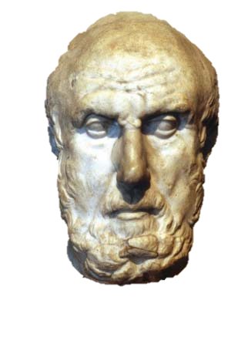
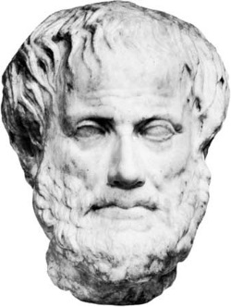
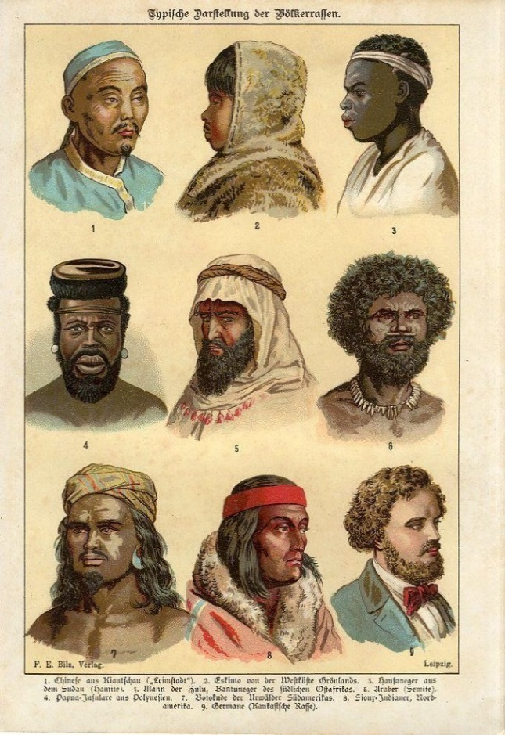
Hippocrates
Aristotle
Race in Antiquity
The Greeks themselves did not possess a word for ‘Race’ as we would know it. The closest word used is Genos meaning ‘Kin’ – yet this term applies not only to race or ‘ethnos’ but to men, women, tribe, family and any other number of differences, demonstrating why we must be cautious in discussion on this topic. Furthermore, it is clear that the Hellenes did not believe that, like many early modern Europeans, physical features defined a peoples’ mental capacity. Hippocrates expresses in Airs, Waters and Places the view that it is a people’s geographic location that defines their physical and mental states. Now this can be defined as a reflection on the authors ethnocentrism however it is Aristotle who shows us Hellenic ideals of racial or ethnic superiority in the book Politics whereby he declares that some men are slaves by nature as they cannot possibly rule themselves. it is this that can be defined as racism in antiquity, that Hellenes or Hellenic people were of superior stock in a ‘natural’ order to others.
Modern ‘Race’ and Racism
To a modern reader the term ‘Race’ will have differing connotations depending on individual experiences and encounters however outdated the term is now. Our understanding of Race and modern Racism is inextricably linked by our societal connections to 18th and 19th century racial ideologies, as well as eugenic and other poor ‘scientific’ justifications for racial superiority that stretched well into the second half of the 20th century, sadly all of which continues to pervade into all aspects of contemporary society. In a short summation there are two key aspects to early modern and contemporary racism:
- That Humans are divisible into groups based on their appearance and that appearance affects mental capacity
- That these mental and physical attributes are hereditary.
The important point here is that it is the physical features which define what a person’s mental capability will be and it is here that we can see the divergence between contemporary racism and what occurred in ancient Greece.
Race in Ancient Greece

