Critique audience experience from a narrative set in a built world. How can you compare this with another example to show a more effective transformation of an actual world phenomenon?

Ashley Price
P1073125
Illustration
2,027 Words
Scott Smith

The constructed, fictional worlds that will be being explored herein are as follows: Animal Farm (Batchelor and Halas, 1954), an animated film based on the novel by George Orwell, and V for Vendetta (McTeigue, 2005), a live action film based on the graphic novel by Alan Moore. The aim of this essay is to compare the depictions of governmental corruption and the overthrowing by the masses within these stories. The focus shall be placed upon exploring these titles’ strong links to narrative theory and its importance in creating these comparisons.
Animal Farm was written as a satirical view on the Russian Revolution, although Orwell is said to have wanted his book to have a wider application (Orwell and Davison, 2013). Orwell believed the revolution was “led by unconsciously power-hungry people,” (Bloom, 2009, p. 53) a concept he was able to represent through his use of anthropomorphic characters. The story begins with the animals deciding they no longer wished to work fruitlessly for the farmer, ultimately choosing to drive away Mr Jones and run the farm themselves. At first, they declare all human dwellings to be unfit for use by the animals, preferring to rid themselves of any influence of their previous leader. However, Napoleon is quick to alter these rules from “No Animal Shall Sleep in Beds” to “No Animal Shall Sleep in Beds with Sheets.” In using his personal trained dogs that imitate a private army and his propagandist, Squealer; Napoleon manages to slowly return the farm to a state similar to, and much worse than, their pre-revolution lives. The animals suffer so that Napoleon and his fellow pigs may live in comfort.
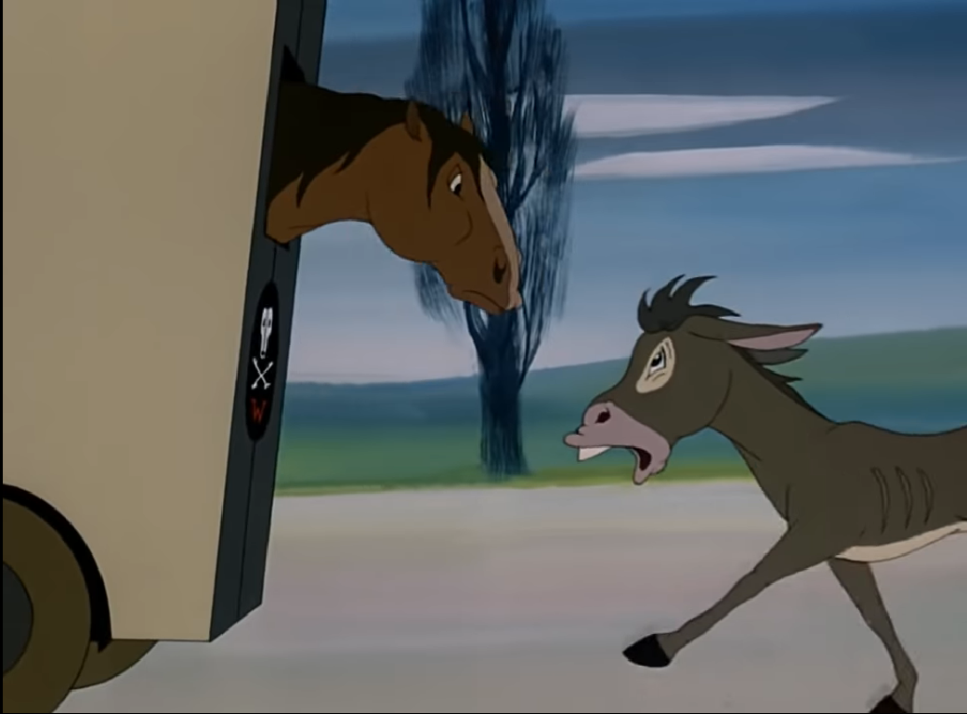
(Fig. 1, Animal Farm, 2017)
The use of anthropomorphism to represent the Russian Revolution allows for a humorous interpretation of the Soviet Union. Orwell opts to represent the leaders as power-hungry pigs, animals known for being dirty and who consume everything veraciously. The private army is represented quite literally as attack dogs – raised and trained for the specific purpose of blindly following orders and exacting the brutal wishes of Napoleon. The hardest worker is represented by a horse, a strong animal that could, if it had the brains, easily take control of the farm with its sheer power. Towards the end of the film this character, Boxer, dies when he continues to work despite being injured. Initially, the animals believe the van that arrives to collect him is an ambulance but they quickly learn it is in fact the “death wagon”. The animals chase the van, as depict above, but cannot catch it, leaving them to watch sadly as Boxer is taken away. This event lead Squealer to deliver a speech with regards to Boxer’s last words that ultimately reveal to the animals that Napoleon’s reign is held through lies and propaganda. Through the sale of Boxer’s body the pigs are afforded alcohol and a party, dividing the two groups of animals. Upon reflection, this event clearly shows the differences in right and wrong and the division between the classes.
The Cold War was between the United States and the Soviet Union, shortly after World War II. A war that can, at least in part, be simplified to Capitalism vs Communism, and is characterised by the threats from each side and the propaganda methods used to discredit the opposition. The CIA funded this film to use as propaganda animation; they used this story to add to their anti-communist and anti-Russia message. They used their financial influence to adjust the narrative from that of the novel to one that suited their own means. Elements that they changed included the ending and the overarching message; this is supported by historian Daniel J. Leab in Orwell Subverted stating that, “Stalin’s regime is not only as bad as Jones’, but worse and more cynical.” This film was intended to reach adult audiences, although they felt they needed to simplify the plot. The movie was released in 1954, over a year after Stalin's death in 1952 but had initially been planned in 1951. As the Cold War was still ongoing propaganda was valuable to the US.
It’s certainly of note that the CIA chose to hire a British animation company instead of one of the more famous American producers like Disney. Halas and Batchelor had started their company during the war as they understood there was a need for propaganda that could be opened to animation (Halas, 2015). Their history with political productions made them a sensible candidate for this adaptation.
Prior to World War II animation was typically a form of childhood entertainment and had few applications outside of this role. However, cartoons became a popular medium for propaganda as it could boost morale and promote the agenda of the government. By making this adaptation an animation they could realise the vision of the anthropomorphic characters and their literal translation. An unintended benefit to animation is that it allowed them to target the film to a younger audience, resulting in being able to push their propaganda and ideologies onto the next generation of children.
The message this film sends out not a subject that many appear to agree on. According to Vivian Halas, the film was initially banned in Paris; it wasn’t shown until 1993 as it was too anti-communist. When it was first played the Mayor of Aubervilliers commented that the film was a tribute to communism (Cohen, 2003) – a dissenting perspective that few share. Other critics have commented that it is an anti-totalitarianism film with a humanist message. Joy Batchelor has said she believed the film was about freedom, showing a disconnect between the animator’s vision and the investors. The film took 15 years to recover its costs, suggesting it was not overly popular.
V for Vendetta is based on a graphic novel by the same name, penned by Alan Moore and David Lloyd (1988). The film reshapes the original story to “fit a post-9/11, postIraq invasion world, explaining that fascism seized Britain,” (Johnson, 2006, p.52-53) as exemplified by the film itself, “as America’s war grew worse and worse, and eventually came to London,” (McTeigue, 2005). A film that advocates terrorism is particularly significant in a post-9/11 world; where America remembers this act through one-minute silences, constant documentaries and conspiracy filmmaking. As one critic has commented, “there are a few queasy moments when you wonder whether this is the kind of landmark-wrecking film that would top Osama Bin Laden’s must-see list,” (Segal, 2006).
The plot of the movie follows V in his contemporary resolution that was initiated through Guy Fawkes’ failed attempt four hundred years earlier. Contrastingly to the historical gunpowder-plot, which was shrouded in secrecy to maximise their chances of success, V uses current technology to broadcast his own intentions to encourage social mobility to his cause. The last scene demonstrates the irony of the government’s own propaganda, “strength through unity, unity through faith,” (V for Vendetta, 2005) as we watch the public attend the bombing of parliament, showing support for a change in political structure as the people take control. These individuals are visually unified through their goals, beliefs and ideologies by the attire V has sent them. Through this ironic twist, it is evident that the people have a greater strength through their unity than that of the government.
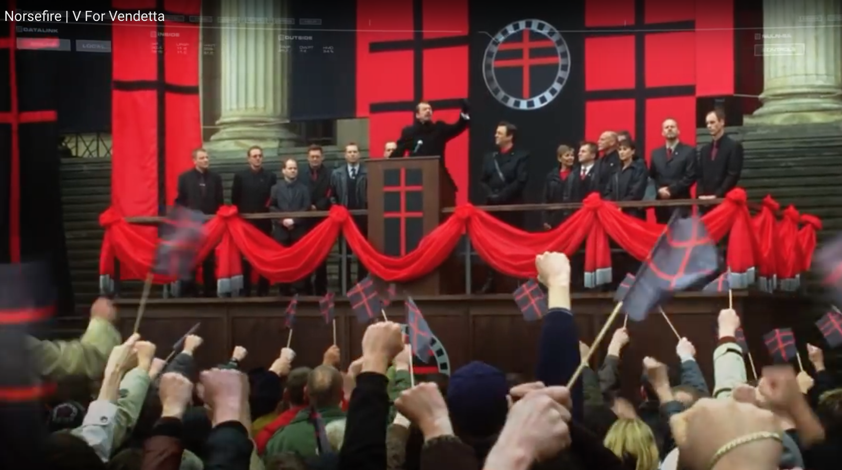
(Fig. 2, V for Vendetta, 2018)
From a semiotic perspective when an audience reads the imagery used, as in the above image which depicts the leader of the fictional fascist party Norsefire, they can begin to make parallels between the iconography used here and that of other, infamous fascist rallies. The speech given here is reminiscent of Nazi Germany and Hitler’s aggressive, militant rallies that incited strong emotions and are full of gesticulation. Firstly, the cross used by the Norsefire party has historical context, the Cross of Lorraine was used as a symbol for Free France during World War II. This works in stark contrast to the neo-fascist speech given by the Chancellor and the mis en scene of the sequence. Secondly, we can see the chancellor encourage the crowd to salute with him, in raised fists. This gesture has a long history with it’s symbolism, often understood as a display of solidarity, defiance or aggression, (Kelly, 2012).
Just as the government used symbols in the film, V comes equipped with his own counter-symbols. The first one is his personal logo; a red V spray-painted that has been encircled. This icon appears similar to an upside-down anarchy symbol and is often depicted with the same colour scheme as the Norsefire party logo; red on a black background. The two logos are in stark contrast with each other; where the Norsefire logo has strong, clean-cut lines with an emphasis on squares and crosses whereas V has opted for the circular image with two curved lines creating a point. The anarchist reference in the logo is further eluded to through the use of having spray-painted it over government posters. “Through its visual iconography, the film thus provides mainstream cinema audiences with an effective introduction to the symbolic vocabulary of postmodern anarchism.” (Call, 2008)
Similarly to Animal Farm, this film was also subject to strong changes in its adaptation from the graphic novel. One of the key differences is the date that the narrative is set in; the novel was a response to Thatcherite Britain but the film is set in the future, the year 2032, to fit a more modern climate. As Hugo Weaving commented, "this is a response to the world in which we live today. So I think that the film and the graphic novel are two separate entities." Similarly, with Animal Farm, these changes were at the discretion of those who contributed the funding; author Alan Moore felt that this resulted in the loss of his anarchist and fascist themes as the plot was altered to fit a more classical liberalism-vs-conservatism theme. Ultimately, these changes lead Moore to choose to have his name removed from the film's production.
Given the scandals with recent political elections, particularly in America, some of the changes to the plot reflect more accurately the current political climate. In the graphic novel the fascist government had been elected and kept in power through an apathetic public. Contrastingly, the film opted to show the government obtain power through the use of highly unethical methods to create an illusion of high intelligence, compassion and generosity. These unethical tactics are reflected in the recent elections in America, although they do not extend to the horrific biological massacre detailed in the film.
Many critics felt that the film shouldn’t have depicted V’s terrorism so favourably, some even linked the imagery of parliament’s firework explosion to that of the collapse of the World Trade Centre. “That the film is “just a film” in no way exempts it from consideration and critique as a comment on a very contemporary set of fears,” (Bulloch, 2007, pp. 431).
Unlike the film Animal Farm, this movie did not take long to recoup the costs and make a profit; in fact, it took it less than a year to gross over one-hundred-and-thirty-two million dollars. Since the film’s release the Guy Fawkes masks have increased in sales, they’re popularly used in both direct relation to the film and in protests. One of the authors of the original novel, David Lloyd, has commented "The Guy Fawkes mask has now become a common brand and a convenient placard to use in protest against tyranny – and I'm happy with people using it, it seems quite unique, an icon of popular culture being used this way,” (Waites, 2011).
The two films initially appear similar, there is plenty of overlap in their revolution-related plots, but they have had very different responses. Due to narrative theory, the adaptation of the plots of each to fit a contemporary climate, the audience’s experiences have changed and developed thus the appeal for both films increased. How effective these films are is entirely dependant upon the audiences’ political climate. At current, however, it would be reasonable to presume that V for Vendetta, with an apathetic population and improperly-gained political power, is a stronger representation of a current real-world phenomenon.
Bibliography
Animal Farm. (1954). Directed by J. Batchelor and J. Halas. [film] USA: Halas and Batchelor.
Bloom, H. (2009). George Orwell's Animal Farm. Infobase Publishing, p.53.
Bulloch, D. (2007). “V is for Vendetta: P is for Power A film reading of V for Vendetta”. Millennium - Journal of International Studies, 35(2), pp.431.
Call, L. (2008). A is for Anarchy, V is for Vendetta: Images of Guy Fawkes and the Creation of Postmodern Anarchism. Anarchist Studies, 16(2), p.154.
Cohen, K. (2003). Animated Propaganda During the Cold War: Part One. [online] Animation World Network. Available at: https://www.awn.com/animationworld/animated-propaganda-during-cold-war-part-one [Accessed 17 Dec. 2018].
Halas, V. (2015). The Halas and Batchelor Collection. [online] Halasandbatchelor.co.uk. Available at: http://halasandbatchelor.co.uk/history.asp?1=1 [Accessed 17 Dec. 2018].
Johnson, Brian D. (2006). The terrorist as romantic superhero. Maclean's, 119(12), 52-53.
Kelly, J. (2012). Breivik: What's behind clenched-fist salutes?. [online] BBC News. Available at: https://www.bbc.co.uk/news/magazine-17739105 [Accessed 17 Dec. 2018].
Leab, D.J., (2007). Orwell subverted: The CIA and the filming of animal farm. USA: Pennsylvania State University Press.
Orwell, G. and Davison, P. (2013). George Orwell: A Life in Letters. London, UK: W. W. Norton & Company, p.334.
Rodden, John, (2016). ANIMAL FARM AT 70. Modern Age, 58(4), pp.26.
Segal, Victoria, (2006). Treason and plot. New Statesman, 135(4784), pp.47–48.
V for Vendetta. (2006). Directed by J. McTeigue. [film] UK: Warner Bros. Pictures.
Waites, R. (2011). V for Vendetta masks: Who's behind them?. [online] BBC News. Available at: https://www.bbc.co.uk/news/magazine-15359735 [Accessed 16 Dec. 2018].

Images
Fig. 1 Aeolus 13 Umbra. (2017). Animal Farm (1954) [video] Available at: https://www.youtube.com/watch?v=h1DcWw9geig [Accessed: 19 December 2018]
Fig. 2 The Templin Institute. (2018). Norsefire | V For Vendetta. [video] Available at: https://www.youtube.com/watch?v=HXp0k-YKtLc [Accessed: 14 December 2018].

Additional Reading
Davison, P. (2004). George Orwell: Animal Farm: A Fairy Story. [online] Wayback Machine. Available at: https://web.archive.org/web/20061212041856/http://www.orwell.ru/library/novels/Animal_Farm/english/eint_pd [Accessed 19 Dec. 2018].

