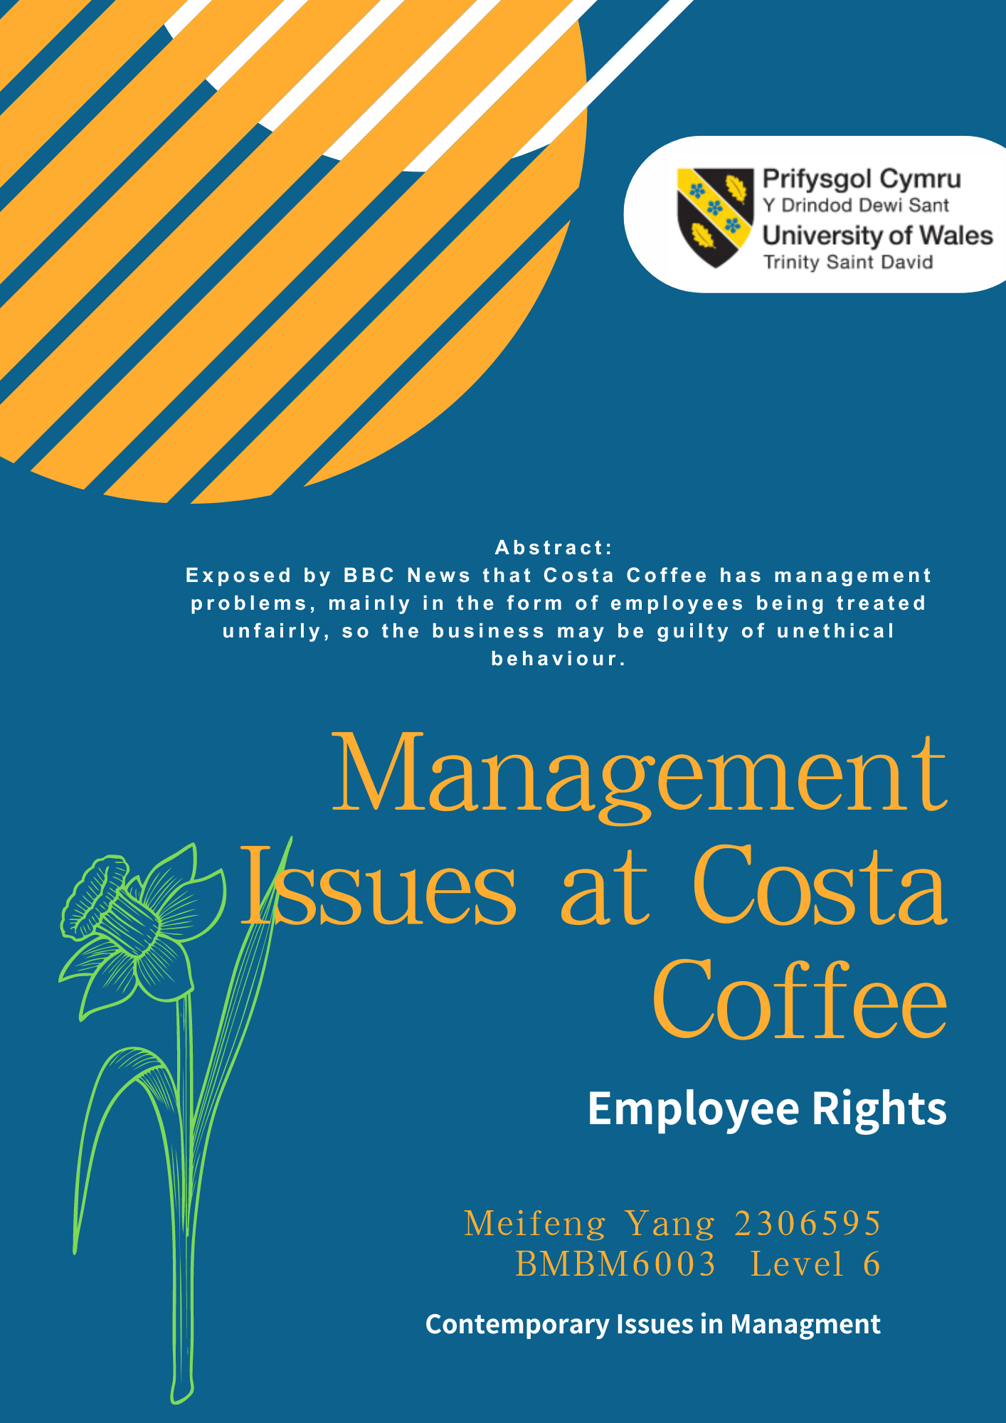
Executive Summary
The context of the whole report is that Costa Coffee has been exposed for not treating their workers fairly, which shows that there are serious management problems within the business. Through the research, Costa Coffee's mission and vision on the official website is consistent with Democratic, but the disadvantage of this management style is that it is difficult for everyone to reach a consensus. Some of Costa Coffee's franchise partners have chosen to use the Bureaucratic management style to increase the profits of the company, so the managers have done a lot of things that harmed the interests of the employees and unethical things. This shows that both management styles are not applicable to deal with the current management problems of the organisation, so the business can try to challenge new management styles to improve the negative impacts. The main thing that the business lacks are co-ordination and command skills because most of the workers are complaining because of the long working hours and dissatisfaction of being paid reduced wages. This shows that the managers have not listened to the suggestions and complaints of the workers and also not coordinating the disputes over holiday salaries within the organisation. Costa Coffee can challenge the use of Paternalistic to deal with unfair treatment of workers, the benefit of this management style is that managers are required not to hurt the stakeholder. The managers need to be relational and sympathetic to the work of the workers so this can improve the probability of the workers being treated unfairly again. Classical management theories view is reflected in the fact that power is monopolised at the senior management level and power is not devolved down to the workers at the bottom. This is also reflected in the unfair treatment of Costa Coffee because the workers had no way of rebelling against the managers' decisions, such as treating them like machines at work. Mainstream theories only focus on efficiency and profit maximisation, which can make workers unable to cope with higher pressure rates. Critical Management Studies is trying to improve the existing business management practices and Costa Coffee's head office has stated that their charity practices are quite successful so the organisation is trying to improve the brand image and trust of their stakeholders by increasing their charity activities.

Contents Page
Introduction 5
2.0 MainFindings 7
2.1 The Role of the Manager 7
2.1.1 Fayol’s Management Processes 7
2.2 Management Styles 8
2.2.1 Democratic Management Styles 9
2.2.2 Bureaucratic Management Styles 9
2.3 Challenges to Management 10
2.4 Management Theory 12
2.4.1 Scientific Management 13
2.5 Critical Theories of Management compared to Mainstream 14
2.5.1 Mainstream 14
2.5.2 Critical Management Studies 15
2.5.3 Compared 16
Conclusion 18
Recommendations 20
References 21

Introduction
Costa Coffee is a British multinational cafe chain founded in 1971 in London, England by Italian br others Sergio Costa and Bruno Costa (Costa Coffee, 2022d). Costa Coffee's core values are that the business is a champion of diversity, inclusivity, and ethics. They would encourage everyone to be their unique, wonderful selves, as simple as a classic cup of espresso (Costa Coffee, 2022c). This shows that the business is focused on the selection of quality coffee bean brands and they require the organisational atmosphere to remain friendly and positive. They also remind businesses to follow ethics and be socially responsible.

According to the BBC 2019, Costa Coffee was exposed to the fact that their workers were not being treated as human. According to interviews, 26 workers for Costa complained that managers refused to pay for sick or annual leave and that they required workers to continue working beyond their contracted hours. (Yusuf, 2019a). This shows that Costa's business is not fulfilling their vision of values and commitment to maintaining a friendly atmosphere environment.

In another news source, workers stated that managers often deducted wages on the reason that it automatically acted as a training charge of about £200. This cost is not communicated to the workers but is directly deducted when settling the monthly salary (Yusuf, 2019b). This shows that the managers of Costa acted in a completely unethical manner by compromising the trust and interests of the employees for the purpose of the company's profit.

These unethical behaviours prove that there is a lack of good management and communication within the organisation, which results in an unfair treatment of the workers. This report will analyse and evaluate the existing management theories of Costa Coffee and give the right management advice to the business, which will include Fayol's Management Processes, Challenges in Management Activities, Democratic. Bureaucratic, Paternalistic, Classical management theories, and Critical Theories of Management compared to Mainstream.

2.0 MainFindings

2.1 The Role of the Manager

2.1.1 Fayol’s Management Processes
According to Henri Fayol, planning, organising, coordinating, commanding and controlling are the elements of management (Fells, 2000).
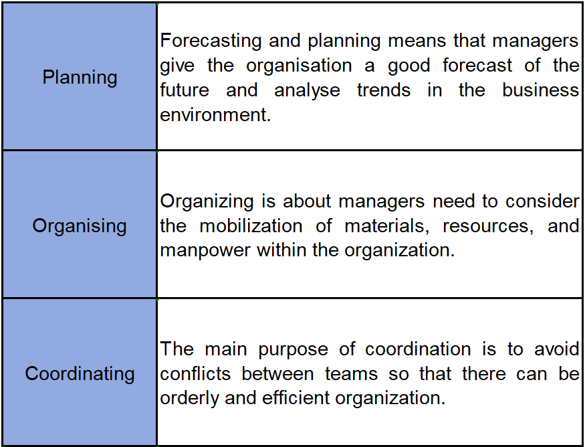
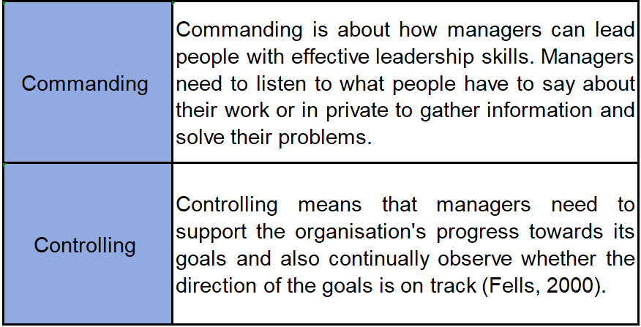

By analysing the negative news about Costa Coffee through Fayol's management process, it is clear that there is a lack of commanding and coordination between managers and workers.

Costa Coffee workers have described the most painful working conditions as the long working hours, and working 13 hours in shifts with only 20 minutes breaks (Yusuf, 2019a). This shows that business managers just keep assigning tasks and what they are missing is staff caring and collecting feedback from them. Managers should communicate more with their workers about their difficulties at work and adjust their working hours wisely.

According to Yusuf (2019b), Costa's workers stated that the unfair treatment they suffered also included managers deliberately charging a week's salary of their workers as training expenses. This shows that the managers of the organisation have not managed to clearly communicate the terms of the training to the workers and lack coordination skills. Managers' duties should be to clearly communicate the direction of business objectives, not hide information. The organisation can work together to co-ordinate the cost and duration of training while the purpose is to increase the motivation of their workers to participate in the training.

2.2 Management Styles
The management style adopted by managers is based on the organisation's environment and culture, which can lead to effective or standard performance measures for the business (Bass et al., 1975). The five most prevalent management styles include autocratic, bureaucratic leadership, paternalistic, democratic, and laissez-faire (Brown, 2023).

2.2.1 Democratic Management Styles
Democratic leadership style means that employees have the right to speak about the policies and decisions of the organisation, usually in the form of meetings that require open and free communication between managers and employees (Woods, 2021, pp. 1-2). Costa Coffee's official wording expresses their belonging to democratic because they promote diversity, fairness, inclusiveness and care for the self-improvement of their employees and encourage their creativity (Costa Coffee, 2019). The advantages of this management style are that it allows Costa's team members to have stronger relationships, increased collaboration, and knowledge sharing. The disadvantage of this management style is the inability to make decisions quickly and requires each team member to reach a consensus. This resulted in some of Costa Coffee's franchise partners being unable to reach a consensus, so they took the liberty of using Bureaucratic reduce employee rights causing unethical behaviour.

2.2.2 Bureaucratic Management Styles
Bureaucratic management styles refer to a very regulated and formalised management style. Decision making is in the hands of the top management and the role of the employees is to strictly follow the procedures (Sharma, 2023). Costa Coffee already in 42 countries, so they developed franchise partners as a business model (Coffee, 2022a). According to the BBC, "workers not treated like humans" is enough to show that Costa Coffee is not entirely democratic and some of the franchise partners may be bureaucratic (Yusuf, 2019a). This shows that there are some franchise partners that have a vision to maximise the profit of the business, and that's why they are treating their workers unfairly and have unethical behaviours.

According to the investigation, franchise partners are suspected of poor working conditions, so Costa Coffee is conducting an independent audit of their legal and ethical compliance (Price, 2019). One of the unethical clauses is that the shop opens late or misses a delivery and the worker will be fined £150 (Yusuf, 2019a). This shows that there are overly strict and unethical employee policies such as the reward and punishment system at bureauucratic implemented by franchise partners. Several Costa workers are behaving in a highly depressing manner because there is no allowance for any mistakes in the workplace. Eventually, this caused Costa's worker turnover rate to become higher and was exposed to the public for unethical behaviour causing the brand against their vision.

2.3 Challenges to Management
The support and dedication of their workers is important for achieving the objectives of the business, so the management plays the role of the guardian who controls the performance (Hoogervorst, 2017). A good management style can reduce turnover and increase productivity. The poor management style can cause stress and reduced productivity of workers (Rotemberg and Saloner, 1993). This shows that good managers must learn to be flexible in using different management styles to achieve the organisation's objectives and vision. The main reason for the complaints against Costa Coffee is that their franchise partners have implemented unethical business policies, which include the lack of employee rights. This means that the company's management is currently faced with the challenge of transforming their bureaucratic and democratic management style into a patriarchal style to improve the company's unethical behaviour.

In Paternalistic management style there is only one dominant person who has the ability to make workers trust, obey and be loyal to the decisions of the "parent" (Pellegrini and Scandura, 2008). The benefits of this management style are creating a friendly working environment and the manager is highly attentive to the needs of the workers and organisation (Harappa, 2021). This shows that the managers of the organisation are empathetic and they can ensure that the workers feel respected.
If Costa Coffee's team could transform into Paternalistic, this could unify their franchise partners to perform caring and helping their workers on a daily basis, reducing the pressure on them. They would no longer intentionally deduct tips from workers because it is unethical and inconsistent with being a "parent" on the team. Teams need their workers to remain trusting and loyal, so managers will not do anything to hurt their members.

In the workplace, employees' emotions affect their productivity, and managers with high emotional intelligence are able to develop and maintain a positive emotional climate in their organisations (Ashkanasy and Daus, 2002). Managers are unable to control the emotions of their employees, but they can use communication and training in attitude management to reduce the number of employees engaging in inappropriate behaviours in the workplace. For example, Costa's employees often work overtime, so they have a great deal of negative emotions to bring into the workplace (Indeed, 2022). Managers can use Paternalistic to act as a "parent" to their team, to care for the physical and mental well-being of their workers, and to provide them with some help. Managers can take the initiative to understand the needs of their workers and make reasonable arrangements for the workers' welfare, which can increase their trust and loyalty.

2.4 Management Theory
A management theory is a basic management strategy that has been proven. Modern organisations apply these frameworks and guidelines to business practices in response to environmental changes, which provide effective assistance to managers in their decision-making (CFI Team, 2022). There are three main types of classical management theories, which include scientific management, administrative management, and bureaucratic management (Mahmood and Basharat, 2012).

2.4.1 Scientific Management
The main principles of scientific management include time management, exercise research, training employees in their responsibilities and clear division of labour. Frederick W. Taylor argued that these principles help managers to maximise the benefits of the company (Kai et al., 2013). This theory does have practical validity and suggests that managers adopt a systematic approach to management to optimise performance.

Taylor suggests that the benefits of this theory are increased labour efficiency and productivity (Taylor, 2003, p. 8). According to a BBC News survey, one of the Costa Coffee shop workers stated that they work an average of 60 hours a week as they are expected to arrive at the shop at 05:30am (Yusuf, 2019a). This shows that managers are trying to satisfy the customers and they lengthen the working hours of the workers to satisfy more productivity. The benefit of this strict working style is that it brings clarity and uniformity to the tasks of the workers.

The disadvantage of scientific management is that the workers at the bottom of the hierarchy have no right to speak up, so communication barriers can cause issues of unfair treatment. Costa workers have stated that they are suffering from severe emotional distress because they devote a lot of their time to work, so they are not able to take time to care for their families at all (Yusuf, 2019a). This management model requires workers to work strictly according to objectives, and a one-dimensional approach to work can cause workers to lose their motivation and creativity.

2.5 Critical Theories of Management compared to Mainstream

2.5.1 Mainstream
Mainstream focuses on common objectives in organisations. By examining the impact of behaviours generated by individuals, teams and structures within organisations. Their aim is to enable managers to rationalise the allocation of resources and training content to co-ordinate and monitor employees to achieve the organisation's objectives (Dow, 1997). This research is asking managers to maximise the benefits of the business by constantly controlling and monitoring the performance of the organisation.

Costa Coffee's franchise partners did not fulfil the code of ethics because they were suspected of treating workers unfairly. Workers reported that their working week was excessively heavy and that one mistake deducted a bonus equal to a full week's effort. This led to several workers stating that it was stressful to work long periods at Costa (Coffee, 2022a). This shows that the managers of Costa's locations have appeared to monitor and control their workers in a strict ways. They deliberately deduct workers' holiday pay for various reasons, which are meant to calculate the income into the business's operating bill and achieve good performance. This kind of behaviour should be criticised because it is an unethical act made from the point of view of hurting the workers, so this management theory is not really suitable for Costa Coffee.

2.5.2 Critical Management Studies
Critical Management Studies is primarily used to examine and challenge traditional management theories and to test the legitimacy of theories through hypotheses. The aim of this research is to reflect and question the existing management practices which can be effective in improving the management models, policies, philosophies and values of the organisations (Akella, 2008). This suggests that CMS is helping managers to understand the shortcomings of their strategic activities and suggesting them to improve the existing model as soon as possible and upgrade into a more stable management system.

Costa Coffee's brand culture has added one more charitable activity from the ordinary service industry because they are realised that they want to build a good image of their brand. Their manifesto is to uplift the standard of living of the communities they belong to and the organisation donates profits to charity. "In 2022, the Costa Foundation will celebrate building 100 schools and changing the life stories of 100,000 children (Costa Coffee, 2022b)." This shows that the Costa coffee team is very focused on social objectives and they organise events on caring themes such as recycling, reducing food waste and meeting the needs of specific communities. This ethical value makes both customers and employees satisfied, which makes Costa's stakeholders respect and trust their business culture.

2.5.3 Compared
In contrast to Critical Management Studies and Mainstream, Mainstream studies are objective and scientific also they advocate that managers should use and allocate labour efficiently. Their aim is to apply minimum cost for maximum benefit (Hewege, 2012). This direction of study will make managers touch unethical behaviour because they would harm stakeholders interests in order to increase shareholders profits.

The CMS studies are subjective, not holistically structured, and suggest that managers look at the problem intuitively. They advise managers to consider and test the usefulness of management theories in different situations and contexts, and not to ignore the stakeholders of the organisation (Hewege, 2012). This study is an improvement and critique of Mainstream's original philosophy and they are very focused on ethical and legal behaviour.

Conclusion
The whole report starts by analysing the lack of command and coordination skills of the managers at Costa Coffee through the Fayol management process. The managers should communicate more with the workers to get feedback and coordinate the workers to participate more in training activities to improve the efficiency.

Costa Coffee's vision is consistent with Democratic, but they could not get a consensus from the franchise partners, so many of the shops adopted Bureaucratic. This style of management allows the managers to control the power and make a lot of actions that hurts the interests of the workers. This has caused workers to feel that they are being treated unfairly, so it is unethical for the business to condone this style of management.

Costa Coffee should be accepting of trying new management styles to improve the current management problems in the business such as Paternalistic. This style of management allows managers to be empathetic and they have to care about the interests of the stakeholders of the business. The benefits include making managers more caring about their workers, which can increase their loyalty and trust.

The benefits of scientific management are that allows Costa Coffee to be more efficient and even maximise benefits. The disadvantage is that it will meet the performance of the business but will tend to make workers feel they have no right to speak up and be treated unfairly.

Mainstream theory wants the organisation to supervise and co-ordinate the workers and maximise the benefits. Costa Coffee's franchise partners do supervise the working conditions of the workers but they are making profits by sacrificing the workers' interests. This behaviour would still be classified as unfair and unethical, so the company should improve the penalty system.

The main purpose of Critical Management Studies is to raise questions which can be effective in improving the differences in corporate policies. Franchise partners should definitely be criticised for their current practices and Costa is to be favoured for establishing a charity organisation for this activity. The charity activity has earned them the trust of their customers and recognition of the company's social ethics. The future practice of the company should be to monitor the business ethics and legal behaviour of the franchise partners.

Recommendations
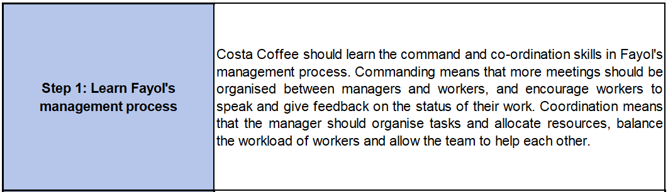
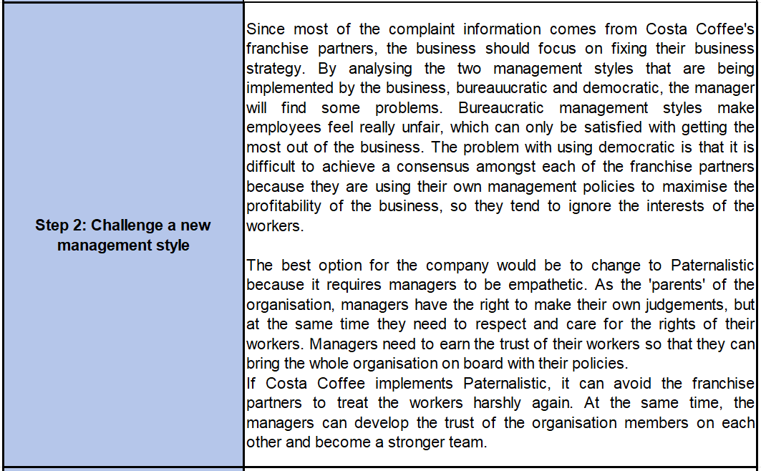
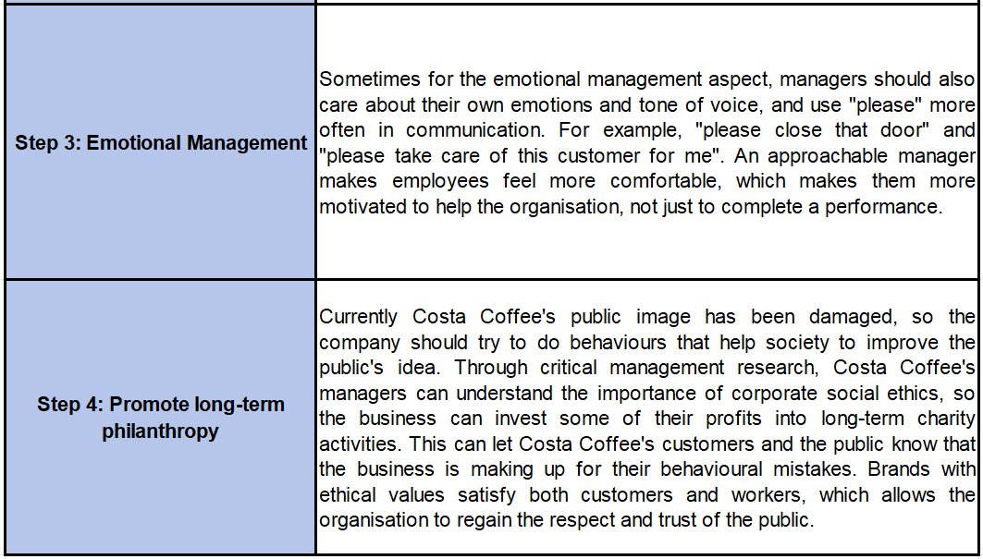

References
Akella, D. (2008). A Reflection on Critical Management Studies. Journal of Management & Organization, 14(1), pp.100–110. doi: https://doi.org/10.5172/jmo.2008.14.1.100 [Accessed 11 Nov. 2023].

Ashkanasy, N.M. and Daus, C.S. (2002). Emotion in the workplace: the New Challenge for Managers. Academy of Management Perspectives, 16(1), pp.76–86. doi: https://doi.org/10.5465/ame.2002.6640191 [Accessed 11 Nov. 2023].

Bass, B.M., Valenzi, E.R., Farrow, D.L. and Solomon, R.J. (1975). Management Styles Associated with organizational, task, personal, and Interpersonal contingencies. Journal of Applied Psychology, 60(6), pp.720–729. doi: https://doi.org/10.1037/0021-9010.60.6.720 [Accessed 11 Nov. 2023].

Brown, E. (2023). 5 Management Styles and Their Pros and Cons. [online] Unito. Available at: https://unito.io/blog/types-of-management-styles/ [Accessed 14 Nov. 2023].

CFI Team (2022). Management Theories. [online] Corporate Finance Institute. Available at: https://corporatefinanceinstitute.com/resources/management/management-theories/ [Accessed 15 Nov. 2023].

Coffee, C. (2022a). Global Locations. [online] Costa Careers. Available at: https://www.costacareers.co.uk/global-locations/# [Accessed 14 Nov. 2023].

Costa Coffee (2019). People — Sustainability | Costa Coffee. [online] Costa.co.uk. Available at: https://www.costa.co.uk/sustainability/people [Accessed 14 Nov. 2023].

Costa Coffee (2022b). Communities. [online] Costa.co.uk. Available at: https://www.costa.co.uk/sustainability/communities [Accessed 16 Nov. 2023].

Costa Coffee (2022c). Our Culture. [online] Costa Careers. Available at: https://www.costacareers.co.uk/our-culture/ [Accessed 11 Nov. 2023].

Costa Coffee (2022d). Our history - Our story | Behind the beans | Costa Coffee. [online] Costa.co.uk. Available at: https://www.costa.co.uk/behind-the-beans/our-story/history [Accessed 11 Nov. 2023].

Dow, S.C. (1997). Mainstream Economic Methodology. Cambridge Journal of Economics, [online] 21(1), pp.73–93. Available at: https://www.jstor.org/stable/23599615 [Accessed 16 Nov. 2023].

Fells, M.J. (2000). Fayol Stands the Test of Time. Journal of Management History (Archive), 6(8), pp.345–360. doi: https://doi.org/10.1108/13552520010359379 [Accessed 11 Nov. 2023].

Harappa (2021). Paternalistic Leadership Style: Examples, Advantages, and Disadvantages. [online] Harappa. Available at: https://harappa.education/harappa-diaries/paternalistic-leadership/ [Accessed 11 Dec. 2023].

Hewege, C.R. (2012). A Critique of the Mainstream Management Control Theory and the Way Forward. SAGE Open, 2(4). doi: https://doi.org/10.1177/2158244012470114 [Accessed 11 Nov. 2023].

Hoogervorst, J. (2017). The Imperative for Employee-centric Organizing and Its Significance for Enterprise Engineering. Organizational Design and Enterprise Engineering, 1(1), pp.43–58. doi: https://doi.org/10.1007/s41251-016-0003-y [Accessed 11 Nov. 2023].

Indeed (2022). Costa Coffee Reviews. [online] UK Indeed. Available at: https://uk.indeed.com/cmp/Costa-Coffee/reviews?fcountry=ALL&ftopic=mgmt [Accessed 14 Nov. 2023].

Kai, P., Tung, J., Lo, S. and Mei, J. (2013). Scientific Management. The International Journal of Organizational Innovation, [online] 5(4), p.78. Available at: https://www.ijoi-online.org/attachments/article/34/FINAL%20ISSUE%20VOL%205%20NUM%204%20APRIL%202013.pdf#page=78 [Accessed 15 Nov. 2023].

Mahmood, Z. and Basharat, M. (2012). Review of Classical Management Theories. International Journal of Social Sciences and Education, [online] 2(1), pp.1–2. Available at: https://www.ijsse.com/sites/default/files/issues/2012/volume%202%20issue%201%20Jan%202012/paper%2039/paper-39.pdf [Accessed 15 Nov. 2023].

Pellegrini, E.K. and Scandura, T.A. (2008). Paternalistic Leadership: A Review and Agenda for Future Research. Journal of Management, 34(3), pp.566–593. doi: https://doi.org/10.1177/0149206308316063 [Accessed 11 Dec. 2023].

Price, K. (2019). Costa Coffee to Launch Independent Audit into... [online] The Caterer. Available at: https://www.thecaterer.com/news/costa-coffee-to-launch-independent-audit-into-franchise-partners [Accessed 14 Nov. 2023].

Rotemberg, J.J. and Saloner, G. (1993). Leadership Style and Incentives. Management Science, 39(11), pp.1299–1318. doi: https://doi.org/10.1287/mnsc.39.11.1299 [Accessed 11 Nov. 2023].

Sharma, R. (2023). Learn How Bureaucratic Leadership Works and When to Use it. [online] Emeritus. Available at: https://emeritus.org/in/learn/leadership-what-is-bureaucratic-leadership/ [Accessed 14 Nov. 2023].

Taylor, F.W. (2003). Scientific Management. [online] Google Books, New York and London: Harper & Brothers , p.8. Available at: doi: https://doi.org/10.4324/9780203498569 [Accessed 15 Nov. 2023].

Woods, P. (2021). Democratic Leadership. [online] uhra.herts.ac.uk, New York: Oxford University Press, pp.1–2. doi: https://doi.org/10.1093/acrefore/9780190264093.013.609 [Accessed 11 Nov. 2023].

Yusuf, H. (2019a). Costa Coffee franchise workers ‘not treated like humans’. BBC News. [online] 23 Aug. Available at: https://www.bbc.co.uk/news/uk-49432367 [Accessed 11 Nov. 2023].

Yusuf, H. (2019b). Costa Coffee: Employees call £200 deductions for training ‘unfair’. BBC News. [online] 19 Aug. Available at: https://www.bbc.co.uk/news/uk-49292051 [Accessed 11 Nov. 2023].

