Cloud Based Web Services
  - Name: Sarann Strange

Student Number: 1701763

University of wales Trinity saint David

Stream: B.Sc. Software engineering

Assignment code: ACCA6024

Lecturer:
Tim Bashford
Mike Dacy

Table of Contents
1 Table of Contents 1
2 Table of figures 2
3 Introduction 3
4 Simple Object Access Protocol (SOAP) 4
4.1 Benefits & Drawbacks 5
5 Representational state transfer (REST) 6
5.1 Benefits and Drawbacks 7
6 GraphQL Web Services 8
6.1 Benefits and Drawbacks 9
7 Compare & Contrast 10
8 Conclusion 11
9 References 12

Table of figures
Figure 1 SOAP message structure example 4
Figure 2 Standardised GET, POST, DELETE, PUT protocols 6
Figure 3 GraphQL Example of request and its response 8
Figure 4 Example of REST round-trips 10

Introduction
The report includes a dynamic webpage that uses AJAX, the website exchanges data from webservices using REST to GET, POST and DELETE data from a database. The website was designed with responsiveness in mind as it implements bootstrap to allow compatibility between devices.
The written section of this report provides information on SOAP, REST and GraphQL and how each work within the context of web services. The information provided within this report includes the individual benefits of SOAP, REST and GraphQL, their drawbacks and how these drawbacks can impact their use when being used.
The final section of the report highlights the individual benefits of SOAP, REST and GraphQL and finally compares each of them against one another to conclude if any are a better choice and when and why one may be favoured over another.

Simple Object Access Protocol (SOAP)
Within the “web services protocol stack” SOAP is an application communication protocol that was designed to be platform independent. It is a lightweight protocol that uses Extensible Mark-up Language (XML) and works over the ‘Hyper Text Transfer Protocol’ (HTTP). It was designed to work with any application using different operating systems such as Linux or Windows [1][2][3].
Its purpose is to allow web-services to communicate with client applications and other web-services, without the need to create complex code to exchange data between applications that are designed in different programming languages. SOAP messages are inherently simple by nature, they are made of an XML element containing a header element and a body element as seen within figure 1 [4][5][6].

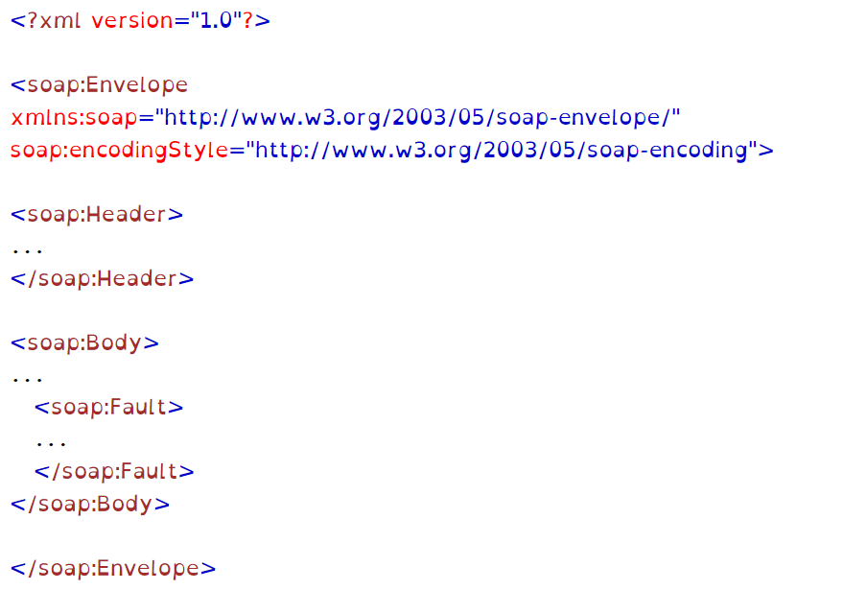

[7]
Figure 1 SOAP message structure example

Benefits & Drawbacks
The benefits of SOAP are the facts that it is both language and platform independent, this means that web-services can be written in PHP, .Net or Java and can still communicate with any platform [8].
SOAP has its own defined security known as WS Security, it dictates the security measures of SOAP, protecting it from external attacks through authentication, confidentiality, and integrity. It also has built in error handling that returns messages and explanations of the failure that has occurred.
A drawback of SOAP is that it is slow and uses more resources and bandwidth, as it uses the XML format which has standards that must be deconstructed and followed. SOAP is ‘Web Service Definition Language’ (WSDL) dependent. WSDL is an interface description language that defines the functionality of the web service and provides information on how to connect to it, this makes it less flexible than REST and GraphQL to changes [9][10]. Due to SOAPs simplicity and human readability; it makes it less secure requiring more encryption if the data being transmitted is of a sensitive nature.

Representational state transfer (REST)
An architecture style known as REST commonly uses HTTP, a stateless client server protocol, to design networked applications. REST is interoperable and can be used by different programming languages as it is platform independent [11][12][13].
REST unlike SOAP is not reliant on XML, it uses the uniform resource locator (URL) to decide how it will respond to requests that are made by a client. REST is lightweight and allows for scalability of web services as it retrieves its resources through servers using the defined and standardised protocols GET, POST, DELETE and PUT as seen within figure 2 This ensures that different clients that preform similar actions arrive at the same endpoint [14][15][16][17].

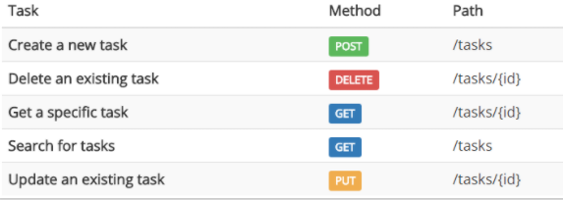

[14]
Figure 2 Standardised GET, POST, DELETE, PUT protocols

Benefits and Drawbacks
REST is simple, standardised and used within industry. There are regular updates and features for the REST API (Application Programming Interface), it is also scalable allowing businesses to alter and update their web service to include more functionality if they wish to do so. REST also supports caching, which is information that has previously been requested from a server being stored onto a device. This improves the performance of a web server as repeated requests are not continually being sent from the client directly to the server, but from the client to their own cached data, overall lowering the traffic across the network [18][19][20][21].
A drawback of REST is that it can be performance heavy and can take up a lot of computational time. This is due to the nature of a GET, returns all related data to the request whether it is relevant or not, this can impact a user who has a limited data plan on a mobile platform. REST also has multiple endpoints so if various resources are accessed at the same time it must perform multiple round-trips to retrieve all of the data, this can make working with the code of the REST API confusing and unwieldy to maintain [22][23].

GraphQL Web Services
Query languages (QL) are a programming language that works with a database, it does this by requesting data and retrieving data using queries. GraphQL is a query language that works with APIs as seen within figure 3 [24].

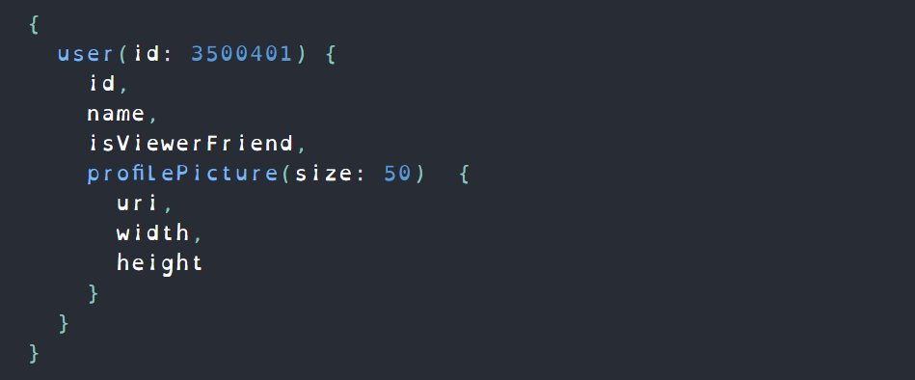
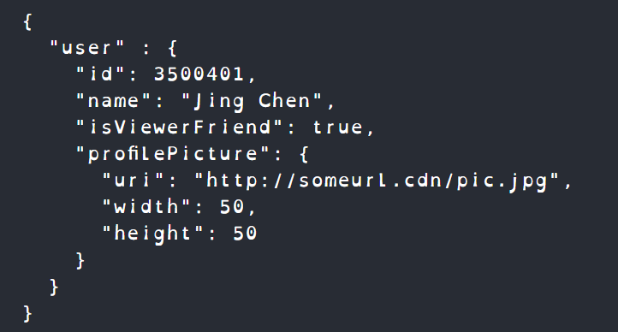

[25]
Figure 3 GraphQL Example of request and its response

GraphQL was created as REST was considered inflexible, and developers found it difficult to create an API that could ideally handle mobile-phones, due to their different front end application frame works. REST was not an ideal solution due to its inability to request specific data [26][27][28].
The main aspects of GraphQL are its schemas and resolve functions. The schema dictates the queries that clients can use and the type of data that can be requested. The resolve specifies the backend connections of the schema. It is these schemas that allow front-end teams to work independently of the back-end teams allowing development to continue freely [24].

Benefits and Drawbacks
A benefit of GraphQL is that it does not retrieve unnecessary data, but instead it allows clients to request the exact data that they want. This makes GraphQL predictable, efficient, and precise in the way requests are made and carried out, making it easier to develop an API as front-end developers can freely make changes when necessary [29].
The queries of GraphQL can retrieve all the relevant data that a client requests through a single request, this means that GraphQL carries out a single round trip to get the data that is requested, making it faster and able to function on slow network connections [30][27][31].
Another benefit of GraphQL are the detailed error messages that are provided before a query is executed enabling developers to quickly identify issues and resolve them.
A drawback of GraphqQL is that it is harder to implement caching than in REST, GraphQL requires additional libraries to correctly implement a caching system. GraphQLs are also susceptible to Denial of service (DOS) attacks, developers must use a few techniques to protect their servers from attacks. These include limiting the complexity of queries and tracking the queries that are made by clients [32].

Compare & Contrast
When choosing SOAP, REST or GraphQL it is important to consider the requirements of the APIs and what the developer wishes to achieve from the system. If for example the API has a lot of domain objects and a lot of requests need to be made to retrieve those objects as they are connected in some way, the GraphQL would be best suited, due to its ability to retrieve different data from one request. By using GraphQL it is preventing under-fetching and over-fetching of data that REST can be susceptible to doing [19][33][34].
When the client requests data through REST API or SOAP it retrieves all data relating to a request. Another issue with SOAP is that it requires developers to use an XML file to carryout requests by clients, and XML files are notoriously large and requires more bandwidth. Due to the GraphQL’s ability to allow clients to be specific in the data that they want to retrieve from the database, it does not retrieve redundant data, making it faster and more efficient [35][36].
When requesting data with REST if the client wanted many resources, a new request would need to be made for each of the resources required as seen within figure 4 SOAP not only works similarly to REST in this instance, but it also requires a developer with a specialised knowledge on its protocols, this makes REST easier to work with. This has been improved by GraphQL due to the nature of it using a dynamic query, the client only needs to create one request for multiple resources to be retrieved [37][38][39].
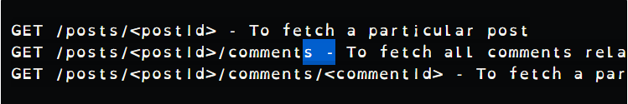
Figure 4 Example of REST round-trips
[40]

A developer may choose REST over GraphQL as it is easier to acquire API analytics that are used by different teams working on the system, they include analytics such as performance and uptimes to customer and product metrics. All this information can provide indications on improvements that can be made to certain aspects of the system [41][42][43].
Due to SOAP’s reliance on XML, REST is lightweight in comparison. REST can use XML, it can also use HTML, plain text and JSON. Another benefit of REST is that it is an architectural style, therefore it has the capability within web-services to implement SOAP as an underlying protocol. But Due to SOAP being a protocol it is unable to use REST in any meaningful way.
Another option that the developer can choose is to combine GraphQL and REST within a single project as they are capable of functioning alongside one another. This may not be an option if the developer is uncertain on how to implement GraphQL as it has a steep learning curve in comparison to REST [38][44].
To conclude there is no definitive choice on what tool is the best as they all have their own drawbacks and benefits it is up to the developer to consider and determine the way in which they want they system to work, based on the devices that will be used to access their servers [45][46].

Conclusion
In addition to the report is a solution that successfully includes the creation of a web application that uses the REST API.
The report discussed and described in detail SOAP, REST and GraphQL APIs, their benefits and drawbacks and finally concluding with an in-depth analysis of all three while expressing their strengths and weaknesses in comparison with one another.
Although SOAP is the oldest out of the three, API and GrqphQL is the most recent REST was discovered to be the most popular, even though GraphQL seems to be the superior of the three options, it remains that each alternative are advantages for a given need.
The conclusion of the report is that it is not as simple as choosing the most recent developments when designing an API as developers must identify what they wish their web application to achieve, before they can successfully identify if they will use REST or GraphQL, or both within the same project.

References

[1] G. Dai, “Design and implementation on SOAP-based things management protocol for internet of things,” in Proceedings of the World Congress on Intelligent Control and Automation (WCICA), 2012, pp. 4305–4308, doi: 10.1109/WCICA.2012.6359203.
[2] Y. Xu, H. Tang, and P. Zhang, “An advanced text-to-speech server system based on soap protocol,” in ICASSP, IEEE International Conference on Acoustics, Speech and Signal Processing - Proceedings, 2003, vol. 1, pp. 728–731, doi: 10.1109/icassp.2003.1198884.
[3] M. Tsenov, “Application of SOAP protocol in e-commerce solution,” in 2002 1st International IEEE Symposium , 2002, vol. 3, pp. 59–62, doi: 10.1109/IS.2002.1042588.
[4] O. Pasteur, T. Dang, and P. E. Delon, “Feedback from SOAP based messaging protocol for power generation information system,” 2007, doi: 10.1109/MED.2007.4433645.
[5] G. M. Waleed and R. B. Ahmad, “Security protection using Simple Object Access Protocol (SOAP) messages techniques,” 2008, doi: 10.1109/ICED.2008.4786714.
[6] S. Pawar and N. N. Chiplunkar, “Open source APIs for processing the XML result of web services,” in 2017 International Conference on Advances in Computing, Communications and Informatics, ICACCI 2017, Nov. 2017, vol. 2017-January, pp. 1848–1854, doi: 10.1109/ICACCI.2017.8126114.
[7] w3schools.com, “XML Soap,” 2020. https://www.w3schools.com/xml/xml_soap.asp (accessed Dec. 18, 2020).
[8] w3schools.com, “XML Soap,” 2020. https://www.w3schools.com/xml/xml_soap.asp (accessed Dec. 23, 2020).
[9] T. Takase and K. Tajima, “Efficient Web Services Message Exchange by SOAP Bundling Framework,” Apr. 2008, pp. 63–63, doi: 10.1109/edoc.2007.38.
[10] C. C. de Melo Silva, H. G. C. Ferreira, R. T. de Sousa Júnior, F. Buiati, and L. J. G. Villalba, “Design and Evaluation of a Services Interface for the Internet of Things,” Wirel. Pers. Commun., vol. 91, no. 4, pp. 1711–1748, Dec. 2016, doi: 10.1007/s11277-015-3168-6.
[11] H. Garg and M. Dave, “Securing IoT Devices and SecurelyConnecting the Dots Using REST API and Middleware,” Apr. 2019, doi: 10.1109/IoT-SIU.2019.8777334.
[12] L. Li, W. Chou, W. Zhou, and M. Luo, “Design Patterns and Extensibility of REST API for Networking Applications,” IEEE Trans. Netw. Serv. Manag., vol. 13, no. 1, pp. 154–167, Mar. 2016, doi: 10.1109/TNSM.2016.2516946.
[13] A. Tarkowska, D. Carvalho-Silva, C. E. Cook, E. Turner, R. D. Finn, and A. D. Yates, “Eleven quick tips to build a usable REST API for life sciences,” PLoS Comput. Biol., vol. 14, no. 12, Dec. 2018, doi: 10.1371/journal.pcbi.1006542.
[14] Kenneth Lange, “Don’t Limit Your REST API to CRUD Operations,” 2020. https://www.kennethlange.com/dont-limit-your-rest-api-to-crud-operations/ (accessed Dec. 18, 2020).
[15] S. P. Ong et al., “The Materials Application Programming Interface (API): A simple, flexible and efficient API for materials data based on REpresentational State Transfer (REST) principles,” Comput. Mater. Sci., vol. 97, pp. 209–215, Feb. 2015, doi: 10.1016/j.commatsci.2014.10.037.
[16] V. Atlidakis, P. Godefroid, and M. Polishchuk, “RESTler: Stateful REST API Fuzzing,” in Proceedings - International Conference on Software Engineering, May 2019, vol. 2019-May, pp. 748–758, doi: 10.1109/ICSE.2019.00083.
[17] S. K. Purushothaman, N. Kashyap, D. Ha, S. Agarwal, S. Iqbal, and V. Behere, “Unified Approach towards Automation of any Desktop Web, Mobile Web, Android, iOS, REST and SOAP API Use Cases,” Dec. 2018, doi: 10.1109/ICCSDET.2018.8821229.
[18] T. Hu et al., “SEAPP: A secure application management framework based on REST API access control in SDN-enabled cloud environment,” J. Parallel Distrib. Comput., vol. 147, pp. 108–123, Jan. 2021, doi: 10.1016/j.jpdc.2020.09.006.
[19] L. Li and W. Chou, “Design and describe REST API without violating REST: A Petri Net based approach,” in Proceedings - 2011 IEEE 9th International Conference on Web Services, ICWS 2011, 2011, pp. 508–515, doi: 10.1109/ICWS.2011.54.
[20] T. Haselmann, G. Thies, and G. Vossen, “Looking into a REST-based API for database-as-a-service systems,” in Proceedings - 12th IEEE International Conference on Commerce and Enterprise Computing, CEC 2010, 2010, pp. 17–24, doi: 10.1109/CEC.2010.11.
[21] S. Allamaraju, RESTful Web Services Cookbook: Solutions for Improving Scalability and ... - Subbu Allamaraju - Google Books. O’Reilly, 2010.
[22] S. J. Chalk, “Leveraging Web 2.0 technologies to add value to the IUPAC Solubility Data Series: development of a REST style website and application programming interface (API),” Pure Appl. Chem, vol. 87, pp. 1127–1137, 2015, doi: 10.1515/pac-2015-0403.
[23] S. M. Sohan, F. Maurer, C. Anslow, and M. P. Robillard, “A study of the effectiveness of usage examples in REST API documentation,” in Proceedings of IEEE Symposium on Visual Languages and Human-Centric Computing, VL/HCC, Nov. 2017, vol. 2017-October, pp. 53–61, doi: 10.1109/VLHCC.2017.8103450.
[24] E. Wittern, A. Cha, J. C. Davis, G. Baudart, and L. Mandel, “An Empirical Study of GraphQL Schemas,” Lect. Notes Comput. Sci. (including Subser. Lect. Notes Artif. Intell. Lect. Notes Bioinformatics), vol. 11895 LNCS, pp. 3–19, Jul. 2019, Accessed: Dec. 23, 2020. [Online]. Available: http://arxiv.org/abs/1907.13012.
[25] Nick Schrock, “GraphQL Introduction,” 2015. https://reactjs.org/blog/2015/05/01/graphql-introduction.html (accessed Dec. 19, 2020).
[26] D. Chaves-Fraga, F. Priyatna, A. Alobaid, and O. Corcho, “Exploiting Declarative Mapping Rules for Generating GraphQL Servers with Morph-GraphQL,” Int. J. Softw. Eng. Knowl. Eng., vol. 30, no. 6, pp. 785–803, Jun. 2020, doi: 10.1142/S0218194020400070.
[27] G. Brito, T. Mombach, and M. T. Valente, “Migrating to GraphQL: A Practical Assessment,” in SANER 2019 - Proceedings of the 2019 IEEE 26th International Conference on Software Analysis, Evolution, and Reengineering, Mar. 2019, pp. 140–150, doi: 10.1109/SANER.2019.8667986.
[28] João Inez, “GraphQL vs REST: putting REST to rest,” imaginarycloud, May 16, 2019. https://www.imaginarycloud.com/blog/graphql-vs-rest/ (accessed Dec. 23, 2020).
[29] GraphQL, “GraphQL Best Practices | GraphQL,” 2020. https://graphql.org/learn/best-practices/ (accessed Dec. 23, 2020).
[30] S. Rasool, R. Khan, and A. N. Mian, “GraphQL and DC-WSN-Based Cloud of Things,” IT Prof., vol. 21, no. 1, pp. 59–66, Jan. 2019, doi: 10.1109/MITP.2018.2876982.
[31] Rully yulian MF, Building GraphQL API Services with ASP.NET Core - Google Books. 2018.
[32] Robin Wieruch, The Road to GraphQL . 2018.
[33] M. Bryant, “GraphQL for archival metadata: An overview of the EHRI GraphQL API,” in Proceedings - 2017 IEEE International Conference on Big Data, Big Data 2017, Jul. 2017, vol. 2018-January, pp. 2225–2230, doi: 10.1109/BigData.2017.8258173.
[34] P. Roksela, M. Konieczny, and S. Zielinski, “Evaluating execution strategies of GraphQL queries,” in 2020 43rd International Conference on Telecommunications and Signal Processing, TSP 2020, Jul. 2020, pp. 640–644, doi: 10.1109/TSP49548.2020.9163501.
[35] S. M. Sohan, C. Anslow, and F. Maurer, “Automated example oriented REST API documentation at Cisco,” in Proceedings - 2017 IEEE/ACM 39th International Conference on Software Engineering: Software Engineering in Practice Track, ICSE-SEIP 2017, Jun. 2017, pp. 213–222, doi: 10.1109/ICSE-SEIP.2017.11.
[36] D. A. Hartina, A. Lawi, and B. L. E. Panggabean, “Performance Analysis of GraphQL and RESTful in SIM LP2M of the Hasanuddin University,” in Proceedings - 2nd East Indonesia Conference on Computer and Information Technology: Internet of Things for Industry, EIConCIT 2018, Nov. 2018, pp. 237–240, doi: 10.1109/EIConCIT.2018.8878524.
[37] E. Lee, K. Kwon, and J. Yun, “Performance Measurement of GraphQL API in Home ESS Data Server,” in 2020 International Conference on Information and Communication Technology Convergence (ICTC), Oct. 2020, pp. 1929–1931, doi: 10.1109/ICTC49870.2020.9289569.
[38] G. Brito and M. T. Valente, “REST vs GraphQL: A controlled experiment,” in Proceedings - IEEE 17th International Conference on Software Architecture, ICSA 2020, Mar. 2020, pp. 81–91, doi: 10.1109/ICSA47634.2020.00016.
[39] ALEXANDRA ALTVATER, “SOAP vs. REST: The Differences and Benefits Between the Two Widely-Used Web Service Communication Protocols – Stackify,” Mar. 14, 2017. https://stackify.com/soap-vs-rest/ (accessed Dec. 23, 2020).
[40] Adarsh, “GraphQL or REST? What should I use? - DEV,” 2018. https://dev.to/sadarshannaiynar/graphql-or-rest-what-should-i-use-38mj (accessed Dec. 19, 2020).
[41] how to GraphQL, “GraphQL vs REST - A comparison,” 2020. https://www.howtographql.com/basics/1-graphql-is-the-better-rest/ (accessed Jan. 02, 2021).
[42] Barclays, “Differences between REST and GraphQL | Barclays API Exchange,” 2020. https://developer.barclays.com/blog/differences-between-rest-and-graphql (accessed Jan. 02, 2021).
[43] Kevin Sundstorm, “Cloudflare Unifies Analytics Data With New GraphQL API | ProgrammableWeb,” programmableWeb, Dec. 13, 2019. https://www.programmableweb.com/news/cloudflare-unifies-analytics-data-new-graphql-api/brief/2019/12/13 (accessed Jan. 02, 2021).
[44] Carolyn Stransky, “Life is hard and so is learning GraphQL at ReactJS Girls Conference - DEV Community,” Oct. 13, 2020. https://dev.to/carolstran/life-is-hard-and-so-is-learning-graphql-at-reactjs-girls-conference-4bg (accessed Jan. 02, 2021).
[45] M. Mikuła and M. Dzieńkowski, “Comparison of REST and GraphQL web technology performance,” J. Comput. Sci. Inst., vol. 16, pp. 309–316, Sep. 2020, doi: 10.35784/jcsi.2077.
[46] Shahadat Hossain, “3 major REST API problem can solve using GraphQL - DEV Community,” DEV, Apr. 16, 2019. https://dev.to/mshossain110/3-major-rest-api-problem-can-solve-using-graphql-1dg2 (accessed Jan. 02, 2021).

Appendix

Index.html
<!DOCTYPE html>
<html>
<head>
<meta charset="utf-8" />
<title>Web Services Assignemt - Sarann Strange</title>

<link rel="stylesheet" href="https://stackpath.bootstrapcdn.com/bootstrap/4.5.2/css/bootstrap.min.css" integrity="sha384-JcKb8q3iqJ61gNV9KGb8thSsNjpSL0n8PARn9HuZOnIxN0hoP+VmmDGMN5t9UJ0Z" crossorigin="anonymous">

<!-- Style.css -->
<link href="../css/StyleSheet.css" rel="stylesheet" />

</head>
<body data-spy="scroll" data-target="#navbarResponsive">

<!-- Start Home Section -->
<div id="home">

<!-- Navigation-->
<nav class="navbar navbar-expand-md fixed-top navbar-dark bg-dark ">
<a class="navbar-brand" href="#">Sarann Strange Web Assignment</a>
<button class="navbar-toggler" type="button" data-toggle="collapse" data-target="#navbarResponsive">
<span class="custom-toggler-icon"><i class="fas fa-hamburger"></i></span>
</button>
<div class="collapse navbar-collapse" id="navbarResponsive">
<ul class="navbar-nav ml-auto">
<li class="nav-item">
<a href="#home" class="nav-link">HOME</a>
</li>
<li class="nav-item">
<a href="#POST" class="nav-link">POST</a>
</li>
<li class="nav-item">
<a href="#DELETE" class="nav-link">DELETE</a>
</li>
<li class="nav-item">
<a href="#GETBYID" class="nav-link">GET BY ID</a>
</li>
<li class="nav-item">
<a href="#GETALL" class="nav-link">GET ALL</a>
</li>
</ul>
</div>

</nav>
</div>

<!-- POST -->
<div class="jumbotron text-center pt-20 mb-0">
<div id="POST" class="container fixing-Gap">
<form id="postdata-form">

<h2 class="font-weight-bold text-uppercase">Add new post</h2>
<div class="underline mx-auto my-4"></div>

<label for="title-text">Title:</label>
<input id="title-text" type="text" /><br />
<label for="body-text">Body:</label>
<input id="body-text" type="text" /><br />
<label for="user-id-text">UserId:</label>
<input id="user-id-text" type="text" /><br />
<input id="post-button" type="button" value="Add Post" />
<div id="postresults">Waiting...</div>
</form>
</div>
</div>

<!-- DELETE -->
<div class="jumbotron text-center pt-20 mb-0">
<div id="DELETE" class="container fixing-Gap">
<form id="getdatabyid-form">
<h2 class="font-weight-bold text-uppercase">Delete existing post</h2>
<label for="id-text">Post Id:</label>
<input id="id-text" type="text" /><br />
<input id="delete-button" type="button" value="Delete Post" />
<div id="deleteresults">Waiting...</div>
</form>
</div>
</div>

<!-- GET BY ID -->
<div class="jumbotron text-center pt-20 mb-0">
<div id="GETBYID" class="container fixing-Gap">
<form id="readdata-form">
<h2 class="font-weight-bold text-uppercase">Get a post By ID</h2>
<label for="getid-text">Post Id:</label>
<input id="getid-text" type="text" /><br />
<input id="getbyid-button" type="button" value="Get Post" />
<div id="getbyidresults">Waiting...</div>
</form>
</div>
</div>

<!-- GET ALL -->
<div class="jumbotron text-center pt-20 mb-0">
<div id="GETALL" class="container fixing-Gap">
<form id="getdata-form">
<h2 class="font-weight-bold text-uppercase">Get All post</h2>
<input id="get-button" type="button" value="Get Posts" />
<input id="get-p-button" type="button" value="Get Posts Using Promise" />
<div id="loadtext">Waiting...</div>
</form>
</div>
</div>

<!-- Script Source Files -->
<!-- jQuery https://code.jquery.com/ -->
<script src="https://code.jquery.com/jquery-3.5.1.min.js" integrity="sha256-9/aliU8dGd2tb6OSsuzixeV4y/faTqgFtohetphbbj0=" crossorigin="anonymous"></script>

<!-- AJAX -->
<script src="https://ajax.googleapis.com/ajax/libs/jquery/3.5.1/jquery.min.js"></script>

<!-- Bootstrap JS https://getbootstrap.com/docs/4.5/getting-started/introduction/ -->
<script src="https://cdn.jsdelivr.net/npm/popper.js@1.16.1/dist/umd/popper.min.js" integrity="sha384-9/reFTGAW83EW2RDu2S0VKaIzap3H66lZH81PoYlFhbGU+6BZp6G7niu735Sk7lN" crossorigin="anonymous"></script>

<script src="https://stackpath.bootstrapcdn.com/bootstrap/4.5.2/js/bootstrap.min.js" integrity="sha384-B4gt1jrGC7Jh4AgTPSdUtOBvfO8shuf57BaghqFfPlYxofvL8/KUEfYiJOMMV+rV" crossorigin="anonymous"></script>

<!-- Font Awesome https://fontawesome.com/ https://use.fontawesome.com/releases/v5.14.0/js/all.js -->
<script src="https://kit.fontawesome.com/87fcbf4a60.js" crossorigin="anonymous"></script>

<!-- Plugins.js -->
<script src="../js/plugins.js"></script>

<!-- JavaScript.js-->
<script src="../js/JavaScript.js"></script>

</body>
</html>

Plugins.js

//colapsed hamburger when click anywhere out side of menu
$(document).ready(function () {
$(document).click(function (event) {
var clickover = $(event.target);
var _opened = $(".navbar-collapse").hasClass("show");
if (_opened === true && !clickover.hasClass("navbar-toggler")) {
$(".navbar-toggler").click();
}
});
});

//this is the animated scroll when click on nav link
$(document).ready(function(){

$("a").on('click', function(event) {

if (this.hash !== "") {

event.preventDefault();

var hash = this.hash;

$('html, body').animate({
scrollTop: $(hash).offset().top
}, 700, function(){
});
}
});
});

JavaScript.js

$(function () {
$.ajaxSetup({ cache: false });

$("#get-button").click(function (e) {
GetPosts();
e.preventDefault();
return false;
});

$("#get-p-button").click(function (e) {
GetPostsUsingPromise();
e.preventDefault();
return false;
});

$("#post-button").click(function (e) {
SendPost();
e.preventDefault();
return false;
});

$("#delete-button").click(function (e) {
DeletePost();
e.preventDefault();
return false;
});

$("#getbyid-button").click(function (e) {
GetPost();
e.preventDefault();
return false;
});
});

function GetPosts() {
$.ajax({
cache: false,
type: "GET",
url: "https://jsonplaceholder.typicode.com/posts",
data: '',
contentType: "application/json; charset=utf-8",
dataType: "json",
success: (json, status, req) => {
var html = "";
console.log(json);
for (i in json) {
html += "Title:" + json[i].title + "<br/>"
+ "Body:" + json[i].body + "<br/>";
}

$("#loadtext").html(html);
},
error: (req, status, error) => window.alert("AJAX error")
});
}

function GetPostsUsingPromise() {

$.ajax({
cache: false,
type: "GET",
url: "https://jsonplaceholder.typicode.com/posts",
data: '',
contentType: "application/json; charset=utf-8",
dataType: "json"
}).done((json, status, req) => {
var html = "";
console.log(json);
for (i in json) {
html += "Title:" + json[i].title + "<br/>"
+ "Body:" + json[i].body + "<br/>";
}
$("#loadtext").html(html);
}).fail((req, status, error) => {
window.alert("AJAX error");
});
}

function SendPost() {
var data = {
title: $("#title-text").val(),
body: $("#body-text").val(),
userId: parseInt($("#user-id-text").val())
};

$.ajax({
cache: false,
type: "POST",
url: "https://jsonplaceholder.typicode.com/posts",
data: JSON.stringify(data),
contentType: "application/json; charset=utf-8",
dataType: "json",
success: (json, status, req) => {
var html = "";
console.log(json);

html += "Id:" + json.id + "<br/>"
+ "Title:" + json.title + "<br/>"
+ "Body:" + json.body + "<br/>"
+ "UserId:" + json.userId + "<br/>";

$("#postresults").html(html);
},
error: (req, status, error) => window.alert("AJAX error")
});
}

function DeletePost() {
var postId = parseInt($("#id-text").val());

$.ajax({
cache: false,
type: "DELETE",
url: `https://jsonplaceholder.typicode.com/posts/${postId}`,
data: '',
contentType: "application/json; charset=utf-8",
dataType: "json",
success: (json, status, req) => $("#deleteresults").html("<p>Success</p>"),
error: (req, status, error) => window.alert("AJAX error")
});
}

function GetPost() {
var postId = parseInt($("#getid-text").val());

$.ajax({
cache: false,
type: "GET",
url: `https://jsonplaceholder.typicode.com/posts/${postId}`,
data: '',
contentType: "application/json; charset=utf-8",
dataType: "json",
success: (json, status, req) => {
var html = "";

html += "Id:" + json.id + "<br/>"
+ "Title:" + json.title + "<br/>"
+ "Body:" + json.body + "<br/>"
+ "UserId:" + json.userId + "<br/>";

$("#getbyidresults").html(html);
},
error: (req, status, error) => window.alert("AJAX error")
});
}

StyleSheet.css
body {
font-family: sans-serif;
color: #484f59;
}

.navbar{
font-size: .8rem;
letter-spacing: .2rem;
}

.navbar-nav li{
padding-right: .9rem;
}

/* making it so it will jump between the headers properly*/
.fixing-Gap:before {
content: "";
height: 63px;
margin-top: -63px;
display: block;
}

Server.js
'use strict';
const express = require('express'); //including express library
const service = express();
const path = require('path');//including path library
const router = express.Router();
const port = process.env.PORT || 8000;

service.use(express.static(path.join(__dirname + '/public'))); //alowing server to use the public folder
router.get('/', (req, res) => {
res.sendFile(path.join(__dirname+'/public/views/index.html'));
});

service.use('/', router);
service.listen(port, () => { console.log(`listening on port ${port}`); });

