University of Wales Trinity Saint David

Wales Institute of Science and Art

Electrical Circuits Testing and Applications

ACHA4010 Electrical Control Systems

James Greenhill-Upward
2005245

2nd April 2023
Contents
1 Task 1 1
1.1 A 1
1.2 B 1
1.3 c (i) 1
1.4 c (ii) 1
1.5 c (iii) 1
1.6 c (iv) 1
1.7 d 1
1.8 e 1
1.9 f 1
1.10 g 1
2 Task 2 2
2.1 Scope Time Division Calculations 2
2.2 Function Generator output sine wave 2
2.3 Unsmoothed Rectifier Wave 2
2.4 Smoothed Rectifier Wave 3
2.5 Drop in Voltage Question 3
2.6 Rectifiers use in Automotive applications Question. 3
2.7 Probing Question 3
3 Task 3 4
3.1 Scope Time Division Calculations 4
3.2 Function Generator output sine wave 4
3.3 Capacitor charge and discharge wave marked at correct points. 4
3.4 Basic Capacitor Calculations 4
3.5 Capacitor discharge table 5
3.6 Gradient Plot and calculations 5
3.7 Inaccuracies Question 5
4 References 6

Task 1

A

B
B=0.3A C=0.3A

c (i)

c (ii)

c (iii)

c (iv)

d

e

f

g

Task 2

Scope Time Division Calculation
$\frac{1}{Frequency }=Period$ / Frequency = 10Hz / $\frac{1}{10}=0.1s$ / Period = 0.1s or 1000ms

Function Generator output sine wave

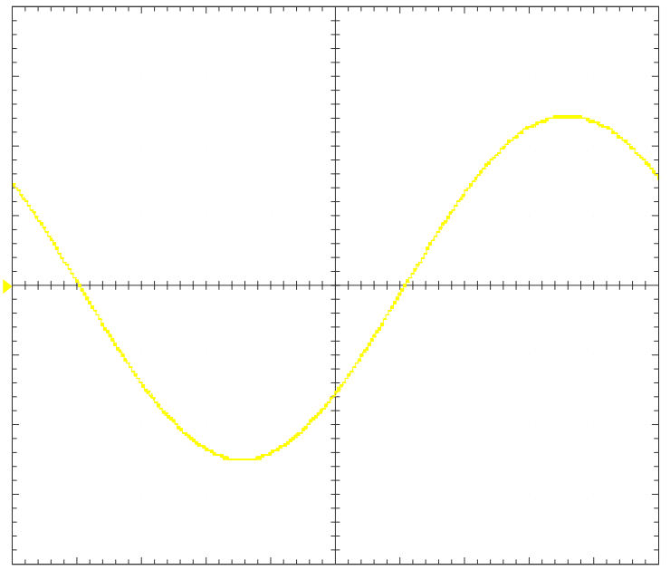
Figure 1 Function Generator sine wave, 10ms, max. Volt. 4.8941, min Volt. -4.9569

Unsmoothed Rectifier Wave

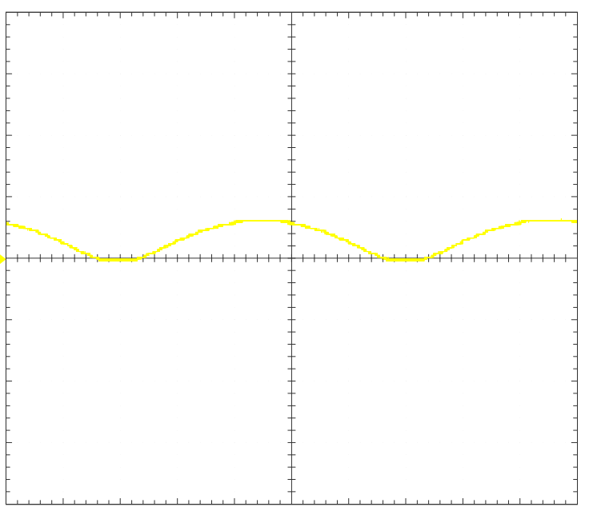
Figure 2 Unsmoothed Rectifier Wave without Cap. 10ms, max. Volt 1.3176, min. Volt. -0.0627

Smoothed Rectifier Wave

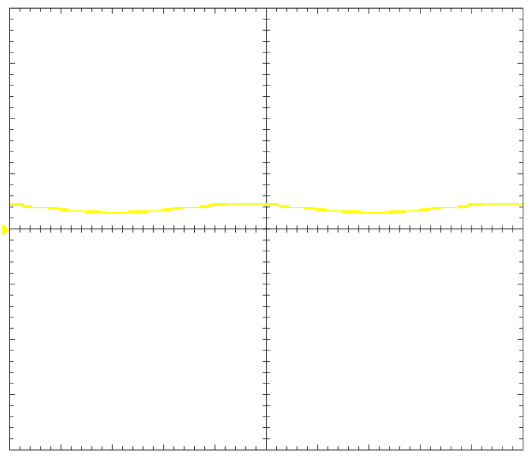
Figure 3 Smoothed Rectifier Wave with 10 Farad/106 Cap. 10ms, max. Volt. 0.9412, min. Volt. 0.6275

Drop in Voltage Question
According to Ian Mackenzie,” In a single phase bridge rectifier, unfiltered or series inductance filtered, supplying a resistive load, the DC output is always the average value of the AC input sine wave.” As the current goes through the rectifier it turns from AC to DC which makes sure the current is only heading in one direction and can not alternate. Because of this the positive half-cycles of the current are allowed to flow whilst the negative half cycles are not, meaning less current overall is travelling through the circuit.

Rectifiers use in Automotive applications Question.
A rectifier is most often used in a vehicle’s charging system where it converts Alternating current to Direct Current or AC to DC. The rectifier can be found in the alternator of a vehicle, the alternator is spun by the motion of the engine through an ancillary belt which creates a magnetic field with the stator and rotor inside the alternator. This produces electricity that needs to be sent through the charging system however it must first be converted from Alternating current to Direct current, this electricity is sent through the rectifier which does just that. This current is used to keep charge within the battery and powers the electrical components of the car, for example the windscreen wipers, starter motor and infotainment system. (Firestone, 2020).

Probing Question

Task 3

Scope Time Division Calculations
- T = R * C. R= 10Ω C=10µ, T= 10 x 10. T=100
- 1/12𝑇≥𝑓𝑓𝑢𝑛𝑐𝑡𝑖𝑜𝑛𝐺𝑒𝑛𝑒𝑟𝑎𝑡𝑜𝑟. T=100, 12T=1200. 1/1200 𝑓𝑓𝑢𝑛𝑐𝑡𝑖𝑜𝑛𝐺𝑒𝑛𝑒𝑟𝑎𝑡𝑜𝑟= 10Hz = 1/10

Function Generator output sine wave

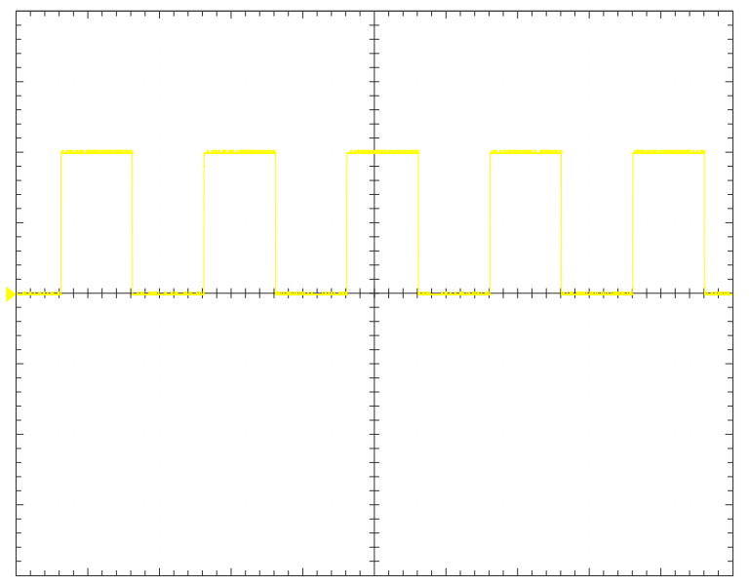
Figure 4 Function Generator Output, 500us, max. Volt. 2.0392, min. Volt. 0.

Capacitor charge and discharge wave marked at correct points.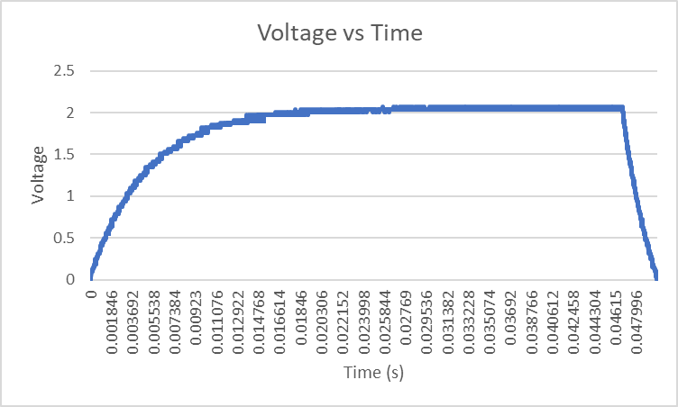
Figure 5 Capacitor charge and discharge wave, 5ms, max. Volt. 2.0706, min. Volt. 0, 63.2% Charge, 1.309v @ 0.4964 ms

Basic Capacitor Calculations

Capacitor discharge table
Figure 6 Capacitor discharge table

Gradient Plot and calculations
Figure 7 Gradient Plot, max. Volt. 1.11, min. Volt. -3.1. Gradient = -0.4096x + 1.8588

Inaccuracies Question
When it comes to inaccuracies of the measurements there are a number of different factors. This can include the equipment used, the program connected to the oscilloscope and if the circuit has been put together correctly.
Keysight Technologies specifies other common causes of inaccuracies including Unknown Bandwidths restraints which relates to the probes and scope being used not having an ideal bandwidth to correlate with each other, Not calibrating the probe which would lead to inaccurate readings in every scenario it was used, increasing probe load meaning the length of the probe used can result in a more latent result, misusing the differential probe and hidden noise impacts that is impacted by the attenuation ratio of the probe itself. These faults can be linked to the use of the oscilloscope and not calibrating the oscilloscope to run optimally.

References
- Firestone (2020.). What Does an Alternator Do? | Firestone Complete Auto Care. [online] Available at: https://www.firestonecompleteautocare.com/blog/maintenance/what-does-an-alternator-do/#.
- Mackenzie, I (2020). In the rectifier circuit, why is the DC voltage at the output lower than the AC voltage at the input? [online] Available at: https://qr.ae/pr3vxj.
- Keysight Technologies. (n.d.) 7 Common Oscilloscope Probing Pitfalls to Avoid TAKE THE MYSTERY OUT OF PROBING.. Available at: https://www.testunlimited.com/images/freeScopeGiveaway/keysight_probing_tips.pdf.

‌

‌

