AC 1.1

According to CIPD (2025b) evidence-based practice means using the best available information from multiple sources to make well-informed decisions and improve outcomes.

Barends et al. (2017) note that two main obstacles to adopting Evidence Based Practice in management are not having enough time and not fully understanding scientific research.

Briner (2023) says we can determine that following a six-step process helps to establish a structure of gathering and using evidence to improve decision making as follows:
Firstly ‘ask’, define the problem or question. Then ‘acquire’ and gather relevant information from multiple sources. Thirdly, ‘appraise’ by critically evaluating the quality and relevance of the evidence. Then ‘aggregate’, combine the different types of evidence to form an overall understanding, weighing up conflicting evidence. The next step is to ‘apply’ and incorporate the evidence into the decision-making process. And finally, to ‘assess’, evaluate the outcome of the decision to determine effectiveness (CIPD, 2025b).

According to Rousseau et al. (2004) evidence-based practice supports objective and defensible decision-making, integrating research evidence with professional judgement, reducing bias and improving credibility in people management. This leads to better results for employees and the organisation, and these improved results can support Sue’s case to persuade Bill and the Board at Technivara to apply evidenced-based practice to the workplace.

Evidence-based human resource management involves using scientifically supported and contextually relevant solutions to guide responsible, effective decisions. Strong human resource policy begins with clear goals and gathering both organisational and research evidence before making choices (CIPD, 2025a).

When looking at recruitment and selection, and learning and development, Technivara could use evidence-based practice to ensure sound decision-making.

In recruitment and selection evidence-based approaches use validated assessment tools, structured interviews to minimise bias, predictive analytics for more accurate hiring decisions, and methods to reduce unconscious bias, all contributing to fairer and more effective talent acquisition (VQ Solutions, 2024).
According to Tricarico (2024) a strong evidenced based hiring strategy uses structured interviews, cognitive tests, and work samples. Evidence-based hiring supports workplace diversity and inclusion. By focusing on objective, predictive factors, organisations can create a fair selection process based on merit.

In learning and development, research-informed learning uses adult education principles, knowledge transfer methods, return on investment measurement, and personalised paths that cater to individual needs, to boost skill development and retention (VQ Solutions, 2024). CIPD (2021) notes that effective learning boosts organisational performance and productivity, making investment in people worthwhile. To ensure positive results, it is essential to identify learning needs, ask targeted questions, assess existing metrics, and consider individual learning preferences. Customising learning approaches helps achieve optimal outcomes.

Evidence-based practice helps Technivara make clear, effective people decisions. Despite needing data and expertise, it improves decision quality, consistency, and credibility.

AC 1.2

Founded in 1970, Technivara is now in its sixteenth year of consecutive growth. Due to its success Technivara’s board would like to expand the business. Technivara requires organised ways that enable it to recognise present problems, new challenges, and future possibilities to make effective decisions. Reducing reliance on assumptions and promoting evidence-based decision-making are two benefits of using the right analysis tools and methods.

The Ansoff Matrix is a strategic tool used to assess how an organization can grow by analysing products and markets, as well as the related risks (Ansoff, 1957, pp. 113–124; Johnson, Scholes, Whittington, 2020). According to The Strategy Institute (2024) this framework offers Technivara a clear way to assess different growth strategies by looking at whether they involve new or existing products and markets. By reviewing its four key areas: Market Penetration, Market Development, Product Development, and Diversification, Technivara can better understand the risks and benefits of each option.

Quantive (2024) suggests the Ansoff Matrix is an effective tool for Technivara’s business growth. By applying this framework to supplying parts for the electronics industry, Technivara can identify key issues, challenges, and opportunities to make informed expansion decisions:

Step 1: Thoroughly assess existing products and services by reviewing features, customer segments, and market performance.
Step 2: Evaluate internal strengths and abilities by examining current resources, such as technology tools, workforce skills, and operational advantages.
Step 3: Conduct market research to find external opportunities and threats in current and new markets. Review industry trends, competitor actions, and customer needs for additional insights.
Step 4: To find the growth strategy that best fits Technivara’s needs and objectives, evaluate all four options: market penetration, market development, product development, and diversification.
Step 5: Choose the strategy that best aligns with Technivara’s business goals.
(Quantive, 2024)

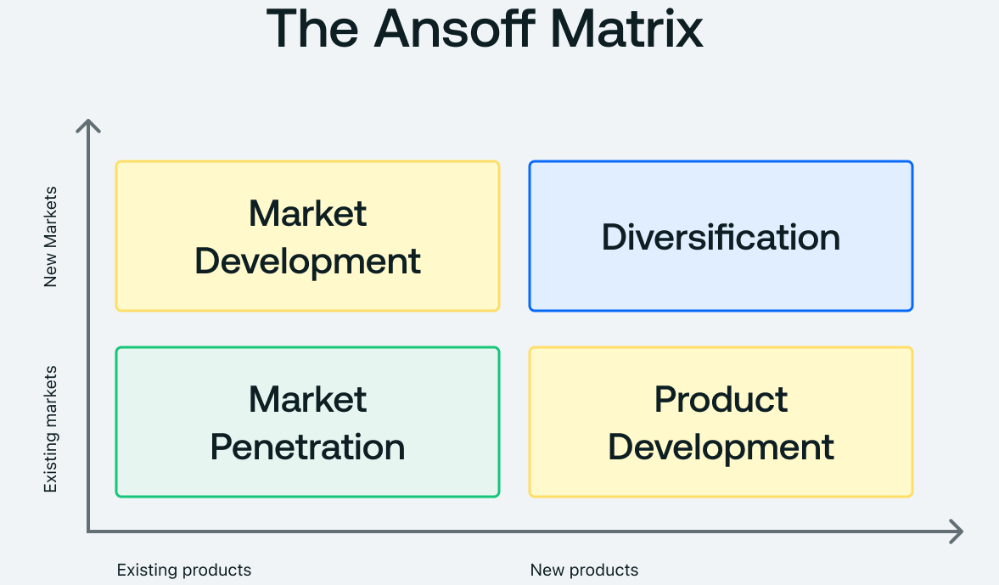

The Ansoff Matrix is a helpful tool for assessing growth strategies, but it has been criticised for its simplicity and lack of consideration for external factors and organisational capabilities (Johnson, Scholes and Whittington, 2020; Lynch, 2018).

According to CIPD (2025c) people analytics plays a crucial role in organisations, enabling informed, evidence-based decision-making regarding workforce management. This approach supports improvements in performance, employee wellbeing, and equality, diversity and inclusion. Technivara can use workforce data to spot issues, challenges and opportunities.

Buncic (2024) states that People Analytics enhances the employee experience by providing data-driven insights throughout recruitment, onboarding, development, performance management, and retention. Analysing metrics like performance and turnover supports Technivara make better hiring, promotion, and team decisions. Effective human resource analytics requires accurate data and skilled analysts for timely evaluation.

There are limitations to workforce data which shows what is happening but not the why. For the greatest effect Technivara would be advised to combine workforce data with qualitative methods such as employee surveys.

AC 1.3

The Foundation for Critical Thinking (2017) believes that critical thinking involves actively and skilfully evaluating information from various sources to guide beliefs and actions. It relies on universal intellectual standards such as clarity, accuracy, precision, consistency, relevance, evidence, logic, depth, breadth, and fairness. In a professional environment like Technivara, it ensures decisions are evidence-based and free from bias.

According to CPD (2022), the main principles of critical thinking involve collecting information from a range of sources and interrogating that information carefully. This process allows an individual to form a well-reasoned opinion while also recognising and addressing their own biases.

Taylor and Woodhams (2022, pp.122-123) explain that research begins by reviewing existing information, with academic literature being a key data source. Other sources include libraries, newspapers, magazines, journals, and websites, though online information can be inconsistent. Bryman et al. (2021) also note methods such as surveys, interviews, focus groups, and participant observation for collecting data.

At Technivara, it is important they present ideas clearly and support them with diverse, credible resources to guide informed decisions. In the Interrogate Information stage, evaluate others’ ideas for evidence, reliability, and bias (CPD, 2022). Assess author bias, logic, and whether the information is current to ensure it is trustworthy and useful.

At this stage ‘constructive challenge’ is key. According to Taylor (2025) its aim is to strengthen decision making, ensure accountability and surface better options without undermining trust or damaging relationships. Done well, constructive challenge will assist objective and rational debate at Technivara.

The next step is to form an opinion. Definition Discovery (2023) states that drawing conclusions means making judgments by connecting evidence and reasoning. At Technivara, employees must maintain consistent reasoning, so conclusions follow logically from arguments. Identifying inconsistencies in others’ arguments improves debates and leads to more reliable results.

When thinking critically, Technivara will aim to spot cognitive biases that can distort judgment. These mental shortcuts help the brain save effort but often undermine objective thinking. Actively identifying and addressing bias in reasoning is essential for fair judgment.
Sustainability Directory (2025) notes that while eliminating bias is unlikely, Technivara can lessen its effects by: recognising biases, seeking diverse viewpoints, questioning assumptions, evaluating all evidence, and considering alternative explanations.

By adopting structured frameworks, gathering diverse perspectives, relying on evidence-based analysis, and conducting regular reviews, Technivara can minimise cognitive bias and enhance decision-making. Employing these strategies supports critical thinking and effective teamwork, leading to more thoughtful decisions.

See Appendix 1, a proforma to support the process of critical thinking and reaching a solution.

AC 1.4

At Technivara, effective decision-making ensures well-informed, consistent choices that meet organisational goals. Both the Rational Decision-Making Process and Parallel Thinking Process can support effective outcomes.

Adair (2007) presents a 5-step rational decision-making model: define the objective, collect information, generate options, make the decision, and implement and evaluate. This data-driven process focuses on evidence, analysis and logical planning (VQ Solutions LTD, 2025) enabling Technivara to make informed choices regarding employee turnover, for example.

Adair (2010) recommends that Technivara clearly state the goal, such as reducing staff turnover. Relevant data like turnover statistics and exit interviews should be gathered. All potential options, including changes to rewards or development, need consideration before choosing the best solution, factoring in cost, compliance, and employee wellbeing. Implementing decisions and evaluating outcomes ensures accountability and ongoing improvement.

De Bono’s Six Thinking Hats is a structured decision-making model developed by Edward De Bono. De Bono (2017) describes Six Thinking Hats as a straightforward and effective parallel thinking technique using coloured hats, that boosts productivity, focus, and mindful participation by exploring one thinking mode at a time to improve decision-making and collaboration. By applying this approach, Technivara could consider a hybrid working policy. The De Bono Group (2019) defines how Technivara could use the hats as follows:

 | White: Data, Facts and Information e.g. employee engagement survey results, absence and turnover data.
 | Yellow: Optimism and opportunities. Exploring the positives e.g. improved work-life balance and increased employee retention.
 | Black: Risks and Dangers (worst case scenario). An action hat with the intent to point out issues of risk with intent to overcome them e.g. reduced collaboration, challenge in remote performance management and cyber security risks.
 | Red: Emotions and intuition. Express emotions and feelings and share fears, likes, dislikes, loves, and hates e.g. some employees will feel more motivated whiles others will feel isolated.
 | Green: Creativity, possibility and new ideas e.g. flexible solutions - introduce trial periods and remote leadership training.
 | Blue: Manages the process. Listens, directs attention, integrates and moves forward. Summarises the data and agrees next steps.

To support these full decision-making processes, Technivara could use the Pareto principle to help identify and prioritise the factors that have the greatest impact. Lawless (2024) states that, in numerous scenarios, approximately 80% of outcomes are attributable to 20% of underlying causes. Appinio (2024) found that Pareto analysis helps managers identify key causes, focus resources effectively, and prioritise decisions using rational, evidence-based approaches.

By using these methods, Technivara can make evidence-based, inclusive, and strategic decisions. These processes improve decision quality, accountability, and employee engagement for better results.

AC 1.5

CIPD (2024a) states that reputation depends on delivering quality products and services, valuing staff and stakeholder relationships, and being accountable. Ethical conduct not only reduces risk but offers a competitive edge. Trust with employees, customers, suppliers, and the wider community is essential for organisational success.

Ethical perspectives guide organisations like Technivara to make decisions responsibly and fairly, in line with their values. Utilitarianism and Deontological (duty-based) Ethics are two key approaches used for this purpose.

Bentham (1789) describes the principle of utility as approving or disapproving actions based on their tendency to promote or reduce the happiness of those affected. This principle forms the basis of his work. According to Wooldridge (2019) Utilitarianism is a consequence based ethical perspective shaped by two main principles: actions are judged solely by their outcomes, specifically the happiness they produce, regardless of motives or intentions; and moral decisions must be made impartially, valuing everyone's happiness equally, whether they are friends, family, or strangers.

When applied to Technivara’s business decisions, utilitarianism focuses on choosing actions that maximise overall benefit while minimising harm to employees or stakeholders. This approach is practical and could be applied to decisions about reward and pay structures by choosing options that deliver the greatest overall improvement in motivation, retention and performance. However, prioritising overall benefit may disadvantage smaller groups, raising fairness and rights concerns, and outcomes such as employee wellbeing and happiness can be difficult to measure accurately (Getrevising, 2017).
Deontological ethics is another ethical perspective which focuses on actions themselves, not their outcomes. According to BBC (2014) people should do what is right simply because it is right and avoid wrong acts because they are wrong. Duty-based ethics assert that certain actions are inherently right or wrong, and individuals have a duty to act accordingly, regardless of the consequences. An action is considered ethical when it aligns with moral values like honesty, fairness, and respect for the rights of others.
According to Radford University (no date) an advantage of this approach is that it allows one to recognise whether an action is inherently right or wrong as it is performed. When Technivara considers recruitment and selection of employees, decisions are based on fair and transparent criteria. By treating everyone with respect and granting others the same rights, deontology values intentions and motivations, creating consistency and fairness. However, it can be inflexible and rigid and may slow down hiring processes and limit managerial discretion.

Utilitarianism will drive Technivara to make efficient, results-oriented decisions for maximum benefit, while deontological ethics will ensure fairness, legality, and respect for individual rights. By combining both approaches, Technivara can achieve effective, ethical decision-making that will foster sustainable success and stakeholder trust.

AC 3.1

Technivara can measure its performance using both financial and non-financial methods, which together give a fuller picture of how well the business is doing. Effective financial methods include financial statement analysis and Key Performance Indicators (KPIs) and non-financial methods include customer/employee surveys and Human Resource Management analytics.

According to Stobierski (2020) Technivara can assess its financial performance by using the balance sheet, also known as the statement of financial position. This report provides a snapshot of the company's stability and liquidity by listing assets, liabilities, and equity at a specific point in time.

As Bill Swanky, the founder of Technivara, seeks to expand the business, Bedi (2025) supports that balance sheets contain essential information for both current and prospective investors. The balance sheet details Technivara’s financial standing and helps assess its suitability as an investment. Additionally, the balance sheet is valuable to suppliers; a robust balance sheet demonstrates the company's reliability and trustworthiness.

Fernando (2025) and Liao (2025) acknowledge that despite its usefulness, the balance sheet has notable limitations when measuring performance. Because it only captures a single moment, it does not provide insight into how results have shifted over the year or how well resources are managed. Furthermore, key assets like brand reputation and employee expertise are not thoroughly accounted for, leading the balance sheet to potentially undervalue Technivara’s business capabilities. Therefore, Technivara ought to consider the balance sheet together with additional financial and non-financial indicators to gain a fuller understanding of overall performance. See appendix 2.

An example of a non-financial way Technivara might assess performance is by conducting employee satisfaction surveys. These surveys collect feedback from employees on topics like motivation, workload, management practices, training opportunities, and workplace culture.

For Technivara, creating channels for employee feedback and actively listening is crucial. As Young (2024) notes, combining surveys with qualitative methods like focus groups is effective: surveys offer an organisation-wide snapshot, while qualitative approaches provide deeper insights into employee satisfaction and concerns. Taylor and Woodhams (2022, p.128) highlight that surveys are cost-effective, quick, and convenient for participants. However, they limit in-depth responses and may lead to low participation rates. Employee satisfaction surveys are valuable, as higher motivation and contentment often boost productivity, service quality, and retention. For example, if Technivara receives positive feedback on training and development, it could benefit from greater productivity, lower turnover, reduced recruitment expenses, and improved customer service.

By employing both metrics, Technivara is able to evaluate short-term financial outcomes while simultaneously tracking key factors that influence long-term performance.

AC 3.2

Effective people practice at Technivara boosts business performance by enhancing employee skills, motivation, and retention. According to CIPD (2024b) we can determine that strong recruitment brings in capable staff with a good cultural fit, reducing turnover and boosting productivity. Ongoing training keeps employees’ skills current, fostering innovation and customer satisfaction. Additionally, robust people practices promote engagement and wellbeing, increasing commitment and reducing absenteeism.

According to Taylor and Woodhams (2022, p.99) fostering employee retention is essential for Technivara to benefit from the continued expertise, experience, and positive contributions of its staff. It is crucial for People Practitioners at Technivara to understand effective strategies for attracting talented professionals and implementing practices that support long-term engagement and retention of top employees.

According to Olubiyi et al. (2019), job satisfaction and employee retention are influenced by five key themes: a friendly workplace environment, flexibility, stability, management support, and independence. In response to this, Technivara could foster a supportive and inclusive workplace culture, introduce flexible working arrangements, and provide employees with greater autonomy in their roles. In addition, by ensuring consistent management support and offering job security where possible, Technivara may enhance employee satisfaction and reduce turnover. The authors also emphasise the importance of person–organisation fit, suggesting that Technivara could improve retention by recruiting and developing employees whose values, interests, and behaviours align with the organisation’s culture, thereby encouraging more positive employee attitudes and behaviours.

Meirinhos, Abrunhosa and Martins (2018) suggest Technivara should consistently keep precise records of turnover and retention rates to effectively track trends and outcomes. This is quantitative HR data. By doing so, they'll gain an evidence-based understanding of employee retention, a crucial factor as they plan to grow their business.

Interviews and open-ended data could be used by Technivara to gain deeper insight into employee retention by exploring staff experiences, perceptions, and reasons for staying or leaving the organisation. For example, Technivara could conduct exit and stay interviews to gather employee views on management practices, career development opportunities, organisational culture, and work–life balance, all of which influence retention decisions. Unlike quantitative measures, these qualitative approaches would allow Technivara to understand the underlying causes of turnover rather than simply identifying patterns (Kvale and Brinkmann, 2009).

The referenced sources demonstrate that both quantitative HR metrics and qualitative employee feedback serve as valuable indicators of retention outcomes and their underlying causes. Integrating these forms of measurement enables Technivara to obtain a comprehensive understanding of its employee retention performance.

AC 2.1
Turnover and recruitment take up for Technivara 2024
 | Total in Department 2024 | Leavers for 2024 | Leavers as a % against total in each Department | Positions Vacant | Vacancies as a % against total in each Department | Positions filled | Positions filled as a % of total in each Department
Audio technical Department | 26 | 6 | 23 | 8 | 31 | 3 | 12
Offices and Administration | 15 | 4 | 27 | 5 | 33 | 5 | 33
Research and Development | 8 | 1 | 13 | 4 | 50 | 4 | 50
Quality control | 4 | 2 | 50 | 3 | 75 | 3 | 75
Dispatch | 15 | 4 | 27 | 6 | 40 | 6 | 40
Engineering | 35 | 8 | 23 | 8 | 23 | 3 | 9
Casting Department | 6 | 3 | 50 | 5 | 83 | 2 | 33
Sales & Marketing | 12 | 4 | 33 | 3 | 25 | 3 | 25
Human Resources | 4 | 1 | 25 | 1 | 25 | 1 | 25
Design | 12 | 3 | 25 | 5 | 42 | 2 | 17

Excel formulas were used to calculate the percentages highlighted in red below:

AC 2.2 - BAR GRAPH

AC 2.2 - COLUMN CHART

AC 2.2 - LINE GRAPH

AC 2.2 - 3D BAR CHART

AC 2.3

This report provides an analysis of feedback from 42 employees who participated in a recent learning and development activity at Technivara. The objective is to identify principal patterns, themes, and trends within the collected data and evaluate the overall effectiveness of the programme. Through examination of participant responses across various evaluation criteria, this report underscores strengths, highlights areas requiring improvement, and offers actionable recommendations to enhance the design, delivery, and impact of future learning and development initiatives.

The data shows there was a strong performance in facilitation and resources. 93% of participants fully agreed or agreed that the facilitator provided a clear set of objectives at the start of the activity and was clearly knowledgeable about the subject matter. This suggests the session began with strong clarity and direction and that the facilitator is a credible tutor.
86% of participants fully agreed or agreed that the resources were of good quality with no negative ratings. This indicates that the resources used were fit for purpose. The learning activity was well supported by a solid delivery foundation, which includes facilitator competence, well-defined learning objectives, and quality materials.

There were mixed responses on ‘the event structure’ and on ‘an explanation on the topics discussed’. In relation to the learning event being appropriately structured 55% gave positive feedback, 26% were unsure and 19% disagreed or strongly disagreed. This suggests that while many participants found the structure acceptable, a significant number found it could be improved. A considerable proportion of participants, specifically 79%, reported that the facilitator delivered clear explanations regarding the discussed topics, while 21% expressed disagreement. These results suggest that, although the explanations were effective for the majority, they may not have addressed all learning styles.

Responses to ‘My learning preferences were considered prior to the learning activity’ show little evidence that learner needs were identified prior to the session, with 43% not sure their preferences had been considered at all. This could be why 76% of participants found they were unable to engage with meaningful questioning and answering on topics being discussed. Pre-session learner analysis would appear to be limited, and the result is participant engagement was weak.

The data shows the participants found it difficult to see the relevance of the learning to their roles. 79% disagreed or strongly disagreed that the set learning outcomes were achieved. 57% did not know how the learning linked to their performance target, with 29% disagreeing or strongly disagreeing that the learning was relevant to their performance at all. When questioned about applying the knowledge, skills and behaviours into their working roles 14% gave positive feedback, 52% did not know how to transfer the learning, with 27% disagreeing or strongly disagreeing that the learning could be applied. This indicates that participants had difficulty recognising the applicability of the learning within their workplace or understanding how to implement it in practice. Consequently, the most significant gap lies in learning transfer and practical relevance.

The evaluation data highlights a range of patterns, themes, and trends within participant feedback. A consistent pattern of positive responses demonstrates strong confidence in the facilitator’s expertise, suggesting that the learning activity was effective in terms of delivery. This pattern, together with repeated positive feedback on clearly defined objectives and high-quality learning materials, forms a theme of well-structured and professionally delivered training. In contrast, a recurring pattern of negative and uncertain responses identifies several areas for improvement. These patterns combine into a theme of limited learner engagement and relevance, particularly due to insufficient opportunities for meaningful interaction and discussion and a lack of consideration for individual learning styles. A clear trend emerges showing a decline from positive perceptions of facilitation and structure to weaker outcomes related to the application of learning, with many participants struggling to connect the content to their job responsibilities or personal performance goals. This trend suggests that while the session was well delivered, its overall impact on workplace effectiveness was limited.

As Technivara prepares to expand its business operations, I recommend that the organisation introduces a structured learning and development strategy to strengthen workforce capabilities, skills, and competencies, ensuring employees are equipped to support current operations and future growth. Hayden (2024) notes that the core purpose of an effective learning and development strategy is to demonstrate how organisational performance needs are addressed through employee development. Without clear alignment to Technivara’s strategic goals, learning and development initiatives risk losing relevance and may fail to gain learner commitment. Relevance is therefore a critical measure of an effective learning and development strategy, as it determines how well learning initiatives respond to the organisation’s current and future challenges and opportunities. While individuals retain responsibility for their own learning, Technivara has a clear obligation to articulate the purpose and intended outcomes of learning to ensure alignment with both employee development and organisational objectives (Hayden, 2024). Ensuring Technivara’s employees understand the relevance of the learning activity is key and will enable them to see the link to their performance targets.

Van Diggele, Burgess, and Mellis (2020) highlight that using a structured approach is vital for keeping the learning on track and ensuring training events runs smoothly. Good preparation and planning are key to delivering clear and organised learning and development activities and Technivara’s facilitators are encouraged to develop a well-organised training agenda which supports good event structure, including learning objectives, a logical order of topics, activities and teaching methods, time management, resources, and responsibilities.

Facilitators should assess participants' learning preferences before activities to tailor instruction and boost engagement. BiteSize Learning (2023) recommends designing training that incorporates different learning styles, such as Honey and Mumford’s (see Appendix 3), using varied methods for inclusivity and better retention. The facilitator is knowledgeable and has received positive feedback; understanding both the topic and participants’ needs supports effective learning. Pre-activity learning also builds confidence and subject knowledge, and activating prior knowledge improves participation (Hattan, Alexander, & Lupo, 2023). During sessions, role plays that reflect real scenarios are advised, as they support experiential learning by encouraging active participation and deeper understanding (Kolb, 1984). All these activities are recommended as they will allow Technivara’s employees to employ the learned knowledge, skills and behaviours into their roles, improving competence, confidence and productivity.

Noe (2020) highlights that effective training, and development improves employee performance, adaptability, and engagement. In the context of Technivara’s planned business expansion, investing in employee development would equip colleagues with the skills required to meet changing operational demands and support organisational growth. By building workforce capability internally, Technivara can enhance performance while developing a sustainable competitive advantage.

READING LIST

Adair, J. E. (2007) Decision Making & Problem Solving Strategies. 2nd edn. London: Kogan Page.

Adair, J. (2010) Decision Making and Problem Solving Strategies. Available at: https://inspiredbyislam.wordpress.com/wp-content/uploads/2022/08/decision-making-and-problem-solving-strategies-john-adair-z-lib.org_.pdf (Accessed: 8 January 2026).
Ansoff, H. I. (1957) ‘Strategies for diversification’, Harvard Business Review, 35(5).
Appinio (2024) Pareto Analysis: Definition, Pareto Chart, Examples. Available at: https://www.appinio.com/en/blog/market-research/pareto-analysis (Accessed: 8 January 2026).

Barends, E., Villanueva, J., Rousseau, DM., Briner, RB., Jepsen, DM., Houghton, E. and ten Have, S. (2017) ‘Managerial Attitudes and Perceived Barriers regarding evidence-based practice: an International Survey’. PLOS ONE, (online) in BR Schmidt 12 (10), p. e0184594. Available at: https://journals.plos.org/plosone/article?id=10.1371/journal.pone.0184594 (Accessed: 19 December 2025).

BBC (2014) Introduction to ethics: Duty-based ethics. Available at: https://www.bbc.co.uk/ethics/introduction/duty_1.shtml (Accessed 10 January 2026).

Bedi, S. (2025). How Does a Balance Sheet Help in Decision Making? Available at: https://arb.accountants/how-does-a-balance-sheet-help-in-decision-making/ (Accessed 18 January 2026).

Bentham, J. (1789) An Introduction to the Principles of Morals and Legislation. Available at: https://www.earlymoderntexts.com/assets/pdfs/bentham1780.pdf (Accessed: 10 January 2026).

BiteSize Learning (2023) Honey & Mumford Learning Styles. Available at: https://www.bitesizelearning.co.uk/resources/honey-mumford-learning-styles (Accessed: 28 January 2026).

Briner, R. (2023) Evidence-based HR and People Analytics are the same, right? Afraid not. Available at: https://www.peoplemanagement.co.uk/article/1851101/evidence-based-hr-people-analytics-same-right-afraid-not (Accessed: 19 December 2025).

Bryman, A., Clark, T., Foster, L. and Sloan, L. (2021) ‘Brynman’s Social Research Methods’. 6th edn.

Buncic, I. (2024) HR analytics: What Are and How to Benefit from Them. Available at: https://www.top-employers.com/us/blog/hr-analytics-how-to-use-and-benefits/ (Accessed: 21 December 2025).

CIPD (2021) Podcast 169: Evidence-based L&D - why does evidence matter? Available at: https://soundcloud.com/cipd/podcast-169-evidence-based-ld-why-does-evidence-matter?utm_source=www.cipd.org&utm_campaign=wtshare&utm_medium=widget&utm_content=https%253A%252F%252Fsoundcloud.com%252Fcipd%252Fpodcast-169-evidence-based-ld-why-does-evidence-matter (Accessed:19 December 2025).

CIPD (2024a) Ethical Practice and the role of people professionals. Available at: https://www.cipd.org/uk/knowledge/factsheets/ethics-role-hr-factsheet/#what-is-ethical-practice-in-organisations (Accessed: 10 January 2026).

CIPD (2024b) Recruitment Process Overview. Available at: https://www.cipd.org/uk/knowledge/factsheets/recruitment-factsheet (Accessed 21 January 2026).

CIPD (2025a) Evidence-Based HRM: Navigating evidence for creating effective HR practices. Available at: https://www.cipd.org/uk/views-and-insights/thought-leadership/insight/evidence-based-hrm/?utm_source=chatgpt.com (Accessed: 15 January 2026).

CIPD (2025b) Evidence-based Practice for Effective decision-making. Available at: https://www.cipd.org/uk/knowledge/factsheets/evidence-based-practice-factsheet/ (Accessed: 19 December 2025).

CIPD (2025c) People Analytics. Available at: https://www.cipd.org/uk/knowledge/factsheets/analytics-factsheet/ (Accessed: 21 December 2025).

CPD (2022) CPD tips - How to develop critical thinking skills. Available at: https://www.cpduk.co.uk/news/how-to-develop-critical-thinking-skills (Accessed: 27 December 2025).

De Bono, E. (2017) Six Thinking Hats. London: Penguin Books.

Definition Discovery (2023) Critical Thinking Drawing Conclusions. Available at: https://www.google.com/search?client=safari&rls=en&q=critical+thinking+drawing+conclusions&ie=UTF-8&oe=UTF-8#fpstate=ive&vld=cid:b7cd0d14 (Accessed: 3 January 2026).

Fernando, J. (2025) Balance Sheet: Explanation, Components, and Examples. Available at: https://www.investopedia.com/terms/b/balancesheet.asp (Accessed 18 January 2026).

Getrevising (2017) Strengths and Weakness of Utilitarianism. Available at: https://getrevising.co.uk/grids/strengths_and_weakness_of_utilitarianism (Accessed: 10 January 2026).

Hattan, C., Alexander, P.A. and Lupo, S.M. (2023) Leveraging What Students Know to Make Sense of texts: What the Research Says about Prior Knowledge Activation. Review of Educational Research, 94(1), pp.73–111. doi:https://doi.org/10.3102/00346543221148478.

Hayden, D. (2024). Learning & Development Strategy and Policy. Available at: https://www.cipd.org/uk/knowledge/factsheets/strategy-development-factsheet (Accessed: 28 January 2026).
Johnson, G., Scholes, K. and Whittington, R. (2020) Exploring Strategy. 12th edn. Harlow: Pearson Education.
Kolb, D.A. (1984) Experiential Learning: Experience as the Source of Learning and Development. Upper Saddle River, New Jersey: Pearson Education Inc.
Kvale, S. and Brinkmann, S. (2009) InterViews Learning the Craft of Qualitative Research Interviewing. Available at: https://books.google.co.uk/books?id=bZGvwsP1BRwC&printsec=frontcover#v=onepage&q&f=false (Accessed 21 January 2026).
Lawless, J. (2024) Pareto Analysis. Available at: https://purplegriffon.com/blog/pareto-analysis (Accessed: 8 January 2026).

Liao, N. (2025) 6 Balance Sheet Limitations. Available at: https://www.linkedin.com/posts/nathanliao_six-balance-sheet-limitations-increase-your-activity-7356670084678860801-yIpZ/ (Accessed 18 January 2026).

Lynch, R. (2018) Strategic Management. 8th edn. Harlow: Pearson Education.

Meirinhos, V., Abrunhosa, S. and Martins, D. (2018) Employees’ Retention: Concept, Practices, and Impact Factors. IBIMA Publishing. Available at: https://ibimapublishing.com/articles/JHRMR/2018/390739/?utm_source=chatgpt.com [Accessed 21 Jan. 2026].

Noe, R.A. (2020) Employee Training and Development, 8th edn. New York: McGraw-Hill.

Olubiyi, O., Smiley, G., Luckel, H. and Melaragno, R. (2019) A Qualitative Case Study of Employee Turnover in Retail Business. Heliyon, 5(6), p.e01796. doi:https://doi.org/10.1016/j.heliyon.2019.e01796.

Quantive (2024) What Is The Ansoff Matrix: Definition, Steps & Examples. Available at: https://quantive.com/resources/articles/ansoff-matrix (Accessed: 21 December 2025).

Radford University (no date) Deontology: Strengths & Weaknesses. Available at: https://viva.pressbooks.pub/phi220ethics/chapter/deontology-pros-cons/ (Accessed: 10 January 2026).

Rousseau, D., Bantz, C., Garman, A., Goodman, P., Griffin, R., Hinings, B., Hirsch, P., Mccarthy, S., Rynes, S., Weingart, L. and Zanardelli, J. (2004) Academy of Management Review. Walshe & Rundall, [online] 31(2), pp.256–269. Available at: https://cebma.org/assets/Uploads/Rousseau-Is-there-such-thing-as-evidence-based-management-v2.pdf (Accessed: 15 January 2026).

Stobierski, T. (2020) 13 Financial Performance Measures Managers Should Monitor. Available at: https://online.hbs.edu/blog/post/financial-performance-measures (Accessed 18 January 2026).

Sustainability Directory (2025) What Role Does Bias Play in Critical Thinking? Available at: https://lifestyle.sustainability-directory.com/question/what-role-does-bias-play-in-critical-thinking/ (Accessed: 3 January 2026).

Taylor, D. (2025) A Guide to Constructive Challenge. Available at: https://www.good-governance.org.uk/publications/insights/constructive-challenge (Accessed: 31 December 2025).

Taylor, S. and Woodhams, C. (2022) Studying Human Resource Management: a Guide to the Study, Context and Practice of HR. 3rd edn. Kogan Page, London.

The De Bono Group (2019) Six Thinking Hats. Available at: https://www.debonogroup.com/services/core-programs/six-thinking-hats/ (Accessed: 8 January 2026).

The Foundation for Critical Thinking (2017) Critical Thinking: Where to Begin. Available at: https://www.criticalthinking.org/pages/critical-thinking-where-to-begin/796 (Accessed: 31 December 2025).

The Strategy Institute (2024) The Ansoff Matrix: a Powerful Tool for Business Strategy and Growth. Available at: https://www.thestrategyinstitute.org/insights/the-ansoff-matrix-a-powerful-tool-for-business-strategy-and-growth (Accessed: 21 December 2025).

The University of Edinburgh (2024) Features of Critical Thinking. Available at: https://www.docs.hss.ed.ac.uk/iad/Student_resources/Critical_Thinking/IAD_Features_of_critical_thinking_CC_2025.pdf (Accessed: 31 December 2025).

Tricarico, N. (2024) What is Evidence-Based Hiring and Why Should You Care? Available at: https://www.linkedin.com/pulse/what-evidence-based-hiring-why-should-you-care-neal-tricarico-d2wzf/ (Accessed: 19 December 2025).

van Diggele, C., Burgess, A. and Mellis, C. (2020) Planning, Preparing and Structuring a Small Group Teaching Session. BMC Medical Education, 20(S2). doi:https://doi.org/10.1186/s12909-020-02281-4 (Accessed: 30 January 2026).

VQ Solutions (2024) Understanding Evidence-Based Practice in Human Resources. Available at: https://vqsolutions.co.uk/understanding-evidence-based-practice-in-human-resources (Accessed: 19 December 2025).

VQ Solutions Ltd (2025) Rational Strategy Formulation in People Management | CIPD Level 5 Guide. Available at: https://www.youtube.com/watch?v=3EVg8wpZcgY (Accessed: 8 January 2026).

Wooldridge, BM. (2019) ‘Utilitarianism: Pros and Cons’. pressbooks.pub. vol. 28. Available at: https://pressbooks.pub/phronesis/chapter/utilitarianism-pros-and-cons/ (Accessed: 10 January 2026).

Young, J. (2024) Employee Engagement & Motivation. Available at: https://www.cipd.org/uk/knowledge/factsheets/engagement-factsheet/#assessing-and-measuring-employee-engagement (Accessed 18 January 2026).

APPENDIX 1:

The University of Edinburgh (2024) suggests using this proforma to support the process of critical thinking and reaching a solution…

Features of critical thinking
Task | Checklist/ notes
Identify a range of positions on a particular issue. Compare and contrast opposing views.
Judge the credibility of the sources. Is there any bias, prejudice or self- interest?
Evaluate the opposing arguments, based on the evidence presented.
Synthesise – bring together a range of evidence to make your point.
Draw conclusions
based on your own line of argument.
Present your argument clearly, in a manner to persuade others.

APPENDIX 2: (Liau, 2025)

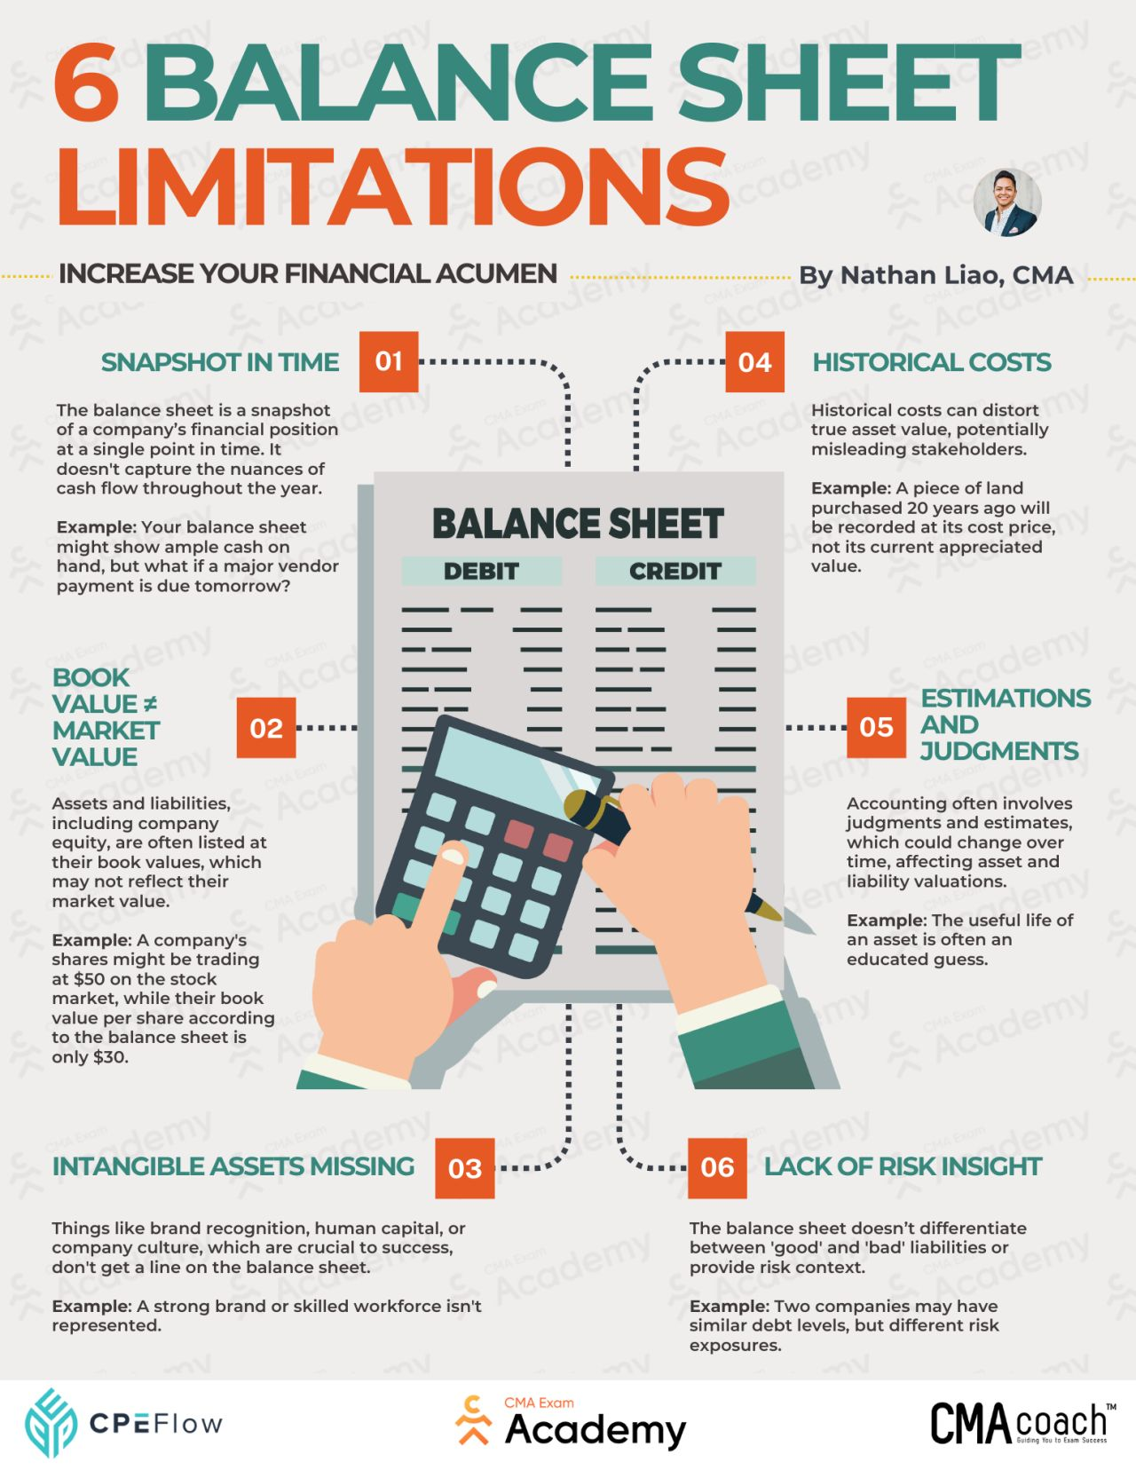

APPENDIX 3: (BiteSize, 2023)



