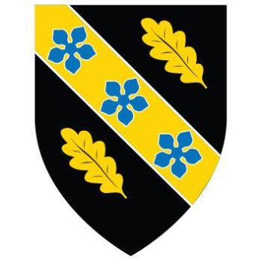

LAB: FT-IR ANALYSIS and IDENTIFICATION OF ORGANIC MATERIALS

L6 -Advanced Chemistry of OME (ACDA6020)
2223155

Table of Contents
Table of figures 2
Aim 2
Hypothesis 3
Variables: 3
Theory 3
Chemicals and equipment 4
Procedure 5
Results and Discussion: 6
Conclusions 10
References (IEEE) 10

Table of figures
Figure 1 - Functional group absorption Frequency 4
Figure 2 - Guanidine Structure [3] 4
Figure 3 - Acetaminophen structure [4] 5
Figure 4 -ascorbic acid structure [5] 5
Figure 5 - Methyl 3-nitrobenzoate Structure [6] 5
Figure 6 - spatulas 5
Figure 7 - Spectra 2 [1] 6
Figure 8 - background scan 6
Figure 9 - sample in place 7
Figure 10 - sample A graph 8
Figure 11 - sample A comparison 8
Figure 12 - sample B graph 9
Figure 13 - sample B comparison 9
Figure 14 - sample C graph 10
Figure 15 - sample C comparison 10
Figure 16 - Sample D Graph 11
Figure 17 - sample D comparison 12

Aim
The aim of this report is to interpret the FT-IR spectra for 4 unidentified compositions. Using data collected identify the functional groups in the spectra to identify out of a list of 4 what the sample is based of its functional groups.

Hypothesis
Each of the potential 4 samples have a unique spectrum depending on the functional groups that it contains. The spectra should be a least 95% match to previous samples in the library assuming that the compassion contains some impurities.

Variables:
Independent: The samples
Dependant: The FT-IR spectrum position and shapes
Control: Instrumentation settings, background corrections, calibrations

Theory
FT-IR is a confirmative test used to identify unknown compositions. It works by shining an infrared light on a sample to see what wavelengths of light are absorbed and transmitted. The light that is not absorbed is then shown on a graph with its intensity. [1] Each functional group has a different fingerprint which is visible on the spectra produced to help identify the overall composition, however this only gives a general spectra so further test would be required if you wanted a more detailed breakdown of the compositions. These potential fingerprints are shown below:
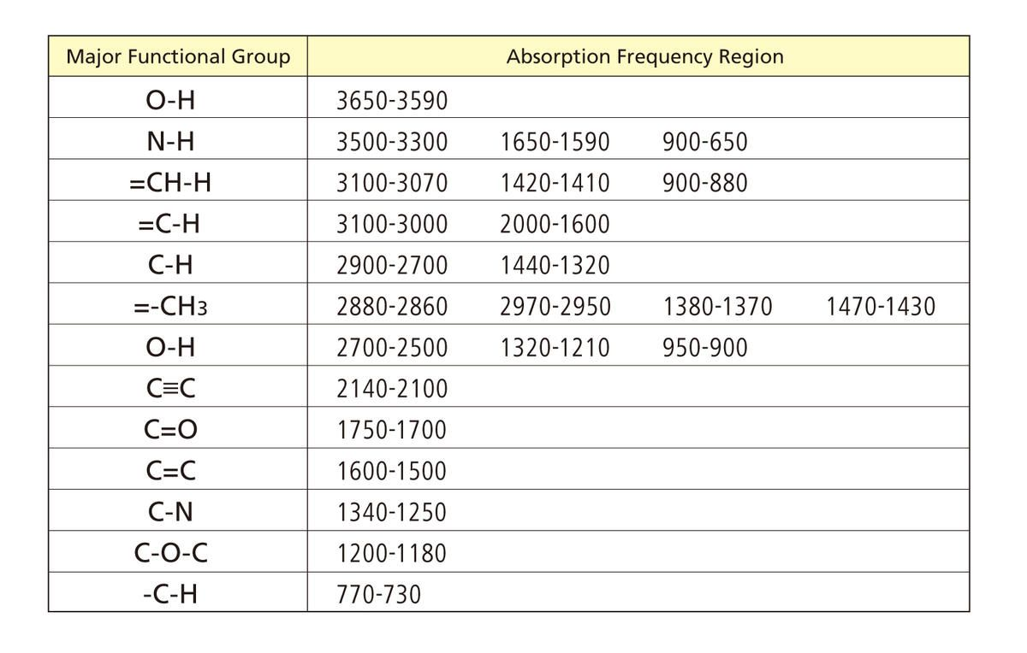
Figure 1 - Functional group absorption Frequency

FT-IR has been used in EOD (explosive ordnance disposal) to help identify the type of explosives found. Portable devices can be used to help during clean-up operations so the operators have a better understanding of the material they have come across and can act accordingly to ensure safety. [2]

Chemicals and equipment

Chemicals
In the experiment samples A, B, C and D are unknown compositions. However, it has potential to be one of the following 4:
- Guanidine
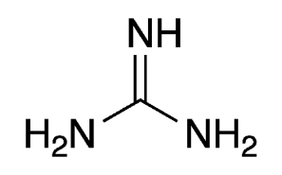
Figure 2 - Guanidine Structure [3]
- Acetaminophen
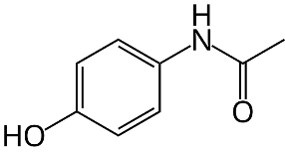
Figure 3 - Acetaminophen structure [4]
- Ascorbic acid
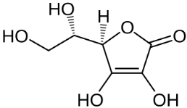
Figure 4 -ascorbic acid structure [5]
- Methyl 3 nitrobenzoate
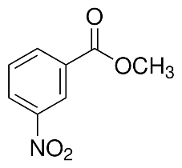
Figure 5 - Methyl 3-nitrobenzoate Structure [6]
The only hazard associated with this composition as that ascorbic acid is an oxidizer.
During this experiment an IPA is also used for cleaning purposes

Equipment
The PPE requirement for this lab is nitrile gloves and safety glasses.
A spatula is used for moving the sample to the sample plate on the machine as well as blue roll for cleaning purpose.
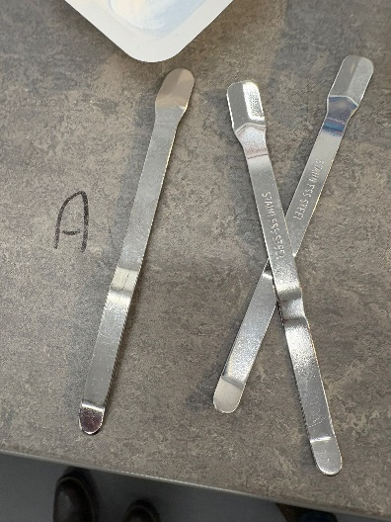
Figure 6 - spatulas
The FT-IR used was Perkin Elmer Spectrum two shown bellow

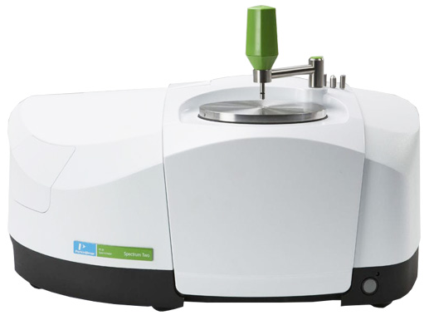
Figure 7 - Spectra 2 [1]
The software connected to the machine that is being used is “Spectrum IR”. During the scans it has a range of 4000-450 cm⁻¹. When a sample is being analysed it runs 15 scans then takes an average as its outputs that average in a graphical format, it does 15 scans as it is proven to be a statistically significant amount to give an accurate representation of the sample.

Procedure

- Turn the computer and the machine on and lode up the spectrum IR software
- Take some IPA and blue cloth to wipe down the arm, foot and sample area to ensure no residue left over from any previous test
- A background scan must be run to ensure that there is no residue left on the plate before looking at the first sample. The arm is pulled towards the sample area till it is over it and then the foot is twisted till you have hear the ratchet click.
- On monitor with the software open click the background scan and let it run till a graph is displayed.
- The following graph must be displayed before continuing
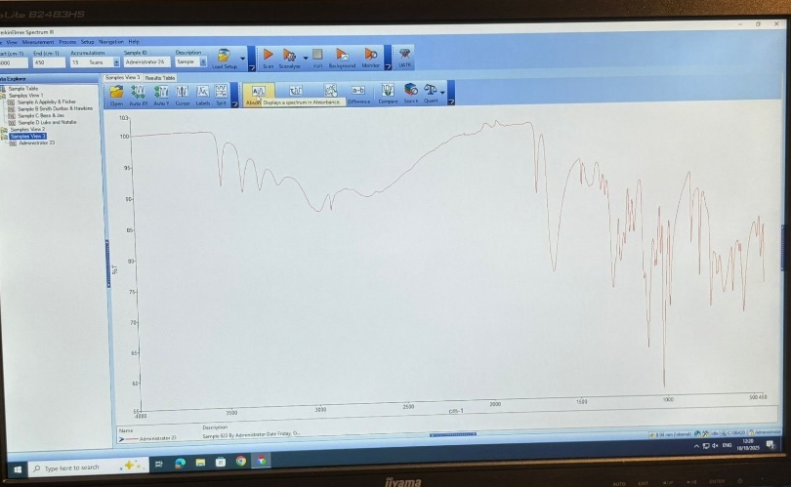
Figure 8 - background scan
If it does not repeat the previous steps. This shows the machine is set up and clean before use. This background is subtracted from the results so will not impact the spectra

- Twist the foot to raise it and push the arm away from the sample area. Using a spatula take a rice sized portion and place it on the sample area. Example is shown below:
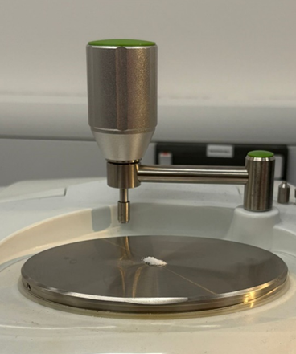
Figure 9 - sample in place
- Make sure it is all covered then bring the arm back over the sample area and twist the foot back down until it clicks.
- Select scan on the software, it will run a preview scan then a full analysis which will show you the full spectra
- The spectra are then compared to others that are in the library for the system to help determine composition the material. If the sample has a 95% similarity, then it can be accepted as that composition.
- Save the file locally to the pc naming the samples A, B, C or D with the sate if completion
- Repeated the steps 1-4 to ensure the sample plate and foot are clean, any waste will be placed in the general waste bins. Once these are complete then move on to the next sample until all samples are complete

Results and Discussion:

Sample A
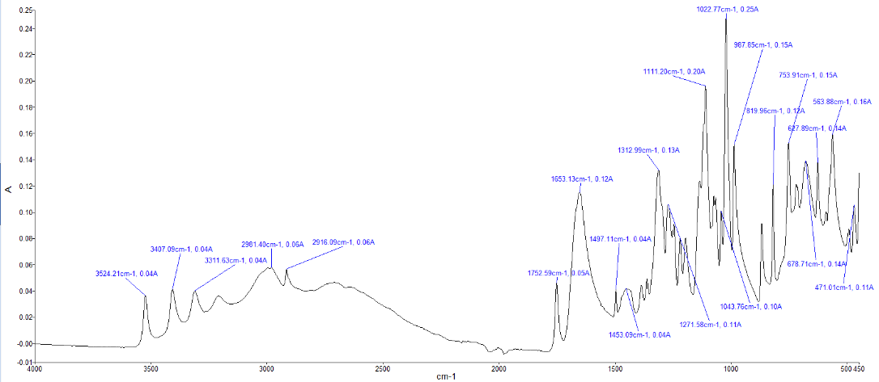
Figure 10 - sample A graph

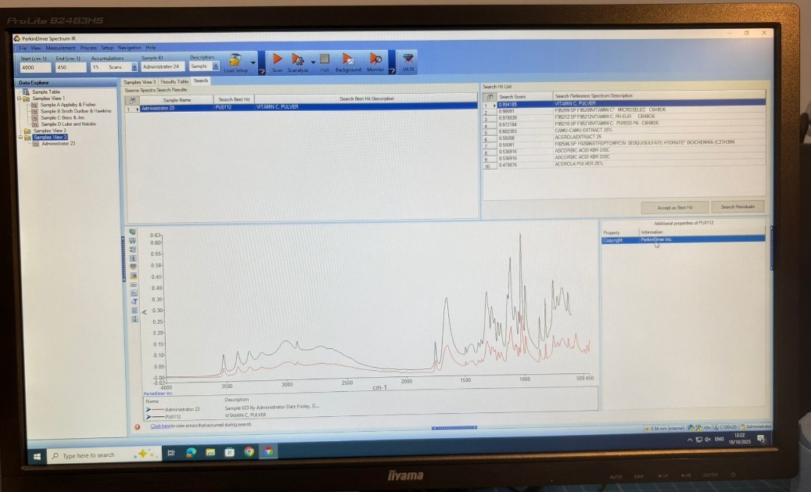
Figure 11 - sample A comparison

Sample A has a 99% similarity to vitamin C powder which is another name for Ascorbic acid, there for sample a is Ascorbic acid

Sample B
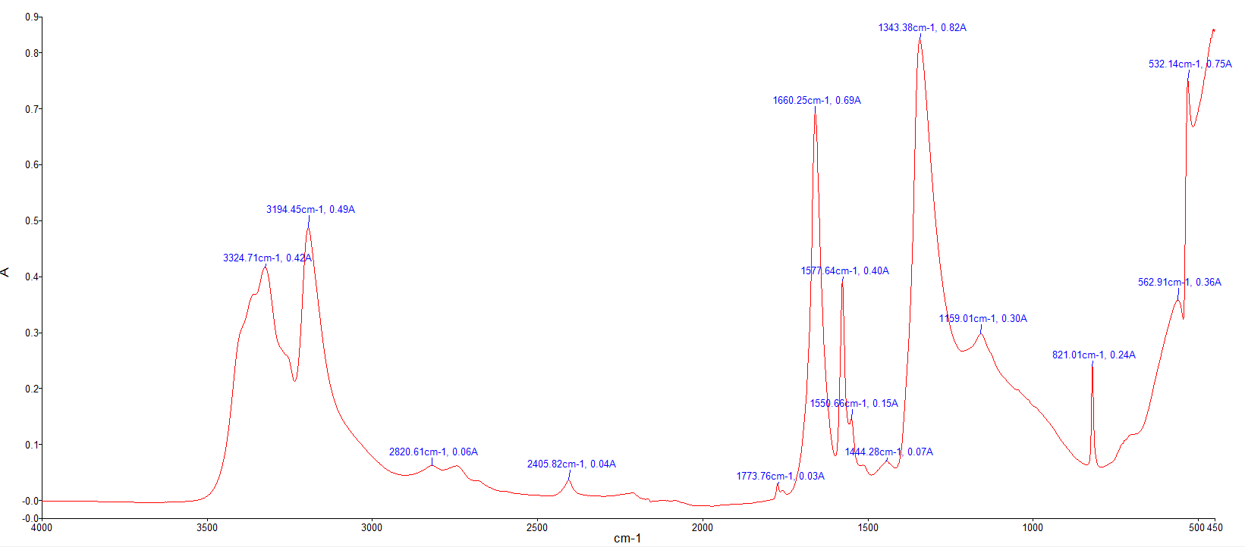
Figure 12 - sample B graph
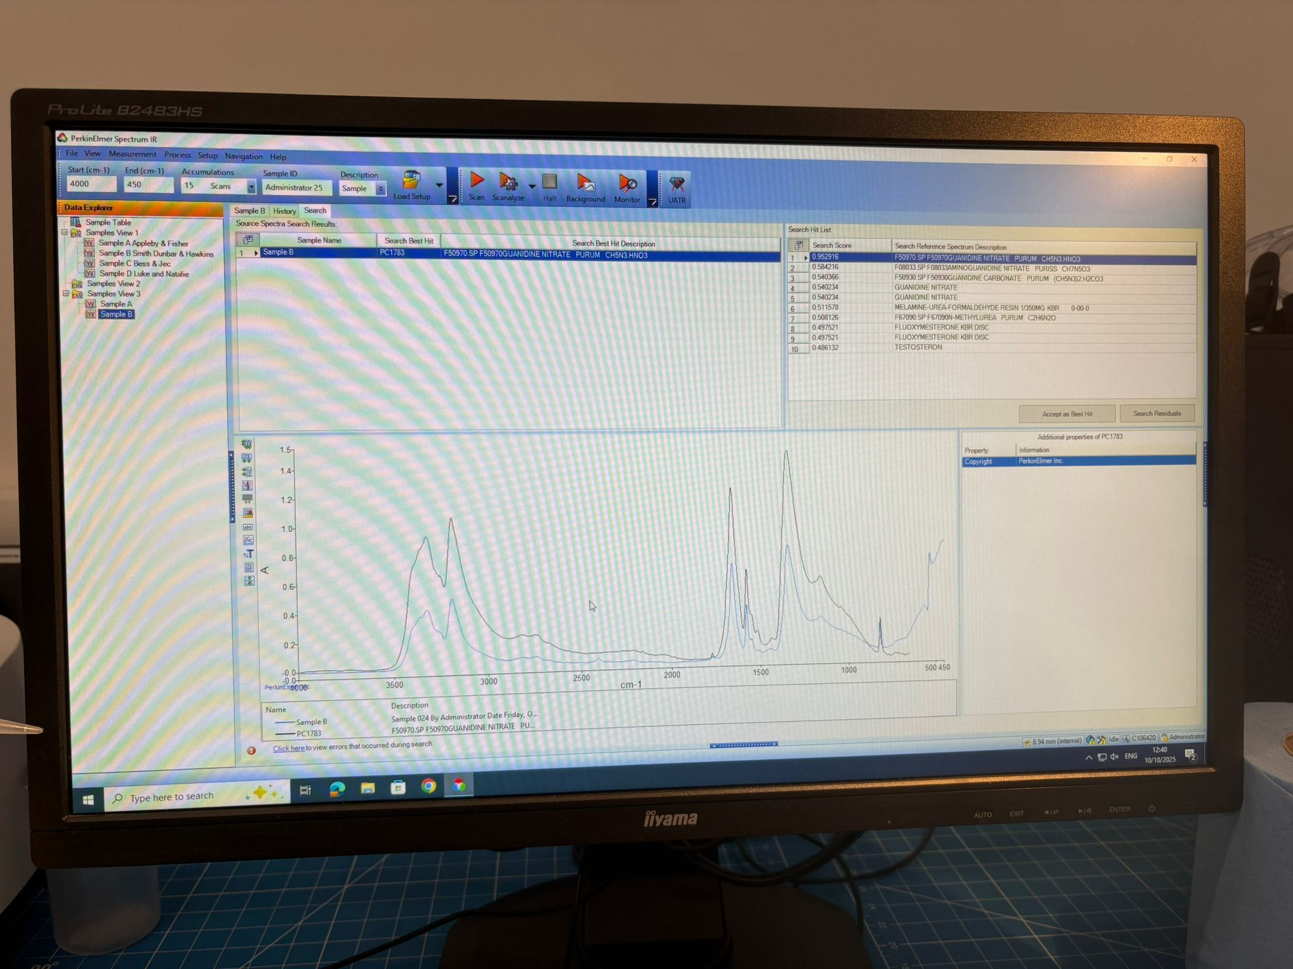
Figure 13 - sample B comparison

Sample B has a 95% similarity to s Guanidine there for sample B is Guanidine

Sample C
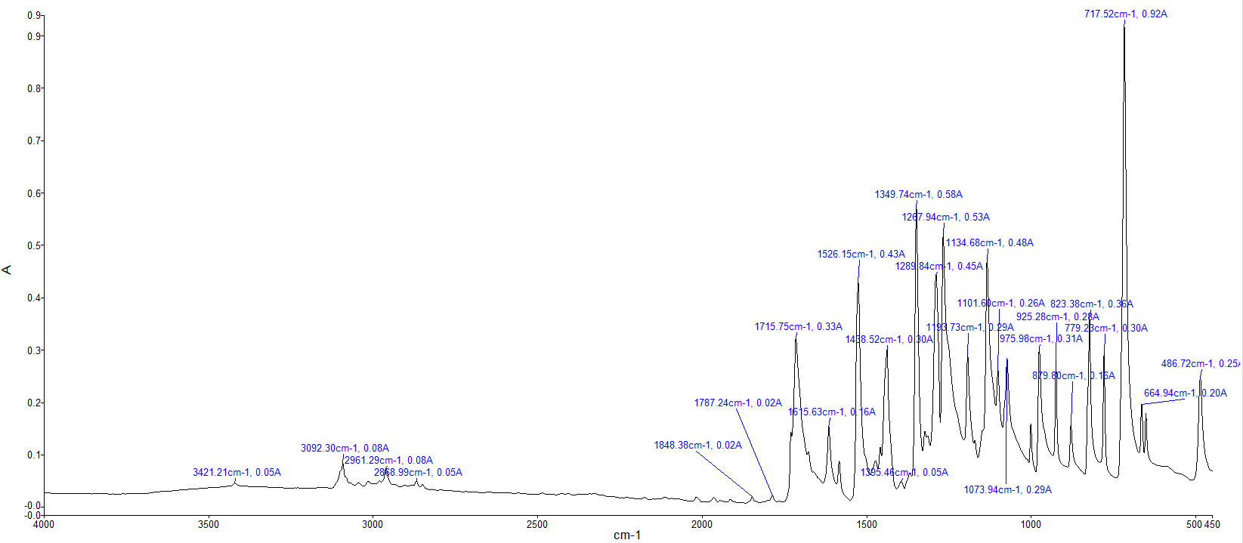
Figure 14 - sample C graph

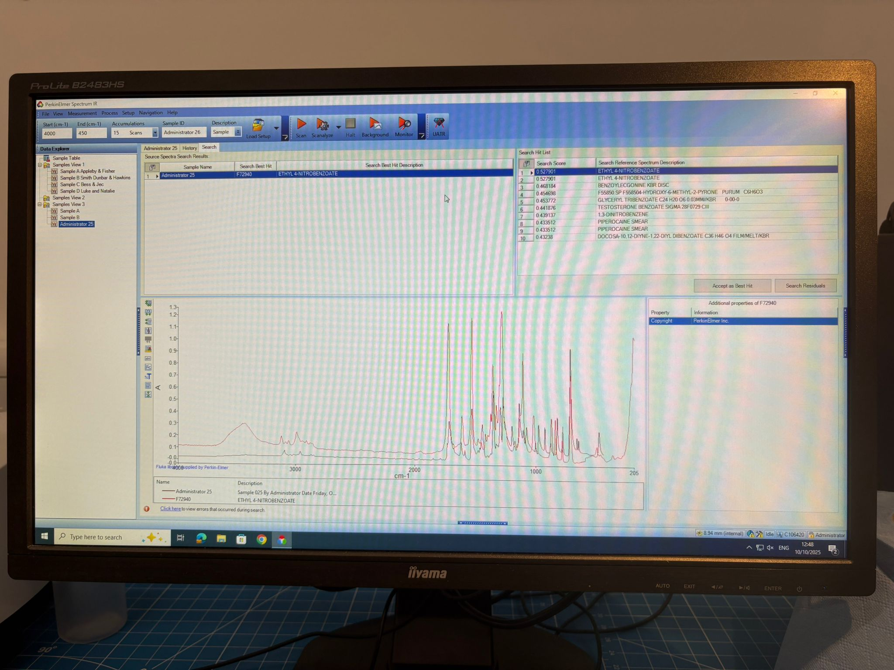
Figure 15 - sample C comparison

Sample c has a 55% similarity to ethyl 4-nitrobezonate, this is not any one of the expected 4 samples however looking at the graph and there peaks its looks like Methyl 3-nitrobezonate, this is also found in ethyl 4-nitrobezonate. We can conclude that sample C is likely to be Methyl 3-nitrobezonate

Sample D
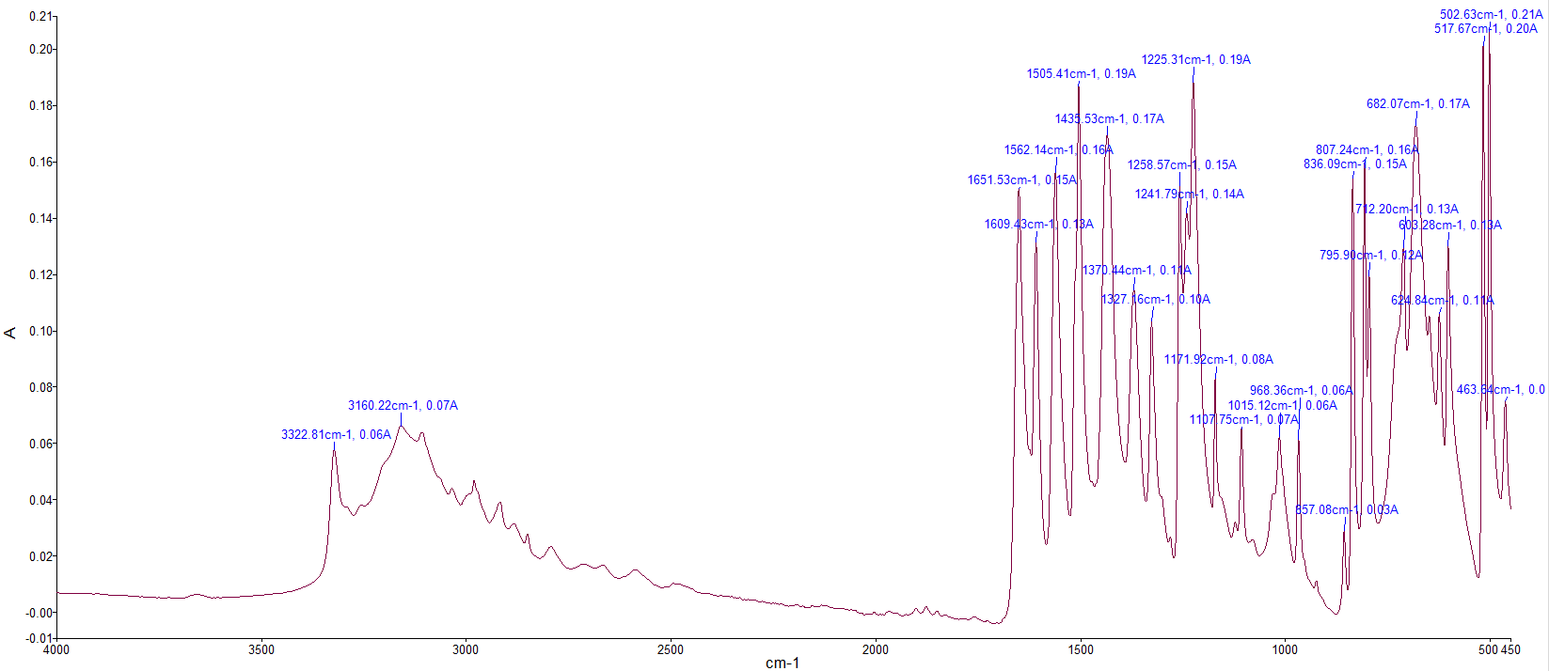
Figure 16 - Sample D Graph
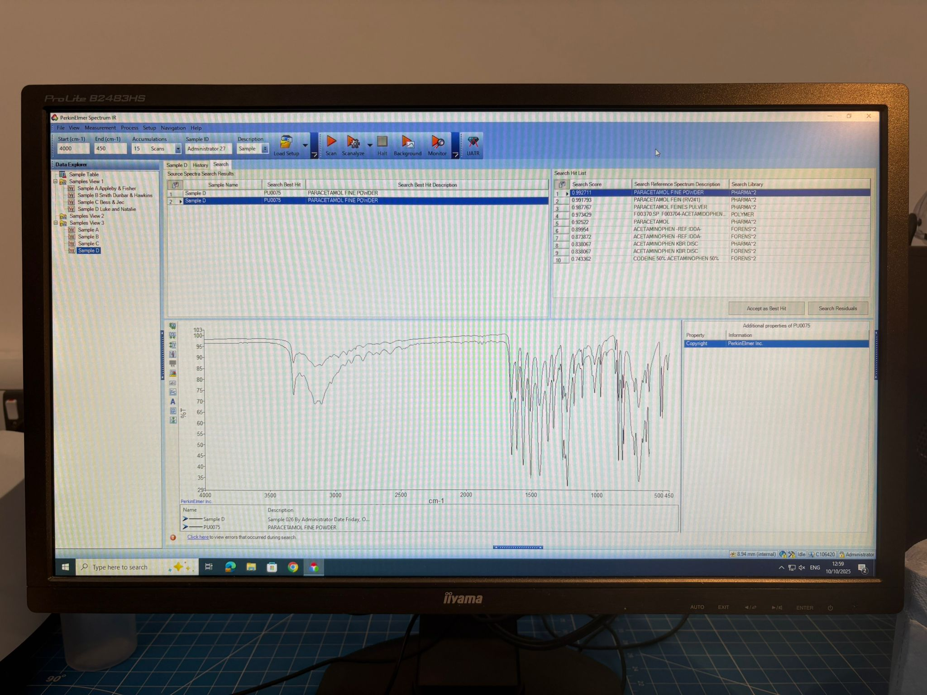
Figure 17 - sample D comparison
Sample D has 99% similarity to parastomal which is another name for acetaminophen therefore sample D is Aceptaminophen

Conclusions
Overall, this experiment is a goof way of showcasing how FT-IR can help identify compounds however contamination can make a huge different to the spectra and potentially lead to a miss- identification of the compositions, it also relies on the same set up every time of constant results which can be hard to achieve.

References

[1] | Bruker, “What is IR Spectroscopy,” [Online]. Available: https://www.bruker.com/en/products-and-solutions/infrared-and-raman/ft-ir-routine-spectrometer/what-is-ft-ir-spectroscopy.html. [Accessed 29 October 2025].
[2] | L. Tuhut, L. Munteanu, A. B. simon-marinca and a. Desnisa matei, “Explosve identification by Infrared spectrometry,” National institute for research devolopment in mine safty and protection to explosion, pp. 32-34, 2022.
[3] | ACS, “Molecule of the week Archive,” 20 July 2020. [Online]. Available: https://www.acs.org/molecule-of-the-week/archive/g/guanidine.html. [Accessed 29 October 2025].
[4] | Wikimedia Commons, “File:Paracetamol-skeletal.svg,” [Online]. Available: https://commons.wikimedia.org/wiki/File:Paracetamol-skeletal.svg. [Accessed 29 October 2025].
[5] | “Chemistry of ascorbic acid,” wikipedia, [Online]. Available: https://en.wikipedia.org/wiki/Chemistry_of_ascorbic_acid. [Accessed 29 October 2025].
[6] | “Methyl 3-nitrobenzoate,” Merck, [Online]. Available: https://www.sigmaaldrich.com/GB/en/product/aldrich/155977?srsltid=AfmBOooF_YACYnu_cZPSyVl_KhAIPwW_ena6jO20wH1R1_WeXFd8gqGj. [Accessed 29 Ocbober 2025].
[7] | Superlab, “PERKIN ELMER Spectrum Two,” [Online]. Available: https://www.super-lab.com/product/perkin-elmer-spectrum-two/. [Accessed 29 October 2025].

