Female Character Representation in Concept Art in the Animation Industry Essay

Charlotte Holly Preston
UWTSD
Swansea College of Art
cpreston.145222@student.uwtsd.ac.uk
cpreston076@gmail.com

Table of Contents:

  - . List of Illustrations_______________________________________________3-4
  - . List of Images_____________________________________________________5
  - . List of Tables______________________________________________________5
. Keywords______________________________________________________________________6-7
. Abstract_________________________________________________________________________8
  - . Introduction______________________________________________________8
  - . Methodology_____________________________________________________8
  - . Project-Specific Research___________________________________________10
  - . Discussions of Progress____________________________________________11
  - . An Awareness of Design____________________________________________12
  - . Results__________________________________________________________13
  - . Discovering the Self_______________________________________________13
  - . Evaluation and Conclusion__________________________________________16
  - .References_______________________________________________________17
  - . Bibliography_____________________________________________________18

List of Illustrations:

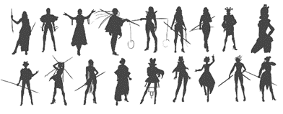
. Female character Silhouette concepts (Personal work). -------------------------------------------------------10
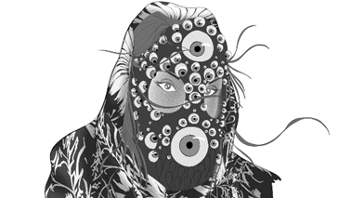
. VR Wizards Project, concept art (Personal work). -----------------------------------------------------------12, 14
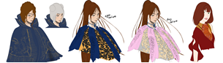
. VR Wizards Project, concept art (Personal work). ----------------------------------------------------------------14
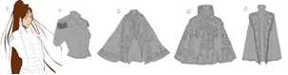
. VR Wizards Project clothing, concept art (Personal work). ----------------------------------------------------14
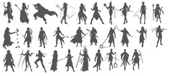
. VR Wizards Project original silhouettes, concept art (Personal work). -------------------------------------14
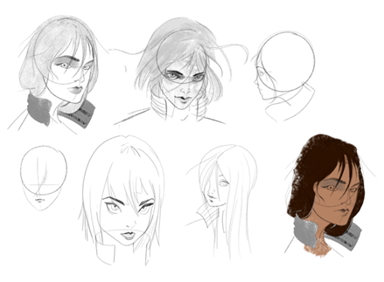
. Hyper, Hero concept art. -----------------------------------------------------------------------------------------------15
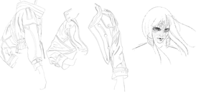
. Hyper, Hero concept art, clothing. -----------------------------------------------------------------------------------15
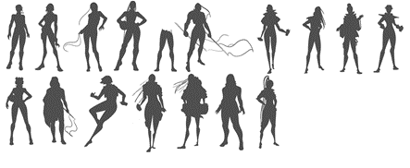
. Hyper original silhouettes. ---------------------------------------------------------------------------------------------15
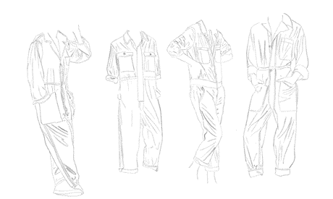
. Hyper, Hero clothing concepts. ---------------------------------------------------------------------------------------15

List of Images:

- Lara Croft Development Concept Art (Концепт-арт, 2015)

- Adventure Time Flame Princess Concept Art (Sugar, 2012)

- Steven Universe: Art and Origins (Vignette, 2018)

- Steven Universe Opal Concept Art (Steven Universe Wiki, 2014)
5.) Adventure Time Marceline Concept Art (Sugar, 2012)

List of Tables

- 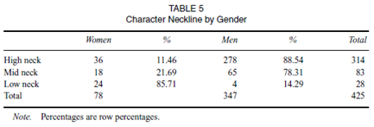 (Beasley and Standley, 2002)
- 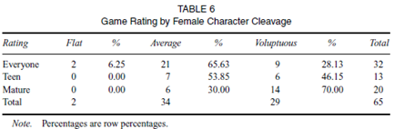(Beasley and Standley, 2002)

Keywords:
  - Female:
“Adjective
Of or denoting the sex that can bear offspring or produce eggs, distinguished biologically by the production of gametes (ova) which can be fertilized by male gametes.
‘A herd of female deer’
Noun
A female person, animal, or plant.
Origin
Middle English: from Old French femelle, from Latin femella, diminutive of femina ‘a woman’. The change in the ending was due to association with male, but the words male and female are not linked etymologically.” (Oxford Dictionaries | English, 2018)

Representation
“Noun
- The action of speaking or acting on behalf of someone or the stage of being so represented.
‘You may qualify for free legal representation’.
- The description or portrayal of someone or something in a particular way. ‘The representation of women in newspapers’.
- (Representations) Formal statements made to an authority, especially so as to communicate an opinion or register a protest. ‘the Law Society will make representations to the Lord Chancellor’
Origin
Late Middle English (in the sense ‘images, Likenesses): from Old French representation or Latin representation (n-), from reprasentare ‘bring before, exhibit’ (see represent).” (Oxford Dictionaries | English, 2018)

Functional
“Adjective
- Of or having a special activity, purpose, or task. ‘a functional role’
- Designed to be practical and useful, rather than attractive. ‘a small, functional bathroom’
- In operation; working. ‘the museum will be fully functional from the opening of the festival’
- Mathematics, relating to a variable quantity whose value depends upon one or more other variables. ‘Using functional notation, we can write – where L is the transactions demand for money’.” (Oxford Dictionaries | English, 2018)

Concept
“Noun
- An abstract idea. ‘structuralism is a difficult concept’ ‘the concept of justice’
  - A plan or intention. ‘the centre has kept firmly to its original concept’
  - An idea or invention to help sell or publicize a commodity. ‘a new concept in corporate hospitality’
  - [As modifier] 9of a car or other vehicle0 produced as an experimental model to test the viability of innovative design features. ‘a concept car for next month’s Geneva motor show’
  - Philosophy An idea or mental image which corresponds to some distinct entity or class of entities, or to its essential features, or determines the application of a term (especially a predicate), and thus plays a part in the use of reason or language.
Origin
Mid-16th century (in the sense ‘thought, imagination’); from Latin conceptum ‘something conceived’, from Latin concept- ‘conceived’, from concipere (see conceive).” (Oxford Dictionaries | English, 2018)

Design
“Noun
- A plan or drawing produced to show the look and function or workings of a building, garment, or other object before it is made. ‘he has just unveiled his design for the new museum’
- A decorative pattern. ‘pottery with a lovely blue and white design’
- [Mass noun] Purpose or planning that exists behind an action, fact, or object. ‘the appearance of design in the universe’
Verb
- Decide upon the look and functioning of (a building, garment, or other object), by making a detailed drawing of it. ‘A number of architectural students were designing a factory’
  - Do or plan (something) with a specific purpose in mind. [with object and infinitive] ‘the tax changes were designed to stimulate economic growth’
Origin
Late Middle English (as a verb in the senzse ‘to designate’): from Latin designare ‘to designate’, reinforced by French designer. The noun is via French from Italian.” (Oxford Dictionaries | English, 2018)

Abstract
The purpose of this paper is to bring attention to the slowly shifting landscape on female character design within the past few years in the animation, and subsequently, the games industry, while comparing these and deciding on what solutions could be made in tackling the issues that arise with this topic. To explore a number of researchers into the growing issues surrounding female character concept design and the affects that this has on its audience. While gathering an audience’s perspective on the topic while analysing and investigating into the misrepresentation of female design. All the while gathering a range of statistics on these concerns that arise and to suggest a possible solution through personal work in ongoing and current projects.

Introduction
As continuing on from this essay’s proposal, this main body of text shall explore the representation of female character design within the modern animation industry, exploring a range of diverse designs, events and occasions in which female characters are used. With current times seemingly showing a shift in development, through a number of conversations when creating female character concepts. While the proposal briefly explored what this paper will be covering, the main body shall explore the ways in which females have been represented, which stem a multitude of concerns that are being shown through visual messages that are being sent to the animation’s female and male audience. Through observing information gathered by Beasley and Standley, and many other researchers, the information found shall be used to figure out a solution to these design problems and challenges through providing this solution through personal work. The results found shall state a clear undeveloped amount of unrealism within many female character concepts which are currently widespread.

Methodology
The subject’s methodology shall be exploring and researching into the design outcomes and decisions of female character concept art in the Animation Industry at current times. While Analysing and understanding what the consequences are of misrepresenting a larger demographic. Also, while to continue exploring into the statistics of the male to female character ratio of the concept art and final shipped designs that are functional over this misrepresentation. This leading into the question that the bulk of the research will either confirm or deny, being, is the animation industry progressing in its representation of the female populace with female character concept art. While retaining the key objectives which the paper shall be outlining are the concerns of this topic and shall explore through each of them in turn.
  - Those of which include:
- Examining the use of female character designs in the animation industry,
- Gathering an audience’s perspective on the topic,
- Investigate the misrepresentation of female design,
- Gather statistics on the concerns that arise,
- Suggest a possible solution,
- Study ways in which to correctly portray the female populace in concept art through personal work by using the explored suggested solutions.
The research shall explore into ways and methods to solving this on-going issue and to find ways to combat these problems, through both examining these problems and to provide a clear solution to said questions and its objectives.
While exploring this subject there are two main considerations with the range of methodological choices, these considerations being the difference between qualitative and quantitative research, both shall be explored while conducting the main research. The collection of qualitative data shall be gathered through conducting questionnaires and through gathering language-based research through the general public when regarding this topic of female design. In comparison, the quantitative data shall be gathering information from a range of statistics and research that’s currently available from researchers regarding the subject matter. Most research papers focus on a main out of the two, this paper shall utilize both methods described in gathering the data needed to come to a strong and clear conclusion, so the answer takes the words of the general public and compares the mathematical findings from the quantitative data to equate to an outcome.
If a concept artist does not fully understand the shape language and reality of designing characters for a large demographic, the artist creates work that indirectly doesn’t correlate to correctly representing these people. The favoured outcome of the paper carrying through from the proposal would be to use the information from the eventual findings to create female designs that feel functional and above all, believable.
There are several problems that arise when discussing the topic of female character design, due to many different opinions verses the factual information. When considering both sides of the argument, there are those which can see the appeal of most female character designs, for example, Tomb Raider’s Lara Croft. Considering that her concept has many aspects of a female adventurer, she doesn’t retain a realistic or functional design when considering the environment that she scales, the clothing of which wouldn’t protect her person.
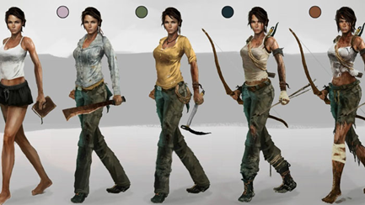
(Концепт-арт, 2015)
While the game itself is portrayed as being set in this hyper-realistic world, the character’s design doesn’t sell the believability that the character is fully protected against her surroundings. While greatly taking this design choice into consideration, the dissertation shall explore and research and experiment into both a quantitative and qualitative strategy when gathering the information needed to analyse.
Taking this approach to the research collection shall allow for both individual and group-based opinions while discussing the strategy and as previously stated, shall investigate into collecting questionnaires, also while reading into academic papers that are written on the topic of female character design. These of which include writers such as, Kinzie and Joseph, Beasley and Standley, McNiff, Bolton, Buchan, Bradley, Bush, B and SP, with Beasley and Standley being extremely prominent in the proposal of this paper. These academics shall be used in evaluating the current circumstance of this topic. As a result of this, this method uses both qualitative and quantitative data analysis.
Although, art-based research shall be primarily used as the method into finding a strong solution as a way of personally understanding and examining the experience of both studies undertaken by researches and the people who are both creating and affected by the representation of female character design, and to provide an answer to this. The exploration of female character design in personal work will hope to take into account a more functional ideation for female concepts that both retains the appeal of a character and is something that fans can appreciate while feeling represented.
Below are a few silhouette designs from current personal work that shall be explored in greater depth later on in this paper, these being a sort of answer in combatting the typical design choices that designers make with female characters.
(C.Preston, 2018)
During the past decade in the animation industry there has been a shift through design, specifically regarding female character design. Part of this massive shift many animation companies have been creating designs that (as many see) still bastardise the female form.
Thankfully, as animation productions for the television have steadily increased, they have also become a staple in the socializing in a child’s life when growing up. One revolutionary who’s making progress for both female character design and the representation of women, is none other, than Cartoon Network’s first female to create an independent series on the network, Rebecca Sugar, with her hit series Steven Universe. The show represents a plethora of female characters that all break the mould considering how female designs are usually designed and considered. The designs prioritise functionality and believability over the sexualisation of the character, as is most often seen in most media.
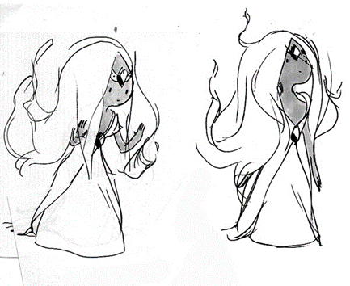
(Sugar, 2012)
Overall, the methodology has been structured in a way that effectively caters to answering the research subject and questions, along with the objectives previously stated.

Project Specific Research
Considering the bulk of the research will be art-based, there are several other methods that need to be fully explored to understand the larger scenario of this representation. Currently exploring the creators of our time in the animation industry and a little on the games industry, and their impact into the millennial generation and their target audience.

Discussions of progress
Considering Cartoon Network’s Rebecca Sugar is a current front runner in the animation industry, her work is filled with the promotion of a positive message for females and its audience as a whole and she shall be used as an example to be analysed for her work and contribution to this positive movement throughout this paper. Sugar states on countless occasions in the “Steven Universe Art and Origins” book, that the Steven Universe crew weights in on the show. The crew of which have all come from a background of strong female representation in their concept art and final designs.
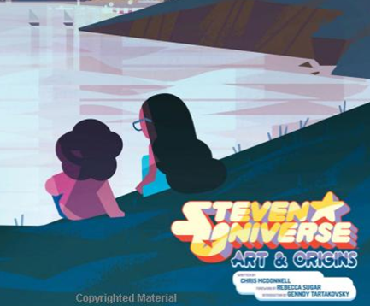
(Vignette, 2018)
Considering the creator comes from a background of female dancers, this gives her a more complex and functional understanding of the female form in motion over other creators that may not have studied the female form to quite a visually high standard and as such lose out on this greater understanding. Which ultimately shows through in their visual work.
When considering the creative team has a strong background in correctly representing women in other animated shows this greatly helps. As an example, Sugar had previously worked on Cartoon Network’s critically acclaimed Adventure Time. Alongside Steven Universe’s current storyboard artist, Hilary Florido, who’s worked on a number of shows, including the network’s animated series, “Regular Show”.
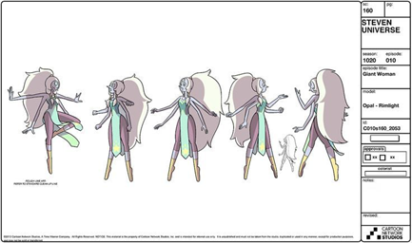
(Steven Universe Wiki, 2014)
Both of which worked on Adventure Time, another show whose female characters aren’t visually sexualised or incorrectly represented. This is partly due to the creative team involving a balanced male to female worker ratio.
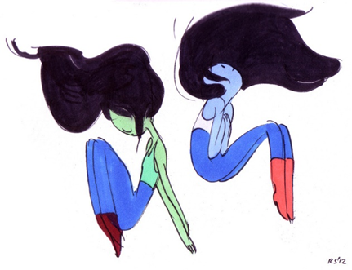
(Sugar, 2012)

An Awareness of Design
An awareness of design is something that can be seen throughout the creative industries at current times, including both the games and animation industries. There are countless games and animated series that greatly lack female characters within their stories, considering out of an analysis of 47 selected games this concluded that only one in four gaming characters were female. While these results aren’t the believable and optimistic half. There also concluded that the female characters that were included had been designed and clothed in a manner that exposed a considerably more amount of skin than their male counterparts. (Beasley and Standley)
(Beasley and Standley, 2002)
Even still to this day there is a clear divide when comparing clothing designs, especially with the lower body, that are statistically different χ2(5) = 130.98, p < .05 (Beasley and Standley, 2002). Though, through primary statistics there also shows a factual change during recent years, although this divide is still clear in the representation of female characters throughout both the mediums of the animation and games industry.
Again, below is an example of personal work that considers these problems, while keeping the main goal to correctly portray the female gender in a more realistic and functional manner.
(C.Preston, 2018)
Through research the data shows that there is a clear connection between females and the narrative drive of the media in question. These “fabulations of women” in most sources aren’t created by women, for the most part, and are only projected to having a pleasurable visual rather than a realistic outcome.
Beasley and Standley spoke of the comparison that included heavily gendered clothing items, such as skirts. For example, the cleavage of female characters has also been analysed.
(Beasley and Standley,2002)
As Beasley and Standley have gathered statistics finding that out of a collective of 71 females of whose cleavage is visible, 2.82% had been considered flat chested, 56.34% average, with 40.85% as voluptuous (Beasley and Standley, 2002). A number of these females being classed as being voluptuous had been unrealistically large. Both go on to state how 31% of these characters are in games with a rating of “E” for everyone. Which ties into the test conducted on a number of elementary students and how they noted themselves that female characters had been “gendered by design”. The results of which not only change women and young girl’s attitude towards games, there are also a multitude of other gender implications in topics as simple as confidence and setting technological literacy limitations (Kinzie and Joseph, 2018).

Results
The overall conclusion that Beasley and Standley amongst many other linguistics settled on was that there is a clear gender role stereotyping within the animation and games industries with female characters being considerably underrepresented in the media, being the animation industry. A similar set of results being seen for the animation industry, as previously stated, only with changes to these results taking affect and becoming more noticeable within the past 5 years becoming the most apparent, as with the release of Rebecca Sugar’s “Steven Universe” (2013).
Another set of results state how female characters that do appear in both animation and games are large breasted and dressed in a manner that puts emphasis on their sexuality by drawing attention to their breasts (Beasley and Standley, 2002). Who repeatedly state how the clear gender role discrimination let it be in animation, games, live action, or any media industry is fundamentally unacceptable. This is currently still an ongoing problem, that although has made progress in recent years, with how female characters are beginning to be designed in a more realistic and functional manner. Which ultimately gives the audience a better look on the female gender and gives the audience more examples of female characters to begin to personally relate to. Which, ultimately, attracts a larger demographic of people to engage in the animation at hand.
While studies previously discussed encompass the journey that female design has encountered over the past decade, it is clear that strides have been made in the right direction through Sugar’s work and Florido’s work, amongst many other artists. When reviewing the results that Kinzie and Joseph made they bring up an interesting point in how children have been noticing the biased gender designs that have been apparent in the animation industry. This correlates with how a large demographic of women have been expressing their concerns as in recent years, only giving a clearer understanding that a solution does in fact need to be found.

Discovering Art of the Self
When discussing the progression of female character design and finding both the common grounds and the ways in which the topic shows room for improvement, there is a need for a solution. One of the key objectives presenting in finding this solution, of which has been explored through personal work, which has been created partly alongside this topic subject but also as a personal goal to become a part of this shift in female character design, is to produce something that people can relate to.
The concept art featured below had been created for a project largely surrounding a wizard’s theme. While most animations and games that centre on the theme of wizards hold that same gender role discrimination as previously discussed. Many designs showing more skin than should be protectively believable. When opposing those style troupes this piece of work has had to keep into consideration the appeal of the character and the feel for the intended character. The goal, to design a high-class wizard with a strong traditional style.
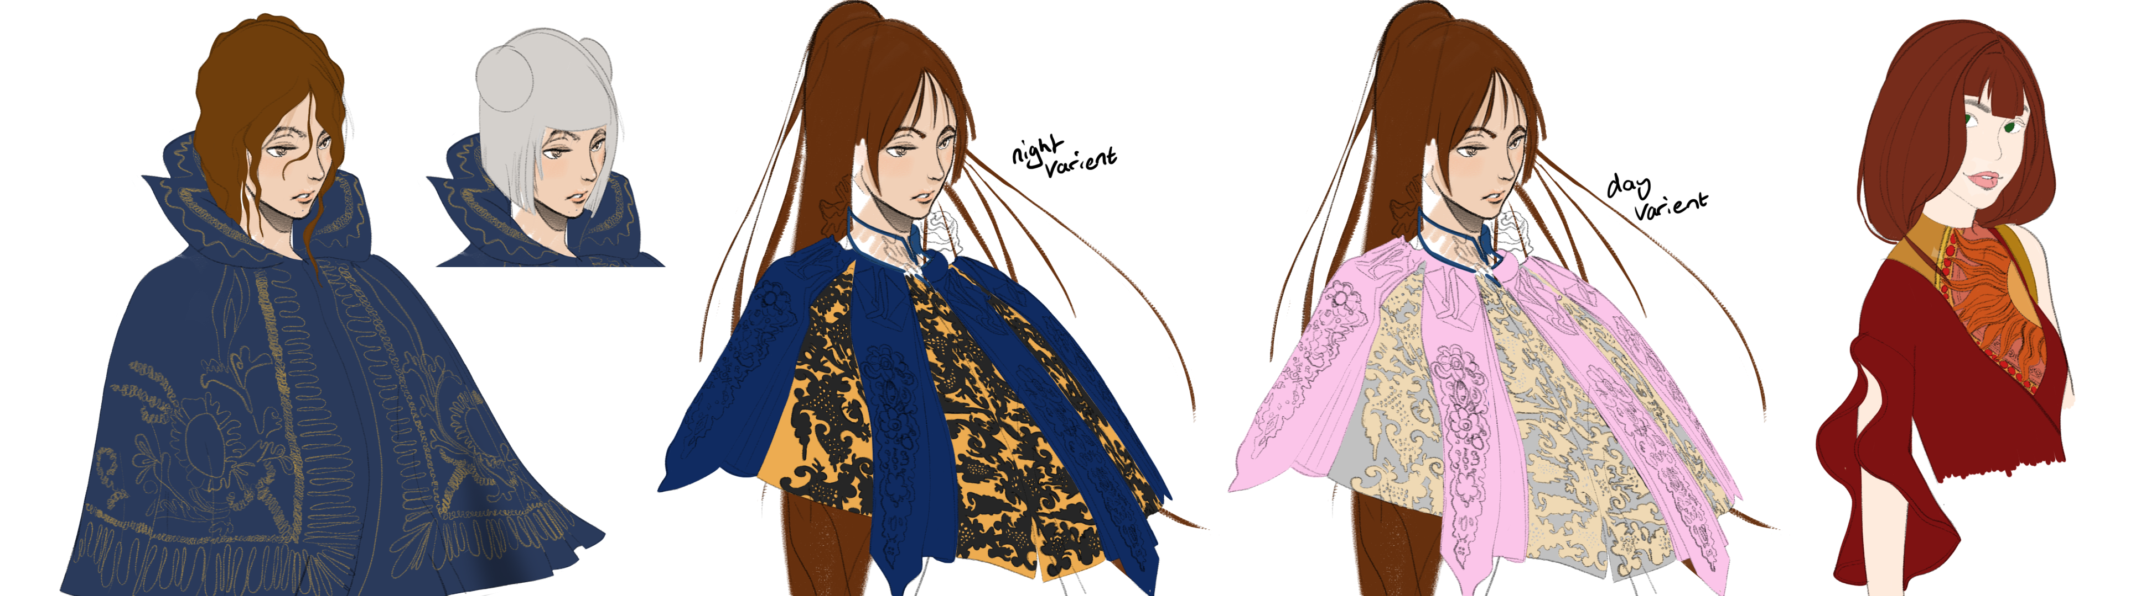
(C.Preston, 2018)
Contrasting the popular female designs of showing skin with covering areas of the body that would be exposed to the weather and enemy attacks from opposing characters in the game. All the while retaining that high-class look, this being achieved by contrasting high detail with heavy materials that layer on the character’s body. While opposing skin tight designs with largely draped capes and military coats.
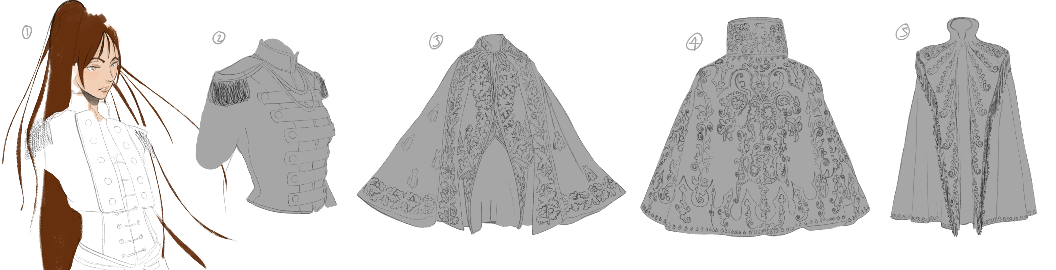
(C.Preston, 2018)
Considering that the characters would be exploring open areas of wooded landscapes and areas that are dangerous, the female characters need to feel prepared for the journey ahead, as the character in game would have this in mind before traveling. A large part of concepting characters is portraying a character in a landscape that to the audience feels believable in whatever setting and giving the correct tool to set out on the hero’s journey.
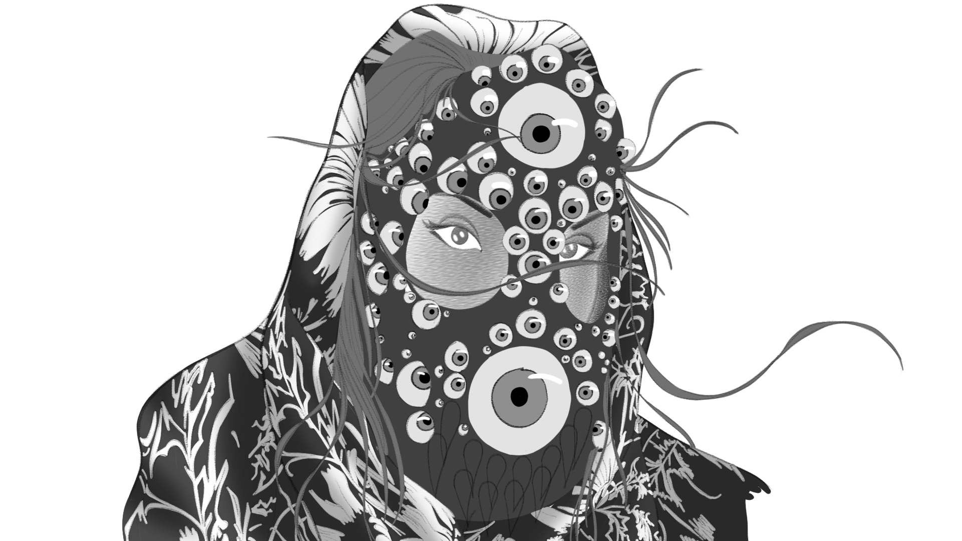
(C.Preston, 2018)
There were several pieces that were personally created for this project, one being a range of character silhouettes that personally pushed this understanding of design and functionality all while retaining appeal. As shown below.
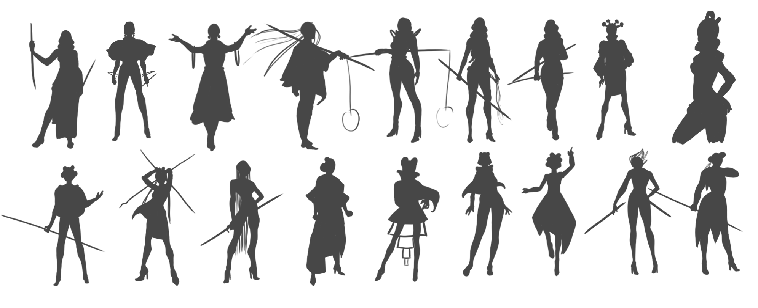
(C.Preston, 2018)
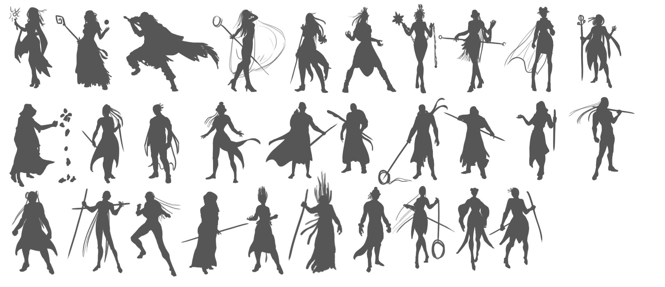
(C.Preston, 2018)
Another project with personal work includes a current racing theme, this being another theme that’s largely known for the misrepresentation of female characters, as a result of this, a personal goal had been to set out to create female designs that retained their femininity with a balance of “edge” and believability. As part of this project it had been discussed very early on that the main character “Nikki Nitrous” needed to be a character that wore clothing that could be seen as gender ambiguous, as the centre of the story was to give people a feeling of inclusivity.
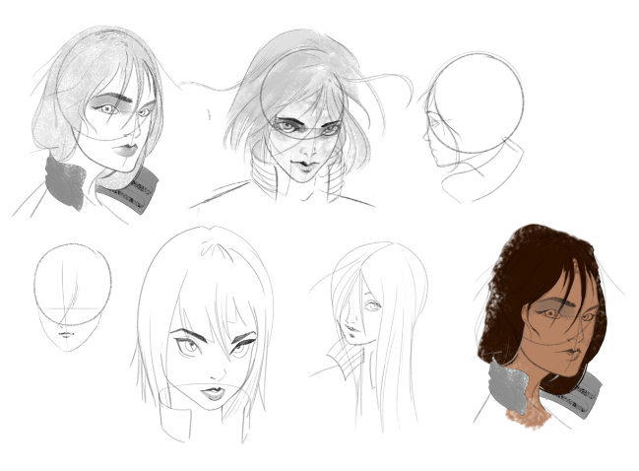
(C.Preston, 2018)
The characters clothing being the decision to be this garage overall that has a worn and oversized visual, with the aim to give the audience the understanding that the female characters overalls can and have been worn by both male and female characters.
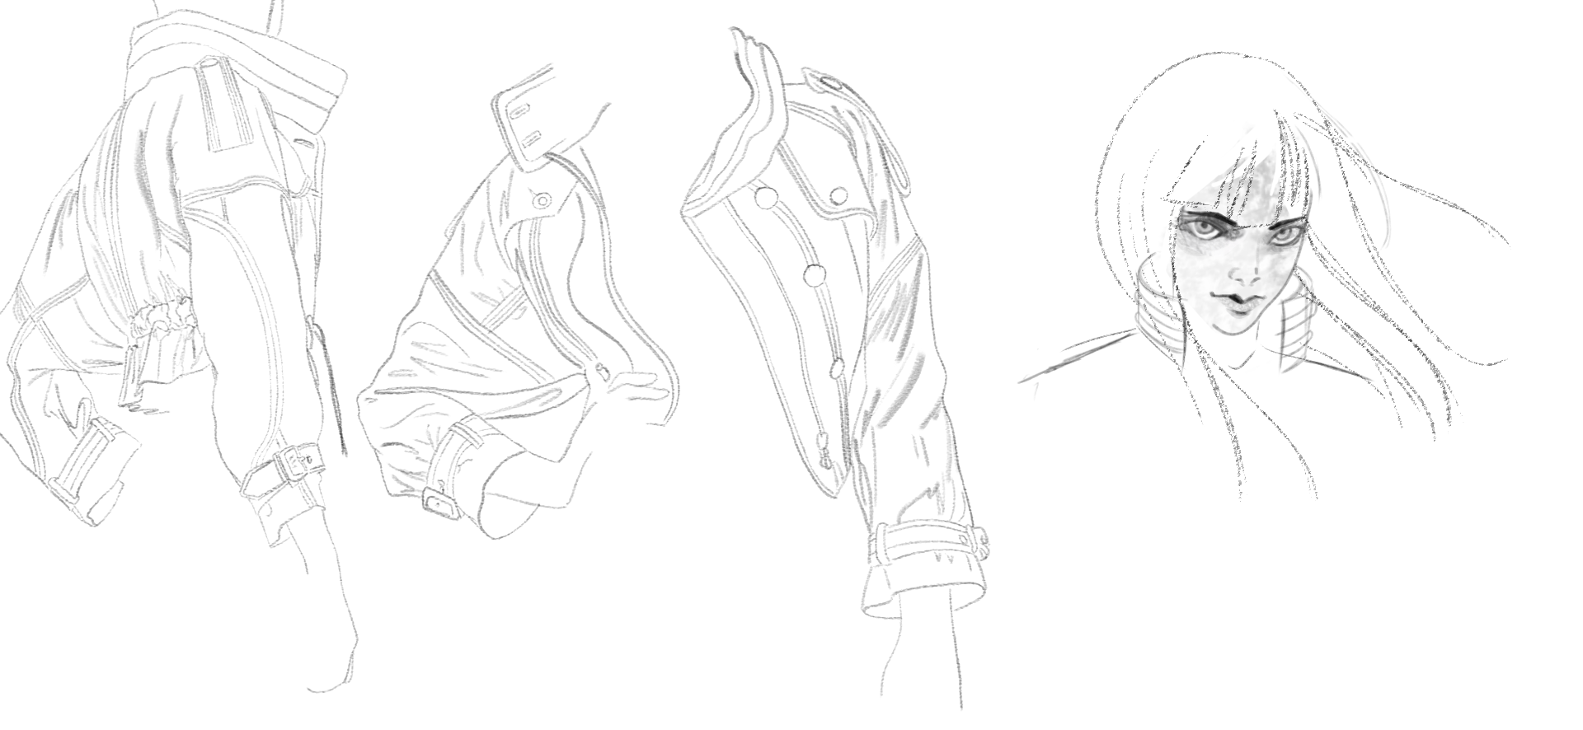
(C.Preston, 2018)
This early design decision put more emphasis on the creation of the character to feel more as a person as opposed to a central appeal icon used in the animation.
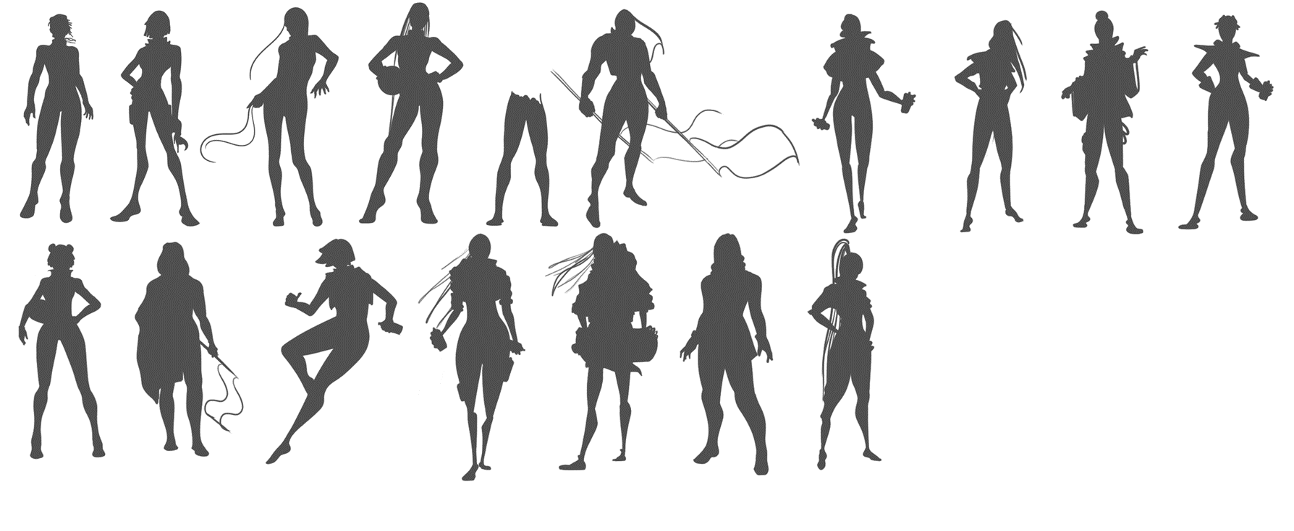
(C.Preston, 2018)
The previous designs of which slightly oppose the early personal work that had been created on the project. These silhouettes featured above still retain a female design biased that had started to seep through from the previous project. Although while the previous project hadn’t been centred on the clothing gender misrepresentation, those designs weren’t what the racing female lead needed in her design so were scrapped in favour of a believable young female teenage lead.
Several design choices in the work previously featured had been decided upon to oppose what Beasley and Standley’s findings were, for example a large percentage of female designs containing large chests, were swapped for a more believable body size. Especially when considering that both female characters in the wizard and the racing projects are physically fit and so the anatomy needed to reflect the character and their surroundings as such, to better bridge the gap between a functional and realistic character over an unrealistic female character design.
When designing the clothing for the racing female lead it had been important that the character shouldn’t be too exposed to the elements around. This largely being a result of being surrounded by machinery and heavy equipment, by giving the character large overalls, she fits in with the environment around her.
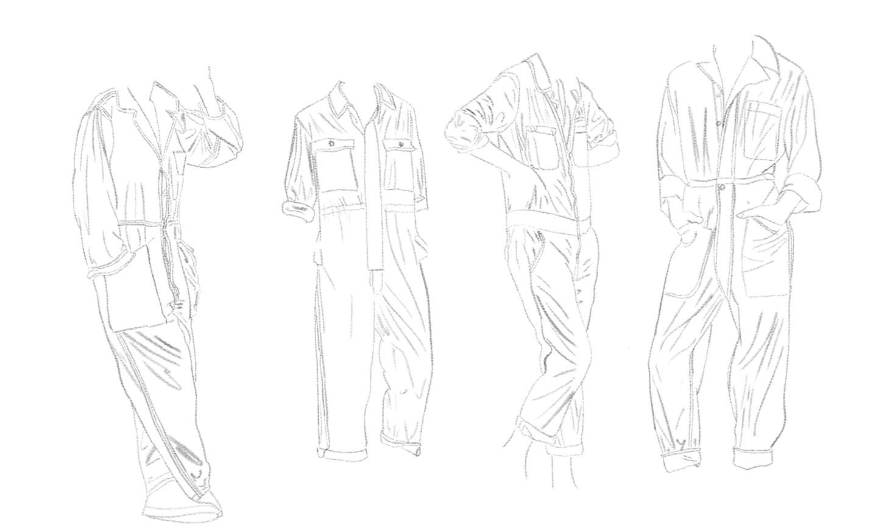
(C.Preston, 2018)

Evaluation and Conclusion
There are numerous aspects that have and still continue to be taken into consideration when weighing up both the negative and positive connotations to this overall sensitive topic. As when designing while taking into account one of the key principles of animation being appealing to representing functional design both must please the audience in a perfect balance that is continually being refined still to this day. While there is still an apparent sense of gender role discrimination in female character designs, there has undoubtedly been a positive change over the past few years as the research has clearly stated, especially with the rise of this becoming a more concerning topic, with creatives wanting to portray believable female characters just like their male counterparts.
Considering both the overall findings and the attempt at providing a solution has given a much greater personal understanding of the female form and how a female character interacts with their surroundings as is extremely important to the animation industry. The results point toward that there are concept artists that are mainly designing with appeal being the sole goal over the functionality of the female in the world that they inhabit. Apart from providing a solution of further studying the female form, it would also be beneficial for concept artists to further study the world that the character exists in.
Thankfully there has been a noticeable shift as findings show, as previously discussed with Sugar’s standing in the animation industry and creators like herself, who only promote believably designed female characters as well as male characters.
Using the information gathered and opposing some of these largely used design traits in female design with personal work provides a temporary solution as while a few projects can be focused on to this change with personal work there is still that need for the larger industry to catch up, which is slowly happening.
Overall, there have been significant changes to the approach to female character concepts within the animation industry, with this shift happening at current times. Any extra progress that concept artists can make through this topic is largely based on studying the female form and keeping in mind the purpose and surrounding elements to the character over designing a character solely based on appealing traits.

References

- Oxford Dictionaries | English. (2018). female | Definition of female in English by Oxford Dictionaries. [online] Available at: https://en.oxforddictionaries.com/definition/female [Accessed 22 Nov. 2018].
- Oxford Dictionaries | English. (2018). representation | Definition of representation in English by Oxford Dictionaries. [online] Available at: https://en.oxforddictionaries.com/definition/representation [Accessed 22 Nov. 2018].
- Oxford Dictionaries | English. (2018). functional | Definition of functional in English by Oxford Dictionaries. [online] Available at: https://en.oxforddictionaries.com/definition/functional [Accessed 22 Nov. 2018].
- Oxford Dictionaries | English. (2018). concept | Definition of concept in English by Oxford Dictionaries. [online] Available at: https://en.oxforddictionaries.com/definition/concept [Accessed 22 Nov. 2018].
- Oxford Dictionaries | English. (2018). design | Definition of design in English by Oxford Dictionaries. [online] Available at: https://en.oxforddictionaries.com/definition/design [Accessed 22 Nov. 2018].
- Kinzie, M. and Joseph, D. (2018). Gender differences in game activity preferences of middle school children: implications for educational game design. [online] Springer Link. Available at: https://link.springer.com/article/10.1007/s11423-007-9076-z [Accessed 22 Oct. 2018].
- Berrin Beasley. And Tracy Collins Standley. (2002) Shirts vs. Skins: Clothing as an Indicator of Gender Role Stereotyping in Video Games. [online] semantic scholar. Available at: https://pdfs.semanticscholar.org/a869/79702bd24d79e70d5c6ef75decacc70296ba.pdf [Accessed 22 Oct. 2018].
- McNiff, S. (2007). Art-Based Research. [online] Moz.ac.at. Available at: https://www.moz.ac.at/files/pdf/fofoe/ff_abr.pdf [Accessed 2 Nov. 2018].
- Bolton, C. (2016). Representation and Design Trends in Games. [online] Gamasutra.com. Available at: https://www.gamasutra.com/blogs/ClaireBolton/20161130/286551/Representation_and_Design_Trends_in_Games.php [Accessed 15 Oct. 2018].
- Buchan, S. (2018). The Animated Female Body, Feminism(s) and 'Mushi'. [online] SpringerLink. Available at: https://link.springer.com/chapter/10.1007/978-3-319-73873-4_11 [Accessed 2 Nov. 2018].
- Bradley, M. (2018). Living in the Liminal: Representation of Transgender and Nonbinary Identity in 'Steven Universe'. [online] Digital Commons @ Ursinus College. Available at: https://digitalcommons.ursinus.edu/media_com_hon/8/ [Accessed 15 Oct. 2018].
- Bush, J. (2018). Moana. [online] Available at: https://muse.jhu.edu/article/683746/summary?casa_token=WrlnadXB9HUAAAAA:sCs5_Ld8GkkPLX0vHzkXIXvEpblMrgoApzFTnrC63rFI9Zsnb5uGM3BNwWps9oryg5itkX252Hg [Accessed 30 Oct. 2018].
- B, M. and SP, K. (2018). Visual Media and Communication: A Conundrum of Gender Disparity in Animated World. [online] Globalmediajournal.com. Available at: http://www.globalmediajournal.com/open-access/visual-media-and-communication-a-conundrum-of-gender-disparity-inanimated-world.pdf [Accessed 2 Nov. 2018].

Appendices
Reference files attached in Moodle, includes Photoshop files.

