DS 1 Isabel Colela – 23/10/2026

IWatch
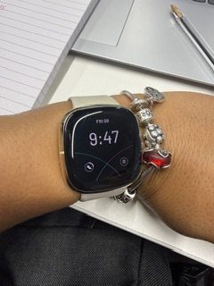
With my iWatch I can check the time and keep track of my food, exercise and sleep program. In addition, I can make and receive calls and respond to messages. I feel more connected to others and more organizes as a result. I should use the watch more to help me with my everyday activities and spend less time reviewing alerts. These are crucial because they allow me to better balance technology and my everyday life, manage the watch at any time and be informed about everything I program on it.

Google Maps
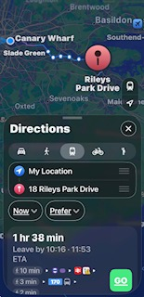
Google maps, help me locate locations and get where I want to go with the help of Google Maps. Helps me avoid traffic, shows me the best routes and provides me with directions. When I travel, especially to new places, I might feel easier and more confident. I need to get better at making travel plans of time and following directions. I believe this is crucial since it will help me travel safely, save time and avoid getting lost.

ID Card
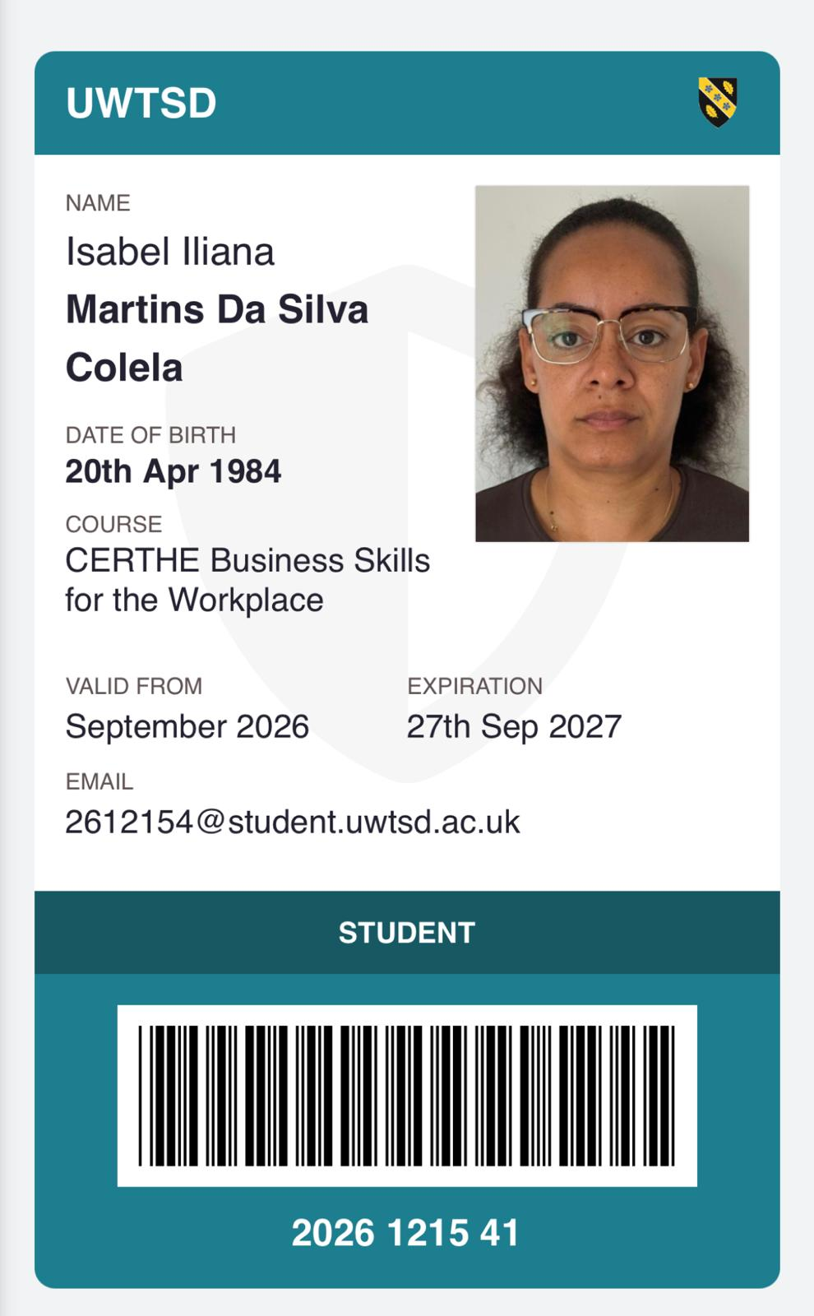
My school ID card helps me to identify myself at school and use the facilities. Because it gives me a sense of security and organization, it demonstrates that I am a part of the institution. I must remember to bring my ID card to school each day and keep it secure. It's crucial since it makes my school day smoother and helps me avoid issues.

Kid with Phone
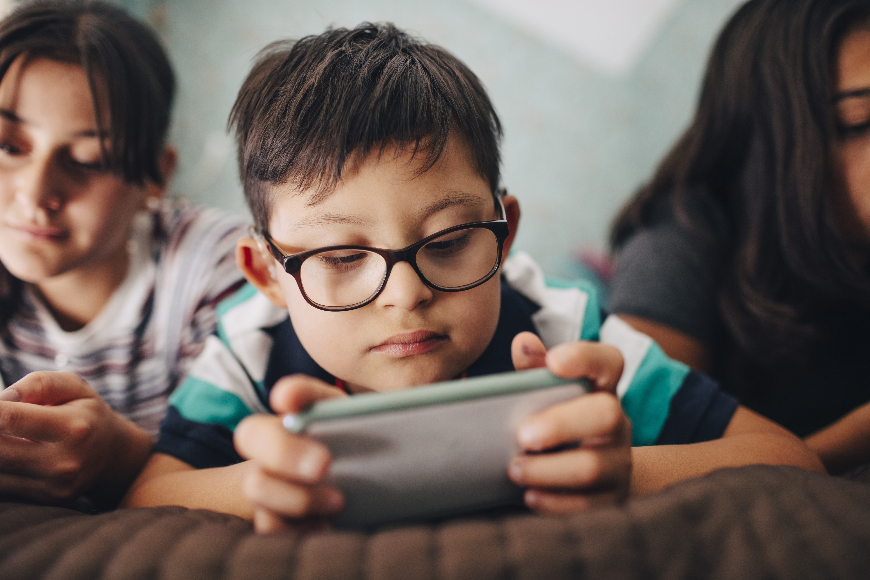
The kid staring at a cell phone. Everyone can view films, play educational games and learn new things using a mobile phone. They may feel delighted, amused, and inquisitive. On the other side, kids should develop better habits by exercising and using their phones less. This is crucial because it fosters effective communication and social skills in kids.

Chef Live Stream
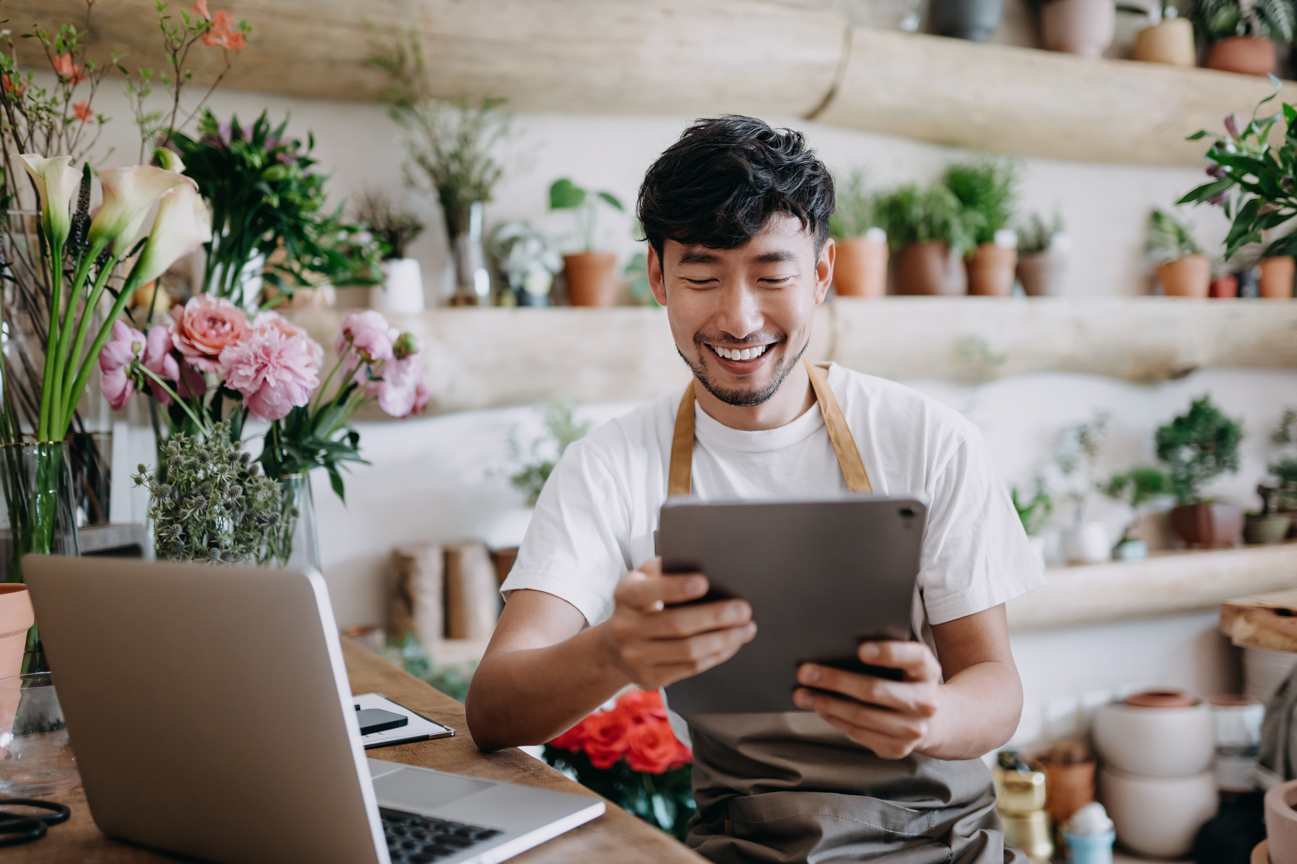
A chif streamed live. A chef can teach new recipes, knowledge about culinary and respond to inquiries in real time during a live feed. The cook may feel content, self-assured and a part of the audience as a result. However, before beginning the live stream, the chef should make sure everything is ready and check the internet connection. This facilitates clear communication, helps the chef avoid issues and improves the viewing experience.

Man at Work
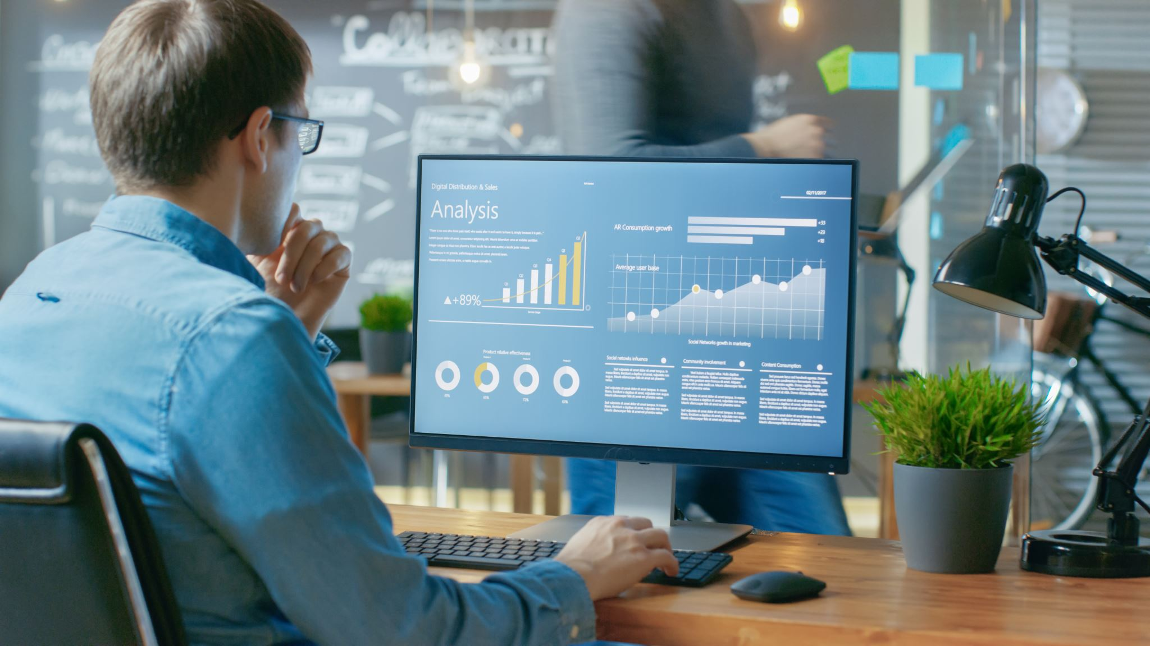
A man at work, examining data on his computer. Everyone can accomplish vital tasks with the use of computers. You can locate information, finish tasks and interact with coworkers at work. He feels more organized, self-assured and productive as a result. However, he must get better at using computers and take regular pauses from the screen. The improvements are crucial because they enable him to operate more effectively, prevent errors and safeguard himself.

My Short Reflection

I use digital tools to help me to be connected and organized with my roles in my day-to-day activities.
Although I am totally comfortable using my phone and navigational ideas daily, my current objective is to improve my computer skills to a better position for myself to get better opportunities in the future, even though I frequently use tools like my computer and smartwatch, I occasionally get anxious when I’m new to technology.
I hope that this module will give me confidence and boost my self-assurance, developing my digital literacy is essential for my everyday life, my present coursework and my long-term professional objectives.

