BA (Hons) Leadership and Management Skills for the Workplace

Managing Business Information (LCLM5004)

Assessment 2 – Information Systems Improvement Report: Evaluation and Recommendation for Maldiva Ltd.

Student name :Desislava Yovcheva
Student ID:2321718

Contents
Introduction 3
Evaluation of Existing Systems 4
Current Information Systems of Maldiva Ltd. 4
Inventory Management System 4
Customer Relationship Management 5
Management Reporting 6
Inefficiencies and Gaps 7
Poor System Integration 7
Inventory Management 8
Poor CRM 9
Decision-Making 9
Cybersecurity and Regulatory Compliance 10
Recommended Solution 11
Proposed Information System 11
Justification for the Recommendation 12
Expected Business Improvements 13
Implementation Plan 14
System Implementation Process 14
Training and System Integration 14
Implementation Challenges 15
Conclusion 15
References 17

Introduction
Today, modern organisations rely on information systems (IS) in dealing with business activities, implement better decision-making processes, and improve communication approaches. Also, efficient IS can improve organisational efficacy, decrease mistakes, and raise levels of customer satisfaction. With the improvement of the businesses, they are required to involve digital systems that help different departments in collaborating and sharing accurate data (Laudon and Laudon, 2023).
This report evaluates Maldiva Ltd., a fast-growing consumer electronics retailer that has physical stores and an online shopping platform. Despite the company experiencing operational problems because of outdated information systems, it indicated a strong sales growth. However, such issues are disconnected customer records, manual inventory management, slow reporting processes, weak communication between departments, and low data security. Based on that, the organisation faces stocking mistakes, inefficient decision-making processes, customer complaints, and data protection risks (Stair and Reynolds, 2023).
The main purpose of this report is to assess the present IS applied by Maldiva Ltd and show the key weaknesses influencing on the business performance. It also provides recommendations like an integrated information system formed on Microsoft Dynamics 365 in order to enhance customer relationship management (CRM), improve inventory, and help the company make better decisions. Finally, the report presents an implementation plan in order to define how the suggested solution can be applied successfully and ensure the company's future growth.

Figure 1. Logo of the company
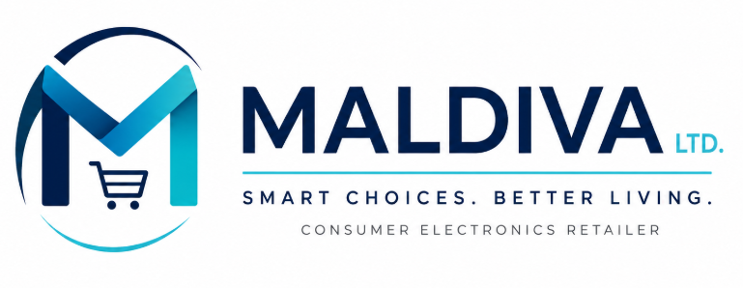

Evaluation of Existing Systems

Current Information Systems of Maldiva Ltd.
Today, Maldiva Ltd. implements many independent information systems in order to support its daily business practices. In addition, the organisation possesses physical stores and an e-commerce platform. However, the systems applied by various departments are not completely related. For example, finance, customer service, sales, and inventory implement different software. This requires staff to transfer information manually between all departments. Based on that, business information gets usually duplicated, postponed, or wrong (Laudon and Laudon, 2023).

Inventory Management System
Stock updates are considered key elements of the inventory management system. Moreover, store staff should often input stock information manually, and online orders are processed separately. As such systems cannot exchange data automatically, inventory records do not provide consistent information. Products, which appear available online, may have already been sold in the physical stores. This can create customer dissatisfaction and raise the number of refund requests (Stair and Reynolds, 2023).

Figure 2. Inventory Management System of Maldiva Ltd.
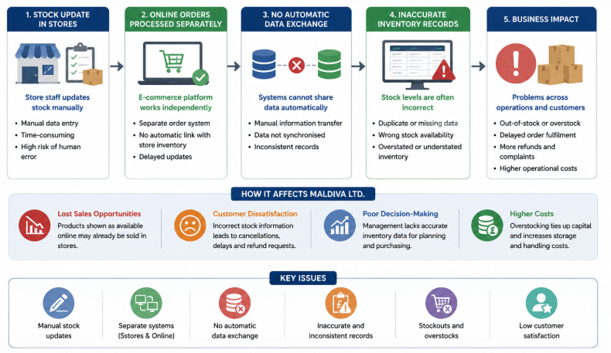

Customer Relationship Management
Another field that experiences many limitations for Maldiva Ltd is customer relationship management (CRM). In addition, customer information is kept in different databases, instead of one integrated CRM system that can be accessed by each department. So, staff do not have direct access to the histories of completed purchases or customer preferences. Moreover, the marketing department cannot create customised promotional campaigns efficiently, and customer service employees need extra time in order to look for customer information before responding to complaints (Buttle and Maklan, 2023).

Figure 3. CRM of Maldiva Ltd.
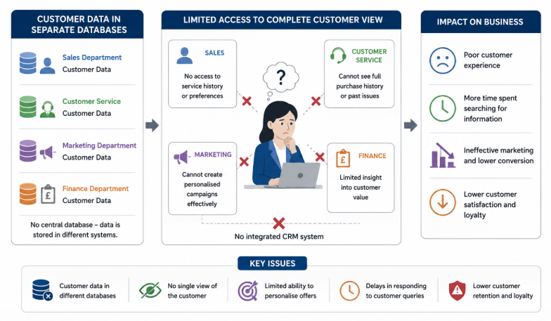

Management Reporting
Management reporting also relies on manual spreadsheet preparation. Moreover, sales data from the different stores are gathered and applied manually before preparing the reports for senior managers. Such a process requires many efforts and time and increases the possibility of calculation errors. Also, reports are usually related to historical information, not real-time business performance. This decreases their value for strategic decision-making (O'Brien and Marakas, 2022).
Moreover, the company indicates weaknesses in information security. Its current systems offer restricted access controls and do not completely comply with the GDPR. Therefore, customer data can be exposed to unauthorised access that increases cybersecurity risks and possible legal consequences. While companies consistently gather large amounts of customer information, security management is crucial (Whitman and Mattord, 2022).

Figure 4. Management Reporting of Maldiva Ltd.
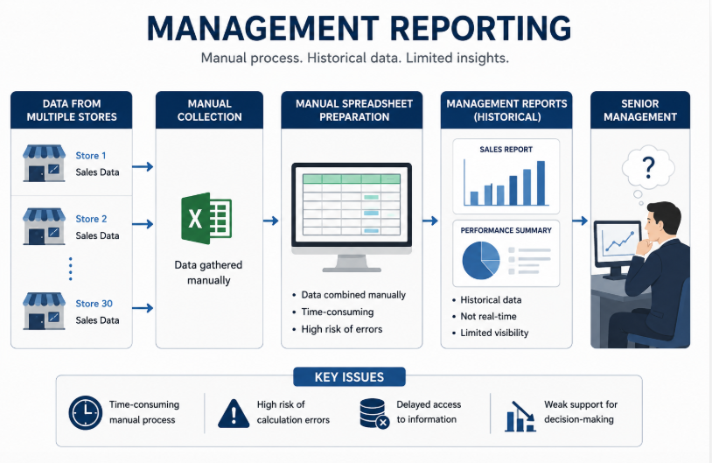

Inefficiencies and Gaps
The IS of Maldiva Ltd pose many operational weaknesses that directly influence the company’s business performance.

Poor System Integration
Poor system integration is a major weakness of Maldiva. As the different departments of the company use separate software applications, staff must enter the same information many times in different systems. From this duplication, administrative work increases, staff waste time, and human error is inevitable. In addition, integrated IS often avoids duplicate data entry through sharing information automatically across departments of companies (Laudon and Laudon, 2023).

Figure 5 Weak System Integration of Maldiva Ltd.
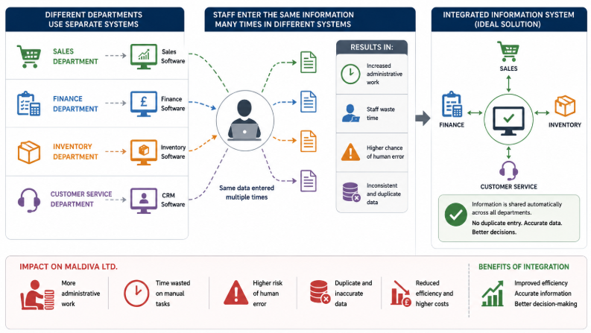

Inventory Management
Inventory management is another weakness because manual stock control avoids monitoring of inventory levels across physical stores and the online platform. So, the organisation faces various stock shortages, overstocking, and postponed orders. Such issues raise operating expenses and decrease customer satisfaction and revenue (Stair and Reynolds, 2023).
Figure 6. Poor Inventory Management at Maldiva Ltd.
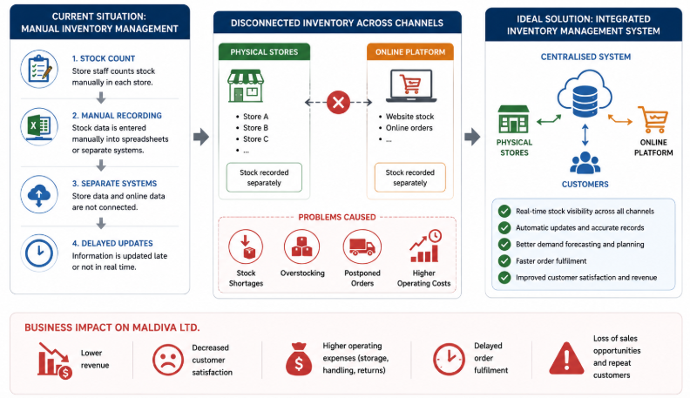

Poor CRM
In addition, CRM is also not well-focused. Maldiva Ltd does not have a central CRM database, which decreases the company’s understanding of different purchasing customer behaviours. Also, this issue poses another gap for Maldiva Ltd in providing customised services. Contemporary retail organisations rely on customer data to enhance marketing performance, increase customer loyalty, and ensure long-term relationships (Buttle and Maklan, 2023).
Figure 7. CRM system at Maldiva Ltd.
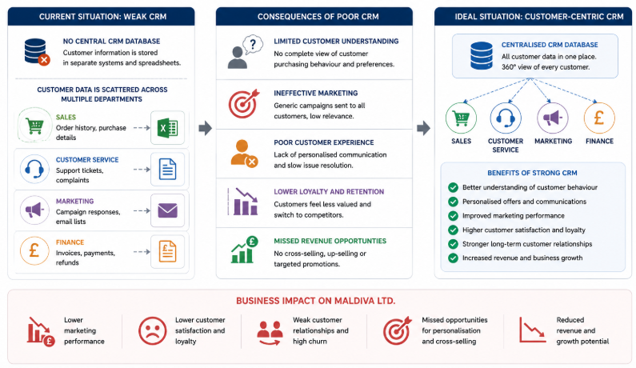

Decision-Making
The outdated reporting methods can influence the decision-making processes at Maldiva Ltd. Moreover, senior managers depend on manual reports, and by the time they are prepared, the data may have already been outdated. Lack of a real-time dashboard decreases the company’s ability to react rapidly to different changes in customer demand, inventory levels, and pricing. Efficient management IS can improve the company’s business decisions because it will provide the latest information all the time (O'Brien and Marakas, 2022).

Figure 8. Decision-Making at Maldiva Ltd.
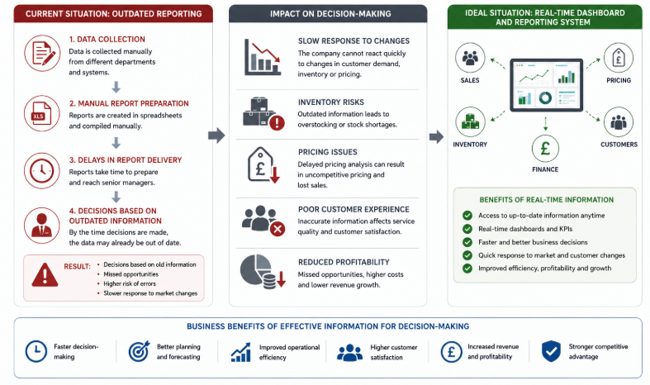

Cybersecurity and Regulatory Compliance
Cybersecurity and regulatory compliance are also major concerns for Maldiva Ltd. Authentication processes and poor access control raise the possibility of data breaches. In addition, not complying with the GDPR requirements can cause financial penalties, harm of reputation, and decreased customer trust. According to Whitman and Mattord (2022), improving data security should be a major strategic priority for the organisation.
Figure 9. Cybersecurity and Compliance Regulation at Maldiva Ltd.
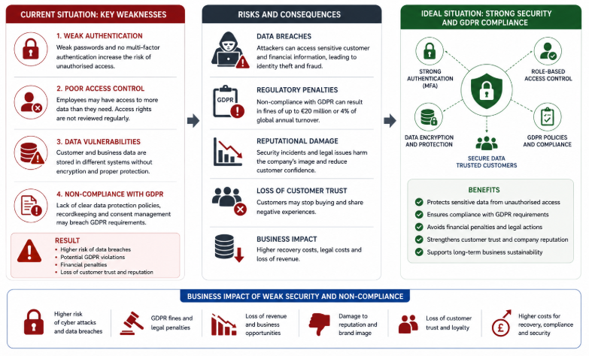
In general, the evaluation indicates that Maldiva Ltd's existing IS cannot contribute to the growth of the company. Lack of integration, manual business practices, low customer management capabilities, and poor security controls pose different operational inefficiencies that decrease the performance of Maldiva Ltd. Based on these results, implementation of a modern integrated enterprise information system should improve effectiveness, customer satisfaction, and decision-making processes.

Recommended Solution

Proposed Information System
In order to handle its current operational issues, Maldiva Ltd. must use Microsoft Dynamics 365. This is an integrated Enterprise Resource Planning (ERP) and Customer Relationship Management (CRM) solution. Despite the company having independent systems, Microsoft Dynamics 365 can connect different business functions in one single platform. Moreover, it uses inventory management, sales, finance, customer service and reporting. This helps the company to provide access to all departments to the same real-time information (Microsoft, 2025).
The system also emphasises cloud-based data storage, automatic information updates, and secure access controls. Therefore, staff should no longer need to transfer information manually between departments. In addition, the company can improve cooperation, decrease duplicating records, and raise operational efficiency. Moreover, Dynamics 365 provides analytical tools and dashboards, which helps management supervise business performance and react rapidly to different customer demands (Velosio, 2024).
Figure 10. Information System for Maldiva Ltd.
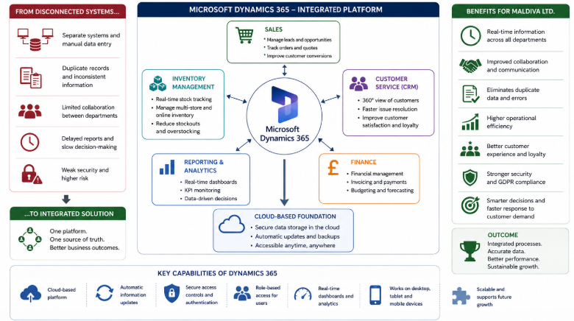

Justification for the Recommendation
Microsoft Dynamics 365 is proper for Maldiva Ltd, as it directly identifies the weaknesses during the evaluation of the current information systems. Initially, the integrated platform avoids disconnected databases, providing a central system for gathering business information. This helps the company improve data accuracy and decrease manual processes. In addition, staff can complete ordinary tasks more effectively (Gartner, 2024).
Also, the system can improve inventory management by automatically synchronising stock levels between all physical stores and the online shopping platform of the company. However, customers can get more precise stock information that can decrease cancelled orders and refund requests. Also, managers can supervise inventory levels in real time and improve purchasing decisions (Forrester, 2023).
Lastly, Microsoft Dynamics 365 is highly scalable. With expanding retail operations, opening additional stores, hiring more staff, and attracting more customers, Maldiva Ltd can perform properly. Despite the fact that the implementation requires an initial financial investment, the long-term operational savings and efficiency improvements can decrease these costs (Nucleus Research, 2023).
Figure 11. Justification for Recommendation
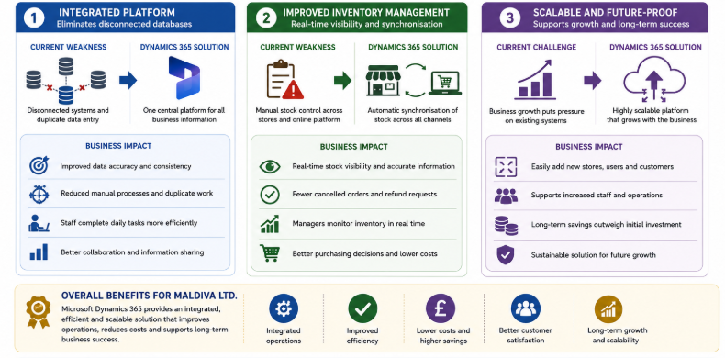

Expected Business Improvements
The application of Microsoft Dynamics 365 should also improve various crucial business activities. In addition, integrated customer information can help the marketing department to design customised promotional campaigns based on purchasing behaviour. Customer service employees will have instant access to complete customer records. Salesforce (2024) states that this will improve customer satisfaction and ensure long-term customer relationships (Salesforce, 2024).
Also, automatic reporting and real-time dashboards will ensure more rapid managerial decision-making because it will provide accurate business information whenever demanded. The integrated security features, such as user authentication, access permissions, and compliance instruments, will also help the company improve GDPR compliance and decrease cybersecurity risks. The recommended information system will raise organisational efficiency, ensure better communication between departments, and create a stronger technological base for the company's future growth (PwC, 2024).

Implementation Plan

System Implementation Process
The application of Microsoft Dynamics 365 must be done under a structured approach. Therefore, the company will decrease operational disruption and guarantee successful adoption. Maldiva Ltd should examine its current business processes and prepare all existing customer, sales, and inventory data for migration processes. In the first stage, inaccurate and duplicate records must be deleted in order to improve the quality of data. Then, after the preparation of the data, a new system should be installed and integrated in all the physical stores of the company and its e-commerce platform. Last, Maldiva Ltd. should do system testing before the official launch to see and resolve technical problems. According to the Project Management Institute (2021), a phased implementation approach helps companies to launch systems gradually and keep their business operations.

Training and System Integration
Staff training is crucial for the successful implementation of a new information system. Employees from different departments like finance, sales, inventory, and customer services must be provided with practical training before the system starts operating. Training programs should consist of system navigation, data entry procedures, reporting functions, and cybersecurity awareness. Moreover, technical support must be available throughout the first weeks after application to assist staff in dealing with operational issues. Efficient training programs can improve user confidence, decrease resistance to change and raise general system performance (Kerzner, 2022).
System integration must also guarantee that information is spread automatically between all departments. Communication in real-time between online sales, inventory databases, and physical stores will enhance operational efficiency and decrease manual data entering (Marnewick, 2023).

Implementation Challenges
During the implementation, many challenges can appear. Staff can resist changing working practices, and temporary operational delays can happen during system migration. The company can also face high implementation costs connected to software licences, employee training programs, and additional technical support. In order to mitigate these risks, senior management should focus on communicating the positives of the project, show consistent staff support, and supervise implementation progress often. System review after deployment of the new program will improve the company’s opportunities and guarantee that Microsoft Dynamics 365 will contribute to the business growth of Maldiva Ltd (Axelos, 2020).
Figure 11. Implementing Microsoft Dynamics 365 at Maldiva Ltd.
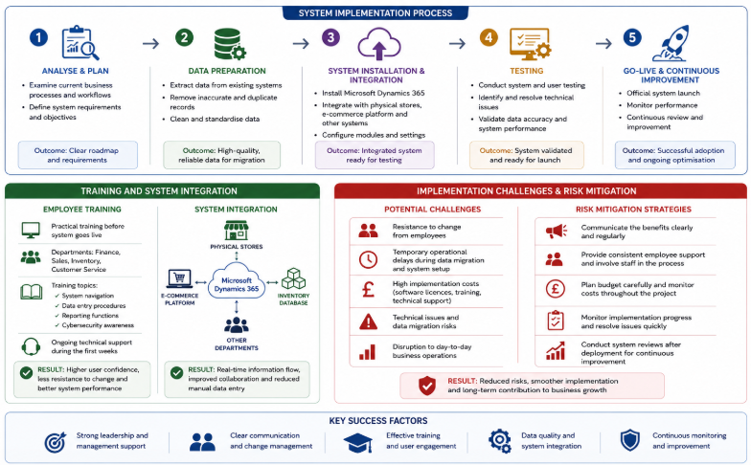

Conclusion
This report analysed the present information systems in Maldiva Ltd and showed many operational weaknesses that limit its performance. Based on the assessment, manual inventory management, repeated customer records, slow reporting processes, and poor security controls decrease effectiveness and customer satisfaction. Such problems also influence managerial decision-making and pose business risks during the company’s expansion.
The report proposed implementing Microsoft Dynamics 365 as an integrated enterprise information system that can connect sales, inventory, finance, customer relationship management and reporting in one secure platform. In addition, the suggested solution will improve data accuracy, enhance collaboration between departments, offer real-time information, and improve decision-making. Moreover, the implementation plan showed how proper data migration, staff training programs, and staged development can decrease implementation bias and ensure organisational change.
Overall, the suggested information system (IS) offers an actual and scalable solution that ensures future business growth. Maldiva Ltd can become a better company by improving operational efficiency, enhancing customer service, increasing the level of inventory control, and complying with GDPR.

References
Axelos (2020) Managing Successful Projects with PRINCE2. 7th edn. London: TSO (The Stationery Office).
Buttle, F. and Maklan, S. (2023) Customer Relationship Management: Concepts and Technologies. 4th edn. London: Routledge.
Forrester (2023) The Total Economic Impact™ of Microsoft Dynamics 365. Cambridge, MA: Forrester Research.
Gartner (2024) Magic Quadrant for Cloud ERP for Product-Centric Enterprises. Stamford, CT: Gartner, Inc.
Kerzner, H. (2022) Project Management: A Systems Approach to Planning, Scheduling, and Controlling. 13th edn. Hoboken, NJ: John Wiley & Sons.
Laudon, K.C. and Laudon, J.P. (2023) Management Information Systems: Managing the Digital Firm. 18th edn. Harlow: Pearson.
Marnewick, C. (2023) Information Technology Project Management. Cape Town: Juta.
Microsoft (2025) Microsoft Dynamics 365. Available at: https://www.microsoft.com/en-us/dynamics-365 (Accessed: 26 July 2026).
Nucleus Research (2023) ROI Guidebook: Microsoft Dynamics 365. Boston, MA: Nucleus Research.
O'Brien, J.A. and Marakas, G.M. (2022) Management Information Systems. 11th edn. New York: McGraw-Hill Education.
Project Management Institute (2021) A Guide to the Project Management Body of Knowledge (PMBOK® Guide). 7th edn. Newtown Square, PA: Project Management Institute.
PwC (2024) Digital Transformation Survey 2024. London: PricewaterhouseCoopers.
Salesforce (2024) State of the Connected Customer. 6th edn. San Francisco, CA: Salesforce.
Stair, R.M. and Reynolds, G.W. (2023) Principles of Information Systems. 15th edn. Boston, MA: Cengage Learning.
Velosio (2024) Microsoft Dynamics 365 Business Benefits. Available at: https://www.velosio.com (Accessed: 26 July 2026).
Whitman, M.E. and Mattord, H.J. (2022) Principles of Information Security. 7th edn. Boston, MA: Cengage Learning.

