
A Professional Development Report

1707424 | The Human Resource Professional | By Ella Williams

Table of Contents
- Introduction…………………………………………………………………………3
  - Report Remit
- Activity 1……………………………………………………………….…...……...3-5
- Activity 2………………………………………………………………………..…6-11
- Activity 3…………………………………………………………………………12-18
- Activity 4 ………………………………………………………………………..19-20

List of Figures
Figure 2.1: The CIPD Map…………………………………………………………5
Figure 3.2: The Belbin Team Roles……………………………………………….7
Figure 3.3: Tuckman's Stages………………………………………….……….…8
Figure 3.4: The Thomas Kilmann Conflict Mode Instrument………………….10
Figure 4.5: Project Management Stages………………………………………..13
Figure 4.6: Eisenhower Model…………………………………………………….17

List of Evidence
Evidence 1 ………………….……………………………………….5
Evidence 2……………………………………………………………8
Evidence 3…………………………………………………….…….11
Evidence 4……………………………………………………………14
Evidence 5……………………………………………………………15
Evidence 6……………………………………………………………15
Evidence 7……………………………………………………………11
Evidence 10…………………………………………………………..20

- Introduction
  - Report Remit
This report evaluates how the Human Resource Profession (HRP) has developed over the years. You will be able to see how much of an impact a HR professional will have on the work place as a lot of problems can arise, but HR professionals always resolve the problem. Models and theories will be included throughout this report and evidence will be used to back up the models.
2. Activity 1
Activity 1: Evaluate what it means to be an HR professional, referring to current CIPD Professional Map.
According to Boxall (2017) “Human resources include the knowledge, network, skills, physical and emotional health, personalities and motivations”. This shows how important Human Resource Management (HRM) is to an organisation.
HRM has been a discipline and a practice within an organisation for over a century. The disciplines and practices have been through a process of theory building, trial and error, and countless concepts by practicing academics and managers. The new form of HRM was developed in 1980’s among the private sector. The management included planning, monitoring and control within an organisation (Farnham & Pimlott, 1995).
In the modern days we live in, HRM focuses on how people are employed and managed within an organisation. HRM also covers corporate social responsibility, human capital management, recruitment and selection, human resource planning, talent and reward management, learning and development, and health and safety (Armstrong & Taylor, 2017).
Organisations can use a CIPD Map to identify skills that are needed to make change happen. It was noticed, the way people work has changed since the 2013 Professional Map was launched, so the CIPD have created a new map. The new Professional Map sets an international benchmark for the HR profession (CIPD, 2019). According to the CIPD (2019), “it is used to make better decisions, act with confidence, perform at your peak, drive change in the organisation and make progress within your career”. The map is used to drive a sustainable organisational change, prove value, build the organisation, teams and yourself and be more confident (CIPD, 2019). This is shown in Figure 2.1.
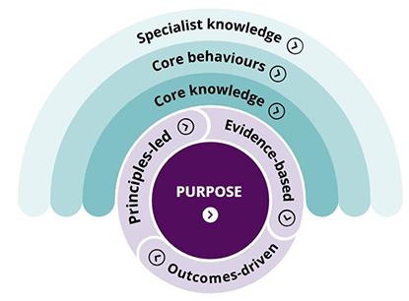
Figure 2.1: The CIPD Map
I understood the Profession Map after reading the hand out I was given in my lecture. I made notes to help with my understanding as you can see in Evidence 1.
HRP must apply ethical values within an organisation. According to Rees and French (2010), “Ethics goes outside the legal requirements for an organisation and therefore is has flexible decisions a behaviour guided by values”. This shows how business ethics is the main form of the ethical values contributed to business decisions. HRP’s have the identity to belong and commit to the profession and obey the values (2017).

3. Activity 2
Activity 2: Briefly describe the elements of group dynamics and give at least two examples of conflict resolution methods within an HR context.
Lewin (1940) established the term “group dynamics”. Lewin noticed individuals taking on different types of roles and behaviours when they are working in a group. Over the years people have developed Lewin’s ideas and his work has become essential for good management practices (Mind-Tools, 2016).
A team with a positive dynamic is very simple to point out, as you can see how members within the team trust each other, work towards a decision, and make everyone aware of what they are accountable for (Mullins & Christy, 2013). Researchers have also found that positive dynamic teams are almost twice as creative as the average group. A negative group dynamic is also very noticeable as it shows weak leadership, members blocking people from wanting to share ideas or opinions and excessive deference to authority. To improve on team dynamics team members need to define their roles and responsibilities as some members of the group do not understand their role (Mind-Tools, 2016). Groups should look at Belbin team roles to see what type of team member they are.
Dr Meredith Belbin and his team discovered nine different team roles which consist of different behaviours. According to Belbin (2019), “research has showed that the most successful teams were made up of a diverse mix of behaviours”, shown in Figure 3.2. This means that there should be an individual with different characteristics and behaviours within a group, so everyone can complete a different task to become a high performing team. Not every team requires nine people as a lot of roles will match the same individual and they may feel comfortable enough to undertake two to three roles (Belbin, 2019).
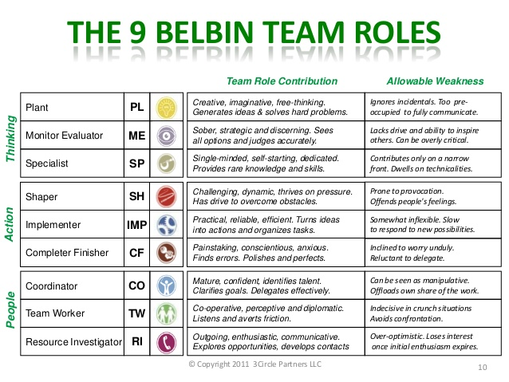
Figure 3.2: The Belbin Team Roles
To understand how groups are not always formed perfectly and how there needs to be different team roles to complete tasks I looked into the Belbin team roles and identified which team role would match my characteristics. I found that my role is the “Team worker” as I enjoy working in a team. I prefer to identify the tasks I need to do so I know how to complete them to the highest standard possible. See Evidence 2.
However, forming a team takes a lot of time, especially when you form with a group of people you have just met. Tuckman (1965) observed stages in team development “forming, storming, norming and performing” in his article “Developing Sequence in Small Groups”. The phrase was used to describe what teams experience when they are on their way to a high performance. Tuckman later added a fifth stage of “adjourning”, as team members will experience their achievements (Mind-Tools, 2019).

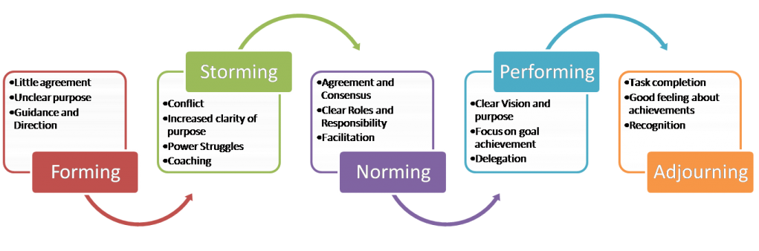
Figure 3.3: Tuckman's Stages

In Figure 3.3, you can see how team work flows through the process. Team members form a group and have an unclear purpose of the tasks and goals they will later achieve. However, conflict may occur as the team get an understanding of the tasks set as not every individual will agree with one-another, showing competitive behaviour. This stage of the process is the most difficult because conflict can result in the group failing to complete their goal as they fall apart.
Team members may have differences with their attitude, value and power, causing conflict. Poor communication, personal problems and any change within the team and tasks will cause conflict as it be a threat (Armstrong & Taylor, 2017). If team members all want to achieve their goals, they will avoid the conflict and start to trust each-other for help and to complete their tasks. If communication is open the group will become more productive (Tuckman, 1965).
According to Armstrong (2014), “Conflict resolution deals with ways of settling every difference between individuals, groups and team members”. To resolve conflict between team member’s organisations must obtain an overview of the whole situation. This will consist of finding out who was involved and speaking to each member to see their side of the story. It is also helpful to speak to team members who were not included to get their views. You would then need to evaluate what you have collected against your own knowledge of what you have thought was happening to reach a conclusion. The parties involved with the conflict will then be brought together to discuss the situation, helping to solve the problem. Both parties can have their say, however, the HR manager should make sure they stick to the facts and not take sides (Armstrong & Taylor, 2017).
To solve conflict communication must be strong and HR mangers must give plenty of feedback to team members, so they are aware of what they are doing right and wrong. Also, within conflict both parties must consider the needs of the other person, as well as their own.
Another way to solve conflict would be either competing, accommodating, avoiding, compromising or collaborating as you can see in Figure 3.4.
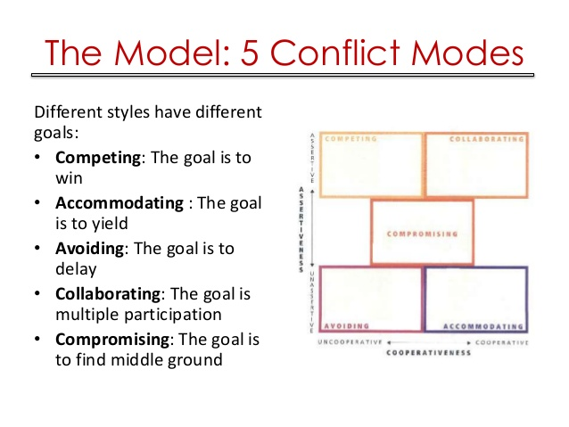
Figure 3.4: The Thomas Kilmann Conflict Mode Instrument
In the 1970’s, Thomas and Kilmann developed a model of conflict. The model identifies two ways a course of action in a conflict situation can occur; assertiveness and cooperativeness. Assertiveness is where you satisfy your own needs, whereas cooperativeness satisfying the other person’s needs and concerns (Killmann & Thomas, 1977). There are five conflict handling modes as shown in Figure 3.4. The best way to cover conflict is by compromising, as it gives more than competing, but less than accommodating and is addressed directly (Killmann & Thomas, 1977).
In one of my lectures I completed a Modified Thomas-Kilmann Conflict Mode Instrument grid. I had to circle the statement that applied with me the most and add my results up at the end. From my results I found that I am willing to compromise when I work in a group and do not like conflict. See Evidence 3.
I also have evidence of understanding of conflict. In a lecture we learned about the “Conflict Cycle” and then had to turn our sheet over and label the different parts of the cycle and I got it all correct. See Evidence 7.

4. Activity 3
Activity 3: With reference to a recent or current project (large or small) which you have led (or been part of a project team):
- Provide evidence of using project management and problem-solving techniques during the project.
- Explain how you successfully influenced, persuaded and negotiated with others during the project (or other related activity).

The principles and practice of well-organised time and project management is crucial for HR professionals. This includes setting objectives for people to be aware of the goal they are trying to achieve. Once the objectives are set, the HRP must classify and put each priority in order. This will control the stress of each team member. Each element of project planning, milestone monitoring, control and scheduling must be time managed and completed to the highest standard possible. HRP’s need project management to work efficiently. This would mean creating aims and objectives and making sure no tasks are delayed (Hayward, 2019).
It is vital to plan a project before executing it to have a proactive approach. The Project Management Institute (PMI) created Project Planning Steps for people to follow when they are managing a project. According to PMI (2019), “Project management is the application of techniques, skills, tools and knowledge to a wide range of activities in order to meet the requirements of a project”.

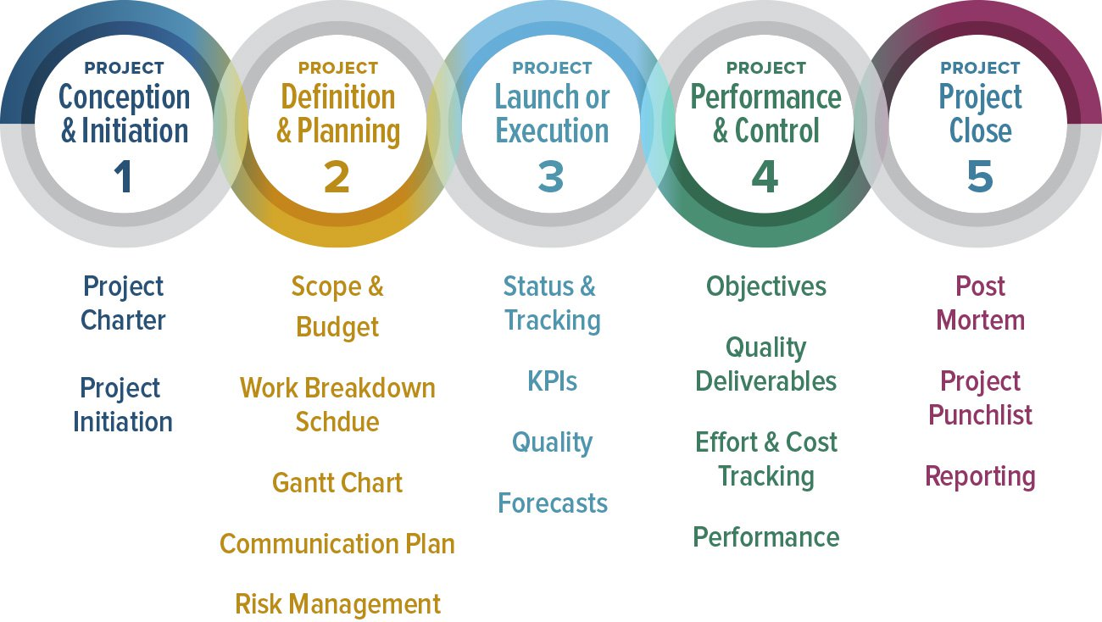
Figure 4.5: Project Management Stages
In Figure 4.5, you can see it is important to define what the project is. Without doing this you would not be aware of what your goal is, finding it difficult to complete tasks (Smart-sheet, 2019).
Next, you need to identify any needs and contributes with stakeholders you are working with. For my project, my team and I worked with a man called Tom Lynch, the manager of the not-for-profit organisation, Matthew’s House. The organisation was established in 2015 and is in The Hill Church, in Swansea. The not-for-profit organisation was set up to support homeless people who have nowhere to go, and no one to talk to. Within the church is a café called “Matts Café” where you just give what you can (Matthews-House, 2019). My group and I undertook meetings with Tom and discussed what we would be able to help Matthew’s House with. Matthews House needed our group to help make their organisation well known and try raise money to refurnish their showers. This was a huge ask as we were only five university students. However, we were extremely determined to complete their goal, although we had not known each-other for more than a month, so we were unaware of each-others work ethic.
As a group we created aims and objectives to help us become aware of what we wanted to do and how we were going to do it. Our aims were to ‘spread awareness’ and ‘to raise money for the showers in Matthew’s House’. To do this we set objectives which were, ‘to like and share the Matthews House Swansea Facebook page’ and ‘to do lots of different types of fundraising’. We used a lot of project management and problem-solving techniques throughout the project. For example, I created a Gantt chart, shown in Evidence 4. It was extremely useful for planning and scheduling the project, especially once we knew what our aims and objectives were. It helped us plan our time efficiently, so we knew what we had to do each week. If we did not create a Gantt Chart we would not have known what our tasks were and we might have focused on a task longer than we should, meaning we would not have had enough time to complete the other tasks that were set (Anderson, 2016).
Evidence 5 shows that we completed our first aim as we liked and shared Matthew’s House’s Facebook page. This meant each member’s post would be posted on their friends and families Facebook feed, helping to make more people aware of the organisation. The picture in evidence 5 is just one of five posts which were shared.
We also created an Eisenhower Matrix Grid to help us see what was important and urgent, so we could plan our tasks better, which is shown in Evidence 6.
As soon as we completed the Gantt Chart, we needed to identify the resources we needed. To start, with we knew we were going to fundraise, but I felt we should do more, so I mentioned about using Matthew’s House’s money collection boxes and spread them around Swansea. Not only would this help raise more money, but it would also help make more people aware of the organisation. The group loved my idea as it helps achieve our aims and wouldn’t take any of our time up, so we were able to complete our other tasks.
The third stage of the planning process is the Project Execution. This is where all the planning is up-to-date and complete, and it is time to perform the activities.
Within the ‘Performance and Control’ stage project objectives must be measured using the Gantt Chart and Eisenhower Model (shown below) to make sure we are on schedule. Budget checks are usually undertaken within this stage, but for our project we did not have to budget anything, only stay up-to-date on how much we had raised weekly. Project performance checks monitor any issues occurring and how fast they are addressed (Smart-sheet, 2019).
The last stage is ‘Project Closure’ which is when the project is completed successfully, and all objectives are met. If the project is completed successfully the team will become recognised and noticed for all their hard work. When my group and I completed our project, we had to hold a meeting in Unit 19 to present what we had done and how successful out fundraising was.

Another important model is the Eisenhower Matrix, which is designed to help prioritise tasks, sorting out the less urgent and most important tasks (Eisenhouwer, 2017). There are four boxes to prioritise which are shown in Figure 4.6.
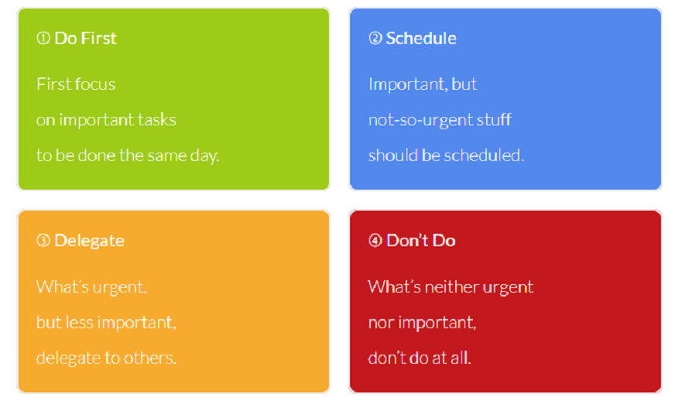
Figure 4.6: Eisenhower Model

The model shows how it is used to plan during a project. The first box is to write down important the tasks which need to be done urgently. The second box is for the tasks which are important but are not urgent. However, the delegate box consists of the tasks which are not important but need to be undertaken urgently, and the last box holds the tasks which are not important or urgent, so it does not matter if they are completed or not (Eisenhouwer, 2017).
According to Watt (2014), “Project planning is the heart of the project life cycle”. This statement proves how important planning is as it makes the people involved aware of what they want to achieve and how they are going to achieve it.
Throughout the project a problem did occur when we planned to walk up Pen Y Fan, however the weather changed rapidly and began to snow the week we were supposed to walk up it. We had created sponsor sheets and raised money which become a problem. Team members suggested we should give the money back to each individual and explain why we were not able to do the walk. This would have been very time consuming, so I suggested we should contact the individual and explain why we were not able to do the walk and see if they would still like to contribute money to the organisation, which every individual did. Every time member agreed with my suggestion as it did not take up time and we still managed to raise money for the organisation.

5. Activity 4
Activity 4: Understand a self-assessment of one area of your practice to identify your professional development needs in that area and options to address these.
Produce a professional development plan (PDP) plan to meet your professional development needs which includes a justification of the option(s) chosen.
In my Professional Development Plan, I stated six subjects/skills I wanted to learn or develop on. I then explained how I am going to achieve them, what resources I need, my success criteria and set targets for when I want to complete them.
I believe the most important task I need to undertake is to learn assertive styles of Managing Conflict. Studying HR means it is vital for me to know how to manage conflict in the workplace. This will benefit me a lot not only for my future career, but when I work in a team for a university project or in my part-time job. Not everyone gets along, and conflict will arise in stressful situations, but it can be resolved straight away with the right knowledge and skills. I also would like to learn this skill because I try to avoid conflict myself a lot because I do not like arguments as they can break relationships, create an awkward atmosphere and make it difficult for a team to complete their goal.
To complete this task, I will attend the ‘Conflict’ lecture. This would help me gain an understanding of what conflict is and how it can be avoided or resolved. I will be able to write notes, so I can look back at them. Also, I will also be able to research the different theories and tools to get a better understanding.
I have also researched into a free online course called “Relationship Management”. The course is flexible as I can start and finish it when I have time and is all online. Evidence 10 shows how I have created an account, so I can just log on and start where I left off. The course takes up to 12 hours to complete, which I can split up over time (Coursera, 2019). I have set myself a goal to start this task once I have finished my assignments and exam, which would be in June. As the course takes approximately 12 hours, I would like to complete it starting in June until the end of the summer holidays (around the 1st September 2019). Also, when I am researching the subject, as well as completing an online course, I would like to review my process half way through my course (six hours), to see if there is any improvement made.

References

Anderson, B., 2016. What is the Purpose of a Gantt Chart. [Online]
Available at: https://www.successfulprojects.com.au/purpose-of-a-gantt-chart/
Armstrong, M. & Taylor, S., 2017. Armstrong's Handbook of Human Resource Management Practice. s.l.:London; New York, NY.
Belbin, 2019. The Nine Belbin Team Roles. [Online]
Available at: https://www.belbin.com/about/belbin-team-roles/
Boxall, P., 2017. Human resources defined. In: Armstrong's handbook of human resource management practice. London: s.n., p. 4.
CIPD, 2017. HR professionalism: what do we stand for?, London: CIPD.
CIPD, 2019. Explore the new Profession Map. [Online]
Available at: https://peopleprofession.cipd.org/profession-map
Coursera, 2019. About this Course. [Online]
Available at: https://www.coursera.org/learn/relationship-management
[Accessed 6 March 2019].
Eisenhouwer, 2017. What is the Eisenhower Matrix?. [Online]
Available at: https://www.eisenhower.me/eisenhower-matrix/
[Accessed 5 March 2019].
Farnham, D. & Pimlott, J., 1995. Understanding industrial relations. s.l.:London.
French, R. & Rees, G., 2010. Leading, Managing and Developing People. 3rd Edition ed. s.l.:Chartered Institute of Personnel and Development.
Hayward, J., 2019. The Human Resource Professional: Project Management and Problem Solving. Swansea: Julie Hayward.
Killmann, R. H. & Thomas, K. .., 1977. Developing a forced-choice measure of conflict-handling behavior: The" MODE" instrument.. s.l.:Educational and psychological measurement.
Matthews-House, 2019. Matt's Cafe!. [Online]
Available at: https://matthewshouse.org.uk/
Michael Armstrong, S. T., 2014. Armstrong's Handbook of Human Resource Management Practice. s.l.:Kogan Page .
Mind-Tools, 2016. Improving Group Dynamics. [Online]
Available at: https://www.mindtools.com/pages/article/improving-group-dynamics.htm
Mind-Tools, 2019. Forming, Storming, Norming, and Performing. [Online]
Available at: https://www.mindtools.com/pages/article/newLDR_86.htm
Mullins, L. J. & Christy, G., 2013. Management & Organisational Behaviour. London: Pitman Publishing.
Smart-sheet, 2019. Demystifying the 5 Phases of Project Management. [Online]
Available at: https://www.smartsheet.com/blog/demystifying-5-phases-project-management
[Accessed 5 March 2019].
Taylor, S. & Woodhams, C., 2012. Studying Human Resource Management. s.l.:Chartered Institute of Personnel and Development.
Tuckman, B. W., 1965. Developmental sequence in small groups. s.l.:Psychological bulletin.
Watt, A., 2014. Project Management. s.l.:BCcampus 2014.

