

BMSW4003

DIGITAL SKILLS AND RESEARCH METHODS

Students Name: Flavia Mateus
ID:1917238

Lecturers Name: Modak

August 30, 2020

|REPORT

The Impact of the

Virtual

Learning Environment



PREPARED BY

FLAVIA MATEUS

PREPARED FOR

UNIVERSITY OF WALES
TRINITY SAINT DAVID

LECTURER:
MR KOUSHIK MODAK

And the effect Moodle has on students

learning experience at University Of

Wales Trinity Saint David

CONTENTS

- INTRODUCTION………………………………………………………………………………………………………1

- RATIONALE……………………………………………………………………………………………………………. 2

- RESEARCH OBJECTIVES……………………………………………………………………………………………3

- LITERATURE REVIEW/ REVIEW OF EXISITING LITERATURE……………………………………….4

- METHOLOGY…………………………………………………………………………………………………………. 5
  - RESEARCH METHODS, DATA, DATA COLLECTION PROCESS………………………… 5
  - POPULATION, SAMPLE AND SAMPLE SIZE, ETHICS IN DATA COLLECTION…… 5

- RESULTS/ FINDINGS, ANALYSIS AND DISCUSSION……………………………………………………6
  - GRAPHS, GRAPH ANALYSIS, PRIMARY AND SECONDARY DATA ANALYSIS…… 6

- CONCLUSION…………………………………………………………………………………………………………. 7

REFERECES………………………………………………………………………………………………………………………. 8

APPENDIX A –QUESTIONS…………………………………………………………………………………………. A-1
APPENDIX B –QUESTIONNAIRE EXCEL WITH GRAPHS ……………………………………..………….. B-1

Introduction

Virtual Learning is done through the use of a desktop, laptop even a smartphone on the internet not only inside, also outside educational facility. The instruction most often takes place in an online environment. Example of this is that the teacher and learner i.e. student are physically separated however (in terms of place, time, or both). VEDAMO (2013-2020)

This study is very important to me as a student. My main goal is to identify student’s problems and finding a solution in the gap of student’s knowledge. The, problem is that many students have expressed a great, misfortune with online studying and also whilst using Moodle.

From my other class Managing enterprise in the 21st century I was able to adapt to my ability of collecting data when writing the best business plan and coming up with the best business idea. Analysis was needed of current jobs and comparison was made when it came to what potential clients require the most.

I was able to apply the same method as it has proven success with my previous research.

- My hypothesis Is that it could be possible that students are simply misinformed therefore express negativity towards (VLE) Online learning? (Do they just need extra information?

Research Objectives

My research objectives are simply to obtain understanding of the

“The Impact of the Virtual Learning Environment,” And the effect Moodle has on students learning experience at University Of Wales Trinity Saint David.

Literature Review/ Review of Existing Literature

z

Figure 2. Question, Are you familiar with Moodle?

Said Yes | 16
Said No | 3

This question does us (the reader) some justice as it indicates that the same amount as (Figure 1) 16% of students are familiar with Moodle however the 3% are not. This comes to my understanding that the 3% students that are unhappy with Online (VLE) are not benefitting therefore are unhappy with Online learning due to their lack in knowledge of Moodle which is preventing them from using Moodle to their best advantage.

The 16% clearly enjoy VLE studies as (Fig 1) clearly shows because they are familiar with the platform Moodle which offers a wide base of learning and understanding from topics presentations to links to YouTube videos for the visual which is very useful for out of class learning as well as in class learning.

Figure 3. Question, Are you satisfied with the outcome you are getting from Moodle?

Said Yes | 13
Said No | 6

In Figure 3 majority of students are satisfied with Virtual studies (VLE) this figure (Fig 3) shows a drop in the number of students that are satisfied with Moodle. It shows a rise in numbers of students that are not happy with Moodle’s Outcome, in question 4 I will further analyse this and come to an understanding.

Figure 4. Question, Are you pleased with the way we use Moodle?

Said Yes | 13
Said No | 6

The results have remained the same as (Figure 3) which we saw a drop-in numbers of Yes response and a rise in No’s. These results could be indication that the same 6% previously unsatisfied with the outcome, they are getting from Moodle (Fig 3) could be the same 6% who are not content because of the way that we use Moodle?

There’s only one way to find out, with more questions. It can be noted that there are many more who have said yes in Figure 4, 13% this can be positive as the number is higher that the displeased now it’s only right to explore around what is making the students that are happy, happy and see what can be done to change the negative feedback to positive feedback.

I go on to ask more questions including open questions in which students express themselves in writing their personal thoughts and opinions.

Figure 5. Question, How familiar are you with Moodle?
(As in accessing the work, navigating around etc)

Fairly | 5
Average | 2
Very | 12

In Figure 5, question 5 I in addition required students to explain themselves a little more I wanted to understand their feelings towards Moodle. (Figure 5) shows a high number of 12% student the ones coloured in grey on the graph have a very good understanding of Moodle. 2% have average meaning some knowledge of using Moodle 5% person have said they fairly understand.

Figure 6. Question, How frequent do you use Online Moodle?

Daily | 5
Weekly | 13
Often | 1

This question helps me identify how many students are making the most of Moodle in order to benefit from it. It also shows where students are going wrong therefore unhappy with what they are getting from Moodle. Figure 6 shows only 5 percent use Moodle daily, with a one percent who logs into Moodle often.

Lastly (figure 6) shows a higher percentage of students who go on Moodle weekly. This 13% could be the students who log into Moodle weekly for their weekly Online Virtual studies, the 5% of students have a higher chance of gaining satisfaction as they show eager in learning outside of the class this is very good and a very positive graph.

Figure 7. Question, Do you use Moodle at UWSTD, or do you use any other Online Virtual Studies platform?

Just Moodle | 15
Other | 4
None | 0

This helps to understand (Figure 1) Figure 1 showed indication of rise in number of students who enjoyed (VLE) this graph (Figure 7) shows indication of 4% of students who do not only study Virtually on Moodle they have stated other this explains the drop-in number as (Fig 3) 3% dropped from enjoying (VLE) (Fig 1) to stating that they were unhappy as (Fig 3,4) shows with the outcome and way we use Moodle.

I will go on to tackle the problem and see if there is any solution in the way we use Moodle and or if improvements could be made to better every student understanding.

Figure 8. Question, Have you had any inconveniences when using Moodle?

Yes | 7
No | 9
Sometimes | 3

Gladly, Figure 8 shows 9% of my peers have no issues or inconvenience’s whilst using Moodle. However, 3% have sometimes which means there are times the 3% are benefitting, there are times that they are not benefitting from Moodle which can be stressful as a student.

Sadly, there is an indication in high number of students who do not benefit at all from Moodle 7% have stated Yes as their response to having inconvenience’s whilst using Moodle, they have not stated sometimes just yes, this is not good at all something must be done to correct this misunderstanding and help the students, so that they can benefit and gain the skills and knowledge needed in order to succeed.

Figure 9. Question, How effective would you say Moodle is from a scale of 1 to 10 (10 being the most effective and 1 the least)

Questions Number of people
1 | 1
2 | 0
3 | 1
4 | 0
5 | 4
6 | 2
7 | 6
8 | 4

9 | 1
10 | 0

In Figure 9, 0 have stated that Moodle is highly effective there is no coherence the graph show indication of rise in numbers then a fall then a rise again so on. 1% agreed with number 9, 4% chose number 8.

The smallest 1% chose least effective for Moodle by putting 1 as their choice. There is a higher number of people who said Moodle is effective which is very positive with only 2% who said it was not effective.

Figure 10. Question, What improvements/ adjustment would you make to Virtual Learning in order to improve it? (Please could you write which changes you would make either how we use it or how Moodle could be made more efficient?)

By removing work that does not apply to our class Terms from Moodle | 2
By simplifying Moodle | 5
By having someone available until say 5pm that can offer support for anyone struggling | 4
If the Lecturer could possibly offer more individual support | 1
If the Lecturer could do a quiz 2 in 2 weeks or ask for feedback weekly from student’s there may be students that didn’t understand the work however are shy, so they do not say it then it shows in their work that they didn’t understand the work. Maybe one-to-one sessions could be offered especially within the class exercise more support can be offered. | 7

The responses that I received for Figure 10 were a bit similar you can see from the graph that students are in great need of help 7% stated various ways in which Online Virtual studying (VLE) can be improved. Matter of fact I personally state that this question was the most efficient out of all the questions I have asked with this open question effective changes can be made. As I was saying 7% agree with
- Quiz 2 in 2 weeks
- Feedback weekly from students (both positive and truthful)
- And maybe one-to-one sessions could be offered especially within the class exercise more support could be given

Figure 10 shows 5% of students who agree with simplifying Moodle. A number of 4% of students agree with extra help they could succeed Moodle if there is someone that can offer help or support for anyone struggling.

This has showed me that the main problems have got solutions that maybe students are unaware of, maybe a revolution is all that is needed and for Team Leaders to gain more knowledge so that they can transfer the information to their peers.

Figure 11. Question, Would you recommend online Moodle as a prime base for undergraduates to use?

Yes | 15
No | 4

15% of students would recommend Moodle as a first base for Virtual online Learning and 4% would not. The higher number is Yes with 15% which is very good.

“How do students feel about Virtual Learning?”, Majority of students enjoy (VLE) (Figure 1) 16% in total
(Fig 2) 16% are, familiar with Moodle (Figure 11) 15%
would recommend (VLE) to others and with solutions in (Fig 10) if improvements are, made we could see a high rise in numbers for (Figures 1, 11) and a decrease in numbers from (Fig 3) with more satisfied (VLE) students.

Conclusion

Due to recent events this was the best way of gathering data successfully and safely without leaving the comfort of your home. However, there were a few implications a lack of response from my peer’s which delayed some work as in adding all calculations and gathering all information I needed.

I do believe this method of questionnaire has been successful as I have previously mentioned it quicker, safer and cheaper way of gathering data/ data collection.

My questions allowed clear difference between online learning and classroom learning within one week (7 days).
Questionnaire method can also be applied to a Business start-up in which you want to gather data, quickly in sums of how many people would verses how many wouldn’t and place them in different questions and collect data. And of-course analyse it.

References

- ABC7 (2018) “Study shows moms work the equivalent of 2.5full time jobs” [https://abc7news.com/family/study-shows-moms-work-the-equivalent-of-25-full-time-jobs/3238637/

- VEDAMO (2020) “What is Virtual Learning?” Online] Available from: https://www.vedamo.com/knowledge/what-is-virtual-learning/

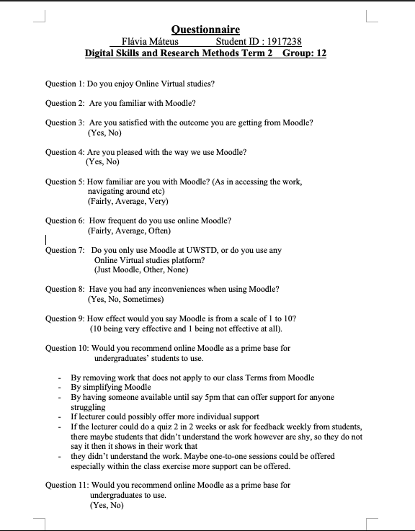
Appendix A

Appendix B


