

ASSIGNMENT 1
PROFESSIONAL CAREER DEVEPLOMENT

STUDENT NUMBER: 1914783
LECTURE: Joanna Walsh
MODULE NAME/CODE: PCD BMSW4005
2000 words

[Document subtitle]

SECTION 1: EXECUTIVE SUMMARY
In this report I will cover the understanding the skills and knowledge needed for working effectively. I have done a plan of researching and presenting findings for this presentation that mention how relevant it is to have a future plans and how important is to stablish career goals and develop a personal action plan and set goals.
I believe this report will help develop my skills and provide them in my academic studies and workplace.

Table of Contents
SECTION 1: EXECUTIVE SUMMARY 1
SECTION 2: INTRODUCTION 1
SECTION 3: SKILLS AND KNOWLEDGE 2
SECTION 4: PROFESSIONAL DEVELOPMENT PLAN (PDP) 3
SECTION 5: CAREER GOALS 3
SECTION 7: ACTION PLAN/ DEVELOPMENT PLAN 6
What must I do to achieve these goals? 6
What do I need to achieve these goals? 6
SECTION 8: PROGRESS TRACKING 7
SECTION 9: CONCLUSION 8
SECTION 10: REFERENCE LIST 8

SECTION 2: INTRODUCTION
This assignment is a report structured by skills, set goal, action plan and tracking process. I have decided to write a brief of what I have learned in this module in term 3, making the use of search technologies to support my ideas, knowledge, and learning.
It will demonstrate an understanding of skills and knowledge which contribute toward working effectively, being job-ready, as well as setting your employment goals and developing a personal action plan/development plan. Now talk about employability is important as we are looking for a way to grow as students and as new leaders of this century. In addition, I will share the way I plan my goals, explaining where I want to work and the skills, I have to get the job I want.

SECTION 3: SKILLS AND KNOWLEDGE
To start writing my skills and knowledge I first made a brief reflection to give an idea about my experiences. During all this time of learning and throughout my career, I have development skills as:
- Effective communication
- Leadership
- Problem solving
- Desition making
- Team working and building
- Active listening
- Coordination
- Adaptability
- Source of positive and enthusiastic
- Performance improvement

All this thanks to the experience that I have developed over time since I started working and growing as a person. Before starting to work, I had no idea what skills I had until I became team leader in a restaurant, there I learned how to use my skills to solve problems, make decisions, listen and lead my team on different events where I had to deal with customers or team members.
This course also gave me the knowledge of how important it is to have skills and know how to use them, have a plan and know what I want for my future and what I will do to achieve my goals. But that depends a lot on:
How self-motivated are you?
Motivation is what drives us to make things happen but staying motivated is not always easy. This is a tricky one because not everyone is motivated and does not know what to do in the future, but we can change that. Here are some tips on how to become and stay motivated by Julie White (2018):

- Set goals: When you set a goal, you decide to act in a way that will help you achieve what you want. Goals give you a direction to focus on – one that is measurable and has an endpoint.
- Choose goals that interest you: You are much more likely to stay motivated if you are working towards something that you genuinely want to do or achieve, rather than what other people want for you.
- Break up your goal: Start with easier tasks and work your way up to bigger challenges. Breaking up a task in your mind into achievable chunks helps build confidence.

SECTION 4: PROFESSIONAL DEVELOPMENT PLAN (PDP)
PDP is a plan and tangible tool where you invest time, energy, and money and by this, I mean that if you want to move forward, you must always keep up. Things do not happen by themselves, so I must invest my time, energy and sometimes money according to Chrissy Scivicque. (2011).
The point of this is to clearly define where I am going in my career and what I need to do to get there and constantly improving myself as a professional. This helps me to better understand what needs to happen in my career and the resources that I need to make things happen. Apart from all that I just think it is a great way to demonstrate my interest in my professional career and taking responsibility for my personal growth.
This professional career development module offered me a unique opportunity to develop the skills that are essential for me to meet my career goals. First, I want to mention how proud I am to finally be in University and has been an achievement for me. After this year full of learning and new challenges, I have decided to continue my studies because the next step that I will do after this year will be to start my business management career.
Why do I want to study business management?
I have always thought that studying a degree in business would be an opportunity to get inside of how the world works. A degree in business management is the ideal foundations to prepare me for my first step on the career ladder whether I am looking to work for a multifunctional firm, a local company, or to open my own business which is something I have always wanted to do at some point in my life. I also believe that living in London has inspired me a lot to choose to study business management because this city is very big and full of businesses and large companies too, so it has inspired me to think and want to be able to one day open the company that I want or work in one of the most important companies.
Why do I want to open my business restaurant?
These days in my point of view it is better to think like a free agent because we are free to choose the job we want and at the time we want, not just think about staying in a company. The answer is that I have always been integrated with the hospitality industry because my dad ran a restaurant business since I was little. When I was old enough, I learned to do everything in our restaurant because I was in charge when my dad was not there, and I had to make the decisions for him. I strongly believe I have the skills, ability, and experience to open my own restaurant business soon.

SECTION 5: CAREER GOALS
“Our goals can only be reached through a vehicle of a plan in which we must fervently believe, and upon which we must vigorously act. There is no other route to success” – Pablo Picasso


A goal is an aspiration or something one works toward. Encyclopedia.com defines a goal as the excepted measurable or observable outcome of a certain plan of action. A short-term goal is that expected outcome in the immediate period, while a long-term goal would be the expected outcome in the projected future.

Short-term goals | Long-term goals
Require a short period of time to be accomplished, usually days or weeks. | Require a long period of time to be accomplished, usually months or years.
Can be a support or enhancement in accomplishing a long-term goal. | Often takes several short-term goals to be achieved.
Takes fewer resources. | Requires more resources.

The difference between a short-term goal and long-term goal is the time it takes to accomplish each. Whilst a short-term goal can take days or weeks to accomplish, a long-term goal can take months or even years. The time here is relative by Anonymous (2018).

I feel that I am a motivated person, so every time I think and plan new challenges and set goals for myself. Below I will mention my short-term goals:
5 months: Improve my speaking and expand my vocabulary

3 months: Pass my driving test
1 month: Get a job related to what I like

And if we talk about long-term goals those are which will take many years to come to fruition. But sometimes long-term goals can be achieved by using a series of short-term goals as steppingstones along the way to the end point. Sometimes our goals can be unrealistic that is why we should not tell everyone what our goals are and just show them once we achieve them.

5 years: learn a new language
5 years: senior manager

4 years: family leisure pursuits
3 years: MBA certification

3 years: open my own restaurant business

1 year: work-life balance. Leader or managing a company

It is important to take time to reflect and be prepared for things to change and do not get upset if I do not reach the goal first time around because it does not mean I have failed or the target was unachievable.

SECTION 7: ACTION PLAN/ DEVELOPMENT PLAN

What must I do to achieve these goals?
To achieve these goals, I have different methods of fulfilling them. For the short-term goals I plan to:
- Start now applying in companies
- that I would like to work for and gain experience.
- Start studying the theory book so then I can do my practical classes
It is time to create an action plan about where I am now and where I want to be. To achieve my long-term goals, I plan to:
- Work in many restaurant companies while I am studying so once I have finished my business degree I can become either a full-time manager in one of the most popular restaurants in London as I believe it would be a unique experience and an incredible way to gain knowledge, experience, specific skills and be ready to open my own restaurant business as a maximum time of 3 years as mentioned above.
- About my MBA certificate I plan to start it February next year which I am excited.
- Once I am established and I have enough time I plan to learn another language because I know it is something that I am passionate about.

What do I need to achieve these goals?
According to Lydia Belanger (2017) to achieve these goals I need:
- Make a list.
- Play the role.
- Minimize other types of distractions.
- Motivate yourself with rewards.
- Conduct periodic progress check-ins.

In this section I will mention the experience that I have had over time which I think is an extra point to achieve my goals.
- I was responsible for training employees
- Greeting the customers or callers
- Establishing efficient workflow processes
- Receiving payments
- Managing database
- Putting prices
- Helping customers
- Delivering good customer services

SECTION 8: PROGRESS TRACKING
To be able to progress it is important to know where you were, where you are now, and where you want to go to propose goals in a planned time, in other words it takes time and practice.
The little advances make a big difference and in this term that is what we did. Each of the students chose a partner to work with and practice to be prepared for the interview of our dreams. Which it was a big help and such a good idea from de teacher because sometimes that is what people needs to progress “a boots” in my opinion. So, I had the opportunity to analyze my objectives and have my ideas clearer about what I want to do for work and where.
After having worked on that and seeing the result of the presentation, I was satisfied with my work and with the feedback from my teacher. Which gave me more motivation and now is the time to take the next steps.
As opined by Zac as a young professional instead of waiting around, get smart, and use these tips and tricks to create a career strategy that helps you progress faster.
Thankfully, job-hopping is losing the stigma it once had. Moving companies is one of the best ways to learn more, grow & advance in your career. Use each new opportunity to expand your knowledge and experience, while also growing your professional network. Moving around between jobs can be emotionally challenging, but it will enable you to work with a wide variety of different personalities, all with their unique advice & lessons to teach you. Over time you will become better at handling change, which is an essential life skill to master.
If job hopping does not work for you, perhaps you need to see out specific fixed-term contracts. If you are working for a fixed period, there is no fear of any challenging discussions with your manager as you will have a clear path set out. More employers are seeking contract-based employees but are warned that it may not always come with the same full-time benefits.
Remember that even the most profitable and successful people, entrepreneurs and companies will have experienced ups and downs.

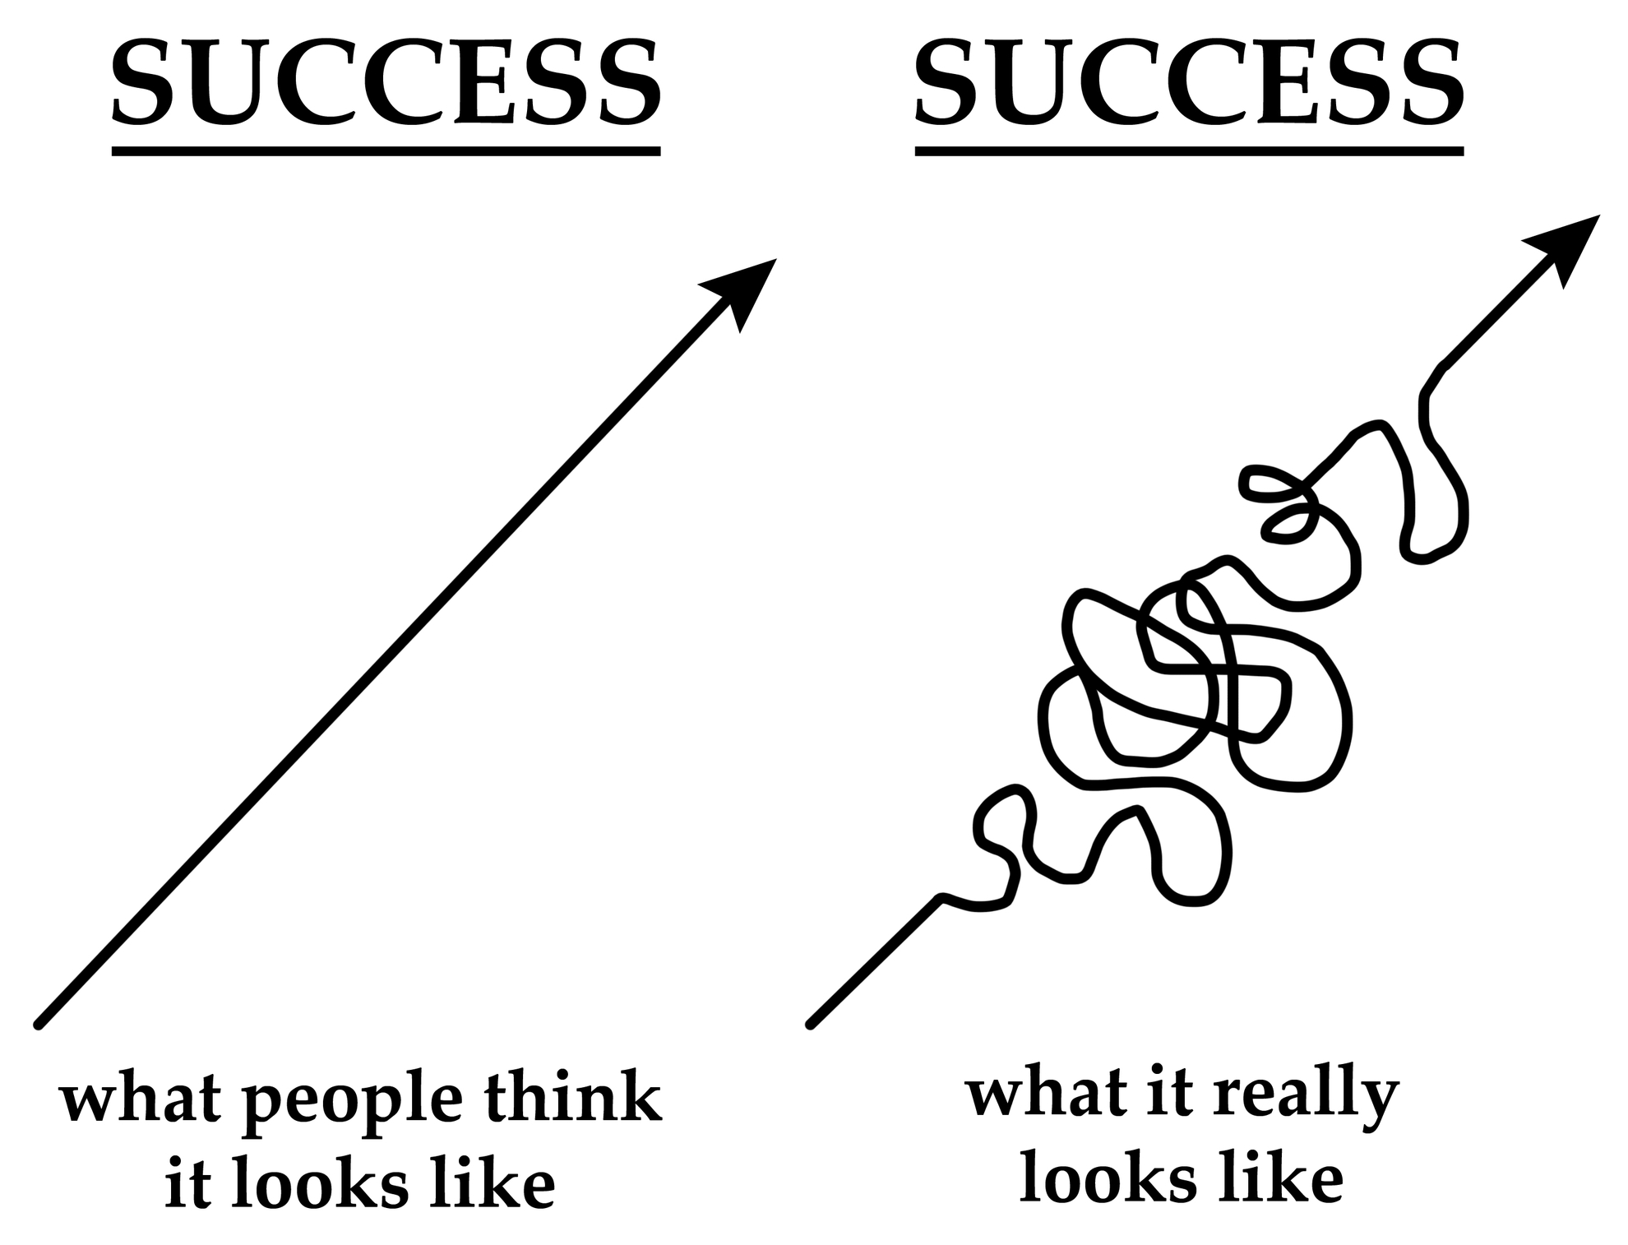

SECTION 9: CONCLUSION
It can be summarized that setting goals is the tool to progress and grow. All the people who have done it have resulted in a huge change both in the work and academic aspects. In this module I understood that the skills and knowledge it is needed for working effectively and growing as a person.

SECTION 10: REFERENCE LIST

• Julie white (February 12, 2018) Motivating tips Available at: reachout.com (Accessed: 27.11.2020)
• Chrissy Scivicque (September 20, 2011) What is a PDP? Available at: https://eatyourcareer.com/ (Accessed: 30.11.2020)
•Anonymous (February 14, 2018) The difference between long-term and short-term goals Available at: https://theydiffer.com/difference-between-short-term-and-long-term-goals/#:~:text=Basically%2C%20the%20difference%20between%20a%20short%20term%20goal,or%20even%20years.%20The%20time%20here%20is%20relative. (Accessed: 01.12.2020)
• Lydia Belanger (January 27, 2017) Things to do to achieve goals Available at: https://www.entrepreneur.com/article/287697#:~:text=%20The%2010%20Things%20You%20Must%20Do%20to,desk%20might%20look%20like%20a%20Pinterest...%20More%20 (Accessed: 01.12.2020)
•Zac Young (August 22, 2016) Fast-track your career development Available at: https://www.glassdoor.co.uk/blog/fast-track-career-development/ (Accessed: 01.12.2020)

