Welsh Language Competency Framework Portfolio
Georgia Theodoulou- 1906468

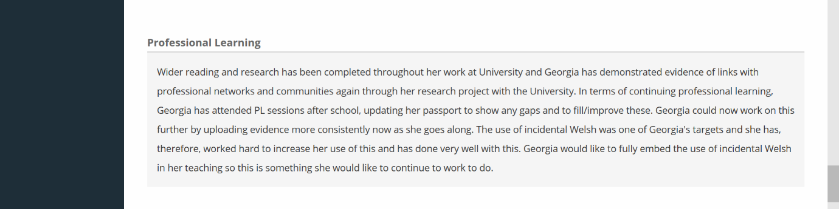
This is an extract from my end of placement review regarding the increase of my use of Welsh in the classroom.

These are notes from a Professional Learning session I attended in my PTE1 school on how the school as a whole was focusing on bilingualism and how I applied it in my lessons and form class time.
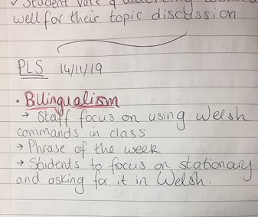

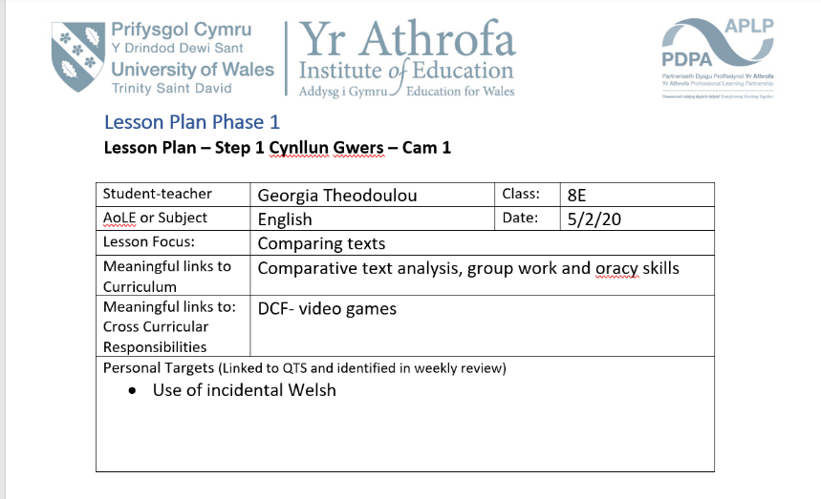
An extract from a lesson plan highlighting my target to extend my use of incidental Welsh.

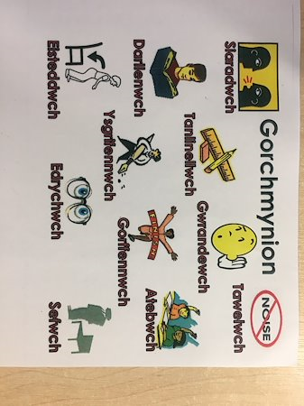
A copy of the Welsh commands I was given in my PTE1 that I used throughout my lessons.

A note written in my journal highlighting my use of incidental welsh in a lower ability class
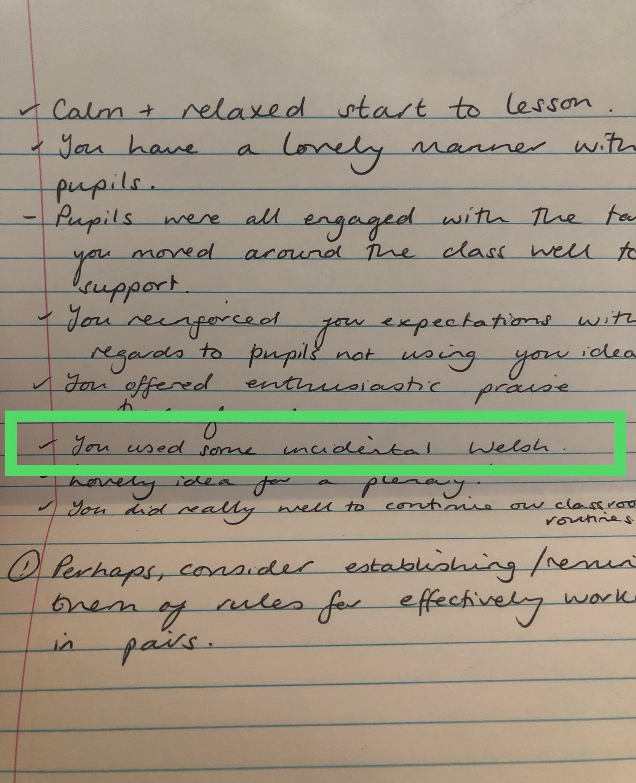

Some examples of marking in lower ability classes
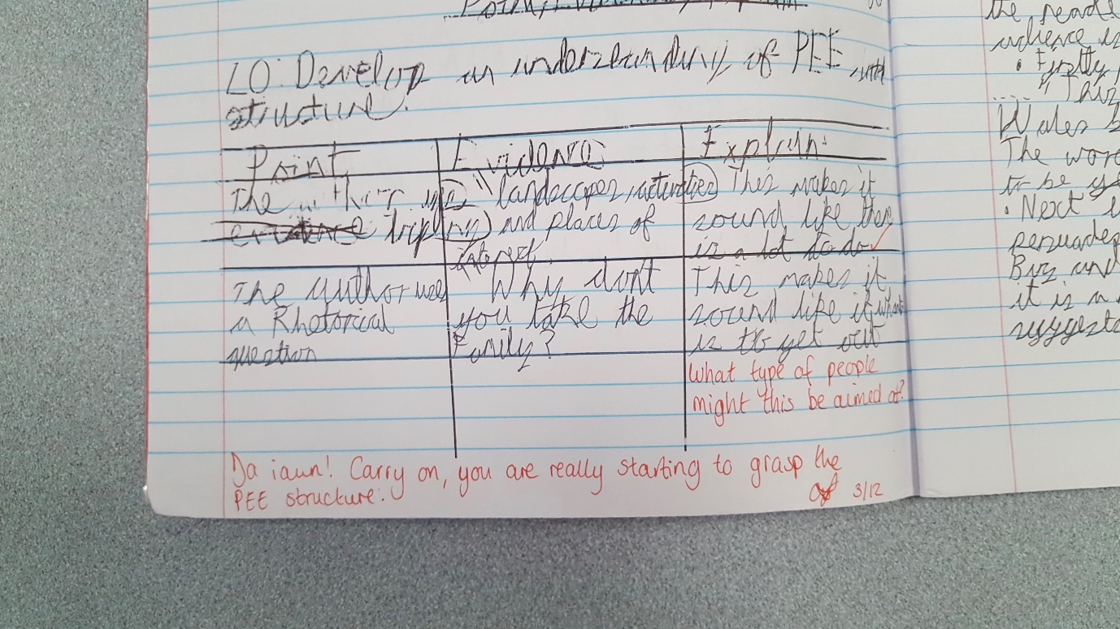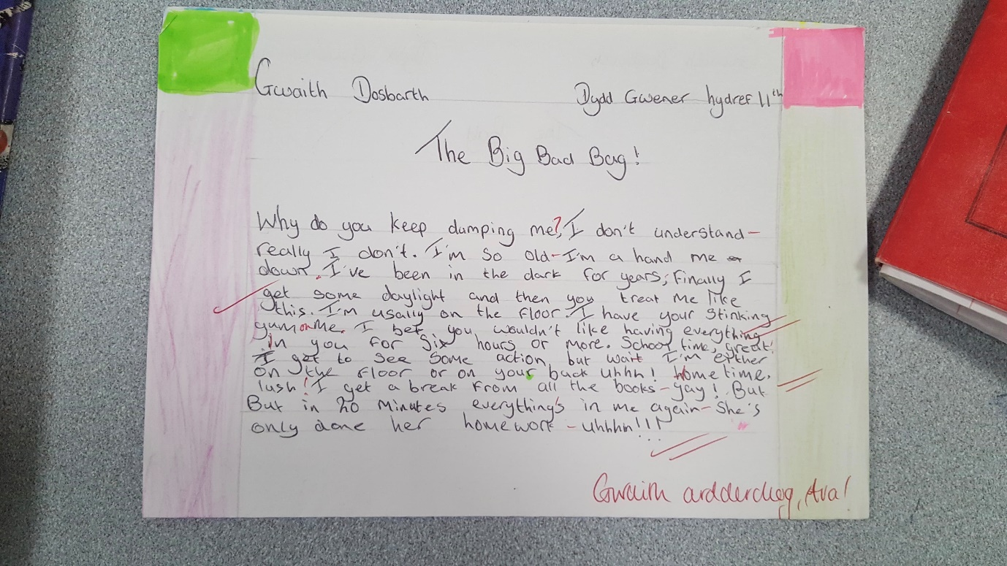

Also uploaded are original resources used in my Year 7 form class.

