show running-config
DLS2#show running-config
Building configuration...

Current configuration : 3473 bytes
!
version 12.2(37)SE1
no service timestamps log datetime msec
no service timestamps debug datetime msec
no service password-encryption
!
hostname DLS2
!
!
enable secret 5 $1$mERr$9cTjUIEqNGurQiFU.ZeCi1
!
!
!
!
!
!
!
!
!
!
!
!
!
!
!
!
!
!
!
vtp domain SoAC
vtp mode transparent
!
spanning-tree mode pvst
spanning-tree vlan 123,234 priority 24576
spanning-tree vlan 12,434,800,1010,1111,3456 priority 28672
!
!
!
!
!
!
vlan 12
name executives
!
vlan 123
name cubes
!
vlan 234
name guest
!
vlan 434
name parking
!
vlan 567
name accounting
!
vlan 800
name native
!
vlan 1010
name voive
!
vlan 1111
name videonet
!
vlan 3456
name management
!
interface Loopback0
ip address 1.1.1.1 255.255.255.255
!
interface Port-channel1
switchport trunk encapsulation dot1q
switchport mode trunk
!
interface Port-channel12
!
interface FastEthernet0/1
shutdown
!
interface FastEthernet0/2
shutdown
!
interface FastEthernet0/3
shutdown
!
interface FastEthernet0/4
shutdown
!
interface FastEthernet0/5
shutdown
!
interface FastEthernet0/6
switchport access vlan 1010
switchport mode access
switchport nonegotiate
shutdown
!
interface FastEthernet0/7
switchport trunk native vlan 800
switchport trunk encapsulation dot1q
switchport mode trunk
channel-group 1 mode active
!
interface FastEthernet0/8
switchport trunk native vlan 800
switchport trunk encapsulation dot1q
switchport mode trunk
channel-group 1 mode active
!
interface FastEthernet0/9
switchport trunk native vlan 800
switchport trunk encapsulation dot1q
switchport mode trunk
!
interface FastEthernet0/10
switchport trunk native vlan 800
switchport trunk encapsulation dot1q
switchport mode trunk
!
interface FastEthernet0/11
switchport trunk encapsulation dot1q
switchport mode trunk
channel-group 12 mode passive
shutdown
!
interface FastEthernet0/12
switchport trunk encapsulation dot1q
switchport mode trunk
channel-group 12 mode passive
shutdown
!
interface FastEthernet0/13
shutdown
!
interface FastEthernet0/14
shutdown
!
interface FastEthernet0/15
switchport access vlan 1111
switchport mode access
switchport nonegotiate
shutdown
!
interface FastEthernet0/16
switchport access vlan 567
switchport mode access
switchport nonegotiate
shutdown
!
interface FastEthernet0/17
switchport access vlan 567
switchport mode access
switchport nonegotiate
shutdown
!
interface FastEthernet0/18
switchport access vlan 567
switchport mode access
switchport nonegotiate
shutdown
!
interface FastEthernet0/19
shutdown
!
interface FastEthernet0/20
shutdown
!
interface FastEthernet0/21
shutdown
!
interface FastEthernet0/22
shutdown
!
interface FastEthernet0/23
shutdown
!
interface FastEthernet0/24
shutdown
!
interface GigabitEthernet0/1
!
interface GigabitEthernet0/2
!
interface Vlan1
no ip address
shutdown
!
interface Vlan12
mac-address 000a.f30a.3501
ip address 172.16.12.1 255.255.255.0
!
interface Vlan123
mac-address 000a.f30a.3502
ip address 172.16.123.1 255.255.255.0
!
interface Vlan234
mac-address 000a.f30a.3503
ip address 172.16.234.1 255.255.255.0
!
interface Vlan1010
mac-address 000a.f30a.3504
ip address 172.16.10.1 255.255.255.0
!
interface Vlan1111
mac-address 000a.f30a.3505
ip address 172.16.11.1 255.255.255.0
!
interface Vlan3456
mac-address 000a.f30a.3506
ip address 172.16.56.1 255.255.255.0
!
ip classless
!
ip flow-export version 9
!
!
!
!
!
!
!
!
line con 0
!
line aux 0
!
line vty 0 4
login
!
!
!
ntp server 172.16.56.1
!
end

Show IP Interface Brief

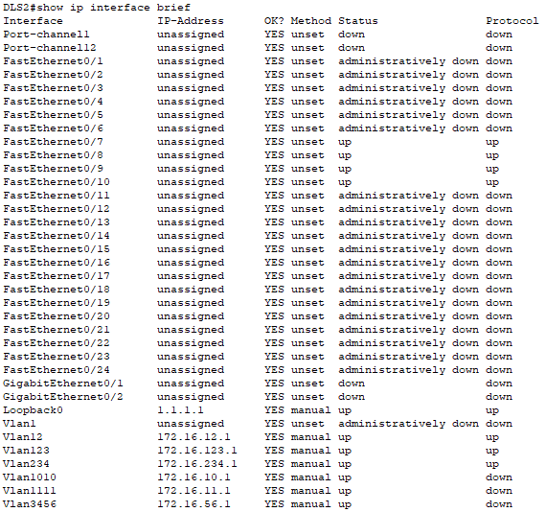

Show VLAN Brief

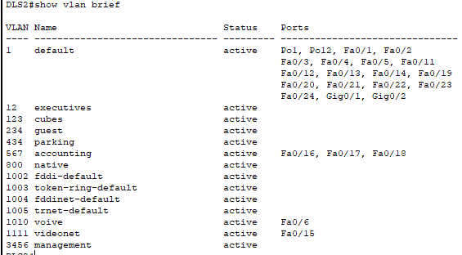

Show VTP Status

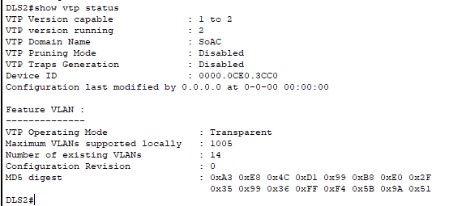

Show etherchannel
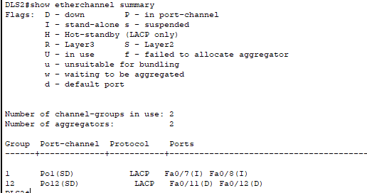
Show spanning-tree Summary

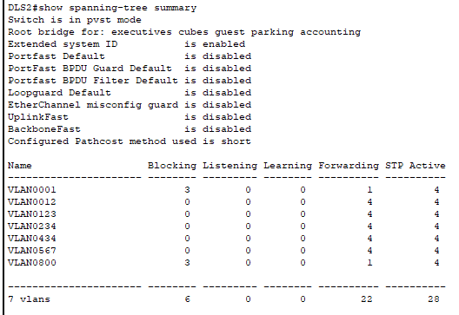

Show standby brief


