University of Wales Trinity Saint David
Wales Institute of Science & Art



Title of Report Here
Module Name (Module Code)

Dominic Jowitt
2510904
October 2025

Table of Contents
Introduction 2
Experimental Procedure 2
Results 4
Steel 4
Aluminium 5
Duralumin 6
PVC 7
Analysis 8
Steel 8
Aluminium 9
Duralumin 10
PVC 11
Conclusion 12
Evaluation 12
Further Work 13
Appendix 13
References 15

Introduction
Tensile testing is a destructive test which increasingly adds an axial load to a dog bone shaped sample whilst measuring the elongation of the sample to determine the yield strength and tensile strength. The aims of the experiment were to determine the tensile strength of four different materials. (Steel, Aluminium, Duralumin and PVC). It was also an aim to record the results to compare the stress against the strain of the material throughout each stage of the test. The experiment was completed using a Tensile Tester Kit ES6. Tensile testing is carried out to determine the strength of materials in engineering scenarios to determine suitable materials. They are also used in the development of new materials. In industry this is important as when engineers are considering potential materials to use in products they need to know how the material will act under the required load. Therefore, they carry out a variety of tests on materials to work out which will be the most suitable material for their product. The tensile strength of a material is determined by the maximum stretching force it can withstand before it breaks or is permanently deformed. It can be demonstrated by looking at the stress and the strain the material is under when being pulled apart in a graph.

Experimental Procedure
The samples that were tested were dog bone shapes of the 4 materials which have a hole for a bolt to attach the sample to the tester. The thin section of the dog bone is the area that is put under stress and is where the material will break. The exact shape used is in Figure 1
Figure 1 - Dog Bone Diagram
The experiment was carried out using a Tecquipment ES6 Tensile Tester which consists of the 2 chucks that hold the material sample. A load nut is located at the top of the tester and moves the top chuck up by 1mm each full rotation and 0.1mm each notch. The bottom chuck is connected to two springs which are attached to the dial indicator which shows the level of force being put through the sample. To attach and detach the sample from the chucks you may need to rotate the load nut to position the chucks into a suitable position to load the sample. Once the chucks are in position using a hexagonal tool tighten the bolts in place to hold the sample securely in position.
Prior to loading a new sample, it is important to measure each sample using Vernier Callipers. After loading the sample into the tester and replacing the safety guard screen you can tare the dial indicator to 0 to begin testing. Once the experiment is ready to begin you can begin to turn the load nut by 2 increments at a time (0.2mm) recording the force on the dial until you have reached an extension of 5mm where you then begin to record the force after each full rotation (1mm at a time).
Once the sample has reached its fracture point, using the hexagonal tool remove the 2 pieces of sample material from the chucks and push the fractured parts together to measure the overall length of the sample to calculate the extension of the material.

Results

Steel
Table 1 - Steel Results

Aluminium
Table 2 - Aluminium Results

Duralumin
Table 3 - Duralumin Results

PVC
Table 4 - PVC Results

Analysis

Steel
Figure 2 shows the stress vs strain graph for the steel sample and Figure 3 shows the elastic region which provides the Youngs Modulus of 21449MPa. However, the researched expected Youngs Modulus is around 200,000MPa which highlights there was clearly an error in the experiment. As you can see from Figure x the steel keeps a steady gradient up to 200MPa where you can begin to see the material yield.

Figure 2 - Steel Tensile Graph

Figure 3 - Steel Elastic Graph

Aluminium
Figure 4 shows the stress vs strain graph for the aluminium sample and Figure 5 shows the elastic region which provides the Youngs Modulus of 9599MPa. Compared to the researched expected value of 69000MPa again showing some slight errors in the experiment. However, you can see from the graph that the aluminium begins to yield around 110Mpa.

Figure 4 - Aluminium Tensile Graph

Figure 5 - Aluminium Elastic Graph

Duralumin
Figure 6 shows the stress vs strain graph for the duralumin sample and Figure 7 shows the elastic region which provides the Youngs Modulus of 13950MPa. Compared to the researched expected Youngs Modulus of 70000MPa shows that again there were evidently some problems in the experiment which were not picked up on.

Figure 6 - Duralumin Tensile Graph

Figure 7 - Duralumin Elastic Graph

PVC
Figure 8 shows the stress vs strain graph for the PVC sample and Figure 9 shows the elastic region which provides the Youngs Modulus of 1092.8MPa. Compared to the researched Youngs Modulus at 2500MPa for particularly rigid PVC highlights that there might be less errors in the experiment for the PVC sample as the Youngs Modulus could vary depending on the grade of PVC and the additives.

Figure 8 - PVC Tensile Graph

Figure 9 - PVC Elastic Graph

Conclusion
The experiment evidently highlighted the different tensile strengths of 4 sample materials. When comparing the tensile stress and yield stress of the 4 samples that were sampled to researched results for these materials it highlighted the following findings.
Table 5 - Comparison to Researched Results
Material | Experiment Tensile Stress  (MPa) | Researched Tensile Stress (MPa) | Experiment Yield Stress (MPa) | Researched Yield Stress (MPa)
Steel | 305 | 400-550 | 163 | 235-250
Aluminium | 160.5 | 310 | 113 | 240
Duralumin | 282.5 | 400 | 215.5 | 280
PVC | 20 | 34-62 | 28 | 40-60

The table highlights there were some accuracy errors in the experiment as a lot of the values recorded from the experiment were significantly lower than the researched values. These errors could be due to impurities in the samples which has affected the strength. For example, if the metal samples had been stored for a long time or in a particularly humid/hot room or a particularly cold room. Furthermore, some recording inaccuracies could lead to anomalous results. A major factor that could play into the different results is the fact that there is uncertainty into the specific grades of each material and therefore when comparing the experimental results to the researched results it is expected to have some differences. Two of the samples should have produced very similar gradients in the elastic region, this was the aluminium and duralumin samples as duralumin has a makeup of roughly 90% aluminium and therefore means their tensile strengths are very similar. However, evidently from the experiment the remaining 10% of the alloy clearly improves the tensile strength of the material as its tensile stress was significantly larger than that of aluminium. It was important to keep a constant force application rate and temperature when testing the PVC samples as because PVC is a polymer it naturally has elastic properties and therefore

Evaluation
There were some measures put in place to try preventing any errors in the experiment such as all samples were tested using the same tester kit and the same people carried it out in the same room, one after another. This meant that the environmental conditions were the same such as the temperature and humidity of the room. By using the same tester kit meant that they all were tested fairly. In addition to this, we completed a second test on a new sample of PVC due to inaccurate readings which ensured that the samples for PVC were as close to accurate as possible.

Further Work
In order to improve the experiment, there could have been multiple samples tested to then take an average of all of the results to reduce the chances of anomalous results from potentially foul samples. Furthermore, another improvement that could be made is automating the machine and the load nut so that the load is increased at the same rate and speed for each sample, this would make the results a lot more accurate as turning the nut by hand and pausing at each increment in order to read the load indicator meant that the results could be slightly off.

Appendix
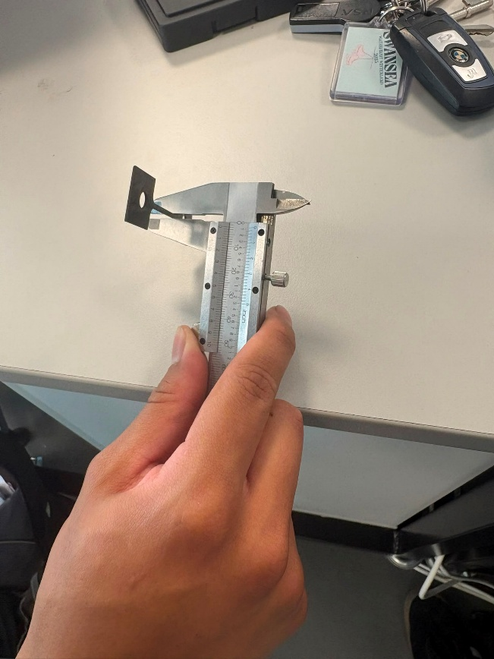
Figure 10 - Measuring of sample
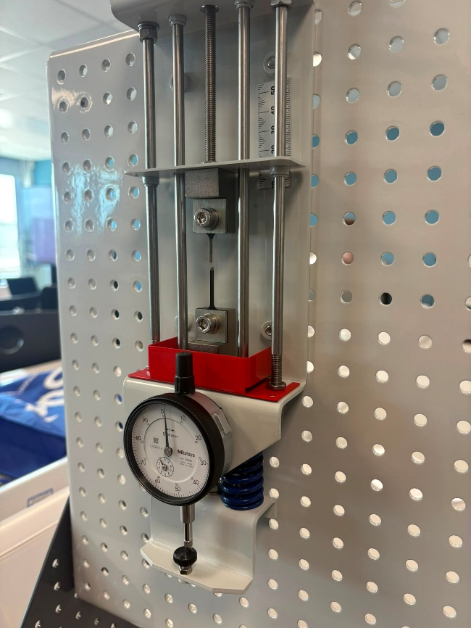
Figure 11 - Fracture point of sample
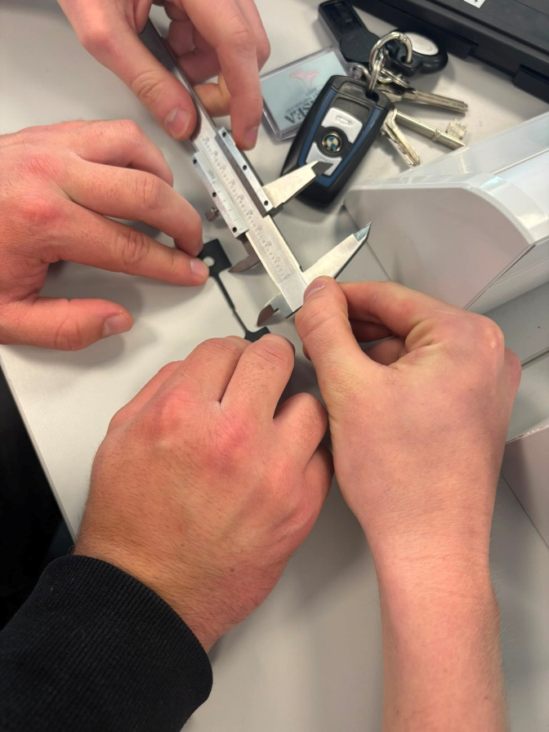
Figure 12 - Measuring Elongation of sample
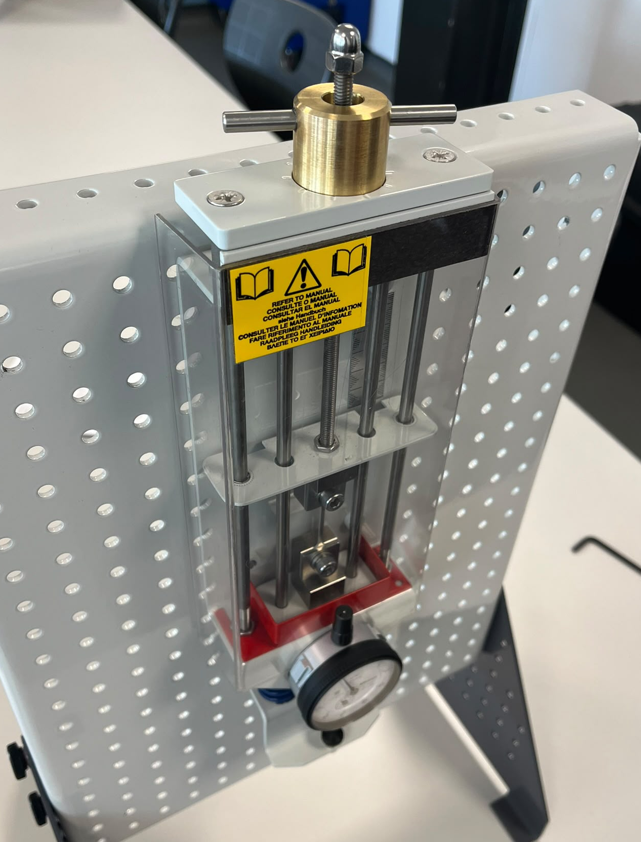
Figure 13 - Experiment in progress

References

UWTSD (n.d.). Engineering Science 1 & Laboratory Skills assignment brief.

ASM International Technical Book Committee (2026). Tensile Testing, 2nd Edition. [online] Google Books. Available at: https://books.google.co.uk/books?hl=en&lr=&id=5uRIb3emLY8C&oi=fnd&pg=PR7&dq=tensile+testing&ots=Ov35_Iaq-K&sig=CmiMtRA_Hrzya6_9ov3d68TXXGQ&redir_esc=y#v=onepage&q&f=false

Tahir, H., Stoltz, G., Veylon, G. and Peyras, L. (2025). Impact of test speed on the thermo-mechanical behavior of various types of geomembranes. Geotextiles and Geomembranes, 53(6), pp.1588–1599. doi:https://doi.org/10.1016/j.geotexmem.2025.08.002.

