

Programmes in C and Documentation

Suzanne Davies – 1809913
Software Development

School of Applied Computing
2nd May 2019

Contents
1. Introduction 3
2. Background Research 4
3. Card Game - Pairs 5
3.1 Problem Formulation 5
3.2 Data Flow Diagram 5
4. Solution Analysis 6
5. Code Annotation 7
6. Testing 8
7. Card Game Rules 12
Bibliography 13

1. Introduction
The purpose of this report is to develop a C program that enable users to play the card matching game Pairs, which contains specific components such as:
- Functions
- Array
- Random Numbers
- For loops
- If statements
- While
- Else
This game has been developed to enable up to a maximum of 2 players to play pairs at any one time.
The game will follow a logical process in the simplest form, recognising if the cards match or not and what needs to happen to them in each scenario.

2. Background Research
The inception of C programming was first introduced approximately 45 years ago, by a man named Dennis Ritchie whose also responsible for the construction of the C language [1].
He [1] created the C language which has since developed to C++ both of which are standardised by the International Organisation for Standardisation (ISO) [2]. Historically, there’s only ever been four approved and tested versions of C++ standardisation:
- Version 1 – Introduction of C++ in 1998
- Version 2 – C++03 developed in 2003
- Version 3 – 2011 saw the introduction of C++11
- Version 4 – C++14 is the current version which was developed in 2014
C++ is a mid-level, object-orientated software development language. It’s quick, frequently utilised, and can be used with ease – particularly with the resources offered presently to create games as well as other programs.

3. Card Game - Pairs

3.1 Problem Formulation
C programming is quite a sophisticated low-level user-friendly system that has the ability to encompass its overall purpose to various modern features [3] that enables event driven programming to create a game; in this case the Pairs card game.
This document therefore demonstrates the application of the card matching game Pairs which has been developed in the C program.
The following program has been written to prompt the players to select cards during their turn and to either keep hold of them if they match or return them to their original position if they don’t.

3.2 Data Flow Diagram
The thought process behind this is to create a simple 2 player game utilising 12 cards in total.
It has been written logically with each stage of the process described in a data-flow diagram.

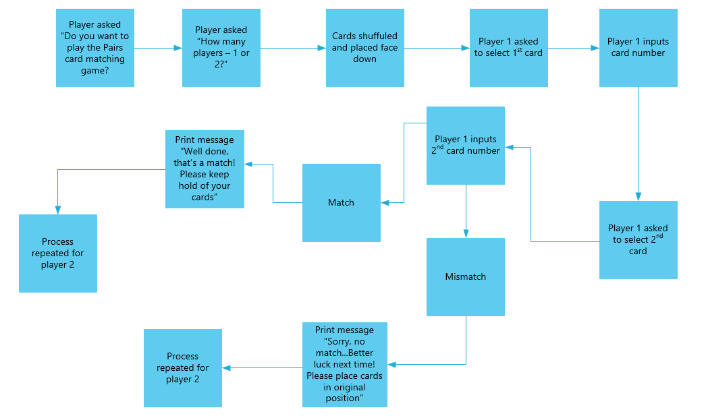
Figure 1 – Data Flow Diagram

4. Solution Analysis
Although the process is demonstrated in figure 1, the solution required to develop a fully established working program consists of:
- An array of 12 numbers labelled 1-6
- Random number generator to shuffle the cards and placed face down ready for the players to select during their turn
- Printf – asks the player if they wish to play pairs
- Scanf - Choice of answer offered in order to answer Y/N
- While the choice is yes, the player is asked to select card 1, before being prompted to select card 2
- If the cards match, the player is asked to keep hold of the card
- Else if they’re a mismatch, the player is asked to return them

5. Code Annotation

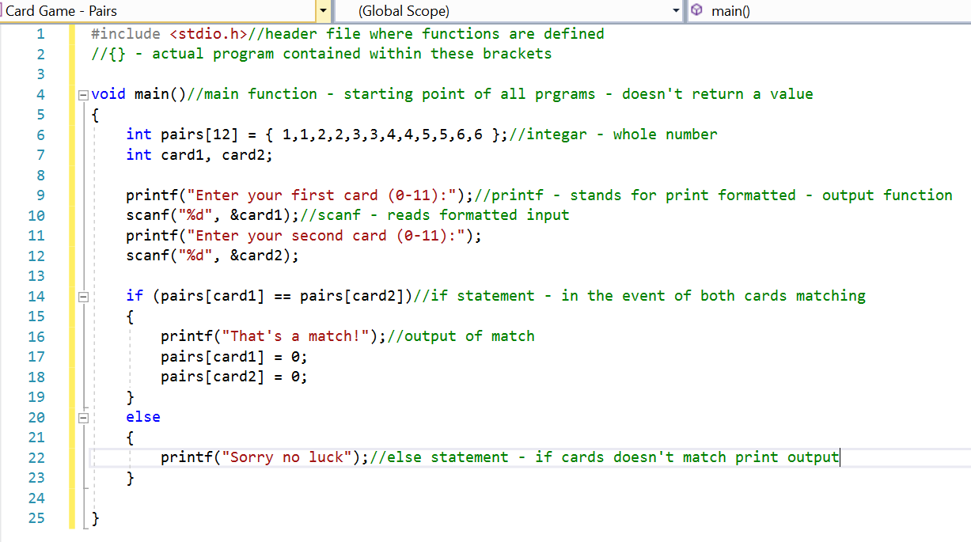
Figure 2 – Basic card game function [4]

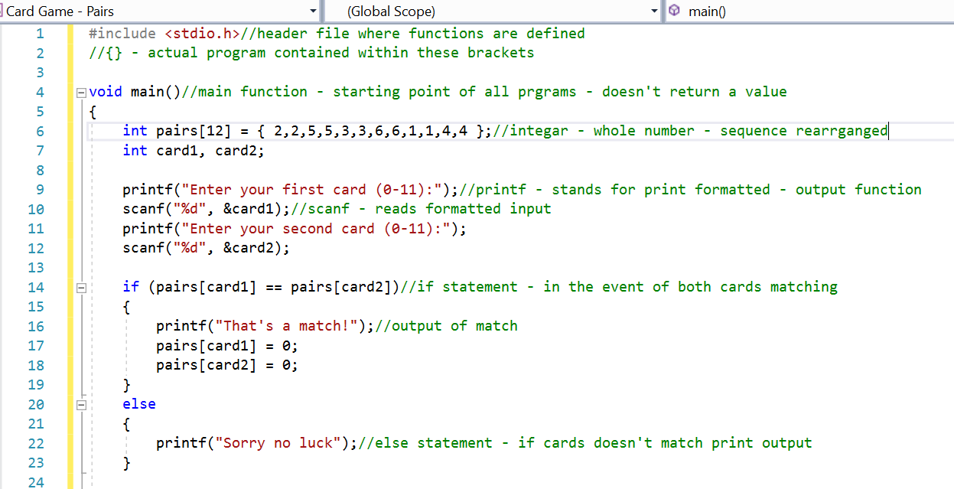
Figure 3 – Basic card game function with card numbers in a mixed array
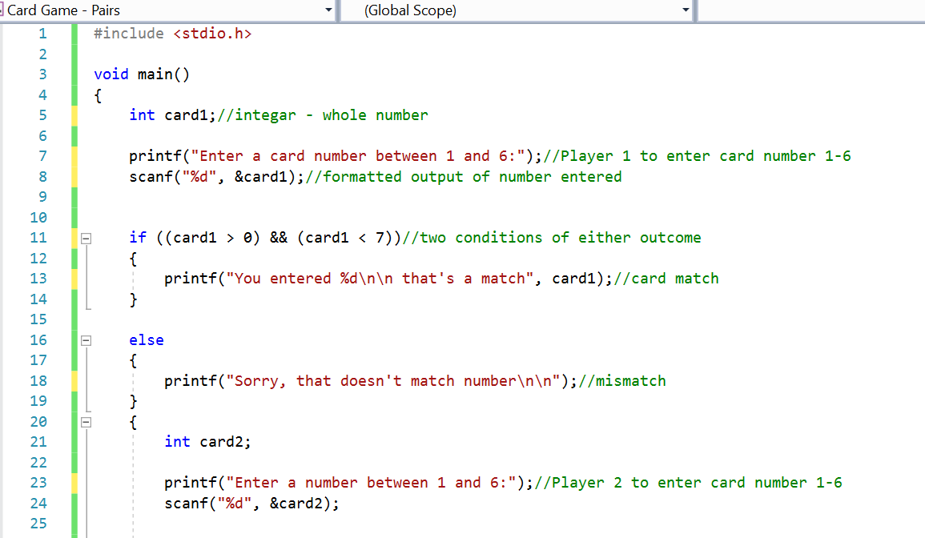

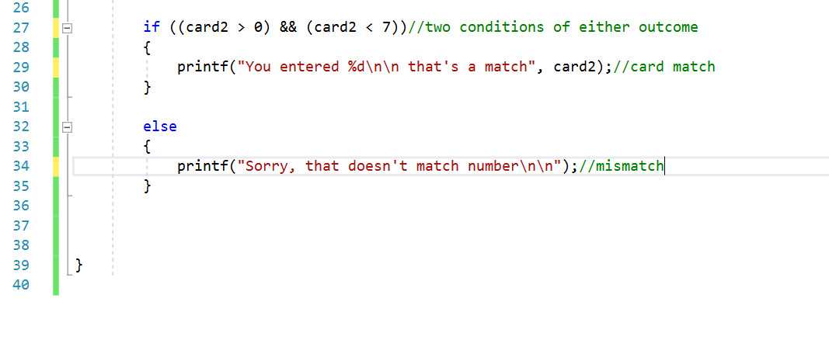
Figure 4 – card game with if and else statement with the two conditions of either outcome
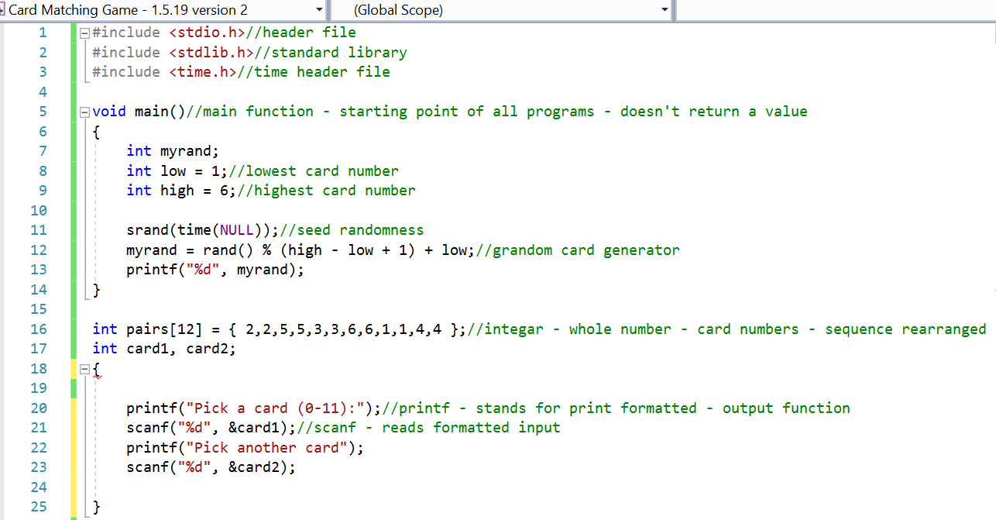

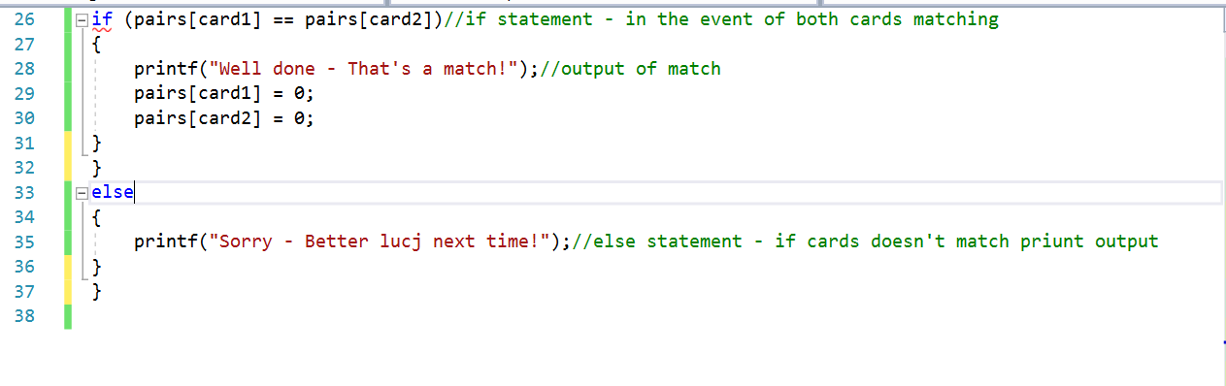

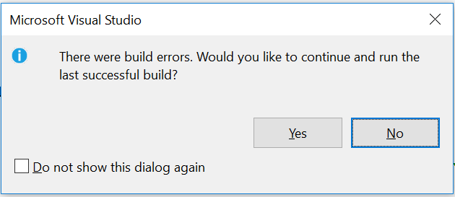

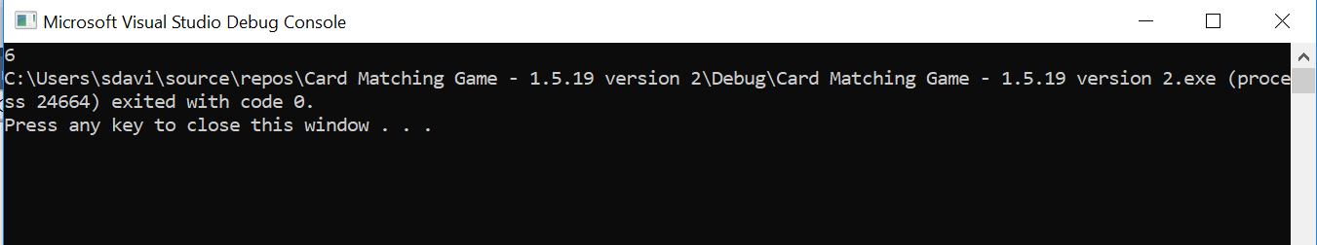
Figure 5 – Attempt to create game with random number to shuffle the cards

6. Testing

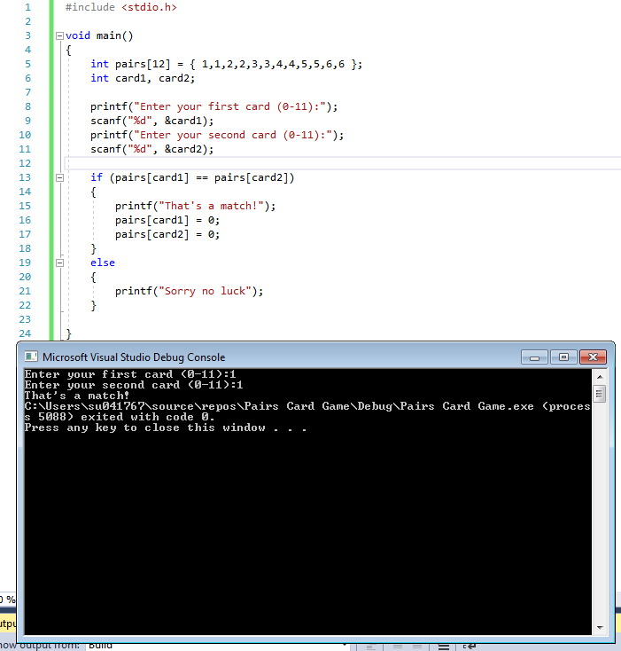
Figure 6 – Testing of figure 2. Enables user to enter matching value of card 1 and 2
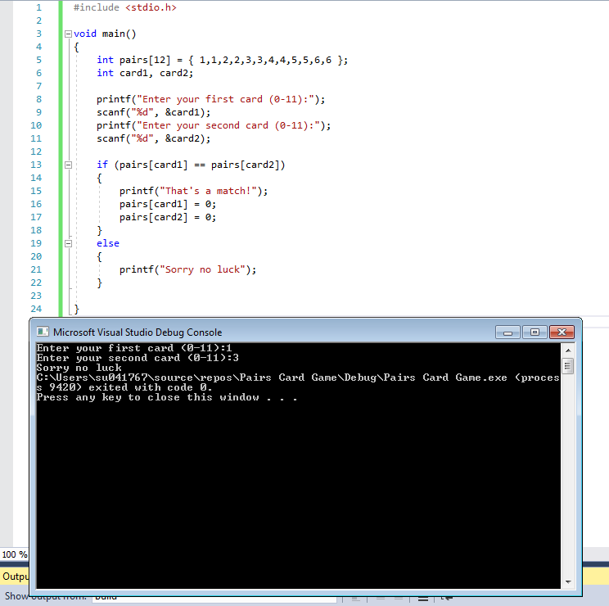
Figure 7 – Testing of figure 2 with values that doesn’t match

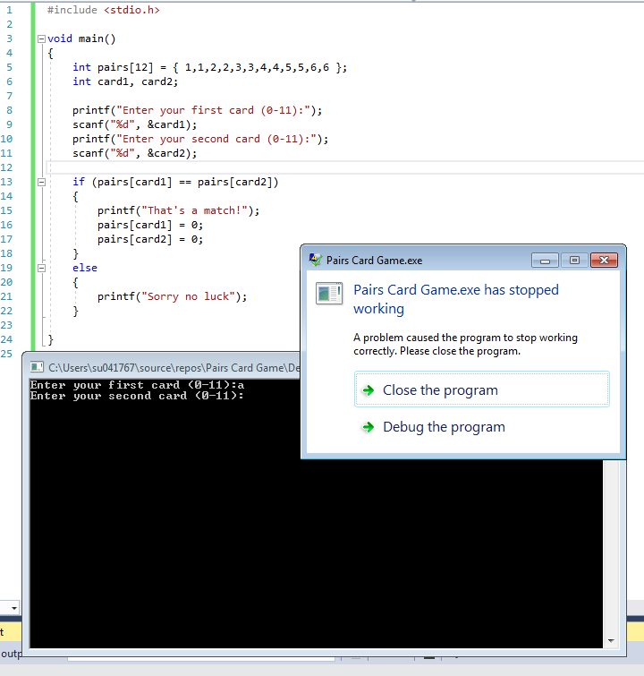
Figure 8 – Testing of figure 2 using a character

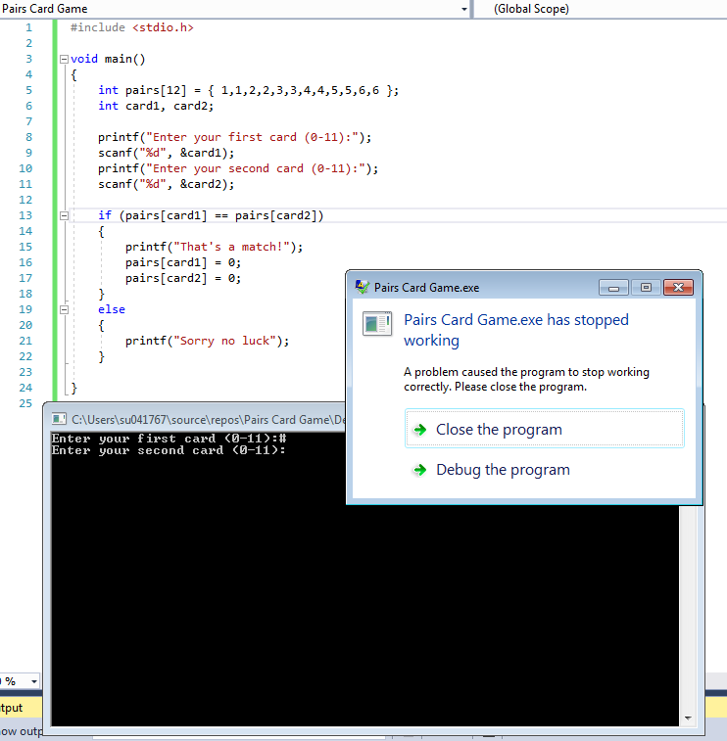

Figure 9 – Testing of figure 2 using symbol

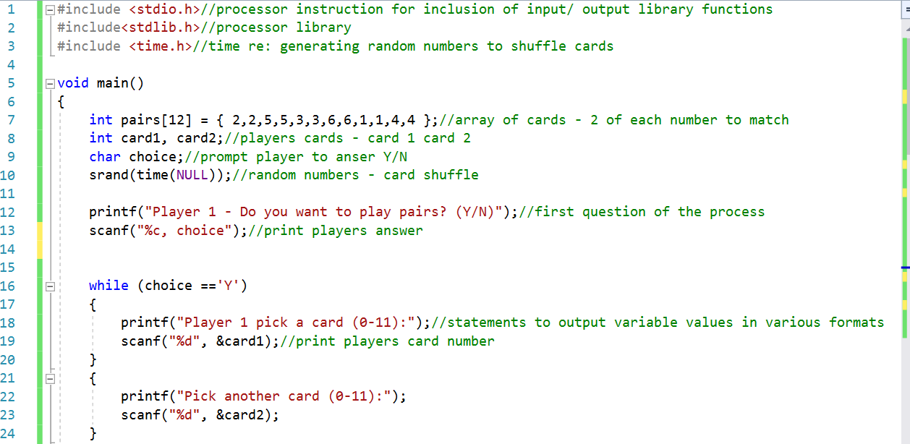
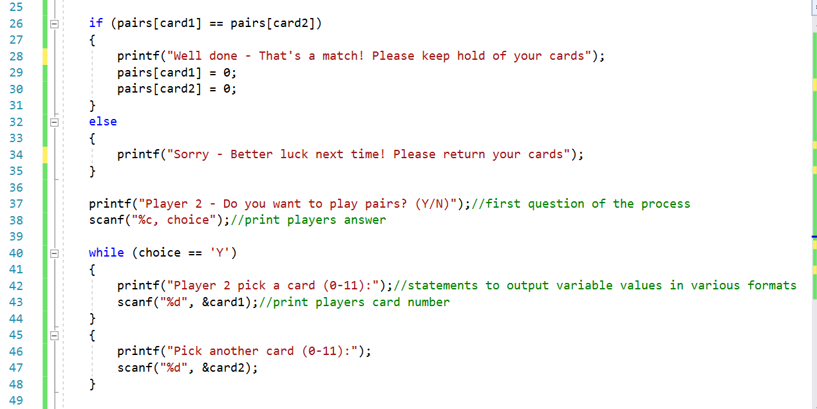
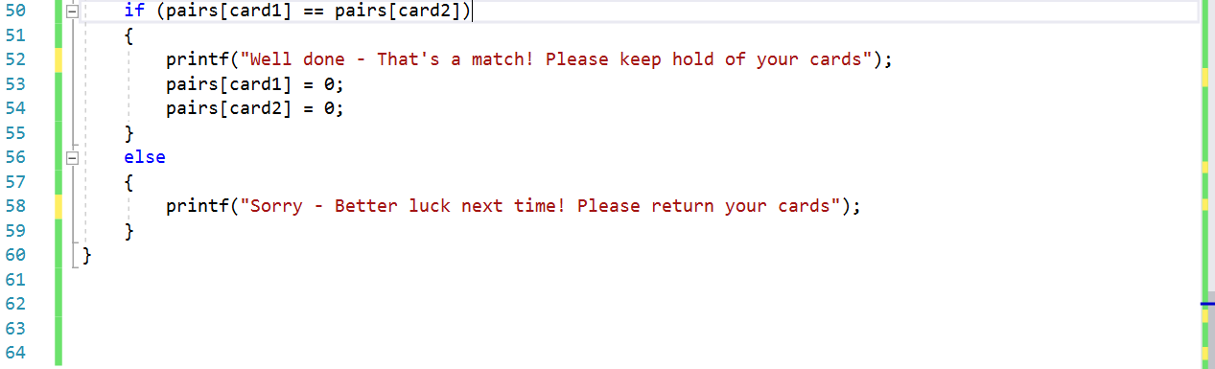

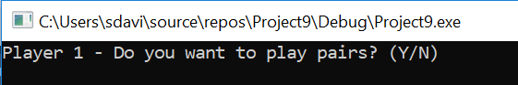

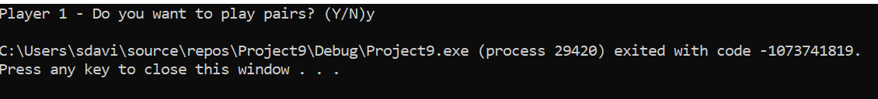
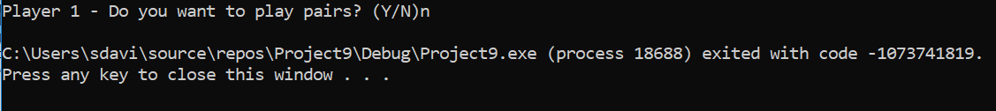

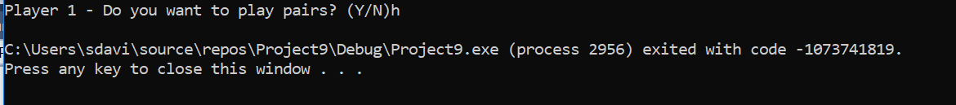
Figure 10 – Attempt at creating a more complex pairs card game, incorporating choice and while

7. Card Game Rules
Pairs is a 2 player memory game, the aim of which is to match all 12 cards with as little attempts as possible.
The rules are:
- Program shuffles a pack of 12 cards and places them face down without the players seeing what they are
- Player 1 selects card 1
- Player 1 selects card 2
If the cards match, this will prompt the message ‘Well done – Your cards are a match!’
The player will keep hold of the cards for the remainder of the game.
If not, they will see the message ‘Sorry, no luck this time!’ and the cards placed back into their original position. The players will need to try and memorise where they’re located ready for the next go.
- Player 2 selects card 1
- Player 2 selects card 2
Whatever the outcome, the program will automatically display one of the above messages depending whether they’re a match or not. The cards will either be held by the player or returned to its original position.
The game will continue as above and will only end once all cards have been matched.
The player with the most paired cards is the winner.

Bibliography

[1] | “5 Excellent C Game Development Tutorials | Game Designing,” [Online]. Available: https://www.gamedesigning.org/learn/c-plus-plus/. [Accessed 1 March 2019].
[2] | “International Organisation for Standardisation,” [Online]. Available: https://www.iso.org/home.html. [Accessed 1 March 2019].
[3] | “Learn C and C++ Programming - Cprogramming.com,” [Online]. Available: https://www.cprogramming.com/. [Accessed 1 March 2019].
[4] | G. Thomas, Pairs Code.

