Kazi Sadia Ahmed, ID 1806239.
Name of business: - WONDERLAND Ltd
Team members: Nazmul Ahmed, Rahima Khanom, Musarat Bibi, Hayath Hareed Deen.
Questionnaire link - https://forms.gle/a6DVbtz5JkWw3ibd6
Gmail login: 1806239uwtsd@gmail.com
Password: nameera8
Brief bit about business:
Our business is a sensory soft play area for children. It has three zones such as toddler zone, sensory play zone and 4 plus zone. It also has a halal café. We are open till 10am to 8pm. We are offering play sessions for special need children which would be run by qualified staff in child care. We do party bookings and after school club. Discounts are given with to annual membership holders.
Analyse two questions

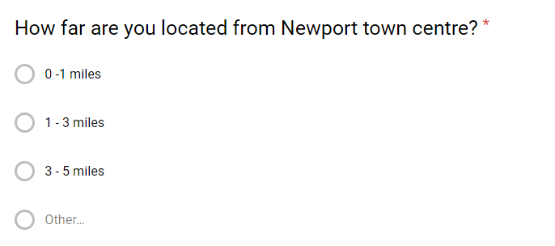

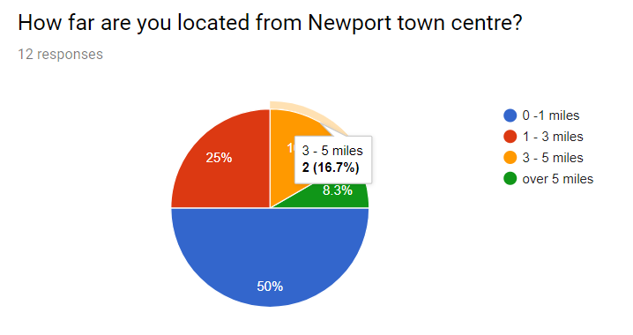

From the analysis of the questionnaire it shows that 50% of the customers are lives within 0 to 1 mile. 25% of customers live within 1 to 3 miles. 16.70% of customers lives within 3 – 5 miles and 8.3% of customers live within over 5 miles. So it shows 50% that of our potential customers are local.
So it will be beneficial for our business in this location since the majority of our potential customers are local and not from a distant area.

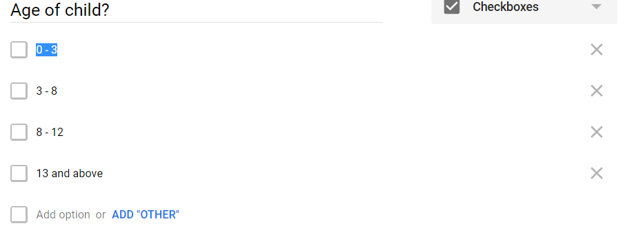

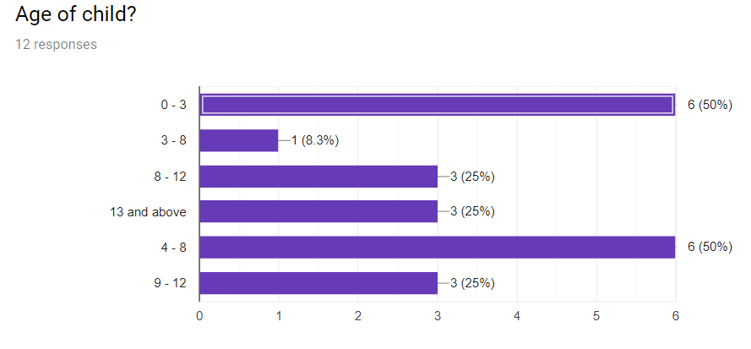
From the analysis of the respondents it shows that 50% of the children are aged between the age of 0 -3 years and another 50% of children are between the age of 4 – 8 years of age. So the settings of our sensory soft play should be designing the settings according to the needs of the children mainly of this age group.

